July 25, 2024

Table of contents

# Some Text from George Box

Science and Statistics Aspects of scientific method are discussed: In particular, its representation as a motivated iteration in which, in succession, practice confronts theory, and theory, practice. Rapid progress requires sufficient flexibility to profit from such confrontations, and the ability to devise parsimonious but effective models, to worry selectively about model inadequacies and to employ mathematics skillfully but appropriately. The development of statistical methods at Rothamsted Experimental Station by Sir Ronald Fisher is used to illustrate these themes.

(Box 1976)

# A Table

## Testing for heading 2

### Test for heading 3

This {flextable} follows the AAGI style guidelines.

| **Ozone** | **Solar.R** | **Wind** | **Temp** | **Month** | **Day** | **Month Name** |
| --- | --- | --- | --- | --- | --- | --- |
| 41 | 190 | 7.4 | 67 | 5 | 1 | May |
| 36 | 118 | 8.0 | 72 | 5 | 2 | May |
| 12 | 149 | 12.6 | 74 | 5 | 3 | May |
| 18 | 313 | 11.5 | 62 | 5 | 4 | May |
|  |  | 14.3 | 56 | 5 | 5 | May |
| 28 |  | 14.9 | 66 | 5 | 6 | May |

# A Histogram

The AAGI theme is automatically applied here as well.

`stat_bin()` using `bins = 30`. Pick better value with `binwidth`.

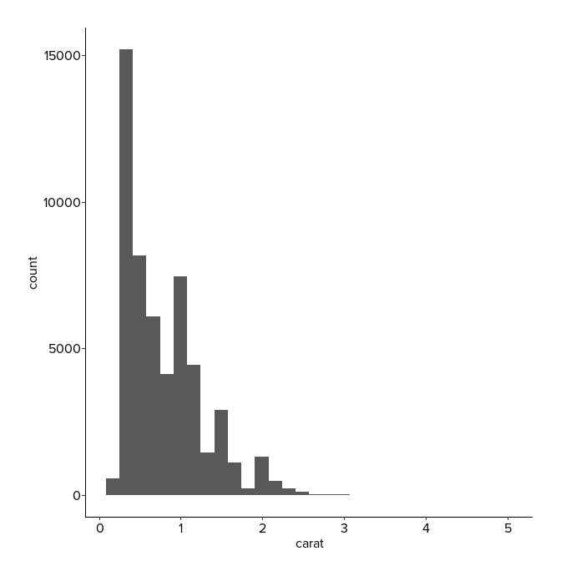

# References

Box, George E. P. 1976. “Science and Statistics.” *Journal of the American Statistical Association* 71 (356): 791–99. <https://doi.org/10.1080/01621459.1976.10480949>.