|  |  |  |  |
| --- | --- | --- | --- |
| **S.No** | **Name** | **SapID** | **Roll no.** |
| **1.** | **Rajat Tak** | **500070511** | **40** |
| **2.** | **Prakhar Bauddh** | **500068867** | **34** |
| **3.** | **Vedant singh** | **500071252** | **68** |
| **4.** | **Rakshit Darmwal** | **500069975** | **42** |

Project: AAHAAR

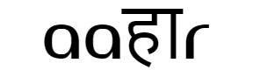

**Index**

|  |  |  |
| --- | --- | --- |
| **S.No.** | **Particulars** | **Page No.** |
| **1.** | **Abstract** | **4** |
| **2.** | **Principle of Agile System** | **5-7** |
| **3.** | **Introduction** | **8-10** |
| **4.** | **E-R Diagram** | **11** |
| **5.** | **DFD Diagram** | **12** |
| **6.** | **Methodology : Waterfall Model** | **13-15** |





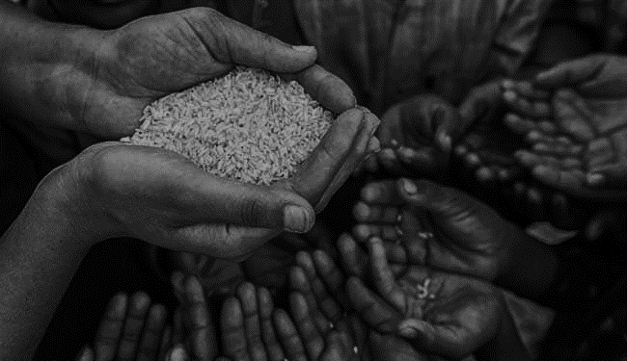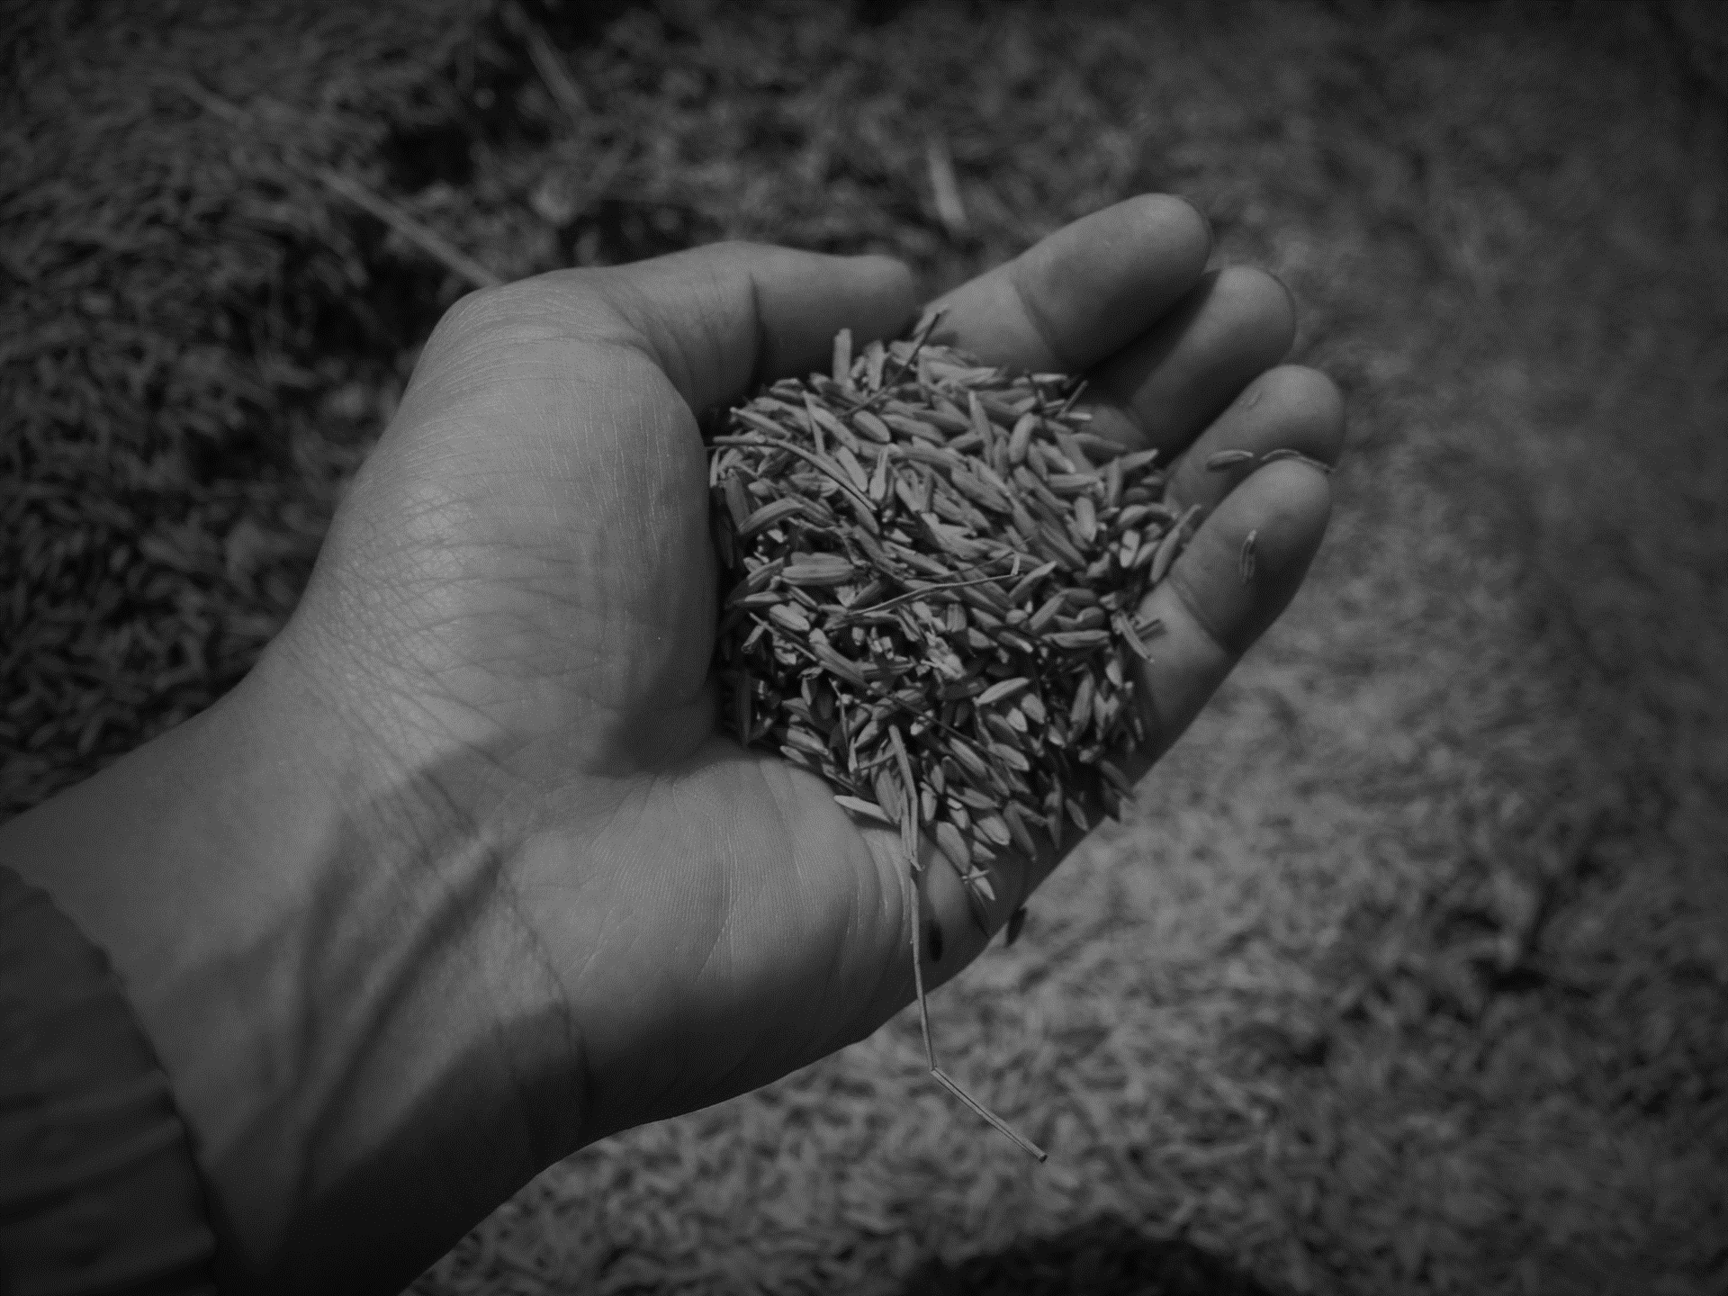

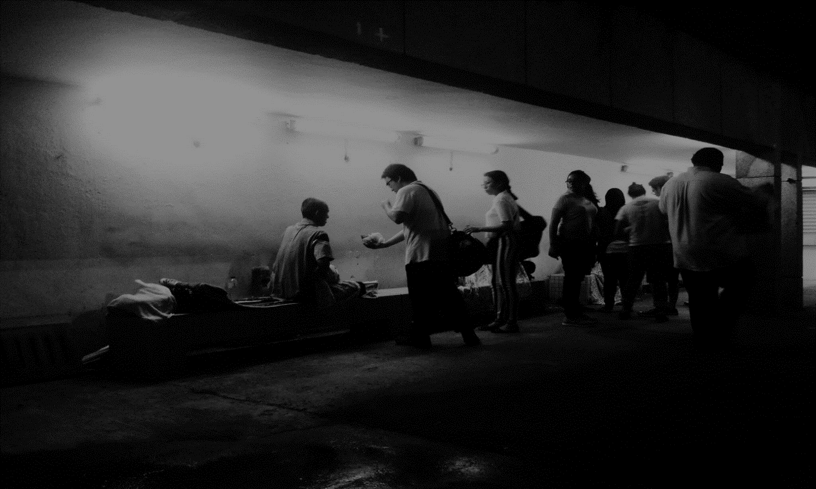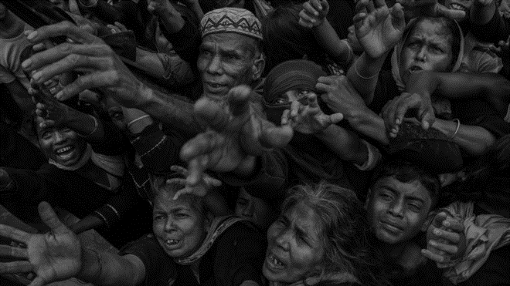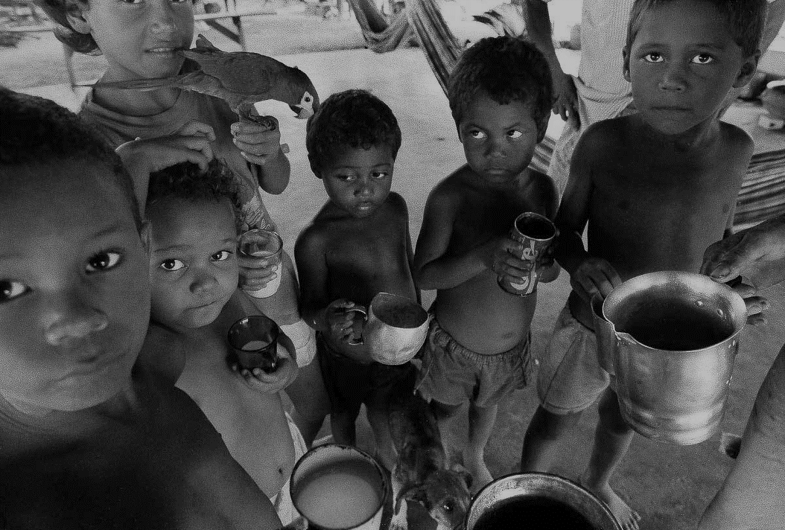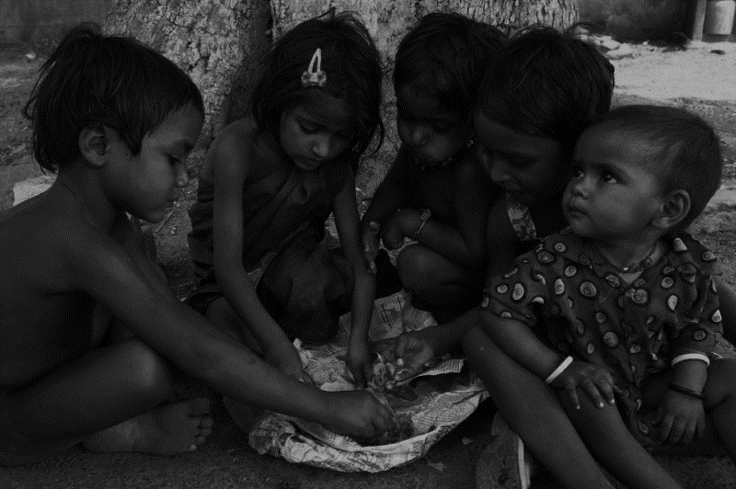

One can, two can, who can?? **YOU CAN**

**ABSTRACT**

Aahaar foundation is an NGO that was originated from an idea that how food can be reused or we can say that how we can use every single grain of food as some body is working day and night in field to grow it and some body is working day and night to get that grain. We here at Aahaar tried to find four major ways to contribute to the society and stand as something new, unique. We think that money is not the only thing that can help or bring change and we don’t demand any money from all the individual that want to work with us or help us to spread these four principal on which aahaar is based . We all tried to make everything super easy and client-friendly. We are planning to design a web portal that is up to today’s trend and can showcase our four principal correctly.



4 PRINCIPALS of Agile Systems

* Individuals and interactions over processes and tools

This is one of the main thought at aahaar and we think in today’s world money act as a tool which people use to satisfy themselves but we focus more on aahaar’s direct interaction with people who are in need and the people who wish to be a part of a medium that is capable to fulfil their basic needs.

According to us if we give more importance to Individuals and Interaction then it have healthy benefits like:

* Connections made are effective.
* Connection made are quick.
* Changes happened are strong as people work together.



* Working software over comprehensive documentation0

This is the principal which can take us further as we know that documentation is important but it cannot overcome a working model or software as it is easy for client to imagine the idea more clearly as we in aahaar are also trying our best to implement it, As we believe that we can save time used in documentation and use it in planning and implementing new things. We work in a different manner then other like if we get a work or an idea then we start planning it and improvise it simultaneously with documentation as

We think if we invest more time in planning then it will make our output more strong.

* Customer collaboration over contract negotiation

****Our main goal is to help and according to us helping is not mandatory so if an individual is willing to come and help then there should be no debate on how to help or we can say that there should be no negotiation on the method. As if an individual is willing to help that is the most important thing for us. As if all are willing to help then there should be no terms and conditions for that because if we and the client are on same page then that the most important thing then all other things. And from our point of view Collaboration is far better than Confrontation as it give way better results. And by this a strong bond is created if very beneficial for all the people related to it.

* Responding to change over following a plan

****This is the principal which is very important to follow as if we find something which is not working as according to our plan then should make changes in our plan to avoid unnecessary risk. As everyday new problem and solutions are introduced in the market and if we find something more efficient then we should modify our plan accordingly to make if better and to the point, So that it that less work force to do better work. Planning is very important but we should learn from the things we do and then implement their result in future work to make it more time, work, energy efficient.



**Introduction**

Aahaar foundation is an NGO that was originated from an idea that how food can be reused or we can say that how we can use every single grain of food as some body is working day and night in field to grow it and some body is working day and night to get that grain. We here at Aahaar tried to find four major ways to contribute to the society and stand as something new, unique. We think that money is not the only thing that can help or bring change and we don’t demand any money from all the individual that want to work with us or help us to spread these four principal on which aahaar is based . We all tried to make everything super easy and client-friendly. We are planning to design a web portal that is up to today’s trend and can showcase our four principal correctly.

Our Four Pillars are:

1. Donate Food
2. Donate Bio-waste
3. Share joy
4. Donate Work



* **Donate Food**

In this section we request all the Hostels, Restaurant, Hotels that the food then is left which they throw can be used to fill many empty stomach. We have a very simple approach there that the food which is made for lunch and then cannot be used further can be simply donated at some predefined point which will be very near to their place and then we can take it with us and then people who can’t even make two meals a day and we don’t demand something more or extraordinary as if you give us the unutilized food than we will help you in promoting your restaurant, hotel, hostel. So you can save a lot of money there as we will have donating points, vans running so we can easily promote your business and quantity does not matter if you want to be a part of a good change as even a family can donate a food if then have food for 4 left from a party or function then they can donate as it can feed a family.

* **Donate Bio – Waste**

In the section we request all the Hotels , Hostel , Homes in short every place where food is make as you prepare food we can you gather some waster which you throw in dustbin can save some one life . Let me explain you in some other ways we all see news that farmer committed suicide because he don’t have enough money grow crop and feed his family so here Aahaar wants to take an initiative that all the waste gather from hotels, hostels etc. And will be utilized to create manure which will be distributed to farmers so it can be a little help for them. Your waste can save someone’s life. And charges will be minimal for this the so cost will be the selling price for this manure.



* **Share joy**

In this section we don’t request for something here you give anything from you heart means that there are many people who want to do something for society on their special occasions so we welcome them as the can provide meal, cloths etc. to as many people as they want and this whole thing will be organized from our side so you just need to select the occasion and leave all the other thing on us. We also have a category where you can sponsor an individual for a time period according to you.

* **Donate Work**

In this section we use the quality means that there may be some people who can’t do anything in the above three section but here they can serve. So here you donate food or bio waste or sponsor somebody but here You can use your skills to help us as many people are good in technological skills many are good will field skills etc. and some of you can help with your resources as if you are an exporter then you can give us the access to an of your bus or minivan which can be used to collect food or bio-waste. If you have technical skills then you can help us to optimize our web portal and those who are good in field skills they can help us serve thing and organize events and meals of these needy people.



****ER DIAGRAM

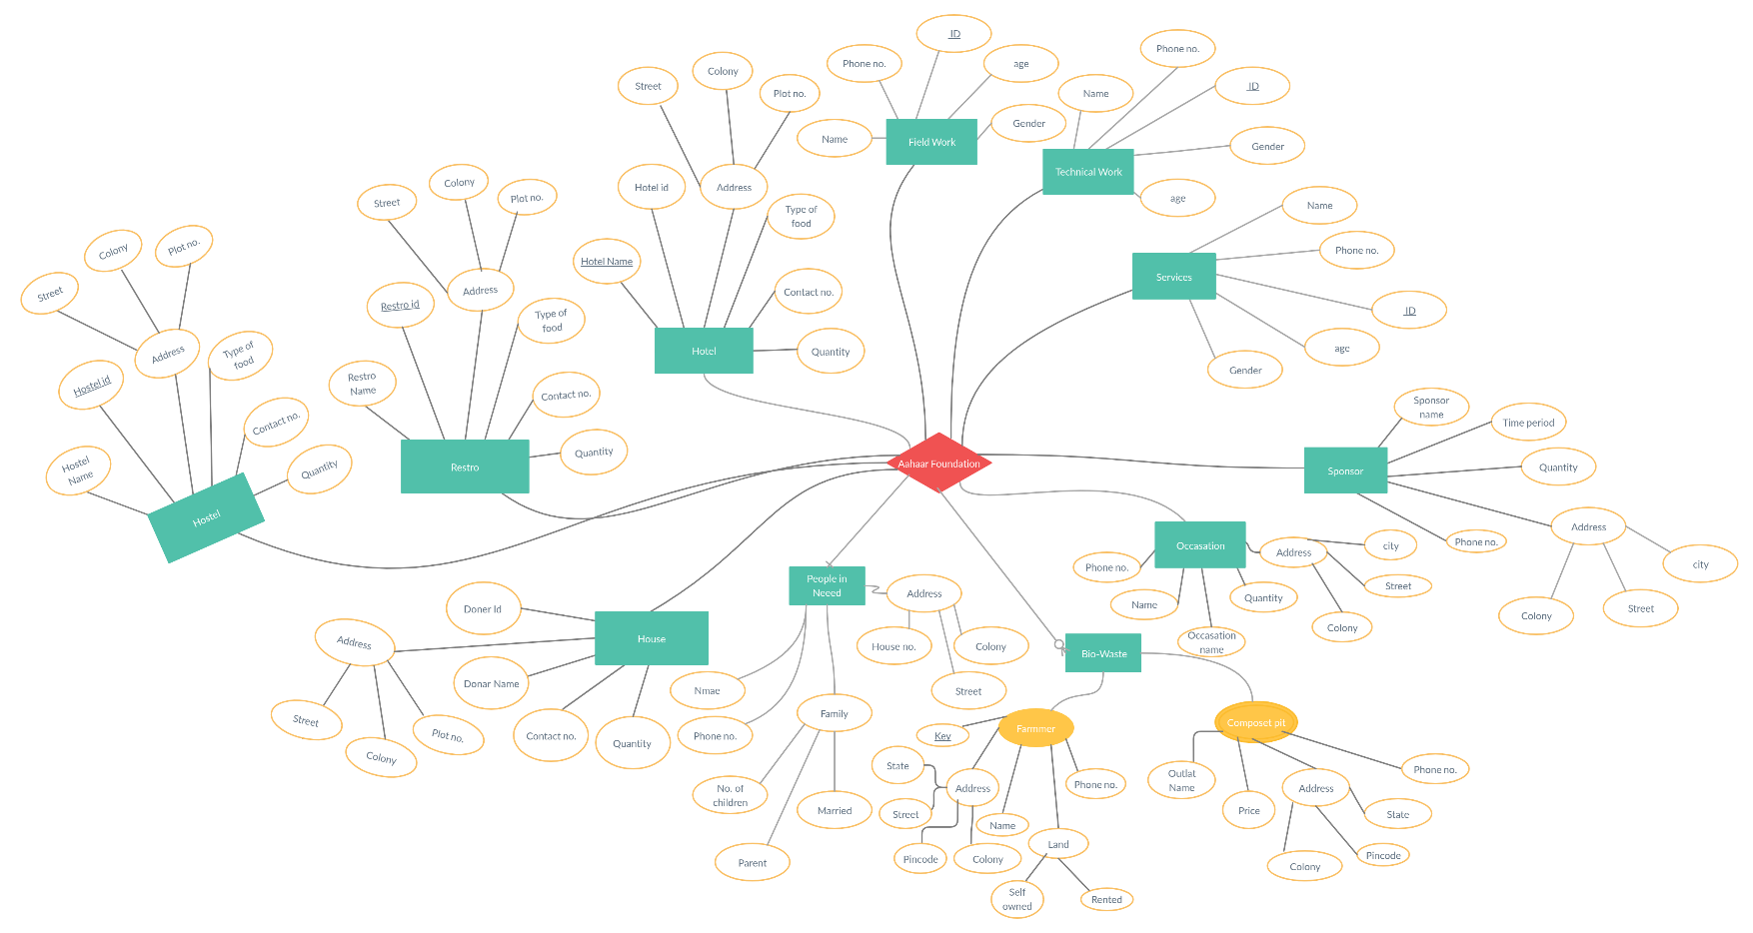

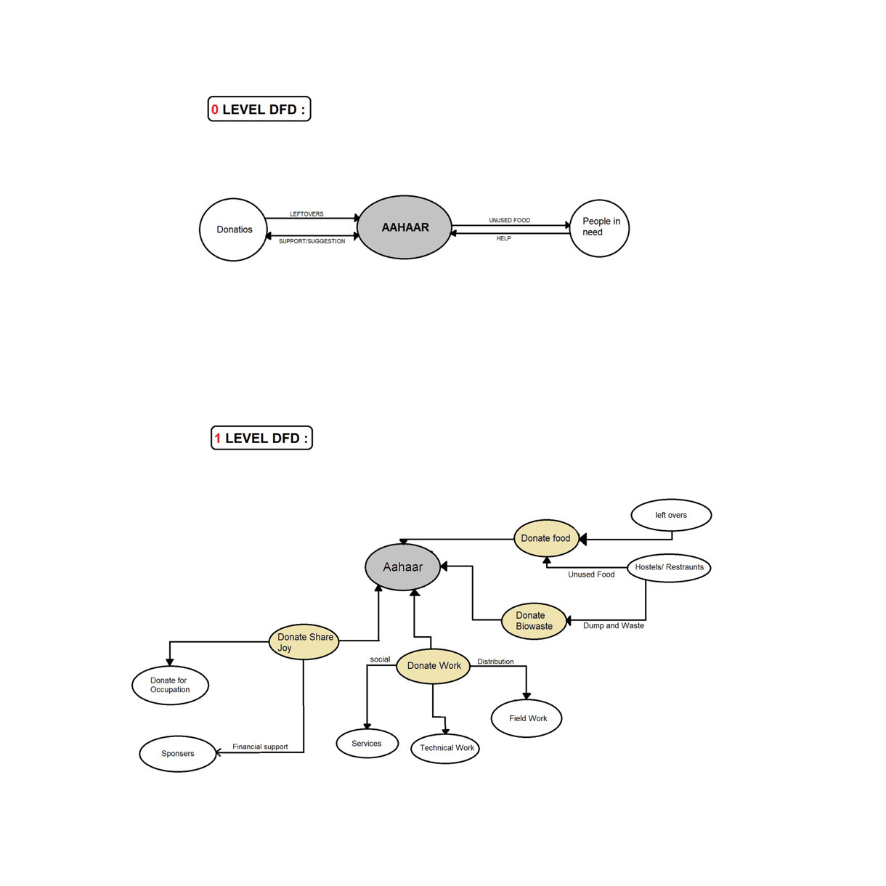DFD DIAGRAM



Waterfall Model

In a waterfall model each phase must be completed before the next phase can begin and there is no overlapping in the phases. This means that any phase in the development process begins only if the previous phase is complete

**\*Requirement gathering and analysis-** in this phase all the requirements of the system are developed and documented. In our project “Aahar” the requirements all we need is firstly to contact all the nearby hostels, houses and to share this idea with them and request them to help for this initiative and give the left out food or the food that has been wasted specially the peel of fruits because it adds nutrients and nitrogen to the soil as they decompose and are particularly effective for use as a natural fertilizer, secondly we require a transportation facility to pick up the food from the people twice daily, and most importantly a smart dustbin that will calculate points according to the weight of the waste dump by the users and they will be rewarded with accordance to their points. We also want people individually to give their feedback and suggestions that can be implemented for this scenario and making it more effective.

**\*System Design**

System design in Aahar includes what can be the possible model made from all the requirements. System a surface design of the plan that how food will be transferred from hostel or homes to NGO, and further to build the design keeping its scope and scalability in mind. That if further the Aahar grows then, how much it’s the design can be improved.

**\*Implementation**

In this phase the inputs from the system design are taken and then the system is developed in small programs called units and each unit is developed and tested for its functionality. Globally India is the leading producer of fruits. Fruits after consumption leave peel which is nuisance to the environment as a solid waste. The fruit peels of banana, orange, lemon, were collected from a local market and their leaves. These fruit peel will be used by us, to prepare manures for the farm which will be given to farmers in low prices.

Hostels nearby are left with a lots of food which is wasted and thrown. The idea which is going to be implemented using this design is to transfer this food from hostels and homes to NGO by some transportation.

**\*Integration and Testing**

All the units developed in the implementation phase are integrated into a system after testing of each unit. Post integration the entire system is tested for any faults and failures. In our project “Aahar” finally all modules are integrated as a one system. All the possible failures which can be generated in Aahar is tested in this phase like the idea of transportation from hostel to NGO. Are hostels, going to agree for transportation on food.

**\*Performance**

Theoretically, the idea is implemented, but the main problem will be identified only when “Aahar” is going to be brought in the market for performance. Then an evaluation will be made that how well Aahar is performing. Are hostels agreeing with the policies or Aahar or not. How many numbers of people agree to work with us?

