Operating system final project shell

Group members
1. Nathenael Takregn
2.Bereket G/dingle
3.Kaleb wondosen

Shell documentation
Introduction

This program is desinged in C and it mimics the some features of the linux terminal. It has basic file management , directory management and a help commands.

Specifications

This shell program have only 7 commands namely cf, cpf, display, ctdir, chgdir, pslist, hlp for creating file, copying file, displaying file content, creating directory, changing working directory, listing current running process and help for each commands respectively. Some commands have a flag for specifying additional operation.

Design and implementation

This shell as described in the introduction part is designed with C language. And for a process list functionality we have inserted our custom module to the kernel.

The commands are executed with separate process from the shell. Technically the parent process forks and the command are executed in child process. Always the shell process wait for the commands (child) process except in a case that the command process is allowed to run in background.

Screen shots

Create file command
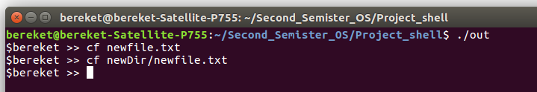
Copy file command
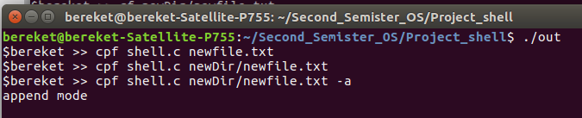
Display command
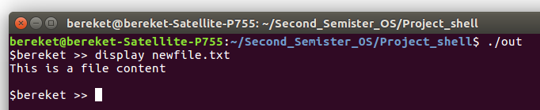

Directory Management commands
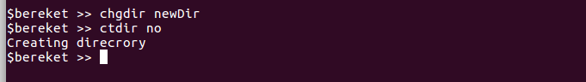
Help commands
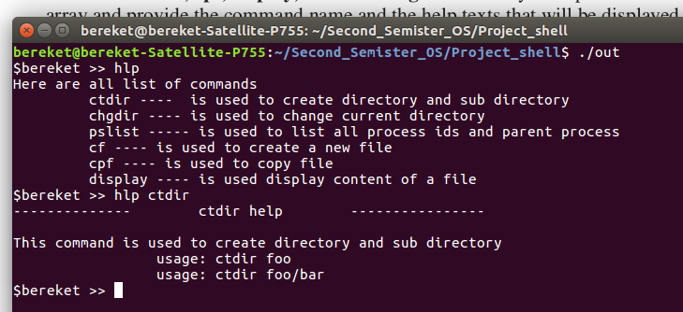
Process list command
