1. **ENTER PASSWORD TO CHECK STRENGTH OF PASSWORD.**

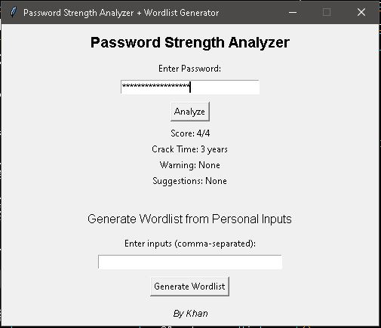

1. **ENTER WORDS TO CREATE NEW PASSWORD COMBINATIONS.**

