[Flight Details](http://localhost/devrev_workspace/view_flights.php)

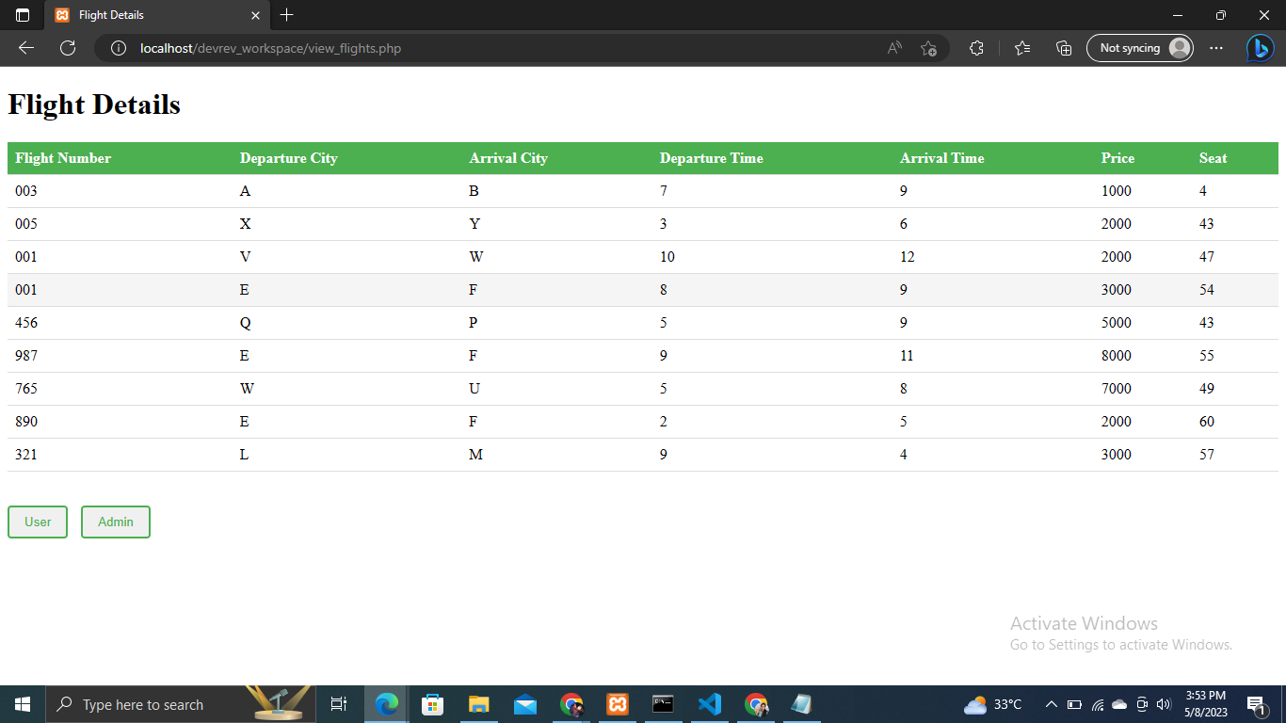

Admin Page

[localhost/devrev_workspace/admin/option.php](http://localhost/devrev_workspace/admin/option.php)

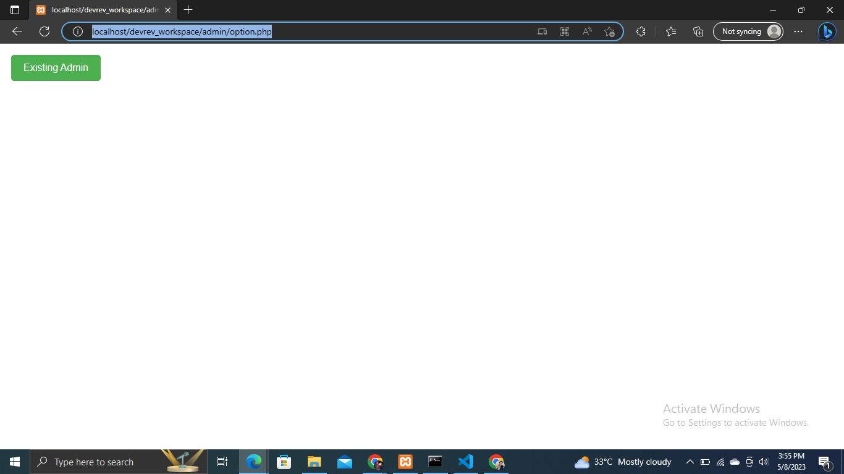

Username : xyz_xyz

Password : 987

[Admin Actions](http://localhost/devrev_workspace/admin/admin_actions.php)

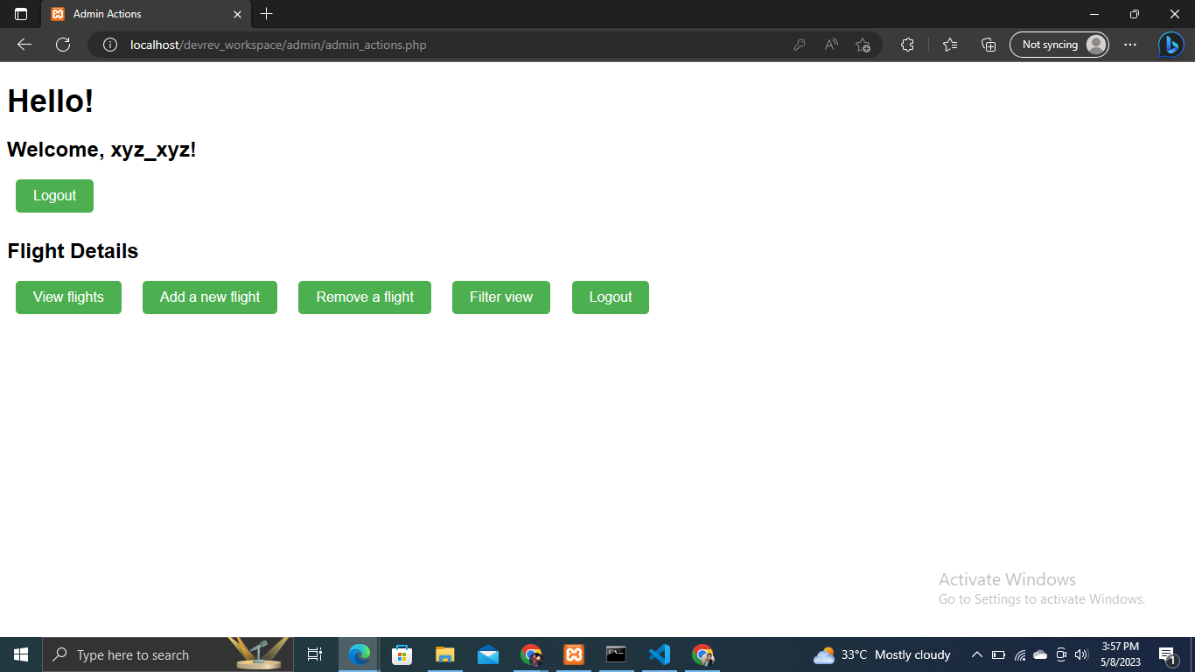

[Admin Add Flight](http://localhost/devrev_workspace/admin/add_flight.php)

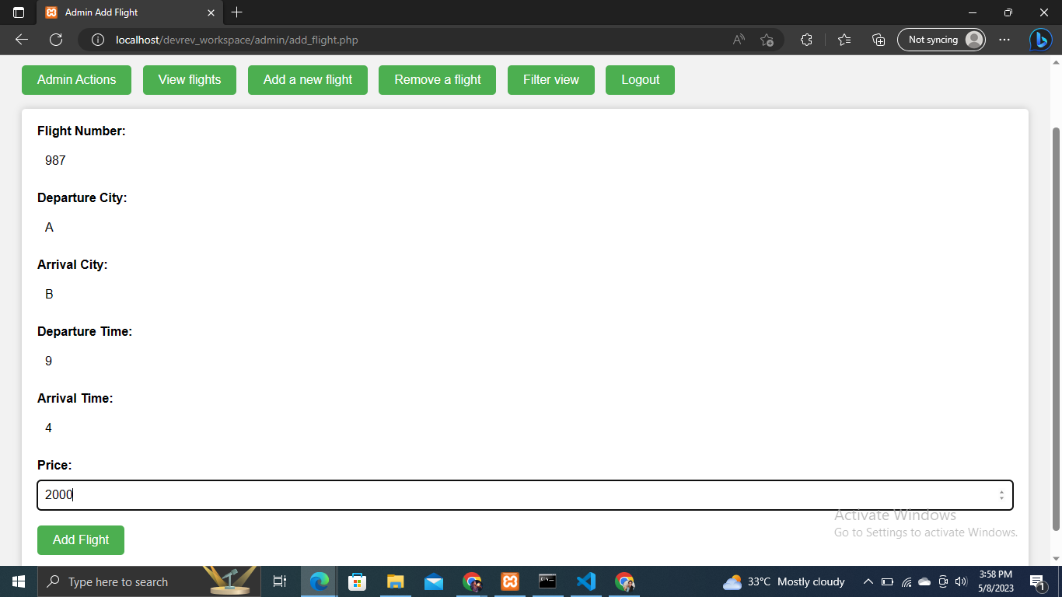

[Remove Flight](http://localhost/devrev_workspace/admin/remove_flight.php)

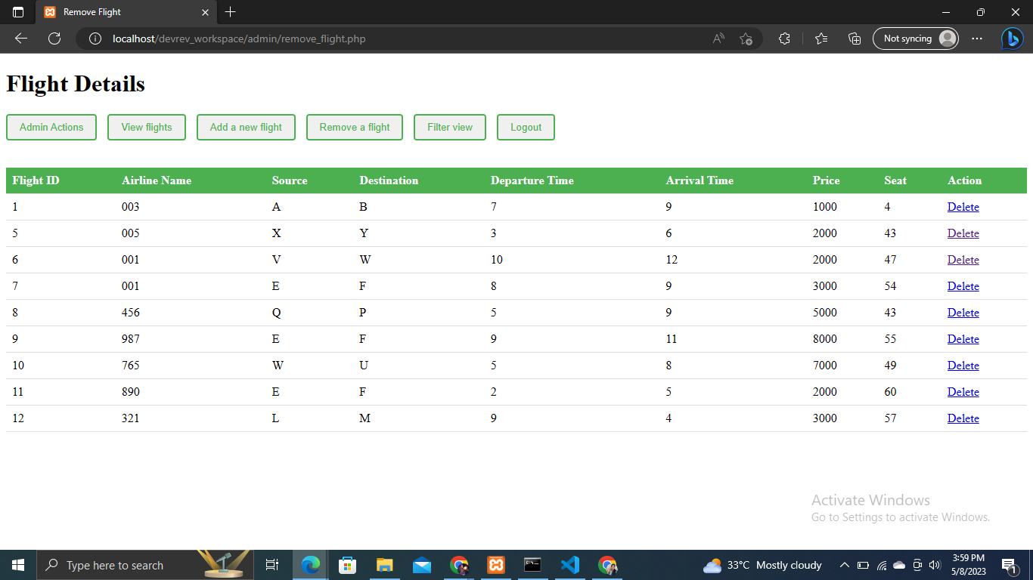

[Admin - Booked Flight](http://localhost/devrev_workspace/admin/filter.php)

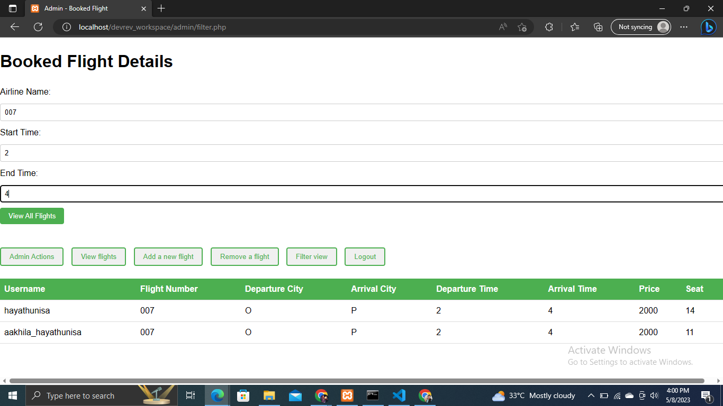

Admin has already logged in

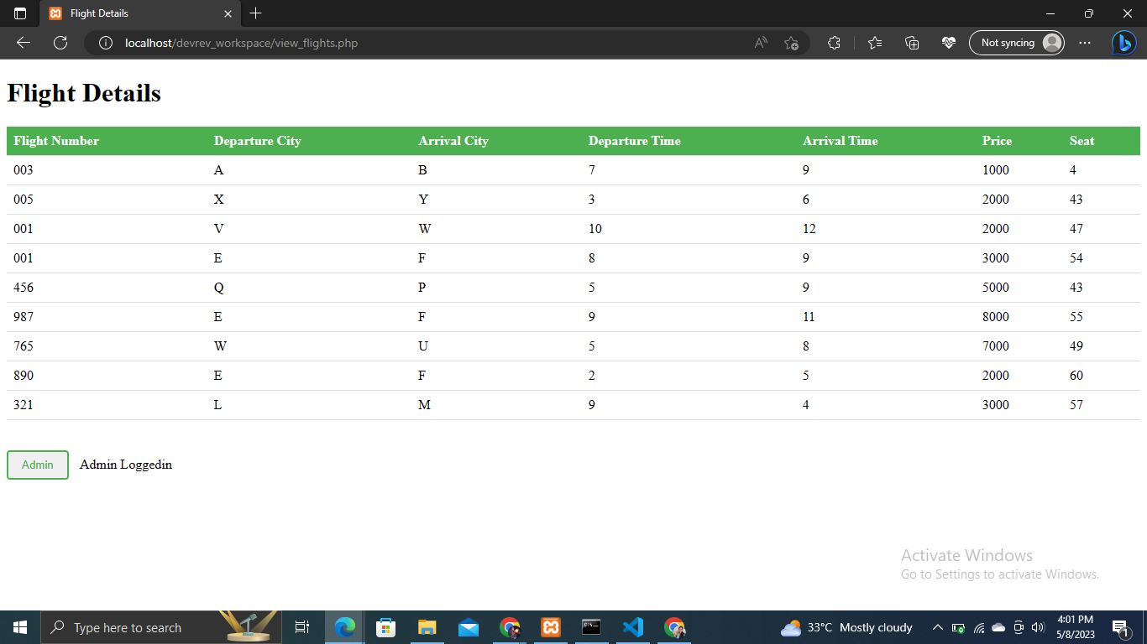

User page

[localhost/devrev_workspace/user/option.php](http://localhost/devrev_workspace/user/option.php)

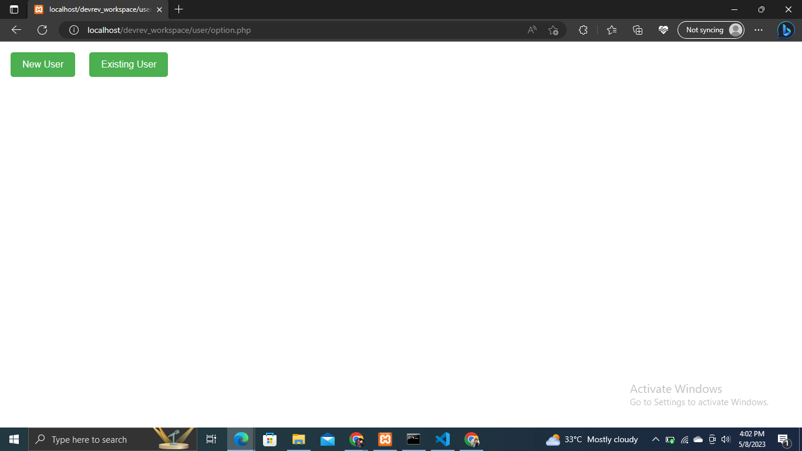

[User Sign Up](http://localhost/devrev_workspace/user/signup.php)

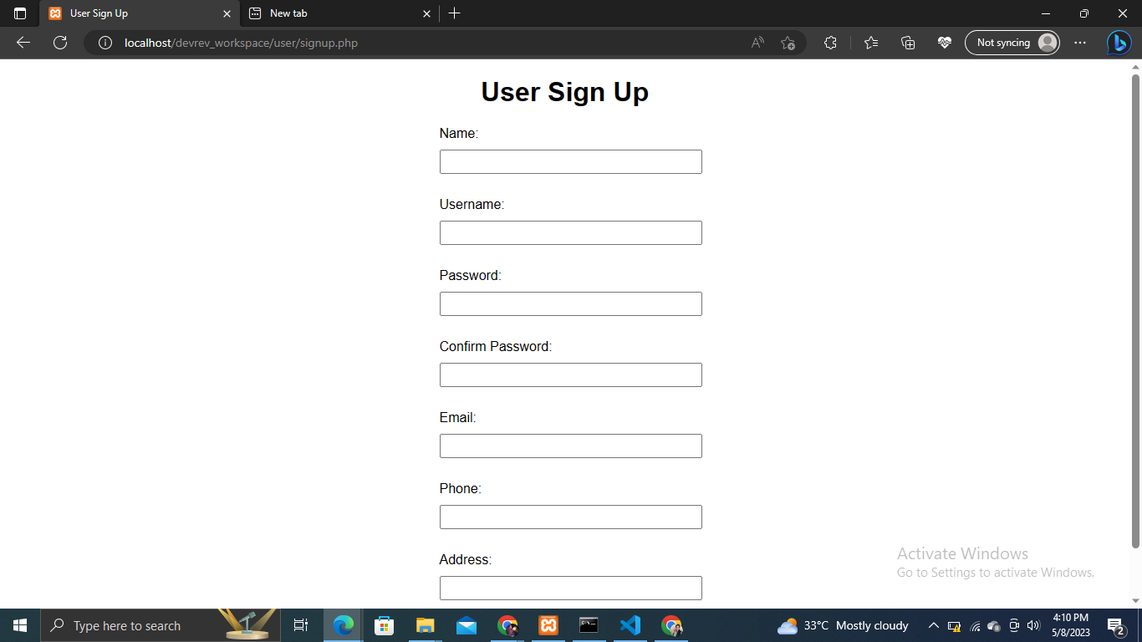

[User Login](http://localhost/devrev_workspace/user/login.php)

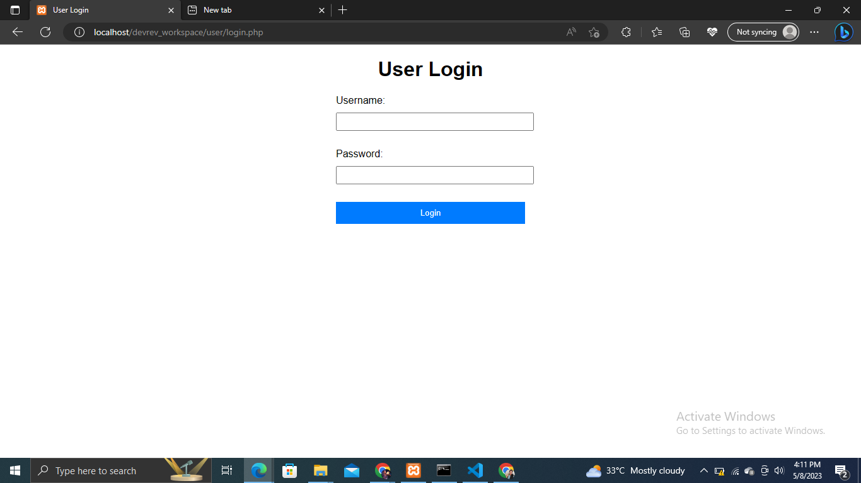

[Flight Search Details](http://localhost/devrev_workspace/user/filter.php)

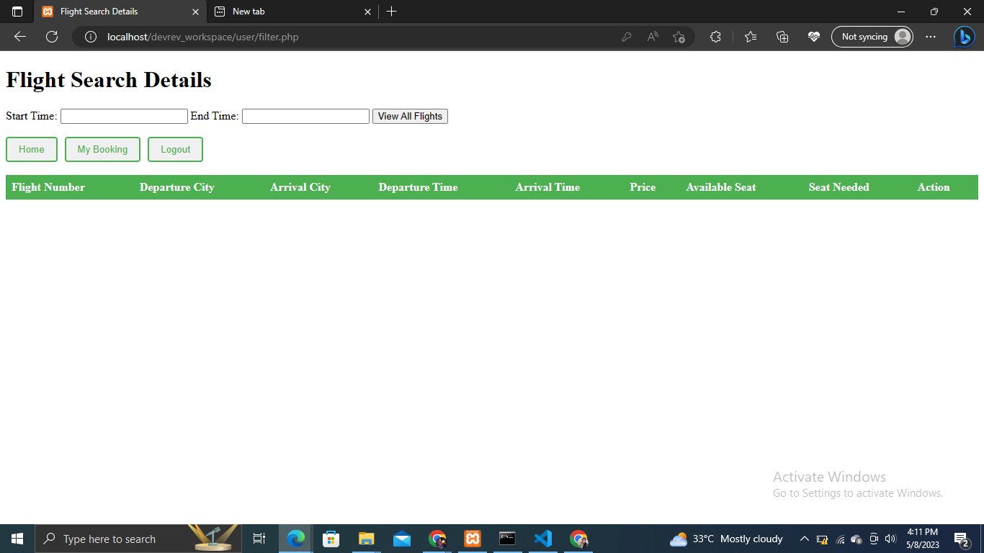

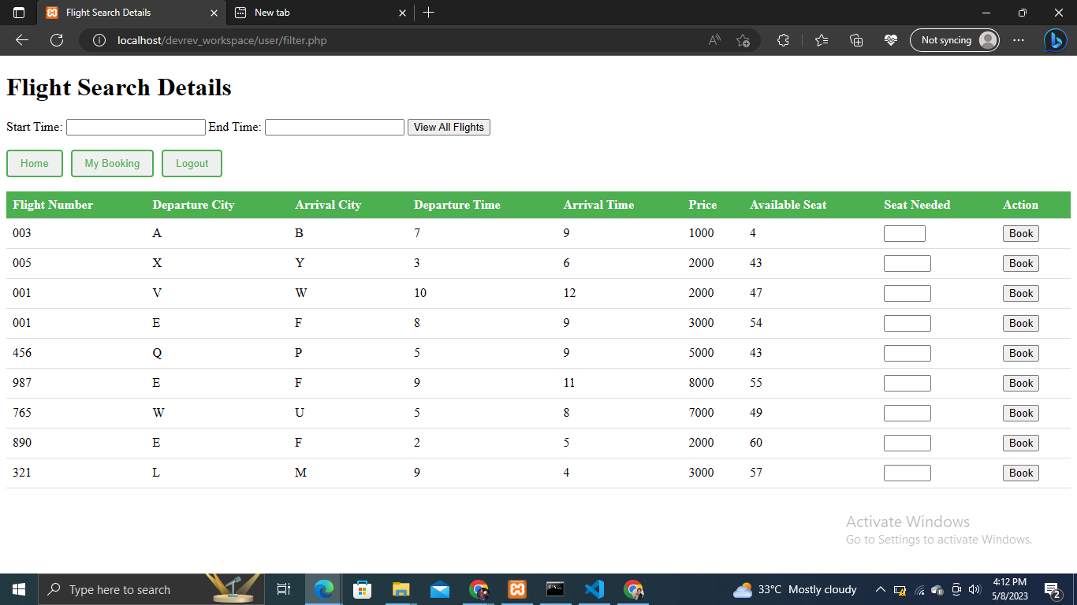

[localhost/devrev_workspace/user/booking.php](http://localhost/devrev_workspace/user/booking.php)

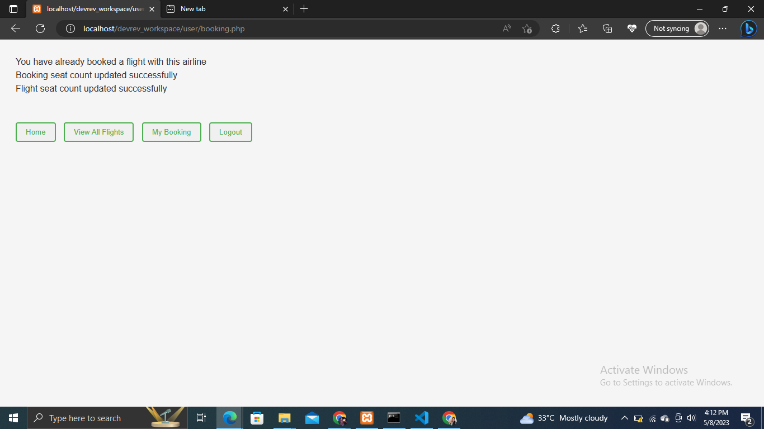

[User Flight Bookings](http://localhost/devrev_workspace/user/mybooking.php)

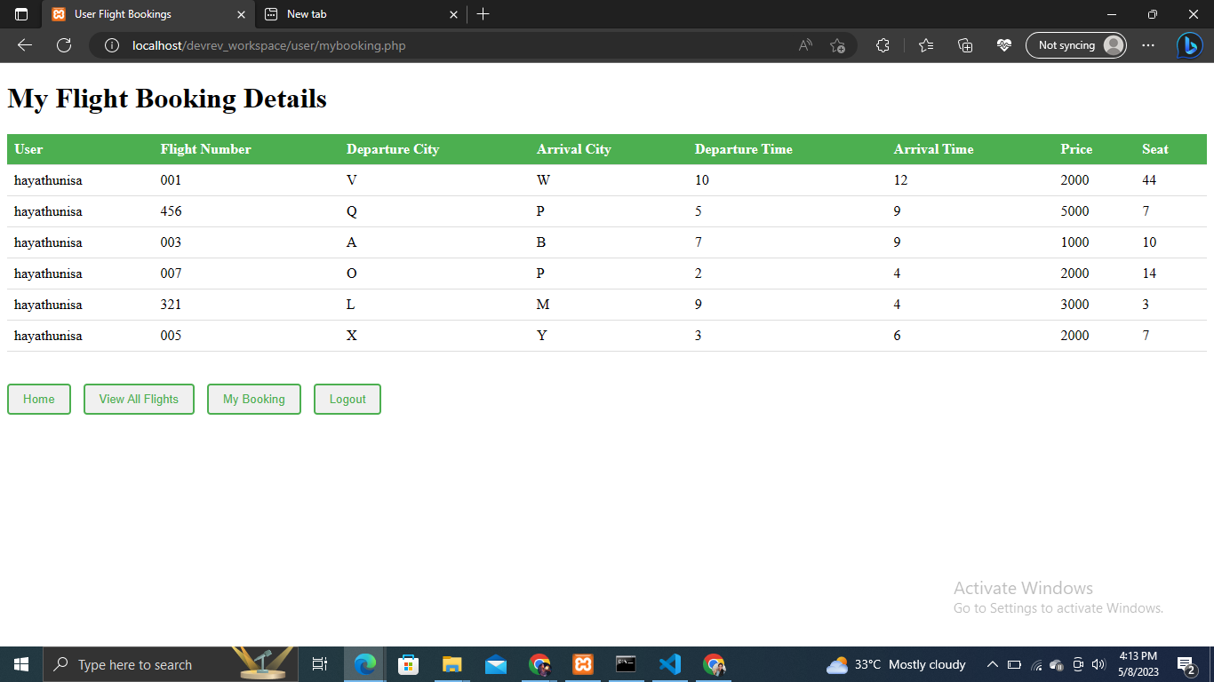

If the user has already logged-in

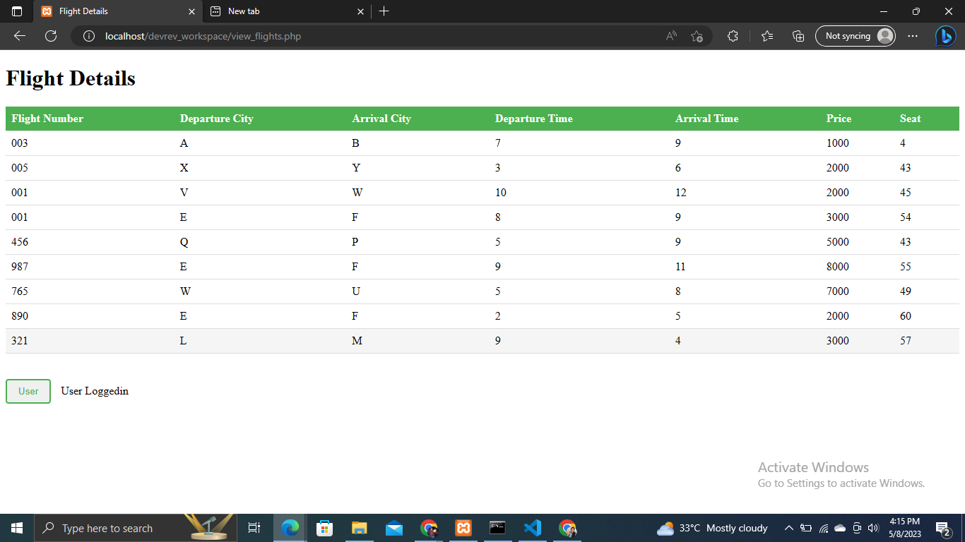

Logout

