Gym Materials Online Store

EAT, SLEEP & REPEAT

Logo

* Home
* [Products](http://docs.google.com/Untitled-2.html)
* [training plan](http://docs.google.com/Untitled-3%20(1).html)
* Stores
* [Contact](http://docs.google.com/Untitled-5%20(1).html)
* Your Account
* Cart

BLACK FRIDAY DEAL

Product 1

Price: $10

Add to Cart

ImageBuy whey protein and get a gifts

BLACK FRIDAY DEAL

Product 2

Price: $10

Add to Cart

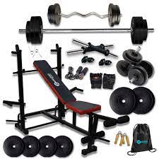Buy 5 equipments and get a gifts

BLACK FRIDAY DEAL

Product 3

Price: $10

Add to Cart

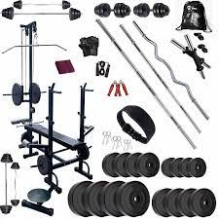Buy gym kit and get a gifts

BLACK FRIDAY DEAL

Product 4

Price: $10

Add to Cart

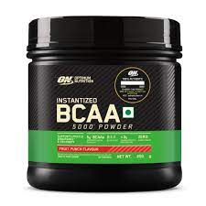Buy BCAA and get a gifts

BLACK FRIDAY DEAL

Product 5

Price: $10

Add to Cart

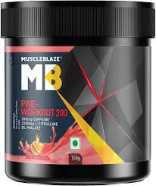Buy preworkout and get a gifts

BLACK FRIDAY DEAL

Product 6

Price: $10

Add to Cart

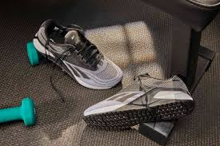Buy gym shoes and get a gifts

### Shopping Cart

# Total Amount: $0

TYPE YOUR COUPON CODE AND WIN GIFTS

Get deals: SUBMIT