Introduction:

The goal of this project is to unify the interaction with each courier at ZidShip, so it becomes simpler and more convenient to interact with each courier. To achieve this goal, we need to "bear" the specifications of each courier by simply putting a layer of abstraction above them all.

|  |  |  |  |  |
| --- | --- | --- | --- | --- |
| ZidShip | | | | |
| Courier 1 | Courier 2 | Courier 3 | …. | Courier n |

What?

Couriers are essential for an eCommerce business, they are simply companies that deliver shipments from point A to point B, and in this case, point A is the eCommerce storage center, and point B is the customer. And these couriers, brings stress & headache to the eCommerce business.

Why?

Dealing with different couriers for a business owner is time & effort consuming. In simple terms, it is a waste of human resources. So, a solution is needed to deal with couriers in simpler way.

How?

the solution suggested is simply a layer of abstraction. By making one simple interface & waybill for all couriers. The interface & the waybill should have no discrimination between any courier.

The Interface:

The Interface will be one for all the couriers and that will be different from each URL. For the create Waybill, it will have the couriers above the list of the orders so the user can choose which courier he/she wants. For the print Waybill, a list of all the orders that have a waybill will be showed with no differentiation between different couriers. For the Track Shipment, also no differentiation between waybills. And lastly, for the Cancel Waybill, it will show only the waybills that can be canceled.

The waybill:

The waybill will be unified also among all couriers. It will have the name of the sender(eCommerce),the receiver's name (the customer), the address of the receiver, the policy number, name of the shipment company. Also, since all couriers have a barcode on their waybill, this barcode will be on the ZidShip waybill. Moreover, a QR code for the costumers' use to display an expanded version of the information.

NOTE: if I have time to do these two codes. I will do it.

Interface Use case:

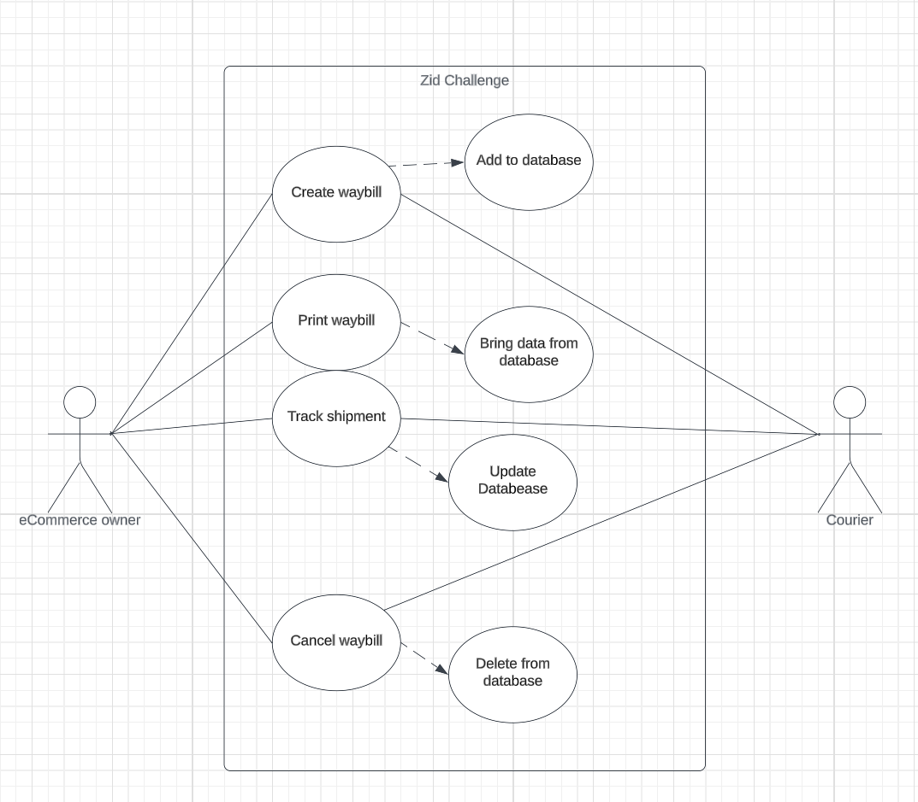

As you can see, this is just a simple CRUD operation.

URLs:

The URLs will be just five (including the home URL). Moreover, this will be implemented as Multi Page Architecture (MPA) rather than Single Page Architecture (SPA) because MPA is more convenient to implement to the user and the developer. The URLs are as mentioned before, simple CRUD and also the home URL. So, it will be like this:

|  |  |
| --- | --- |
| URL | Description |
| / | This is the home URL, or in other words, the main URL. It will has a dashboard. |
| /CreateWaybill | This, will display a list of all the orders that their status "Ready To Be Shipped" |
| /PrintWaybill | This will display all orders that have a waybill created for them. User will choose the orders that he/she wants to print their waybill. |
| /TrackShipment | This will display all orders that have a waybill created for them. User will see their status. The status will be explained in depth bellow this table. |
| /CancelWaybill | This will display all waybills that can be canceled . The user chooses the waybill that he/she wants to cancel then just cancel it. |

Home directory "/" :

This directory is the main directory. It will have the components:   
-dashboard:

* Number of orders in the "Ready To Be Shipped" status.
* Number of waybills currently.

Creating a waybill directory "/CreateWaybill" :

This directory will display the shipments that have the status Ready to be shipped" as a list, the user selects the shipments that he/she wants to ship and create a waybill to. Also, the user can choose a courier from the list of couriers that he/she can choose from to be shipped by. The couriers will have a piece of information that tells the user if they allow cancelation option or not.

Printing a waybill "/PrintWaybill" :

In here, a list of all the waybills that have the status "Ready to be shipped" will be displayed, the user chooses the waybill that he/she wants to print then simply it will be printed.

Tracking shipments "/TrackShipment" :

This will display all waybills have been created with their current status.

Canceling waybills "/CancelWaybill" :

This will display only the waybills that can be canceled. And the waybills that can be canceled is based on the courier if they allow this option.