Software Requirements
Specification
for
CodingHarness
An AI-Powered Automated Coding and Repository Execution Platform
Version 1.0
Prepared by
Aaditya Singhal (Roll No. 202401100100001)
Aalap Raj (Roll No. 202401100100002)
Department of Computer Science
KIET Deemed To Be University
10 September 2026

Table of Contents
Revision History ii
1. Introduction 1
1.1 Purpose 1
1.2 Document Conventions 1
1.3 Intended Audience and Reading Suggestions 1
1.4 Product Scope 1
1.5 References 1
2. Overall Description 1
2.1 Product Perspective 1
2.2 Product Functions 1
2.3 User Classes and Characteristics 1
2.4 Operating Environment 1
2.5 Design and Implementation Constraints 1
2.6 User Documentation 1
2.7 Assumptions and Dependencies 1
3. External Interface Requirements 1
3.1 User Interfaces 1
3.2 Hardware Interfaces 1
3.3 Software Interfaces 1
3.4 Communications Interfaces 1
4. System Features 1
4.1 User Authentication and Access Control 1
4.2 Task Submission and Management 1
4.3 Repository Management (Git and Repository Manager) 1
4.4 Project Analysis and Context Building 1
4.5 AI Agent Planning and Orchestration 1
4.6 Tool Execution Layer 1
4.7 Docker Sandbox Execution 1
4.8 Build, Test, Error Detection and Iterative Fixing 1
4.9 Real-Time Monitoring 1
4.10 Result, Diff and Delivery 1
4.11 Task History and Persistence 1
5. Other Nonfunctional Requirements 1
5.1 Performance Requirements 1
5.2 Safety Requirements 1
5.3 Security Requirements 1
5.4 Software Quality Attributes 1
5.5 Business Rules 1
6. Other Requirements 1
6.1 Database Requirements 1
6.2 Deployment and CI/CD Requirements 1
6.3 Testing Requirements 1
6.4 Legal and Licensing Requirements 1
6.5 Implementation Phases 1
6.6 Requirements Traceability 1
Appendix A: Glossary 1
Appendix B: Analysis Models 1
B.1 System Architecture 1
B.2 Task State Transition Model 1
B.3 Entity-Relationship Model 1
B.4 Use Case Summary 1
Appendix C: To Be Determined List 1

Revision History
Name | Date | Reason For Changes | Version
Aaditya Singhal, Aalap Raj | 10-09-2026 | Initial SRS prepared from the Master Plan and the Software Requirement Report | 1.0

1. Introduction

1.1 Purpose
This Software Requirements Specification (SRS) defines the functional and non-functional requirements for CodingHarness, release 1.0. CodingHarness is an AI-powered automated coding and repository execution platform in which an AI agent works as a controlled developer inside an isolated environment. A user submits a coding task and a repository, and the system autonomously produces a tested, working code change together with full execution logs and a Git diff.
This SRS covers the complete system: the web frontend, the backend orchestration server, the AI agent, the tool execution layer, the Docker sandbox, the Git and repository manager, the queue system, and the persistence layer. It is derived from the project Master Plan and the CodingHarness Software Requirement Report, and it serves as the reference for design, implementation, testing, and evaluation.

1.2 Document Conventions
- The keyword shall denotes a mandatory requirement. The keyword should denotes a desirable requirement that may be deferred if constraints demand it.
- Every requirement carries a unique identifier of the form FEATURE-NN (for example, AUTH-01, SBX-03). Feature prefixes are defined in Section 4. Non-functional requirements use the prefixes PERF, SAFE, SEC, QA, and BR.
- Every requirement has its own priority (High, Medium, or Low). Priorities are not inherited from the parent feature.
- Items marked TBD (To Be Determined) are placeholders for information not yet finalised. All TBD items are tracked in Appendix C.
- Body text is set in Times New Roman. File names, API endpoints, commands, tool names, and code identifiers are set in Courier New.
- Numerical limits given as defaults (for example, 512 MB memory, 60 s command timeout, 10 iterations) are taken from the Master Plan and shall be configurable.

1.3 Intended Audience and Reading Suggestions
Reader | Interest | Suggested Sections
Project guide / evaluators | Scope, objectives, feasibility, and completeness of the requirements | 1, 2, 4 (overview of each feature), 5, Appendix B
Developers (project team) | Detailed functional behaviour, interfaces, and constraints | 2.4 to 2.7, 3, 4, 6
Testers | Verifiable requirements and acceptance criteria | 4 (functional requirement tables), 5, 6.3
Future maintainers / operators | Environment, deployment, security, and data | 2.4, 2.5, 3.3, 5.3, 6.1, 6.2

The document is organised as follows. Section 1 introduces the product and this SRS. Section 2 gives an overall description of the product, its users, and its environment. Section 3 specifies the external interfaces. Section 4 specifies the functional requirements, grouped by system feature. Section 5 specifies non-functional requirements. Section 6 covers database, deployment, testing, legal, and traceability requirements. The appendices contain a glossary, analysis models, and the TBD list. Readers new to the project should read Sections 1 and 2 first, then proceed to the sections relevant to their role.

1.4 Product Scope
CodingHarness automates routine coding work such as bug fixing, small feature additions, refactoring, and test repair on real repositories. Unlike a conversational chatbot that only returns text suggestions, CodingHarness executes its plan: it clones the repository, reads and edits files, runs real build and test commands inside a Docker container, observes the actual output, and iterates until the change works or a limit is reached. Every run produces verifiable artefacts (logs and a Git diff) that a human can review before accepting the change.
Objectives and benefits:
- Reduce developer time spent on repetitive coding and debugging tasks.
- Provide a safe, observable, and controlled environment in which an autonomous agent can operate on real code without risk to the host system.
- Deliver only validated changes, backed by build and test results, rather than unverified suggestions.
- Serve as a platform for studying and evaluating autonomous AI-agent-based software development.
In scope: user authentication; task submission with a repository URL or ZIP upload; repository cloning and project analysis; LLM-driven planning and code modification through whitelisted tools; sandboxed build and test execution; automated error-driven iteration; live progress streaming; Git diff generation; patch download and pull request creation; task history.
Out of scope for release 1.0: automatic merging of changes into any branch; IDE plugins; tasks spanning multiple repositories; hosting or fine-tuning of LLMs; billing and subscription management; native mobile applications. The system is an assistive tool and does not replace human code review.

1.5 References
# | Document | Author / Source | Version / Date
1 | Coding Harness: Master Project Plan and Workflow (MASTER_PLAN.md) | Project team | Current version
2 | CodingHarness Software Requirement Report | A. Singhal, A. Raj, KIET Deemed To Be University | 2026
3 | IEEE Std 830-1998, IEEE Recommended Practice for Software Requirements Specifications | IEEE Computer Society | 1998
4 | ISO/IEC/IEEE 29148:2018, Systems and software engineering: Life cycle processes, Requirements engineering | ISO/IEC/IEEE | 2018
5 | Software Requirements Specification Template | Karl E. Wiegers | 1999
6 | Docker Engine API documentation | Docker Inc., docs.docker.com | Current
7 | BullMQ documentation | docs.bullmq.io | Current
8 | Prisma ORM documentation | prisma.io/docs | Current
9 | OpenAI API documentation (function calling) | platform.openai.com/docs | Current
10 | Gemini API documentation (function calling) | ai.google.dev | Current
11 | Socket.IO documentation | socket.io/docs | Current
12 | GitHub REST API documentation (Pull Requests, OAuth Apps) | docs.github.com | Current

2. Overall Description

2.1 Product Perspective
CodingHarness is a new, self-contained product. It is not a replacement for an existing system, but it integrates with several external services: hosted LLM providers (OpenAI and Gemini) for reasoning, Git hosting (GitHub) for repository access and pull requests, and the Docker Engine on the host for isolated execution. Figure 1 shows the major components, their interconnections, and the external interfaces.
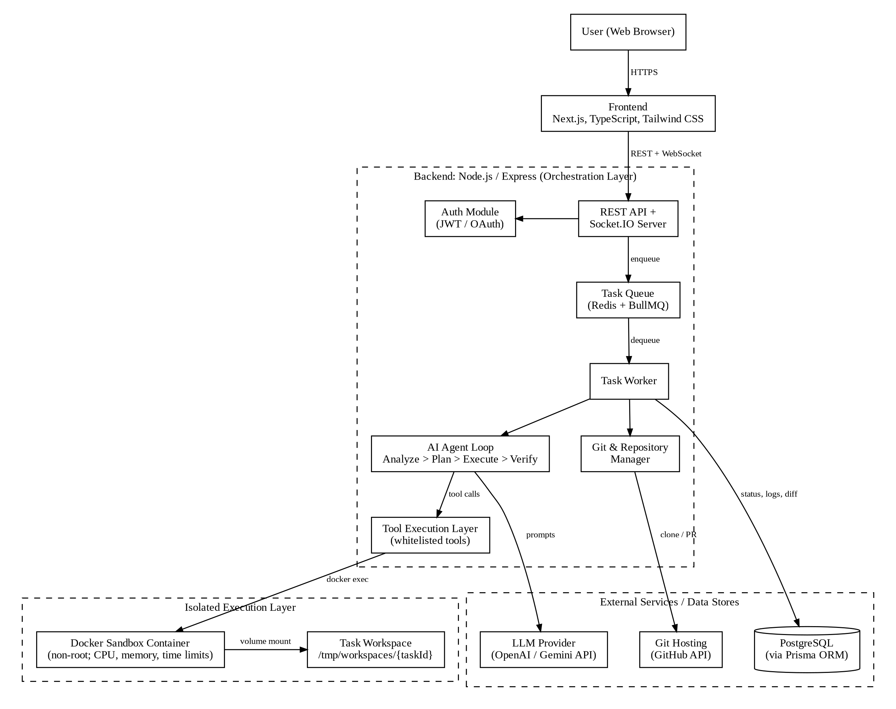
Figure 1: CodingHarness system architecture and external interfaces
The system is organised into three layers. The presentation layer (Next.js frontend) handles task submission, live monitoring, and result review. The orchestration layer (Node.js/Express backend) exposes REST and WebSocket interfaces, authenticates users, queues tasks in Redis through BullMQ, and runs worker processes that host the AI agent loop, the Git manager, and the tool execution layer. The isolated execution layer consists of one Docker container per task, attached only to that task's workspace, in which all builds, tests, and commands run.

2.2 Product Functions
The major functions of CodingHarness are summarised below. Detailed requirements appear in Section 4.
- User account management: registration, login, JWT sessions, and optional GitHub OAuth for private repositories.
- Task submission: accept a natural-language task, a repository (URL or ZIP), and an optional branch; queue the task for background processing.
- Repository management: clone or extract the repository into an isolated per-task workspace; manage branches; generate diffs.
- Project analysis: scan structure, detect language, framework, dependencies, and build/test commands to give the agent context.
- AI planning and orchestration: generate a plan and drive the Analyze, Plan, Execute, Verify loop through the LLM.
- Controlled tool execution: expose a whitelisted set of file and command tools to the agent.
- Sandboxed execution: run every command inside a resource-limited, non-root Docker container.
- Verification and iteration: run builds and tests, detect errors, feed failures back to the agent, and retry up to a limit.
- Live monitoring: stream logs, agent reasoning, tool calls, and stage changes to the browser in real time.
- Result delivery: show the final diff, status report, and logs; allow patch download or pull request creation.
- Task history: store and display previous tasks and their outcomes.
The end-to-end workflow of a task is:
- User submits a task description and a repository (URL or ZIP) through the frontend.
- The Git and Repository Manager clones the repository into an isolated temporary workspace.
- The system analyses the file structure, dependencies, and language/framework to build context.
- The LLM generates a step-by-step plan of files to inspect and edit.
- The agent calls read, write, and search tools exposed by the Tool Execution Layer.
- The agent applies exact code edits to the working copy.
- Commands are routed to the Docker sandbox, where all builds, tests, and commands run.
- The project is built and its test suite (or task-specific checks) is executed.
- Output and logs are parsed to detect build or test failures.
- On failure, the agent receives the error context, revises the code, and loops back to build and test.
- On success, the result is validated against the original task requirements.
- A Git diff is generated and optionally committed to a new branch.
- The user receives the modified code, the diff, the execution logs, and a final status report.

2.3 User Classes and Characteristics
User Class | Characteristics | Functions Used | Importance
Developer / Student (primary) | Technically skilled; familiar with Git, builds, and tests; uses the system frequently to delegate coding tasks. | Task submission, live monitoring, diff review, patch download, pull request creation, task history. | Most important
Project Evaluator / Reviewer | Assesses the behaviour and quality of the autonomous agent; uses the system occasionally; reads logs and diffs in detail. | Task submission on sample repositories, log and diff review, status reports. | Important
System Administrator / Operator | Deploys and maintains the platform; configures limits, LLM keys, and images; has host-level access. | Configuration, monitoring of workers and containers, termination of runaway tasks, log inspection. | Important (non-end-user)

The AI agent is an internal actor rather than a user class. It acts only through the tools granted by the system and has no privileges of its own.

2.4 Operating Environment
Component | Environment
Server host | Linux x86_64 (Ubuntu 22.04 LTS or later recommended) with Docker Engine installed and running. Exact CPU and RAM specification is TBD (see 3.2).
Backend runtime | Node.js, current LTS release (20.x or later), TypeScript.
Database | PostgreSQL (version TBD, 14 or later recommended), accessed through Prisma ORM.
Queue | Redis 6.2 or later, used by BullMQ.
Sandbox images | Official language images per detected project type (Node.js and Python in release 1.0). The Master Plan names node:18-alpine and python:3.9 as examples; supported, non end-of-life versions shall be used in practice.
Reverse proxy (production) | Nginx, providing TLS termination and routing to frontend and backend containers.
Client | Current desktop versions of Chrome, Firefox, Edge, or Safari with JavaScript and WebSocket support.
Development machine | Windows, macOS, or Linux with Docker Desktop or Docker Engine; minimum 8 GB RAM (16 GB recommended).

2.5 Design and Implementation Constraints
- The codebase shall be a TypeScript monorepo (npm workspaces or Turborepo) with /frontend, /backend, and /shared packages, and uniform ESLint and Prettier configuration.
- The technology stack is fixed by the Master Plan: Next.js and Tailwind CSS (frontend); Express (backend); PostgreSQL with Prisma; Redis with BullMQ; dockerode for container control; simple-git for Git operations; multer and unzipper for uploads; socket.io for live updates; Jest and Supertest for testing; GitHub Actions for CI.
- LLM reasoning is available only through hosted third-party APIs (OpenAI, Gemini). The design must tolerate their latency, rate limits, per-token cost, context-window limits, and occasional outages.
- All code and command execution must occur inside Docker. The worker process needs access to the Docker daemon, which is a privileged capability; therefore the worker shall be separated from the public API surface and shall never expose Docker access to the agent or the sandbox.
- Because workers may run as processes separate from the API server, live events from workers to browsers shall be relayed through Redis (for example, the Socket.IO Redis adapter or BullMQ queue events).
- Default resource and loop limits are fixed by the Master Plan: 512 MB memory per container, 60 s per command, and a maximum of 10 fix iterations per task.
- The project is developed by a two-member team under an academic timeline, in six phases (see Section 6.5).

2.6 User Documentation
Document | Contents | Format
README | Project overview, local setup using Docker Compose, required environment variables. | Markdown in repository
User Guide | Registering, submitting a task, reading live logs, reviewing diffs, downloading patches, creating pull requests. | Markdown / in-app help page
API Reference | REST endpoints, request and response payloads, error codes, WebSocket events. | Markdown; OpenAPI specification (TBD)
Deployment Guide | Production Compose file, Nginx and TLS configuration, scaling workers, backups. | Markdown in repository
Developer Guide | Architecture, adding a new tool to the registry, adding a new sandbox language image, running tests. | Markdown in repository

2.7 Assumptions and Dependencies
Assumptions:
- Users have legitimate access rights to every repository they submit.
- The host provides a working Docker Engine and sufficient CPU, memory, and disk for concurrent containers.
- Stable internet connectivity is available for LLM API calls, Git operations, and dependency installation.
- Submitted repositories are of moderate size and have a discoverable build and/or test command; repositories without tests are handled with reduced validation (see VER-05).
Dependencies:
- Availability, pricing, and terms of the OpenAI and Gemini APIs, including support for function (tool) calling.
- GitHub REST API and OAuth App availability for private repository access and pull request creation.
- Open-source libraries listed in Section 2.5 and their continued maintenance.
- Official Docker base images for supported languages.

3. External Interface Requirements

3.1 User Interfaces
The user interface is a responsive web application built with Next.js and Tailwind CSS. The screens are listed below.
Screen | Purpose | Key Elements
Login / Register | Account creation and sign-in. | Email and password fields, submit button, optional Sign in with GitHub, inline validation errors.
Dashboard | Entry point after login; task submission and recent tasks. | Task form (repository URL or ZIP upload, branch, task description); list of recent tasks with status labels (Pending, Running, Completed, Failed).
Live Execution View (/tasks/[id]) | Real-time monitoring of a running task. | Split-pane layout. Pane 1: live terminal showing logs, agent reasoning, and tool outputs. Pane 2: agent state showing the current stage (Analyzing, Planning, Editing, Testing, Fixing, Validating).
Result Viewer | Review of the completed task. | Diff viewer (react-diff-viewer), final status report, Download Patch and Create Pull Request buttons, failure reason and logs for failed tasks.
Task History | Access to previous tasks. | Sortable list of tasks with date, repository, status; link to each result view.

General UI standards:
- Status shall be shown as a text label, not by colour alone.
- Logs, commands, and diffs shall use a monospaced font; the live terminal shall auto-scroll, with the ability to pause scrolling.
- Form validation errors shall appear inline next to the relevant field; system errors shall appear as a dismissible notification with a readable message.
- Long-running actions shall show a loading indicator. The primary target is desktop screens (1280 px and wider); layouts shall remain usable on tablets.
- The result screen shall state that changes are AI-generated and require human review before merging.

3.2 Hardware Interfaces
CodingHarness has no direct interface with physical devices. It interacts with host hardware only indirectly, through the Docker Engine, which applies CPU, memory, and process limits to each sandbox container using Linux control groups. Recommended hardware is given below; the production server specification is TBD.
Environment | Recommended Hardware
Development machine | Multi-core CPU (4 cores or more), 8 GB RAM minimum (16 GB recommended), 20 GB free disk, Docker support.
Deployment server | Enough CPU and RAM to run the API, database, Redis, workers, and several concurrent sandbox containers (each up to 512 MB by default). Exact specification TBD.
Network | Stable broadband connection for LLM API calls, Git operations, and package downloads.

3.3 Software Interfaces
Interface | Type / Library | Data In / Out | Purpose
OpenAI API | HTTPS REST, openai SDK / @langchain/openai | Out: system prompt, context, tool schemas, conversation. In: text and structured tool calls. | Agent reasoning and planning
Gemini API | HTTPS REST, Gemini SDK | Same as above. | Alternative LLM provider
Docker Engine API | Unix socket, dockerode | Out: container create, exec, stop, remove requests with limits. In: stdout, stderr, exit codes. | Sandbox lifecycle and command execution
PostgreSQL | Prisma Client | Users, tasks, sessions, logs, diffs. | Persistent storage
Redis | BullMQ | Task jobs, job state, worker events. | Background job queue and event relay
Git | Git CLI via simple-git | Clone, checkout, diff, branch, commit. | Repository management
GitHub REST API | HTTPS REST | OAuth token exchange; branch push; pull request creation. | Private repositories and pull requests
File uploads | multer, unzipper | ZIP archive in; extracted files out. | Repository upload
Logging | winston or pino | Structured application logs. | Observability

Data shared across components (task, user, and API payload types) shall be defined once in the /shared package and imported by both frontend and backend.

3.4 Communications Interfaces
- REST over HTTPS: all client-server requests use JSON over HTTPS; ZIP uploads use multipart/form-data. Authenticated requests carry the JWT in the Authorization: Bearer header.
- WebSocket (Socket.IO over WSS): used for live logs and status updates. The JWT is verified during the handshake, and each client joins only the rooms of tasks it owns.
- TLS: in production, Nginx terminates TLS and forwards traffic to internal services. Internal services are not exposed publicly.
- Outbound connections: HTTPS to LLM providers and GitHub; Git over HTTPS with token-based authentication for private repositories.
REST endpoints:
Method | Endpoint | Auth | Description | Source
GET | /health | No | Server health check | Master Plan
POST | /api/auth/register | No | Register a new user | Master Plan
POST | /api/auth/login | No | Log in and receive a JWT | Master Plan
POST | /api/tasks | Yes | Submit a new task (URL or ZIP); enqueues a job | Master Plan
GET | /api/tasks | Yes | List the user's tasks | Master Plan
GET | /api/tasks/:id | Yes | Task status, details, and result | Master Plan
GET | /api/tasks/:id/patch | Yes | Download the diff as a patch file | Proposed
POST | /api/tasks/:id/pull-request | Yes | Create a pull request from the result branch | Proposed

WebSocket events (names proposed): task:status (status change), task:stage (agent stage change), task:log (log line, reasoning summary, tool call, or command output), and task:complete (final status with summary). All events carry the task ID and a timestamp.

4. System Features
Functional requirements are organised by system feature. Each feature lists its description and priority, its stimulus/response sequences, and its detailed functional requirements.

4.1 User Authentication and Access Control

4.1.1 Description and Priority
Allows users to register, log in, and access only their own tasks. Access to every task-related function requires authentication. Priority: High.

4.1.2 Stimulus/Response Sequences
Stimulus (User / System Event) | System Response
User submits the registration form with email and password. | Validates input, rejects duplicate email, hashes the password, creates the user, and confirms success.
User submits login credentials. | Verifies credentials, issues a signed JWT, and redirects to the dashboard.
User signs in with GitHub (optional). | Completes the OAuth flow, stores the access token securely, and links it to the user account.
A request to a protected endpoint arrives without a valid token. | Rejects the request with HTTP 401.

4.1.3 Functional Requirements
ID | Requirement | Priority
AUTH-01 | The system shall allow a new user to register with a unique email address and a password. | High
AUTH-02 | The system shall hash passwords with bcrypt before storage and shall never store or log plaintext passwords. | High
AUTH-03 | The system shall authenticate users by email and password and issue a signed JWT with an expiry time (duration TBD) on success. | High
AUTH-04 | The system shall reject any request to a protected endpoint that lacks a valid, unexpired JWT with HTTP 401. | High
AUTH-05 | The system shall restrict each task, its logs, and its diff to the user who created it; requests for another user's resources shall return HTTP 404. | High
AUTH-06 | The system should support GitHub OAuth sign-in to obtain a repository access token for private repositories, requesting the minimum scopes required. | Medium
AUTH-07 | On invalid credentials, the system shall show a generic error that does not reveal whether the email is registered. | Medium

4.2 Task Submission and Management

4.2.1 Description and Priority
Allows an authenticated user to submit a coding task against a repository, and tracks the task through its lifecycle using a background queue. Priority: High.

4.2.2 Stimulus/Response Sequences
Stimulus (User / System Event) | System Response
User fills in the task form (repository URL or ZIP, optional branch, task description) and submits. | Validates input, creates a Task with status PENDING, enqueues a job in TaskQueue, and returns the task ID.
Submission has missing or invalid fields. | Returns HTTP 400 with field-level error messages; no task is created.
A worker becomes free and a job is waiting. | Worker dequeues the job and sets the task status to RUNNING.
User opens the dashboard. | Returns the user's tasks with their current status.

4.2.3 Functional Requirements
ID | Requirement | Priority
TASK-01 | The system shall allow an authenticated user to submit a task consisting of a natural-language description and a repository reference (Git URL or ZIP archive). | High
TASK-02 | The system shall allow the user to specify a target branch; if omitted, the repository's default branch shall be used. | Medium
TASK-03 | The system shall validate each submission (non-empty description, well-formed HTTPS Git URL or valid ZIP within the size limit, TBD) and reject invalid input with HTTP 400 and a descriptive message. | High
TASK-04 | On valid submission, the system shall create a Task record with a unique ID and status PENDING, and add a job for it to the BullMQ TaskQueue. | High
TASK-05 | The system shall provide the endpoints POST /api/tasks, GET /api/tasks/:id, and GET /api/tasks. | High
TASK-06 | The system shall track task status as PENDING, RUNNING, COMPLETED, or FAILED, and shall expose the current agent stage while the task is running. | Medium
TASK-07 | Tasks shall be executed asynchronously by worker processes; the submission response shall not wait for task execution. | High
TASK-08 | The system shall apply per-user rate limiting to the task submission endpoint. | Medium

4.3 Repository Management (Git and Repository Manager)

4.3.1 Description and Priority
Prepares an isolated working copy of the submitted repository, manages branches, and produces diffs of the agent's changes. Priority: High.

4.3.2 Stimulus/Response Sequences
Stimulus (User / System Event) | System Response
Worker starts a task with a Git URL. | Clones the repository into /tmp/workspaces/{taskId} and checks out the requested branch.
Worker starts a task with a ZIP upload. | Extracts the archive safely into the workspace and initialises a Git baseline commit.
Clone fails (invalid URL, access denied, timeout, missing branch). | Marks the task FAILED with a clear error message.
Task finishes. | Generates the diff, optionally commits to a new branch, and schedules workspace cleanup.

4.3.3 Functional Requirements
ID | Requirement | Priority
REPO-01 | The system shall clone a public Git repository over HTTPS into a dedicated per-task workspace (/tmp/workspaces/{taskId}). | High
REPO-02 | The system shall clone private repositories using the user's OAuth token without writing the token into logs, workspace files, Git configuration, or the sandbox. | High
REPO-03 | The system shall accept a ZIP upload, extract it while rejecting entries that escape the workspace (path traversal / zip slip), and initialise a Git baseline for diffing. | High
REPO-04 | The system shall check out the requested branch; if the branch does not exist, the task shall be marked FAILED with a descriptive message. | Medium
REPO-05 | The system shall generate a unified Git diff between the baseline commit and the final working copy. | High
REPO-06 | The system should commit the changes to a new branch (for example, harness/{taskId}) and shall never commit or push directly to the default branch. | Medium
REPO-07 | The system shall delete the workspace after task completion, once the retention period (TBD) expires. | High
REPO-08 | The system shall enforce a maximum repository size (TBD) and a clone timeout. | Medium

4.4 Project Analysis and Context Building

4.4.1 Description and Priority
Examines the cloned repository to give the agent an accurate initial picture of the project before any change is planned. Priority: High.

4.4.2 Stimulus/Response Sequences
Stimulus (User / System Event) | System Response
Workspace is ready. | Scans the directory tree and manifest files; detects language, framework, package manager, and build/test commands.
Analysis completes. | Builds a context summary for the LLM and selects the matching sandbox image.
Project type is unsupported. | Marks the task FAILED with an explanation, or uses a generic image if configured.

4.4.3 Functional Requirements
ID | Requirement | Priority
ANLZ-01 | The system shall scan the workspace directory tree, excluding dependency, build, and VCS folders (for example, node_modules, dist, build, .git). | High
ANLZ-02 | The system shall detect the primary language, framework, and package manager from manifest files such as package.json, requirements.txt, and pyproject.toml. | High
ANLZ-03 | The system shall identify the build and test commands to use for verification (for example, the test script in package.json). | High
ANLZ-04 | The system shall compile a context summary (directory tree, key manifests, README excerpt, detected commands) as the agent's initial input, within a token budget (TBD). | High
ANLZ-05 | The system shall select a sandbox base image that matches the detected language (Node.js or Python in release 1.0). | High
ANLZ-06 | If the project type is not supported, the system shall mark the task FAILED with an explanatory message. | Medium

4.5 AI Agent Planning and Orchestration

4.5.1 Description and Priority
Integrates the LLM and runs the autonomous loop that plans the work, invokes tools, and decides when the task is complete. Priority: High.

4.5.2 Stimulus/Response Sequences
Stimulus (User / System Event) | System Response
Context summary is ready. | Sends the system prompt, task, and context to the LLM; receives and logs a step-by-step plan.
LLM returns a tool call. | Validates and routes it to the Tool Execution Layer; returns the result to the LLM.
LLM returns a malformed or unknown tool call. | Returns a structured error to the LLM instead of crashing the loop.
LLM API returns a transient error. | Retries with exponential backoff; marks the task FAILED if retries are exhausted.

4.5.3 Functional Requirements
ID | Requirement | Priority
AGNT-01 | The system shall provide a system prompt that defines the agent's role, rules, available tools, and completion criteria. | High
AGNT-02 | The agent shall produce a step-by-step plan (files to inspect or modify and verification steps) before making edits; the plan shall be logged and streamed. | High
AGNT-03 | The agent loop shall be implemented as a state machine with the stages Analyze, Plan, Tool Execution, and Verification. | High
AGNT-04 | The system shall obtain tool calls through the provider's native function-calling or structured-output mechanism and validate them against the tool schemas. | High
AGNT-05 | Each valid tool call shall be routed to the Tool Execution Layer and its result returned to the LLM as the next message. | High
AGNT-06 | The LLM client shall present a common interface over OpenAI and Gemini, with the provider and model selectable through configuration. | Medium
AGNT-07 | The system shall truncate or summarise long tool outputs so that the conversation stays within the model's context window. | Medium
AGNT-08 | The system shall enforce a per-task limit on LLM calls or tokens (TBD) to bound cost. | Medium
AGNT-09 | The system shall record every LLM request summary, response summary, and tool call with timestamps in the session log. | High
AGNT-10 | The system shall retry transient LLM API failures (rate limit, 5xx) with exponential backoff, up to 3 attempts. | Medium

4.6 Tool Execution Layer

4.6.1 Description and Priority
Exposes a fixed, whitelisted set of tools through which the agent reads, searches, and modifies files and runs commands. The registry contains: view_file(path, lines), write_file(path, content), replace_file_content(path, target, replacement), list_dir(path), grep_search(query, path), and run_command(cmd). Priority: High.

4.6.2 Stimulus/Response Sequences
Stimulus (User / System Event) | System Response
Agent calls a file tool with valid arguments. | Performs the operation inside the workspace and returns a structured result.
Agent calls a tool that is not registered, or passes invalid arguments. | Rejects the call and returns a structured error.
Agent passes a path outside the workspace. | Rejects the call and logs a security warning.
Agent calls run_command. | Validates the command and executes it inside the task's sandbox; returns stdout, stderr, and exit code.

4.6.3 Functional Requirements
ID | Requirement | Priority
TOOL-01 | The system shall expose only the tools registered in the tool registry; calls to any other tool shall be rejected. | High
TOOL-02 | Each tool shall have a defined input and output schema, and inputs shall be validated before execution. | High
TOOL-03 | All path arguments shall be resolved against the workspace root; absolute paths, .. traversal, and symbolic links that escape the workspace shall be rejected. | High
TOOL-04 | replace_file_content shall fail with a descriptive error if the target text is not found or occurs more than once. | High
TOOL-05 | view_file shall support line ranges and shall cap the size of returned content. | Medium
TOOL-06 | grep_search shall return the file path, line number, and matching line for each hit, with a cap on the number of results. | Medium
TOOL-07 | run_command shall execute only inside the task's Docker sandbox (via docker exec) and never on the host. | High
TOOL-08 | run_command shall check each command against the allowed-command policy and sanitise its input to prevent command injection. | High
TOOL-09 | Every tool shall return a structured result containing a success flag, the output, and an error message on failure. | High

4.7 Docker Sandbox Execution

4.7.1 Description and Priority
Provides a secure, isolated, resource-limited container for each task, in which all builds, tests, and commands run. Priority: High.

4.7.2 Stimulus/Response Sequences
Stimulus (User / System Event) | System Response
Analysis selects an image for a task. | Creates a container from that image with the workspace mounted and limits applied.
A command exceeds its time limit. | Kills the process and returns a timeout error to the agent.
Task completes, fails, or the worker crashes. | Stops and removes the container; orphaned containers are removed at worker start-up.

4.7.3 Functional Requirements
ID | Requirement | Priority
SBX-01 | The system shall create one dedicated container per task through the Docker Engine API (dockerode). | High
SBX-02 | Only the task's workspace shall be mounted into the container; no other host path, and never the Docker socket, shall be mounted. | High
SBX-03 | Each container shall have a memory limit (default 512 MB), a CPU limit (NanoCPUs), and a process-count limit. | High
SBX-04 | Processes in the container shall run as a non-root user, with Linux capabilities dropped and privilege escalation disabled. | High
SBX-05 | Network access shall be disabled during build and test execution; a controlled dependency-installation phase may enable restricted network access (policy TBD). | High
SBX-06 | Each command shall have a timeout (default 60 s), after which it is killed and reported as timed out. | High
SBX-07 | The system shall capture stdout, stderr, and the exit code of every command. | High
SBX-08 | The system shall force-stop and remove the container when the task completes or fails, and shall remove orphaned containers when a worker starts. | High
SBX-09 | No secrets (LLM API keys, database credentials, OAuth tokens) shall be passed into the container as environment variables or files. | High

4.8 Build, Test, Error Detection and Iterative Fixing

4.8.1 Description and Priority
Verifies every change by actually building and testing the project, and drives the agent to fix failures automatically within defined limits. Priority: High.

4.8.2 Stimulus/Response Sequences
Stimulus (User / System Event) | System Response
Agent finishes an edit cycle. | Runs the detected build and test commands in the sandbox.
Build or test fails and the iteration limit is not reached. | Feeds the failing command and trimmed error output back to the agent, which revises the code; the loop repeats.
Build or test fails and the iteration limit is reached. | Marks the task FAILED with the last error and full logs.
Build and tests pass. | Performs final validation against the task and proceeds to result generation.

4.8.3 Functional Requirements
ID | Requirement | Priority
VER-01 | After each edit cycle, the system shall run the detected build and test commands (for example, npm test, tsc, pytest) inside the sandbox. | High
VER-02 | The system shall determine pass or fail from the command exit code, supplemented by parsing the output for error messages. | High
VER-03 | On failure, the system shall send the failing command and its trimmed stdout and stderr to the agent as the next message, with an instruction to fix the error. | High
VER-04 | The system shall limit fix iterations per task (default 10, configurable); on reaching the limit, the task shall be marked FAILED with the last error. | High
VER-05 | If the repository has no test suite, the agent shall run task-specific checks (build, type-check, lint, or a check it writes) and the report shall state that full test validation was not available. | Medium
VER-06 | Before a task is marked COMPLETED, a final verification run shall pass and the agent shall provide a summary mapping its changes to the task requirements. | High
VER-07 | The system shall record each iteration (number, command, exit code, duration) in the session log. | Medium

4.9 Real-Time Monitoring

4.9.1 Description and Priority
Streams task progress to the browser so that the user can observe the agent's reasoning, tool calls, and command output as they happen. Priority: Medium.

4.9.2 Stimulus/Response Sequences
Stimulus (User / System Event) | System Response
User opens the Live Execution View of a running task. | Authenticates the socket, joins the task room, and streams logs and stage changes.
Worker or agent produces an event. | Relays the event through Redis to the API server, which emits it to the task room.
Connection drops and reconnects. | Client fetches the persisted log so far, then resumes the live stream.

4.9.3 Functional Requirements
ID | Requirement | Priority
MON-01 | The backend shall run a Socket.IO server alongside the REST API. | Medium
MON-02 | The worker and agent loop shall emit events for status changes, stage changes, reasoning summaries, tool calls, and command output. | Medium
MON-03 | A client shall receive events only for tasks it owns, verified by JWT during the socket handshake. | High
MON-04 | The Live Execution View shall show a live terminal pane with streaming logs and auto-scroll. | Medium
MON-05 | The Live Execution View shall show an agent state pane with the current stage. | Medium
MON-06 | After a reconnect, the client shall load the persisted log and resume streaming without losing events. | Medium

4.10 Result, Diff and Delivery

4.10.1 Description and Priority
Presents the outcome of a task and lets the user take the change away as a patch or a pull request. Priority: High.

4.10.2 Stimulus/Response Sequences
Stimulus (User / System Event) | System Response
Task completes successfully. | Saves the diff and report, sets status COMPLETED, and shows the Result Viewer.
User clicks Download Patch. | Returns the diff as a .patch file.
User clicks Create Pull Request. | Pushes the result branch and opens a pull request through the GitHub API; returns the PR link.
Task fails. | Shows the failure reason, the last error output, and the full logs.

4.10.3 Functional Requirements
ID | Requirement | Priority
RES-01 | On successful completion, the system shall store the final Git diff in Session.resultDiff, save the logs, and set the task status to COMPLETED. | High
RES-02 | The Result Viewer shall display the diff using react-diff-viewer. | High
RES-03 | The system should allow the user to download the diff as a .patch file that applies cleanly with git apply to the base commit. | Medium
RES-04 | The system should create a pull request through the GitHub API only on explicit user action and only when the user has granted the required OAuth permission. | Medium
RES-05 | The system shall produce a final status report containing the task, status, iterations used, files changed, commands run, final test result, and the agent's summary. | High
RES-06 | For failed tasks, the system shall display the failure reason, the last error output, and the full logs; any partial diff shall be clearly labelled as unvalidated. | Medium

4.11 Task History and Persistence

4.11.1 Description and Priority
Stores users, tasks, and execution sessions so that past work can be reviewed. Priority: Low.

4.11.2 Stimulus/Response Sequences
Stimulus (User / System Event) | System Response
User opens Task History. | Lists previous tasks, newest first, with repository, date, and status.
User selects a past task. | Shows its logs, diff, and status report.

4.11.3 Functional Requirements
ID | Requirement | Priority
HIST-01 | The system shall list the user's previous tasks, sorted by creation date, with their status. | Low
HIST-02 | The system shall allow the user to open any previous task to view its logs, diff, and status report. | Low
HIST-03 | The system shall persist users, tasks, and sessions in PostgreSQL using Prisma schema migrations. | High
HIST-04 | The system shall apply a data retention policy (TBD) to logs and diffs of old tasks. | Low

5. Other Nonfunctional Requirements

5.1 Performance Requirements
The values below are initial targets for the single-server deployment and shall be confirmed during testing. Agent execution time depends mostly on LLM latency and the target project's build and test time, so the targets focus on the platform's own overhead.
ID | Requirement | Priority
PERF-01 | Non-agent REST endpoints (authentication, task list, task status) shall respond within 500 ms at the 95th percentile under nominal load (load profile TBD). | Medium
PERF-02 | Task submission shall be acknowledged (task created and enqueued) within 1 s, excluding ZIP upload transfer time. | Medium
PERF-03 | A queued task shall be picked up within 5 s when a worker is idle. | Medium
PERF-04 | Live log events shall reach the browser within 1 s of being generated. | Medium
PERF-05 | A sandbox container shall be ready for commands within 15 s when its image is cached locally (target TBD). | Low
PERF-06 | Each command shall time out after 60 s by default, and each task shall have a total wall-clock limit (TBD). | High
PERF-07 | Worker concurrency shall be configurable so that multiple tasks run in parallel, bounded by host resources. | Medium

5.2 Safety Requirements
CodingHarness executes AI-generated code, which may be incorrect or harmful. The following safeguards prevent loss of data or damage to systems.
ID | Requirement | Priority
SAFE-01 | AI-generated code shall never execute on the host; it shall run only inside the task's sandbox container. | High
SAFE-02 | The system shall never modify, force-push to, or merge into the user's default branch; changes leave the platform only as a patch or a pull request on a new branch. | High
SAFE-03 | Destructive or runaway behaviour inside a sandbox (for example, deleting files, fork bombs, infinite loops) shall be contained by resource limits, timeouts, and workspace isolation. | High
SAFE-04 | A failure in one task shall not affect other tasks, the workers, or the platform. | High
SAFE-05 | The user interface shall state that changes are AI-generated and must be reviewed by a human before merging. | Medium

5.3 Security Requirements
ID | Requirement | Priority
SEC-01 | All external traffic shall use HTTPS/WSS with TLS terminated at the reverse proxy. | High
SEC-02 | JWTs shall be signed with a secret loaded from the environment and shall expire (duration TBD). | High
SEC-03 | API keys, database credentials, and OAuth tokens shall be stored in environment variables or a secret manager, shall never be sent to the client, and shall be redacted from all logs. | High
SEC-04 | OAuth access tokens shall be encrypted at rest and requested with minimum scopes. | High
SEC-05 | All inputs to the Tool Execution Layer shall be validated and sanitised to prevent command injection and path traversal from malicious LLM output. | High
SEC-06 | Repository content shall be treated as untrusted input to the LLM; instructions found in repository files shall not change the agent's tool permissions or limits (prompt-injection containment). | High
SEC-07 | Task submission and authentication endpoints shall be rate limited (express-rate-limit). | Medium
SEC-08 | The backend shall apply secure HTTP headers (helmet) and restrict CORS to the frontend origin. | Medium
SEC-09 | The Docker sandbox configuration shall be audited before release for mount, privilege, and network weaknesses. | High
SEC-10 | The CI pipeline shall run dependency vulnerability checks (for example, npm audit). | Low

5.4 Software Quality Attributes
ID | Attribute | Requirement
QA-01 | Reliability | Build and test failures shall always be detected and recorded. Every task shall end in COMPLETED or FAILED; no task shall remain RUNNING after its time limit.
QA-02 | Availability | Task submission and monitoring shall remain available while tasks run. Worker or container failures shall not bring down the API. Uptime target TBD.
QA-03 | Fault tolerance | If a worker crashes, its job shall be retried or marked FAILED by BullMQ, and its container shall be cleaned up.
QA-04 | Scalability | Throughput shall scale by adding worker processes or instances without code changes.
QA-05 | Maintainability | Code shall be modular (auth, tasks, git, analysis, agent, tools, sandbox, monitoring) in TypeScript with shared types, and shall pass ESLint and Prettier checks.
QA-06 | Extensibility | A new tool or a new sandbox language shall be addable by registering it, without changing the agent loop.
QA-07 | Portability | All services shall run through Docker Compose on any host with Docker Engine.
QA-08 | Testability | The agent loop shall be testable with a mocked LLM client, so that tool parsing and loop logic can be tested without real API calls.
QA-09 | Usability | A developer shall be able to submit a task and find its diff without documentation; status and errors shall be understandable without knowledge of the infrastructure.
QA-10 | Observability | All services shall produce structured logs (winston or pino) that include the task ID.

5.5 Business Rules
ID | Rule
BR-01 | Only registered and authenticated users may submit tasks.
BR-02 | A user may view, download, or create pull requests only for their own tasks.
BR-03 | A user may submit only repositories they own or are authorised to modify.
BR-04 | The platform never merges changes. Creating a pull request requires explicit user action; merging remains the user's decision.
BR-05 | An administrator may terminate any running task and view system logs, but shall not have access to users' OAuth tokens in plaintext.
BR-06 | Every task is bound by iteration, time, and resource limits set by the administrator; users cannot override these limits.
BR-07 | Per-user rate limits apply to task submission.

6. Other Requirements

6.1 Database Requirements
The database is PostgreSQL, managed through Prisma schema and migrations. The core entities from the Master Plan are listed below; the entity-relationship model is shown in Appendix B.
Entity | Attributes | Constraints and Notes
User | id, email, passwordHash, createdAt | id is the primary key; email is unique. OAuth token fields are to be added for AUTH-06 (stored encrypted).
Task | id, userId, repoUrl, prompt, status, createdAt | userId references User. status is an enum: PENDING, RUNNING, COMPLETED, FAILED. Branch and source type (URL or ZIP) fields are to be added. Indexed on userId and status.
Session | id, taskId, logs, resultDiff, startedAt, finishedAt | taskId references Task. Stores the execution log and the final diff for a run.

- All schema changes shall be applied through Prisma migrations; manual schema edits are not permitted.
- Deleting a user shall delete their tasks and sessions (cascade).
- Very large logs may need to be stored outside the database (storage approach TBD).

6.2 Deployment and CI/CD Requirements
- A docker-compose.yml shall start the full development stack (frontend, backend, PostgreSQL, Redis).
- A docker-compose.prod.yml shall define the production stack, with Nginx as the reverse proxy handling routing and TLS termination.
- Separate Dockerfiles shall build the frontend and backend images.
- A GitHub Actions workflow shall run ESLint, TypeScript compilation, and Jest tests on every pull request, and shall build Docker images automatically.

6.3 Testing Requirements
- Unit tests shall cover the file system tools (fileSystem.ts) and the Git service (gitService.ts), including path-escape and ambiguous-replace cases.
- Integration tests shall cover all REST endpoints using Supertest.
- Mock tests shall cover the agent loop (tool-call parsing, routing, iteration limit, failure handling) without calling a real LLM.
- End-to-end tests shall run at least one complete task on a sample repository with a known failing test and confirm that a passing diff is produced.

6.4 Legal and Licensing Requirements
- Source code from submitted repositories is sent to third-party LLM providers. Users shall be informed of this before their first submission.
- Use of the OpenAI and Gemini APIs shall comply with the providers' terms of service.
- The platform shall not alter licence files in user repositories unless the task explicitly requires it.
- Licences of all third-party libraries used shall permit academic and open-source use.

6.5 Implementation Phases
Phase | Scope | Key Deliverables
1. Foundation and Project Setup | Monorepo, database schema, server skeleton, shared types. | Monorepo with ESLint/Prettier; Prisma schema (User, Task, Session) and migrations; Express server with /health; structured logging.
2. Core Backend, Git Manager and Queue | Queue, Git operations, authentication, task APIs. | BullMQ queue and worker; gitService.ts (clone, ZIP, diff, branch); register/login with bcrypt and JWT; task endpoints.
3. Tool Execution Layer and Docker Sandbox | Secure execution and agent tools. | dockerManager.ts with limits and cleanup; tool registry with schemas; run_command via docker exec with timeouts.
4. AI Agent Orchestration and Iteration Loop | LLM integration and autonomous loop. | System prompt and project analysis; agent state machine; tool-call parsing; test-driven fix loop with iteration limit; diff and result saving.
5. Frontend Interface | Real-time web UI. | Socket.IO integration; task dashboard; live execution view; diff viewer with patch and PR actions.
6. Testing, Security Hardening and Deployment | Robustness and release. | Unit, integration, and mock tests; sandbox audit; input sanitisation; rate limiting; CI pipeline; production Compose with Nginx.

6.6 Requirements Traceability
The table maps each feature in this SRS to the functional requirement IDs in the CodingHarness Software Requirement Report and to the implementation phase in the Master Plan.
SRS Feature (Requirement IDs) | Requirement Report IDs | Master Plan Phase
4.1 User Authentication (AUTH-01 to AUTH-07) | FR-01 | Phase 2
4.2 Task Submission and Management (TASK-01 to TASK-08) | FR-03, FR-14 | Phase 2
4.3 Repository Management (REPO-01 to REPO-08) | FR-02, FR-04, FR-16 | Phase 2
4.4 Project Analysis (ANLZ-01 to ANLZ-06) | FR-05 | Phase 4
4.5 AI Agent Orchestration (AGNT-01 to AGNT-10) | FR-06 | Phase 4
4.6 Tool Execution Layer (TOOL-01 to TOOL-09) | FR-07, FR-08, FR-09 | Phase 3
4.7 Docker Sandbox (SBX-01 to SBX-09) | FR-10 | Phase 3
4.8 Build, Test and Iterative Fixing (VER-01 to VER-07) | FR-11, FR-12, FR-13, FR-17 | Phase 4
4.9 Real-Time Monitoring (MON-01 to MON-06) | FR-15 | Phase 5
4.10 Result, Diff and Delivery (RES-01 to RES-06) | FR-16, FR-18 | Phases 4 and 5
4.11 Task History and Persistence (HIST-01 to HIST-04) | FR-19 | Phases 1 and 5
5.2, 5.3 Safety and Security (SAFE, SEC) | Report Sections 4.1, 8 | Phases 3 and 6

Appendix A: Glossary
Term | Definition
Agent (AI Agent) | The LLM-driven component that plans and performs coding actions through the tools provided by the system.
Agent Loop | The repeating cycle of Analyze, Plan, Tool Execution, and Verification that the agent follows until the task succeeds or a limit is reached.
Agent Stage | The current phase of a running task shown to the user: Analyzing, Planning, Editing, Testing, Fixing, or Validating.
BullMQ | A Node.js job queue library backed by Redis, used to run tasks in the background.
CI/CD | Continuous Integration / Continuous Delivery: automated linting, building, testing, and packaging of the code.
Container | An isolated process environment created by Docker from an image.
Diff / Patch | A textual representation of changes between two versions of files; a patch is a diff saved as a file that can be applied with git apply.
Docker Sandbox | The per-task container, with resource limits and no host access, in which all commands run.
dockerode | A Node.js client library for the Docker Engine API.
JWT | JSON Web Token: a signed token used to authenticate API requests.
LLM | Large Language Model, such as the models offered through the OpenAI and Gemini APIs.
OAuth | An authorisation protocol used here to obtain GitHub access tokens on behalf of the user.
ORM / Prisma | Object-Relational Mapping; Prisma is the ORM used to access PostgreSQL.
p95 | 95th percentile: the value below which 95 per cent of measurements fall.
Prompt Injection | Text inside processed data (for example, a repository file) that attempts to override the agent's instructions.
PR | Pull Request: a request to merge a branch into another branch on a Git hosting service.
Redis | An in-memory data store used by BullMQ and for relaying live events.
REST | Representational State Transfer: the HTTP-based API style used by the backend.
Socket.IO | A library for real-time, bidirectional communication over WebSockets.
SRS | Software Requirements Specification: this document.
TBD | To Be Determined: information not yet available (see Appendix C).
Tool / Tool Call | A registered operation (for example, view_file, run_command) and the agent's request to execute it.
Whitelist | The fixed list of tools and commands the agent is allowed to use.
Workspace | The per-task temporary directory (/tmp/workspaces/{taskId}) holding the working copy of the repository.
Zip Slip | A vulnerability in which archive entries with paths such as ../ are written outside the extraction directory.

Appendix B: Analysis Models

B.1 System Architecture
The component architecture is shown in Figure 1 (Section 2.1).

B.2 Task State Transition Model
A task's persisted status follows the state machine in Figure 2. While a task is RUNNING, its agent stage progresses as shown in Figure 3.
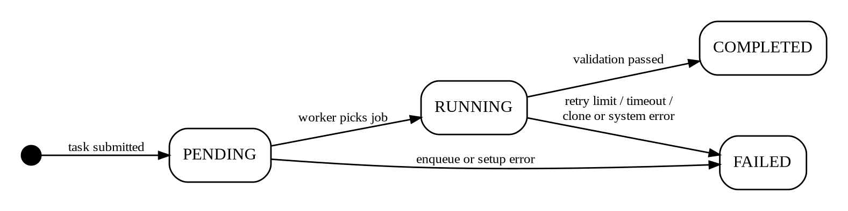
Figure 2: Task status state-transition diagram
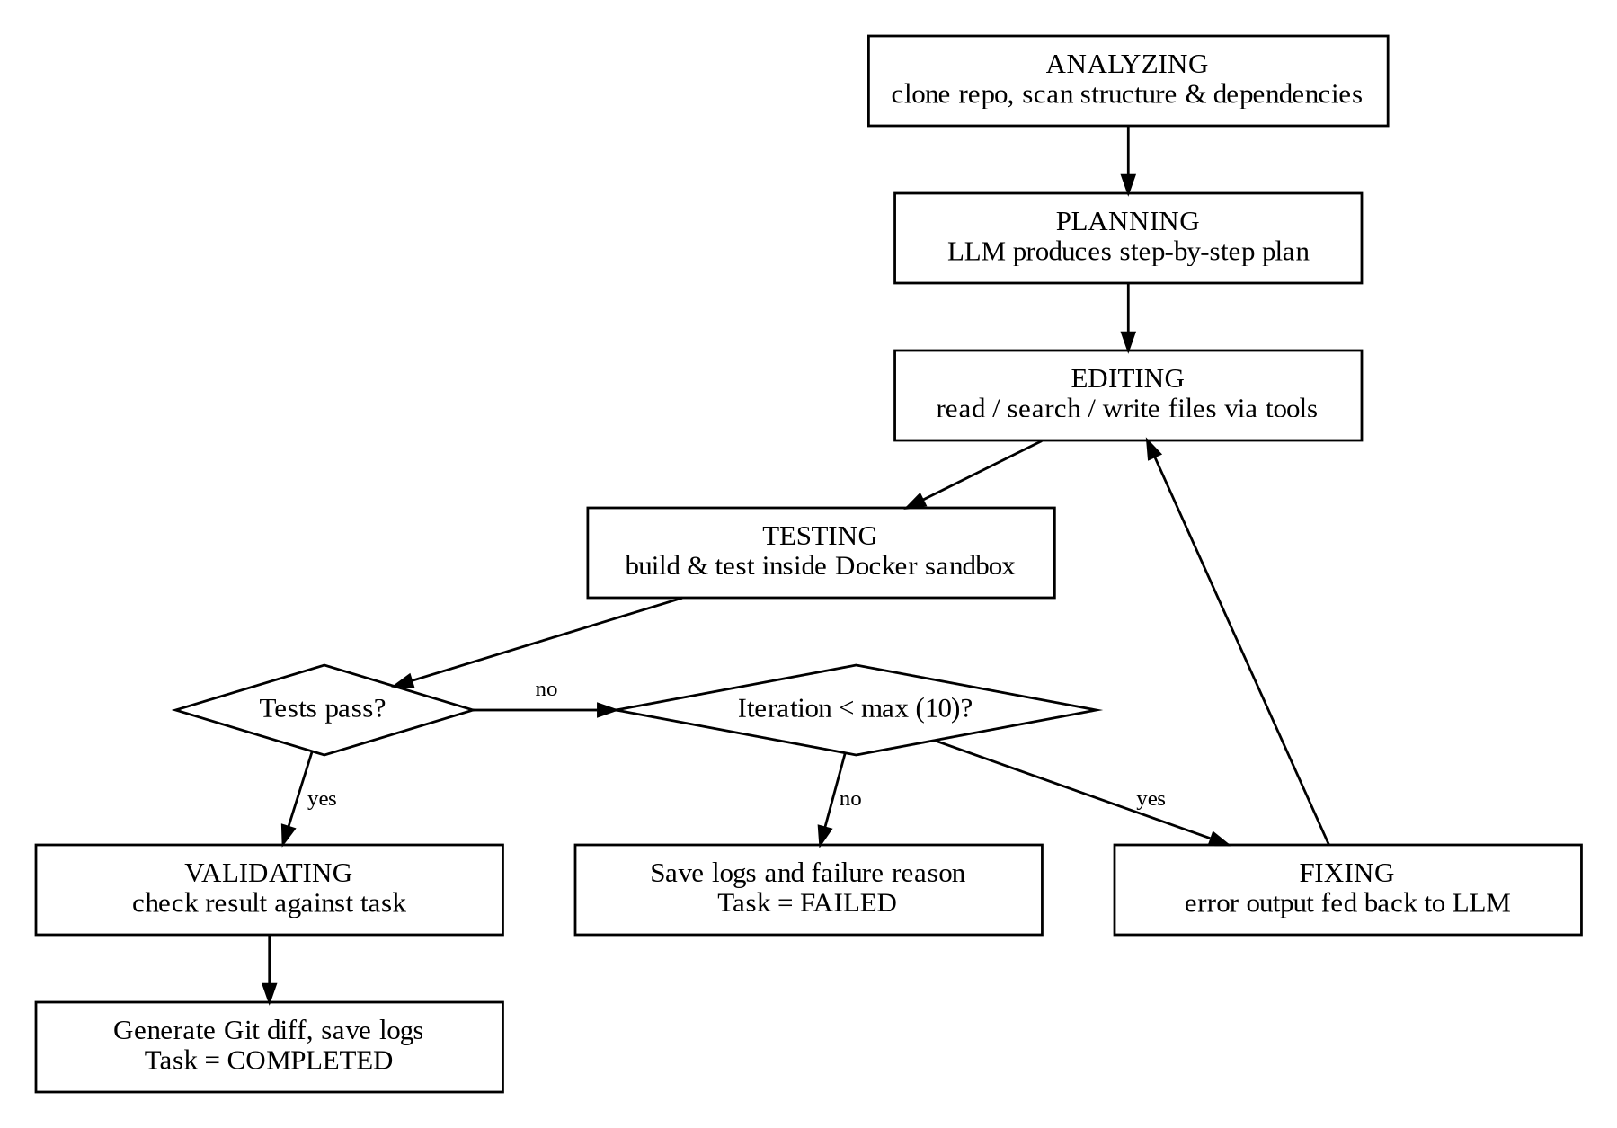
Figure 3: Agent stage flow and iteration loop within a RUNNING task

B.3 Entity-Relationship Model
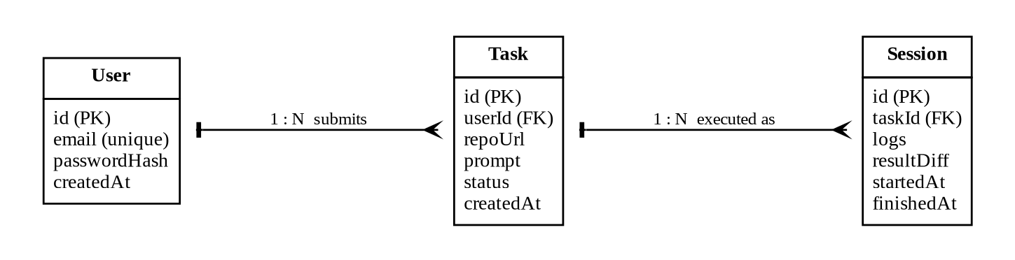
Figure 4: Entity-relationship model of the core database entities

B.4 Use Case Summary
The use cases below are defined in detail in the CodingHarness Software Requirement Report (Section 10).
ID | Use Case | Primary Actor | Related Requirements
UC-01 | User Login | Registered User | AUTH-01 to AUTH-07
UC-02 | Submit Coding Task | Authenticated User | TASK-01 to TASK-08
UC-03 | Analyze Repository | System (Worker) | REPO-01 to REPO-04, ANLZ-01 to ANLZ-06
UC-04 | Execute AI Coding Task | AI Agent | AGNT-01 to AGNT-10, TOOL-01 to TOOL-09
UC-05 | Run Tests | System (Docker Sandbox) | SBX-01 to SBX-09, VER-01, VER-02
UC-06 | Handle Failure and Retry | AI Agent / System | VER-03, VER-04, VER-07
UC-07 | View Live Progress | Authenticated User | MON-01 to MON-06
UC-08 | View Final Diff / Result | Authenticated User | RES-01 to RES-06, HIST-01, HIST-02

B.5 Data Flow Diagram (DFD)
Figure 5 presents the Level 1 data flow diagram (DFD) of CodingHarness. It decomposes the platform into its major processes and shows how data flows between the developer, the external services (Git/GitHub, LLM/AI API and the Docker sandbox) and the internal data stores. The context (Level 0) and the AI-agent execution decomposition (Level 2) are provided in the accompanying DFD document.
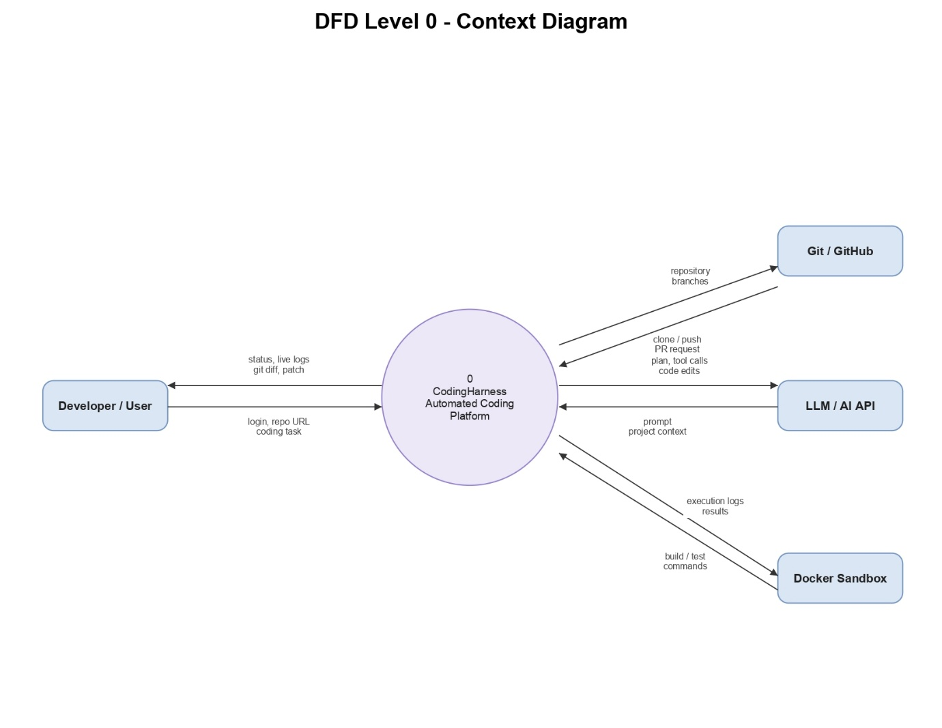
Figure 5: Level 1 data flow diagram of the CodingHarness platform

Appendix C: To Be Determined List
# | TBD Item | Referenced In
1 | JWT expiry duration and refresh-token strategy. | AUTH-03, SEC-02
2 | Maximum repository size and ZIP upload size. | TASK-03, REPO-08
3 | Retention period for workspaces, logs, and diffs. | REPO-07, HIST-04
4 | Sandbox network policy for dependency installation (for example, registry-only egress). | SBX-05
5 | Token budget for project context and per-task LLM call or cost limit. | ANLZ-04, AGNT-08
6 | Default LLM provider and model. | AGNT-06
7 | Total wall-clock time limit per task. | PERF-06
8 | Container start-up time target. | PERF-05
9 | Expected concurrent users and load profile for performance testing. | PERF-01
10 | Supported languages and base image versions beyond Node.js and Python. | 2.4, ANLZ-05
11 | Production server hardware specification. | 2.4, 3.2
12 | PostgreSQL version. | 2.4
13 | Platform uptime target. | QA-02
14 | Whether the agent stage is persisted in the database or only streamed. | TASK-06
15 | Storage approach for very large logs. | 6.1
16 | OpenAPI specification for the REST API. | 2.6

