**Aaron Lim**

**CSE572**

**LAB 2**

1. **List all the rows of the departments table.**

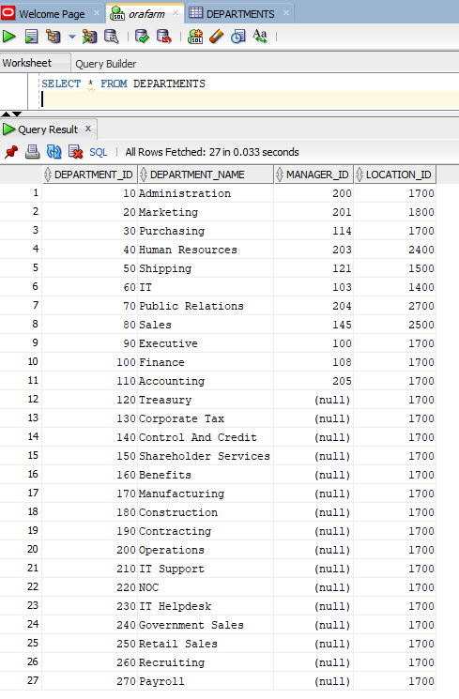

1. **Find the number of employees in the database (hint: use the COUNT() aggregate function for this);**

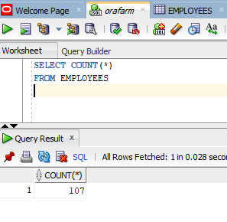

* 1. **a. List the employees who:**
  2. **b. have a salary greater than 15000,**
  3. 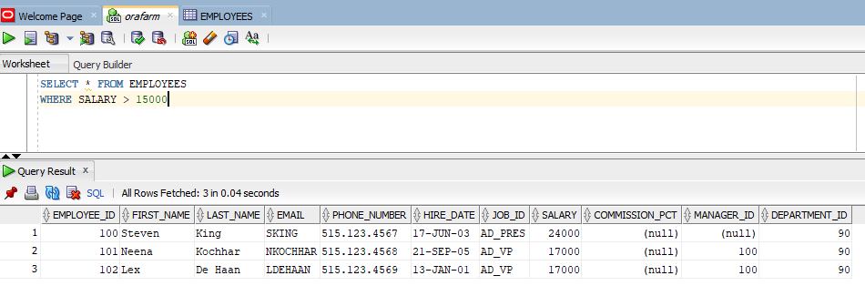
  4. **c. were hired between January 1, 2002 and January 1, 2005,**
  5. 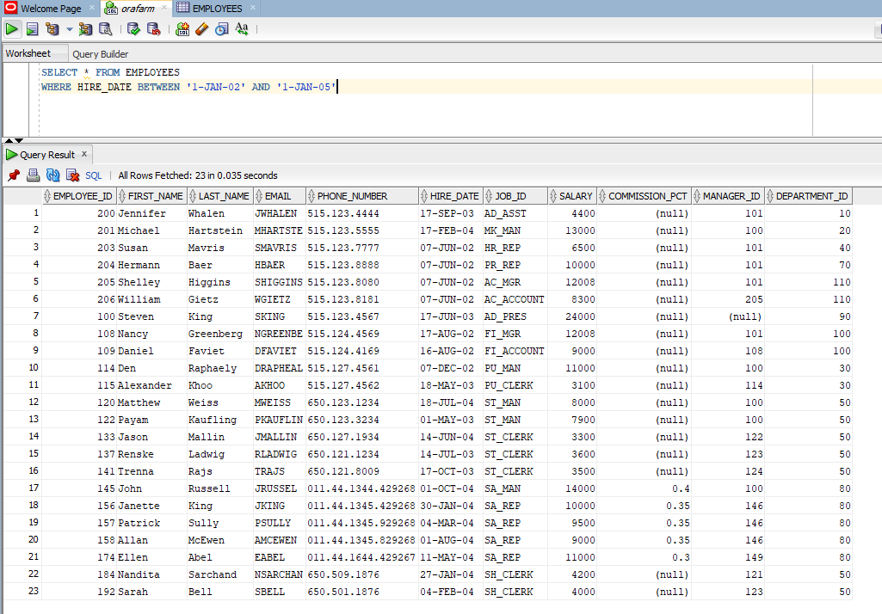
  6. **3.) have a phone number that doesn't start with 515**
  7. 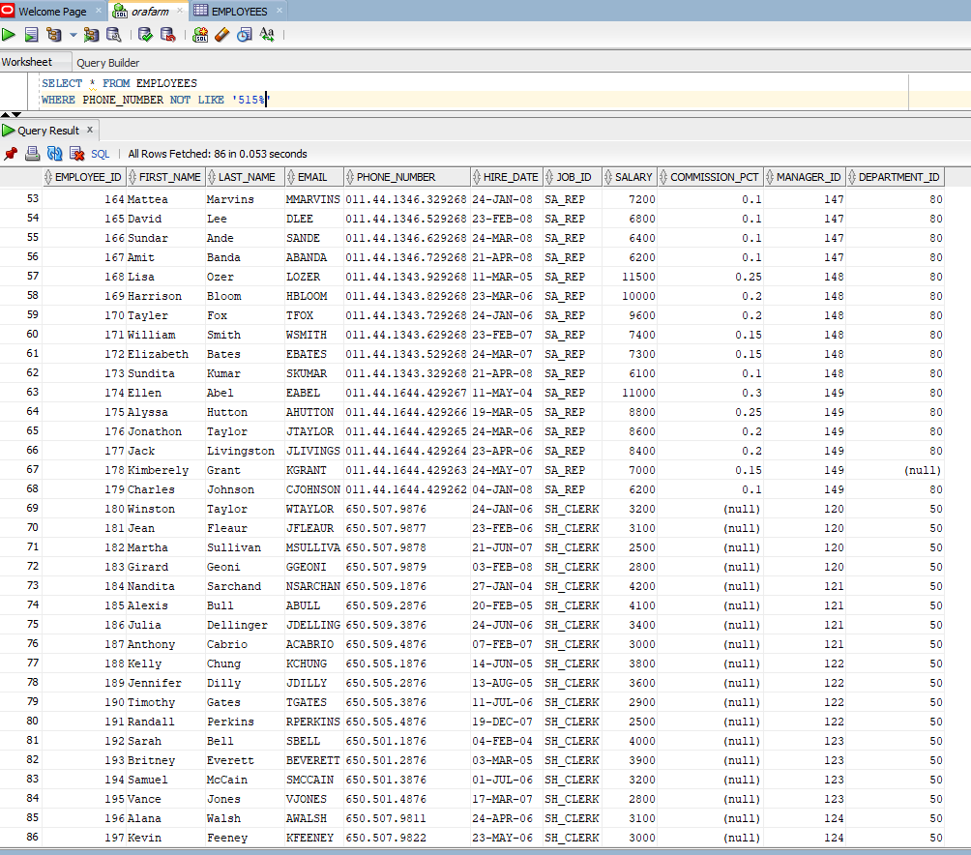

**4.) List the names of the employees who are in the finance department. Try to format the names as “firstname lastname” using concatenation (i.e., ||) and order them alphabetically.**

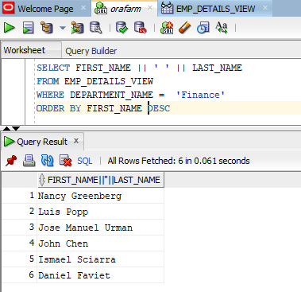

**5.) List the city, state and country name for all locations in the Asian region.**

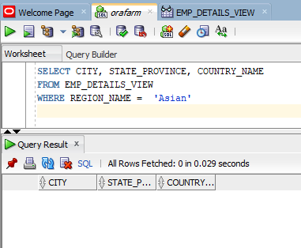

**6.) List the locations that have no state or province specified in the database.**

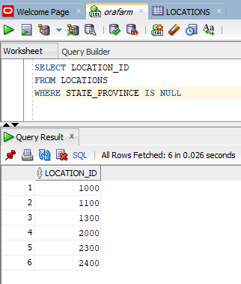

**7.) Create a query to display the highest, lowest, sum and average salary of all employees. Label the columns Maximum, Minimum, Sum and Average, respectively**

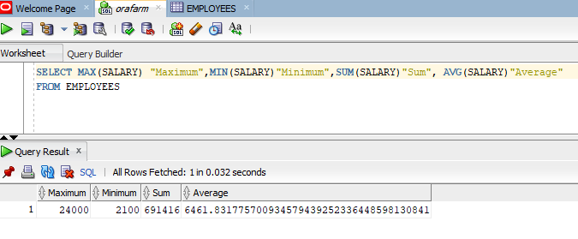

**8.) Modify the query in Step 7 to display the minimum, maximum, sum, and average salary for each job type.**

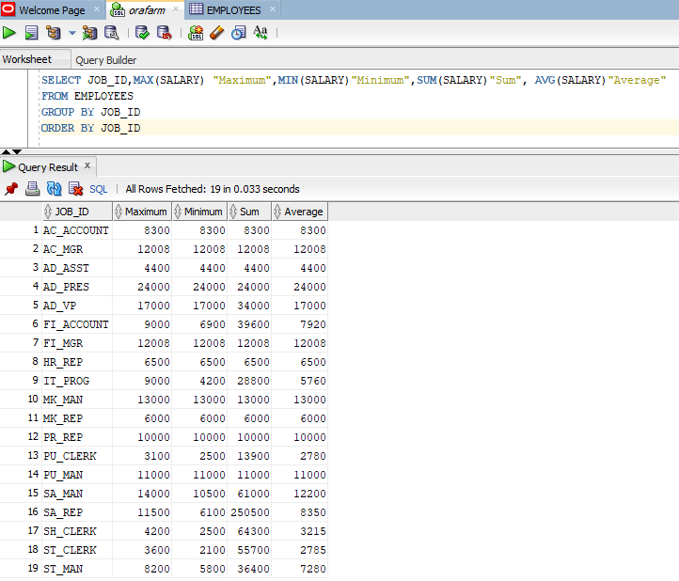

**9.) Create a query to display the number of employees with the same job.**

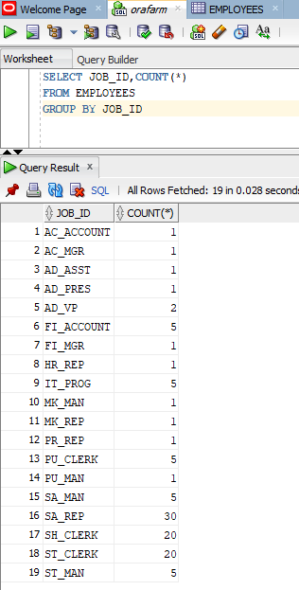

**10.) Determine the number of managers without listing them. Label the column Number of Managers. HINT: Use the MANAGER_ID column to determine the number of managers. Save your SQL statement in a text file named LAB08_4.sql. Run your query.**

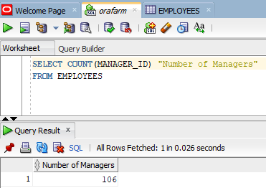 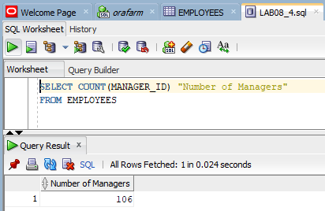

**11.) Write a query that displays the difference between the highest and lowest salaries. Label the column DIFFERENCE.**

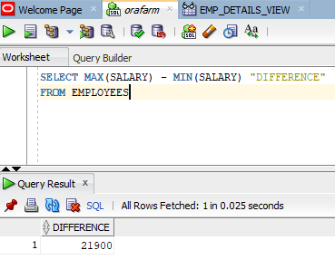

**12.) Display the manager number and the salary of the lowest paid employee for that manager. Exclude anyone whose manager is not known. Exclude any groups where the minimum salary is $6,000 or less. Sort the output in descending order of salary.**

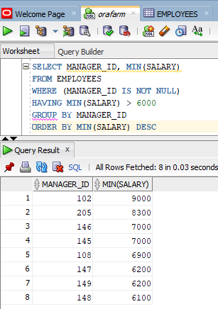

**13.) Write a query to display each department’s name, location, number of employees, and the average salary for all employees in that department. Label the columns Department , Location, Number of Workers, and Average Salary, respectively. Round the average salary to two decimal places.**

