Aaron Lim

Student ID: 005893468

CSE 572

Lab_3

***CREATE.sql***

***/\****

***1. Log on to orafarm.cse.csusb.edu using SQL Developer.***

***2. Use the SQL Developer to create the four tables EMP, DEPT, PROJ, EMP_PROJ with the appropriate***

***constraints except FOREIGN KEY constraints. For filename, use CREATE.sql accordingly.***

***3. Import data from the csv files to EMP, DEPT, and PROJ tables.***

***4. Check that all data for EMP, DEPT, and PROJ tables has been imported.***

***\*/***

CREATE TABLE EMP

(empNo number(4) PRIMARY KEY,

fname varchar2(50) NOT NULL,

lname varchar2(50) NOT NULL,

address varchar2(50),

sex Char(1),

salary number(6) CHECK(SALARY > 12000 ),

position varchar2(50),

deptNo number)

--Testing/Fix Mistakes

select * FROM EMP

DESCRIBE EMP

DROP TABLE EMP

CREATE TABLE DEPT

(deptNumber number(2) PRIMARY KEY,

deptName varchar2(50) NOT NULL,

Mgr number(4)NOT NULL)

--Testing/Fix Mistakes

select * FROM DEPT

DESCRIBE DEPT

DROP TABLE DEPT

CREATE TABLE PROJ

(projNumber number(2) PRIMARY KEY,

projName varchar2(50),

deptNum number(2))

--Testing/Fix Mistakes

select * FROM PROJ

DESCRIBE PROJ

DROP TABLE PROJ

CREATE TABLE EMP_PROJ

(empNo number(4),

projNo number(2),

hoursWorked number(3,1),

CONSTRAINT PK_EmpProj PRIMARY KEY (empNo,projNo))

--Testing/Fix Mistakes

select * FROM EMP_PROJ

DESCRIBE EMP_PROJ

DROP TABLE EMP_PROJ

**ALTER.sql**

***/\****

***5. In SQL Developer add the FOREIGN KEY constraints for each of the EMP, DEPT, PROJ and EMP_PROJ tables***

***using Alter statement. For filename, use ALTER.sql accordingly.***

***\*/***

ALTER TABLE EMP

ADD FOREIGN KEY(deptNo)

REFERENCES DEPT(deptNumber)

ALTER TABLE DEPT

ADD FOREIGN KEY(Mgr)

REFERENCES EMP(empNo)

ALTER TABLE PROJ

ADD FOREIGN KEY(deptNum)

REFERENCES DEPT(deptNumber)

ALTER TABLE EMP_PROJ

ADD FOREIGN KEY(empNo)

REFERENCES EMP(empNo)

***/\****

***6. Use the substitution & method of INSERT command to populate EMP_PROJ table.***

***7. Check that all data for EMP_PROJ table has been entered.***

***\*/***

INSERT INTO EMP_PROJ

VALUES(&empNo, &projNo, &hoursWorked)

***/\****

***8. Use the alter table to add a new column named email in the employees table.***

***\*/***

ALTER TABLE EMP

ADD email varchar2(255);

***/\****

***9. Try to execute the following insert statement and explain what is happening.***

***INSERT INTO EMPLOYEES VALUES (1172, ‘joe’, ‘Calvert’, ‘672 White Pine, Austin, TX’, ‘X’, 10000, 10) ;***

***\*/***

INSERT INTO EMPLOYESS VALUES (1172, ‘joe’, ‘Calvert’, ‘672 White Pine, Austin, TX’, ‘X’, 10000, 10) ;

/*

What is Happening:

The statement is attempting to insert the values within the parenthesis into the EMPLOYEES table.

Within the parathesis, string values are enclosed within '' and number values are not, but ‘ ’ is incorrect and should be ''.

Between each comma is a value to be inserted into a designated column (left to right),

but there is only 7 values and need to be 9 to equal the number of columns within the EMPLOYEES table.

The issue with this statement is that there is an error at command line: 47 column: 37, where there is an invalid character.

The cause is due to the identifier name starting with as ASCII character (‘ ’) and not a letter or a number.

Also the table is named EMP and not EMPLOYEES

*/

DESCRIBE EMP

/*

Name Null? Type

-------- -------- -------------

EMPNO NOT NULL NUMBER(4)

FNAME NOT NULL VARCHAR2(50)

LNAME NOT NULL VARCHAR2(50)

ADDRESS VARCHAR2(50)

SEX CHAR(1)

SALARY NUMBER(6)

POSITION VARCHAR2(50)

DEPTNO NUMBER

EMAIL VARCHAR2(255)

*/

--------

***/\****

***10. Please necessary corrections on the insert statement above.***

***\*/***

SELECT * FROM EMP

INSERT INTO EMP VALUES (1172, 'joe', 'Calvert', '672 White Pine, Austin, TX', 'X', 13000, 10, NULL, NULL);

/*

CORRECTIONS:

-Salary has to be greater than 12000 (it was 10000)

-Changed ‘ ’ into ''

-Added 2 extra column values to equal the required amount of 9

-Changed EMPLOYEES into EMP to match naming scheme

*/

**TABLES**

**EMP**

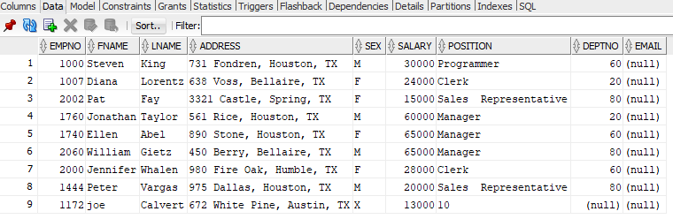

**DEPT**

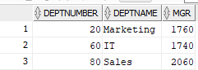

**PROJ**

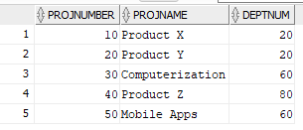

**EMP_PROJ**

