**Name:** Aaron Lim

SQL Programming – Level 1 Programming Project 01

# Meta data commands | Column Aliases | Simple Comparisons

***Reminder: read the Project Guidelines document for instructions on how to format and submit your assignments.***

## Part 1 – use the Oracle 9i database for the following problems.

Verify and demonstrate that you’re using a 9i version of the database, by executing this Oracle SQL command:  
 SELECT *  
 FROM v$version;

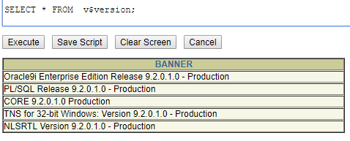

1. ***Use the “metadata” command to display the structure of the MOVIE table.***

DESCRIBE Movie;

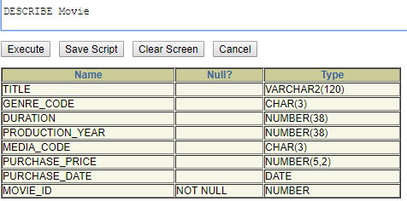

1. ***Using an English-language dictionary (here’s a link to an online dictionary:***[***http://www.m-w.com/***](http://www.m-w.com/)***) list the definition of metadata. Then in your own words, explain how this database command demonstrates this definition of metadata.***

**-Definition:** data that provides information about other data

-**Own Words:** This database commands is selecting all the information within every column of the Movies table. The command thoroughly lists all information originally stored within the table and leaves nothing out.

1. ***Prepare an SQL program that will display the movie id (mid) and movie title (title) for all of the movies in the database.***

**ANSWER:**

SELECT MOVIE_ID "MID", TITLE "title"

FROM Movie;

**RESULTS:**

101 rows selected

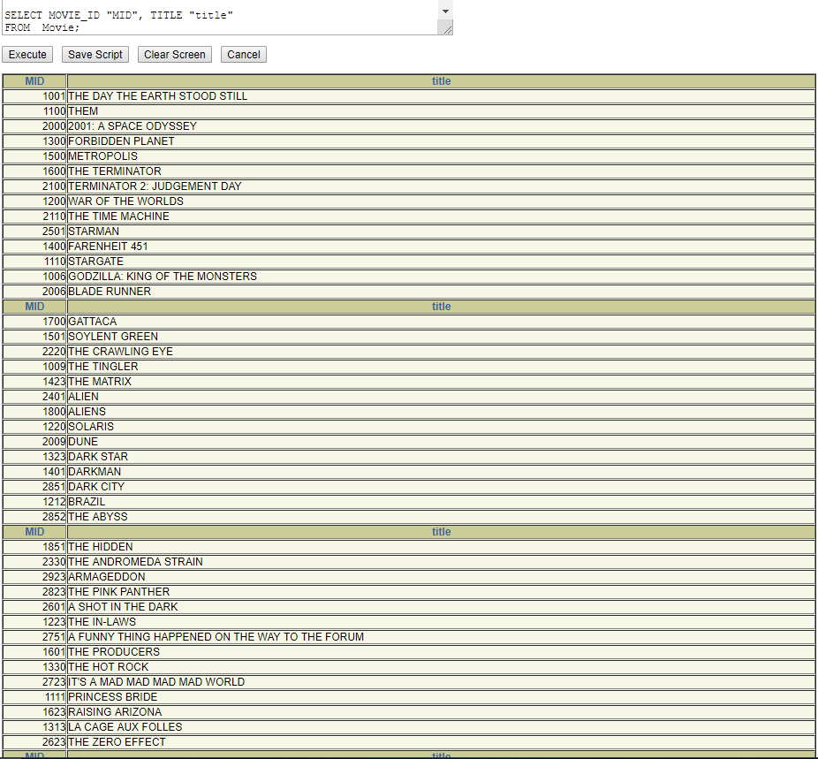

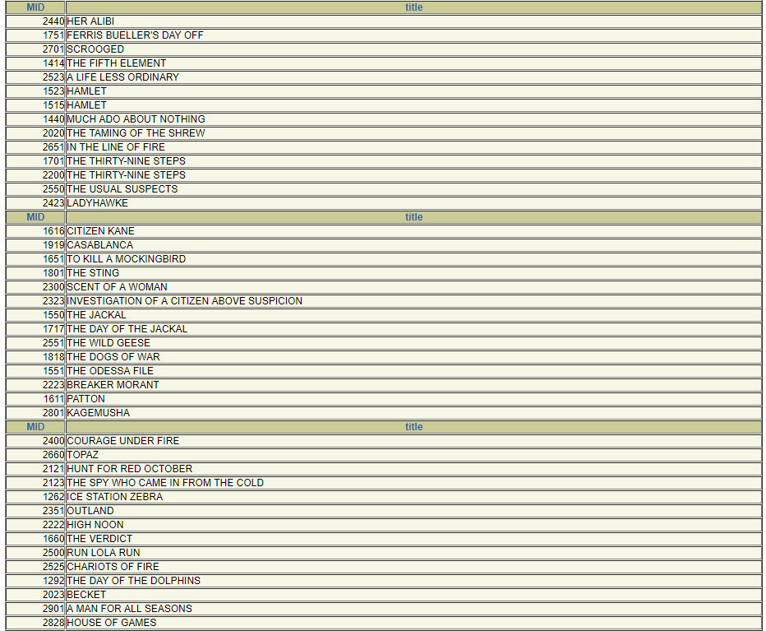

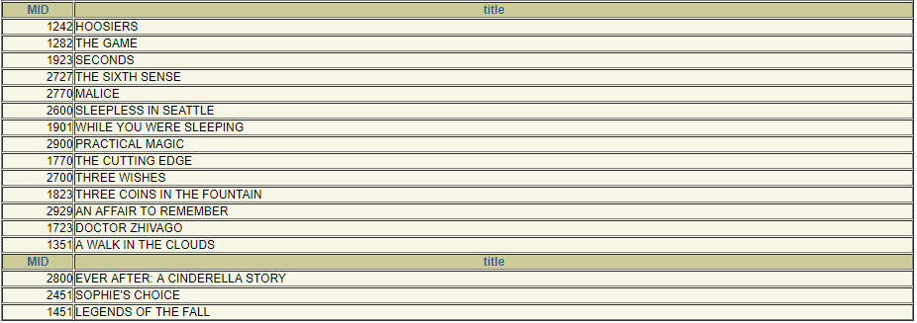



## Part 2 – use the Oracle 10g database for the following problems.

Verify and demonstrate that you’re using a 10g version of the database, by executing this Oracle SQL command:  
 SELECT *  
 FROM v$version;

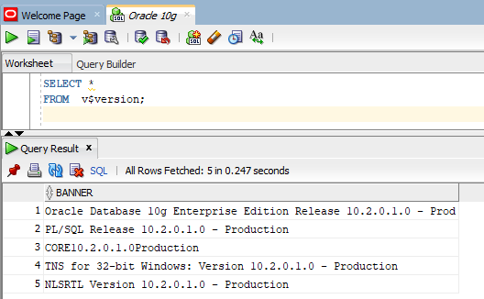

1. ***Use the metadata command to display the structure of the MOVIE table.***

DESCRIBE Movie;

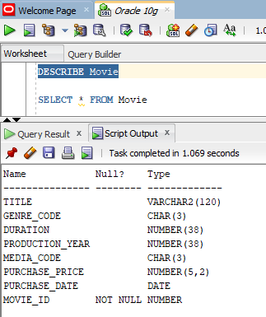

1. ***Prepare an SQL program that will display the movie id and movie title (title) for all of the movies in the database.***

SELECT MOVIE_ID, TITLE "title"

FROM Movie

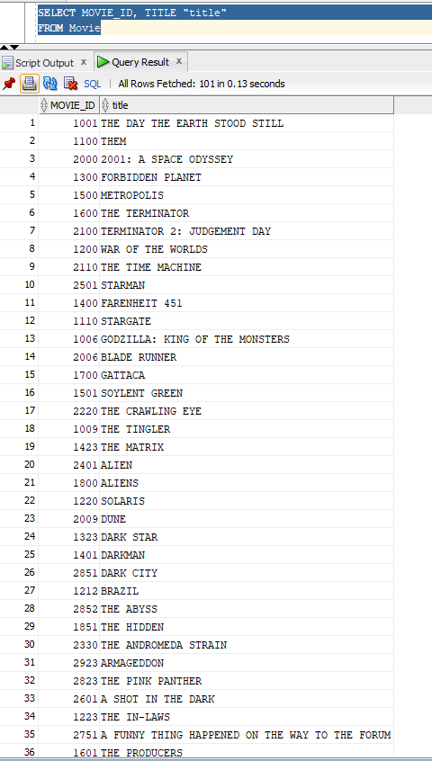

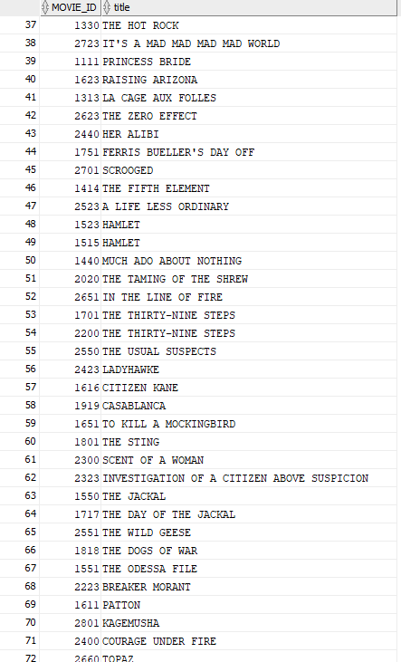

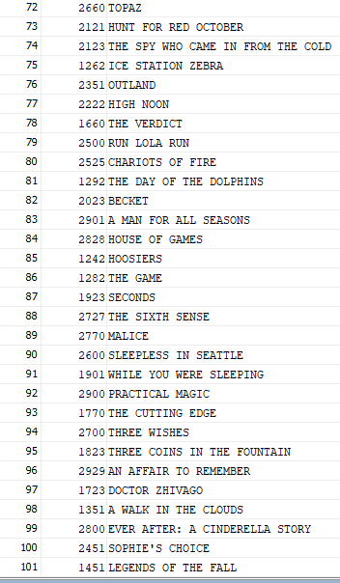

1. ***Prepare an SQL program that will display the movie id, and movie title for every movie in the database. Rename the title column as Movie Name in the result table.***

SELECT MOVIE_ID, TITLE "Movie Name"

FROM Movie

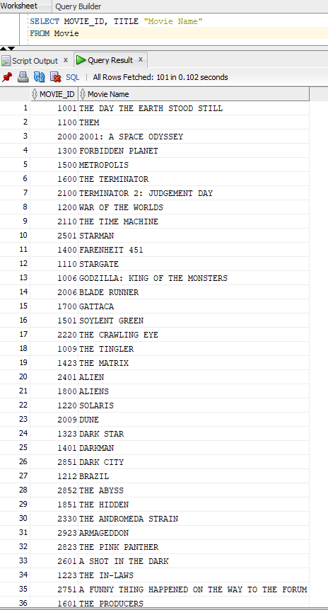

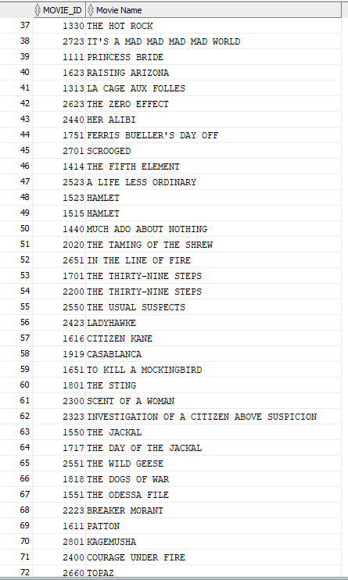

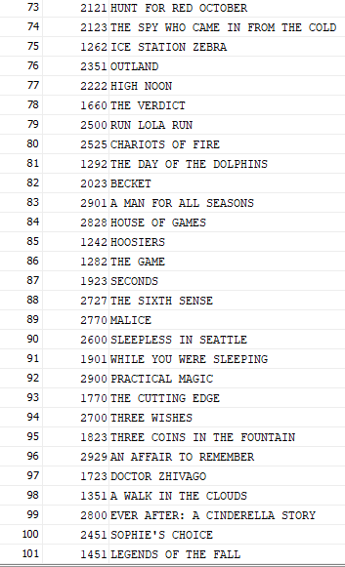

1. ***Prepare a report that shows the movie id, title, and genre for all films in the science fiction category (genre=SF)***

SELECT MOVIE_ID, TITLE, GENRE_CODE

FROM Movie

WHERE GENRE_CODE = ‘SF’

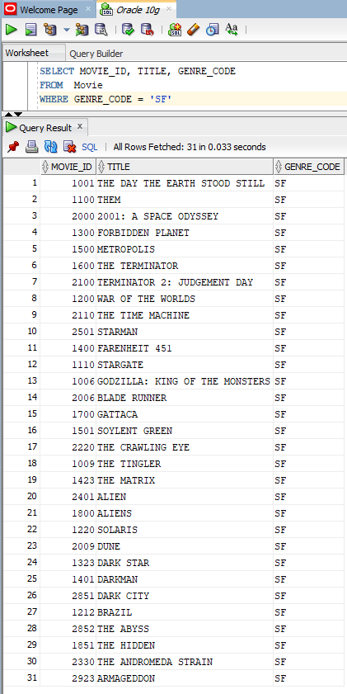

1. ***Prepare a report that shows the movie name and purchase price of the movie for all films that cost more than $20.***

SELECT TITLE, PURCHASE_PRICE

FROM Movie

WHERE PURCHASE_PRICE > 20

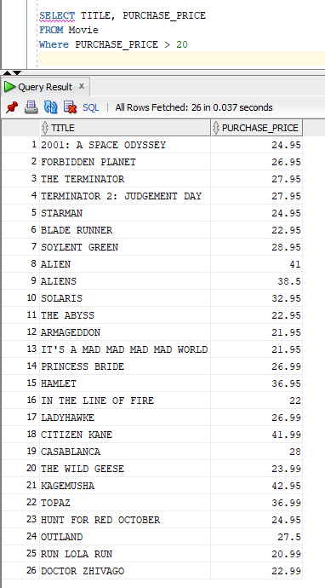

1. ***Prepare a report that shows movie name, genre, purchase price, and purchase date for all films that cost $22 or more.***

SELECT TITLE, GENRE_CODE, PURCHASE_PRICE, PURCHASE_DATE

FROM Movie

WHERE PURCHASE_PRICE >= 22

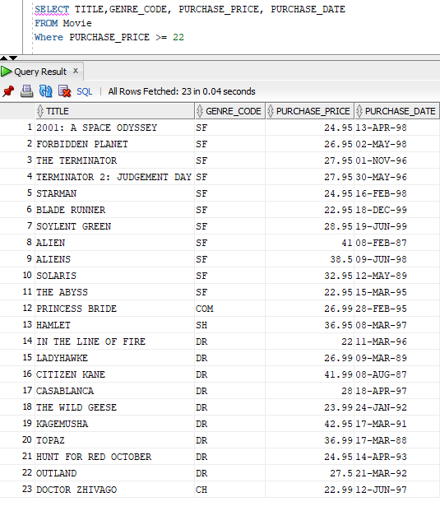

1. ***Prepare a report that shows all of the information available on all of the movies that were purchased before 1988.***

SELECT * FROM Movie

WHERE PURCHASE_DATE < ’01-JAN-88’

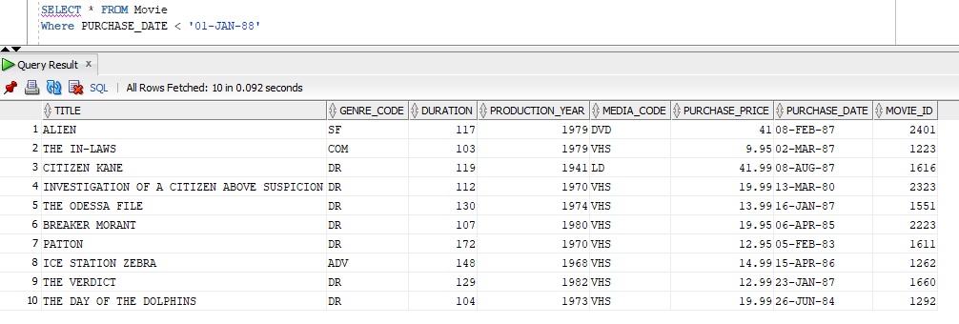

1. ***Prepare a report that shows all of the available information for any movies purchased on or after April 13, 1998.***

SELECT * FROM Movie

WHERE PURCHASE_DATE >= ’13-APR-98’

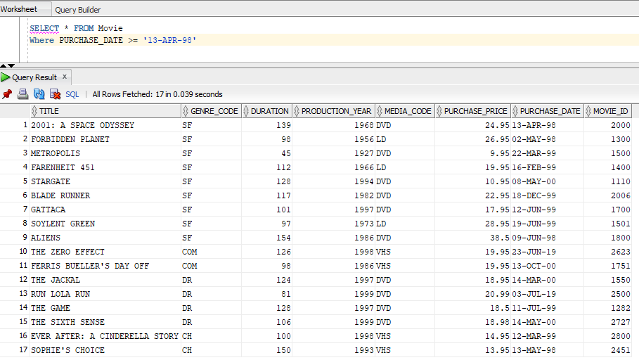

1. ***The result set in problem 1 describes the structure of the Movie table. The result set from Problem 3 displays the contents of the Movie table. How are these two result sets different? Is there any ‘information’ displayed in the result set from Problem 1 that you can’t “see” in the result set from Problem 3?***

**ANSWER:**

The results in problem 1 and problem 3 are different in the case that problem 1 is a literal description of the movie table. It displays the name of every column listed in the movie table, is they accept NULL values or not, the type of values that can be inserted into the table, and also the number of int/char characters that each field can accept as well. Problem 3 displays the movie table and shows all of its contents that has been inserted into the table thus far under every column that was created for the table.

For problem 1 displaying results that is not visible within problem 3, I would say yes. I say this because the DESCRIBE command allows the user to see if NULL values are accepted and the type of data that is being inserted into each column.

***Part 3 – use the MySQL database for the following problems.***

1. ***Use the metadata command to display the structure of the MOVIE table.***

DESCRIBE movies;

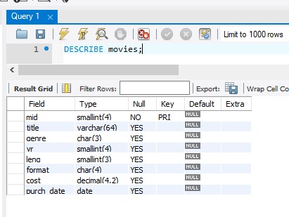

1. ***How does the result set from Problem 13 (MySQL) differ from the result set in question 1? Is there any new information in the MySQL result set?***

***ANSWER:***

For one they are two different tables, one is “Movie” and the other is “Movies.” Also the Movie table allows for more larger movie titles, duration , and some others within its tables which is showing with the larger numbers within the ( ). Also the columns are named different. The newest information within the MySQL results is that it lists the movie ID as the primary key for the table.

1. ***Prepare a report that shows the movie id, title, and genre for all films in the Shakespeare category (genre code=SH).***

SELECT mid, title, genre

FROM movies

WHERE genre = 'SH'

