**Name:** Aaron Lim

SQL Programming – Level 1 Programming Project 02

*Simple comparisons | Boolean operators | Numeric operations*

***Reminder: read the Project Guidelines document for instructions on how to format and submit your assignments.***

## Part 1 – use the Oracle 9i server for these problems.

**Demonstrate that you are using the Oracle 9i server by issuing:**  
SELECT *   
FROM v$version;

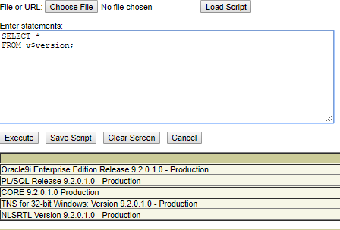

1. **List the name and running time (duration) for all movies whose running time is less than 60 minutes.**

SELECT TITLE, DURATION

FROM Movie

WHERE DURATION < 60

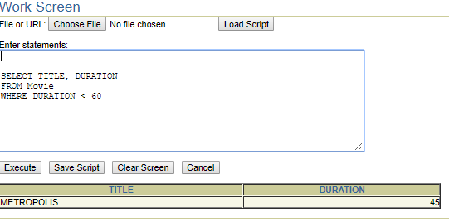

1. **List the name and running time for all movies whose running time is less than 90 minutes.**

SELECT TITLE, DURATION

FROM Movie

WHERE DURATION < 90

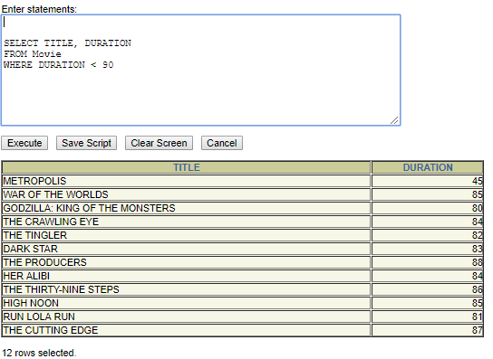

1. **List the name and running time for all movies whose running time is longer than 3 hours.**

SELECT TITLE, DURATION

FROM Movie

WHERE DURATION > 180

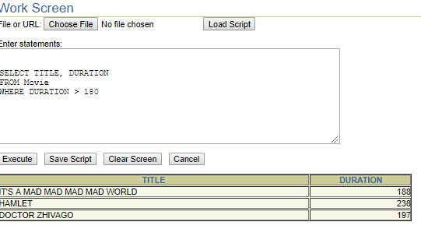

## Part 2 – use the Oracle 10g server for these problems.

**Demonstrate that you are using the Oracle 10g server by issuing:**

SELECT * FROM v$version;  
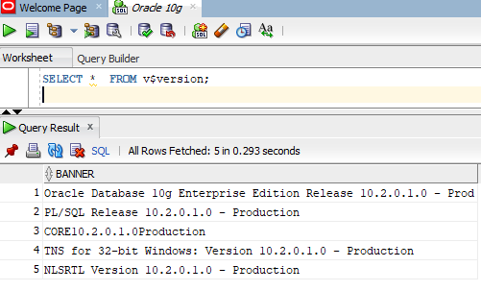

1. **List all of the information about the movie TOPAZ (ie. The movie title is Topaz)**

SELECT * FROM movie

WHERE TITLE = 'TOPAZ'

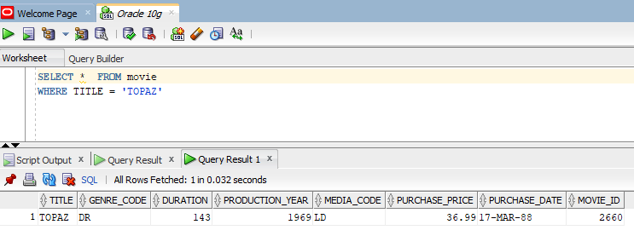

1. **List all of the information that is available about the movie Three Wishes.**

SELECT * FROM movie

WHERE TITLE = 'THREE WISHES'

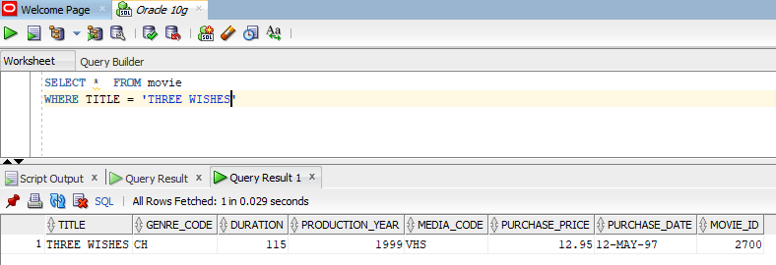

1. **List the title, cost, and date of purchase for all movies purchased during 1995.**

SELECT TITLE, PURCHASE_PRICE, PURCHASE_DATE FROM movie

WHERE PURCHASE_DATE BETWEEN '01-JAN-95' AND '31-DEC-95'

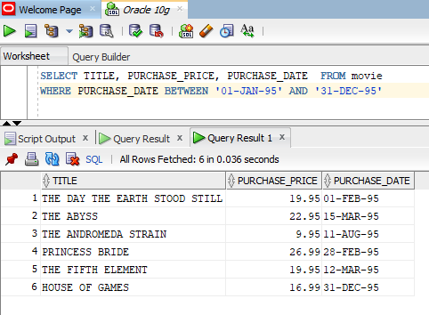

1. **Do it again. List the title, cost, and purchase date for all movies purchased during 1995. But this time, use a different predicate (comparison expression)**

**for this solution than you did with the last problem.**

SELECT TITLE, PURCHASE_PRICE, PURCHASE_DATE FROM movie

WHERE PURCHASE_DATE >= '01-JAN-95' AND PURCHASE_DATE <= '31-DEC-95'

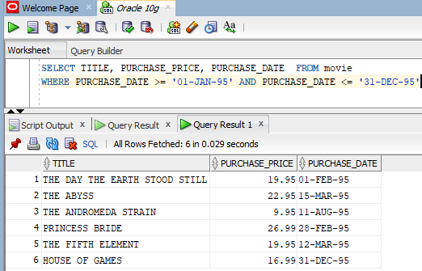

1. **List the title, purchase price, and purchase date for all movies that were NOT purchased during 1995.**

SELECT TITLE, PURCHASE_PRICE, PURCHASE_DATE FROM movie

WHERE NOT PURCHASE_DATE >= '01-JAN-95' AND PURCHASE_DATE <= '31-DEC-95

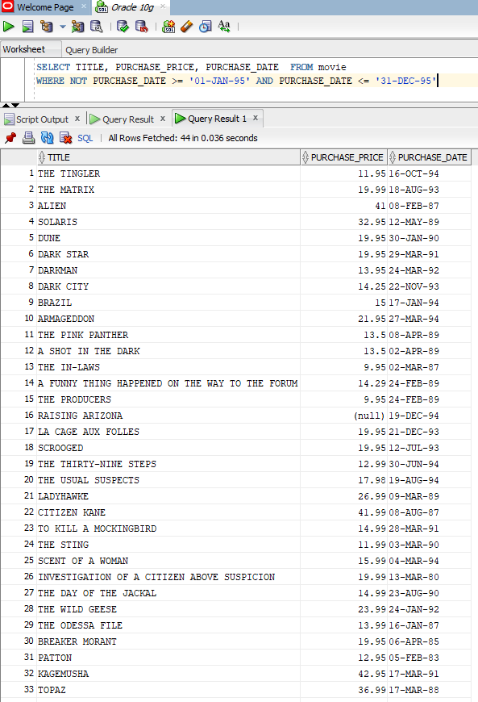

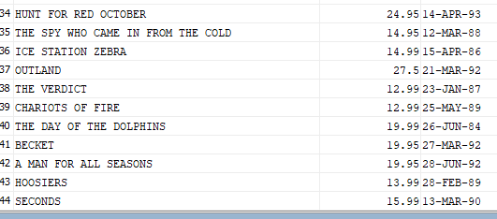

1. **List the title, cost, and purchase date for all movies purchased during 1995 or 1997.**

SELECT TITLE, PURCHASE_PRICE, PURCHASE_DATE FROM movie

WHERE ((PURCHASE_DATE BETWEEN '01-JAN-95' AND '31-DEC-95' OR (PURCHASE_DATE BETWEEN '01-JAN-97' AND '31-DEC-97')))

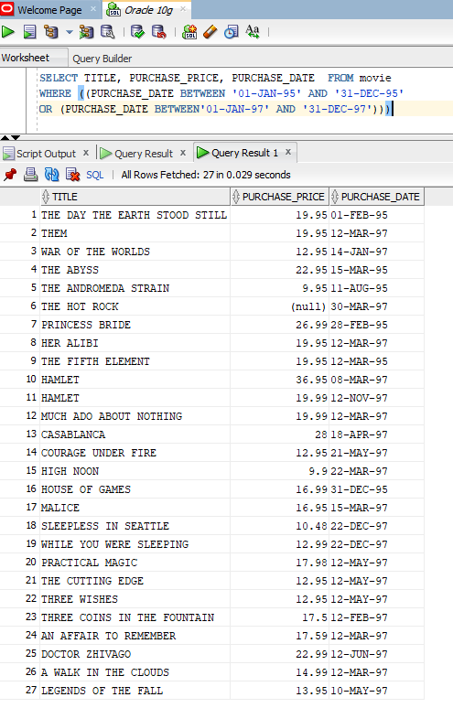

1. **List the title, genre, duration and year produced for all of the science fiction films (genre=sf) that were produced before 1960.**

SELECT TITLE, GENRE_CODE, DURATION, PRODUCTION_YEAR

FROM movie

WHERE GENRE_CODE = 'SF' AND PRODUCTION_YEAR < 1960

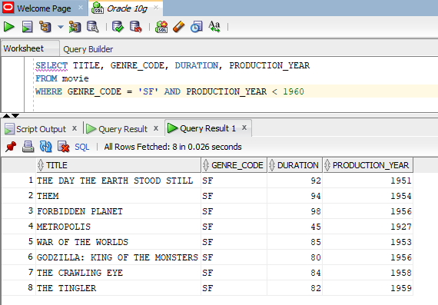

1. **List the title, genre, length and production year for all of the science fiction films that were produced before 1960, with a running time of more than 75 minutes.**

SELECT TITLE, GENRE_CODE, DURATION, PRODUCTION_YEAR

FROM movie

WHERE GENRE_CODE = 'SF' AND PRODUCTION_YEAR < 1960 AND DURATION > 7

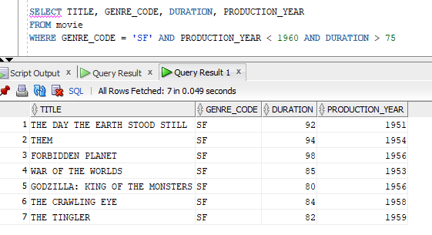

1. **List the title, genre, length and year produced for all of the science fiction films on DVD, that were produced before 1960, with a running time of more than 75 minutes.**

SELECT TITLE, GENRE_CODE, DURATION, PRODUCTION_YEAR

FROM movie

WHERE (GENRE_CODE = 'SF') AND (MEDIA_CODE = 'DVD') AND (PRODUCTION_YEAR < 1960) AND (DURATION > 75)

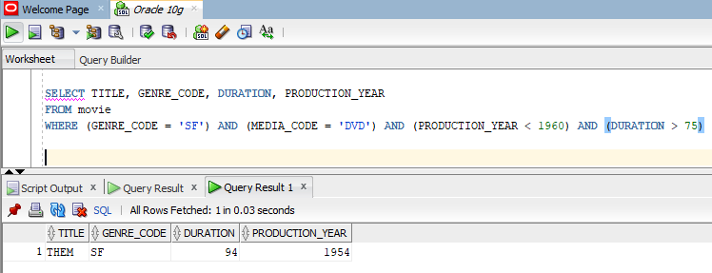

***Part 3 – use the MySQL server for these problems***

1. **List the title, length, and the length in hours (divide by 60) for all DVDs in the collection. Name the new column Length in Hours.**

SELECT title, leng, leng / 60 'Length in Hours'

FROM movies

WHERE format = 'DVD'

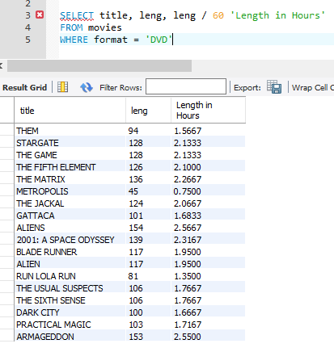

1. **List the title, cost, and cost plus 10% for all DVDs.**

SELECT title, cost, cost + ((cost * 10) / 100)

FROM movies

WHERE format = 'DVD'

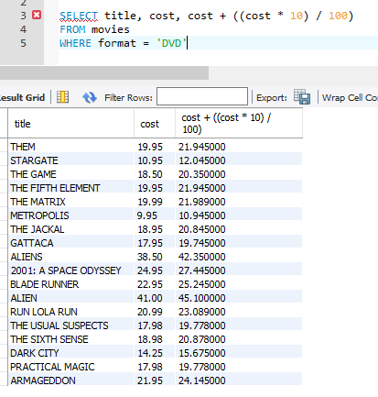

1. **List the title, cost, and cost plus 10% for all DVDs that are over 2 hours long.**

SELECT title, cost, cost + ((cost * 10) / 100)

FROM movies

WHERE (format = 'DVD') and (leng > 120)

