**Aaron Lim**

SQL Programming – Level 1 Programming Project 05

# Sorting | Column functions | GROUP BY

***Reminder: read the Project Guidelines document for instructions on how to format and submit your assignments.***

## Part 1 – use either of the Oracle servers for the following problems.

1. Use the sorting capabilities of SQL to prepare a list of all DVDs, sorted by year produced, with the oldest title appearing at the top of the listing. Show the title and year produced.

SELECT TITLE, PRODUCTION_YEAR

FROM movie

WHERE MEDIA_CODE = 'DVD'

ORDER BY PRODUCTION_YEAR

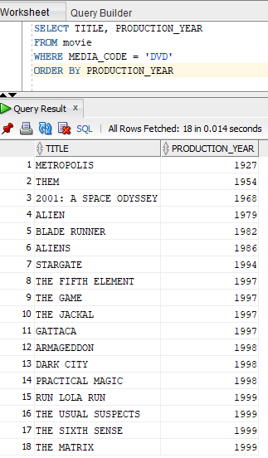

1. Use the sorting capabilities of SQL to prepare a list of the most recently produced DVDs. Show the newest titles at the top of the report. Show the title and production year.

SELECT TITLE, PRODUCTION_YEAR

FROM movie

WHERE MEDIA_CODE = 'DVD'

ORDER BY PRODUCTION_YEAR DESC

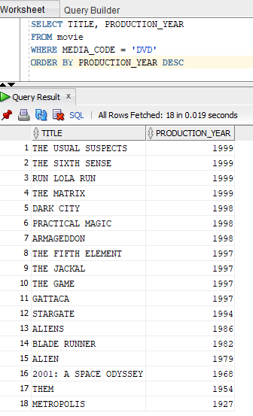

1. What are the smallest, largest and average values in the movie id column (movie_ID)? [3 cols]

SELECT MIN(MOVIE_ID),MAX(MOVIE_ID),AVG(MOVIE_ID)

FROM movie

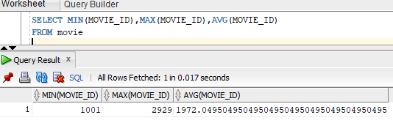

1. Write a SQL query that will display the smallest, largest and range of values (ie. largest – smallest) for the movie ID field. The range of values is the *difference* between the high and low values, so if the high value were 12, and the low value were 3, the range would be 9. [3 cols]

SELECT MIN(MOVIE_ID),MAX(MOVIE_ID),(MAX(MOVIE_ID) - MIN(MOVIE_ID)) AS "Range"

FROM movie

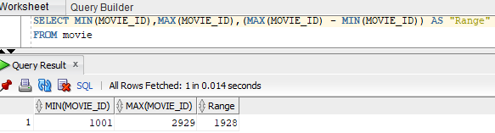

1. How many movies are there in the database?

SELECT COUNT(*)

FROM movie

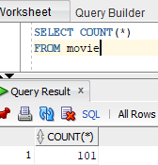

Note: using **SELECT DISTINCT * FROM movie** produces same result

1. How many different genre codes are there in the database? The result of your SQL program should be a single row.

SELECT COUNT(DISTINCT GENRE_CODE)

FROM movie

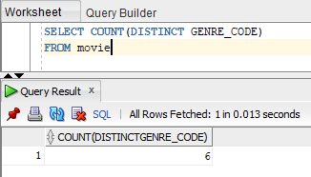

1. Display the number of titles in each of the different genre categories. [2 cols]

SELECT COUNT(TITLE), GENRE_CODE

FROM movie

GROUP BY GENRE_CODE

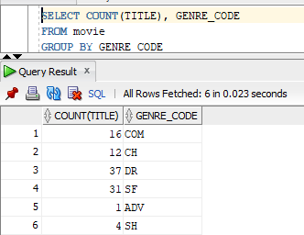

1. In addition to showing the number of each of the different genre of film, show the cheapest, most expensive and average price of videos in each category. [5 cols]

SELECT COUNT(TITLE), GENRE_CODE, MIN(NVL(PURCHASE_PRICE,0)), MAX(NVL(PURCHASE_PRICE,0)), AVG(NVL(PURCHASE_PRICE,0))

FROM movie

GROUP BY GENRE_CODE

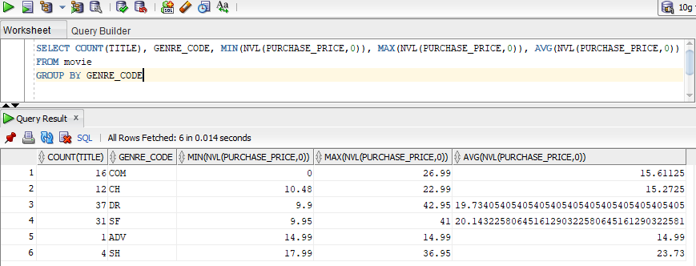

1. For only those videos that were produced after 1990, show the number of each of the different genre of video, as well as the cheapest, most expensive and average cost of videos for each category.

SELECT COUNT(TITLE), GENRE_CODE, MIN(NVL(PURCHASE_PRICE,0)), MAX(NVL(PURCHASE_PRICE,0)), AVG(NVL(PURCHASE_PRICE,0))

FROM movie

WHERE PRODUCTION_YEAR > 1990

GROUP BY GENRE_CODE

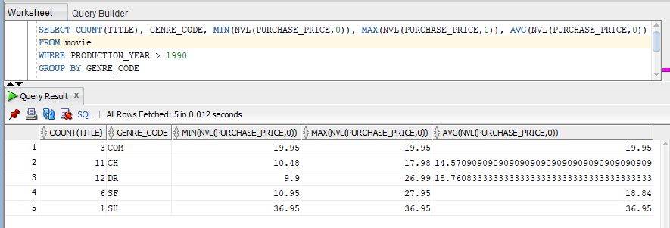

1. For only those films that were produced after 1990, show the number of each of the different genre of film, as well as the cheapest, most expensive and average cost of film for each category. Only display those genre that include a dozen or more titles.

SELECT COUNT(TITLE), GENRE_CODE, MIN(NVL(PURCHASE_PRICE,0)), MAX(NVL(PURCHASE_PRICE,0)), AVG(NVL(PURCHASE_PRICE,0))

FROM movie

WHERE PRODUCTION_YEAR > 1990

HAVING COUNT(TITLE) >= 12

GROUP BY GENRE_CODE

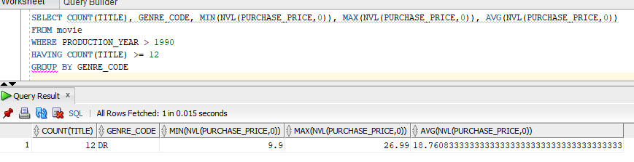

1. How much money was spent on the entire movie collection?

SELECT SUM(NVL(PURCHASE_PRICE,0))

FROM movie

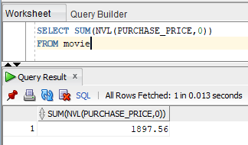

## Part 2 – use the MySQL database server for the following problems.

1. How much was spent on just the science fiction part of the collection?

SELECT IFNULL(SUM(cost),0) FROM movies

WHERE genre = 'SF'

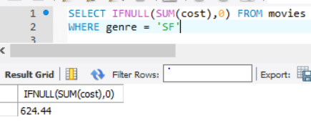

1. What was the average price of the movies? [1 cols]

SELECT IFNULL(AVG(cost),0) FROM movies

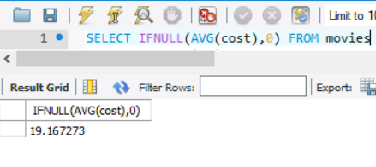

1. What is the average price of science fiction movies? [1 cols]

SELECT IFNULL(AVG(cost),0) FROM movies

WHERE genre = 'SF'

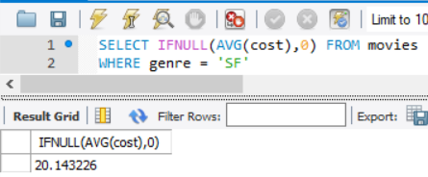

1. Display the number of titles, as well as the names of each of the titles for each of the different genre categories. [3 cols]

SELECT IFNULL(COUNT(title),0), title, genre

FROM movies

GROUP BY genre, title



