**Aaron Lim**

SQL Programming – Level 1 Programming Project 06

# NULLs | Subqueries | Any | All …

***Reminder: read the Project Guidelines document for instructions on how to format and submit your assignments.***

## Part 1 – use the Oracle 9i database for the following problems.

Verify that you’re using a 9i version of the database, by executing this Oracle SQL command:

SELECT *  
FROM v$version;

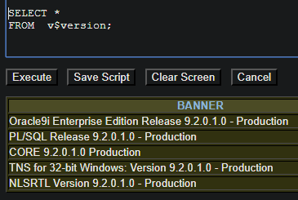

1. How many records in the database have NULL values in any of these columns: genre, purchase date, production year. You are looking for a single number.

SELECT COUNT(*)FROM movie

WHERE genre_code IS NULL

OR purchase_date IS NULL

OR production_year IS NULL

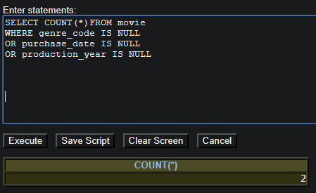

1. For each of the videos in the comedy genre, show the title and cost of the movie. If the cost of the movie is NULL, show that cost as 0.

SELECT title, NVL(purchase_price, 0)

FROM movie

WHERE genre_code = 'COM'

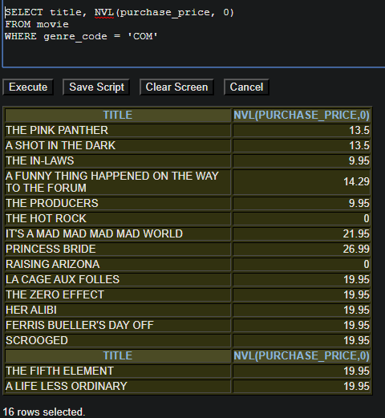

1. What was the cost for the most expensive movie(s) in the collection?

SELECT MAX(PURCHASE_PRICE) FROM movie

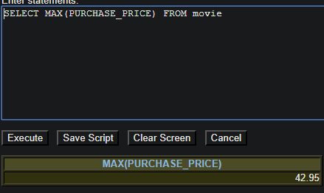

1. What is the name of the most expensive video(s)? (In other words: what films have a cost equal to the cost of the most expensive movie?)

SELECT title

FROM movie

WHERE PURCHASE_PRICE IN (SELECT MAX(PURCHASE_PRICE)

FROM movie)

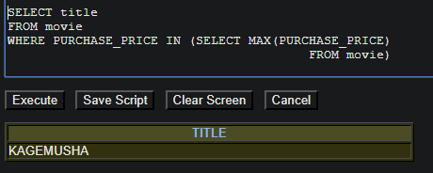

1. What are the names for the least expensive movies in the collection? Show both the title of the film and the cost.

SELECT TITLE, PURCHASE_PRICE

FROM movie

WHERE PURCHASE_PRICE IN (SELECT MIN(PURCHASE_PRICE)

FROM movie)

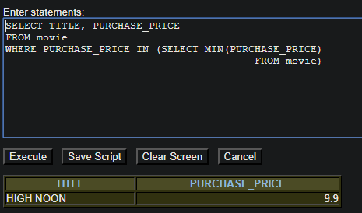

Note* This is the least expensive movie

1. What are the names of the movies that cost within $2 of the most expensive film(s)?

SELECT title

FROM movie

WHERE PURCHASE_PRICE > (SELECT MAX(PURCHASE_PRICE)

FROM movie) – 2

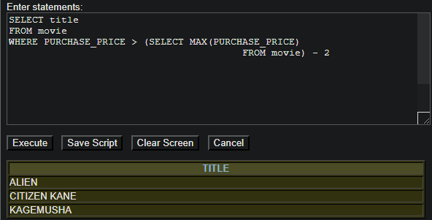

1. Using the count function, how many videos are there in the collection that cost within $2 of the most expensive film(s)?

SELECT COUNT(*)

FROM movie

WHERE PURCHASE_PRICE > (SELECT MAX(PURCHASE_PRICE)

FROM movie) – 2

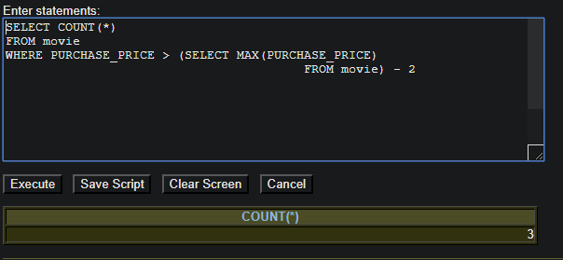

## Part 2 – use the Oracle 10g database for the following problems.

Verify that you’re using a 10g version of the database, by executing this Oracle SQL command:

SELECT *  
FROM v$version;

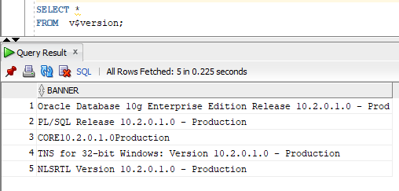

1. Display the title and year and genre for all of the SH and CH genre videos.

SELECT TITLE,PRODUCTION_YEAR,GENRE_CODE

FROM movie

WHERE GENRE_CODE IN ('SH', 'CH')

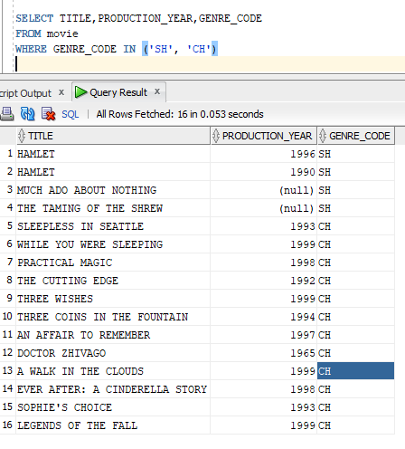

1. Display the title and year for all of the films that were produced in the same year as any of the SH and CH videos.

SELECT TITLE,PRODUCTION_YEAR

FROM movie

WHERE PRODUCTION_YEAR IN (SELECT PRODUCTION_YEAR

FROM movie

WHERE GENRE_CODE IN ('SH', 'CH'))

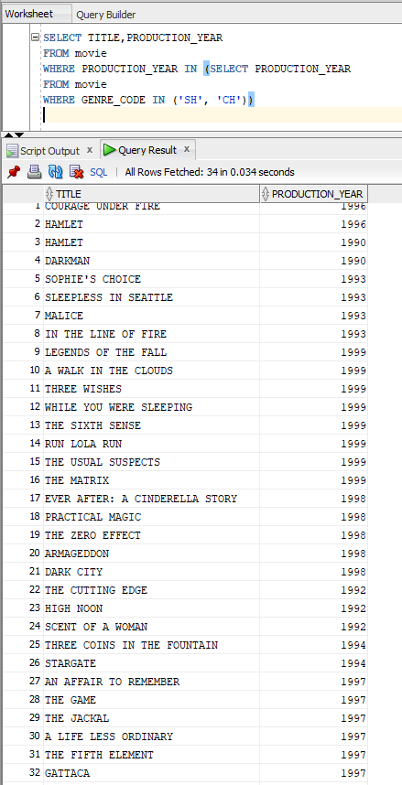



1. Display the title and year for all of the films that were produced before any of the SH and CH videos were produced.

SELECT a.TITLE, a.PRODUCTION_YEAR

FROM movie a

WHERE EXISTS(

SELECT PRODUCTION_YEAR

FROM movie b

WHERE GENRE_CODE IN ('SH', 'CH') AND a.PRODUCTION_YEAR < b.PRODUCTION_YEAR);

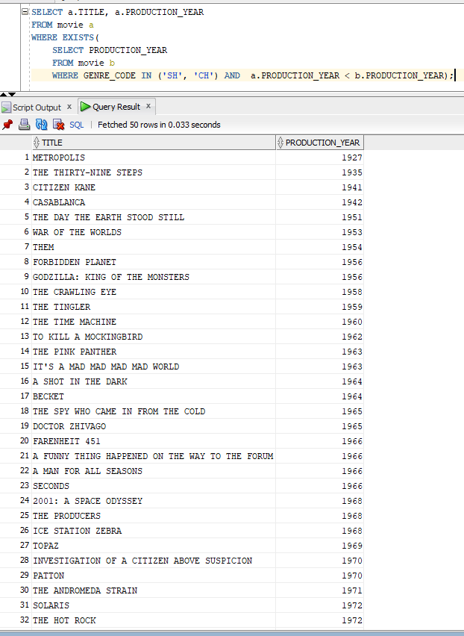

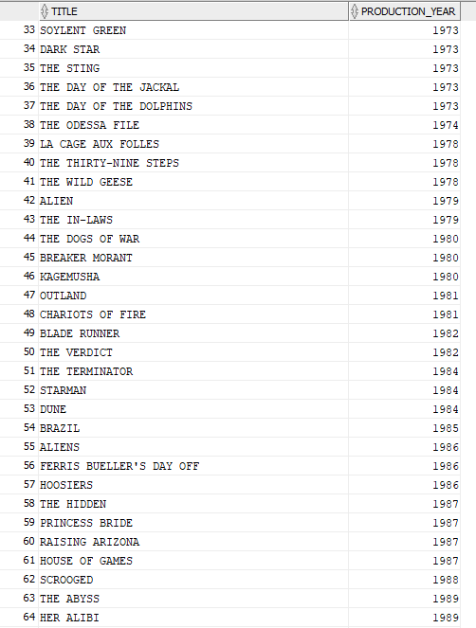

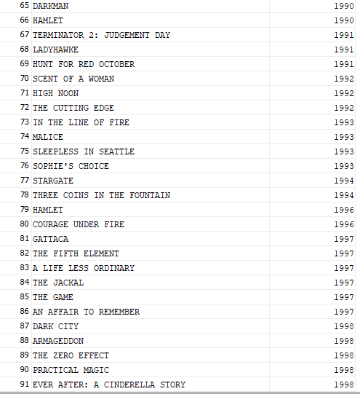

1. Display the title and year of all non SH and non CH films that were produced in the same year as any of the SH or CH videos were produced.

SELECT TITLE,PRODUCTION_YEAR

FROM movie

WHERE GENRE_CODE NOT IN ('SH','CH')

AND PRODUCTION_YEAR IN (SELECT PRODUCTION_YEAR

FROM movie

WHERE GENRE_CODE IN ('SH', 'CH'))

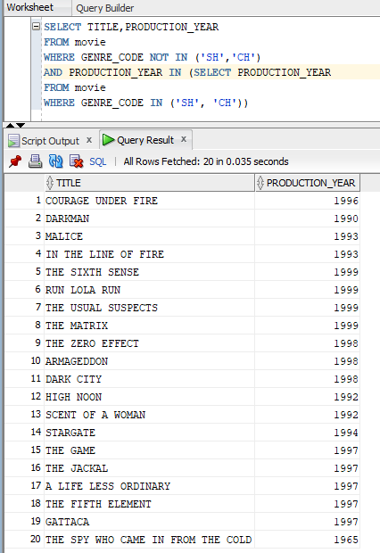

## Part 3 – use the MySQL database for the following problems.

1. How many records in the database have NULL values in any of these columns: genre, purchase date, production year.

SELECT COUNT(*)FROM movies

WHERE genre IS NULL

OR cost IS NULL

OR yr IS NULL

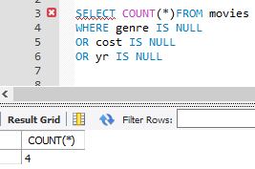

1. For each of the films in the comedy genre, show the title and cost of the movie. If the cost of the movie is NULL, show that cost as 0.

SELECT title, COALESCE(cost, 0)

FROM movies

WHERE genre = 'COM'

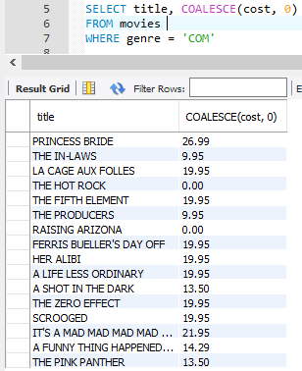

1. What are the names of the movies that were produced in the earliest year of the collection?

SELECT title

FROM movies

WHERE yr IN (SELECT MIN(yr) FROM movies)

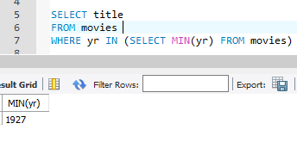

1. What are the MID, titles, and genre of the movies that were produced in the earliest year of the collection?

SELECT mid,COALESCE(title,''),COALESCE(genre,'')

FROM movies

WHERE yr IN (SELECT MIN(yr) FROM movies)

