SQL Programming – Level 1 Programming Project 7 **Aaron Lim**

*DDL & Views*

***For each of these questions, be sure to show the question, your code, and the system response (eg. TABLE CREATED) in your solution***.

## Use the Oracle 9i server for questions 1 thru 9.

1. **Prepare and execute the simple DDL (data definition language) statements for the myMovies table design described in the following table instance charts. (2 pts)**

## myMovies

|  |  |  |  |  |  |
| --- | --- | --- | --- | --- | --- |
| **Column Name** | **ID** | **Title** | **YR Produced** | **Studio** | **Director** |
| **Nulls/Unique** | **Not Null** | **Not Null** | **Not Null** | **Null** | **Null** |
| **Sample Data** | **1001** | **Aliens** |  |  |  |
|  | **1002** | **The Wild Geese** |  |  |  |
|  | **1003** | **North by Northwest** |  |  |  |

CREATE TABLE myMovies

(

ID INT NOT NULL,

Title VARCHAR(50) NOT NULL,

YR_Produced INT NOT NULL,

Studio VARCHAR(50),

Director VARCHAR(50)

);

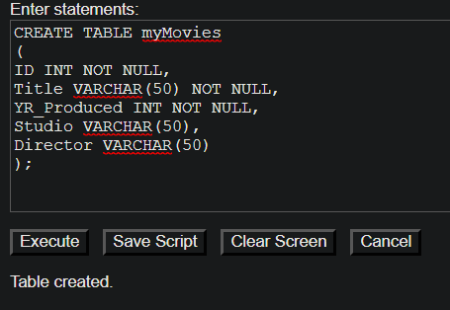

1. **Insert 5 or more rows of data into the table – provide meaningful values for each column.**

INSERT INTO myMovies (ID, Title, YR_Produced, Studio, Director)

VALUES ('1004', 'Joker', '2019', 'Warner Bros', 'Todd Phillips');

INSERT INTO myMovies (ID, Title, YR_Produced, Studio, Director)

VALUES ('1005', 'The Dark Knight', '2008', 'Warner Bros', 'Christopher Nolan');

INSERT INTO myMovies (ID, Title, YR_Produced, Studio, Director)

VALUES ('1006', 'Titanic', '1997', 'Paramount Pictures', 'James Cameron');

INSERT INTO myMovies (ID, Title, YR_Produced, Studio, Director)

VALUES ('1007', 'IT', '2017', 'Warner Bros', 'Andy Mushietti');

INSERT INTO myMovies (ID, Title, YR_Produced, Studio, Director)

VALUES ('1008', 'Star Wars', '1977', '20th Century Fox', 'George Lucas');

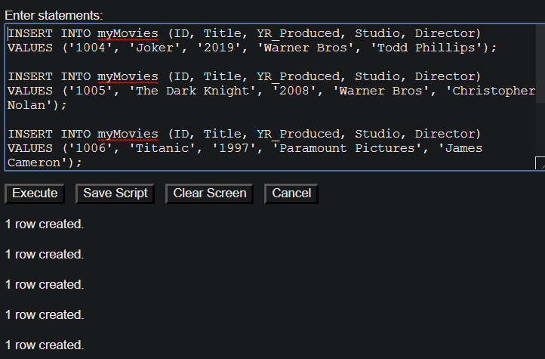

1. **Describe the table, and then show all of the rows in the table.**

Describe myMovies

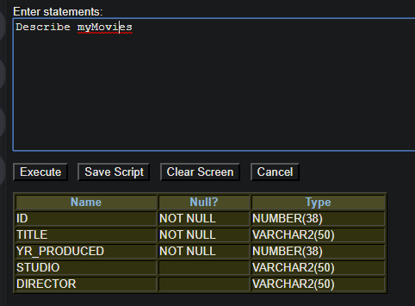

SELECT * FROM myMovies

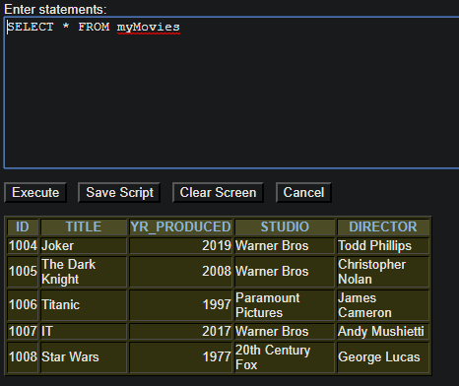

1. **Prepare and execute the simple DDL (data definition language) statements for the myBooks table design described in the following table instance charts. (2 pts)**

## myBooks

|  |  |  |  |  |  |
| --- | --- | --- | --- | --- | --- |
| **Column Name** | **ID** | **Title** | **Author** | **Publisher ID** | **YR Published** |
| **Nulls/Unique** | **Not Null** | **Not Null** | **Not Null** | **Null** | **Null** |
| **Sample Data** | **3001** | **Fahrenheit 451** | **Bradbury** |  |  |
|  | **3002** | **Disclosure** | **Crichton** |  |  |
|  | **3003** | **The Fist of God** | **Forsyth** |  |  |

CREATE TABLE myBooks

(

ID INT NOT NULL,

Title VARCHAR(50) NOT NULL,

Author VARCHAR(50) NOT NULL,

Publisher_ID INT,

YR_Published INT

);

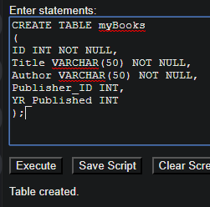

1. **Insert 5 or more rows of data into the table – provide meaningful values for each column.**

INSERT INTO myBooks (ID, Title, Author, Publisher_ID, YR_Published)

VALUES (3004, 'The Institute: A Novel', 'Stephen King', 104, 2019);

INSERT INTO myBooks (ID, Title, Author, Publisher_ID, YR_Published)

VALUES (3005, 'The Hate U Give', 'Angie Thomas', 105, 2017);

INSERT INTO myBooks (ID, Title, Author, Publisher_ID, YR_Published)

VALUES (3006, 'Five Feet Apart', 'Rachael Lippincott', 106, 2018);

INSERT INTO myBooks (ID, Title, Author, Publisher_ID, YR_Published)

VALUES (3007, 'IT', 'Stephen King', 107, 1980);

INSERT INTO myBooks (ID, Title, Author, Publisher_ID, YR_Published)

VALUES (3008, 'Wonder', 'R J Palacio', 108, 2012);

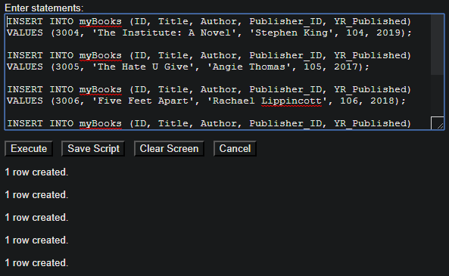

1. **Describe the table, and then show all of the rows in the table**

DESCRIBE myBooks

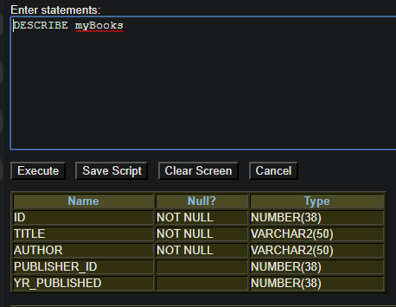

SELECT * FROM myBooks

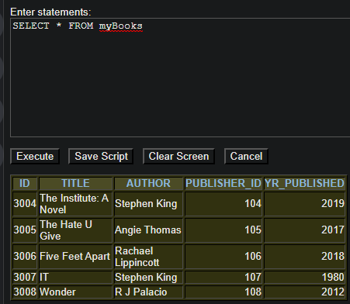

1. **Prepare and execute the simple DDL (data definition language) statements for the myPublisher table design described in the following table instance charts. (2 pts)**

## myPublisher

|  |  |  |  |  |
| --- | --- | --- | --- | --- |
| **Column Name** | **ID** | **Name** | **City** | **Country** |
| **Nulls/Unique** | **Not Null** | **Not Null, Unique** | **Not Null** | **Not Null** |
| **Sample Data** | **9001** |  |  |  |
|  | **9002** |  |  |  |
|  | **9003** |  |  |  |

CREATE TABLE myPublisher

(

ID INT NOT NULL,

Name VARCHAR(50) NOT NULL UNIQUE,

City VARCHAR(50) NOT NULL,

Country VARCHAR(50) NOT NULL

);

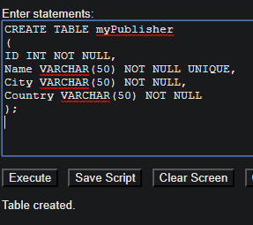

1. **Insert 5 or more rows of data into the table – provide meaningful values for each column.**

INSERT INTO myPublisher (ID, Name, City, Country)

VALUES (9004, 'Aaron', 'Murrieta', 'US');

INSERT INTO myPublisher (ID, Name, City, Country)

VALUES (9005, 'Ted', 'Temecula', 'US');

INSERT INTO myPublisher (ID, Name, City, Country)

VALUES (9006, 'Samantha', 'Hemet', 'ENG');

INSERT INTO myPublisher (ID, Name, City, Country)

VALUES (9007, 'Beverly', 'Tokyo', 'JAP');

INSERT INTO myPublisher (ID, Name, City, Country)

VALUES (9008, 'Jake', 'Hong Kong', 'CH');

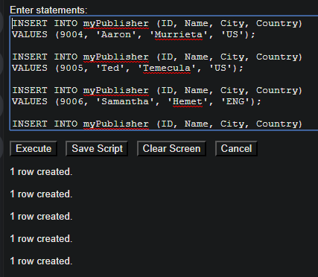

1. **Describe the table, and then show all of the rows in the table**

DESCRIBE myPublisher

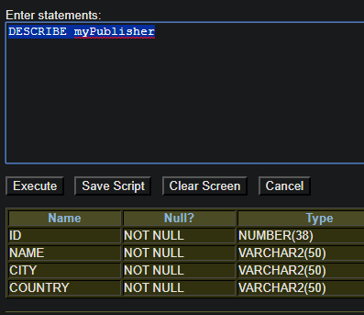

SELECT * FROM myPublisher

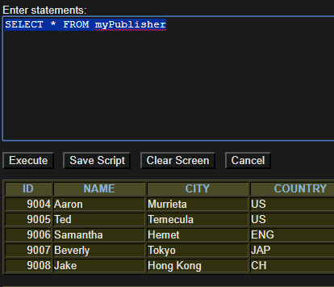

*** I’m assuming the rest of the questions we can use SQL Developer over 9i ? *****

1. **Create a view named ‘SCIFI’ that is based on the old movies table that we’ve been using all semester. This view should include all of the columns from the movies table, but only the rows for genre=SF films.**

CREATE VIEW SCIFI AS

SELECT * FROM movie

WHERE GENRE_CODE = 'SF';

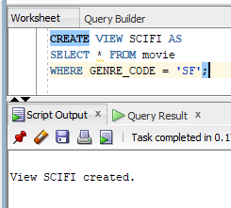

1. **Describe the view, and then show all of the rows in the view**

DESCRIBE SCIFI

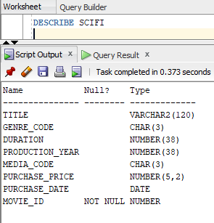

SELECT * FROM SCIFI;

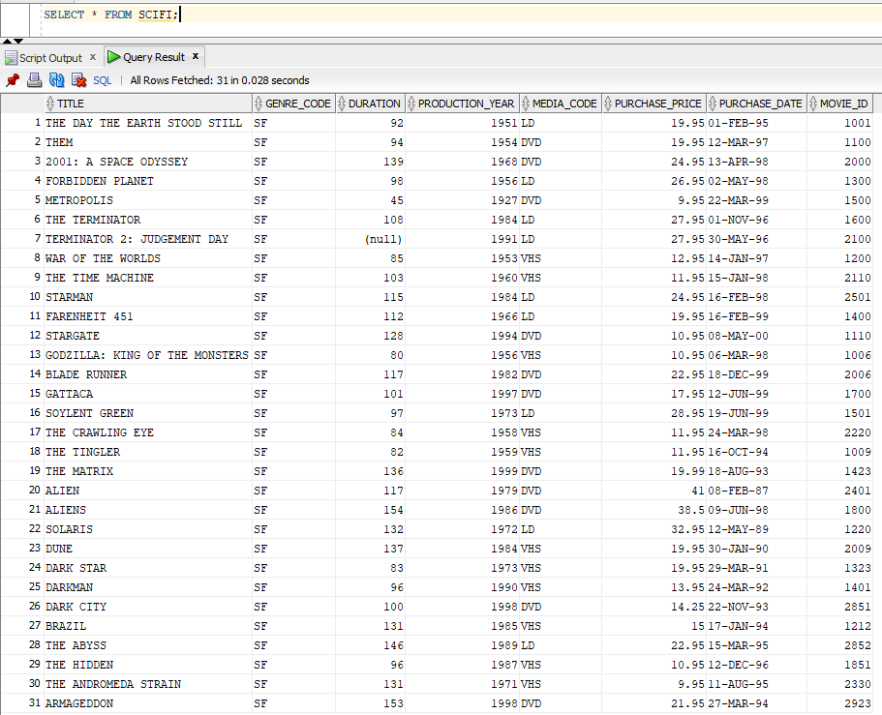

1. **Use the view to find and display all of the films that contain the word ‘The’ in their title.**

SELECT * FROM SCIFI

WHERE TITLE LIKE UPPER('%The %')

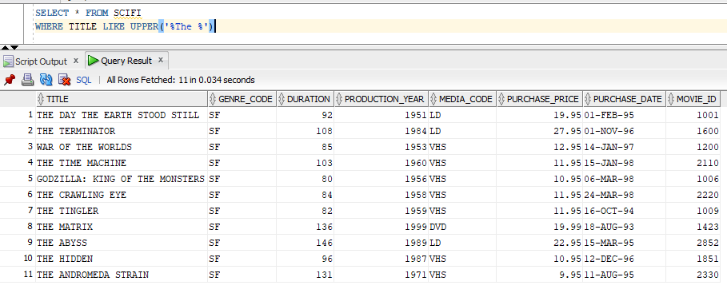

NOTE* for problems 1 – 9 I did not insert the values that were in the existing table to describe, but if I was, I would just have INSERT them