*DDL & Views*

***For each of these questions, be sure to show the question, your code, and the system response (eg. TABLE CREATED) in your solution***.

## Use the Oracle 9i server for questions 1 thru 9.

1. Prepare and execute the simple DDL (data definition language) statements for the myBook table design described in the following table instance charts. Note: table names and column names should match the specifications, column datatypes need to accommodate the sample data depicted, and the NOT NULL constraints should be implemented.

# myBook

|  |  |  |  |  |  |
| --- | --- | --- | --- | --- | --- |
| Column Name | ID | Title | Author | Publisher ID | YR Published |
| Key Type |  |  |  |  |  |
| Nulls/Unique | Not Null | Not Null | Not Null | Null | Null |
| Sample Data | 3001 | Fahrenheit 451 | 8001 | 9001 | 1968 |

Create TABLE myBook

(

ID INT NOT NULL,

Title VARCHAR(50) NOT NULL,

Author INT NOT NULL,

Publisher_ID INT,

YR_Published INT

);

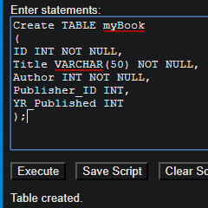

1. Insert 5 rows of data into the table – provide meaningful values for each column.

INSERT INTO myBook (ID, Title, Author, Publisher_ID, YR_Published)

VALUES (3002, 'The Institute: A Novel', 8002, 104, 2019);

INSERT INTO myBook (ID, Title, Author, Publisher_ID, YR_Published)

VALUES (3003, 'The Hate U Give', 8003, 105, 2017);

INSERT INTO myBook (ID, Title, Author, Publisher_ID, YR_Published)

VALUES (3004, 'Five Feet Apart', 8004, 106, 2018);

INSERT INTO myBook (ID, Title, Author, Publisher_ID, YR_Published)

VALUES (3005, 'IT', 8005, 107, 1980);

INSERT INTO myBook (ID, Title, Author, Publisher_ID, YR_Published)

VALUES (3006, 'Wonder', 8006, 108, 2012);

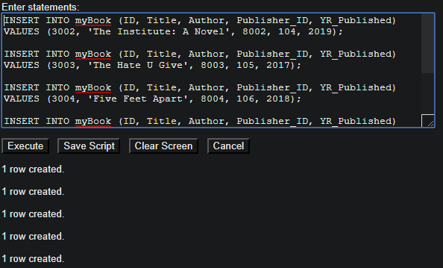

1. Describe the table, and then show all of the rows in the table

DESCRIBE myBook

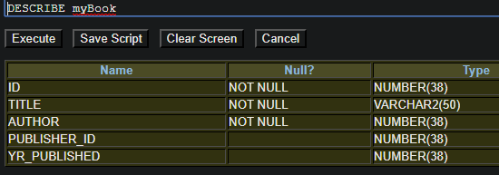

SELECT * FROM myBook

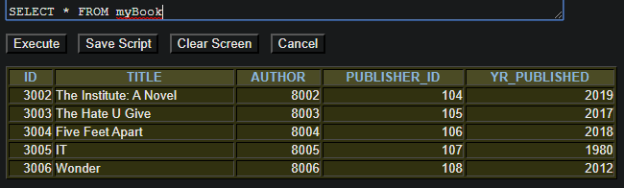

1. Prepare and execute the simple DDL (data definition language) statements for the myPublisher table design described in the following table instance charts. Note: table names and column names should match the specifications, column datatypes need to accommodate the sample data depicted, and the NOT NULL constraints should be implemented.

# myPublisher

|  |  |  |  |  |
| --- | --- | --- | --- | --- |
| Column Name | ID | Name | City | Country |
| Key Type |  |  |  |  |
| Nulls/Unique | Not Null | Not Null | Not Null | Not Null |
| Sample Data | 9001 | Faraday Publishers | Santa Fe | USA |

# CREATE TABLE myPublisher

# (

# ID INT NOT NULL,

# Name VARCHAR(50) NOT NULL,

# City VARCHAR(50) NOT NULL,

# Country VARCHAR(50) NOT NULL

# );

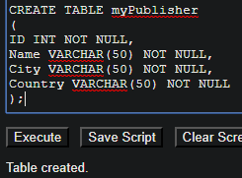

1. Insert 5 rows of data into the table – provide meaningful values for each column.

INSERT INTO myPublisher (ID, Name, City, Country)

VALUES (9002, 'Aaron Lim', 'Murrieta', 'USA');

INSERT INTO myPublisher (ID, Name, City, Country)

VALUES (9003, 'Ted Fares', 'Temecula', 'USA');

INSERT INTO myPublisher (ID, Name, City, Country)

VALUES (9004, 'Samantha Bis', 'Hemet', 'ENG');

INSERT INTO myPublisher (ID, Name, City, Country)

VALUES (9005, 'Beverly Melon', 'Tokyo', 'JAP');

INSERT INTO myPublisher (ID, Name, City, Country)

VALUES (9006, 'Jake Hall', 'Hong Kong', 'CH');

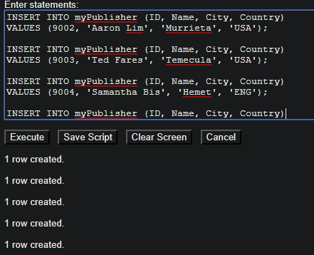

1. Describe the table, and then show all of the rows in the table

DESCRIBE myPublisher

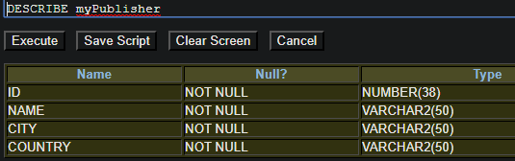

SELECT * FROM myPublisher

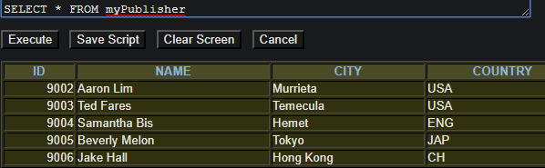

1. Prepare and execute the simple DDL (data definition language) statements for the myAuthor table design described in the following table instance charts. Note: table names and column names should match the specifications, column datatypes need to accommodate the sample data depicted, and the NOT NULL constraints should be implemented.

# myAuthor

|  |  |  |  |  |
| --- | --- | --- | --- | --- |
| Column Name | ID | Full Name | Birthdate | Country |
| Key Type |  |  |  |  |
| Nulls/Unique | Not Null | Not Null | Null | Null |
| Sample Data | 8001 | Bradbury | 22-Jan-1930 | USA |

CREATE TABLE myAuthor

(

ID INT NOT NULL,

Full_Name VARCHAR(50) NOT NULL,

Birthdate DATE,

Country VARCHAR(50)

);

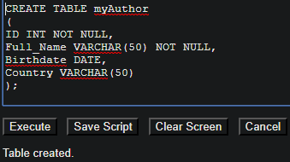

1. Insert 5 rows of data into the table – provide meaningful values for each column.

INSERT INTO myAuthor (ID, Full_Name, Birthdate, Country)

VALUES (8002, 'Stephen King', '21-Jan-1930', 'CH');

INSERT INTO myAuthor (ID, Full_Name, Birthdate, Country)

VALUES (8003, 'Angie Thomas', '28-FEB-1990', 'ENG');

INSERT INTO myAuthor (ID, Full_Name, Birthdate, Country)

VALUES (8004, 'Rachael Lippincott', '20-MAR-1980', 'JAP');

INSERT INTO myAuthor (ID, Full_Name, Birthdate, Country)

VALUES (8005, 'Rachael Lippincott', '25-OCT-1970', 'USA');

INSERT INTO myAuthor (ID, Full_Name, Birthdate, Country)

VALUES (8006, 'Stephen King', '24-DEC-1950', 'USA');

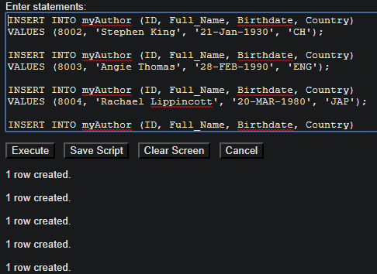

1. Describe the table, and then show all of the rows in the table

DESCRIBE myAuthor

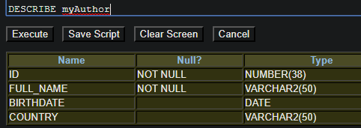

SELECT * FROM myAuthor

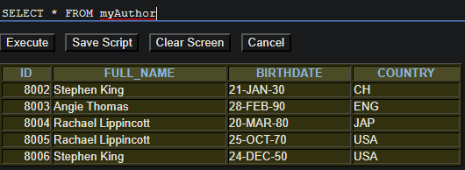

## Use the MySQL server for questions 10 thru 18.

1. Prepare and execute the simple DDL (data definition language) statements for the myBook table design described in the following table instance charts.

# myBook

|  |  |  |  |  |  |
| --- | --- | --- | --- | --- | --- |
| Column Name | ID | Title | Author | Publisher ID | YR Published |
| Key Type |  |  |  |  |  |
| Nulls/Unique | Not Null | Not Null | Not Null | Null | Null |
| Sample Data | 3001 | Fahrenheit 451 | 8001 | 9001 | 1968 |

# Create TABLE myBook

# (

# ID INT NOT NULL,

# Title VARCHAR(50) NOT NULL,

# Author INT NOT NULL,

# Publisher_ID INT,

# YR_Published INT

# );

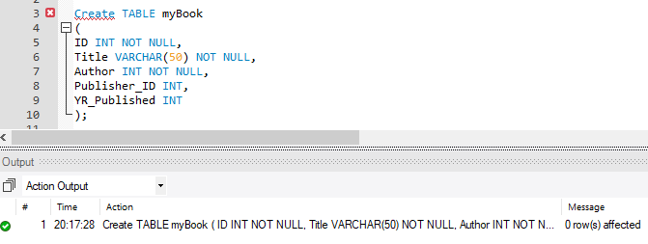

1. Insert 5 rows of data into the table – provide meaningful values for each column.

INSERT INTO myBook (ID, Title, Author, Publisher_ID, YR_Published)

VALUES (3002, 'The Institute: A Novel', 8002, 104, 2019);

INSERT INTO myBook (ID, Title, Author, Publisher_ID, YR_Published)

VALUES (3003, 'The Hate U Give', 8003, 105, 2017);

INSERT INTO myBook (ID, Title, Author, Publisher_ID, YR_Published)

VALUES (3004, 'Five Feet Apart', 8004, 106, 2018);

INSERT INTO myBook (ID, Title, Author, Publisher_ID, YR_Published)

VALUES (3005, 'IT', 8005, 107, 1980);

INSERT INTO myBook (ID, Title, Author, Publisher_ID, YR_Published)

VALUES (3006, 'Wonder', 8006, 108, 2012);

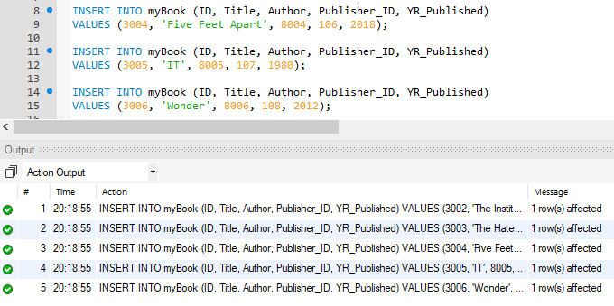

1. Describe the table, and then show all of the rows in the table

DESCRIBE myBook

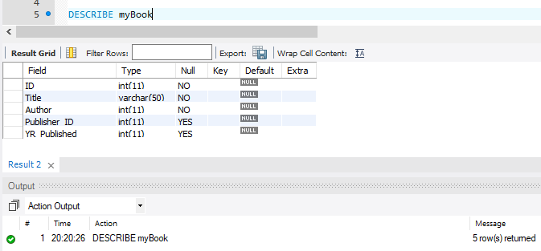

SELECT * FROM myBook

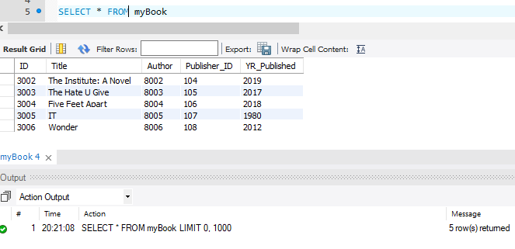

1. Prepare and execute the simple DDL (data definition language) statements for the myPublisher table design described in the following table instance charts.

# myPublisher

|  |  |  |  |  |
| --- | --- | --- | --- | --- |
| Column Name | ID | Name | City | Country |
| Key Type |  |  |  |  |
| Nulls/Unique | Not Null | Not Null | Not Null | Not Null |
| Sample Data | 9001 | Faraday Publishers | Santa Fe | USA |

# CREATE TABLE myPublisher

# (

# ID INT NOT NULL,

# Name VARCHAR(50) NOT NULL,

# City VARCHAR(50) NOT NULL,

# Country VARCHAR(50) NOT NULL

# );

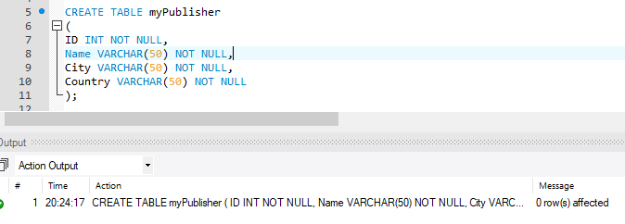

1. Insert 5 rows of data into the table – provide meaningful values for each column.

INSERT INTO myPublisher (ID, Name, City, Country)

VALUES (9002, 'Aaron Lim', 'Murrieta', 'USA');

INSERT INTO myPublisher (ID, Name, City, Country)

VALUES (9003, 'Ted Fares', 'Temecula', 'USA');

INSERT INTO myPublisher (ID, Name, City, Country)

VALUES (9004, 'Samantha Bis', 'Hemet', 'ENG');

INSERT INTO myPublisher (ID, Name, City, Country)

VALUES (9005, 'Beverly Melon', 'Tokyo', 'JAP');

INSERT INTO myPublisher (ID, Name, City, Country)

VALUES (9006, 'Jake Hall', 'Hong Kong', 'CH');

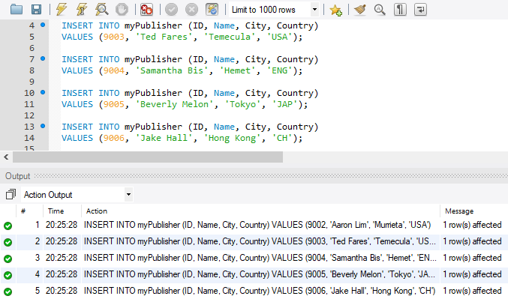

1. Describe the table, and then show all of the rows in the table  
   DESCRIBE myPublisher

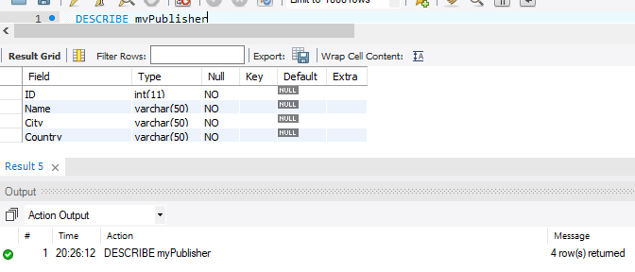

SELECT * FROM myPublisher

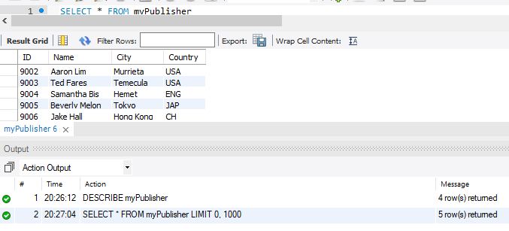

1. Prepare and execute the simple DDL (data definition language) statements for the myAuthor table design described in the following table instance charts.

# myAuthor

|  |  |  |  |  |
| --- | --- | --- | --- | --- |
| Column Name | ID | Full Name | Birthdate | Country |
| Key Type |  |  |  |  |
| Nulls/Unique | Not Null | Not Null | Null | Null |
| Sample Data | 8001 | Bradbury | 22-Jan-1930 | USA |

CREATE TABLE myAuthor

(

ID INT NOT NULL,

Full_Name VARCHAR(50) NOT NULL,

Birthdate DATE,

Country VARCHAR(50)

);

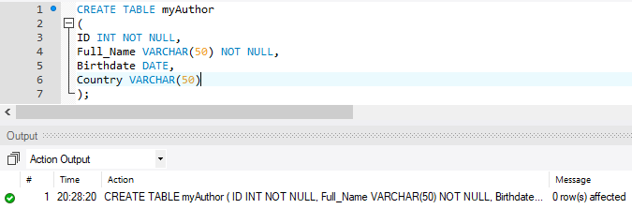

1. Insert 5 rows of data into the table – provide meaningful values for each column.

INSERT INTO myAuthor (ID, Full_Name, Birthdate, Country)

VALUES (8002, 'Stephen King', '1930-01-21', 'CH');

INSERT INTO myAuthor (ID, Full_Name, Birthdate, Country)

VALUES (8003, 'Angie Thomas', '1990-02-28', 'ENG');

INSERT INTO myAuthor (ID, Full_Name, Birthdate, Country)

VALUES (8004, 'Rachael Lippincott', '1980-03-20', 'JAP');

INSERT INTO myAuthor (ID, Full_Name, Birthdate, Country)

VALUES (8005, 'Rachael Lippincott', '1970-10-25', 'USA');

INSERT INTO myAuthor (ID, Full_Name, Birthdate, Country)

VALUES (8006, 'Stephen King', '1950-12-24', 'USA');

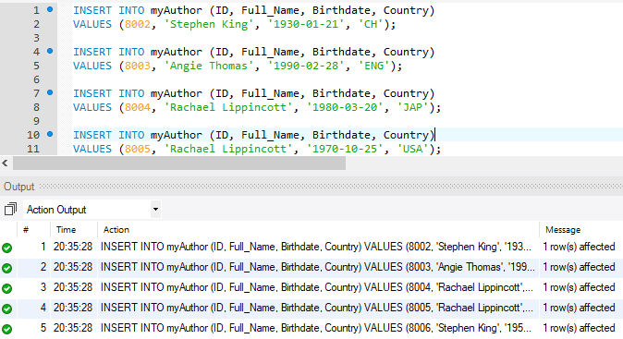

1. Describe the table, and then show all of the rows in the table

DESCRIBE myAuthor

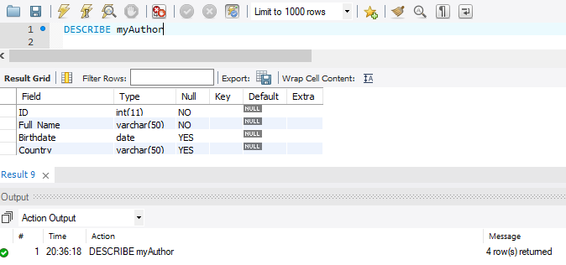

SELECT * FROM myAuthor

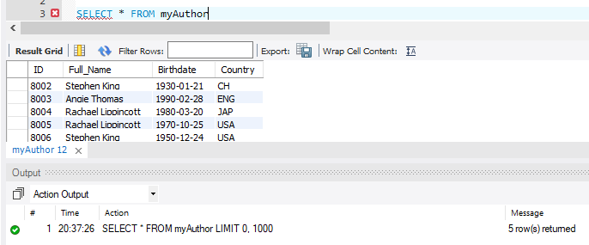

*In the second programming project, you can expect to see problems along these lines:*

*Use the alter table command to define these constraints. Be sure to use meaningful names for the constraints.*

1. *Define Primary Key constraints on each of the tables.*
2. *Define foreign key constraints for each of the FK columns in the Book table.*
3. *Define a check constraint on the YR Published column in the books table to ensure that all books in the database were published in the 1900’s*
4. *Define a check constraint on the birthdate column for the Author table to ensure that if birthdates are provided for an author that the dates fall between 01-Jan-1880 and 01-Jan-1995. (Hint, you may have to use the TO_DATE function)*
5. *Define a check constraint on the country column of the author table to ensure that all authors were born in USA or CANADA or MEXICO.*
6. *Insert at least 3 rows into the Publisher table. Try to insert additional rows (that fail) that test each of the constraints.*
7. *Insert at least 8 rows into the Author table. Try to insert additional rows (that fail) that test each of the constraints.*
8. *Insert 10 rows (for legitimate books) into the Book table. Try to insert additional rows (that fail) that test each of the constraints.*
9. *Show all data in each of the tables.*