*DDL & Views*

In the first programming project you created these tables.

# myBook

|  |  |  |  |  |  |
| --- | --- | --- | --- | --- | --- |
| Column Name | ID | Title | Author | Publisher ID | YR Published |
| Key Type | PK |  | FK | FK |  |
| Nulls/Unique | Not Null | Not Null | Not Null | Null | Null |
| Sample Data | 3001 | Fahrenheit 451 | 8001 | 9001 | 1968 |

# myPublisher

|  |  |  |  |  |
| --- | --- | --- | --- | --- |
| Column Name | ID | Name | City | Country |
| Key Type | PK |  |  |  |
| Nulls/Unique | Not Null | Not Null, Unique | Not Null | Not Null |
| Sample Data | 9001 | Faraday Publishers | Santa Fe | USA |

# myAuthor

|  |  |  |  |  |
| --- | --- | --- | --- | --- |
| Column Name | ID | Full Name | Birthdate | Country |
| Key Type | PK |  |  |  |
| Nulls/Unique | Not Null | Not Null, Unique | Null | Null |
| Sample Data | 8001 | Bradbury | 22-Jan-1930 | USA |

In this programming exercise, I want you to build on the work of the first project. ***For each of these questions, be sure to show the question, your code, and the system response (eg. TABLE CREATED) in your solution***. Before you start, it would be a good idea to delete any existing data in these tables.

## Use the Oracle 9i server for these questions.

1. Define primary key constraints for each of the myBook, myPublisher, and myAuthor tables.

Create TABLE myBook

(

ID INT NOT NULL,

Title VARCHAR(50) NOT NULL,

Author INT NOT NULL,

Publisher_ID INT,

YR_Published INT,

CONSTRAINT bid_pk PRIMARY KEY (ID)

);

CREATE TABLE myPublisher

(

ID INT NOT NULL,

Name VARCHAR(50) NOT NULL,

City VARCHAR(50) NOT NULL,

Country VARCHAR(50) NOT NULL,

CONSTRAINT pid_pk PRIMARY KEY (ID)

);

CREATE TABLE myAuthor

(

ID INT NOT NULL,

Full_Name VARCHAR(50) NOT NULL,

Birthdate DATE,

Country VARCHAR(50),

CONSTRAINT aid_pk PRIMARY KEY (ID)

);

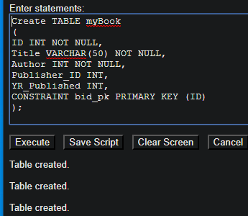

1. Define foreign key constraints for each of the FK columns in the myBook table.

ALTER TABLE myBook

ADD CONSTRAINT fk_afk FOREIGN KEY (Author)

REFERENCES myAuthor(ID);

ALTER TABLE myBook

ADD CONSTRAINT fk_pfk FOREIGN KEY (Publisher_ID)

REFERENCES myPublisher(ID);

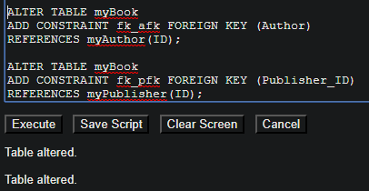

1. Define unique constraints for the myPublisher Name and the myAuthor Full Name columns.

ALTER TABLE myPublisher

ADD CONSTRAINT unique_pname UNIQUE(Name);

ALTER TABLE myAuthor

ADD CONSTRAINT unique_aname UNIQUE(Full_Name);

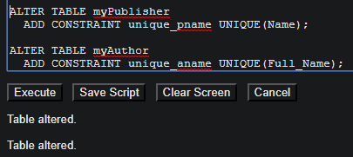

1. Define a check constraint on the YR Published column in the myBook table to ensure that all books in the database were published in the 1900’s

ALTER TABLE myBook

ADD CONSTRAINT check_yr_published

CHECK (YR_Published >= 1990 AND YR_Published <= 2000);

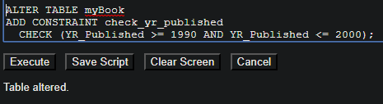

1. Define a check constraint on the birthdate column for the myAuthor table to ensure that if birthdates are provided for an author that the dates fall between 01-Jan-1880 and 01-Jan-1995. (Hint, you may have to use the TO_DATE function)

ALTER TABLE myAuthor

ADD CONSTRAINT check_birthdate

CHECK (Birthdate >= TO_DATE('01-Jan-1880', 'dd-mon-yyyy')

AND Birthdate <= TO_DATE('01-Jan-1995','dd-mon-yyyy'));

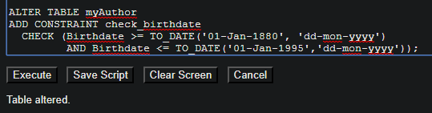

1. Define a check constraint on the country column of the myAuthor table to ensure that all authors were born in USA or CANADA or MEXICO.

ALTER TABLE myAuthor

ADD CONSTRAINT check_country

CHECK (Country = 'USA' OR Country = 'CANADA' OR Country = 'MEXICO')

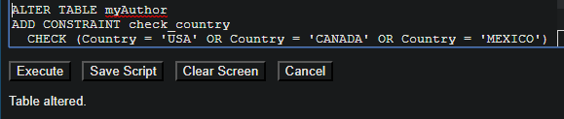

1. Insert at least 3 rows into the myPublisher table.
2. Try to insert a row into the myPublisher table that fails the primary key constraint.
3. Try to insert a row into the myPublisher table that fails the City – Not Null constraint.
4. Try to insert a row into the myPublisher table that fails the name unique constraint.
5. Insert at least 6 rows into the myAuthor table.
6. Try to insert a row into the myAuthor table that fails the birth date check constraint.
7. Try to insert a row into the myAuthor table that fails the country check constraint.
8. Try to insert a row into the myAuthor table that fails the full name unique constraint.
9. Insert 10 rows (for legitimate books) into the myBook table.
10. Try to insert a row into the myBook table that fails the author foreign key constraint.
11. Try to insert a row into the myBook table that fails the publisher foreign key constraint.
12. Show all data in each of the tables.