*DDL & Views*

In the first programming project you created these tables.

# myBook

|  |  |  |  |  |  |
| --- | --- | --- | --- | --- | --- |
| Column Name | ID | Title | Author | Publisher ID | YR Published |
| Key Type | PK |  | FK | FK |  |
| Nulls/Unique | Not Null | Not Null | Not Null | Null | Null |
| Sample Data | 3001 | Fahrenheit 451 | 8001 | 9001 | 1968 |

# myPublisher

|  |  |  |  |  |
| --- | --- | --- | --- | --- |
| Column Name | ID | Name | City | Country |
| Key Type | PK |  |  |  |
| Nulls/Unique | Not Null | Not Null, Unique | Not Null | Not Null |
| Sample Data | 9001 | Faraday Publishers | Santa Fe | USA |

# myAuthor

|  |  |  |  |  |
| --- | --- | --- | --- | --- |
| Column Name | ID | Full Name | Birthdate | Country |
| Key Type | PK |  |  |  |
| Nulls/Unique | Not Null | Not Null, Unique | Null | Null |
| Sample Data | 8001 | Bradbury | 22-Jan-1930 | USA |

In this programming exercise, I want you to build on the work of the first project. ***For each of these questions, be sure to show the question, your code, and the system response (eg. TABLE CREATED) in your solution***. Before you start, it would be a good idea to delete any existing data in these tables.

***Note: This assignment is ‘just like’ Project 2, but for the fact that you’ll be working on the MySQL server instead of the Oracle server.***

## Use the MySQL server for these questions.

1. Define primary key constraints for each of the myBook, myPublisher, and myAuthor tables.

Create TABLE myBook

(

ID INT NOT NULL,

Title VARCHAR(50) NOT NULL,

Author INT NOT NULL,

Publisher_ID INT,

YR_Published INT,

CONSTRAINT bid_pk PRIMARY KEY (ID)

);

CREATE TABLE myPublisher

(

ID INT NOT NULL,

Name VARCHAR(50) NOT NULL,

City VARCHAR(50) NOT NULL,

Country VARCHAR(50) NOT NULL,

CONSTRAINT pid_pk PRIMARY KEY (ID)

);

CREATE TABLE myAuthor

(

ID INT NOT NULL,

Full_Name VARCHAR(50) NOT NULL,

Birthdate DATE,

Country VARCHAR(50),

CONSTRAINT aid_pk PRIMARY KEY (ID)

);

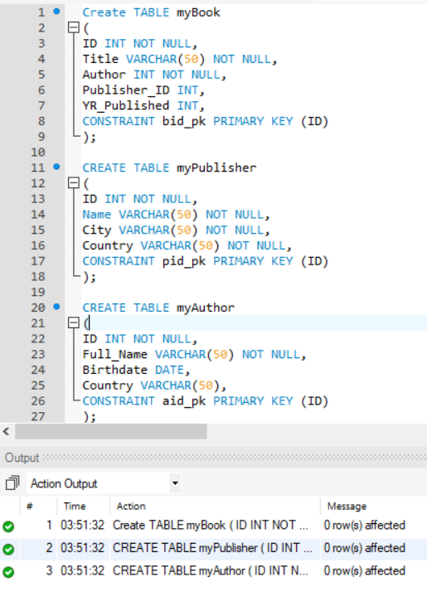

1. Define foreign key constraints for each of the FK columns in the myBook table.

ALTER TABLE myBook

ADD CONSTRAINT fk_afk FOREIGN KEY (Author)

REFERENCES myAuthor(ID);

ALTER TABLE myBook

ADD CONSTRAINT fk_pfk FOREIGN KEY (Publisher_ID)

REFERENCES myPublisher(ID);

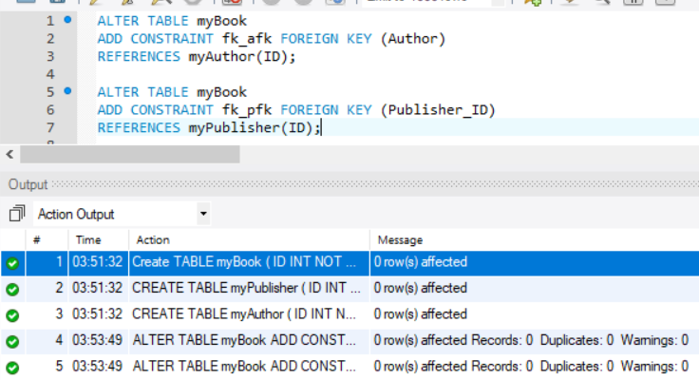

1. Define unique constraints for the name column in the myPublisher table and the full name column in the myAuthor table.

ALTER TABLE myPublisher

ADD CONSTRAINT unique_pname UNIQUE(Name);

ALTER TABLE myAuthor

ADD CONSTRAINT unique_aname UNIQUE(Full_Name);

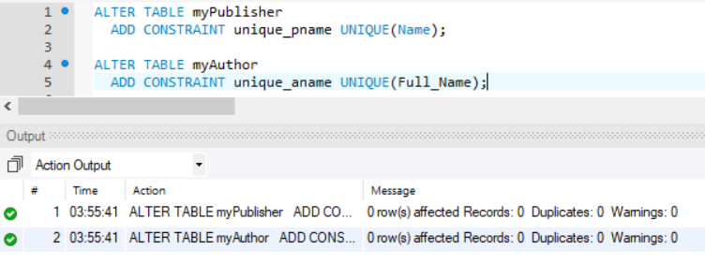

1. Can you define a check constraint on the YR Published column in the books table to ensure that all books in the database were published in the 1900’s?

Yes, I was able to create a check constraint. See below.

ALTER TABLE myBook

ADD CONSTRAINT check_yr_published

CHECK (YR_Published >= 1990 AND YR_Published <= 2000);

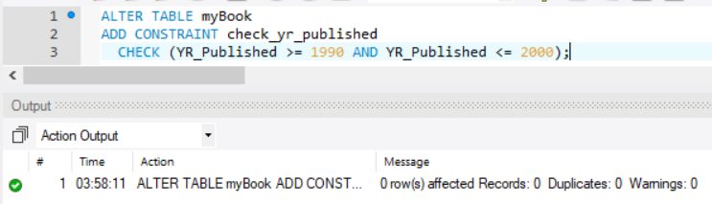

1. Can you define a check constraint on the birthdate column for the Author table to ensure that if birthdates are provided for an author that the dates fall between 01-Jan-1880 and 01-Jan-1995.

ALTER TABLE myAuthor

ADD CONSTRAINT check_birthdate

CHECK (Birthdate >= TO_DATE('01-Jan-1880', 'dd-mon-yyyy')

AND Birthdate <= TO_DATE('01-Jan-1995','dd-mon-yyyy'));

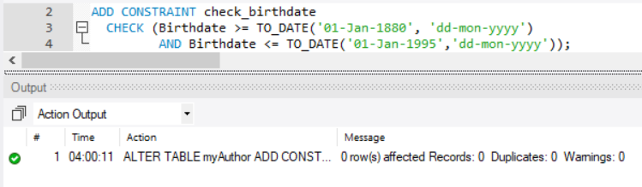

1. Can you define a check constraint on the country column of the author table to ensure that all authors were born in USA or CANADA or MEXICO. **Explain how MySQL supports check constraints**.

MySQL will allow you to create a constraint, but it does NOT support check constraints(They are ignored)

ALTER TABLE myAuthor

ADD CONSTRAINT check_country

CHECK (Country = 'USA' OR Country = 'CANADA' OR Country = 'MEXICO')

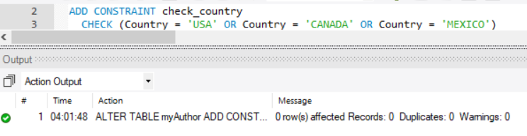

1. Insert at least 3 rows into the myPublisher table.

INSERT INTO myPublisher (ID, Name, City, Country)

VALUES (9002, 'Aaron Lim', 'Murrieta', 'USA');

INSERT INTO myPublisher (ID, Name, City, Country)

VALUES (9003, 'Ted Fares', 'Temecula', 'USA');

INSERT INTO myPublisher (ID, Name, City, Country)

VALUES (9004, 'Samantha Bis', 'Hemet', 'ENG');

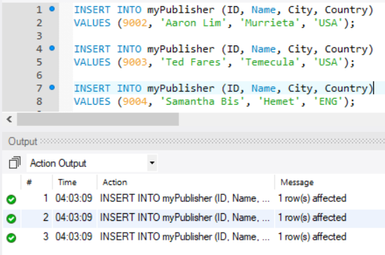

1. Try to insert a row into the myPublisher table that fails the primary key constraint.

INSERT INTO myPublisher (ID, Name, City, Country)

VALUES (9002, 'Duck Dodgers', 'temecula', 'ENG');

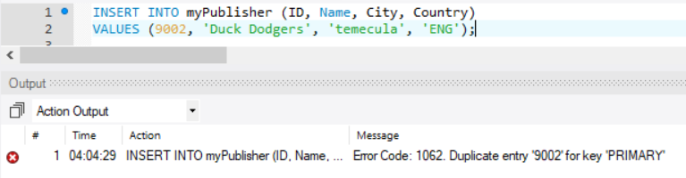

1. Try to insert a row into the myPublisher table that fails the City – Not Null constraint.

INSERT INTO myPublisher (ID, Name, City, Country)

VALUES (9005, 'Duck Dodgers',NULL , 'ENG');

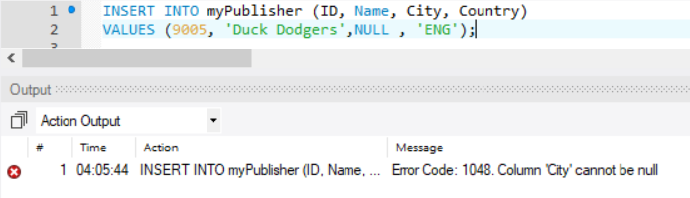

1. Try to insert a row into the myPublisher table that fails the name unique constraint.

INSERT INTO myPublisher (ID, Name, City, Country)

VALUES (9005, 'Aaron Lim','Temecula' , 'ENG');

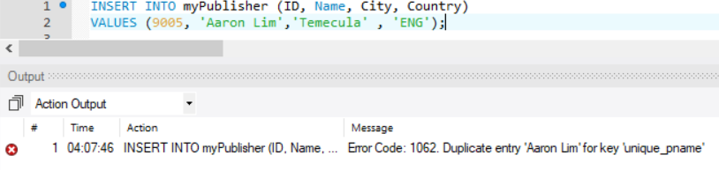

1. Insert at least 8 rows into the myAuthor table.

INSERT INTO myAuthor (ID, Full_Name, Birthdate, Country)

VALUES (8002, 'Steve King', '1930-01-21', 'CANADA');

INSERT INTO myAuthor (ID, Full_Name, Birthdate, Country)

VALUES (8003, 'Angie Thomas', '1990-02-28', 'CANADA');

INSERT INTO myAuthor (ID, Full_Name, Birthdate, Country)

VALUES (8004, 'Rachael Smith', '1980-03-20', 'MEXICO');

INSERT INTO myAuthor (ID, Full_Name, Birthdate, Country)

VALUES (8005, 'Rachael Lippincott', '1970-10-25', 'USA');

INSERT INTO myAuthor (ID, Full_Name, Birthdate, Country)

VALUES (8006, 'Stephen King', '1950-12-24', 'USA');

INSERT INTO myAuthor (ID, Full_Name, Birthdate, Country)

VALUES (8007, 'Author One', '1952-04-28', 'MEXICO');

INSERT INTO myAuthor (ID, Full_Name, Birthdate, Country)

VALUES (8008, 'Author Two', '1950-01-24', 'CANADA');

INSERT INTO myAuthor (ID, Full_Name, Birthdate, Country)

VALUES (8009, 'Author Three', '1952-06-28', 'MEXICO');

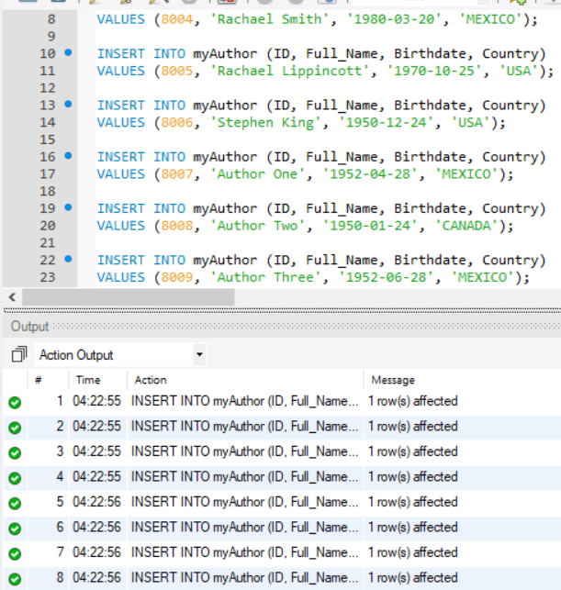

NOTE: If you want to read the date as dd-mon-yyyy, you would just have to use the DATE_FORMAT function when selecting what to read

1. Try to insert a row into the myAuthor table that fails the primary key constraint.

INSERT INTO myAuthor (ID, Full_Name, Birthdate, Country)

VALUES (8002, 'Author FOUR', '1952-07-28', 'CANADA');

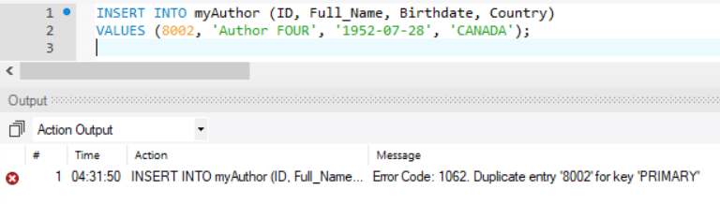

1. Try to insert a row into the myAuthor table that fails the full name unique constraint.

INSERT INTO myAuthor (ID, Full_Name, Birthdate, Country)

VALUES (8010, 'Author THREE', '1952-07-28', 'CANADA');

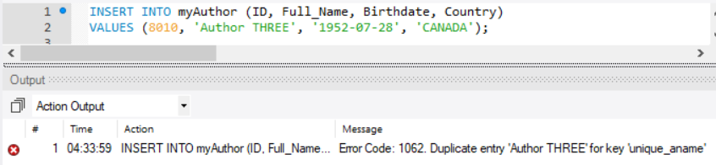

1. Insert 10 rows (for legitimate books) into the myBook table.

INSERT INTO myBook (ID, Title, Author, Publisher_ID, YR_Published)

VALUES (3002, 'The Institute: A Novel', 8002, 9002, 1998);

INSERT INTO myBook (ID, Title, Author, Publisher_ID, YR_Published)

VALUES (3003, 'The Hate U Give', 8003, 9003, 1997);

INSERT INTO myBook (ID, Title, Author, Publisher_ID, YR_Published)

VALUES (3004, 'Five Feet Apart', 8004, 9004, 1996);

INSERT INTO myBook (ID, Title, Author, Publisher_ID, YR_Published)

VALUES (3005, 'IT', 8005, 9002, 1995);

INSERT INTO myBook (ID, Title, Author, Publisher_ID, YR_Published)

VALUES (3006, 'Wonder', 8006, 9003, 1994);

INSERT INTO myBook (ID, Title, Author, Publisher_ID, YR_Published)

VALUES (3007, 'The Institute: A Novel', 8002, 9004, 1993);

INSERT INTO myBook (ID, Title, Author, Publisher_ID, YR_Published)

VALUES (3008, 'The Hate U Give', 8003, 9002, 1992);

INSERT INTO myBook (ID, Title, Author, Publisher_ID, YR_Published)

VALUES (3009, 'Five Feet Apart', 8004, 9003, 2000);

INSERT INTO myBook (ID, Title, Author, Publisher_ID, YR_Published)

VALUES (3010, 'IT', 8005, 9004, 1991);

INSERT INTO myBook (ID, Title, Author, Publisher_ID, YR_Published)

VALUES (3011, 'IT', 8005, 9002, 1990);

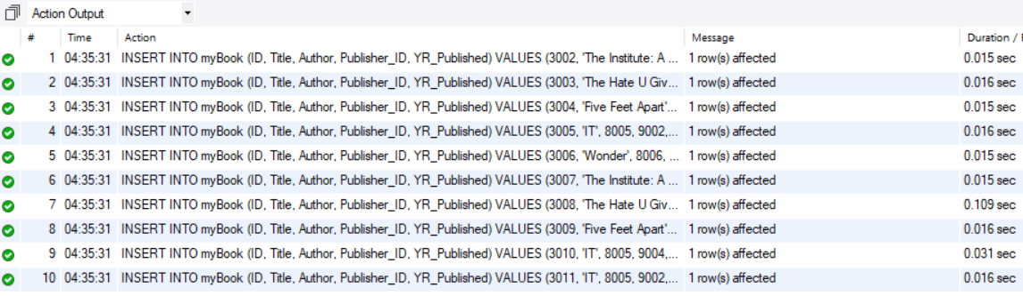

1. Try to insert a row into the myBook table that fails the author foreign key constraint.

INSERT INTO myBook (ID, Title, Author, Publisher_ID, YR_Published)

VALUES (3012, 'Book1', 8001, 9002, 1990);

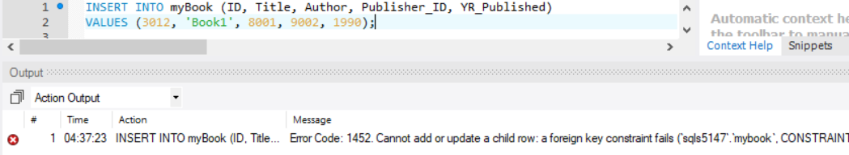

1. Try to insert a row into the myBook table that fails the publisher foreign key constraint.

INSERT INTO myBook (ID, Title, Author, Publisher_ID, YR_Published)

VALUES (3012, 'Book1', 8002, 9005, 1990);

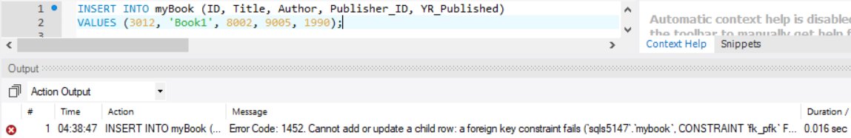

1. Show all data in each of the tables.

Select * FROM myBook;

Select * FROM myPublisher;

Select * FROM myAuthor;



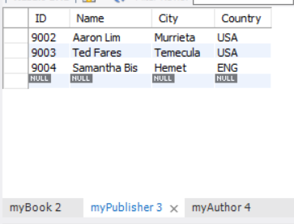

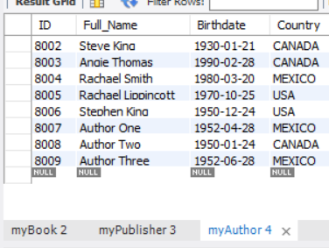

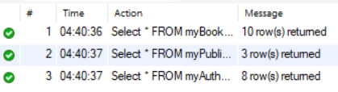

**CONSTRAINTS:**

