SQL Programming – Level 2 Programming Project 04

# Joins – Lunches

Reminder: read the Project Guidelines document for instructions on how to format and submit your assignments. It may also be advisable for you to consider formatting your output in landscape orientation so that you can better accommodate the ‘wider’ result tables that are formed in these join problems. ***In this problem set, use the WHERE clause to form the joins, that is do NOT use the FROM Clause to form any of these joins).***

## Use the Oracle 9i server for questions 1 thru 12.

1. Cross join the suppliers table (L_suppliers) with the foods (L_foods) table. Show all columns. [80 rows]

SELECT * FROM L_suppliers

CROSS JOIN L_foods

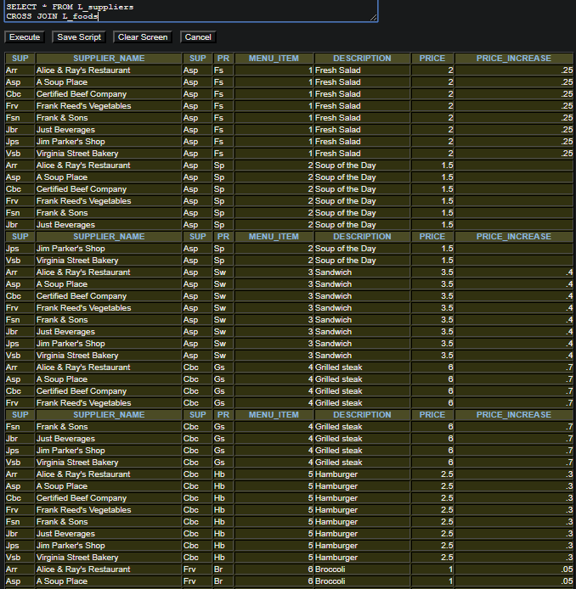

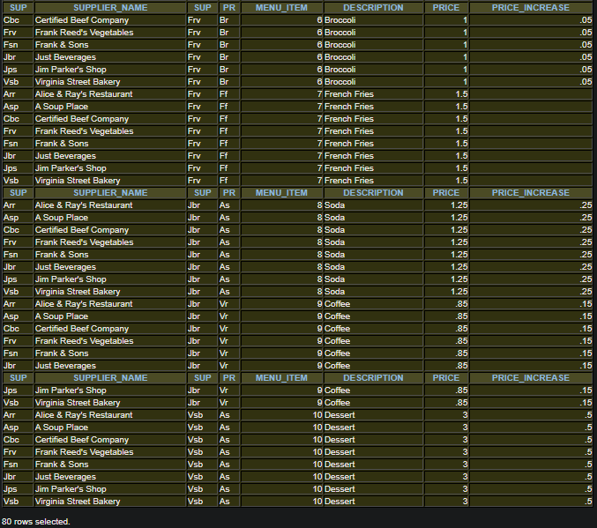

1. Equi join the suppliers table (L_suppliers) with the foods (L_foods) table. Show all columns. [10 rows]

SELECT * FROM L_suppliers, L_foods

WHERE L_suppliers.SUPPLIER_ID = L_foods.SUPPLIER_ID

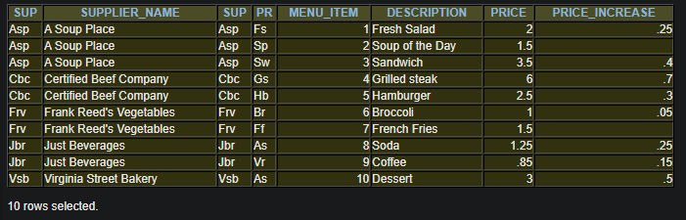

1. Natural join the suppliers table (L_suppliers) with the foods (L_foods) table. Show all columns. [10 rows]

SELECT * FROM L_suppliers

NATURAL JOIN L_foods

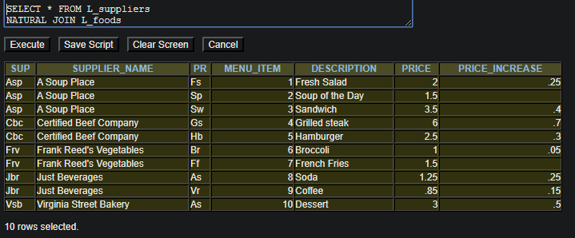

1. Equi join the L-lunch_items table with the L_suppliers table, with the L-foods table. Show these columns in this order: lunch_id, item_number, product code, supplier_id, supplier_name. [71 rows]

SELECT L_lunch_items.LUNCH_ID,

L_lunch_items.ITEM_NUMBER,

L_lunch_items.PRODUCT_CODE,

L_suppliers.SUPPLIER_ID,

L_suppliers.SUPPLIER_ID

FROM L_lunch_items, L_suppliers, L_foods

WHERE L_lunch_items.SUPPLIER_ID = L_suppliers.SUPPLIER_ID

AND L_lunch_items.ITEM_NUMBER = L_foods.MENU_ITEM

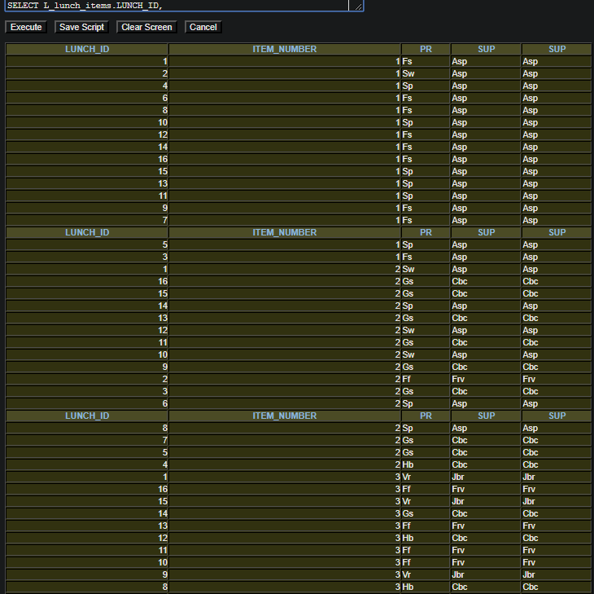

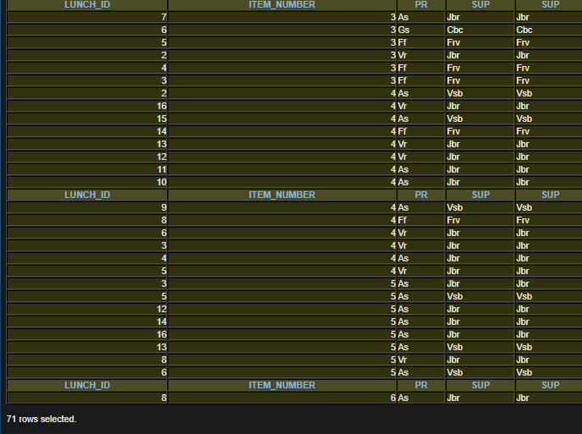

1. Equi join the L_lunches table with the L-lunch_items table with the L_suppliers table, with the L-foods table. Show these columns in this order: employee_id, lunch_id, lunch_date, item_number, product code, supplier_id, supplier_name. Arrange the rows in employee id order. [71 rows]

SELECT L_lunches.EMPLOYEE_ID,

L_lunches.LUNCH_ID,

L_lunches.LUNCH_DATE,

L_lunch_items.ITEM_NUMBER,

L_lunch_items.PRODUCT_CODE,

L_suppliers.SUPPLIER_ID,

L_suppliers.SUPPLIER_NAME

FROM L_lunches, L_lunch_items, L_suppliers, L_foods

WHERE L_lunches.LUNCH_ID = L_lunch_items.LUNCH_ID

AND L_lunch_items.SUPPLIER_ID = L_suppliers.SUPPLIER_ID

AND L_lunch_items.ITEM_NUMBER = L_foods.MENU_ITEM

ORDER BY EMPLOYEE_ID

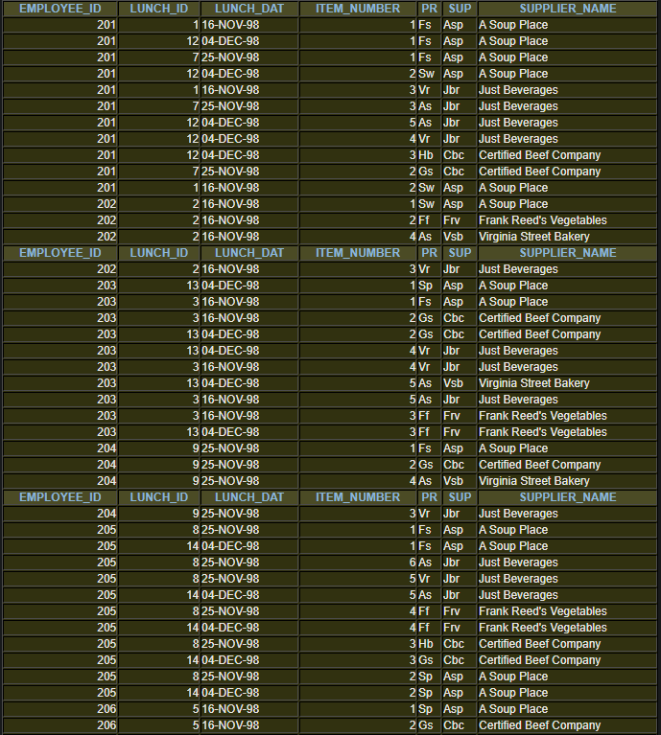

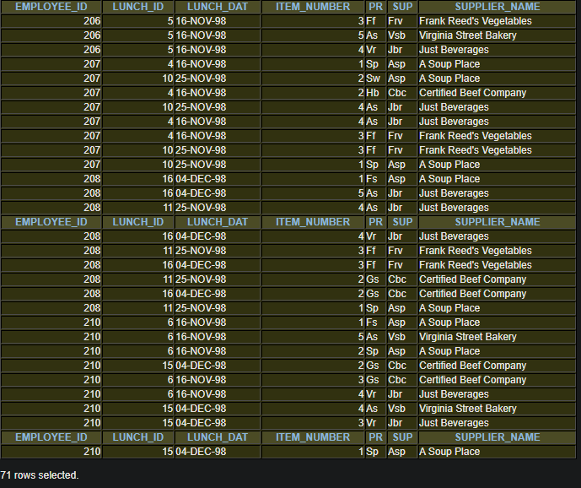

1. Equi join the L-employees table with the L_lunches table with the L-lunch_items table with the L_suppliers table, with the L-foods table. Show these columns in this order: employee_id, employee_name, dept_code, lunch_id, lunch_date, item_number, product code, supplier_id, supplier_name. Arrange the rows in dept_code, employee name order, lunch_date order. [71 rows]

SELECT L_employees.EMPLOYEE_ID,

L_employees.FIRST_NAME,

L_employees.LAST_NAME,

L_employees.DEPT_CODE,

L_lunches.LUNCH_ID,

L_lunches.LUNCH_DATE,

L_lunch_items.ITEM_NUMBER,

L_lunch_items.PRODUCT_CODE,

L_suppliers.SUPPLIER_ID,

L_suppliers.SUPPLIER_NAME

FROM L_employees, L_lunches, L_lunch_items, L_suppliers, L_foods

WHERE L_employees.EMPLOYEE_ID = L_lunches.EMPLOYEE_ID

AND L_lunches.LUNCH_ID = L_lunch_items.LUNCH_ID

AND L_lunch_items.SUPPLIER_ID = L_suppliers.SUPPLIER_ID

AND L_lunch_items.ITEM_NUMBER = L_foods.MENU_ITEM

ORDER BY DEPT_CODE, FIRST_NAME, LAST_NAME, LUNCH_DATE

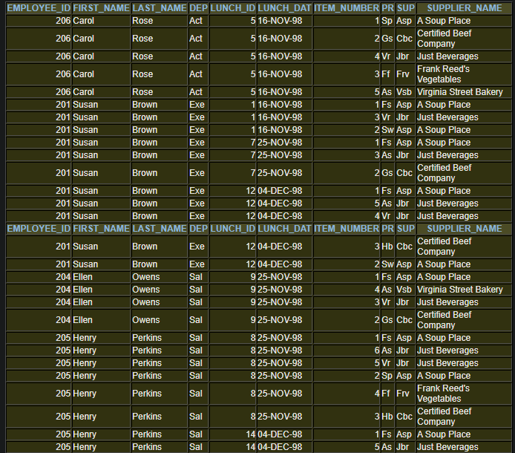

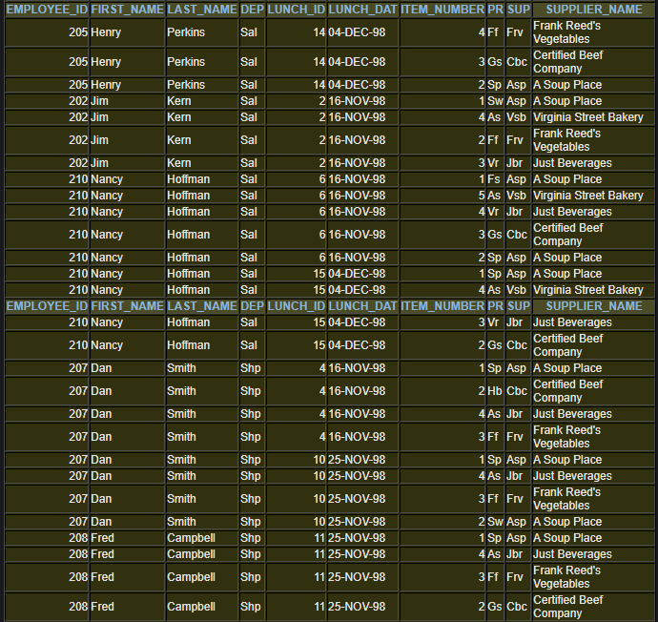

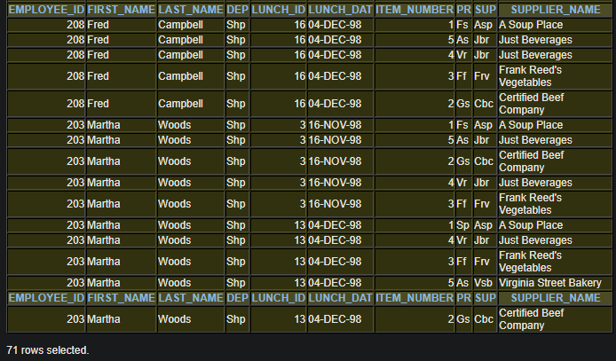

1. Which of our employees, who work in either the Sales or Shipping departments, dined in the cafeteria. Show the employee name, dept code, and each of the dates when they used the cafeteria. [12 rows]

SELECT FIRST_NAME, LAST_NAME, DEPT_CODE, LUNCH_DATE

FROM L_employees, L_lunches

WHERE (DEPT_CODE = 'Sal'

OR DEPT_CODE = 'Shp')

AND L_employees.EMPLOYEE_ID = L_lunches.EMPLOYEE_ID

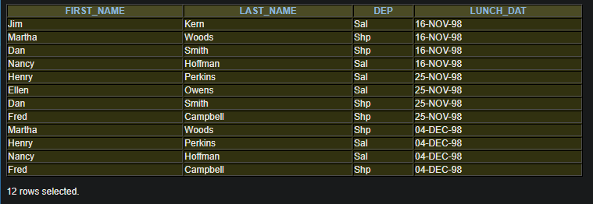

1. Which of our employees ordered coffee with their meal (or ordered coffee as a single item) from the cafeteria. Show the employee_id, name, lunch_id, product code and description. [11 rows]

SELECT L_employees.EMPLOYEE_ID,

L_employees.FIRST_NAME,

L_employees.LAST_NAME,

L_lunches.LUNCH_ID,

L_lunch_items.PRODUCT_CODE,

L_foods.DESCRIPTION

FROM L_employees,L_lunches, L_lunch_items,L_foods

WHERE L_employees.EMPLOYEE_ID = L_lunches.EMPLOYEE_ID

AND L_lunches.LUNCH_ID = L_lunch_items.LUNCH_ID

AND L_lunch_items.PRODUCT_CODE = L_foods.PRODUCT_CODE

AND L_foods.PRODUCT_CODE = 'Vr'

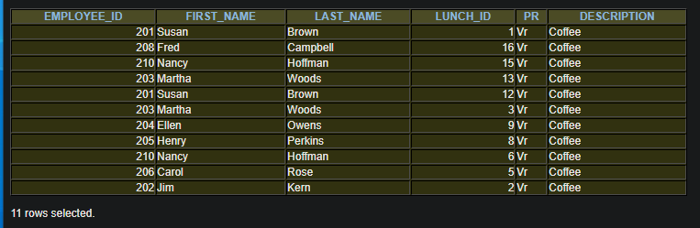

1. Equi join the l_employees table with the l_employees table. This is a recursive join that links employees with their managers. Show the workers employee_id, first_name, and last_name, along with the manager’s employee_id, first-name, and last_name. [11 rows]

SELECT e.EMPLOYEE_ID,

e.FIRST_NAME,

e.LAST_NAME,

m.EMPLOYEE_ID,

m.FIRST_NAME,

m.LAST_NAME

FROM L_employees e, L_employees m

WHERE m.EMPLOYEE_ID = e.MANAGER_ID

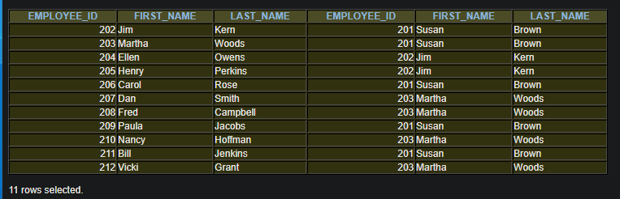

1. Same as the previous question, but be sure that every employee is included in the report. [12 rows]

SELECT e.EMPLOYEE_ID,

e.FIRST_NAME,

e.LAST_NAME,

m.EMPLOYEE_ID,

m.FIRST_NAME,

m.LAST_NAME

FROM L_employees e, L_employees m

WHERE m.EMPLOYEE_ID(+) = e.MANAGER_ID

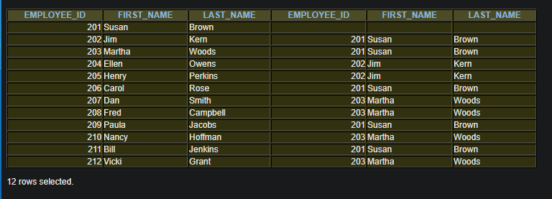

1. Prepare a report showing employee id and name information, along with their manager’s id and name information, for those employees whose manager works in the same department as they do. [4 rows]

SELECT e.EMPLOYEE_ID,

e.FIRST_NAME,

e.LAST_NAME,

m.EMPLOYEE_ID,

m.FIRST_NAME,

m.LAST_NAME

FROM L_employees e, L_employees m

WHERE m.EMPLOYEE_ID = e.MANAGER_ID

AND e.DEPT_CODE = m.DEPT_CODE

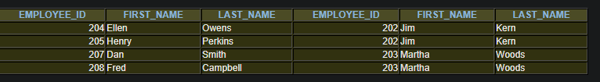

1. Prepare a report showing employee id and name information, along with their manager’s id and name information, but only show this information for those employees whose manager does NOT work in the same department as they do. [7 rows]

SELECT e.EMPLOYEE_ID,

e.FIRST_NAME,

e.LAST_NAME,

m.EMPLOYEE_ID,

m.FIRST_NAME,

m.LAST_NAME

FROM L_employees e, L_employees m

WHERE m.EMPLOYEE_ID = e.MANAGER_ID

AND e.DEPT_CODE <> m.DEPT_CODE

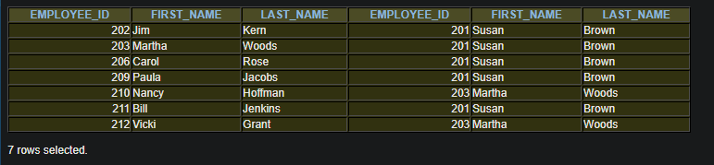

## Use the MySQL server for questions 13 thru 15.

1. Which of our employees, who work in either the Sales or Shipping departments, dined in the cafeteria. Show the employee name, dept code, and each of the dates when they used the cafeteria. [12 rows]

SELECT FIRST_NAME, LAST_NAME, DEPT_CODE, LUNCH_DATE

FROM L_employees, L_lunches

WHERE (DEPT_CODE = 'Sal'

OR DEPT_CODE = 'Shp')

AND L_employees.EMPLOYEE_ID = L_lunches.EMPLOYEE_ID

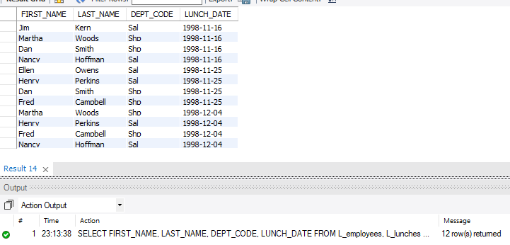

1. Which of our employees ordered coffee with their meal (or ordered coffee as a single item) from the cafeteria. Show the employee_id, name, lunch_id, product code and description. [11 rows]

SELECT L_employees.EMPLOYEE_ID,

L_employees.FIRST_NAME,

L_employees.LAST_NAME,

L_lunches.LUNCH_ID,

L_lunch_items.PRODUCT_CODE,

L_foods.DESCRIPTION

FROM L_employees,L_lunches, L_lunch_items,L_foods

WHERE L_employees.EMPLOYEE_ID = L_lunches.EMPLOYEE_ID

AND L_lunches.LUNCH_ID = L_lunch_items.LUNCH_ID

AND L_lunch_items.PRODUCT_CODE = L_foods.PRODUCT_CODE

AND L_foods.PRODUCT_CODE = 'Vr'

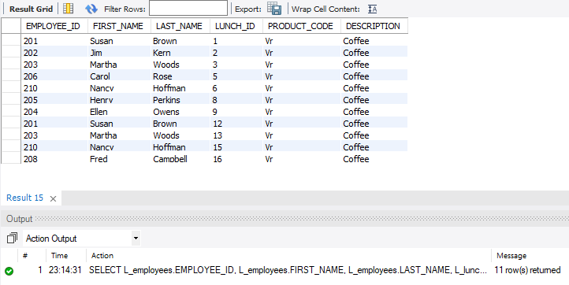

1. Equi join the l_employees table with the l_employees table. This is a recursive join that links employees with their managers. Show the workers employee_id, first_name, and last_name, along with the manager’s employee_id, first-name, and last_name. [11 rows]

SELECT e.EMPLOYEE_ID,

e.FIRST_NAME,

e.LAST_NAME,

m.EMPLOYEE_ID,

m.FIRST_NAME,

m.LAST_NAME

FROM L_employees e, L_employees m

WHERE m.EMPLOYEE_ID = e.MANAGER_ID

