SQL Programming – Level 2 Programming Project 05

# Joins - Books

Reminder: read the Project Guidelines document for instructions on how to format and submit your assignments. It may also be advisable for you to consider formatting your output in landscape orientation so that you can better accommodate the ‘wider’ result tables that are formed in these join problems. ***In this problem set, use the WHERE clause to form the equi-joins***. It would also be a good idea to prepare a diagram (ER Model) of the books database before you begin these problems – it’s important to see how the written by table factors in to the model.

## Use the Oracle 9i server for questions 1 thru 7.

1. List the book(id, title, and cost) and author(id, name) info for all books in the collection. [42 rows]

SELECT book.ID,book.TITLE,book.COST,author.ID,author.NAME

FROM book,author, writtenby

WHERE book.ID = writtenby.bookID

AND author.iD = writtenby.authorID

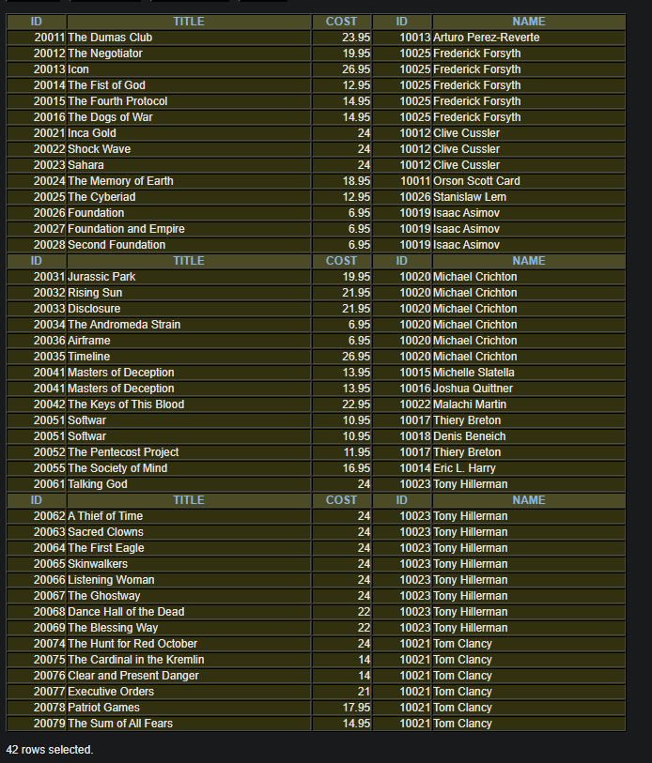

1. List the book(id, title, and cost) and author(id, name) info for all books in the collection, that cost less than $10. [5 rows]

SELECT book.ID,book.TITLE,book.COST,author.ID,author.NAME

FROM book,author, writtenby

WHERE book.ID = writtenby.bookID

AND author.iD = writtenby.authorID

AND book.COST < 10

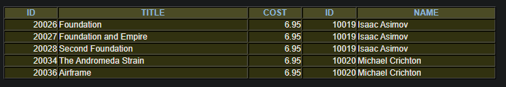

1. List the book(id, title, and cost) and author(id, name) info for all books in the collection, that cost more than the average book cost. [23 rows]

SELECT book.ID,book.TITLE,book.COST,author.ID,author.NAME

FROM book,author, writtenby

WHERE book.ID = writtenby.bookID

AND author.iD = writtenby.authorID

AND book.COST > ( SELECT AVG(COST) FROM book)

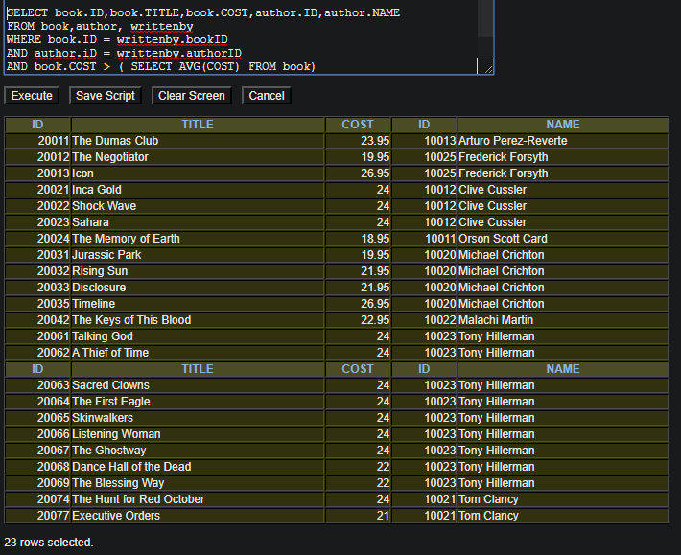

1. List the book(id, title, and cost) and author(id, name) info for all books in the collection, that cost between $13 and the average book cost. [9 rows]

SELECT book.ID,book.TITLE,book.COST,author.ID,author.NAME

FROM book,author, writtenby

WHERE book.ID = writtenby.bookID

AND author.iD = writtenby.authorID

AND book.COST BETWEEN 13 AND ( SELECT AVG(COST) FROM book)

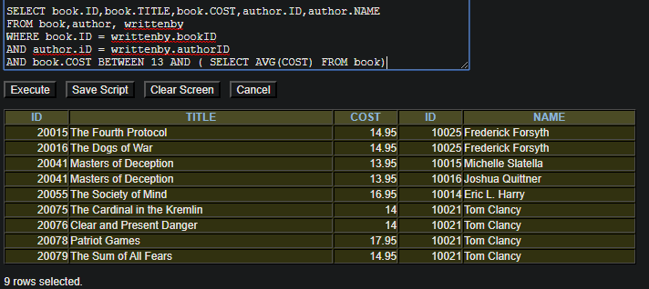

1. List the book(id, title, and cost) and author(id, name) info for all books in the collection, that don't reside at HOME. [4 rows]

SELECT book.ID,book.TITLE,book.COST,author.ID,author.NAME

FROM book,author, writtenby

WHERE book.ID = writtenby.bookID

AND author.iD = writtenby.authorID

AND book.LOCATION <> 'HOME'

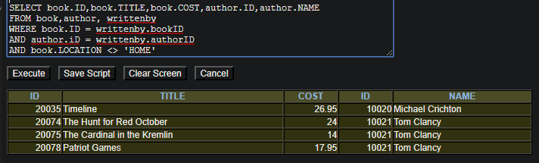

1. List the book(id, title, and cost) and author(id, name) and publisher(id, name) info for all books in the collection. [42 rows]

SELECT book.ID,book.TITLE,book.COST,

author.ID,author.NAME,

publisher.ID, publisher.NAME

FROM book,author, publisher, writtenby

WHERE book.ID = writtenby.bookID

AND author.iD = writtenby.authorID

AND book.PUBLID = publisher.ID

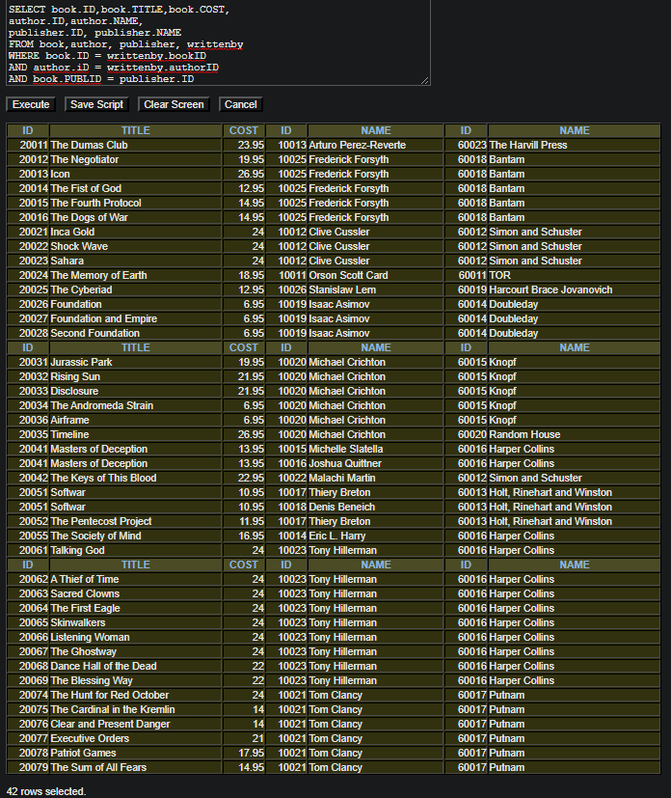

1. List the book(id, title, and cost) and author(id, name) and publisher(id, name) info for all books in the collection, written by an author whose last name starts with a letter in the first half of the alphabet (ie. A -> M). [39 rows]

SELECT book.ID,book.TITLE,book.COST,

author.ID,author.NAME,

publisher.ID, publisher.NAME

FROM book,author, publisher, writtenby

WHERE book.ID = writtenby.bookID

AND author.iD = writtenby.authorID

AND book.PUBLID = publisher.ID

AND author.LASTNAME >= 'A'

AND author.LASTNAME < 'N'

ORDER BY LASTNAME

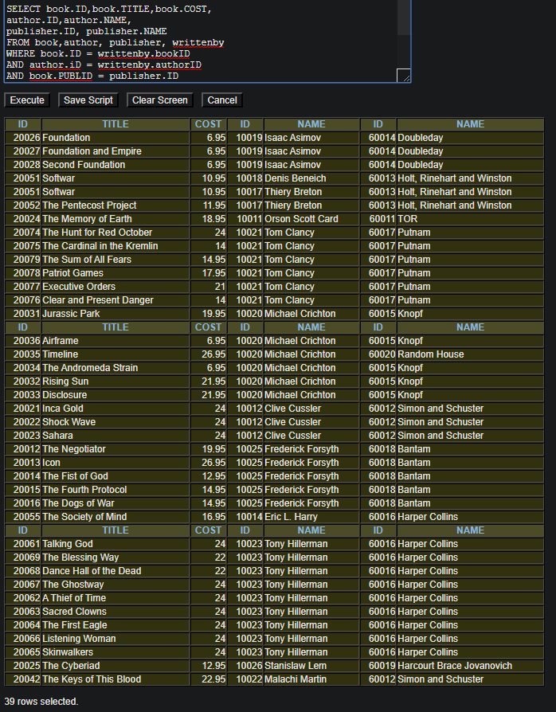

NOTE* unsure if this is correct, if I did AND author.LASTNAME <= 'M' I would only generate 38 rows, but saying < N produces the desired amount of rows. Professors, can you please explain?

## Use the Oracle 10g server for questions 8 thru 11.

1. List the book(id, title, and cost) and author(id, name) and publisher(id, name) info for all books in the collection, written by an author whose name includes a double vowel sequence. In your solution, I want you to use a regular expression to identify the double vowel sequence (eg., ‘ie’, ‘oo’, ‘ai’, … Note: there are 5 * 5 = 25 possible double vowel sequences in English).

SELECT book.ID,book.TITLE,book.COST,

author.ID,author.NAME,

publisher.ID, publisher.NAME

FROM book,author, publisher, writtenby

WHERE book.ID = writtenby.bookID

AND author.iD = writtenby.authorID

AND book.PUBLID = publisher.ID

AND regexp_like (author.NAME,'[aeiou]{2}')

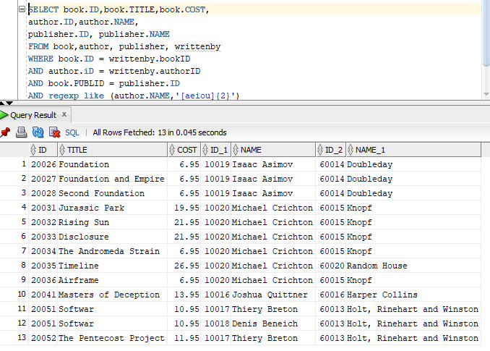

1. List the book(id, title, and cost) and author(id, name) and publisher(id, name) info for all books in the collection, with a copyright year older than your instructor (ie. before 1975 :-). [4 rows]

SELECT book.ID,book.TITLE,book.COST,

author.ID,author.NAME,

publisher.ID, publisher.NAME

FROM book,author, publisher, writtenby

WHERE book.ID = writtenby.bookID

AND author.iD = writtenby.authorID

AND book.PUBLID = publisher.ID

AND book.COPYYEAR < 1975

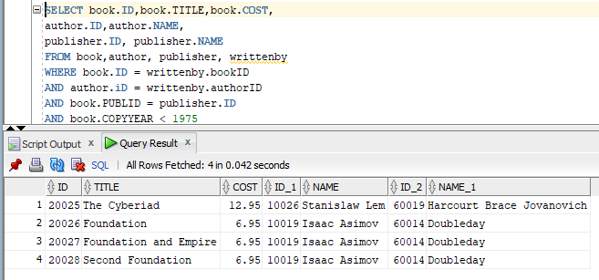

1. How many books are there in the collection?

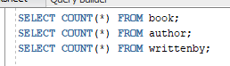

SELECT COUNT(*) FROM book;

How many authors are there?



SELECT COUNT(*) FROM author;

How many writtenby rows are there?



SELECT COUNT(*) FROM writtenby;

Explain the discrepancy between these counts.



The values are all different, meaning there is most likely books by the same author/publisher OR some authors or have different publishers/books, or publishers with different authors/books.

1. List the book(id, title, and cost) and author(id, name) and publisher(id, name) info for all coauthored books in the collection. (2 pts). [4 rows]

SELECT book.ID,book.TITLE,book.COST,

author.ID,author.NAME,

publisher.ID, publisher.NAME

FROM book,author, publisher, writtenby

WHERE book.ID = writtenby.bookID

AND author.iD = writtenby.authorID

AND book.PUBLID = publisher.ID

AND book.ID IN (SELECT bookID

FROM writtenby

GROUP BY bookID

HAVING COUNT(*) > 1)

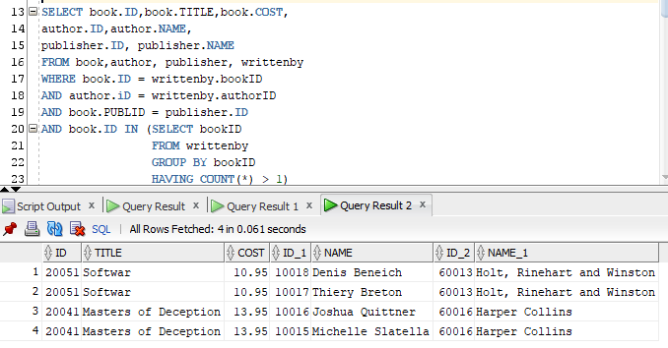

## Use the MySQL server for the remaining questions.

1. List the book(id, title, and cost) and author(id, name) info for all books in the collection, that cost more than the average book price, but less than $23. [9 rows]

SELECT book.ID,book.TITLE,book.COST,author.ID,author.NAME

FROM book,author, writtenby

WHERE book.ID = writtenby.bookID

AND author.iD = writtenby.authorID

AND book.COST > ( SELECT AVG(COST) FROM book)

AND book.COST < 23

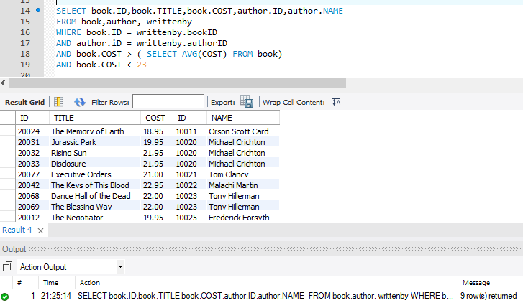

1. List the book(id, title, and cost) and author(id, name) info for all books in the collection, that were writtenby an author whose last name starts with the letter ‘C’. [16 rows]

SELECT book.ID,book.TITLE,book.COST,

author.ID,author.NAME,

publisher.ID, publisher.NAME

FROM book,author, publisher, writtenby

WHERE book.ID = writtenby.bookID

AND author.iD = writtenby.authorID

AND book.PUBLID = publisher.ID

AND author.LASTNAME LIKE 'C%'

