SQL Programming – Level 2 Programming Project 06

# Joins – Lunches

Reminder: read the Project Guidelines document for instructions on how to format and submit your assignments. It may also be advisable for you to consider formatting your output in landscape orientation so that you can better accommodate the ‘wider’ result tables that are formed in these join problems. ***In this problem set, use the FROM clause to form the join.***

## Use the Oracle 9i server for questions 1 thru 12.

1. Cross join the suppliers table (L_suppliers) with the foods (L_foods) table. Show all columns. [80 rows]

SELECT * FROM L_suppliers

CROSS JOIN L_foods

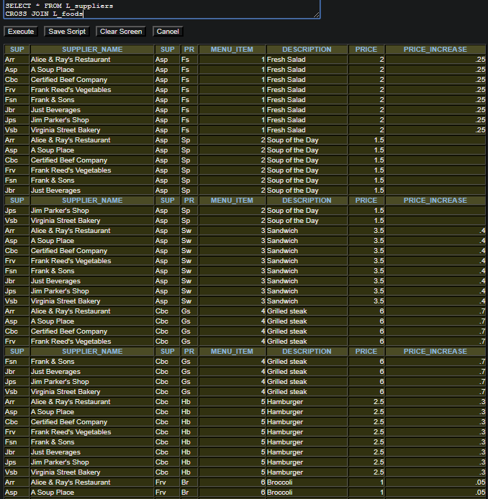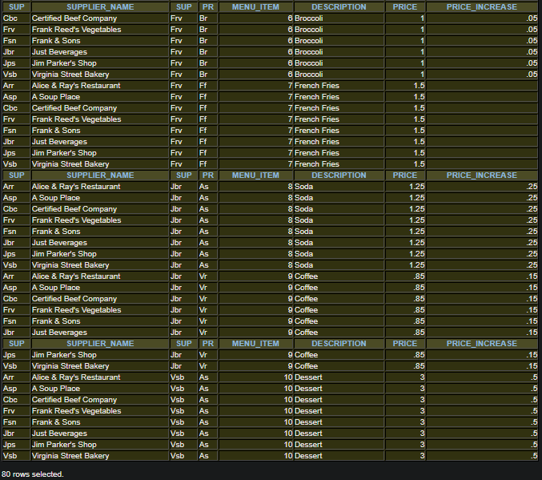

1. Equi join the suppliers table (L_suppliers) with the foods (L_foods) table. Show all columns. [10 rows]

SELECT * FROM L_suppliers

JOIN L_foods

ON L_suppliers.SUPPLIER_ID = L_foods.SUPPLIER_ID

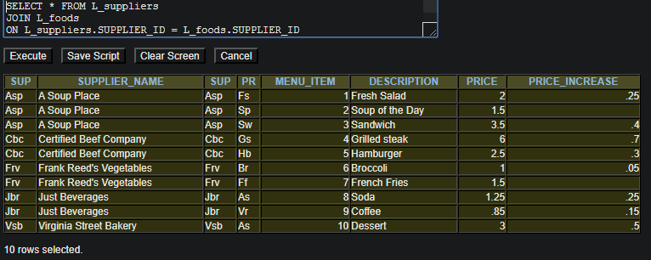

1. Natural join the suppliers table (L_suppliers) with the foods (L_foods) table. Show all columns. [10 rows]

SELECT * FROM L_suppliers

NATURAL JOIN L_foods

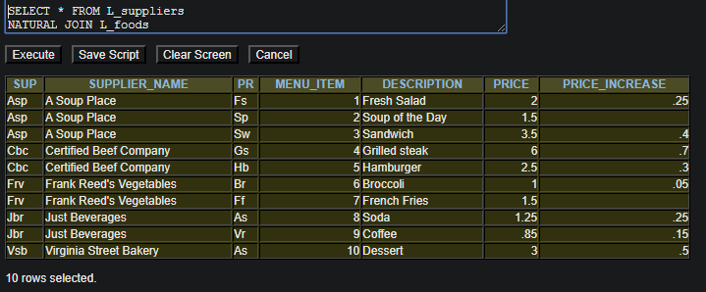

1. Equi join the L-lunch_items table with the L_suppliers table, with the L-foods table. Show these columns in this order: lunch_id, item_number, product code, supplier_id, supplier_name. [71 rows]

SELECT L_lunch_items.LUNCH_ID,

L_lunch_items.ITEM_NUMBER,

L_lunch_items.PRODUCT_CODE,

L_suppliers.SUPPLIER_ID,

L_suppliers.SUPPLIER_ID

FROM L_lunch_items

JOIN L_suppliers

ON L_lunch_items.SUPPLIER_ID = L_suppliers.SUPPLIER_ID

JOIN L_foods

ON L_lunch_items.ITEM_NUMBER = L_foods.MENU_ITEM

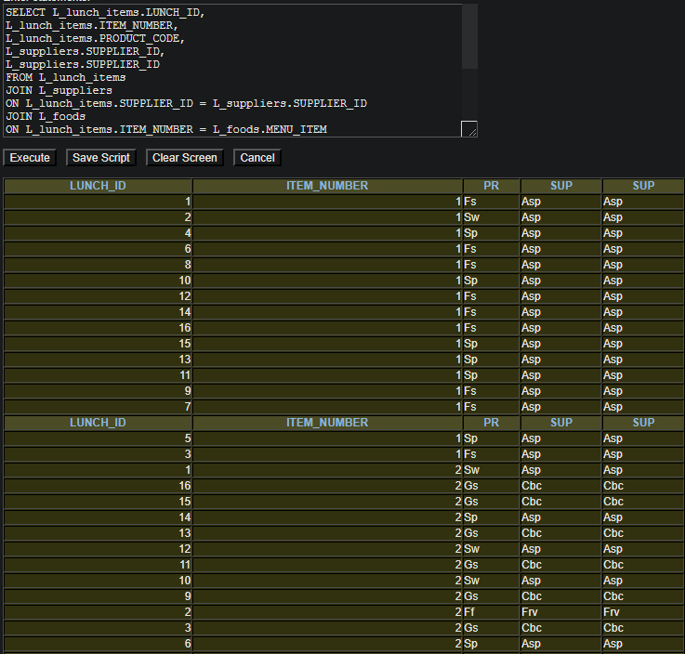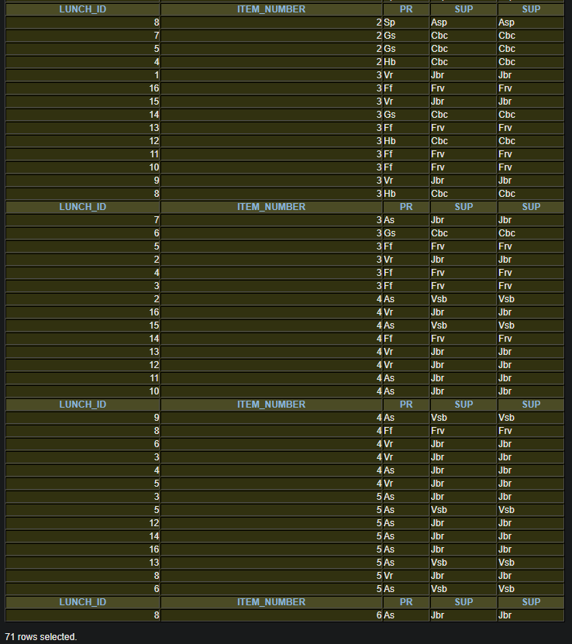

1. Equi join the L_lunches table with the L-lunch_items table with the L_suppliers table, with the L-foods table. Show these columns in this order: employee_id, lunch_id, lunch_date, item_number, product code, supplier_id, supplier_name. Arrange the rows in employee id order. [71 rows]

SELECT L_lunches.EMPLOYEE_ID,

L_lunches.LUNCH_ID,

L_lunches.LUNCH_DATE,

L_lunch_items.ITEM_NUMBER,

L_lunch_items.PRODUCT_CODE,

L_suppliers.SUPPLIER_ID,

L_suppliers.SUPPLIER_NAME

FROM L_lunches

JOIN L_lunch_items

ON L_lunches.LUNCH_ID = L_lunch_items.LUNCH_ID

JOIN L_suppliers

ON L_lunch_items.SUPPLIER_ID = L_suppliers.SUPPLIER_ID

JOIN L_foods

ON L_lunch_items.ITEM_NUMBER = L_foods.MENU_ITEM

ORDER BY EMPLOYEE_ID

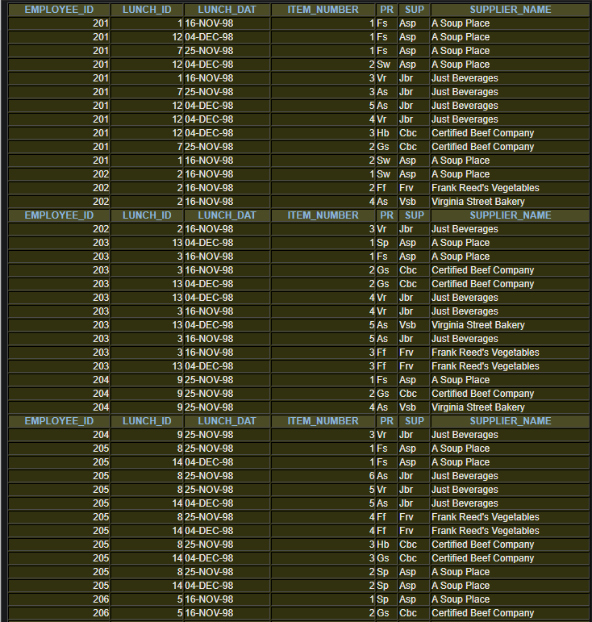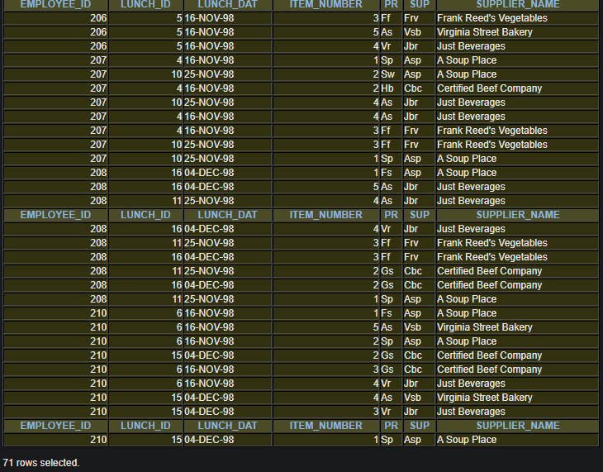

1. Equi join the L-employees table with the L_lunches table with the L-lunch_items table with the L_suppliers table, with the L-foods table. Show these columns in this order: employee_id, employee_name, dept_code, lunch_id, lunch_date, item_number, product code, supplier_id, supplier_name. Arrange the rows in dept_code, employee name order, lunch_date order. [71 rows]

SELECT L_employees.EMPLOYEE_ID,

L_employees.FIRST_NAME,

L_employees.LAST_NAME,

L_employees.DEPT_CODE,

L_lunches.LUNCH_ID,

L_lunches.LUNCH_DATE,

L_lunch_items.ITEM_NUMBER,

L_lunch_items.PRODUCT_CODE,

L_suppliers.SUPPLIER_ID,

L_suppliers.SUPPLIER_NAME

FROM L_employees

JOIN L_lunches

ON L_employees.EMPLOYEE_ID = L_lunches.EMPLOYEE_ID

JOIN L_lunch_items

ON L_lunches.LUNCH_ID = L_lunch_items.LUNCH_ID

JOIN L_suppliers

ON L_lunch_items.SUPPLIER_ID = L_suppliers.SUPPLIER_ID

JOIN L_foods

ON L_lunch_items.ITEM_NUMBER = L_foods.MENU_ITEM

ORDER BY DEPT_CODE, FIRST_NAME, LAST_NAME, LUNCH_DATE

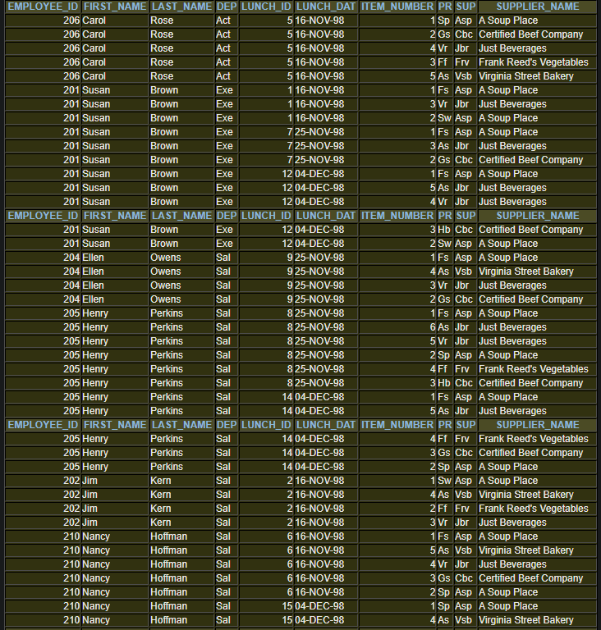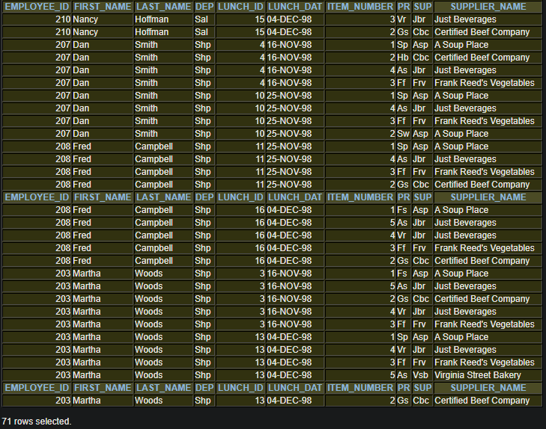

1. Which of our employees, who work in either the Sales or Shipping departments, dined in the cafeteria. Show the employee name, dept code, and each of the dates when they used the cafeteria. [12 rows]

SELECT FIRST_NAME, LAST_NAME, DEPT_CODE, LUNCH_DATE

FROM L_employees

JOIN L_lunches

ON L_employees.EMPLOYEE_ID = L_lunches.EMPLOYEE_ID

AND (DEPT_CODE = 'Sal'

OR DEPT_CODE = 'Shp')

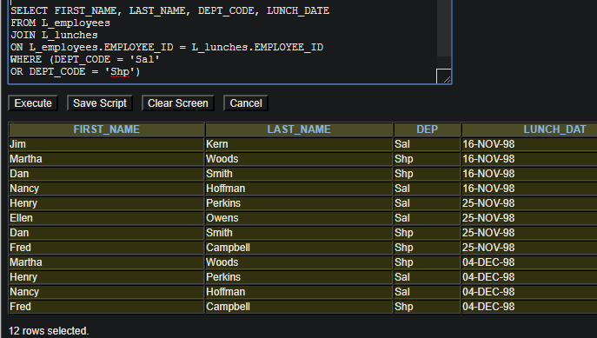

1. Which of our employees ordered coffee with their meal (or ordered coffee as a single item) from the cafeteria. Show the employee_id, name, lunch_id, product code and description. [11 rows]

SELECT L_employees.EMPLOYEE_ID,

L_employees.FIRST_NAME,

L_employees.LAST_NAME,

L_lunches.LUNCH_ID,

L_lunch_items.PRODUCT_CODE,

L_foods.DESCRIPTION

FROM L_employees

JOIN L_lunches

ON L_employees.EMPLOYEE_ID = L_lunches.EMPLOYEE_ID

JOIN L_lunch_items

ON L_lunches.LUNCH_ID = L_lunch_items.LUNCH_ID

JOIN L_foods

ON L_lunch_items.PRODUCT_CODE = L_foods.PRODUCT_CODE

AND L_foods.PRODUCT_CODE = 'Vr'

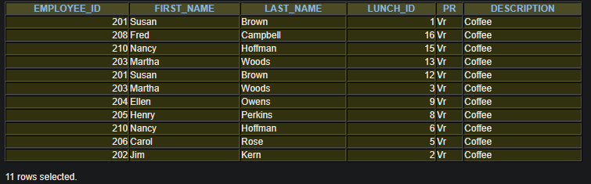

1. Equi join the l_employees table with the l_employees table. This is a recursive join that links employees with their managers. Show the workers employee_id, first_name, and last_name, along with the manager’s employee_id, first-name, and last_name.[11 rows]

SELECT e.EMPLOYEE_ID,

e.FIRST_NAME,

e.LAST_NAME,

m.EMPLOYEE_ID,

m.FIRST_NAME,

m.LAST_NAME

FROM L_employees e

JOIN L_employees m

ON m.EMPLOYEE_ID = e.MANAGER_ID

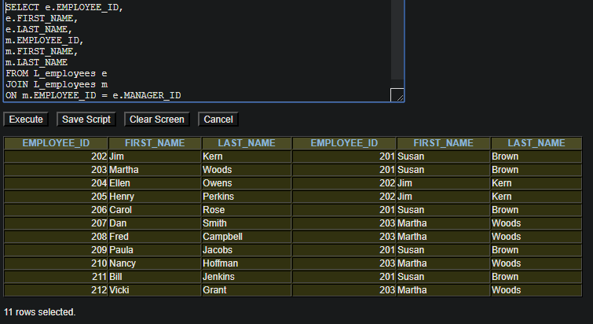

1. Same as the previous question, but be sure that every employee is included in the report. [12 rows]

SELECT e.EMPLOYEE_ID,

e.FIRST_NAME,

e.LAST_NAME,

m.EMPLOYEE_ID,

m.FIRST_NAME,

m.LAST_NAME

FROM L_employees e

JOIN L_employees m

ON m.EMPLOYEE_ID(+) = e.MANAGER_ID

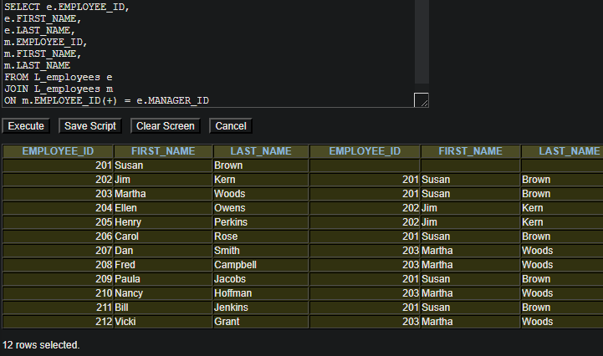

1. Prepare a report showing employee id and name information, along with their manager’s id and name information, for those employees whose manager works in the same department as they do. [4 rows]

SELECT e.EMPLOYEE_ID,

e.FIRST_NAME,

e.LAST_NAME,

m.EMPLOYEE_ID,

m.FIRST_NAME,

m.LAST_NAME

FROM L_employees e

JOIN L_employees m

ON m.EMPLOYEE_ID = e.MANAGER_ID

AND e.DEPT_CODE = m.DEPT_CODE

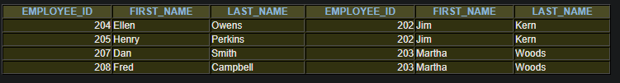

1. Prepare a report showing employee id and name information, along with their manager’s id and name information, but only show this information for those employees whose manager does NOT work in the same department as they do. [7 rows]

SELECT e.EMPLOYEE_ID,

e.FIRST_NAME,

e.LAST_NAME,

m.EMPLOYEE_ID,

m.FIRST_NAME,

m.LAST_NAME

FROM L_employees e

JOIN L_employees m

ON m.EMPLOYEE_ID = e.MANAGER_ID

AND e.DEPT_CODE <> m.DEPT_CODE

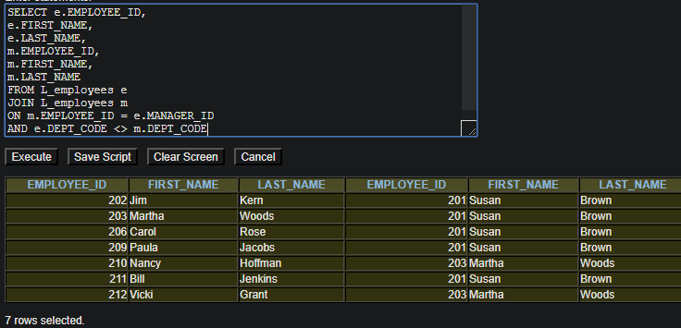

## Use the MySQL server for questions 13 thru 15.

1. Which of our employees, who work in either the Sales or Shipping departments, dined in the cafeteria. Show the employee name, dept code, and each of the dates when they used the cafeteria. [12 rows]

SELECT FIRST_NAME, LAST_NAME, DEPT_CODE, LUNCH_DATE

FROM L_employees

JOIN L_lunches

ON L_employees.EMPLOYEE_ID = L_lunches.EMPLOYEE_ID

AND (DEPT_CODE = 'Sal'

OR DEPT_CODE = 'Shp')

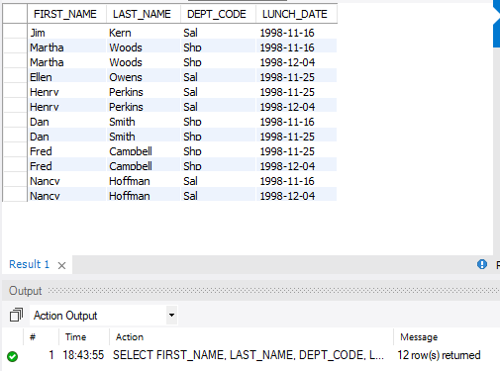

1. Which of our employees ordered coffee with their meal (or ordered coffee as a single item) from the cafeteria. Show the employee_id, name, lunch_id, product code and description. [11 rows]

SELECT L_employees.EMPLOYEE_ID,

L_employees.FIRST_NAME,

L_employees.LAST_NAME,

L_lunches.LUNCH_ID,

L_lunch_items.PRODUCT_CODE,

L_foods.DESCRIPTION

FROM L_employees

JOIN L_lunches

ON L_employees.EMPLOYEE_ID = L_lunches.EMPLOYEE_ID

JOIN L_lunch_items

ON L_lunches.LUNCH_ID = L_lunch_items.LUNCH_ID

JOIN L_foods

ON L_lunch_items.PRODUCT_CODE = L_foods.PRODUCT_CODE

AND L_foods.PRODUCT_CODE = 'Vr'

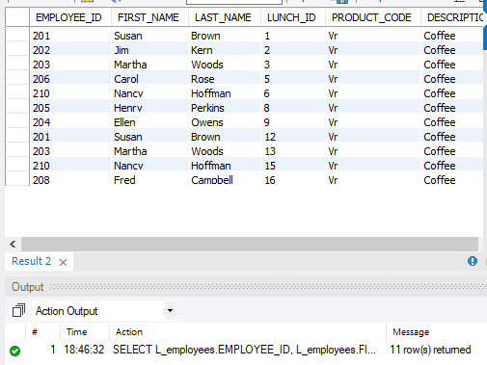

1. Equi join the l_employees table with the l_employees table. This is a recursive join that links employees with their managers. Show the workers employee_id, first_name, and last_name, along with the manager’s employee_id, first-name, and last_name. [11 rows]

SELECT e.EMPLOYEE_ID,

e.FIRST_NAME,

e.LAST_NAME,

m.EMPLOYEE_ID,

m.FIRST_NAME,

m.LAST_NAME

FROM L_employees e

JOIN L_employees m

ON m.EMPLOYEE_ID = e.MANAGER_ID

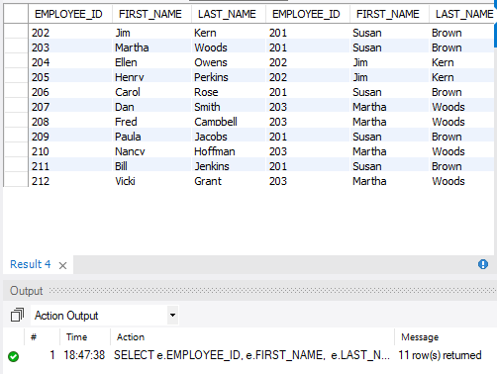

1. ***Analysis***. For question 6, the number of rows in the result set should be 71. What is the maximum number of rows we could see for a question like this? Why (explain your rationale)?

According to Module 9, Slide 23, We should no expect to see more rows in the result table than the maximum number of rows in the largest table. The largest table is the L_lunch_items table (71 rows).

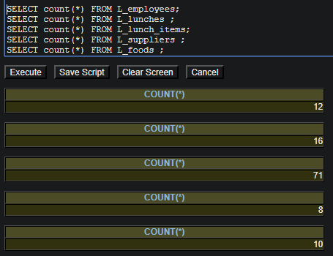

1. ***Analysis***. Questions 9 and 10 involve a recursive relationship on the employees table. Why is the value for the number of rows returned different between these two result sets? Be sure to specifically address why there are fewer rows in the result set for question 9.

The results are different between question 9 and 10 because one is taking into consideration all rows, while the other is only looking at the condition statement.

Question 9 as 1 less row because the row for Susan Brown, does not meet the condition in the where statement, while question 10 uses the (+) operator to create a FULL OUTER JOIN, which insures all rows in each table are represented in the results table. (module 9, slide 50)