Electronic Product Engineering Workshop Project (ECP307)

Topic: DTMF Controlled Robot

Under the guidance of:

Dr. K.D. Kulat

A Joint Work of

1. Abhay Khandelwal (BT17ECE001)

2. Abhi Raga Sukhiya Tadigiri (BT17ECE002)

3. Abhilash Gedam (BT17ECE003)

4. Abhilekh Dixit (BT17ECE004)

**Aim**: To design and control a robot using DTMF generator.

**Apparatus**:

* DTMF frequency generator
* Chassis
* Wheels
* IR Sensor
* ATMEGA8 development board
* Wires
* Power supply
* Adapter
* Motors

**Theory**:DTMF stands for Dual Tone Multi Frequency and it is the basis for your telephone system. Your touch-tone phone is technically a DTMF generator that produces DTMF tones as you press the buttons. Multi-frequency signaling (MF) is a group of signaling methods that use a mixture of two [pure tone](https://en.wikipedia.org/wiki/Pure_tone) (pure [sine wave](https://en.wikipedia.org/wiki/Sine_wave)) sounds. The DTMF system uses a set of eight audio frequencies transmitted in pairs to represent 16 signals, represented by the ten digits, the letters A to D, and the symbols # and *. As the signals are audible tones in the voice frequency range, they can be transmitted through electrical repeaters and amplifiers, and over radio and microwave links, thus eliminating the need for intermediate operators on long-distance circuits.

**Working Principle**: A DTMF frequency generator is used which generates different types of frequencies when given different types of commands. A sensor is used which identifies all the different types of frequencies and decides them and converts them to simple binary notations. These binary data are fed to ATMEGA 8 development board. The development board is then coded in a way to use these binary data and generate voltages accordingly. The development board is connected to the hardware systems like motor. When the series of positive voltages is supplied then the motor starts working accordingly. Other hardware is also connected to these devices and word accordingly to the voltage received.

The various functions and activities the robot can perform are:

1. Move forward (On the press of 2)
2. Move backward (On the press of 8)
3. Stop (On the press of 5)
4. Take a right (On the press of 6)
5. Take a left (On the press of 4)
6. Avoid the obstacle that is in front of it (On the press of 7)
7. To perform a combination of the above functions consecutively after another as per the sequence given by the instructor (On the press of dial).

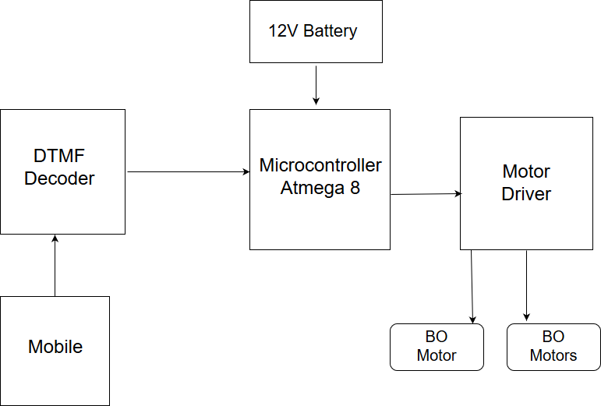

**Look Up Table:**

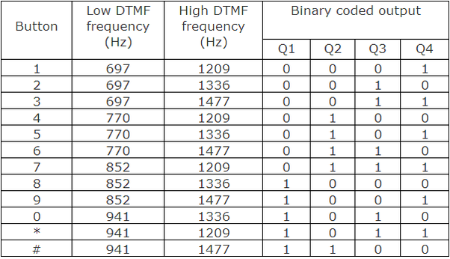

**Code:-**

#include<avr/io.h>

#include<util/delay.h>

forward()

{ PORTB = 0b11111010;

}

backward()

{ PORTB=0b11110101;

}

stop()

{ PORTB=0b11110000;

}

left()

{ PORTB=0b11110110;

}

right()

{ PORTB=0b11111001;

}

main()

{ DDRB = 0b11111111;

DDRC = 0;

char x;

char y;

while(1)

{ x = PINC;

if( x == 0b00000010)

forward();

if( x == 0b00000100)

left();

if( x == 0b00000110)

right();

if( x == 0b00001000)

backward();

if( x == 0b00000101)

stop();

if( x == 0b00000111)

{ y = PINC & 0b00100000;

if ( y== 0b00100000)

{ backward();

_delay_ms(500);

left();

_delay_ms(500);}

if(y==0)

forward();} } }

**Cost Estimation:**

|  |  |
| --- | --- |
| **Product** | **Cost(in Rs.)** |
| ATMEGA 8 development board | 600 |
| DTMF frequency generator | 120 |
| Jumpers | 30 |
| BO Motors | 136 |
| Adapter | 190 |
| Chassis | 177 |
| Wheels | 118 |
| IR Sensor | 60 |

**Total cost = Rs. 1431**