Team “ Y A I Y “

The Physic Dungeon

PHYSICS PROJECTS

**Content**

1. Team2
2. **Andrey Mutlu**2
3. **Yoan Todorov**2
4. **Yoan Panov**2
5. **Ivan Dadakov**2
6. Goals3
7. Stages of development 3
8. Start of the project and planning3
9. Realization4
10. Game description and structure4
11. Structure 4
12. Description 5
13. **Team**

The name of our team is " Y A I Y ". Our team is formed out of four students. Two students from 9V class and two from 9A class. Project participants:

1. Andrey Mutlu 9V - SCRUM Trainer

I am the leader and I organized my team. I’m working on the map and on some parts of the code. I created the repo and the files inside so that my team could work on them.

1. Yoan Todorov 9V - Backend Developer

I worked on the project code together with Yoan Panov. I worked on the mechanics of the game and the creation and adding the map. We helped each other with the code of the game, and we created our own project

1. Yoan Panov 9A - Backend Developer

I worked on the project code together with Yoan Todorov. I helped him with the code. I worked mainly on the mechanics of the game. We helped each other with the code of the game when it was necessary.

1. Ivan Dadakov 9A – QA engineer

I started making the presentation of the project. I am responsible for the documentation part of our project and I have to monitor the quality of our product. I made QA documentation and project documentation.

1. **Goals**

Our goal is to create a game closely related to the subject physics.

We tried to create a game that would be interesting and entertaining for the players, but also educational, so people who play the game could learn more thing about the subject physics at the same time. We want our game to be useful for the players, helping them to acquire new knowledge related to the subject.

1. **Stages of development**
2. **Start of the project and planning**

After we formed our team, we got together and decided what everyone's role is, and then the leader of our team registered us. We decided when we are going to have meetings and then we were ready to start.

We started our work using Microsoft teams and Discord as communication platforms. We discussed ideas and gave different suggestions on how each of us sees the final product. After we reached a consensus, we decided what part of the project everyone should do and we started working. If there were any problems we helped each other in the process of work.

1. **Realization**

We used Microsoft Teams and Discord to communicate and discuss our ideas as well as to work on the project. The code for our game is written in Visual Studio. To create our game we used C ++ and SDL by structuring the code in separate functions and giving them appropriate names. We created a presentation of the project using PowerPoint, as well as created project documentation through Word and QA documentation using Excel.

1. **Game description and structure**
2. **Structure**

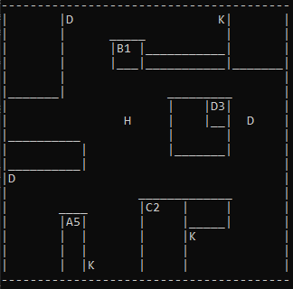

H - hero

D - door

K - key

1. **Description**

The game name is The Physic Dungeon

In this game you need to find 3 keys which are invisible to you. Once you go on the right coordinates your character will be asked if he is worthy of getting the key. To be decided if he is worthy or not he will need to answer a Physics question. If he answers the question wrong the key will dissapear ending the game. If he answers the question right he will obtain the key. Once the key is obtained the player can either open a door to get a piece of an artifact or to go find a second key. For every Key he will need to answer a question. Once he gets all the keys and opens all doors he will get all the parts of the artifact and win the game.