Title:-DS-MTFNet: A Dual-Stream Multi-Task Deep Learning Framework for Detection of AI-Generated and AI-Edited Images with Semantic Content Classification

📝 PROBLEM STATEMENT
The rapid advancement of generative artificial intelligence (AI) has enabled the creation of highly realistic synthetic images and sophisticated image editing techniques that are increasingly indistinguishable from real photographs. Modern AI models such as diffusion-based generators and intelligent editing tools allow users to effortlessly generate or manipulate images, leading to the widespread availability of AI-generated and AI-edited visual content. While these technologies offer significant benefits, they also introduce serious challenges related to misinformation, identity fraud, deepfake generation, digital manipulation, and loss of trust in visual media.
Traditional image authentication techniques and human visual inspection are no longer sufficient to reliably detect AI-generated and AI-edited images, particularly when the generated content exhibits high photorealism or when subtle editing is applied through mobile enhancement tools and AI-based editing applications. Existing deep learning approaches primarily focus on binary classification between real and AI-generated images, often neglecting the more complex task of distinguishing AI-edited images from both real and fully synthetic images. Moreover, most current solutions lack semantic understanding of image content and fail to provide explainable outputs that can assist forensic analysts in understanding the nature and location of manipulation.
This project aims to address these challenges by developing a robust and intelligent image forensics framework capable of accurately classifying images into three distinct categories: real, AI-generated, and AI-edited, while simultaneously identifying the semantic content of the image as human, face, or animal. The system leverages a dual-stream deep learning architecture that combines spatial-domain visual features with frequency-domain forensic features extracted using Fast Fourier Transform (FFT), enabling effective detection of subtle artifacts introduced during AI generation and editing processes. Additionally, the incorporation of multi-task learning and explainable AI mechanisms ensures enhanced classification performance, improved generalization to unseen AI models, and visual localization of manipulated regions.
By providing a reliable, scalable, and interpretable solution for image authenticity verification, the proposed system contributes towards combating digital misinformation, enhancing cybersecurity, supporting forensic investigations, and restoring trust in visual media in the era of generative artificial intelligence.

📝 ABSTRACT
The rapid evolution of generative artificial intelligence (AI) has enabled the creation and manipulation of highly realistic images, significantly blurring the distinction between authentic, AI-generated, and AI-edited visual content. This growing capability poses serious challenges in digital forensics, misinformation detection, cybersecurity, identity verification, and media authentication. Traditional visual inspection and conventional deep learning models often fail to reliably identify subtle manipulations and lack interpretability, especially when images are enhanced using mobile editing tools or generated using advanced diffusion models.
To address these challenges, this work proposes DS-MTFNet, a novel Dual-Stream Multi-Task Deep Learning Framework for robust detection of real, AI-generated, and AI-edited images, while simultaneously performing semantic content classification into human, face, and animal categories. The proposed framework integrates two complementary feature extraction streams: a spatial-domain RGB stream that captures visual and semantic features, and a frequency-domain stream based on Fast Fourier Transform (FFT) that learns intrinsic forensic artifacts introduced during AI image generation and editing processes. The extracted features are fused and optimized through a multi-task learning strategy, enabling accurate and generalized image authenticity classification.
Furthermore, Grad-CAM-based explainable AI techniques are incorporated to provide visual localization of manipulated regions, enhancing the interpretability and trustworthiness of the system. Extensive experimental evaluation conducted on a curated dataset comprising real, AI-generated, and AI-edited images demonstrates that the proposed approach achieves superior performance compared to conventional single-stream models, exhibiting strong generalization to unseen generative models and robust detection of subtle image edits.
The proposed framework offers a scalable, reliable, and interpretable solution for real-world applications including deepfake detection, digital image forensics, misinformation prevention, and content authenticity verification, contributing towards the development of trustworthy AI systems in the era of generative technologies.
1)Data Collection:-Kaggle , Google Dataset , Stable Diffusion , Pexel
No. Of Trials | No.of Images | No. Of Categories | Expected Accuracy
1. | 1200 | 3 | (Real vs AI vs AI-Edited)  Expected: 94 ± 2%  (Human vs Face vs Animal)  Expected: 98 ± 1%  (Correct Origin + Correct Content)  Expected: 92 ± 2%

Now, Firstly I We have took three classes for classification (AI, Non-AI, AI_Edited) in this Each class contains of 3 sub category for now (Human, Face , Animal(Cat,Dog,Elephant,Lion,Horse)) We have collected 400 images for each sub category and for animal this are divided into (80+80+80+80+80) and face and human contain 400 images Which we have splitted in 70%+15%+15%

File structure
dataset/
│
├── train/70%
│ ├── ai/
│ │ ├── human/
│ │ ├── face/
│ │ └── animal/
│ │ ├── cat/
│ │ ├── dog/
│ │ ├── elephant/
│ │ ├── horse/
│ │ └── lion/
│ │
│ ├── real/
│ │ ├── human/
│ │ ├── face/
│ │ └── animal/
│ │ ├── cat/
│ │ ├── dog/
│ │ ├── elephant/
│ │ ├── horse/
│ │ └── lion/
│ │
│ └── ai_edited/
│ ├── human/
│ ├── face/
│ └── animal/
│ ├── cat/
│ ├── dog/
│ ├── elephant/
│ ├── horse/
│ └── lion/
│
├── val/ (same)15%
└── test/ (same)15%

Sources Of images collection
AI_Images :-for Human,Face,Animal(Cat,Dog,Elephant,Lion, Horse) Live Generated from AI Stable Diffusion
Non_AI :- For this we have collected images from Kaggle and pexel
AI_edited :-The images which are collected from the kaggle and pexel now they are converted into AI_images by live ai_editing
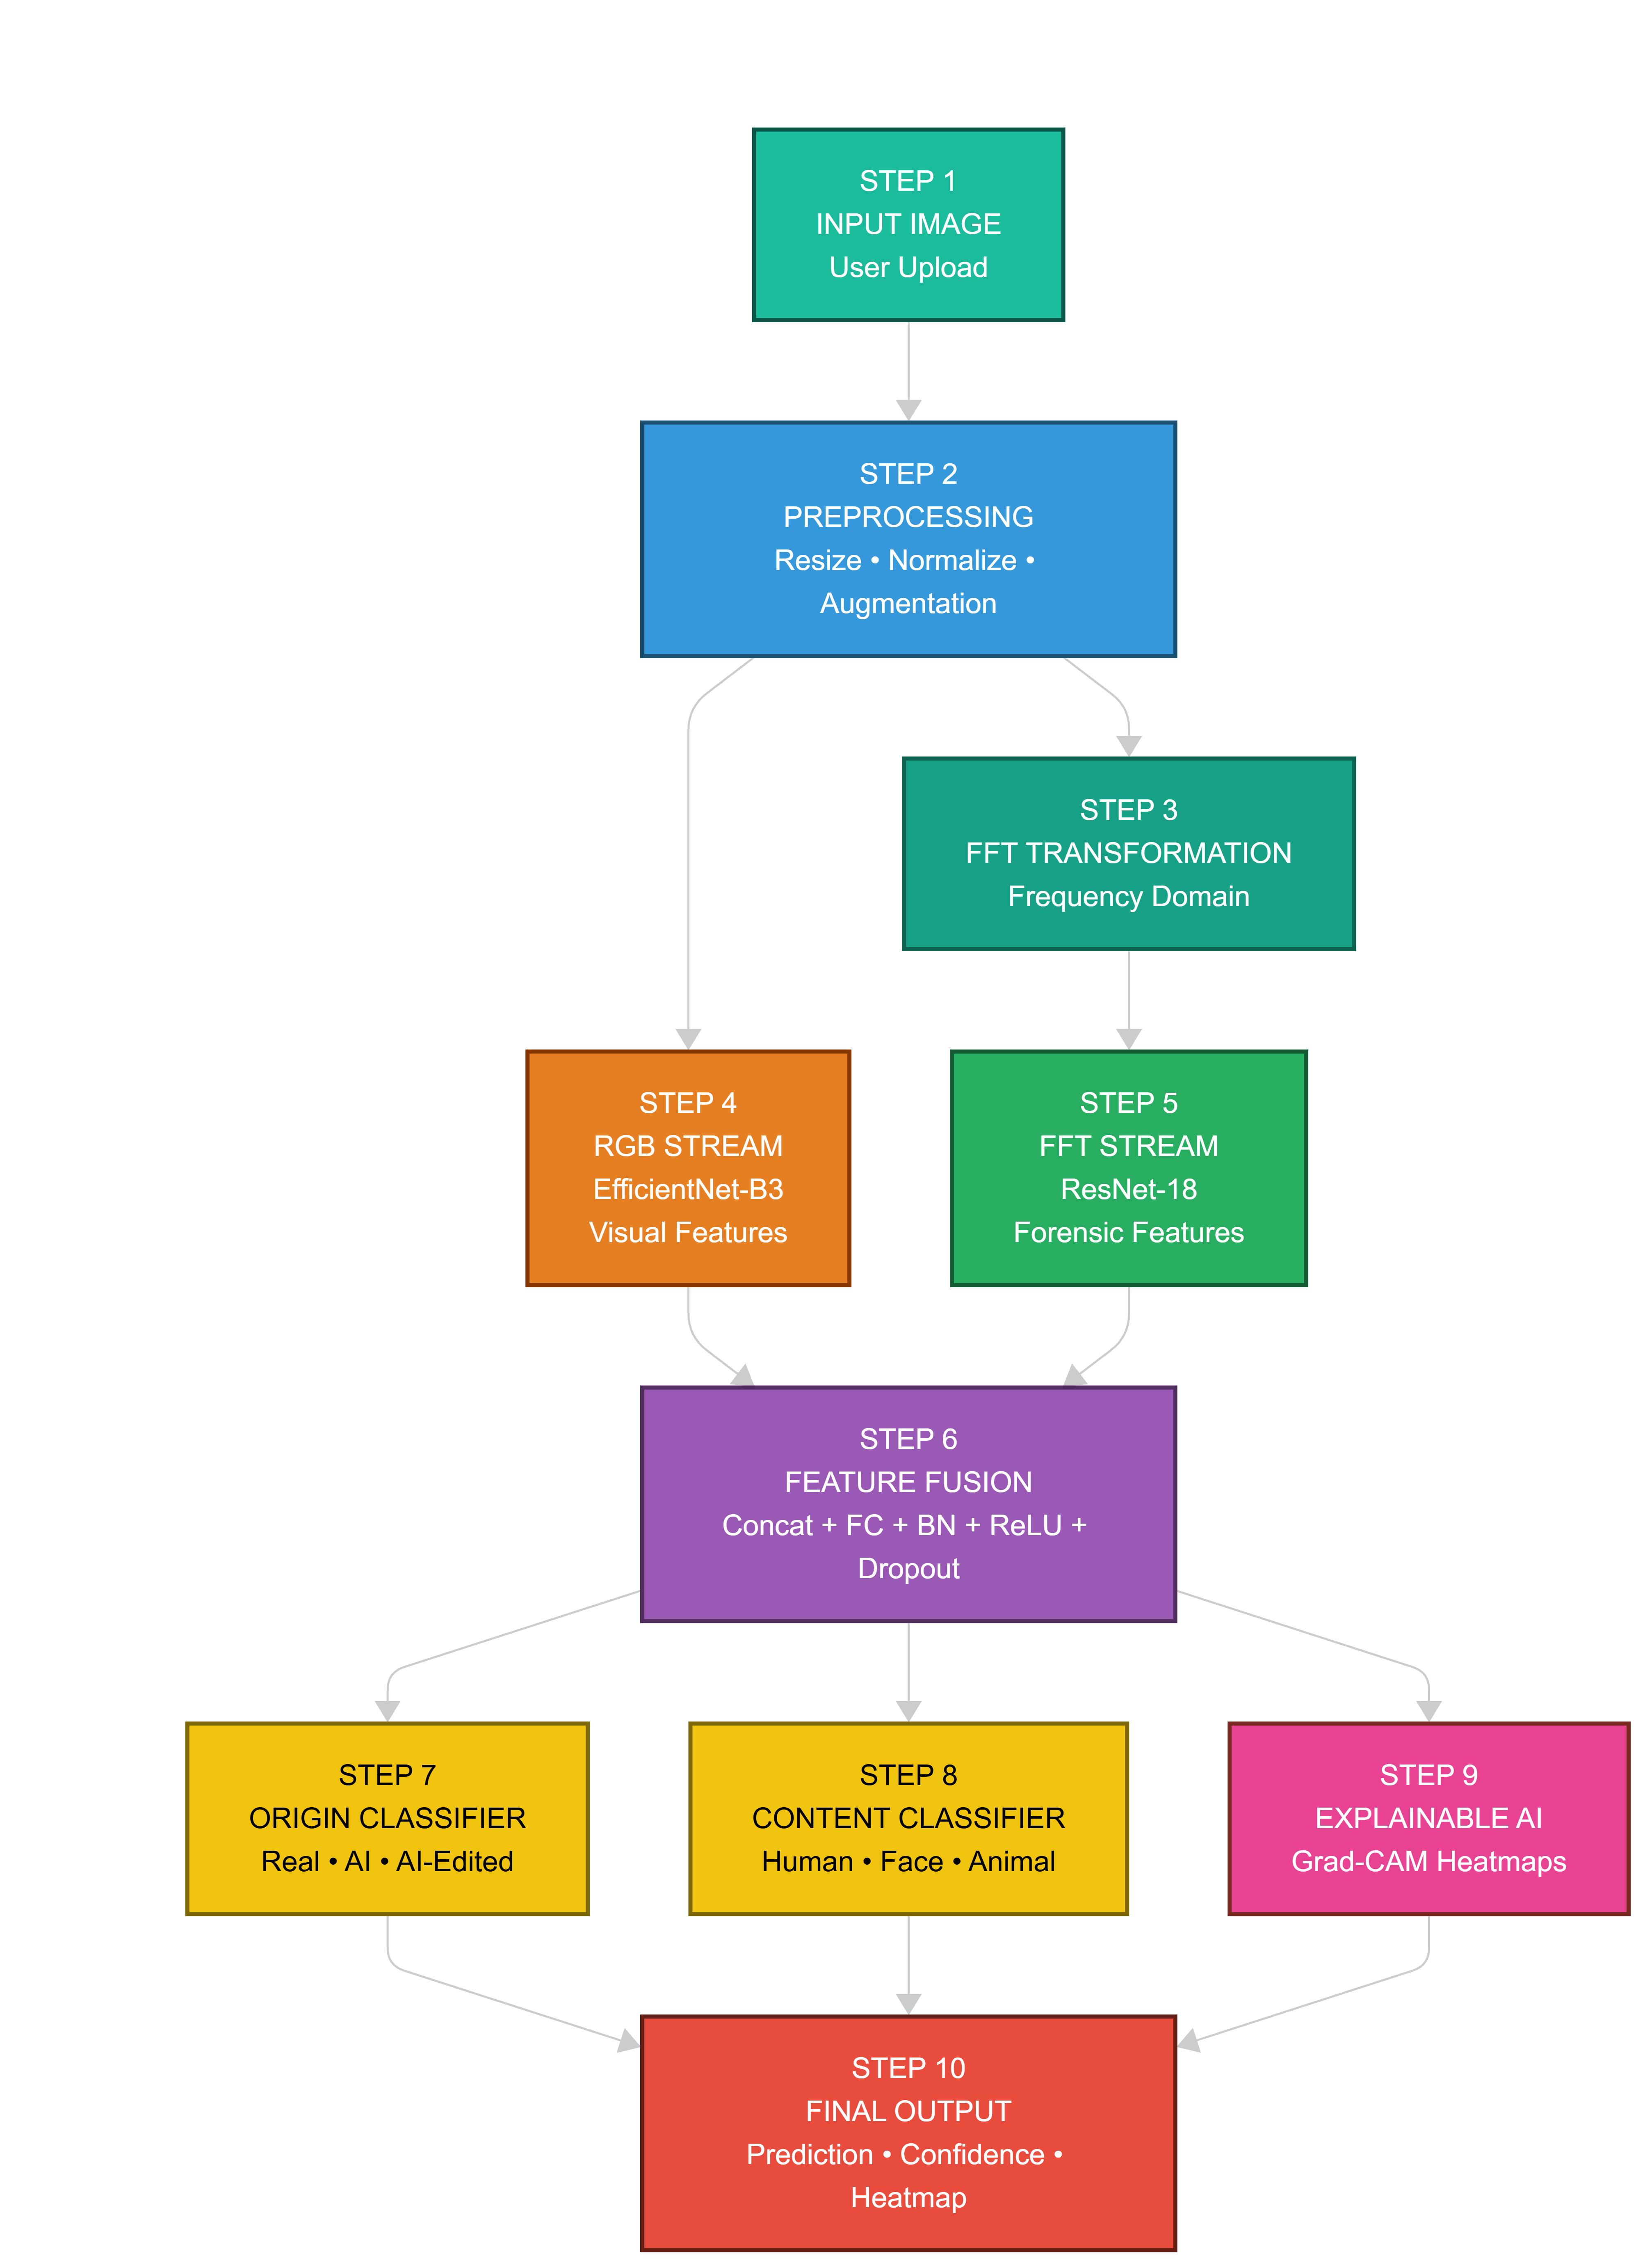

🧠 STEP-BY-STEP FLOW EXPLANATION (FOR REPORT & PRESENTATION)
You can directly paste this in your system design explanation section 👇

Step 1 – Image Input
User uploads an image into the system via the frontend interface.

Step 2 – Preprocessing
The input image is resized, normalized, and augmented to standardize data and enhance model robustness.

Step 3 – FFT Transformation
The image is converted into the frequency domain using Fast Fourier Transform (FFT) to extract forensic artifacts.

Step 4 – RGB Stream Feature Extraction
The preprocessed RGB image is passed through EfficientNet-B3 to extract high-level visual and semantic features.

Step 5 – FFT Stream Feature Extraction
The frequency-domain image is processed using ResNet-18 to learn hidden AI and editing fingerprints.

Step 6 – Feature Fusion
Features from both streams are concatenated and refined using fully connected layers to create a unified representation.

Step 7 – Origin Classification
The fused features are classified into Real, AI-generated, or AI-edited categories.

Step 8 – Content Classification
Simultaneously, the semantic content is classified as Human, Face, or Animal.

Step 9 – Explainable AI (Grad-CAM)
Grad-CAM generates heatmaps to highlight manipulated or discriminative regions in the image.

Step 10 – Final Output
The system displays predicted class labels, confidence scores, and heatmap overlays to the user.

WORKFLOW ARCHITECTURE
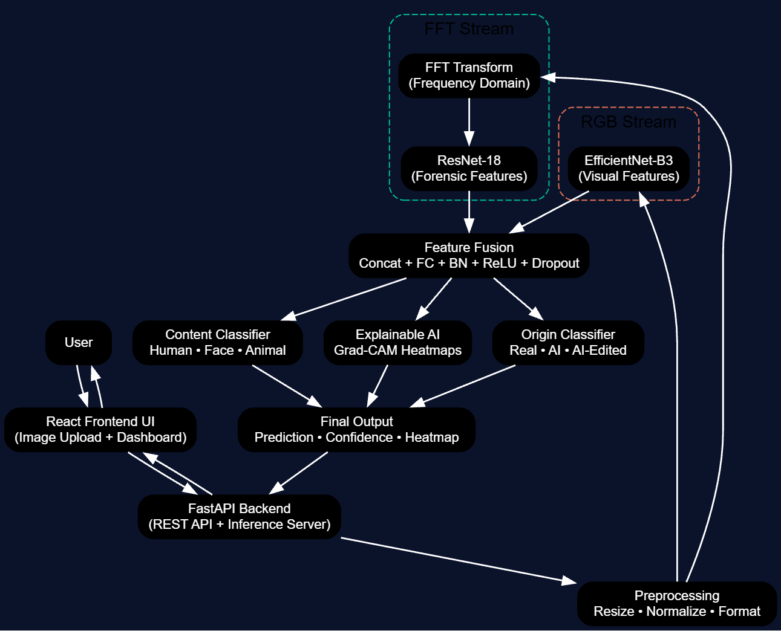

🔹 BACKEND TECHNOLOGY STACK
This handles API, inference, communication, and deployment.

🚀 Backend Framework
- FastAPI
Why FastAPI?
- Very fast ⚡
- Easy REST API development
- Built-in Swagger UI
- Perfect for ML model serving
- Async support

🧠 AI Inference Engine
- PyTorch
Used for:
- Loading trained model
- Running real-time predictions
- Heatmap generation (Grad-CAM)

🖼 Image Processing
- OpenCV
- Pillow (PIL)
Used for:
- Image reading
- Preprocessing
- FFT transformation
- Heatmap overlay

📡 API Communication
- REST APIs
- JSON responses
- Multipart file upload

🗄 Database (Optional – Logging & Analytics)
- MongoDB / SQLite
Used to store:
- Uploaded images
- Prediction logs
- Confidence scores
- Time stamps

☁ Deployment (Optional Advanced)
- Docker
- AWS EC2 / GCP / Azure
- Nginx (reverse proxy)

🔹 BACKEND FLOW
Frontend (React)
↓
FastAPI Backend
↓
PyTorch Model Inference
↓
Grad-CAM + Prediction
↓
Response → Frontend UI

🔹 MODEL BUILDING (AI ENGINE) STACK
This is the core intelligence of your project.

🧠 Deep Learning Framework
- PyTorch
Why?
- Research friendly
- Industry standard
- Flexible model design
- Easy debugging

🧬 Model Architecture Components

1️⃣ RGB Stream Backbone
- EfficientNet-B3 (Pretrained)
Used for:
- Visual feature extraction
- Semantic understanding

2️⃣ FFT Stream Backbone
- ResNet-18
Used for:
- Learning frequency domain artifacts
- AI / editing fingerprint detection

3️⃣ Feature Fusion Module
- Fully Connected Layers (FC)
- Batch Normalization
- ReLU
- Dropout
Used for:
- Combining RGB + FFT features

4️⃣ Multi-Task Learning Heads
- Origin Classifier
→ Real / AI / AI-Edited
- Content Classifier
→ Human / Face / Animal

🔹 Image Forensics Techniques
- Fast Fourier Transform (FFT)
- Frequency-domain artifact learning
- Noise & texture pattern detection

🔹 Explainable AI
- Grad-CAM (Gradient-weighted Class Activation Mapping)
Used for:
- Heatmap generation
- Edited region localization
- Model explainability

🔹 Training Techniques
- Transfer Learning
- Fine Tuning
- Data Augmentation
- Multi-task loss optimization
- Cosine learning rate scheduling

🔹 Model Building Flow
Image → Preprocessing → RGB Stream + FFT Stream
→ Feature Fusion → Multi-task Heads
→ Origin + Content Prediction + Heatmap

🏆 COMPLETE TECH STACK SUMMARY (ONE TABLE)
Layer | Technology
Frontend | React.js, Tailwind CSS
Backend | FastAPI, Python
ML Framework | PyTorch
CV Tools | OpenCV, PIL
Model | EfficientNet-B3 + ResNet18
Forensics | FFT
Explainability | Grad-CAM
DB (optional) | MongoDB / SQLite
Deployment | Docker, Cloud

🎯 ONE-LINE TECH STACK (FOR PPT)
The system is built using a FastAPI backend integrated with a PyTorch-based dual-stream multi-task deep learning model employing EfficientNet-B3, ResNet-18, FFT-based forensic analysis, and Grad-CAM explainable AI.

