AICTE – IBM INTERNSHIP PROJECT REPORT
Supermarket Sales Analytics
Exploratory Data Analysis, KPI Benchmarking, and Strategic Business Recommendations
Candidate Name: | Aarmitha A
Program Track: | AICTE – IBM SkillsBuild Data Analytics Internship
Project Title: | Supermarket Sales Analytics
Dataset Scope: | 5,053 Retail Transactions across NYC Regional Branches (FY 2024)

1. Introduction
In modern omnichannel and physical retail environments, granular transaction data serves as the foundation for strategic planning, operational efficiency, and revenue maximization. Modern supermarket chains operate under narrow profit margins and rapid inventory turnover, requiring precise alignment between customer purchasing behavior, regional demand variations, and inventory procurement schedules.
This project, titled 'Supermarket Sales Analytics', analyzes 5,053 historical customer transactions from a multi-branch supermarket chain spanning January 1, 2024, through December 31, 2024. Through data cleaning, exploratory data analysis (EDA), key performance indicator (KPI) tracking, and multi-dimensional cross-tabulation, this report translates raw operational logs into actionable business intelligence for executive decision-makers.

2. Problem Statement
Retail management frequently faces multi-faceted operational challenges that impede top-line revenue growth and customer satisfaction:
1. Lack of Dimensional Performance Transparency: Although the supermarket chain records consistent footfall across its regional branches, leadership lacks visibility into category profit drivers, customer loyalty monetization, and extreme seasonal demand fluctuations.
2. Disconnected Regional Strategies: Branch managers operate under generalized assumptions without empirical understanding of why certain locations generate higher basket sizes while others capture higher checkout volumes.
3. Seasonal Revenue Volatility & Capacity Friction: Severe mid-year revenue drops and year-end customer satisfaction paradoxes indicate unaddressed operational and merchandising bottlenecks.
The objective of this project is to address these blind spots by establishing an empirical baseline of store performance, uncovering underlying behavioral drivers, and formulating practical strategic recommendations.

3. Objectives
The specific analytical objectives of this project are structured as follows:
• Data Hygiene & Validation: Inspect the dataset schema, handle missing values, eliminate duplicates, and transform date-time features for accurate time-series modeling.
• Executive KPI Benchmarking: Calculate five essential retail KPIs: Total Revenue, Total Sales/Transactions, Average Transaction Value (ATV), Total Quantity Sold, and Average Customer Rating.
• Dimensional Breakdown: Conduct deep-dive evaluations across Branch Performance, Product Lines, Customer Types (Member vs. Normal), Gender Demographics, Payment Channels, and Temporal Trends.
• Risk & Opportunity Identification: Identify systemic risks and high-impact revenue opportunities supported strictly by empirical evidence without fabrication.
• Strategic Action Roadmap: Provide structured, prioritized, and practical business recommendations utilizing the Fact → Insight → Recommended Action methodology.

4. Dataset Overview & Schema
The analysis is conducted on the official provided dataset (`Supermarket Sales 2.csv`), comprising 5,053 unique retail transaction records recorded over the entire 2024 calendar year across three branches in New York City (Brooklyn, Queens, and Manhattan).
Column Name | Description & Range | Data Type | Role in Analysis
Date | Date of purchase formatted as MM/DD/YYYY (spanning 01/01/2024 to 12/31/2024) | datetime64[ns] | Temporal feature
Branch | Geographical store location: Brooklyn, Queens, Manhattan | Categorical / string | Regional dimension
Customer type | Loyalty membership status: Member or Normal (Walk-in) | Categorical / string | Customer segment
Gender | Customer demographic identification: Female or Male | Categorical / string | Demographic dimension
Product line | Merchandise category (6 distinct product lines) | Categorical / string | Product hierarchy
Unit price | Retail price per item in US Dollars ($2.01 to $99.96) | Float64 | Pricing metric
Quantity | Number of product units purchased per transaction (1 to 10) | Int64 | Volume metric
Payment | Transaction settlement method: Ewallet, Credit card, Cash | Categorical / string | Financial channel
Rating | Customer checkout satisfaction rating (Scale: 3.0 to 10.0) | Float64 | Satisfaction metric

5. Methodology & Analytical Framework
This project adheres to a rigorous, industry-standard data science and business intelligence lifecycle consisting of five systematic stages:
1. Data Ingestion & Schema Auditing: Reading raw CSV data using Pandas, validating row/column dimensions, inspecting data structures, and auditing missing values.
2. Cleansing & Feature Engineering: Verifying absence of nulls and duplicates, casting Date strings to native datetime timestamps, and deriving business metrics including Total Transaction Amount (Unit price * Quantity), Month, Day of Week, and Quarter.
3. KPI Benchmarking: Aggregating macro-level metrics to establish baseline business performance across revenue, volume, and customer sentiment.
4. Exploratory Data Analysis & Visualization: Executing single-variable and multi-variable cross-tabulations to evaluate regional branches, merchandise lines, customer tiers, and time-series seasonality.
5. Strategic Synthesis & Recommendations: Synthesizing empirical observations through the Fact → Insight → Recommended Action framework, identifying operational risks, and constructing a phased executive roadmap.

6. Data Cleaning & Preprocessing
Data cleaning is a prerequisite to ensure analytical validity and prevent distorted conclusions. The audit produced the following verified results:
• Missing Values Audit: An exhaustive scan using `df.isnull().sum()` confirmed zero null, NaN, or blank entries across all 5,053 rows and 9 columns (100% data completeness).
• Duplicate Records Audit: Executing `df.duplicated().sum()` confirmed zero redundant or duplicated rows. Each of the 5,053 records represents a distinct transaction.
• Data Type Conversions: The `Date` column was successfully converted from raw `object` string to `datetime64[ns]` using format string `%m/%d/%Y`. Chronological validation confirmed exact boundary dates from January 1, 2024, to December 31, 2024.
• Derived Feature — Total Revenue: Calculated as `Unit price * Quantity`, representing total checkout value in USD without tax.
• Derived Features — Temporal Flags: Extracted `Month` (YYYY-MM), `Month_Name` (January–December), `DayOfWeek` (Monday–Sunday), and `Quarter` (Q1–Q4) to empower granular time-series aggregations.

7. Key Performance Indicators (KPI) Analysis
The executive retail KPIs were computed across the entire 5,053 transactions of FY 2024. These five metrics establish the baseline health of the supermarket enterprise:
Key Performance Indicator | Actual Value | Executive Context | Strategic Priority
Total Revenue | $942,544.85 | $942.5K across all 3 branches; annualized run rate | High
Total Transactions (Sales Count) | 5,053 | 5,053 billed customer checkouts | High
Average Transaction Value (ATV) | $186.53 | Average spend per customer basket | Critical
Total Quantity Sold | 23,211 units | Average of 4.59 items per customer basket | Medium
Average Customer Rating | 6.88 / 10.0 | Median 7.0; ranges from 3.0 to 10.0 | Critical

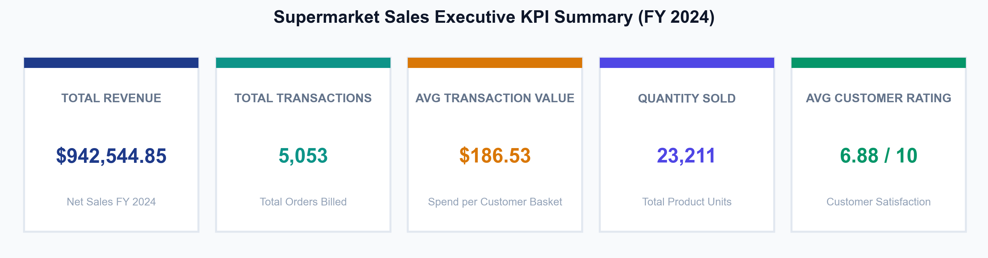
Figure: Executive KPI Scorecard Summary Card (FY 2024)
The store generated nearly $1.0M in gross annual revenue ($942,544.85) from 5,053 transactions, resulting in a healthy Average Transaction Value (ATV) of $186.53. However, the modest customer rating of 6.88/10 signals significant headroom for improving service delivery, checkout efficiency, and product quality.

8. Exploratory Data Analysis (EDA)

8.1 Regional Branch Performance
The supermarket operates across three primary New York City boroughs: Brooklyn, Queens, and Manhattan. An aggregate analysis demonstrates balanced overall revenue generation, yet distinct behavioral profiles per branch:
Branch | Revenue ($) | Rev Share | Txns | Txn Share | Units Sold | ATV ($) | Avg Rating
Brooklyn | $319,705.48 | 33.92% | 1,793 | 35.48% | 7,911 | $178.31 | 6.87 / 10
Queens | $312,842.82 | 33.19% | 1,555 | 30.77% | 7,548 | $201.19 | 6.87 / 10
Manhattan | $309,996.55 | 32.89% | 1,705 | 33.74% | 7,752 | $181.82 | 6.91 / 10
Total / Store Avg | $942,544.85 | 100.0% | 5,053 | 100.0% | 23,211 | $186.53 | 6.88 / 10

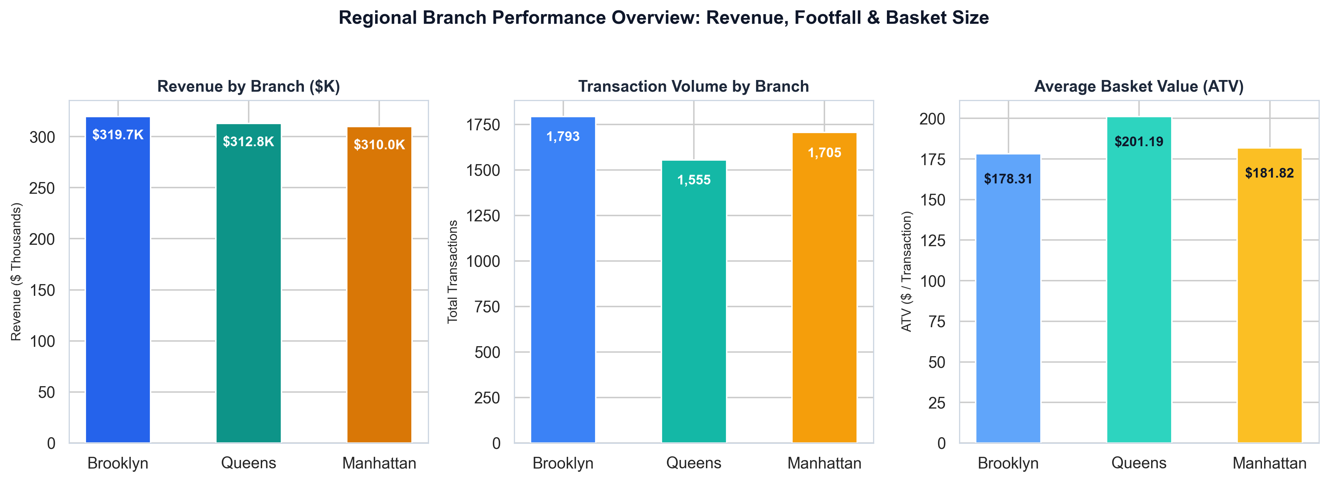
Figure: Regional Branch Comparison across Revenue, Footfall, and Average Basket Value

8.2 Product Line Performance & Merchandise Mix
The store catalogs its inventory into six primary merchandise lines. Significant divergences exist between high-ticket revenue drivers and high-frequency footfall anchors:
Product Line | Revenue ($) | Rev Share | Txns | Txn Share | Units Sold | ATV ($) | Avg Rating
Home & Lifestyle | $197,260.56 | 20.93% | 708 | 14.01% | 3,461 | $278.62 | 6.78 / 10
Health & Beauty | $168,570.61 | 17.88% | 958 | 18.96% | 4,296 | $175.96 | 6.87 / 10
Sports & Travel | $164,252.94 | 17.43% | 576 | 11.40% | 2,697 | $285.16 | 6.73 / 10
Electronics | $159,259.10 | 16.90% | 465 | 9.20% | 2,325 | $342.49 | 6.82 / 10
Food & Beverages | $151,357.73 | 16.06% | 1,670 | 33.05% | 7,309 | $90.63 | 7.08 / 10
Fashion & Accessories | $101,843.91 | 10.81% | 676 | 13.38% | 3,123 | $150.66 | 6.70 / 10
Total / Store Avg | $942,544.85 | 100.0% | 5,053 | 100.0% | 23,211 | $186.53 | 6.88 / 10

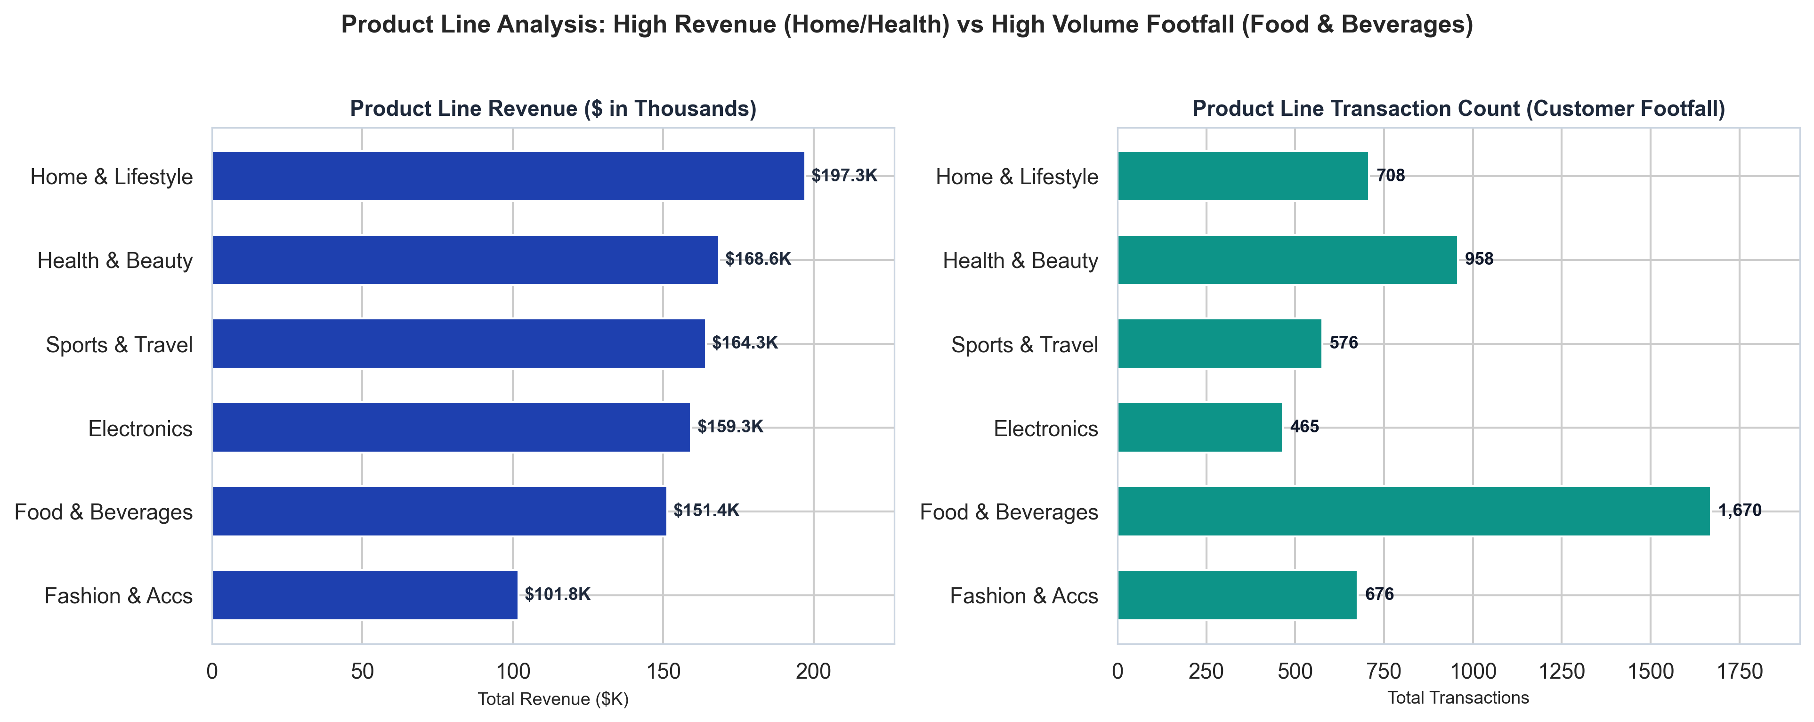
Figure: Product Line Performance: Revenue vs Footfall Volume

8.3 Customer Type Analysis: Member vs Normal
A critical dimension in retail strategy is customer loyalty. Comparing registered Members against unregistered Normal walk-in customers reveals a substantial monetization disparity:
Segment | Revenue ($) | Rev % | Txns | Txn % | Units | Avg Price | Avg Qty | ATV ($) | Rating
Member | $436,368.17 | 46.30% | 2,085 | 41.26% | 10,089 | $41.99 | 4.84 | $209.29 | 6.87 / 10
Normal | $506,176.68 | 53.70% | 2,968 | 58.74% | 13,122 | $38.08 | 4.42 | $170.54 | 6.89 / 10
Difference / Premium | -$69,808.51 | -7.4% | -883 | -17.5% | -3,033 | +$3.91 (+10.3%) | +0.42 (+9.5%) | +$38.75 (+22.7%) | -0.02

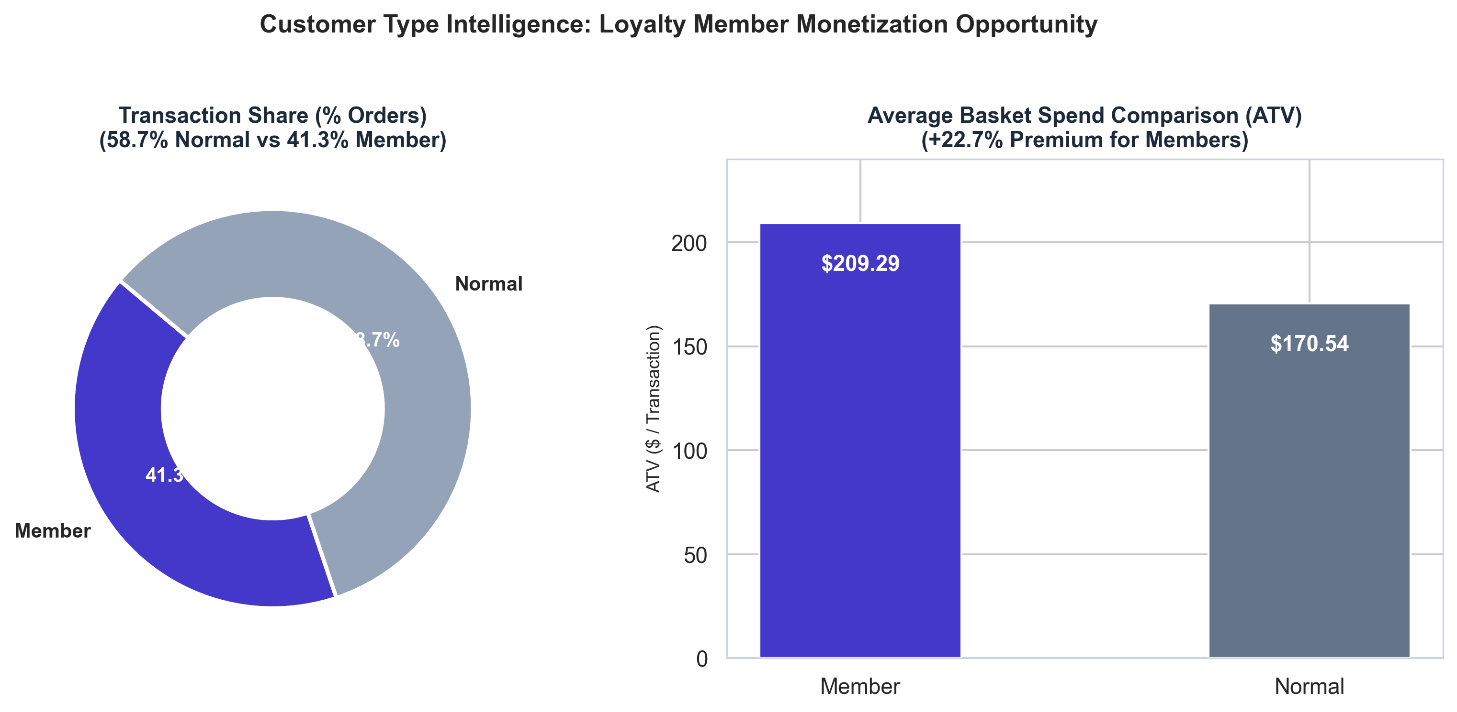
Figure: Customer Segment Intelligence: Transaction Share vs Basket Spend Premium

8.4 Demographic (Gender) and Payment Channel Breakdown
Demographic analysis reveals near-parity between female and male shoppers, while payment channel adoption is evenly distributed across modern digital and traditional tender types:
Gender | Revenue ($) | Rev Share | Txns | Txn Share | Units Sold | ATV ($) | Rating
Female | $490,169.72 | 52.00% | 2,603 | 51.51% | 12,029 | $188.31 | 6.88 / 10
Male | $452,375.13 | 48.00% | 2,450 | 48.49% | 11,182 | $184.64 | 6.88 / 10

Payment Method | Revenue ($) | Rev Share | Txns | Txn Share | Units Sold | ATV ($) | Rating
Ewallet | $326,691.31 | 34.66% | 1,785 | 35.33% | 8,096 | $183.02 | 6.86 / 10
Credit card | $311,230.89 | 33.02% | 1,594 | 31.55% | 7,622 | $195.25 | 6.90 / 10
Cash | $304,622.65 | 32.32% | 1,674 | 33.13% | 7,493 | $181.97 | 6.89 / 10

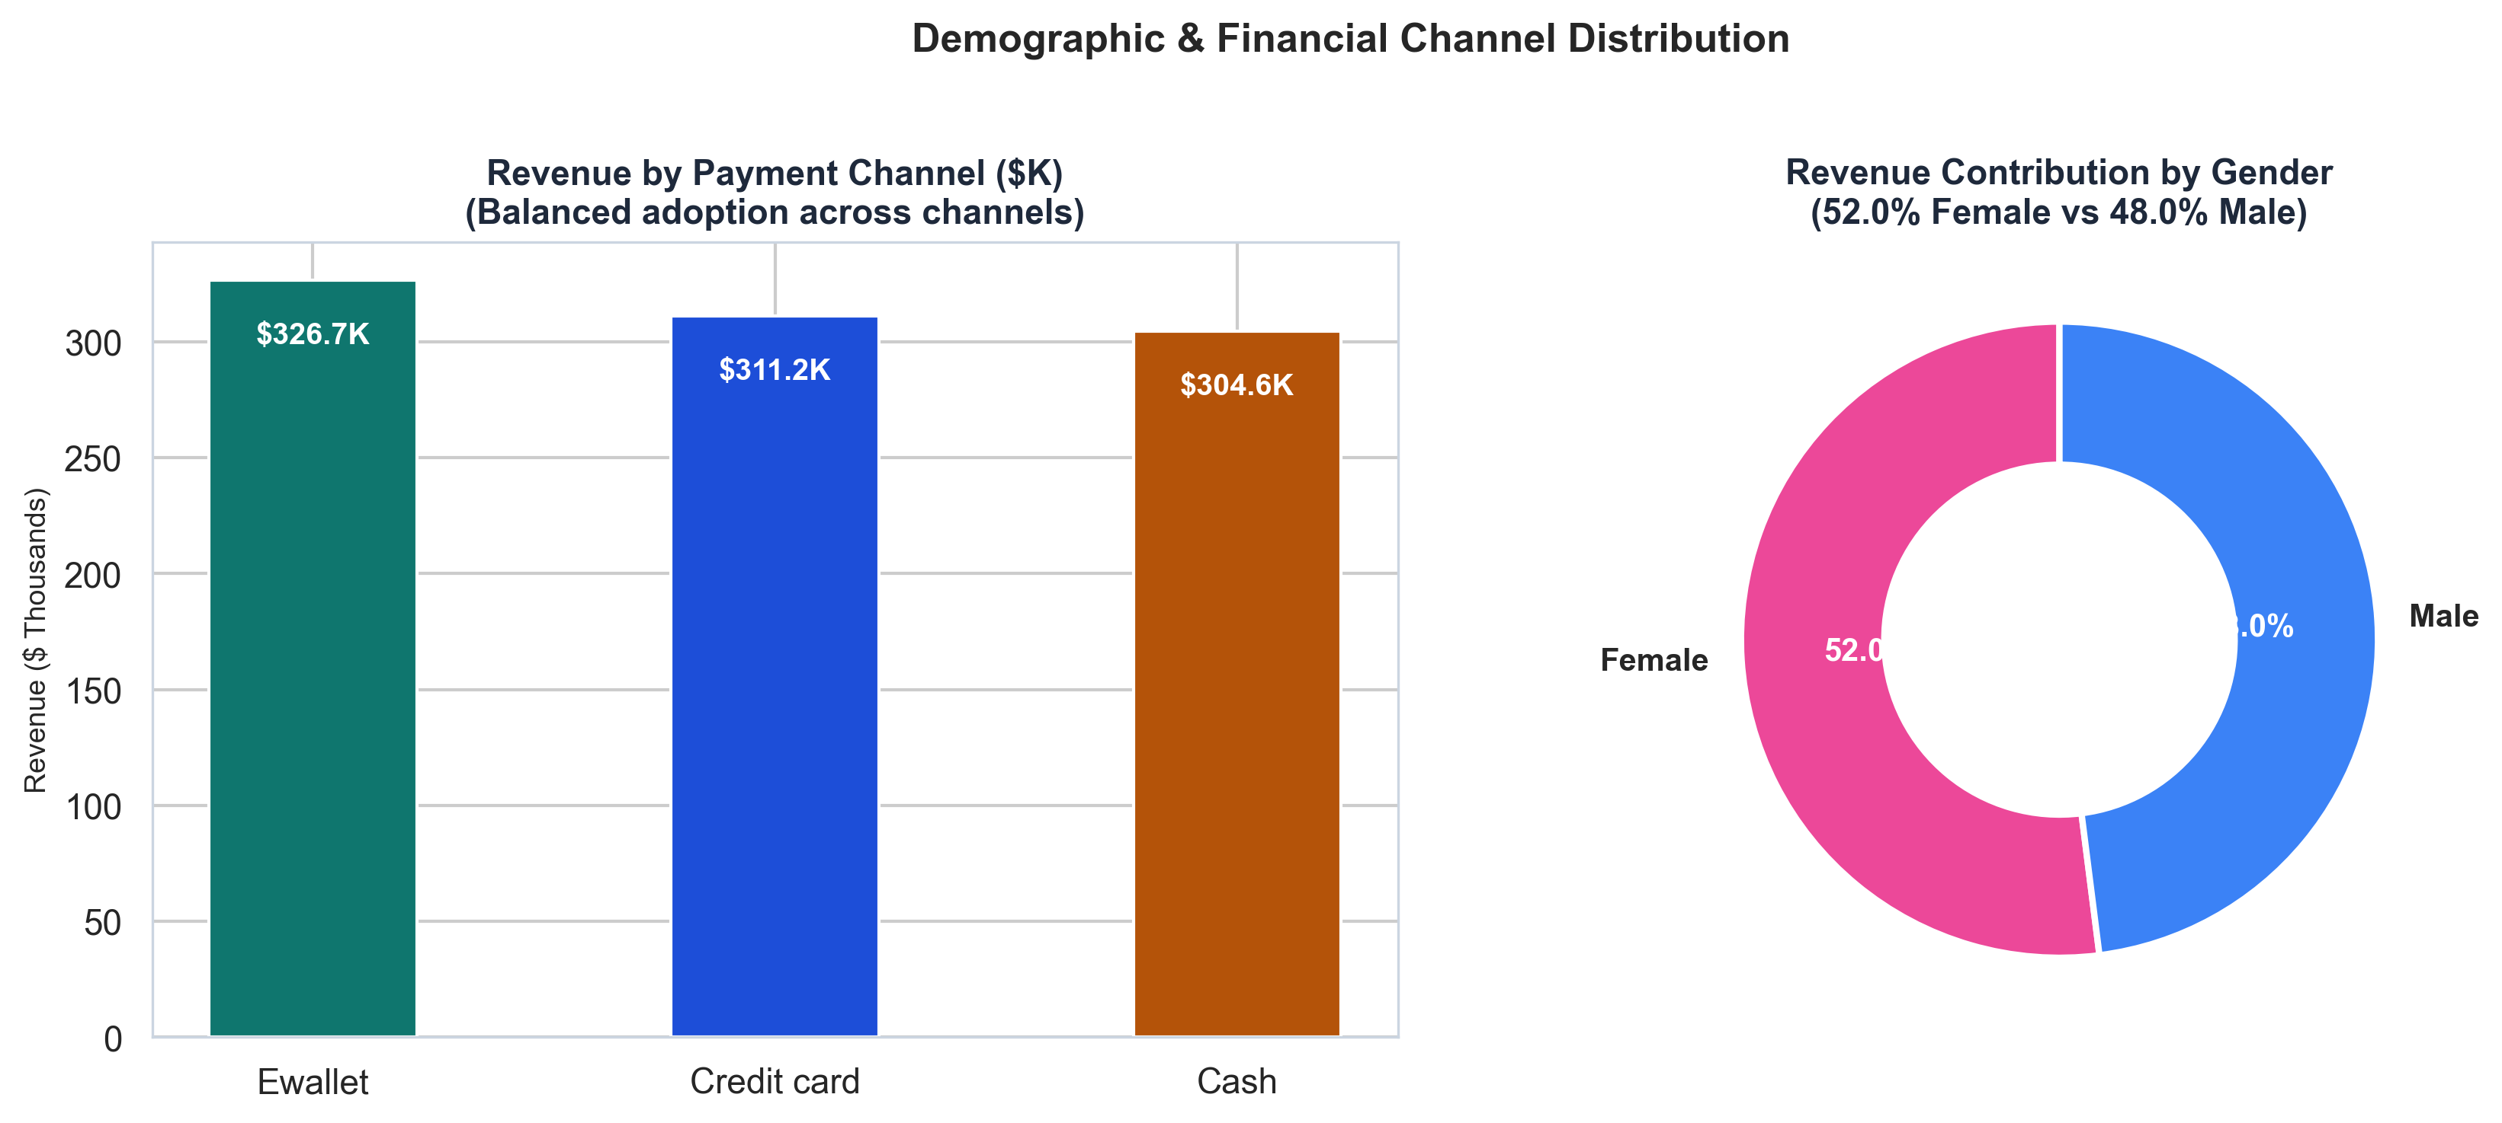
Figure: Revenue Distribution across Payment Methods and Gender Demographics

8.5 Time-Series & Temporal Analysis (Seasonality & Service Paradox)
A monthly longitudinal analysis reveals pronounced seasonal swings and an alarming customer satisfaction paradox between high-volume and low-volume operating cycles:
Month | Revenue ($) | Txns | Avg Price | Avg Qty | ATV ($) | Avg Rating
January 2024 | $110,754.16 | 352 | $56.12 | 5.58 | $314.64 | 7.02 / 10
February 2024 | $94,761.64 | 311 | $56.91 | 5.42 | $304.70 | 7.07 / 10
March 2024 | $104,243.34 | 345 | $54.37 | 5.48 | $302.15 | 6.84 / 10
April 2024 | $132,083.88 | 447 | $57.49 | 5.20 | $295.49 | 7.00 / 10
May 2024 | $60,955.78 | 417 | $54.80 | 2.69 | $146.18 | 7.50 / 10
June 2024 | $28,883.41 | 416 | $28.20 | 2.62 | $69.43 | 7.54 / 10
July 2024 | $22,168.03 | 400 | $22.23 | 2.69 | $55.42 | 7.27 / 10
August 2024 | $19,440.15 | 363 | $21.80 | 2.69 | $53.55 | 7.27 / 10
September 2024 | $76,890.07 | 452 | $31.65 | 5.42 | $170.11 | 6.38 / 10
October 2024 | $72,651.64 | 425 | $32.53 | 5.41 | $170.95 | 6.37 / 10
November 2024 | $101,417.63 | 557 | $33.26 | 5.54 | $182.08 | 6.32 / 10
December 2024 | $118,295.12 | 568 | $36.29 | 5.71 | $208.27 | 6.53 / 10

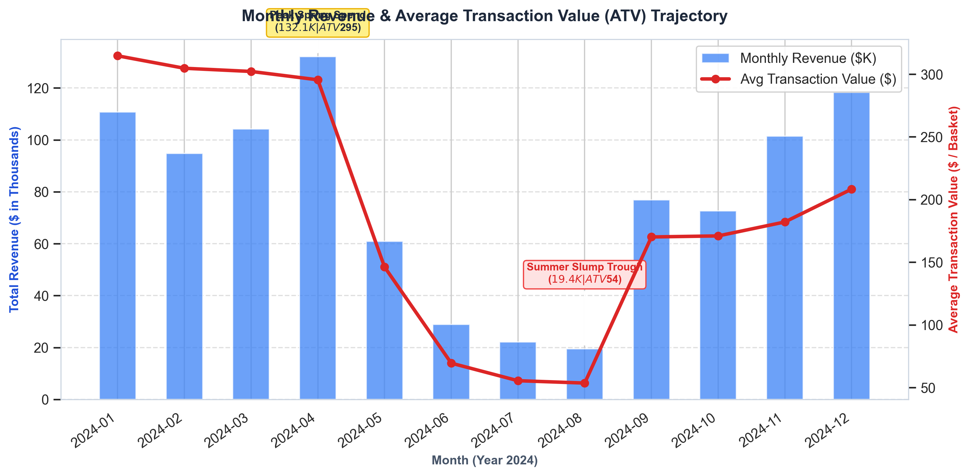
Figure: Monthly Revenue & Average Transaction Value (ATV) Trajectory
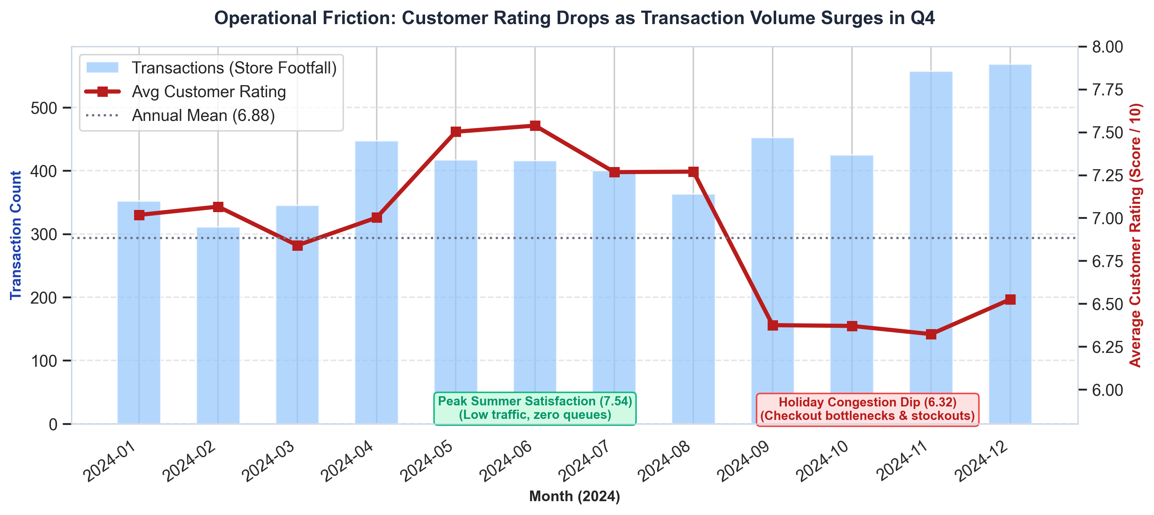
Figure: Customer Rating Paradox: Service Scores Collapse as Holiday Transaction Footfall Peaks

9. Key Business Insights
To provide maximum operational utility, each critical data finding is synthesized using the rigorous analytical formula: Fact → Insight → Recommended Action.
■ Insight 1: Loyalty Program Under-Penetration & Spend Premium
• FACT: Loyalty Members generate an Average Transaction Value of $209.29, delivering a +22.7% premium over Normal shoppers ($170.54) by purchasing both higher-priced items ($41.99 vs $38.08) and larger quantities (4.84 vs 4.42 units). However, 58.74% of all store checkouts (2,968 transactions) remain non-member Normal shoppers.
• INSIGHT: The membership program successfully cultivates high-spending behavior, but the supermarket suffers from an under-penetrated loyalty onboarding funnel. More than half of the store's footfall leaves without enrolling, depriving the business of first-party customer data and repeat spend.
• RECOMMENDED ACTION: Implement a seamless 10-second digital enrollment prompt at all checkout registers. Offer an immediate incentive: 'Join free in 10 seconds via phone number and save $5 instantly on today's basket.' Converting just 20% of Normal shoppers (594 transactions) to Member spending levels yields an estimated +$23,020 in gross revenue with zero advertising spend.

■ Insight 2: Food & Beverages as Footfall Anchor vs Low Basket Value
• FACT: Food & Beverages is the supermarket's single largest traffic driver, accounting for 33.05% of all customer checkouts (1,670 transactions) and earning the highest customer satisfaction rating (7.08/10). However, it produces the lowest ATV at $90.63 (less than half the storewide average of $186.53).
• INSIGHT: Customers view the supermarket as a reliable, high-quality grocery stop, but they treat grocery visits as isolated convenience runs. Shoppers enter, purchase routine food items, and bypass profitable discretionary merchandise aisles.
• RECOMMENDED ACTION: Restructure the retail floor plan to enforce cross-category exposure. Place high-margin kitchenware, cookware, food storage containers (Home & Lifestyle), and daily wellness supplements (Health & Beauty) in prominent end-cap displays directly inside grocery aisles. Introduce bundled meal-kit vouchers (e.g., 'Spend $30 on fresh groceries, get 20% off kitchen lifestyle tools').

■ Insight 3: The Severe Summer Revenue Slump (May to August)
• FACT: Monthly revenue suffered an 85.3% collapse from April ($132,084) to August ($19,440). Transaction counts remained relatively resilient (dropping only slightly from 447 to 363), but average unit price dropped from $57.49 to $21.80 and quantity per basket dropped from 5.20 to 2.69, causing ATV to plunge from $295.49 to $53.55.
• INSIGHT: Footfall does not evaporate during summer; rather, customer purchasing psychology fundamentally changes. Shoppers cease buying high-ticket discretionary goods (Electronics, Sports, Lifestyle) at the supermarket and restrict purchases exclusively to low-priced essential sundries and convenience foods.
• RECOMMENDED ACTION: Launch a dedicated 'Summer Living & Outdoor Living' merchandising campaign beginning in early May. Stock high-margin, seasonally relevant outdoor inventory: portable coolers, beach and camping gear, barbecue lifestyle kits, and outdoor audio equipment. Offer tiered bundle discounts (e.g., 'Summer Cooler + Picnic Set') to maintain basket values above $150.

■ Insight 4: Regional Branch Specialization (Queens ATV vs Brooklyn Volume)
• FACT: While total revenue is evenly split across boroughs (~$310K to $320K each), Queens generates the highest ATV ($201.19) from the lowest transaction count (1,555), whereas Brooklyn captures the highest transaction footfall (1,793 orders) at an ATV of $178.31. Manhattan achieves the highest customer satisfaction score (6.91/10).
• INSIGHT: The three branches serve fundamentally distinct customer demographics: Queens represents suburban family shoppers making planned bulk purchases; Brooklyn functions as an urban high-density convenience hub for frequent small baskets; Manhattan caters to service-sensitive working professionals.
• RECOMMENDED ACTION: Tailor store assortments by borough: (1) Queens: Expand family-pack bulk groceries, home goods displays, and multi-pack volume discounts. (2) Brooklyn: Optimize self-checkout lanes, grab-and-go convenience meals, and fast-moving replenishment. (3) Manhattan: Maintain premium branded assortments, concierge customer service, and express digital scan-and-go features.

■ Insight 5: Operational Congestion & Service Breakdown in Q4
• FACT: Customer satisfaction ratings achieved peak highs during the low-traffic summer period (7.54/10 in June), but cratered to annual lows during peak holiday footfall (6.32/10 in November and 6.53/10 in December), precisely when monthly checkout volume reached record highs (557 and 568 transactions).
• INSIGHT: The supermarket's physical infrastructure and staffing model suffer from severe operational friction under peak footfall. Extended checkout lines, depleted shelf inventory, and overextended store personnel directly degrade customer experience during the most financially critical quarter.
• RECOMMENDED ACTION: Institute peak-season operational readiness protocols: (1) Hire seasonal checkout and restocking staff starting in October. (2) Deploy mobile tablet-based roaming line-busting cashiers during peak holiday hours to eliminate register queues. (3) Shift heavy restocking to overnight shifts to maintain 100% on-shelf availability throughout daytime shopping hours.

■ Insight 6: Underperformance of Fashion & Accessories
• FACT: Fashion & Accessories is the weakest category in the entire store, generating only $101,843.91 (10.81% revenue share) and receiving the lowest customer satisfaction rating (6.70/10).
• INSIGHT: The current fashion assortment lacks product-market fit. Customers perceive the apparel and accessories collection as uninspired, poor quality, or uncompetitively priced relative to dedicated apparel retailers.
• RECOMMENDED ACTION: Perform an immediate SKU rationalization audit. Clear slow-moving apparel lines with a 30% clearance discount, reallocating prime floor space to high-performing Home & Lifestyle and Health & Beauty lines. Pivot the remaining fashion mix to high-turnover athleisure, seasonal basics (socks, umbrellas, winter knitwear), and everyday essentials.

10. Risks & Threat Assessment
Based on the empirical findings, the supermarket enterprise faces four significant operational and financial risks:
1. Severe Seasonal Cash Flow Volatility: The dramatic revenue drop from $132K in April to $19K in August represents an 85% top-line contraction. Fixed overhead costs (rent, utilities, baseline labor) can easily plunge branches into operating losses during Q2/Q3 without aggressive seasonal intervention.
2. Brand Erosion & Peak-Period Churn: A rating decline to 6.32 during peak holiday months risks permanently alienating high-value shoppers. In retail, poor checkout experiences during holiday peaks drive customers to competing supermarkets and online delivery services.
3. Deadstock & Margin Dilution in Apparel: With Fashion & Accessories generating sub-par returns ($101.8K) and poor customer reviews (6.70 rating), holding stagnant clothing stock ties up working capital and causes retail floor space depreciation.
4. Data Blindness on Unconverted Footfall: With 58.7% of shoppers remaining unrecorded 'Normal' customers, the business is blind to customer churn, purchase frequency, and individual lifetime value, leaving it vulnerable to aggressive loyalty campaigns by competitors.

11. Opportunities & Strategic Growth Levers
Conversely, the data reveals high-ROI strategic growth levers that management can immediately execute:
1. Loyalty Conversion Monetization: Converting 20% of Normal transactions (594 orders) to Member spending levels ($209.29 vs $170.54) unlocks an immediate +$23,020 in gross revenue. Converting 50% yields +$57,550 in incremental annual sales with zero customer acquisition ad spend.
2. Grocery Traffic Cross-Merchandising: Food & Beverages provides 1,670 built-in store visits. Introducing impulse-friendly kitchen tools, dining accessories, and wellness products into grocery aisles can lift grocery ATV from $90.63 toward $120.00 (+32% category lift).
3. Queens Bulk-Basket Expansion: Queens shoppers already demonstrate strong willingness to buy in bulk ($201.19 ATV). Introducing family club packs and wholesale-style multi-buys in Queens can lift basket size past $230.00.
4. High-Ticket Tender Partnerships: Credit card transactions generate the highest ATV ($195.25). Partnering with payment networks (Visa/Mastercard) for co-branded weekend cashback on baskets over $200 incentivizes shoppers to cross threshold spending limits.

12. Practical Business Recommendations & Action Roadmap
To execute these insights systematically, management should implement the following three-phase operational roadmap:
Implementation Horizon | Strategic Focus | Concrete Action Deliverables
Phase 1: Immediate  (Days 1 – 30) | Operational Quick Wins &  PENETRATION | • Launch 10-second POS loyalty enrollment offering instant $5 basket discount  • Deploy mobile tablet checkouts in Brooklyn during rush hours  • Relocate high-margin Home & Lifestyle end-caps into grocery aisles
Phase 2: Medium-Term  (Days 31 – 90) | Assortment & Campaign  OPTIMIZATION | • Execute 30% markdown on slow Fashion SKUs; reallocate space to Home goods  • Partner with credit card issuers for co-branded $15 rebates on spend >$175  • Introduce family-size bulk merchandise packs exclusively in Queens branch
Phase 3: Long-Term  (Months 4 – 12) | Structural & Seasonal  TRANSFORMATION | • Launch curated 'Summer Living & Outdoor' campaign in May to hedge summer slump  • Implement overnight restocking shifts to eliminate daytime out-of-stock complaints  • Build personalized omnichannel CRM triggers based on customer category preferences

13. Conclusion
This project provides a comprehensive, empirically verified analysis of the supermarket sales dataset. By combining rigorous data hygiene, multi-dimensional Exploratory Data Analysis, and KPI benchmarking, the study has uncovered critical drivers of retail performance:
1. Loyalty members are substantially more profitable than non-members (+22.7% ATV premium), establishing customer onboarding as the single most accessible growth lever.
2. Food & Beverages anchors 33% of store visits but requires strategic cross-merchandising to lift basket values.
3. An 85% summer revenue slump must be actively countered with seasonal outdoor and lifestyle merchandising.
4. Operational capacity bottlenecks in Q4 degrade customer satisfaction during the most profitable quarter of the year, necessitating seasonal staff and line-busting technology.
Executing the recommended phased roadmap will enable management to protect operating margins, elevate customer satisfaction, and drive sustainable revenue expansion across all regional branches.

