**29/08/23**

**C program to implement single source shortest path**

**Code:**

#include<stdio.h>

int main()

{

int cost[10][10],i,j,n,source,target,visited[10]={0},min=999,dist[10],pre[10];

int start,m,d,path[10];

printf("Enter number of nodes: ");

scanf("%d",&n);

printf("Enter weight of all the paths in adjacency matrix form\n");

for(i=1;i<=n;i++)

{

for(j=1;j<=n;j++)

{

scanf("%d",&cost[i][j]);

if(cost[i][j]==0)

cost[i][j]=999;

}

}

printf("\nEnter the source:");

scanf("%d",&source);

printf("\nEnter the target:");

scanf("%d",&target);

start=source;

for(i=1;i<=n;i++)

{

dist[i]=999;

pre[i]=-1;

}

visited[source]=1;

dist[source]=0;

while(visited[target]==0)

{

min=999;

m=0;

for(i=1;i<=n;i++)

{

d=dist[start]+cost[start][i];

if(d<dist[i] && visited[i]==0)

{

dist[i]=d;

pre[i]=start;

}

if(min>dist[i] && visited[i]==0)

{

min=dist[i];

m=i;

}

}

start=m;

visited[m]=1;

}

start=target;

j=0;

while(start!=-1)

{

path[j++]=start;

start=pre[start];

}

for(i=j-1;i>=0;i--)

{

if(i!=j-1)

printf(" to ");

printf("%d",path[i]);

}

printf("\n shortest path is %d",dist[target]);

return 0;

}

**Sample input & output:**

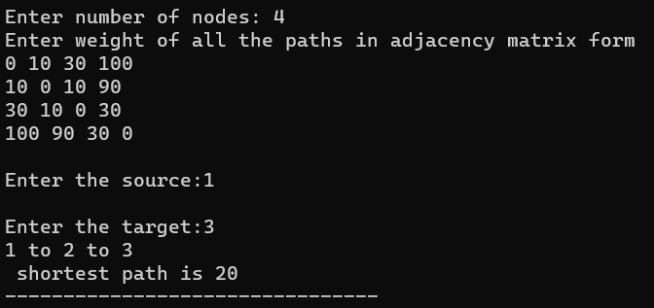

**C program to implement prim’s algorithm**

**Code:**

#include<stdio.h>

#include<stdlib.h>

#define infinity 9999

#define MAX 20

int G[MAX][MAX],spanning[MAX][MAX],n;

int prims();

int main()

{

int i,j,total_cost;

printf("Enter no. of vertices:");

scanf("%d",&n);

printf("\nEnter the adjacency matrix:\n");

for(i=0;i<n;i++)

for(j=0;j<n;j++)

scanf("%d",&G[i][j]);

total_cost=prims();

printf("\nspanning tree matrix:\n");

for(i=0;i<n;i++)

{

printf("\n");

for(j=0;j<n;j++)

printf("%d\t",spanning[i][j]);

}

printf("\n\nTotal cost of spanning tree=%d",total_cost);

return 0;

}

int prims()

{

int cost[MAX][MAX];

int u,v,min_distance,distance[MAX],from[MAX];

int visited[MAX],no_of_edges,i,min_cost,j;

for(i=0;i<n;i++)

for(j=0;j<n;j++)

{

if(G[i][j]==0)

cost[i][j]=infinity;

else

cost[i][j]=G[i][j];

spanning[i][j]=0;

}

distance[0]=0;

visited[0]=1;

for(i=1;i<n;i++)

{

distance[i]=cost[0][i];

from[i]=0;

visited[i]=0;

}

min_cost=0;

no_of_edges=n-1;

while(no_of_edges>0)

{

min_distance=infinity;

for(i=1;i<n;i++)

if(visited[i]==0&&distance[i]<min_distance)

{

v=i;

min_distance=distance[i];

}

u=from[v];

spanning[u][v]=distance[v];

spanning[v][u]=distance[v];

no_of_edges--;

visited[v]=1;

for(i=1;i<n;i++)

if(visited[i]==0&&cost[i][v]<distance[i])

{

distance[i]=cost[i][v];

from[i]=v;

}

min_cost=min_cost+cost[u][v];

}

return(min_cost);

}

**Sample input & output:**

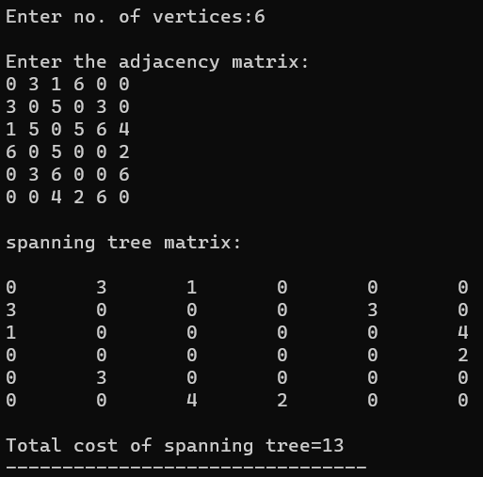

**C program to implement kruskal’s algorithm**

**Code:**

#include <stdio.h>

#define MAX 30

typedef struct edge {

int u, v, w;

} edge;

typedef struct edge_list {

edge data[MAX];

int n;

} edge_list;

edge_list elist;

int Graph[MAX][MAX], n;

edge_list spanlist;

void kruskalAlgo();

int find(int belongs[], int vertexno);

void applyUnion(int belongs[], int c1, int c2);

void sort();

void print();

void kruskalAlgo() {

int belongs[MAX], i, j, cno1, cno2;

elist.n = 0;

for (i = 1; i < n; i++)

for (j = 0; j < i; j++) {

if (Graph[i][j] != 0) {

elist.data[elist.n].u = i;

elist.data[elist.n].v = j;

elist.data[elist.n].w = Graph[i][j];

elist.n++;

}

}

sort();

for (i = 0; i < n; i++)

belongs[i] = i;

spanlist.n = 0;

for (i = 0; i < elist.n; i++) {

cno1 = find(belongs, elist.data[i].u);

cno2 = find(belongs, elist.data[i].v);

if (cno1 != cno2) {

spanlist.data[spanlist.n] = elist.data[i];

spanlist.n = spanlist.n + 1;

applyUnion(belongs, cno1, cno2);

}

}

}

int find(int belongs[], int vertexno) {

return (belongs[vertexno]);

}

void applyUnion(int belongs[], int c1, int c2) {

int i;

for (i = 0; i < n; i++)

if (belongs[i] == c2)

belongs[i] = c1;

}

void sort() {

int i, j;

edge temp;

for (i = 1; i < elist.n; i++)

for (j = 0; j < elist.n - 1; j++)

if (elist.data[j].w > elist.data[j + 1].w) {

temp = elist.data[j];

elist.data[j] = elist.data[j + 1];

elist.data[j + 1] = temp;

}

}

void print() {

int i, cost = 0;

for (i = 0; i < spanlist.n; i++) {

printf("\n%d - %d : %d", spanlist.data[i].u, spanlist.data[i].v, spanlist.data[i].w);

cost = cost + spanlist.data[i].w;

}

printf("\nSpanning tree cost: %d", cost);

}

int main() {

int i, j, total_cost;

n = 6;

Graph[0][0] = 0;

Graph[0][1] = 4;

Graph[0][2] = 4;

Graph[0][3] = 0;

Graph[0][4] = 0;

Graph[0][5] = 0;

Graph[0][6] = 0;

Graph[1][0] = 4;

Graph[1][1] = 0;

Graph[1][2] = 2;

Graph[1][3] = 0;

Graph[1][4] = 0;

Graph[1][5] = 0;

Graph[1][6] = 0;

Graph[2][0] = 4;

Graph[2][1] = 2;

Graph[2][2] = 0;

Graph[2][3] = 3;

Graph[2][4] = 4;

Graph[2][5] = 0;

Graph[2][6] = 0;

Graph[3][0] = 0;

Graph[3][1] = 0;

Graph[3][2] = 3;

Graph[3][3] = 0;

Graph[3][4] = 3;

Graph[3][5] = 0;

Graph[3][6] = 0;

Graph[4][0] = 0;

Graph[4][1] = 0;

Graph[4][2] = 4;

Graph[4][3] = 3;

Graph[4][4] = 0;

Graph[4][5] = 0;

Graph[4][6] = 0;

Graph[5][0] = 0;

Graph[5][1] = 0;

Graph[5][2] = 2;

Graph[5][3] = 0;

Graph[5][4] = 3;

Graph[5][5] = 0;

Graph[5][6] = 0;

kruskalAlgo();

print();

}

**Sample input & output:**

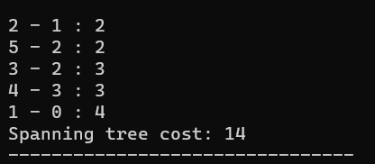

**C program for graph traversal depth first search**

**Code:**

#include<stdio.h>

void DFS(int);

int G[10][10],visited[10],n;

int main()

{

int i,j;

printf("Enter number of vertices:");

scanf("%d",&n);

printf("\nEnter adjecency matrix of the graph:");

for(i=0;i<n;i++)

for(j=0;j<n;j++)

scanf("%d",&G[i][j]);

for(i=0;i<n;i++)

visited[i]=0;

DFS(0);

}

void DFS(int i)

{

int j;

printf("\n%d",i);

visited[i]=1;

for(j=0;j<n;j++)

if(!visited[j]&&G[i][j]==1)

DFS(j);

}

**Sample input & output:**

