

Multimedia University

CCP6124 Object Oriented Programming and Data Structures 2410

Lecture section: TC3L
Tutorial section: T11L
Group number: 21
Group leader student name: VENICE GOH KIT YEE

Num | Student  ID | Student Name by  alphabetical order | Task Descriptions | Percentage (%)
1 | 12111111818 | AARON LIM CJUN SHIEN | Report, UML, Kill, Reenter (inc linkedlist & queue) | 25
2 | 1211108881 | LEE HONG YI | Report, UML, actionMove, actionLook | 25
3 | 121110886 | VENICE GOH KIT YEE | Report, UML, Display Battlefield (inc overload), Upgrade | 25
4 | 1211108527 | WONG HUI TING | Report, UML, actionFire, actionStep | 25
 |  |  | Total | 100%

Assignment Evaluation Criteria (40%)
Student 1
Student ID | 1211111818 | Total Score 40%
Student name | AARON LIM CJUN SHIEN
Task descriptions | Report, UML, Kill, Reenter (inc linkedlist & queue)

Student 2
Student ID | 1211108881 | Total Score 40%
Student name | LEE HONG YI
Task descriptions | Report, UML, actionMove, actionLook

Student 3
Student ID | 1211108846 | Total Score 40%
Student name | VENICE GOH KIT YEE
Task descriptions | Report, UML, Display Battlefield (inc overload), Upgrade

Student 4
Student ID | 1211108527 | Total Score 40%
Student name | WONG HUI TING
Task descriptions | Report, UML, actionRire, actionStep

Assignment implementation (30%)
Criteria | Max | A1 | A2 | Mark
Q1. Design documentation, UML class diagram, two sample inputs and outputs or -30  - has UML class diagram + screenshots (inputs, outputs) + figures,  - has code segments + pseudocodes,  - accept & has explanations, good, great | 5 | * | * | ?
Q2. Initialization of a simulation, read input file and output initial of all robots, fixed seed integer for random functions | 1 | * | * | ?
Q3. Display and logging of the status of the battlefield of robots at each turn  - accept & has file output, good, great | 3 | * | * | ?
Q4. Display and logging of the robot actions and the status of each robot at each turn  - accept & has file output, good, great | 3 | * | * | ?
Q5. Implementation of the required 7 robot classes with OOP concepts +1 or I&P&OO -3 | 8 | * | * | ?
Q6. The algorithms used to optimize the actions of robots, optimize the two actions or -2  - has screenshots (inputs, outputs) + figures,  - has code segments + pseudocodes,  - accept & has explanations, good, great | 5 |  | * | ?
Q7. Design and implementation of data structures, linked list and queues or -2  - has linked list with screenshots (inputs, outputs) + figures + code segments + explanations + linked list to keep track robot actions during the simulation,  - has queues with screenshots (inputs, outputs) + figures + code segments + explanations + two queues to keep track of the destroyed and waiting robots,  - accept & has explanations, good, great | 5 |  | * | ?
Q8. Extra
Implementation of additional three robot classes | 3
Total | 33 => 30 |  |  | ?

Examined with the additional term test
Item  9. Questions added as part of the assignment (individual marks) |  | Maximum marks | Actual  Marks
- Student Name 1: AARON LIM CJUN SHIEN  - Student Name 2: LEE HONG YI  - Student Name 3: VENICE GOH KIT YEE  - Student Name 4: WONG HUI TING |  | 10 | ?1  ?2  ?3  ?4
Total |  | 40 | ?1  ?2  ?3  ?4

Additional Comments

Table of contents with page numbers and links

Q1. [5] Design documentation, UML class diagram, two sample inputs and outputs 3
Explanation: 3
Sample 1 input file 3
Sample 2 input file 3
Q2. [1] Initialization of a simulation, read input file and output initial of all robots, fixed seed integer for random functions 3
Initialization of simulation 3
Read Input file, output initial of all robots and fixed seed integer for random functions 3
Q3. [3] Display and logging of the status of the battlefield of robots at each turn 3
Q4. [3] Display and logging of the robot actions and the status of each robot at each turn 3
a. RoboCop: 3
b. Terminator: 3
c. TerminatorRoboCop: 3
d. BlueThunder: 3
e. Madbot: 3
f. RoboTank: 3
g. UltimateRobot: 3
Q5. [8] Implementation of the required 7 robot classes with OOP concepts +1 or I&P&OO -3 3
Inheritance 3
Polymorphism 3
Operator overloading 3
Q6. [5] The algorithms used to optimize the actions of robots, optimize the two actions or -2 3
Algorithm 1 optimize the action MOVE, figures, explanations 3
Algorithm 2 optimize the action FIRE, figures, explanations 3
Q7. [5] Design and implementation of data structures, linked list and queues or –2 3
Linked List: 3
Two queues: 3

Questions Section

Q1. [5] Design documentation, UML class diagram, two sample inputs and outputs

Screenshots (inputs, outputs), figures, UML class diagram, explanations
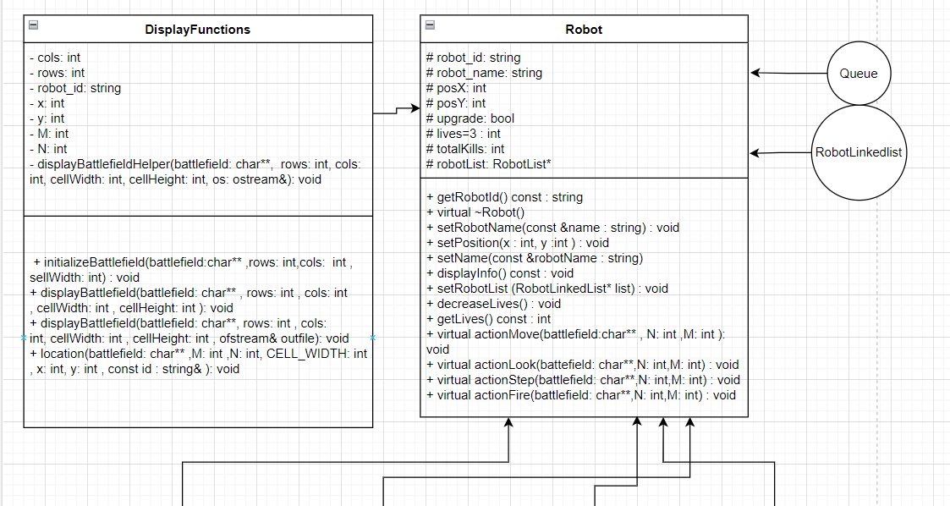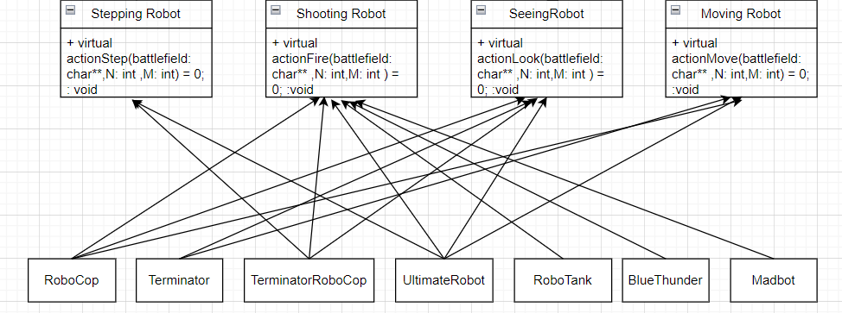
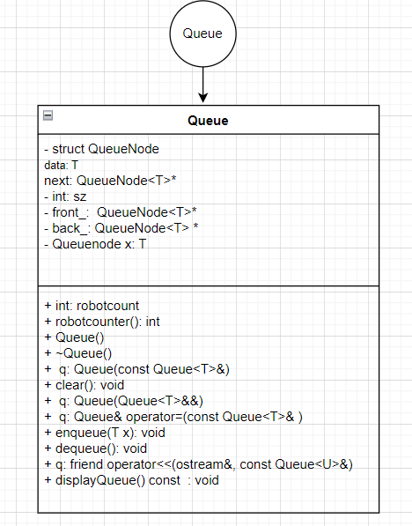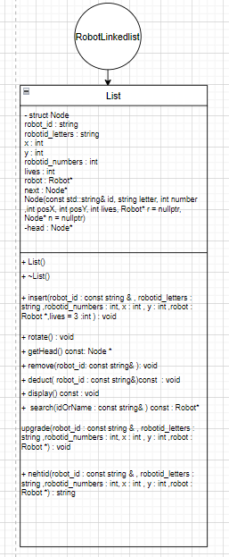
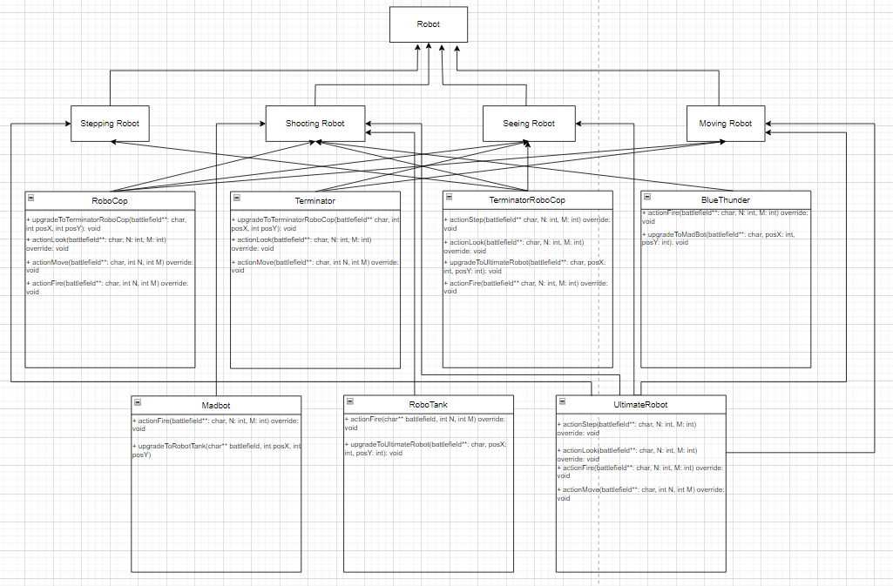

Explanation:
- The generalization relationships from SeeingRobot, MovingRobot, ShootingRobot, and SteppingRobot to Robot indicate inheritance, showing that these classes are derived from the Robot base class.

- The 7 robots have associations with Battlefield through methods that take a Battlefield* parameter.

- RoboCop is inherited from SeeingRobot, MovingRobot, and ShootingRobot.

- Terminator inherits from SeeingRobot and MovingRobot.

- TerminatorRoboCop inherits from SeeingRobot, ShootingRobot, and SteppingRobot.

- UltimateRobot inherits from SeeingRobot, MovingRobot, ShootingRobot, and SteppingRobot.

- RoboTank inherits from ShootingRobot.

- BlueThunder inherits from ShootingRobot.

- Madbot inherits from ShootingRobot.

Sample 1 input file
filename: fileInput1.txt
M by N: 8 8
Turns: 10
Robots: 7
TerminatorRoboCop TR01 random random
RoboCop RC01 random random
Terminator TE01 random random
UltimateRobot UR01 random random
RoboTank RT01 random random
Madbot MB01 random random
BlueThunder BT01 random random

Sample 1 output file
filename: fileOutput1.txt
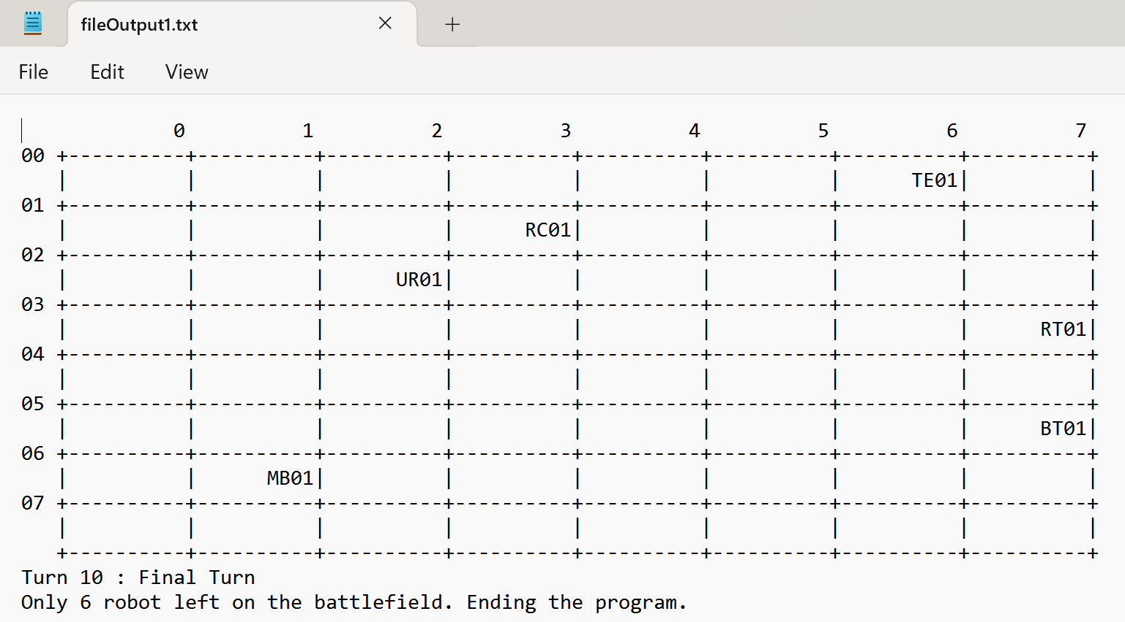

step by step screenshot outputs, output file, explanations
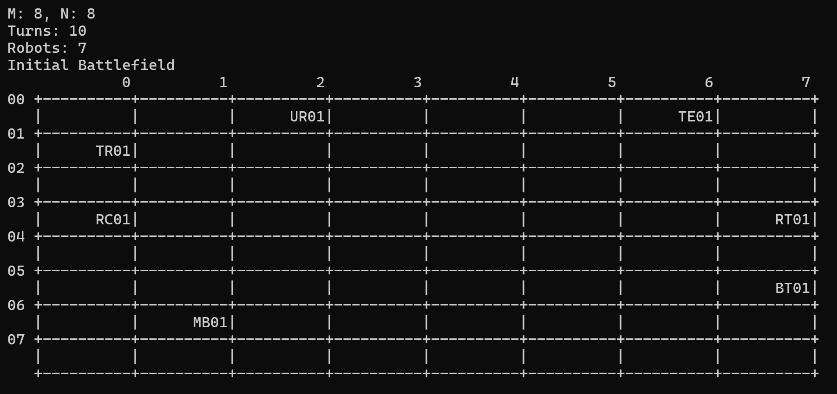Explanation: The initial Battlefield is displayed.

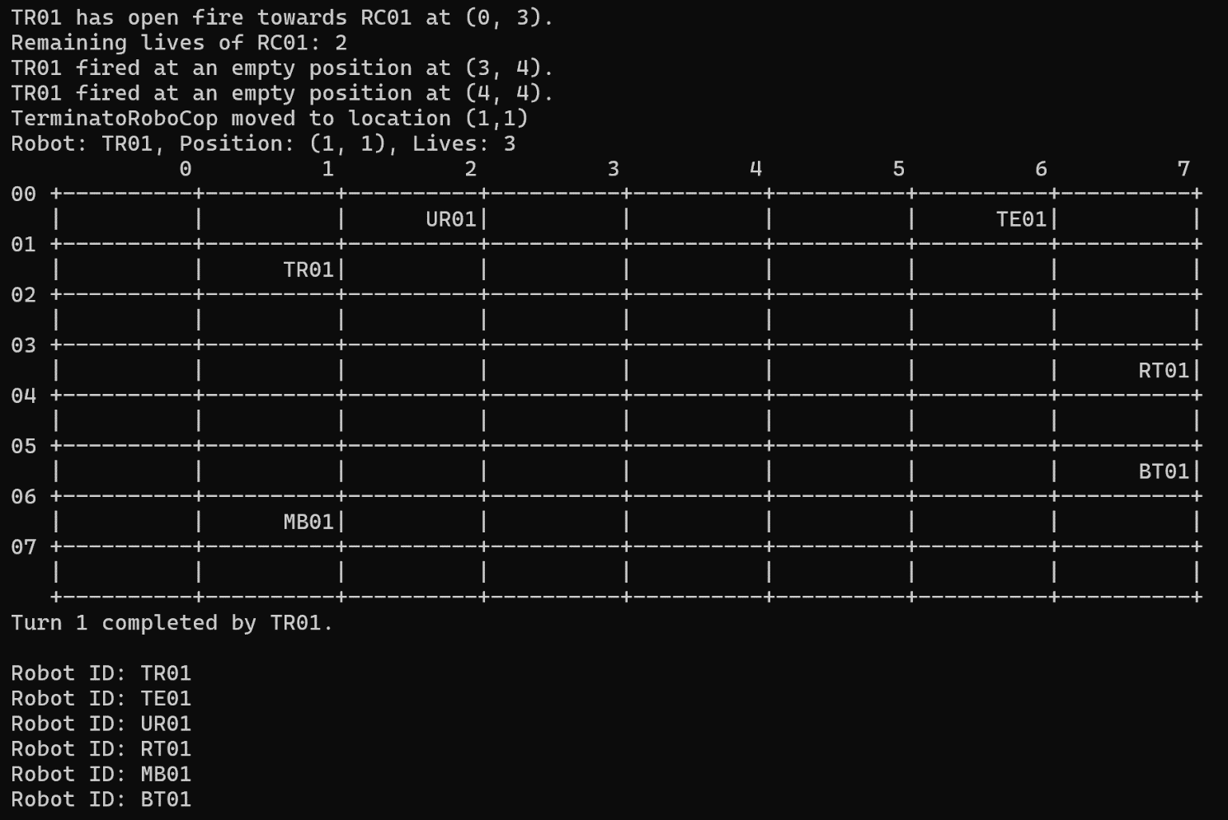Explanation:
TerminatorRoboCop fires three times and shoots RoboCop, RoboCop is removed from robot list and insert into reenter queue. RoboCop’s remaining lives decrease from 3 to 2. TerminatorRoboCop then moves to location (1,1).
Reentry Queue: RC01
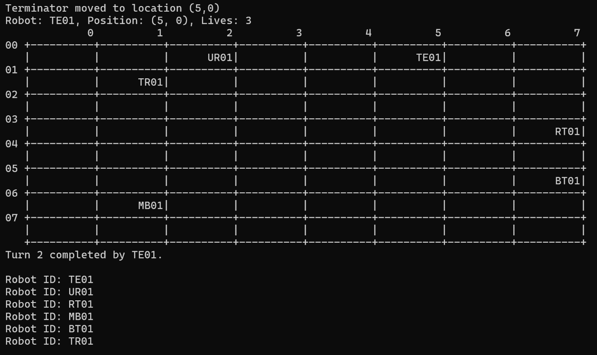Explanation: Terminator moved to location (5,0).
Reentry Queue: RC01

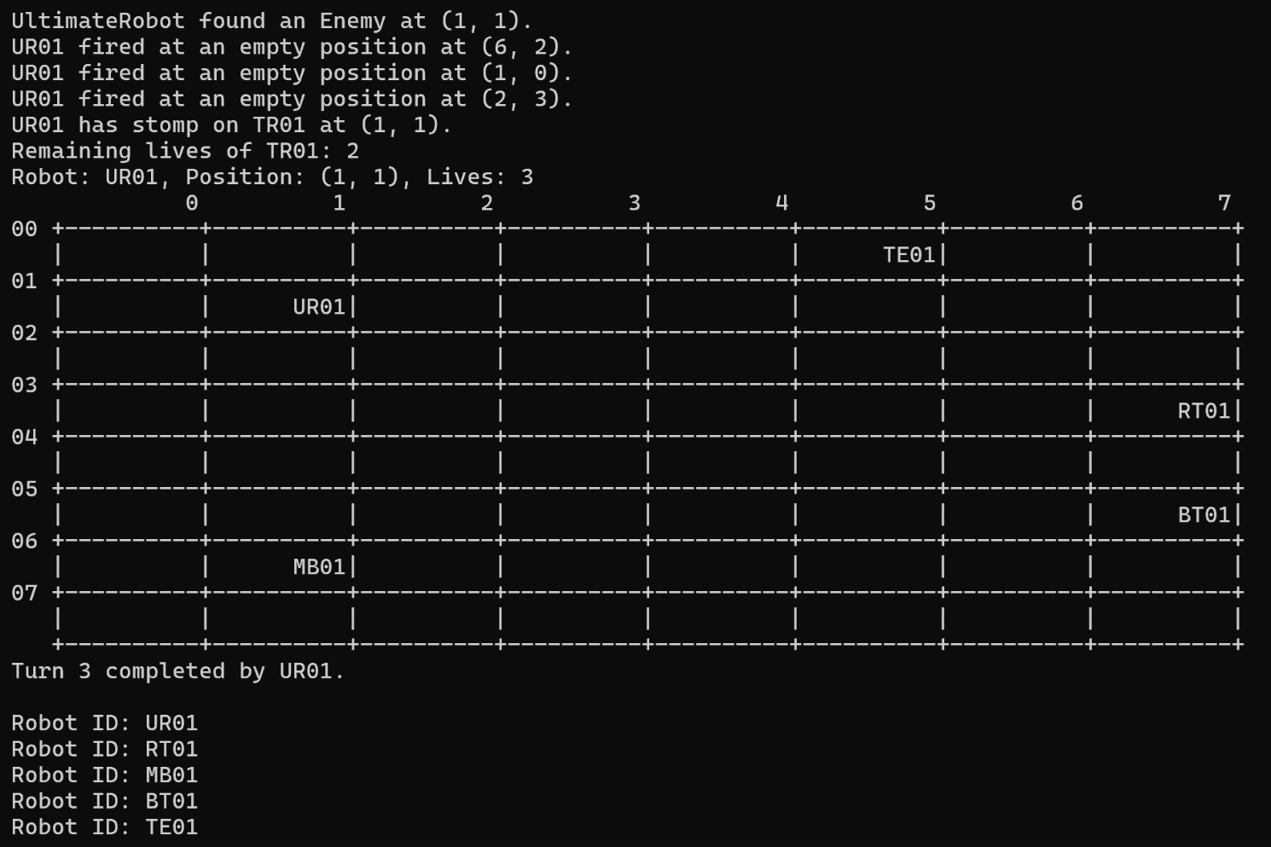Explanation:
UltimateRobot looks around it and detects an enemy. Fires three times and steps on TerminatorRoboCop at location (1,1), TerminatorRoboCop is removed from robot list and insert into reentry queue. TerminatorRoboCop’s remaining lives decrease from 3 to 2.
Reentry Queue: RC01 TR01
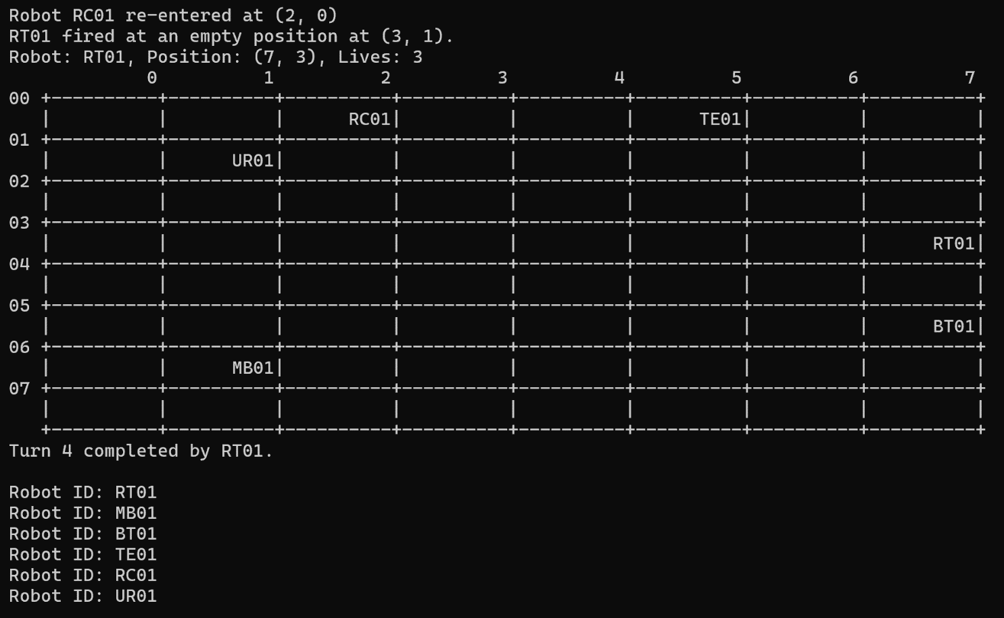Explanation: RoboCop re-entered at a random position (2,0) when there were 2 robots queueing in the robot list (RoboCop and TerminatorRoboCop). RoboTank fired at an empty position (3,1).
Reentry Queue: TR01

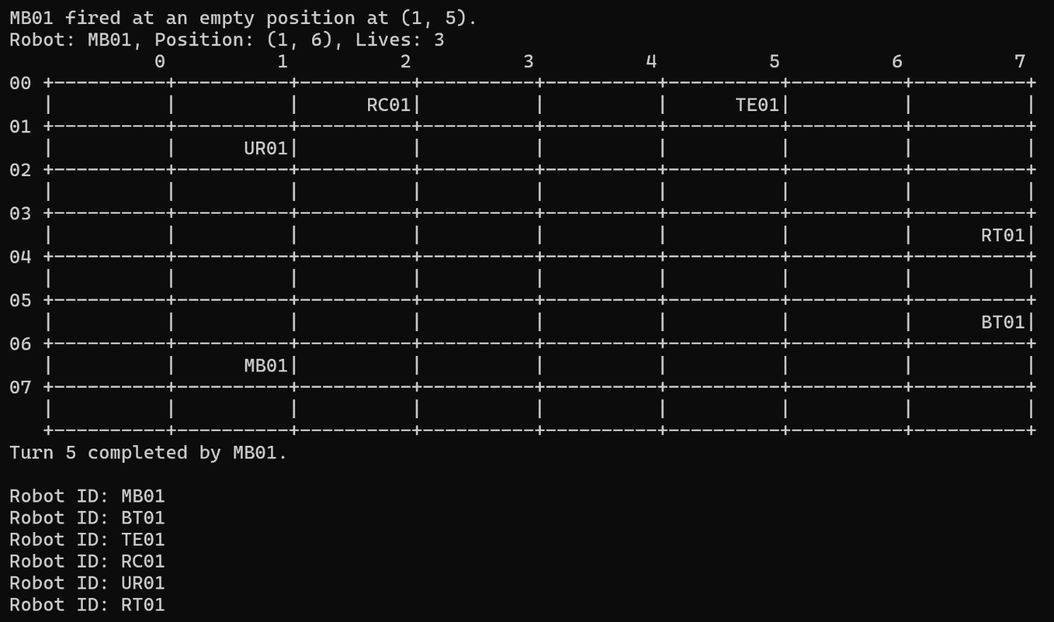Explanation: Madbot fired at an empty position (1, 5).
Reentry Queue: TR01
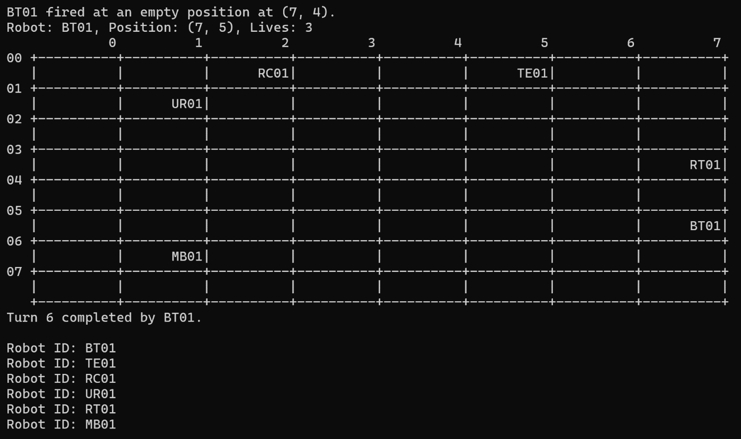Explanation: BlueThunder fired at an empty position (7, 4).
Reentry Queue: TR01

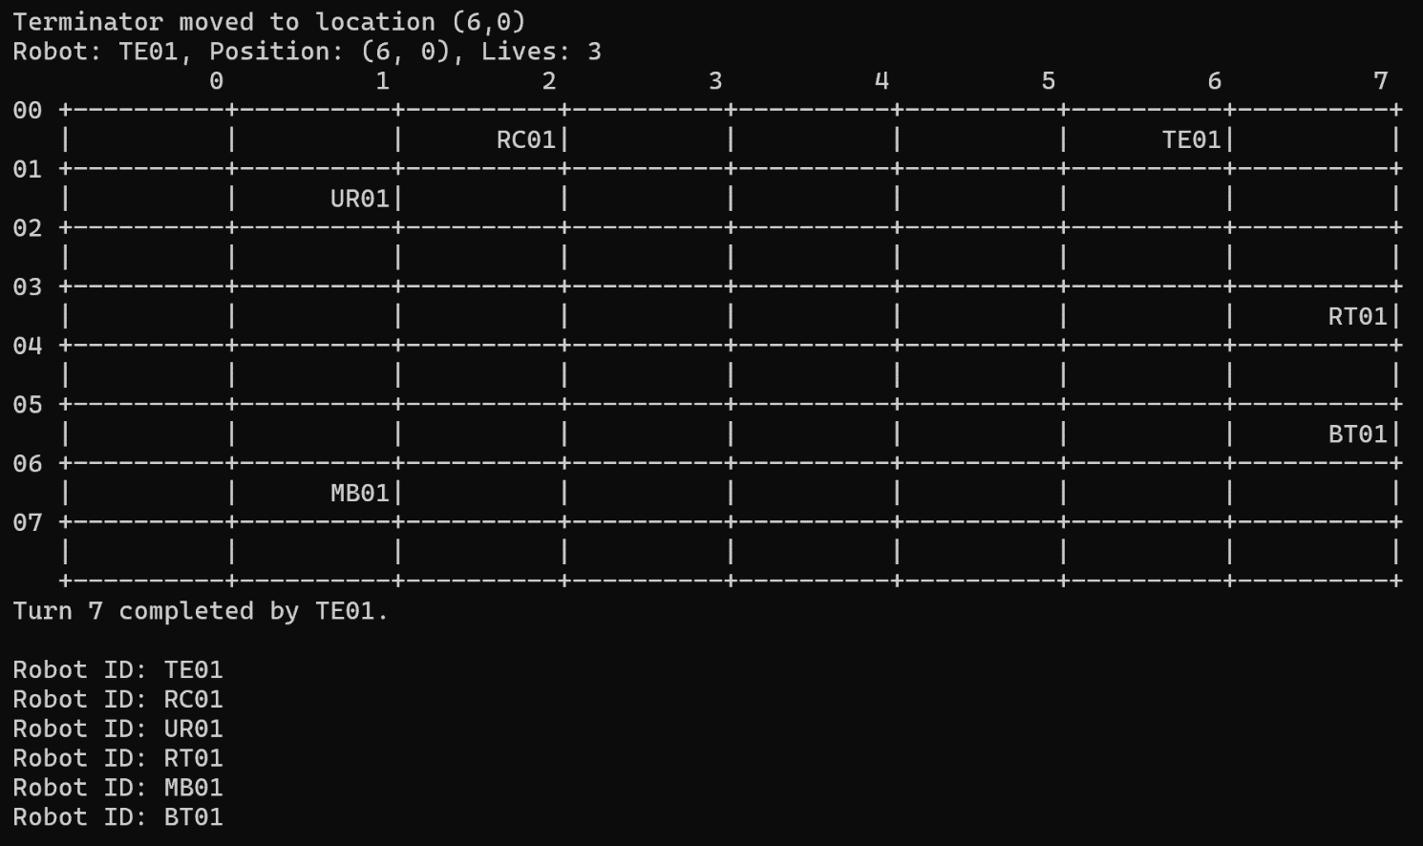Explanation: Terminator moved to location (6, 0)
Reentry Queue: TR01

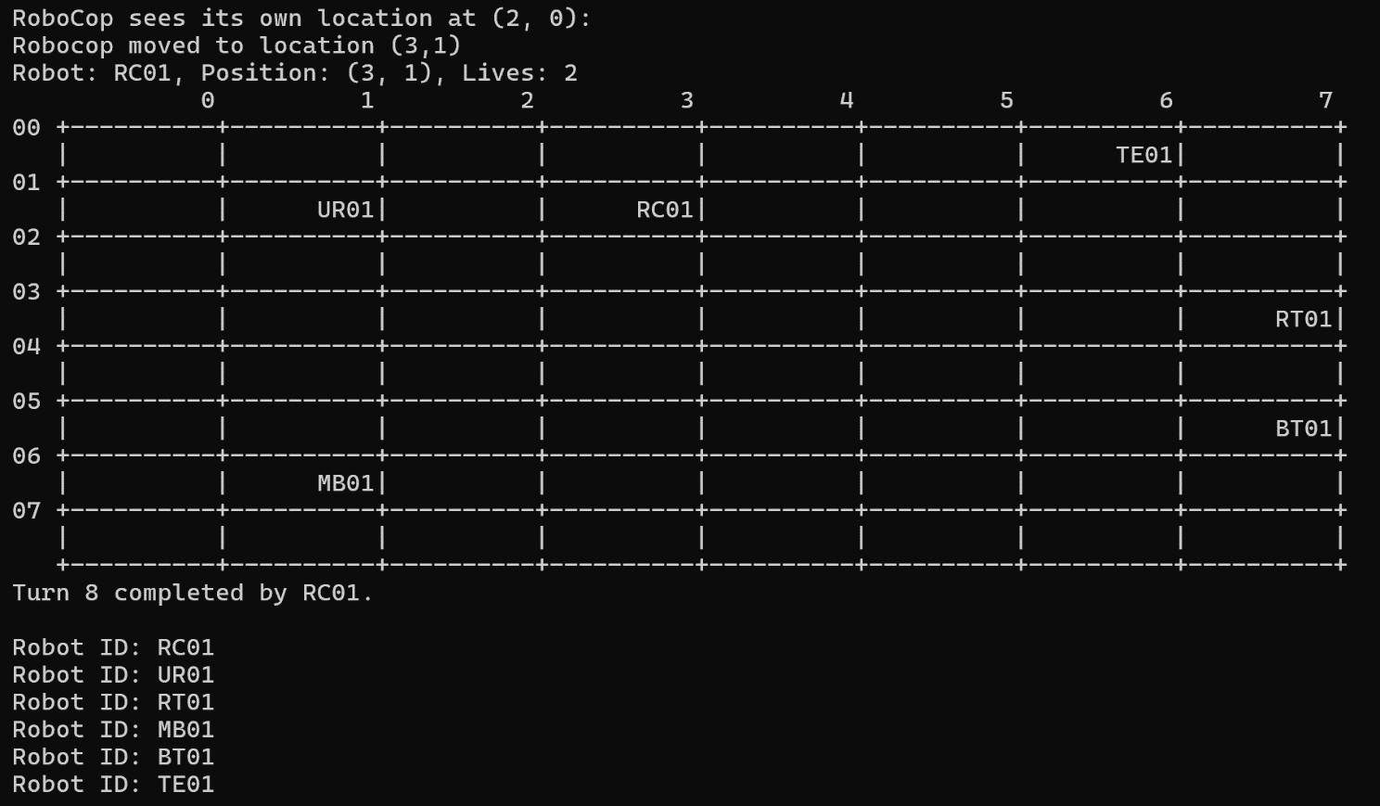Explanation: RoboCop sees its own location (2, 0) and move to location (3,1)
Reentry Queue: TR01

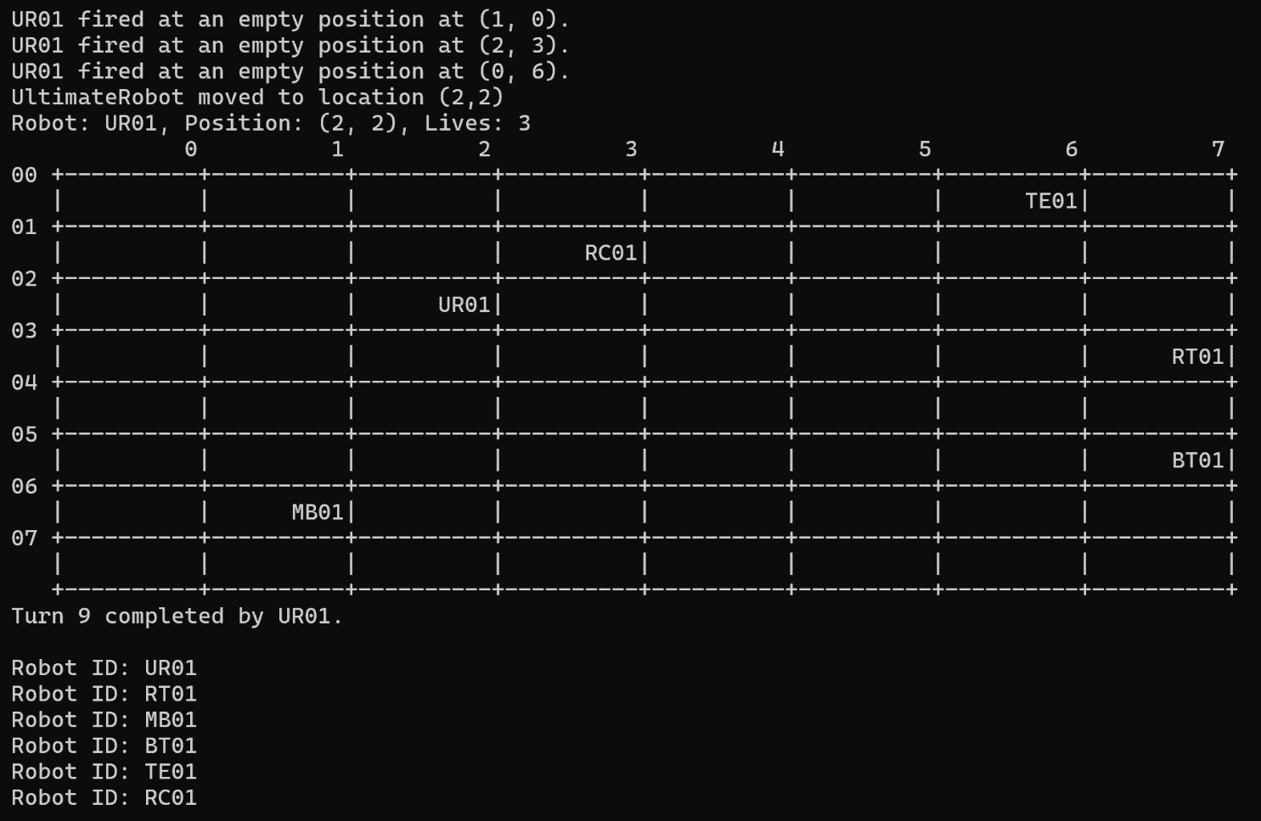Explanation:
UltimateRobot looks around and detects no enemy. Fires three times and moved to location (2,2).
Reentry Queue: TR01

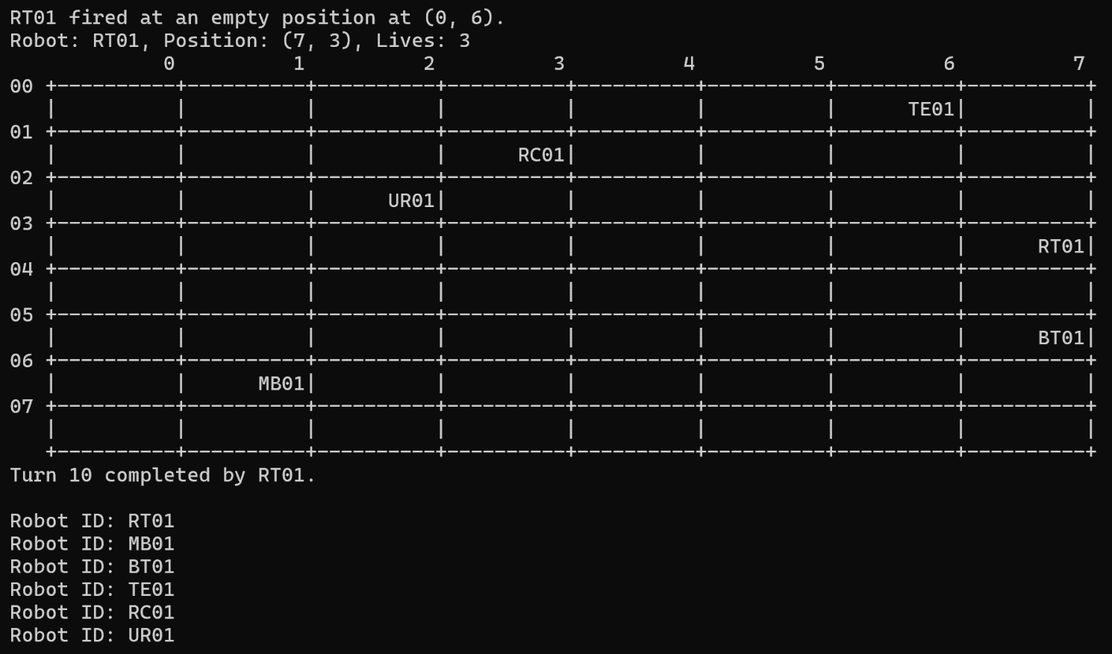Explanation: RoboTank fired at an empty position at (0, 6). Turns reached 10 as specified in input file and thus the program ends.
Reentry Queue: TR01

Sample 2 input file
filename: fileInput2.txt
/////
M by N: 5 5
Turns: 10
Robots: 5
RoboCop RC01 0 0
Terminator TE01 0 1
TerminatorRoboCop TR01 0 4
Madbot MB01 0 2
RoboCop RC02 1 1
/////

Sample 2 output file
filename: fileOutput2.txt
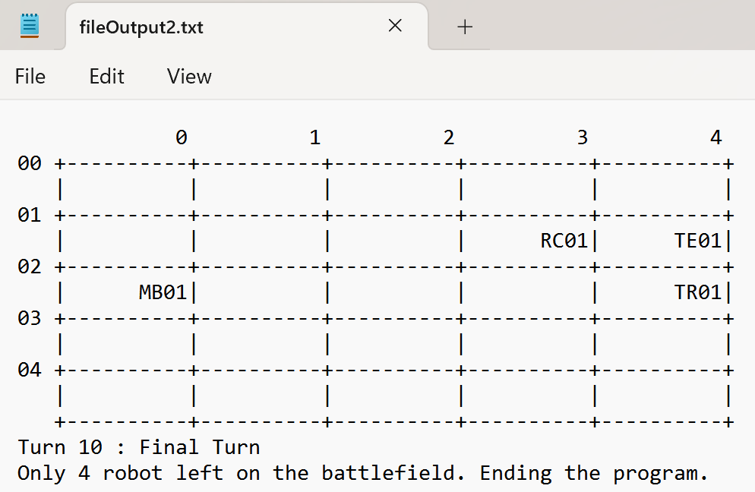

step by step screenshot outputs, output file, explanations
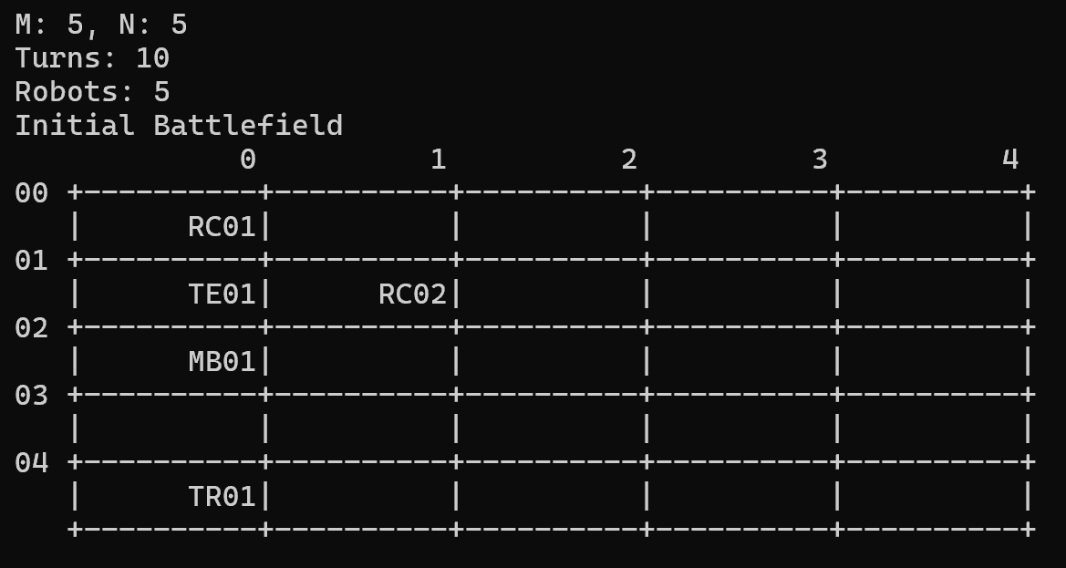Explanation: The initial Battlefield is displayed.

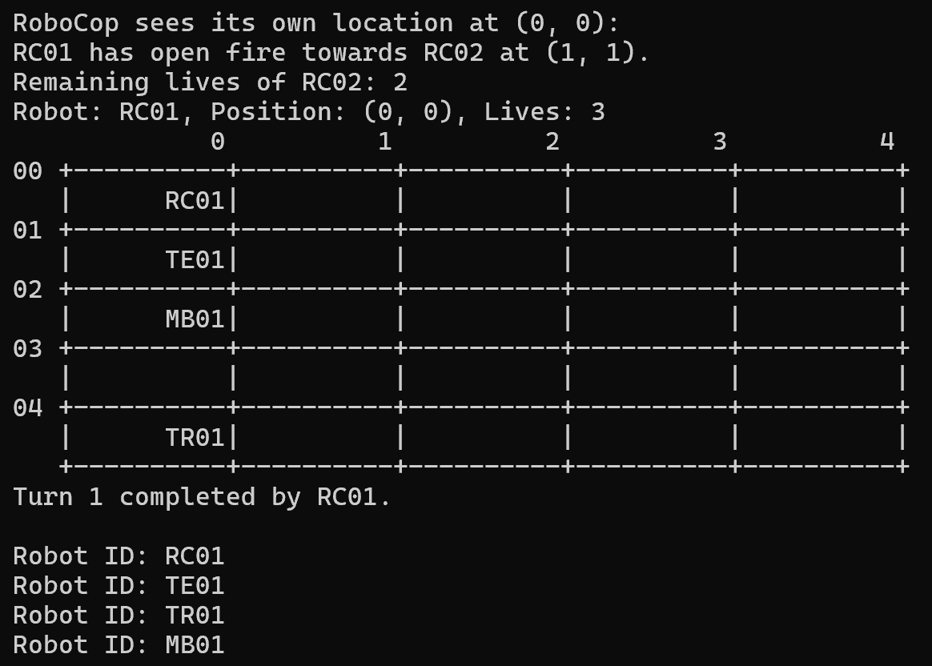Explanation: Robocop (RC01) looks at its own location (0,0) and fires towards RoboCop (RC02) at (1, 1). RC02 is removed from robot list and insert into reentry queue. RC02’s remaining lives decrease from 3 to 2.
Reentry Queue: RC02
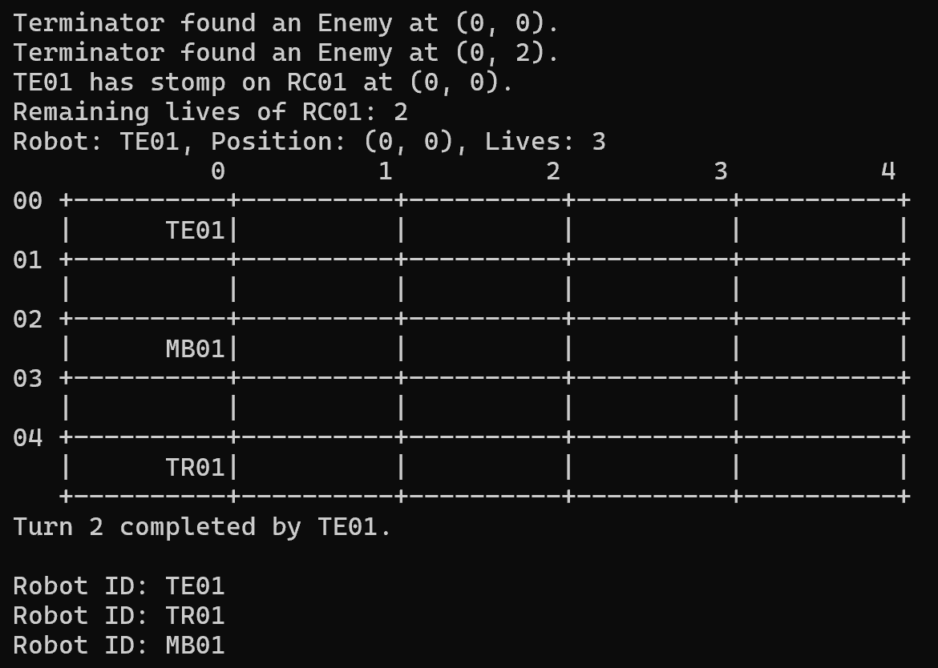Explanation: Terminator detects two enemies around it. Terminator steps on RoboCop(RC01). RC01 is removed from robot list and insert into reentry queue. RC01’s remaining lives decrease from 3 to 2.
Reentry Queue: RC02 RC01

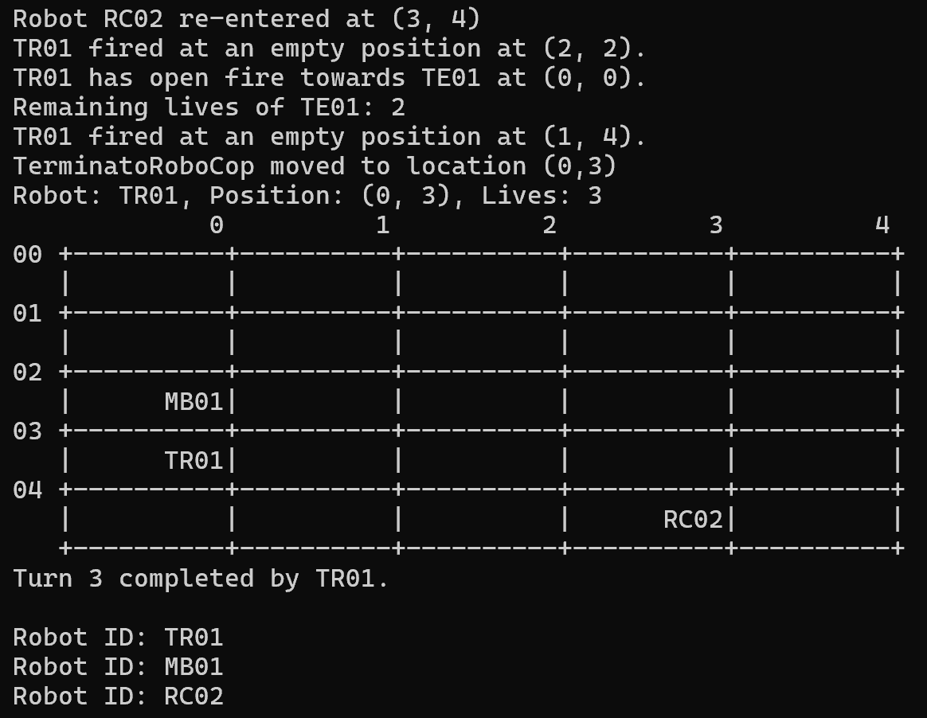Explanation: Robocop(RC02) reenters the battlefield at location (3,4). TerminatorRoboCop fires at Terminator at (0,0) and moved to location (0,3). Terminator is removed from robot list and insert into reentry queue. Terminator’s remaining lives decrease from 3 to 2.
Reentry Queue: RC01 TE01
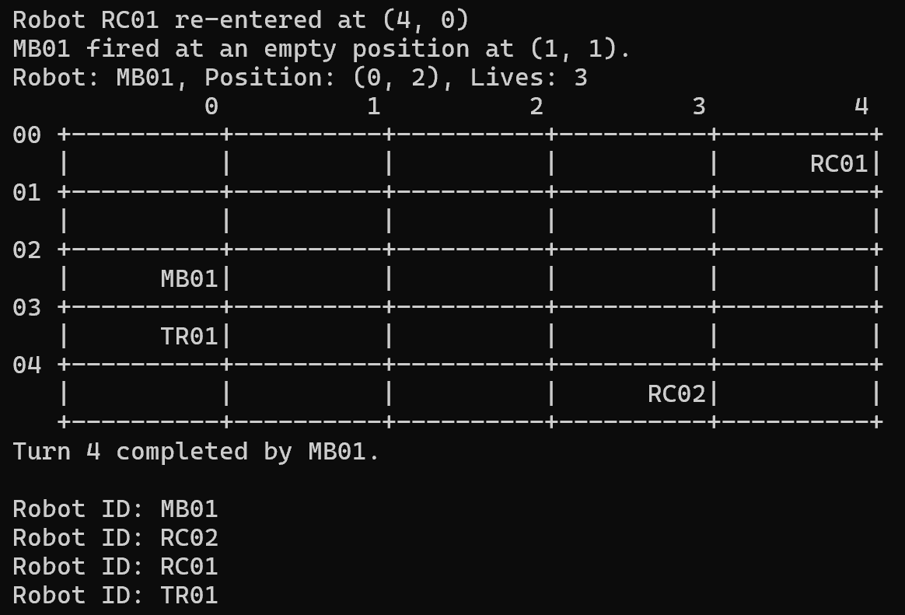Explanation: Robocop(RC01) reenters the battlefield at location (4,0). Madbot fired at an empty position (1,1).
Reentry Queue:TE01

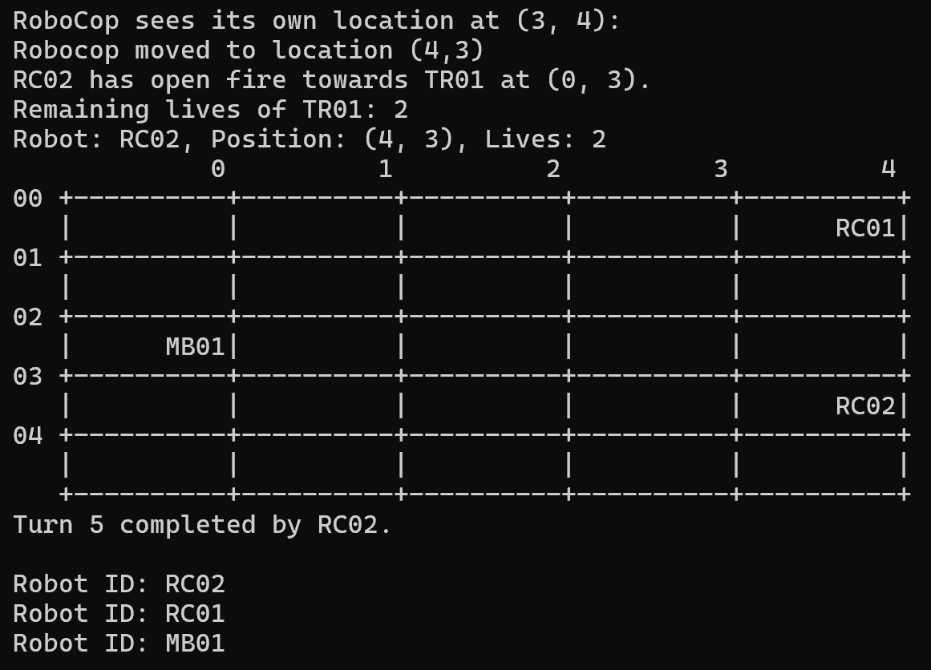Explanation: Robocop(RC02) sees its own location at (3, 4) and moves to location (4,3) then opens fire towards TerminatorRoboCop at (0, 3). TR01 is removed from robot list and insert into reentry queue. TR01’s remaining lives decrease from 3 to 2.
Reentry Queue: TE01 TR01

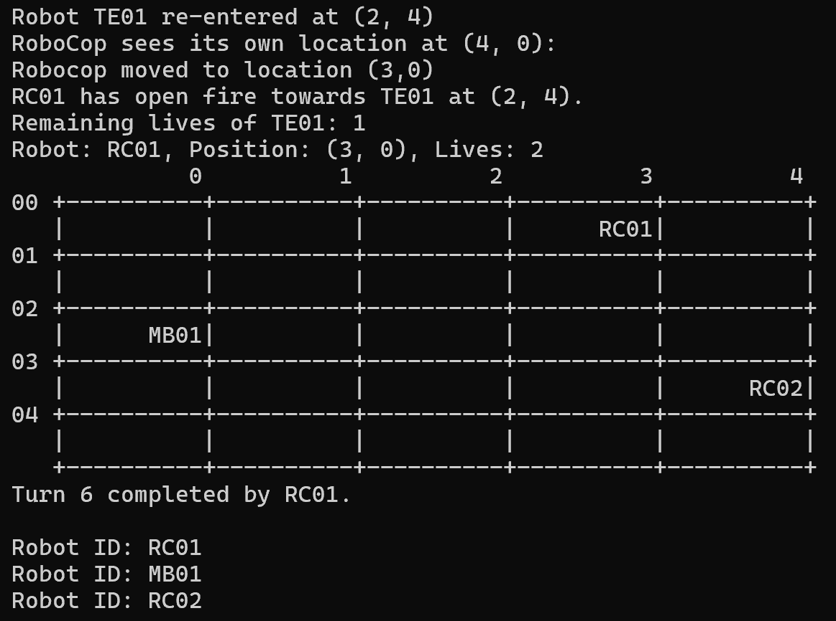Explanation:
Robot Terminator (TE01) reentered the battlefield at (2,4). Robocop(RC01) sees its own location at (4,0) moved to location (3,0) and opens fire towards Terminator at (2,4). TR01 is removed from robot list and insert into reentry queue. TR01’s remaining lives decrease from 2 to 1.

Reentry Queue: TR01 TE01

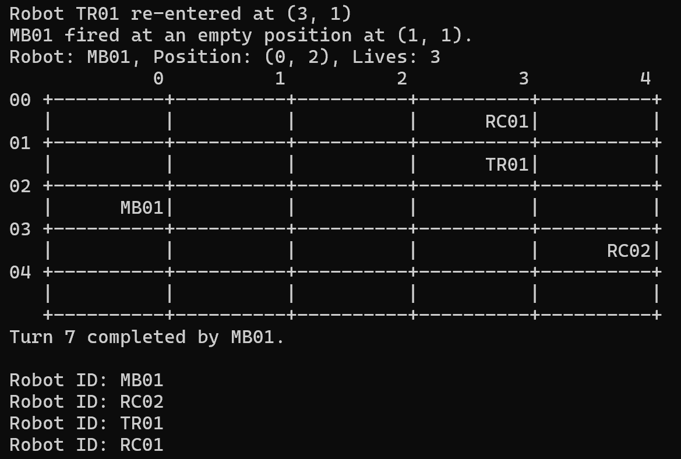Explanation: TerminatorRoboCop (TR01) reentered the battlefield at a random position (3,1). Madbot fired at an empty position (1,1).
Reentry Queue: TE01
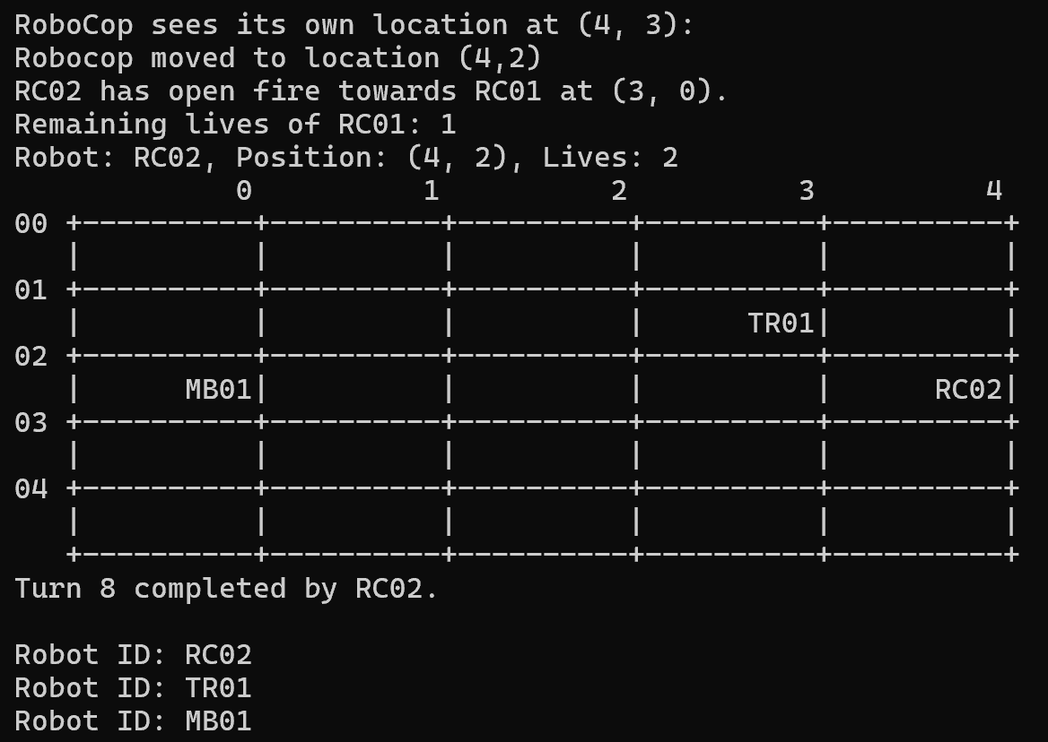Explanation:
Robocop(RC02) sees its own location at (4, 3) then moved to location (4,2) and opened fire towards Robocop(RC01) at (3,0). RC01 is removed from robot list and insert into reentry queue. RC01’s remaining lives decrease from 2 to 1.

Reentry Queue: TE01 RC01

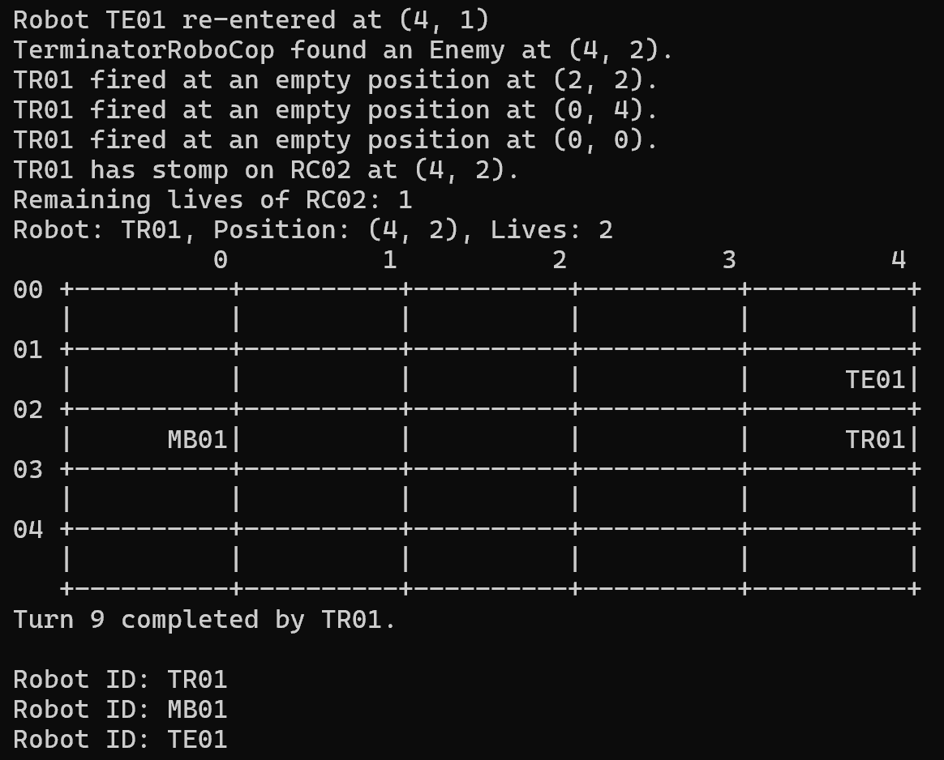Explanation:
Terminator reentered the battlefield at (4,1). TerminatorRoboCop detects an enemy at (4,2) and fired three times at an empty position then stepps on Robocop(RC02) at (4,2). RC02 is removed from robot list and insert into reentry queue. RC02’s remaining lives decrease from 2 to 1.

Reentry Queue: RC01 RC02
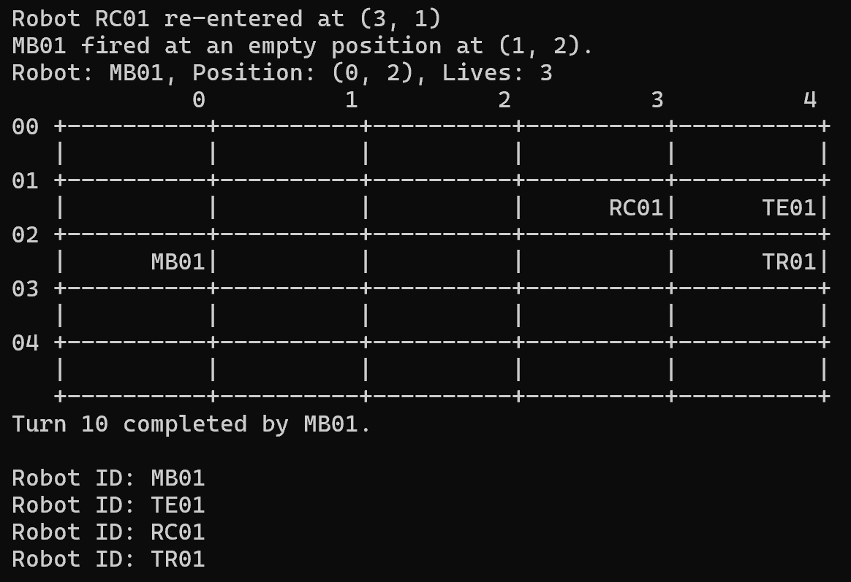Explanation: Robocop(RC01) reentered the battlefield. Madbot fired at an empty position at (1,2). Turns reached 10 as specified in input file and thus the program ends.
Reentry Queue: RC02

Q2. [1] Initialization of a simulation, read input file and output initial of all robots, fixed seed integer for random functions
Screenshots (inputs, outputs), figures, explanations
Code segments, fixed seed integer, pseudocode parts, explanations

Initialization of simulation
void DisplayFunctions::initializeBattlefield(char** battlefield, int rows, int cols, int cellWidth) {
for (int i = 0; i < rows; ++i) {
for (int j = 0; j < cols; ++j) {
memset(battlefield[i] + j * (cellWidth + 1), ' ', cellWidth);
battlefield[i][j * (cellWidth + 1) + cellWidth] = '\0'; // Null-terminate the C-string
}
}
}

Pseudocode:

FUNCTION initializeBattlefield(battlefield, rows, cols, cellWidth):

FOR i from 0 to rows - 1:
FOR j from 0 to cols - 1:

// Calculate starting position of the current cell
startPos = battlefield[i] + j * (cellWidth + 1)

// Fill the cell with spaces
FOR k from 0 to cellWidth - 1:
startPos[k] = ' '

// Null-terminate the cell
startPos[cellWidth] = '\0'

Explanation:
- Outer Loop:
- This loop iterates over each row in the battlefield.
- i ranges from 0 to rows - 1.

- Inner Loop:
- This nested loop iterates over each column in the current row.
- j ranges from 0 to cols - 1.

- Filling the Cell with Spaces:
- Pointer Arithmetic: battlefield[i] gives the start of the i-th row.
- Offset Calculation: j * (cellWidth + 1) calculates the starting position of the j-th cell in the i-th row.
- memset: This function sets the next cellWidth characters starting from the calculated position to a space character (' ').
- Purpose: This initializes the cell with spaces to ensure it is blank.
- Null-Terminating the Cell:
- Index Calculation: j * (cellWidth + 1) + cellWidth calculates the position immediately after the last space in the current cell.
- Null Character: The null character ('\0') is placed at this position.
- Purpose: This ensures that the cell is a properly terminated C-string, which is important for string handling in C/C++.

Read Input file, output initial of all robots and fixed seed integer for random functions
int main(int argc, char* argv[]) {
ifstream infile;
ofstream outfile("fileOutput1.txt");
queueWaitingRobots.clear();
infile.open("fileinput.txt");

if (infile.fail()) {
cout << "Error message: file is not found" << endl;
return EXIT_FAILURE;
}

// Check if the output file is opened successfully
if (!outfile.is_open()) {
cout << "Error: Unable to open the output file." << endl;
return EXIT_FAILURE;
}

// Clear the queue at the beginning
queueWaitingRobots.clear();
srand(static_cast<unsigned>(time(0))); // Initialize random seed
DisplayFunctions df; // Object for Display Functions class
int M, N, turns, robots; // Variables to store the extracted numbers
const int CELL_WIDTH = 10;
const int CELL_HEIGHT = 1;

// Read the first line separately to get M and N
string line, robot_id, robotid_letters;
int robotid_numbers;
if (getline(infile, line)) {
istringstream sstream(line);
string label;
sstream >> label >> label >> label; // Skip the "M by N:" part
sstream >> M >> N; // Extract the numbers (M = columns, N = rows)
}
char** battlefield = new char*[N];
for (int i = 0; i < N; ++i) {
battlefield[i] = new char[M * (CELL_WIDTH + 1)];
}

df.initializeBattlefield(battlefield, N, M, CELL_WIDTH);

cout << "M: " << M << ", N: " << N << endl;
// Output the extracted M and N for debugging

// Create a linked list to store robots
RobotLinkedList robotList;

while (getline(infile, line)) { // Read each subsequent line
istringstream sstream(line);
string instruction;
sstream >> instruction; // Extract the first word (instruction)
instruction = trim(instruction); // Trim the instruction

if (instruction == "Turns:") {
sstream >> turns; // Extract the number after "Turns:"
cout << "Turns: " << turns << endl;
// Additional logic for Turns
}
else if (instruction == "Robots:") {
sstream >> robots; // Extract the number after "Turns:"
cout << "Robots: " << robots << endl;
}
else if (instruction == "RoboCop" || instruction == "Terminator" || instruction == "TerminatorRoboCop" || instruction == "BlueThunder" || instruction == "Madbot" || instruction == "RoboTank" || instruction == "UltimateRobot") {
string coordinate_X, coordinate_Y;
int x, y;
sstream >> robot_id >> coordinate_X >> coordinate_Y;

if (coordinate_X == "random" || coordinate_Y == "random") {
x = rand() % M; // Random column
y = rand() % N; // Random row
} else {
x = stoi(coordinate_X); // Column
y = stoi(coordinate_Y); // Row
}
robotid_letters = robot_id.substr(0, 2);
robotid_numbers = stoi(robot_id.substr(2));
Robot* robot = nullptr;
if (instruction == "RoboCop") {
robot = new RoboCop();
}
else if (instruction == "Terminator") {
robot = new Terminator();
}
else if (instruction == "TerminatorRoboCop") {
robot = new TerminatorRoboCop();
}
else if (instruction == "BlueThunder") {
robot = new BlueThunder();
}
else if (instruction == "Madbot") {
robot = new Madbot();
}
else if (instruction == "RoboTank") {
robot = new RoboTank();
}
else if (instruction == "UltimateRobot") {
robot = new UltimateRobot();
}

if (robot) {
robot->setName(robot_id);
robot->setRobotList(&robotList);
robot->setPosition(x, y);
robotList.insert(robot_id, robotid_letters, robotid_numbers, x, y, robot);
df.location(battlefield, N, M, CELL_WIDTH, x, y, robot_id);
}

}
else {
cout << "Error: Unknown instruction: " << instruction << endl;
}
}

Pseudocode:
FUNCTION main(argc, argv):

Open input file "fileinput.txt" as infile
Open output file "fileOutput1.txt" as outfile

IF infile fails to open:
PRINT "Error message: file is not found"
RETURN EXIT_FAILURE

IF outfile fails to open:
PRINT "Error: Unable to open the output file."
RETURN EXIT_FAILURE

CLEAR queueWaitingRobots
INITIALIZE random seed
CREATE DisplayFunctions object df
DECLARE variables M, N, turns, robots
SET CELL_WIDTH to 10
SET CELL_HEIGHT to 1

READ the first line from infile
EXTRACT M and N from the line

Allocate memory for battlefield as a 2D array with N rows and M columns

CALL df.initializeBattlefield(battlefield, N, M, CELL_WIDTH)

PRINT M and N for debugging

CREATE RobotLinkedList object robotList

WHILE there are more lines to read from infile:
READ the next line as line
EXTRACT the first word from line as instruction
TRIM the instruction

IF instruction is "Turns:":
EXTRACT the number of turns
PRINT turns for debugging
// Additional logic for Turns

ELSE IF instruction is "Robots:":
EXTRACT the number of robots
PRINT robots for debugging

ELSE IF instruction matches any robot type:
EXTRACT robot_id, coordinate_X, and coordinate_Y
IF coordinate_X or coordinate_Y is "random":
SET x to a random column within M
SET y to a random row within N
ELSE:
CONVERT coordinate_X to integer x
CONVERT coordinate_Y to integer y

EXTRACT robotid_letters from the first two characters of robot_id
EXTRACT robotid_numbers from the rest of robot_id

INITIALIZE robot as NULL
IF instruction is "RoboCop":
CREATE a RoboCop object and assign to robot
ELSE IF instruction is "Terminator":
CREATE a Terminator object and assign to robot
ELSE IF instruction is "TerminatorRoboCop":
CREATE a TerminatorRoboCop object and assign to robot
ELSE IF instruction is "BlueThunder":
CREATE a BlueThunder object and assign to robot
ELSE IF instruction is "Madbot":
CREATE a Madbot object and assign to robot
ELSE IF instruction is "RoboTank":
CREATE a RoboTank object and assign to robot
ELSE IF instruction is "UltimateRobot":
CREATE an UltimateRobot object and assign to robot

IF robot is NOT NULL:
SET the robot's name to robot_id
SET the robot's robotList to robotList
SET the robot's position to (x, y)
INSERT the robot into robotList with its details
CALL df.location to update the battlefield with robot's position and id

ELSE:
PRINT "Error: Unknown instruction: " + instruction
Explanation:
- File Handling:
- The program opens an input file (fileinput.txt) for reading and an output file (fileOutput1.txt) for writing.
- It checks if the input file fails to open and prints an error message if it does.
- It checks if the output file fails to open and prints an error message if it does.

- Initialization:
- The queueWaitingRobots queue is cleared at the beginning.
- The random number generator is seeded using the current time.
- An instance of the DisplayFunctions class is created.
- Variables M, N, turns, and robots are declared to store the dimensions of the battlefield, the number of turns, and the number of robots.
- Constants CELL_WIDTH and CELL_HEIGHT are defined to set the dimensions of each cell in the battlefield.

- Reading Initial Battlefield Dimensions:
- The first line of the input file is read to extract M (columns) and N (rows) for the battlefield.
- Memory for a 2D battlefield array is allocated based on the extracted dimensions.

- Initializing the Battlefield:
- The initializeBattlefield method of the DisplayFunctions class is called to initialize the battlefield array.
- The extracted dimensions M and N are printed for debugging.

- Processing Instructions:
- A RobotLinkedList is created to store robots.
- The program reads subsequent lines from the input file and processes each line based on the instruction provided.
- If the instruction is "Turns:", the number of turns is extracted and printed.
- If the instruction is "Robots:", the number of robots is extracted and printed.
- If the instruction matches a specific robot type (e.g., "RoboCop", "Terminator"), robot details are extracted and a new robot object is created based on the type.
- Robot positions are either set to random coordinates or parsed from the input file.
- The robot is initialized with its ID, position, and added to the RobotLinkedList.
- The robot's location is updated on the battlefield.

- Error Handling:
- If an unknown instruction is encountered, an error message is printed.

Q3. [3] Display and logging of the status of the battlefield of robots at each turn
Code Segments:
class DisplayFunctions {
public:
void initializeBattlefield(char** battlefield, int rows, int cols, int cellWidth);
void displayBattlefield(char** battlefield, int rows, int cols, int cellWidth, int cellHeight);
void displayBattlefield(char** battlefield, int rows, int cols, int cellWidth, int cellHeight, ofstream& outfile);
void location(char** battlefield, int M, int N, int CELL_WIDTH, int x, int y, const string& id);

private:
void displayBattlefieldHelper(char** battlefield, int rows, int cols, int cellWidth, int cellHeight, ostream& os);
};

void DisplayFunctions::initializeBattlefield(char** battlefield, int rows, int cols, int cellWidth) {
for (int i = 0; i < rows; ++i) {
for (int j = 0; j < cols; ++j) {
memset(battlefield[i] + j * (cellWidth + 1), ' ', cellWidth);
battlefield[i][j * (cellWidth + 1) + cellWidth] = '\0'; // Null-terminate the C-string
}
}
}

void DisplayFunctions::displayBattlefieldHelper(char** battlefield, int rows, int cols, int cellWidth, int cellHeight, ostream& os) {
os << " "; // Leading spaces for column headers
for (int j = 0; j < cols; ++j) {
os << setw(cellWidth) << setfill(' ') << j << ' ';
}
os << endl;

for (int i = 0; i < rows; ++i) {
os << setw(2) << setfill('0') << i << " +";
for (int j = 0; j < cols; ++j) {
for (int w = 0; w < cellWidth; ++w) {
os << '-';
}
os << '+';
}
os << endl;

for (int h = 0; h < cellHeight; ++h) {
os << " |"; // Left boundary
for (int j = 0; j < cols; ++j) {
os << setw(cellWidth) << setfill(' ') << (battlefield[i] + j * (cellWidth + 1)) << '|';
}
os << endl;
}
}

os << " +";
for (int j = 0; j < cols; ++j) {
for (int w = 0; w < cellWidth; ++w) {
os << '-';
}
os << '+';
}
os << endl;
}

void DisplayFunctions::displayBattlefield(char** battlefield, int rows, int cols, int cellWidth, int cellHeight) {
displayBattlefieldHelper(battlefield, rows, cols, cellWidth, cellHeight, cout);
}

void DisplayFunctions::displayBattlefield(char** battlefield, int rows, int cols, int cellWidth, int cellHeight, ofstream& outfile) {
displayBattlefieldHelper(battlefield, rows, cols, cellWidth, cellHeight, outfile);
}

void DisplayFunctions::location(char** battlefield, int N, int M, int CELL_WIDTH, int x, int y, const string& id) {
if (x >= 0 && x < M && y >= 0 && y < N) { // Check bounds to prevent out-of-bounds access
strncpy(battlefield[y] + x * (CELL_WIDTH + 1), id.c_str(), CELL_WIDTH); // Copy id into the battlefield cell
battlefield[y][x * (CELL_WIDTH + 1) + CELL_WIDTH] = '\0'; // Ensure null-termination
} else {
cout << "Error: Coordinates (" << x << ", " << y << ") are out of bounds." << endl;
}
}
---------------------------------------------------------------------------------------------------------------------
for ( turn = 0; turn < turns; ++turn) {
// Only the current robot takes an action
Robot* currentRobot = robotList.getHead()->robot;

// Perform actions based on the type of robot
if (SeeingRobot* seeingRobot = dynamic_cast<SeeingRobot*>(currentRobot)) {
seeingRobot->actionLook(battlefield, N, M);
}
if (MovingRobot* movingRobot = dynamic_cast<MovingRobot*>(currentRobot)) {
movingRobot->actionMove(battlefield, N, M);
}
if (ShootingRobot* shootingRobot = dynamic_cast<ShootingRobot*>(currentRobot)) {
shootingRobot->actionFire(battlefield, N, M);
}
if (SteppingRobot* steppingRobot = dynamic_cast<SteppingRobot*>(currentRobot)) {
steppingRobot->actionStep(battlefield, N, M);
}

//robotList.display();
currentRobot->displayInfo();
df.displayBattlefield(battlefield, N, M, CELL_WIDTH, CELL_HEIGHT);
cout << "Turn " << turn + 1 << " completed by " << currentRobot->getRobotId() << "." << endl<<endl;
robotList.display();
cout << endl << "--------------------------------------------------------------------------------------------" << endl;
robotCount = countRobotsOnBattlefield(battlefield, N, M, CELL_WIDTH);
if (robotCount <= 1) {
cout << "Only " << robotCount << " robot left on the battlefield. Ending the program." << endl;
break;
}
reEnterBattlefield(battlefield, N, M, &robotList);
robotList.rotate(); // Move to the next robot in the linked list
}

df.displayBattlefield(battlefield, N, M, CELL_WIDTH, CELL_HEIGHT, outfile);
outfile << "Turn " << turn << " : Final Turn" << endl;
outfile << "Only " << robotCount << " robot left on the battlefield. Ending the program." << endl;
outfile << endl << "--------------------------------------------------------------------------------------------" << endl;

Pseudocode:
Function: initializeBattlefield

FUNCTION initializeBattlefield(battlefield, rows, cols, cellWidth):
FOR i FROM 0 TO rows-1:
FOR j FROM 0 TO cols-1:
SET battlefield[i][j * (cellWidth + 1)] TO ' ' // Fill with spaces
SET battlefield[i][j * (cellWidth + 1) + cellWidth] TO '\0' // Null-terminate

Function: displayBattlefieldHelper

FUNCTION displayBattlefieldHelper(battlefield, rows, cols, cellWidth, cellHeight, os):
PRINT leading spaces for column headers
FOR j FROM 0 TO cols-1:
PRINT column index with cellWidth spaces

PRINT newline

FOR i FROM 0 TO rows-1:
PRINT row index with leading zeros and a '+' character
FOR j FROM 0 TO cols-1:
FOR w FROM 0 TO cellWidth-1:
PRINT '-' // Horizontal boundary
PRINT '+'
PRINT newline

FOR h FROM 0 TO cellHeight-1:
PRINT left boundary '|'
FOR j FROM 0 TO cols-1:
PRINT battlefield[i][j * (cellWidth + 1)] with cellWidth spaces and '|'
PRINT newline

PRINT bottom boundary '+'
FOR j FROM 0 TO cols-1:
FOR w FROM 0 TO cellWidth-1:
PRINT '-'
PRINT '+'
PRINT newline

Function: displayBattlefield (Overloaded)

FUNCTION displayBattlefield(battlefield, rows, cols, cellWidth, cellHeight):
CALL displayBattlefieldHelper(battlefield, rows, cols, cellWidth, cellHeight, cout)

FUNCTION displayBattlefield(battlefield, rows, cols, cellWidth, cellHeight, outfile):
CALL displayBattlefieldHelper(battlefield, rows, cols, cellWidth, cellHeight, outfile)

Function: location

FUNCTION location(battlefield, N, M, CELL_WIDTH, x, y, id):
IF x IS WITHIN [0, M-1] AND y IS WITHIN [0, N-1]:
COPY id TO battlefield[y][x * (CELL_WIDTH + 1)] WITH CELL_WIDTH characters
SET battlefield[y][x * (CELL_WIDTH + 1) + CELL_WIDTH] TO '\0' // Ensure null-termination
ELSE:
PRINT "Error: Coordinates (" + x + ", " + y + ") are out of bounds."

Main Loop for Turns

FUNCTION mainLoop(turns, battlefield, N, M, CELL_WIDTH, CELL_HEIGHT, robotList, df, outfile):
FOR turn FROM 0 TO turns-1:
SET currentRobot TO robotList.getHead().robot

IF currentRobot IS A SeeingRobot:
CALL currentRobot.actionLook(battlefield, N, M)

IF currentRobot IS A MovingRobot:
CALL currentRobot.actionMove(battlefield, N, M)

IF currentRobot IS A ShootingRobot:
CALL currentRobot.actionFire(battlefield, N, M)

IF currentRobot IS A SteppingRobot:
CALL currentRobot.actionStep(battlefield, N, M)

CALL currentRobot.displayInfo()
CALL df.displayBattlefield(battlefield, N, M, CELL_WIDTH, CELL_HEIGHT)
PRINT "Turn " + (turn + 1) + " completed by " + currentRobot.getRobotId() + "."
CALL robotList.display()
PRINT separator line

SET robotCount TO countRobotsOnBattlefield(battlefield, N, M, CELL_WIDTH)
IF robotCount <= 1:
PRINT "Only " + robotCount + " robot left on the battlefield. Ending the program."
BREAK

CALL reEnterBattlefield(battlefield, N, M, robotList)
CALL robotList.rotate()

CALL df.displayBattlefield(battlefield, N, M, CELL_WIDTH, CELL_HEIGHT, outfile)
outfile PRINT "Turn " + turn + " : Final Turn"
outfile PRINT "Only " + robotCount + " robot left on the battlefield. Ending the program."
outfile PRINT separator line

Explanation:
- Initialization and File Handling:
- The program begins by opening the input and output files. If the input file is not found or the output file cannot be opened, it prints an error message and exits.
- It initializes a DisplayFunctions object for handling the battlefield visualization and a RobotLinkedList object to manage the list of robots.
- The battlefield dimensions (M x N) are read from the input file, and the battlefield is initialized as a 2D array of characters.

- Reading Input File:
- The program reads the number of turns and robots from the input file.
- For each robot, it reads the robot type, ID, and coordinates. If the coordinates are "random", it assigns a random position within the battlefield dimensions.
- Based on the robot type, it creates an appropriate robot object (e.g., RoboCop, Terminator) and inserts it into the robot linked list. It also updates the battlefield with the robot's initial position.

- Main Game Loop:
- For each turn, the current robot is retrieved from the head of the linked list.
- The robot performs its action based on its type:
  - SeeingRobot: Calls actionLook to perform a look action.
  - MovingRobot: Calls actionMove to perform a move action.
  - ShootingRobot: Calls actionFire to perform a fire action.
  - SteppingRobot: Calls actionStep to perform a step action.
- The robot's information is displayed, and the battlefield is updated.
- The program checks the number of robots remaining on the battlefield. If only one robot is left, the game ends.
- Robots may re-enter the battlefield, and the robot list is rotated to the next robot for the next turn.

- Final Output and Cleanup:
- The final state of the battlefield is displayed and written to the output file.
- The program cleans up the allocated memory for the battlefield array and closes the input and output files.

Figures for Battlefield:
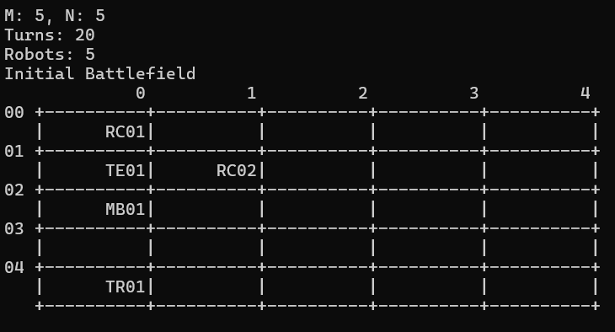

Output Text File:
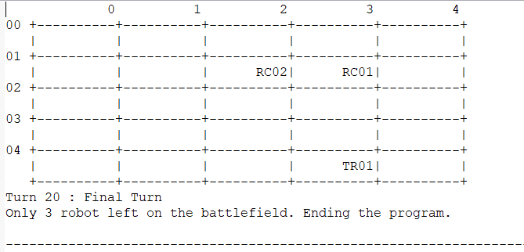

Q4. [3] Display and logging of the robot actions and the status of each robot at each turn

a. RoboCop:
In each turn, this robot looks at its current position and decides on a move to one of its 8 neighboring locations. RoboCop cannot move to a location that contains another robot. It moves to one random location.
In the same turn, this robot fires (three times) at random positions in the battlefield.
This sequence is repeated for each turn. The maximum city block distance of firing should be set to 10 (i.e. for any fire (robotPositionX + x, robotPositionY + y), (x + y) is at most 10 at least 1).
If RoboCop fires a total of 3 robots, then it will be upgraded to be allowed to move to a location that contains another robot, thus stepping and killing that robot. This type of robot is called

Code segments:
void RoboCop::actionLook(char** battlefield, int N, int M) {
cout << "RoboCop sees its own location at (" << posX << ", " << posY << "): " << endl;

}

void RoboCop::actionMove(char** battlefield, int N, int M) {
// Attempt to move RoboCop to a random new position
int newX, newY;

// Attempt to move to a new position up to 10 times to find a free spot
for (int attempt = 0; attempt < 10; ++attempt) {
newX = posX + rand() % 3 - 1; // Move randomly within -1, 0, or 1 in x direction
newY = posY + rand() % 3 - 1; // Move randomly within -1, 0, or 1 in y direction

// Check if the new position is within bounds and not occupied by another robot
if (newX >= 0 && newX < M && newY >= 0 && newY < N && battlefield[newY][newX * (CELL_WIDTH + 1)] == ' '&& (newX != posX || newX != posY)) {
// Erase ID from previous position
strncpy(battlefield[posY] + posX * (CELL_WIDTH + 1), " ", CELL_WIDTH);
battlefield[posY][posX * (CELL_WIDTH + 1) + CELL_WIDTH] = '\0'; // Ensure null-termination

// Update the position of RoboCop
posX = newX;
posY = newY;

// Place ID at the new position
strncpy(battlefield[posY] + posX * (CELL_WIDTH + 1), robot_id.c_str(), CELL_WIDTH);
battlefield[posY][posX * (CELL_WIDTH + 1) + CELL_WIDTH] = '\0'; // Ensure null-termination
cout<<"Robocop moved to location ("<<posX<<","<<posY<<")"<<endl;
return; // Successfully moved to the new position
}
}
}

void RoboCop::actionFire(char** battlefield, int N, int M) {
// Fire at three random positions within the battlefield

for (int fireCount = 0; fireCount < 3; ++fireCount) {
int fireX = rand() % M;
int fireY = rand() % N;

// Check if the firing position is within the maximum city block distance
if (abs(fireX - posX) + abs(fireY - posY) <= 10 && abs(fireX - posX) + abs(fireY - posY) >=1 ) {
// Check if there's a robot at the firing position
if (battlefield[fireY][fireX * (CELL_WIDTH + 1)] != ' ')
{
// A robot is hit
string destroyedrobotid = battlefield[fireY] + fireX * (CELL_WIDTH + 1);
const string& destroyedRobotName = destroyedrobotid;
cout << robot_id << " has open fire towards " << destroyedRobotName << " at (" << fireX << ", " << fireY << ")." << endl;
Robot* destroyedRobot =robotList->search(destroyedRobotName);
if (destroyedRobot) {
destroyedRobot->decreaseLives();
cout << "Remaining lives of " << destroyedRobotName << ": " << destroyedRobot->getLives() << endl;
if (destroyedRobot->getLives() > 0) {
robotList->remove(destroyedRobotName); // Remove from linked list
queueWaitingRobots.enqueue(destroyedRobot); // Queue for reentry
} else {
queueDestroyedRobots.enqueue(destroyedRobot);
robotList->remove(destroyedRobotName);
cout<< destroyedRobotName << " has no lives left and is permanently destroyed."<< endl;
//robotList->remove(destroyedRobotName);
//strncpy(battlefield[fireY] + fireX * (CELL_WIDTH + 1), " ", CELL_WIDTH);
//battlefield[fireY][fireX * (CELL_WIDTH + 1) + CELL_WIDTH] = '\0'; // Ensure null-termination
//return;
}
}
totalKills++; // Increase the kill count
strncpy(battlefield[fireY] + fireX * (CELL_WIDTH + 1), " ", CELL_WIDTH);
battlefield[fireY][fireX * (CELL_WIDTH + 1) + CELL_WIDTH] = '\0'; // Ensure null-termination

// Check if RoboCop has killed 3 robots to upgrade
if (totalKills == 3)
{
string rc=battlefield[posY] + posX * (CELL_WIDTH + 1);
const string& robocop = rc;
robotList->remove(robocop);
upgradeToTerminatorRoboCop(battlefield, posX, posY);
// Exit the method after upgrade
}
}
}
}
}

void RoboCop::upgradeToTerminatorRoboCop(char** battlefield, int posX, int posY) {
// Get the ID of the current RoboCop
// Clear the battlefield cell of the current RoboCop
strncpy(battlefield[posY] + posX * (CELL_WIDTH + 1), " ", CELL_WIDTH);
battlefield[posY][posX * (CELL_WIDTH + 1) + CELL_WIDTH] = '\0'; // Ensure null-termination

// Inform about the upgrade and update battlefield with TerminatorRoboCop
upgrade = true; // Set upgrade flag
cout << "RoboCop has upgraded to TerminatorRoboCop!" << endl;

// Create a new TerminatorRoboCop object
Robot* newRobot = new TerminatorRoboCop();
// Insert the new TerminatorRoboCop into the list
//robotList->insert("TR02", "TerminatorRoboCop", 02, posX, posY, newRobot);
const string& current_robot_id = "RC01"; // Example current robot ID to upgrade
const string& new_robotid_letters = "TR"; // New robot letters ID
int new_robotid_numbers = 1; // New robot numbers ID
robot_id=robotList->nehtid(current_robot_id,new_robotid_letters,new_robotid_numbers,posX,posY,newRobot);;
strncpy(battlefield[posY] + posX * (CELL_WIDTH + 1), robot_id.c_str(), CELL_WIDTH);
battlefield[posY][posX * (CELL_WIDTH + 1) + CELL_WIDTH] = '\0'; // Ensure null-termination
robotList->upgrade(current_robot_id,new_robotid_letters,new_robotid_numbers,posX,posY,newRobot);
}

Pseudocode parts:
CLASS RoboCop extends SeeingRobot, MovingRobot, ShootingRobot:
PRIVATE ammo = 3
PRIVATE totalKills = 0
PRIVATE upgrade = false

METHOD actionLook(battlefield, N, M):
PRINT "RoboCop sees its own location at (posX, posY)"

METHOD actionMove(battlefield, N, M):
FOR attempt FROM 0 TO 9:
newX = posX + RANDOM(-1, 1)
newY = posY + RANDOM(-1, 1)

IF newX and newY are within bounds AND new position is empty AND new position is not the same as current:
CLEAR battlefield at (posX, posY)
posX = newX
posY = newY
UPDATE battlefield at (posX, posY) with robot_id
PRINT "RoboCop moved to location (posX, posY)"
RETURN
METHOD actionFire(battlefield, N, M):
FOR fireCount FROM 0 TO 2:
fireX = RANDOM(0, M-1)
fireY = RANDOM(0, N-1)

IF abs(fireX - posX) + abs(fireY - posY) <= 10 AND abs(fireX - posX) + abs(fireY - posY) >= 1:
IF battlefield[fireY, fireX] contains robot:
destroyedRobotName = GET robot name from battlefield[fireY, fireX]
PRINT robot_id " fired at " destroyedRobotName " at (fireX, fireY)"
destroyedRobot = robotList.search(destroyedRobotName)

IF destroyedRobot EXISTS:
destroyedRobot.decreaseLives()
PRINT "Remaining lives of " destroyedRobotName ": " destroyedRobot.getLives()

IF destroyedRobot.getLives() > 0:
robotList.remove(destroyedRobotName)
queueWaitingRobots.enqueue(destroyedRobot)
ELSE:
queueDestroyedRobots.enqueue(destroyedRobot)
robotList.remove(destroyedRobotName)
PRINT destroyedRobotName " is permanently destroyed"

INCREASE totalKills
CLEAR battlefield at (fireY, fireX)

IF totalKills == 3:
robotList.remove(robot_id)
upgradeToTerminatorRoboCop(battlefield, posX, posY)
RETURN
METHOD upgradeToTerminatorRoboCop(battlefield, posX, posY):
CLEAR battlefield at (posX, posY)
upgrade = true
PRINT "RoboCop has upgraded to TerminatorRoboCop!"

newRobot = CREATE new TerminatorRoboCop
current_robot_id = "RC01"
new_robotid_letters = "TR"
new_robotid_numbers = 1
robot_id = robotList.nehtid(current_robot_id, new_robotid_letters, new_robotid_numbers, posX, posY, newRobot)
UPDATE battlefield at (posX, posY) with robot_id
robotList.upgrade(current_robot_id, new_robotid_letters, new_robotid_numbers, posX, posY, newRobot)

Explanations:
Attributes:
- totalKills:
  - A counter for the number of kills made by RoboCop
Methods:
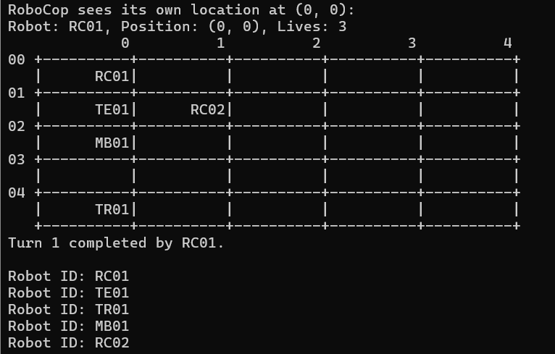
- actionLook:
  - Purpose: Inspects the immediate 3x3 neighborhood around RoboCop's current position.
  - Functionality:
    - Clears any previous enemy positions stored.
    - Checks all cells in a 3x3 grid centered on RoboCop’s position.
    - For each cell that contains an enemy (not empty and not RoboCop itself), it adds the position to enemyPositions.
    - Outputs the coordinates of detected enemies

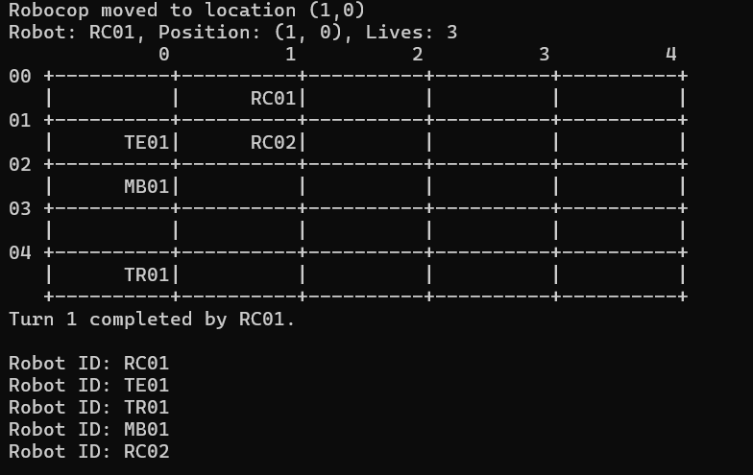

- actionMove:
  - Purpose: Moves RoboCop to a new position on the battlefield.
  - Functionality:
    - Tries up to 10 times to move to a random new position within -1, 0, or 1 in both x and y directions.
    - Ensures the new position is within bounds, not occupied, and not the same as the current position.
    - Updates the battlefield to reflect RoboCop's new position.
    - Outputs the new position.

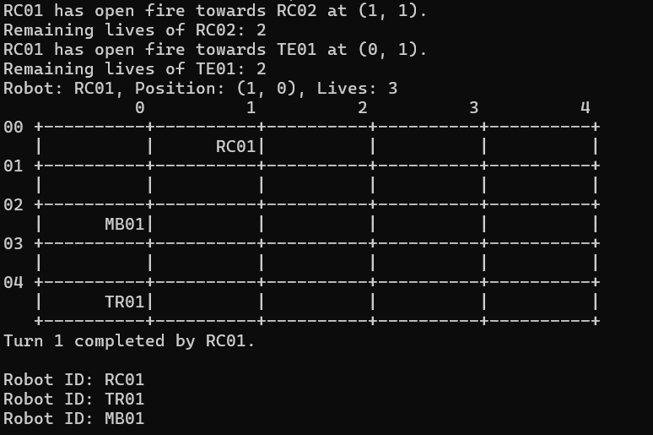
- actionFire:
  - Purpose: Fires at enemies on the battlefield.
  - Functionality:
    - Fires at three random positions within the battlefield.
    - Checks if the target position is within a city block distance of 10 from RoboCop's position.
    - If an enemy robot is at the firing position, it:
      - Decreases the enemy's lives.
      - Removes the enemy from the robot list if it still has lives, or permanently destroys it if it has no lives left.
      - Clears the enemy's position on the battlefield.
      - Increases the total kill count.
      - If RoboCop has achieved three kills, it upgrades to TerminatorRoboCop.
    - Outputs details about the firing action and the state of the enemy.
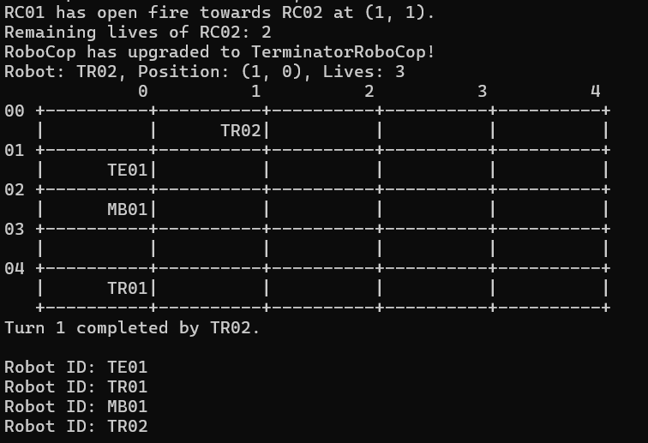
- upgradeToTerminatorRoboCop:
  - Purpose: Upgrades RoboCop to TerminatorRoboCop when certain conditions are met.
  - Functionality:
    - Clears RoboCop's current position on the battlefield.
    - Sets the upgrade flag and prints an upgrade message.
    - Creates a new TerminatorRoboCop object and updates the robot list with the new robot's ID.
    - Updates the battlefield with the new TerminatorRoboCop's ID at RoboCop’s position.

b. Terminator:
In each turn, this robot looks at the immediate 8 neighborhoods (3x3 window centered at the robot position) and performs a move to one of the 8 neighbors. Thus, a Terminator will not fire at all and will terminate robots in its path. It will prefer locations which contain enemy robots.
If the Terminator kills a total of 3 other robots, then the Terminator will be upgraded to be allowed to fire in a similar way to a RoboCop fire, this type of robot will now become a TerminatorRoboCop as well.

Code segments:
void Terminator::actionLook(char** battlefield, int N, int M) {
// Clear the previous look results
enemyPositions.clear();

// Look at the immediate neighborhood (3x3 window)
for (int dx = -1; dx <= 1; ++dx) {
for (int dy = -1; dy <= 1; ++dy) {
int x = posX + dx;
int y = posY + dy;

// Check if the position is within bounds
if (x >= 0 && x < M && y >= 0 && y < N &&(x != posX || y != posY)) {
char* cell = battlefield[y] + x * (CELL_WIDTH + 1);

// Check if the cell contains an enemy robot
if (cell[0] != ' ' && cell[0] != robot_id[0]) {
enemyPositions.push_back({x, y});
cout<<"Terminator found an Enemy at (" << x << ", " << y<< ")."<<endl;
}
}
}
}
}
void Terminator::actionMove(char** battlefield, int N, int M) {

// If enemies are found, move to the first enemy position
if (!enemyPositions.empty()) {
int bestX = enemyPositions[0].first;
int bestY = enemyPositions[0].second;
// "Kill" the enemy
totalKills++;

// Print message about destroyed robot
string destroyedrobotid=battlefield[bestY] + bestX * (CELL_WIDTH + 1);
const string& destroyedRobotName = destroyedrobotid;
cout << robot_id << " has stomp on " << destroyedrobotid << " at (" << bestX << ", " << bestY << ")." << endl;
// Remove the destroyed robot from the linked list
Robot* destroyedRobot = robotList->search(destroyedRobotName);
if (destroyedRobot) {
destroyedRobot->decreaseLives();
cout << "Remaining lives of " << destroyedRobotName << ": " << destroyedRobot->getLives() << endl;
if (destroyedRobot->getLives() > 0) {
robotList->remove(destroyedRobotName); // Remove from linked list
queueWaitingRobots.enqueue(destroyedRobot); // Queue for reentry
} else {
queueDestroyedRobots.enqueue(destroyedRobot);
robotList->remove(destroyedRobotName);
cout<< destroyedRobotName << " has no lives left and is permanently destroyed."<< endl;
//robotList->remove(destroyedRobotName);
//strncpy(battlefield[bestY] + bestX * (CELL_WIDTH + 1), " ", CELL_WIDTH);
//battlefield[bestY][bestX * (CELL_WIDTH + 1) + CELL_WIDTH] = '\0'; // Ensure null-termination
//return;
}
}

// Clear the battlefield position of the destroyed robot
strncpy(battlefield[bestY] + bestX * (CELL_WIDTH + 1), " ", CELL_WIDTH);
battlefield[bestY][bestX * (CELL_WIDTH + 1) + CELL_WIDTH] = '\0'; // Ensure null-termination

// Erase ID from previous position
strncpy(battlefield[posY] + posX * (CELL_WIDTH + 1), " ", CELL_WIDTH);
battlefield[posY][posX * (CELL_WIDTH + 1) + CELL_WIDTH] = '\0'; // Ensure null-termination

// Move to the new position
posX = bestX;
posY = bestY;

// Mark the new position with the robot ID
strncpy(battlefield[posY] + posX * (CELL_WIDTH + 1), robot_id.c_str(), CELL_WIDTH);
battlefield[posY][posX * (CELL_WIDTH + 1) + CELL_WIDTH] = '\0'; // Ensure null-termination
if (totalKills == 3) {
// Upgrade to TerminatorRoboCop
string te=battlefield[posY] + posX * (CELL_WIDTH + 1);
const string& terminator = te;
robotList->remove(terminator);
upgradeToTerminatorRoboCop(battlefield, posX, posY);

}
return;
} else {
// No enemies found, attempt to move to a new position
int newX, newY;

// Attempt to move to a new position up to 3 times to find a free spot
for (int attempt = 0; attempt < 3; ++attempt) {
newX = posX + rand() % 3 - 1; // Move randomly within -1, 0, or 1 in x direction
newY = posY + rand() % 3 - 1; // Move randomly within -1, 0, or 1 in y direction

if (newX >= 0 && newX < M && newY >= 0 && newY < N && battlefield[newY][newX * (CELL_WIDTH + 1)] == ' '&&(newX != posX || newY != posY)) {
// Erase ID from previous position
strncpy(battlefield[posY] + posX * (CELL_WIDTH + 1), " ", CELL_WIDTH);
battlefield[posY][posX * (CELL_WIDTH + 1) + CELL_WIDTH] = '\0'; // Ensure null-termination

// Update the position of the Terminator
posX = newX;
posY = newY;

// Place ID at the new position
strncpy(battlefield[posY] + posX * (CELL_WIDTH + 1), robot_id.c_str(), CELL_WIDTH);
battlefield[posY][posX * (CELL_WIDTH + 1) + CELL_WIDTH] = '\0'; // Ensure null-termination
cout<<"Terminator moved to location ("<<posX<<","<<posY<<")"<<endl;
return; // Successfully moved to the new position
}
}
}
}

void Terminator::upgradeToTerminatorRoboCop(char** battlefield, int posX, int posY) {

strncpy(battlefield[posY] + posX * (CELL_WIDTH + 1), " ", CELL_WIDTH);
battlefield[posY][posX * (CELL_WIDTH + 1) + CELL_WIDTH] = '\0'; // Ensure null-termination

upgrade = true; // Set upgrade flag
cout << "Terminator has upgraded to TerminatorRoboCop!" << endl;

// Create a new TerminatorRoboCop object
Robot* newRobot = new TerminatorRoboCop();
const string& current_robot_id = "TE01"; // Example current robot ID to upgrade
const string& new_robotid_letters = "TR"; // New robot letters ID
int new_robotid_numbers = 1; // New robot numbers ID
robot_id=robotList->nehtid(current_robot_id,new_robotid_letters,new_robotid_numbers,posX,posY,newRobot);
strncpy(battlefield[posY] + posX * (CELL_WIDTH + 1), robot_id.c_str(), CELL_WIDTH);
battlefield[posY][posX * (CELL_WIDTH + 1) + CELL_WIDTH] = '\0'; // Ensure null-termination
}

Pseudocode parts:
CLASS Terminator EXTENDS SeeingRobot, MovingRobot, ShootingRobot:

PRIVATE VARIABLES:
ammo = 3
totalKills = 0
upgrade = false

METHOD actionLook(battlefield, N, M):
Clear previous look results
FOR each cell in 3x3 window around current position:
IF cell is within bounds AND is an enemy:
Add cell to enemy positions list
PRINT "Terminator found an enemy at (x, y)."

METHOD actionMove(battlefield, N, M):
IF enemy positions list is not empty:
Move to the first enemy position
Increment total kills
PRINT "Terminator stomped on enemy at (x, y)."
IF enemy has remaining lives:
Remove enemy from battlefield and queue for reentry
ELSE:
Permanently destroy enemy and remove from battlefield
Clear destroyed enemy's position on battlefield
Move Terminator to new position
IF totalKills == 3:
Call upgradeToTerminatorRoboCop method
ELSE:
Attempt to move randomly to a new free position up to 3 times
METHOD actionFire(battlefield, N, M):
// Implement fire functionality
METHOD upgradeToTerminatorRoboCop(battlefield, posX, posY):
CLEAR current position on battlefield
SET upgrade flag to true
PRINT "Terminator has upgraded to TerminatorRoboCop!"
CREATE and place new TerminatorRoboCop object at current position

Explanations:

Attributes:
- enemyPositions:
  - Purpose: To store positions of detected enemies within the robot's immediate vicinity.
  - Usage: During the actionLook method, enemy positions are identified and stored in this list for further action.
- totalKills:
  - Purpose: A counter to keep track of the number of enemies the robot has eliminated.
  - Usage: Incremented each time the robot destroys an enemy in the actionMove method.
Methods:
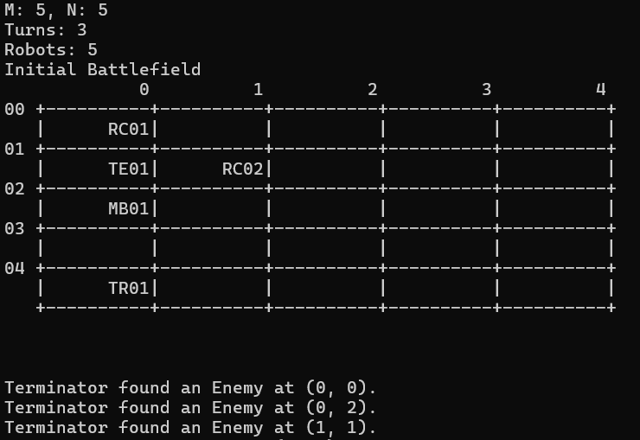
- actionLook:
  - Purpose: To inspect the immediate 3x3 neighborhood around the robot's current position for any enemies.
  - Functionality:
    - Clears previous look results from enemyPositions.
    - Iterates through a 3x3 grid centered on the robot's current position (posX, posY).
    - Checks if the grid cells are within the battlefield bounds and contain an enemy (not empty and not the robot itself).
    - If an enemy is detected, its position is added to enemyPositions and a message is printed.
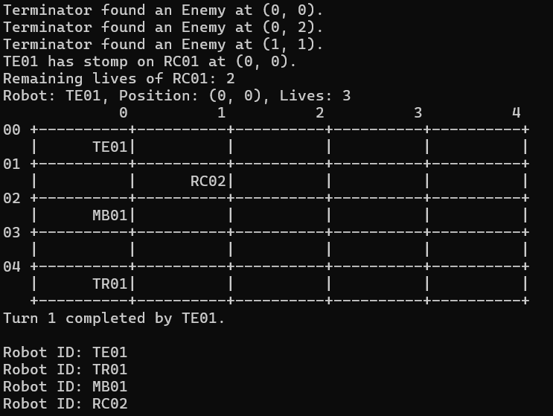
- actionMove:
  - Purpose: To move the robot on the battlefield based on the presence of enemies.
  - Functionality:
    - If enemies are detected in enemyPositions:
      - Moves towards the first enemy.
      - Increments totalKills and prints a message about the enemy being stomped on.
      - Checks the remaining lives of the destroyed robot:
        - If the robot still has lives, it is queued for reentry.
        - If no lives are left, it is permanently destroyed.
      - Clears the battlefield position of the destroyed robot.
      - Updates the robot's position on the battlefield.
      - If totalKills reaches 3, the robot upgrades to TerminatorRoboCop.
    - If no enemies are found:
      - Attempts to move to a random new position within the 3x3 neighborhood up to 3 times.
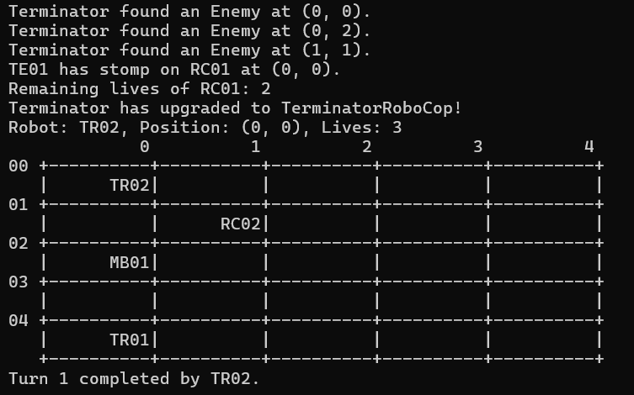
- upgradeToTerminatorRoboCop:
  - Purpose: Upgrades the current robot to a more advanced version (TerminatorRoboCop).
  - Functionality:
    - Clears the current position on the battlefield.
    - Sets an upgrade flag.
    - Prints a message indicating the upgrade.
    - Creates a new TerminatorRoboCop object and updates the robot's ID on the battlefield.

c. TerminatorRoboCop:
This is either an upgraded RoboCop or an upgraded Terminator, it means it is a robot that can fire like RoboCop, and step on other robots like Terminator.
If the TerminatorRoboCop kills 3 other robots, it will be upgraded to UltimateRobot (see below).

Code segments:
void RoboCop::upgradeToTerminatorRoboCop(char** battlefield, int posX, int posY) {
// Get the ID of the current RoboCop
// Clear the battlefield cell of the current RoboCop
strncpy(battlefield[posY] + posX * (CELL_WIDTH + 1), " ", CELL_WIDTH);
battlefield[posY][posX * (CELL_WIDTH + 1) + CELL_WIDTH] = '\0'; // Ensure null-termination

// Inform about the upgrade and update battlefield with TerminatorRoboCop
upgrade = true; // Set upgrade flag
cout << "RoboCop has upgraded to TerminatorRoboCop!" << endl;

// Create a new TerminatorRoboCop object
Robot* newRobot = new TerminatorRoboCop();
// Insert the new TerminatorRoboCop into the list
//robotList->insert("TR02", "TerminatorRoboCop", 02, posX, posY, newRobot);
const string& current_robot_id = "RC01"; // Example current robot ID to upgrade
const string& new_robotid_letters = "TR"; // New robot letters ID
int new_robotid_numbers = 1; // New robot numbers ID
robot_id=robotList->nehtid(current_robot_id,new_robotid_letters,new_robotid_numbers,posX,posY,newRobot);;
strncpy(battlefield[posY] + posX * (CELL_WIDTH + 1), robot_id.c_str(), CELL_WIDTH);
battlefield[posY][posX * (CELL_WIDTH + 1) + CELL_WIDTH] = '\0'; // Ensure null-termination
robotList->upgrade(current_robot_id,new_robotid_letters,new_robotid_numbers,posX,posY,newRobot);

}

void Terminator::upgradeToTerminatorRoboCop(char** battlefield, int posX, int posY) {

strncpy(battlefield[posY] + posX * (CELL_WIDTH + 1), " ", CELL_WIDTH);
battlefield[posY][posX * (CELL_WIDTH + 1) + CELL_WIDTH] = '\0'; // Ensure null-termination

upgrade = true; // Set upgrade flag
cout << "Terminator has upgraded to TerminatorRoboCop!" << endl;

// Create a new TerminatorRoboCop object
Robot* newRobot = new TerminatorRoboCop();
const string& current_robot_id = "TE01"; // Example current robot ID to upgrade
const string& new_robotid_letters = "TR"; // New robot letters ID
int new_robotid_numbers = 1; // New robot numbers ID
robot_id=robotList->nehtid(current_robot_id,new_robotid_letters,new_robotid_numbers,posX,posY,newRobot);
strncpy(battlefield[posY] + posX * (CELL_WIDTH + 1), robot_id.c_str(), CELL_WIDTH);
battlefield[posY][posX * (CELL_WIDTH + 1) + CELL_WIDTH] = '\0'; // Ensure null-termination
}

void TerminatorRoboCop::actionLook(char** battlefield, int N, int M) {
// Clear the previous look results
enemyPositions.clear();
// Look at the immediate neighborhood (3x3 window)
for (int dx = -1; dx <= 1; ++dx) {
for (int dy = -1; dy <= 1; ++dy) {
int x = posX + dx;
int y = posY + dy;

// Check if the position is within bounds
if (x >= 0 && x < M && y >= 0 && y < N &&(x != posX || y != posY)) {
char* cell = battlefield[y] + x * (CELL_WIDTH + 1);

// Check if the cell contains an enemy robot
if (cell[0] != ' ' && cell[0] != robot_id[0]) {
enemyPositions.push_back({x, y});
cout<<"TerminatorRoboCop found an Enemy at (" << x << ", " << y<< ")."<<endl;
}
}
}
}
}

void TerminatorRoboCop::actionFire(char** battlefield, int N, int M) {
for (int fireCount = 0; fireCount < 3; ++fireCount) {
int fireX, fireY;
bool validTarget = false;

while (!validTarget) {
int range = rand() % 10 + 1; // Random range between 1 and 10
int dx = rand() % (2 * range + 1) - range; // Random x offset between -range and +range
int dy = rand() % (2 * range + 1) - range; // Random y offset between -range and +range

if (abs(dx) + abs(dy) >= 1 && abs(dx) + abs(dy) <= 10) {
fireX = posX + dx;
fireY = posY + dy;

if (fireX >= 0 && fireX < M && fireY >= 0 && fireY < N) {
bool isEnemyPosition = std::find(enemyPositions.begin(), enemyPositions.end(), std::make_pair(fireX, fireY)) != enemyPositions.end();

if (!isEnemyPosition) {
validTarget = true;
}
}
}
}

if (battlefield[fireY][fireX * (CELL_WIDTH + 1)] != ' ') {
totalKills++;
string destroyedrobotid = battlefield[fireY] + fireX * (CELL_WIDTH + 1);
const string& destroyedRobotName = destroyedrobotid;
Robot* destroyedRobot = robotList->search(destroyedRobotName);
cout << robot_id << " has open fire towards " << destroyedRobotName << " at (" << fireX << ", " << fireY << ")." << endl;
if (destroyedRobot) {
destroyedRobot->decreaseLives();
cout << "Remaining lives of " << destroyedRobotName << ": " << destroyedRobot->getLives() << endl;
if (destroyedRobot->getLives() > 0) {
robotList->remove(destroyedRobotName); // Remove from linked list
queueWaitingRobots.enqueue(destroyedRobot); // Queue for reentry
} else {
queueDestroyedRobots.enqueue(destroyedRobot);
robotList->remove(destroyedRobotName);
cout << destroyedRobotName << " has no lives left and is permanently destroyed." << endl;
}
}

if (totalKills == 3) {
string tre = battlefield[posY] + posX * (CELL_WIDTH + 1);
const string& terminatorRoboCop = tre;
robotList->remove(terminatorRoboCop);
upgradeToUltimateRobot(battlefield, posX, posY);
}
strncpy(battlefield[fireY] + fireX * (CELL_WIDTH + 1), " ", CELL_WIDTH);
battlefield[fireY][fireX * (CELL_WIDTH + 1) + CELL_WIDTH] = '\0'; // Ensure null-termination
} else {
cout << robot_id << " fired at an empty position at (" << fireX << ", " << fireY << ")." << endl;
}
}
}

void TerminatorRoboCop::actionStep(char** battlefield, int N, int M) {

// If enemies are found, move to the first enemy position
if (!enemyPositions.empty()) {
int bestX = enemyPositions[0].first;
int bestY = enemyPositions[0].second;

// "Kill" the enemy
totalKills++;

// Print message about destroyed robot
string destroyedrobotid = battlefield[bestY] + bestX * (CELL_WIDTH + 1);
const string& destroyedRobotName = destroyedrobotid;
cout << robot_id << " has stomp on " << destroyedRobotName << " at (" << bestX << ", " << bestY << ")." << endl;
Robot* destroyedRobot = robotList->search(destroyedRobotName);
if (destroyedRobot) {
destroyedRobot->decreaseLives();
cout << "Remaining lives of " << destroyedRobotName << ": " << destroyedRobot->getLives() << endl;
if (destroyedRobot->getLives() > 0) {
robotList->remove(destroyedRobotName); // Remove from linked list
queueWaitingRobots.enqueue(destroyedRobot); // Queue for reentry
} else {
queueDestroyedRobots.enqueue(destroyedRobot);
robotList->remove(destroyedRobotName);
cout<< destroyedRobotName << " has no lives left and is permanently destroyed."<< endl;
//robotList->remove(destroyedRobotName);
//strncpy(battlefield[bestY] + bestX * (CELL_WIDTH + 1), " ", CELL_WIDTH);
//battlefield[bestY][bestX * (CELL_WIDTH + 1) + CELL_WIDTH] = '\0'; // Ensure null-termination

//return;
}
}

// Clear the battlefield position of the destroyed robot
strncpy(battlefield[bestY] + bestX * (CELL_WIDTH + 1), " ", CELL_WIDTH);
battlefield[bestY][bestX * (CELL_WIDTH + 1) + CELL_WIDTH] = '\0'; // Ensure null-termination

// Erase ID from previous position
strncpy(battlefield[posY] + posX * (CELL_WIDTH + 1), " ", CELL_WIDTH);
battlefield[posY][posX * (CELL_WIDTH + 1) + CELL_WIDTH] = '\0'; // Ensure null-termination

// Move to the new position
posX = bestX;
posY = bestY;

// Mark the new position with the robot ID
strncpy(battlefield[posY] + posX * (CELL_WIDTH + 1), robot_id.c_str(), CELL_WIDTH);
battlefield[posY][posX * (CELL_WIDTH + 1) + CELL_WIDTH] = '\0'; // Ensure null-termination
if (totalKills == 3)
{
upgradeToUltimateRobot(battlefield, posX, posY);
}
return;
} else {
// No enemies found, attempt to move to a new position
int newX, newY;

// Attempt to move to a new position up to 3 times to find a free spot
for (int attempt = 0; attempt < 3; ++attempt) {
newX = posX + rand() % 3 - 1; // Move randomly within -1, 0, or 1 in x direction
newY = posY + rand() % 3 - 1; // Move randomly within -1, 0, or 1 in y direction

if (newX >= 0 && newX < M && newY >= 0 && newY < N && battlefield[newY][newX * (CELL_WIDTH + 1)] == ' '&&(newX != posX || newY != posY)) {
// Erase ID from previous position
strncpy(battlefield[posY] + posX * (CELL_WIDTH + 1), " ", CELL_WIDTH);
battlefield[posY][posX * (CELL_WIDTH + 1) + CELL_WIDTH] = '\0'; // Ensure null-termination

// Update the position of the Terminator
posX = newX;
posY = newY;

// Place ID at the new position
strncpy(battlefield[posY] + posX * (CELL_WIDTH + 1), robot_id.c_str(), CELL_WIDTH);
battlefield[posY][posX * (CELL_WIDTH + 1) + CELL_WIDTH] = '\0'; // Ensure null-termination
cout<<"TerminatoRoboCop moved to location ("<<posX<<","<<posY<<")"<<endl;
return; // Successfully moved to the new position
}
}
}
}

void TerminatorRoboCop::upgradeToUltimateRobot(char** battlefield, int posX, int posY) {

// Inform about the upgrade and update battlefield with TerminatorRoboCop
upgrade = true; // Set upgrade flag
cout << "TerminatorRoboCop has upgraded to Ultimate Robot!" << endl;

// Create a new TerminatorRoboCop object
Robot* newRobot = new UltimateRobot();
const string& current_robot_id = "TR01"; // Example current robot ID to upgrade
const string& new_robotid_letters = "UR"; // New robot letters ID
int new_robotid_numbers = 1; // New robot numbers ID
robot_id=robotList->nehtid(current_robot_id,new_robotid_letters,new_robotid_numbers,posX,posY,newRobot);;
strncpy(battlefield[posY] + posX * (CELL_WIDTH + 1), robot_id.c_str(), CELL_WIDTH);
battlefield[posY][posX * (CELL_WIDTH + 1) + CELL_WIDTH] = '\0'; // Ensure null-termination
robotList->upgrade(current_robot_id,new_robotid_letters,new_robotid_numbers,posX,posY,newRobot);

}

Pseudocode parts:
CLASS TerminatorRoboCop extends SeeingRobot, MovingRobot, ShootingRobot:

PRIVATE ammo = 3
PRIVATE totalKills = 0
PRIVATE upgrade = false

METHOD actionLook(battlefield, N, M):
enemyPositions.clear()
FOR dx FROM -1 TO 1:
FOR dy FROM -1 TO 1:
x = posX + dx
y = posY + dy
IF (x, y) WITHIN BOUNDS AND (x, y) IS NOT (posX, posY):
cell = battlefield[y][x]
IF cell CONTAINS ENEMY:
enemyPositions.add((x, y))
PRINT "Enemy found at (x, y)"

METHOD actionMove(battlefield, N, M):
IF enemyPositions IS NOT EMPTY:
bestX, bestY = enemyPositions[0]
totalKills += 1
destroyedRobot = REMOVE ROBOT AT (bestX, bestY)
IF destroyedRobot HAS LIVES LEFT:
QUEUE destroyedRobot FOR REENTRY
ELSE:
QUEUE destroyedRobot FOR PERMANENT DESTRUCTION
battlefield[bestY][bestX] = EMPTY
battlefield[posY][posX] = EMPTY
posX = bestX
posY = bestY
battlefield[posY][posX] = robot_id
IF totalKills == 3:
upgradeToTerminatorRoboCop(battlefield, posX, posY)
ELSE:
FOR attempt FROM 1 TO 3:
newX, newY = RANDOM MOVE WITHIN 3x3
IF new POSITION IS VALID AND EMPTY:
battlefield[posY][posX] = EMPTY
posX = newX
posY = newY
battlefield[posY][posX] = robot_id
PRINT "Moved to (posX, posY)"
BREAK

METHOD actionFire(battlefield, N, M):
FOR fireCount FROM 0 TO 2:
validTarget = FALSE
WHILE NOT validTarget:
range = RANDOM(1, 10)
dx = RANDOM(-range, range)
dy = RANDOM(-range, range)
IF valid fire range:
fireX = posX + dx
fireY = posY + dy
IF fire POSITION IS WITHIN BOUNDS:
validTarget = TRUE
IF battlefield[fireY][fireX] IS NOT EMPTY:
totalKills += 1
destroyedRobot = REMOVE ROBOT AT (fireY, fireX)
IF destroyedRobot HAS LIVES LEFT:
QUEUE destroyedRobot FOR REENTRY
ELSE:
QUEUE destroyedRobot FOR PERMANENT DESTRUCTION
PRINT "Fired at (fireX, fireY), destroyed destroyedRobot"
IF totalKills == 3:
upgradeToTerminatorRoboCop(battlefield, posX, posY)
ELSE:
PRINT "Fired at empty position (fireX, fireY)"

METHOD upgradeToTerminatorRoboCop(battlefield, posX, posY):
battlefield[posY][posX] = EMPTY
upgrade = TRUE
PRINT "Upgraded to TerminatorRoboCop"
newRobot = CREATE NEW TerminatorRoboCop
robot_id = GENERATE NEW ID "TR"
battlefield[posY][posX] = robot_id
INSERT newRobot INTO robotList

Explanations:

Attributes:
- enemyPositions:
  - This attribute is used to store the positions of detected enemies within the robot's immediate neighborhood. It is a list of pairs, where each pair contains the x and y coordinates of an enemy robot.
- totalKills:
  - This attribute is a counter that keeps track of the number of enemy robots the robot has killed. It increases every time an enemy robot is destroyed.

Methods:

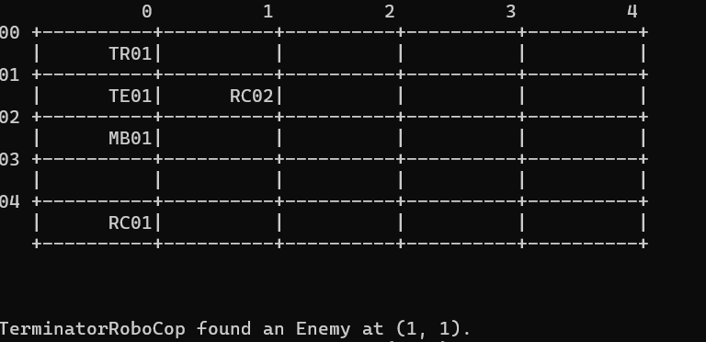
- actionLook:
  - Purpose: Inspects the immediate 3x3 neighborhood around the robot to detect enemy robots.
  - Process:
    - Clears the previous list of detected enemies.
    - Iterates through a 3x3 grid centered on the robot’s current position.
    - Checks if each position within this grid is within the bounds of the battlefield.
    - If a position contains an enemy robot, it adds the position to the enemyPositions list and prints a message indicating the enemy’s location.

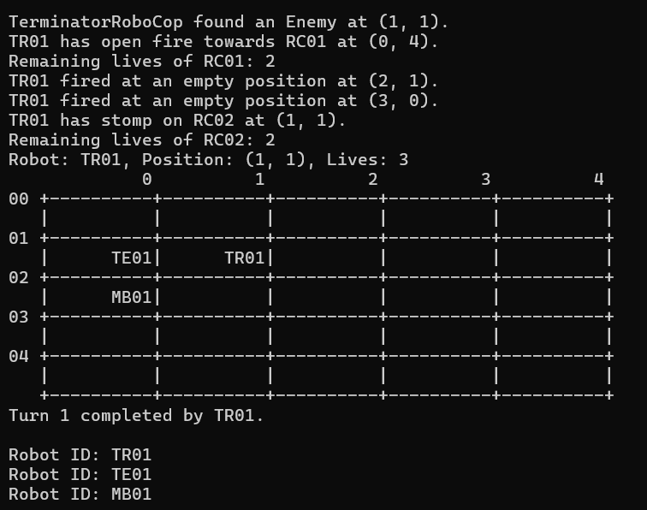
- actionFire:
  - Purpose: Fires at enemies on the battlefield.
  - Process:
    - Fires up to 3 times.
    - Each fire attempt selects a random position within a specified range.
    - Ensures the target position is within the battlefield bounds.
    - If the target position contains an enemy, it destroys the enemy and updates the totalKills.
    - If the destroyed enemy has lives left, it is queued for reentry; otherwise, it is permanently destroyed.
    - If totalKills reaches 3, calls upgradeTo UltimateRobot.

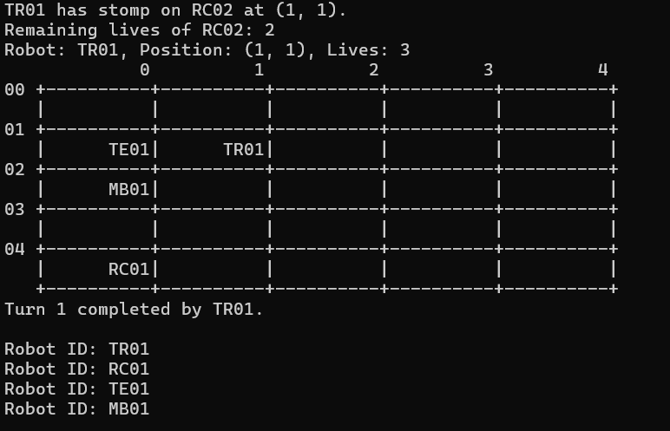
- actionStep:
  - Purpose: Moves the robot on the battlefield towards detected enemies or to a new position if no enemies are found.
  - Process:
    - Checks if there are any detected enemies.
    - If there are enemies, moves the robot to the first enemy's position, kills the enemy, and updates the battlefield and totalKills.
    - If there are no enemies, tries to move the robot to a new random position within a 3x3 grid up to three times.
    - Ensures the new position is within the battlefield bounds and is empty.
    - If totalKills reaches 3, calls upgradeToUltimateRobot.

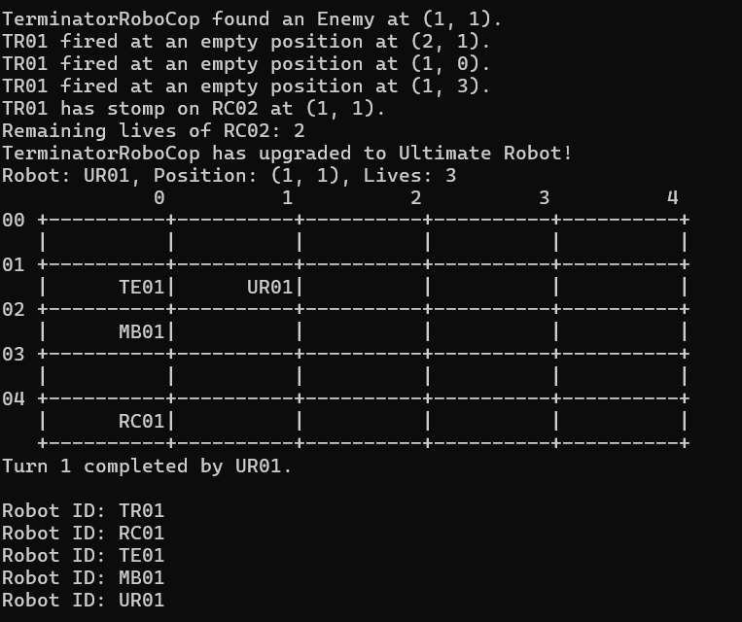
- upgradeToUltimateRobot:
  - Purpose: Upgrades the current robot to a more advanced version (UltimateRobot).
  - Functionality:
    - Clears the current position on the battlefield.
    - Sets an upgrade flag.
    - Prints a message indicating the upgrade.
    - Creates a new UltimateRobot object and updates the robot's ID on the battlefield.

d. BlueThunder:
This robot does not move and cannot look. It fires at only one of its immediate 8 neighboring cells surrounding it. In each turn, the target location to fire is not random. The sequence of firing is such that it starts from the location up and continues with a new location clockwise in each following turn.
If BlueThunder fires a total of 3 other robots, it will be upgraded to Madbot.

Code segments:
void BlueThunder::actionFire(char** battlefield, int N, int M) {

firingSequence = { {0, -1}, {1, -1}, {1, 0}, {1, 1}, {0, 1}, {-1, 1}, {-1, 0}, {-1, -1} };
int targetX = posX + firingSequence[fireSequenceIndex].first;
int targetY = posY + firingSequence[fireSequenceIndex].second;
// Ensure the target position is within bounds
if (targetX >= 0 && targetX < M && targetY >= 0 && targetY < N)
{
//Check if there's a robot at the target position
if (battlefield[targetY][targetX * (CELL_WIDTH + 1)] != ' ') {
// A robot is hit
string destroyedrobotid = battlefield[targetY] + targetX * (CELL_WIDTH + 1);
const string& destroyedRobotName = destroyedrobotid;
cout << robot_id << " has open fire towards " << destroyedRobotName << " at (" << targetX << ", " << targetY << ")." << endl;
Robot* destroyedRobot = robotList->search(destroyedRobotName);
if (destroyedRobot) {
destroyedRobot->decreaseLives();
cout << "Remaining lives of " << destroyedRobotName << ": " << destroyedRobot->getLives() << endl;
if (destroyedRobot->getLives() > 0) {
robotList->remove(destroyedRobotName); // Remove from linked list
queueWaitingRobots.enqueue(destroyedRobot); // Queue for reentry
} else {
queueDestroyedRobots.enqueue(destroyedRobot);
robotList->remove(destroyedRobotName);
cout<< destroyedRobotName << " has no lives left and is permanently destroyed."<< endl;
//robotList->remove(destroyedRobotName);
//strncpy(battlefield[targetY] + targetX * (CELL_WIDTH + 1), " ", CELL_WIDTH);
//battlefield[targetY][targetX * (CELL_WIDTH + 1) + CELL_WIDTH] = '\0'; // Ensure null-termination
//return;
}
}
//robotList->remove(destroyedRobotName);
//robotList.remove(destroyedRobotName);
totalKills++; // Increase the shot count

// Clear the battlefield position of the destroyed robot
strncpy(battlefield[targetY] + targetX * (CELL_WIDTH + 1), " ", CELL_WIDTH);
battlefield[targetY][targetX * (CELL_WIDTH + 1) + CELL_WIDTH] = '\0'; // Ensure null-termination

// Check if BlueThunder has shot 3 robots to upgrade
if (totalKills == 3) {
string mb=battlefield[posY] + posX * (CELL_WIDTH + 1);
const string& madbot = mb;
robotList->remove(madbot);
upgradeToMadBot(battlefield, posX, posY);
}
}
else {
cout << robot_id << " fired at an empty position at (" << targetX << ", " << targetY << ")." << endl;
}
fireSequenceIndex = (fireSequenceIndex + 1) % firingSequence.size(); // Move to the next position in the firing sequence (circular)
}
}
void BlueThunder::upgradeToMadBot(char** battlefield, int posX, int posY){

strncpy(battlefield[posY] + posX * (CELL_WIDTH + 1), " ", CELL_WIDTH);
battlefield[posY][posX * (CELL_WIDTH + 1) + CELL_WIDTH] = '\0'; // Ensure null-termination
// Inform about the upgrade and update battlefield with TerminatorRoboCop
upgrade = true; // Set upgrade flag
cout << "BlueThunder has upgraded to MadBot!" << endl;
Robot* newRobot = new Madbot();
const string& current_robot_id = "BT01"; // Example current robot ID to upgrade
const string& new_robotid_letters = "MB"; // New robot letters ID
int new_robotid_numbers = 1; // New robot numbers ID
robot_id=robotList->nehtid(current_robot_id,new_robotid_letters,new_robotid_numbers,posX,posY,newRobot);;
strncpy(battlefield[posY] + posX * (CELL_WIDTH + 1), robot_id.c_str(), CELL_WIDTH);
battlefield[posY][posX * (CELL_WIDTH + 1) + CELL_WIDTH] = '\0'; // Ensure null-termination
robotList->upgrade(current_robot_id,new_robotid_letters,new_robotid_numbers,posX,posY,newRobot);
}

Pseudocode parts:
CLASS BlueThunder EXTENDS ShootingRobot:

PRIVATE ammo = 3
PRIVATE totalKills = 0
PRIVATE upgrade = false
PRIVATE firingSequence = [ {0, -1}, {1, -1}, {1, 0}, {1, 1}, {0, 1}, {-1, 1}, {-1, 0}, {-1, -1} ]
PRIVATE fireSequenceIndex = 0

METHOD actionFire(battlefield, N, M):
targetX = posX + firingSequence[fireSequenceIndex].first
targetY = posY + firingSequence[fireSequenceIndex].second

IF (targetX >= 0 AND targetX < M AND targetY >= 0 AND targetY < N):
IF (battlefield[targetY][targetX] != ' '):
destroyedRobotName = battlefield[targetY][targetX]
PRINT(robot_id + " has fired towards " + destroyedRobotName + " at (" + targetX + ", " + targetY + ").")

destroyedRobot = robotList.search(destroyedRobotName)

IF destroyedRobot:
destroyedRobot.decreaseLives()
PRINT("Remaining lives of " + destroyedRobotName + ": " + destroyedRobot.getLives())

IF destroyedRobot.getLives() > 0:
robotList.remove(destroyedRobotName)
queueWaitingRobots.enqueue(destroyedRobot)
ELSE:
queueDestroyedRobots.enqueue(destroyedRobot)
robotList.remove(destroyedRobotName)
PRINT(destroyedRobotName + " has no lives left and is permanently destroyed.")

totalKills += 1
battlefield[targetY][targetX] = ' '

IF (totalKills == 3):
robotList.remove(robot_id)
upgradeToTerminatorRoboCop(battlefield, posX, posY)
ELSE:
PRINT(robot_id + " fired at an empty position at (" + targetX + ", " + targetY + ").")

fireSequenceIndex = (fireSequenceIndex + 1) % firingSequence.size()

METHOD upgradeToMatBot(battlefield, posX, posY):
battlefield[posY][posX] = ' '
PRINT("BlueThunder has upgraded to MadBot!")

upgrade = true
newRobot = NEW Madbot()
robot_id = robotList.nehtid(current_robot_id, "MB", 1, posX, posY, newRobot)

battlefield[posY][posX] = robot_id
robotList.upgrade(current_robot_id, "MB", 1, posX, posY, newRobot)

Explanations:

Attributes:
- firesequence:
  - This attribute is used to store the firing sequence starting from top in a clockwise turn.
- totalKills:
  - A counter that keeps track of the number of robots the BlueThunder has destroyed.

Methods:
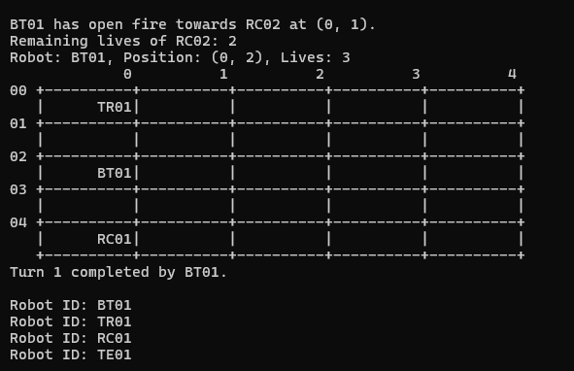
- actionFire(battlefield, N, M):
  - This method is responsible for the robot's firing actions:
    - It determines the target position based on a predefined firing sequence.
    - It checks if the target position is within the battlefield's bounds.
    - If there is an enemy robot at the target position, it prints a message indicating the attack and retrieves the target robot.
    - It decreases the target robot's lives and checks if the robot has any remaining lives:
      - If the robot has remaining lives, it is removed from the battlefield and queued for reentry.
      - If the robot has no remaining lives, it is permanently destroyed and removed from the battlefield.
    - It increments the totalKills counter and clears the battlefield position of the destroyed robot.
    - If totalKills reaches 3, the BlueThunder upgrades to a MadBot.

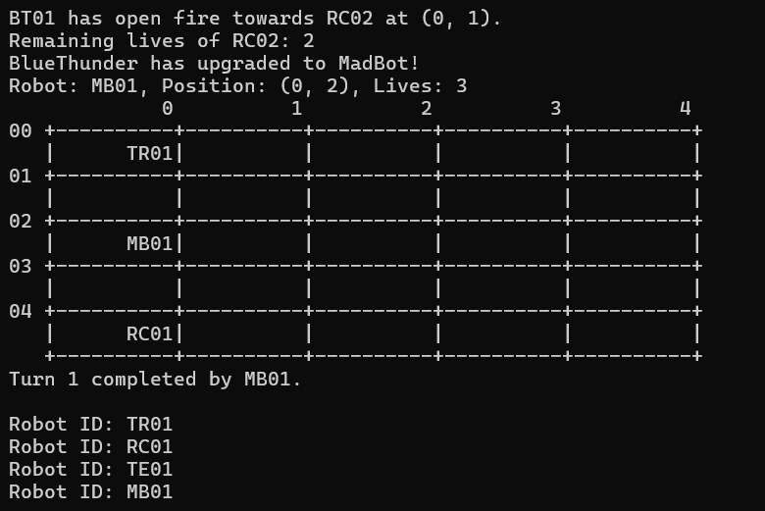
- upgradeToMadBot(battlefield, posX, posY):
  - This method handles the upgrade of BlueThunder to a MadBot:
    - It clears the current position of BlueThunder on the battlefield.
    - It prints an upgrade message.
    - It sets the upgrade flag to true.
    - It creates a new MadBot robot.
    - It updates the robot's ID to reflect the new MadBot identity.
    - It updates the battlefield with the new robot ID and upgrades the robot in the robot list.

e. Madbot:
This robot does not move. It fires at only one of its immediate neighboring locations 8 neighborhoods randomly.
If Madbot eliminates a total of 3 other robots, it will be upgraded to RoboTank.
Code segments:
void Madbot::actionFire(char** battlefield, int N, int M) {
int fireX, fireY;
bool validTarget = false;

// Loop until a valid target is found within bounds
while (!validTarget) {
fireX = posX + rand() % 3 - 1; // Fire randomly within -1, 0, or 1 in x direction
fireY = posY + rand() % 3 - 1; // Fire randomly within -1, 0, or 1 in y direction

if (fireX >= 0 && fireX < M && fireY >= 0 && fireY < N && (fireX != posX || fireY != posY)) {
validTarget = true;

// Check if there's a robot at the target position
if (battlefield[fireY][fireX * (CELL_WIDTH + 1)] != ' ') {
// A robot is hit
string destroyedrobotid = battlefield[fireY] + fireX * (CELL_WIDTH + 1);
const string& destroyedRobotName = destroyedrobotid;
cout << robot_id << " has open fire towards " << destroyedRobotName << " at (" << fireX << ", " << fireY << ")." << endl;

Robot* destroyedRobot = robotList->search(destroyedRobotName);
if (destroyedRobot) {
destroyedRobot->decreaseLives();
cout << "Remaining lives of " << destroyedRobotName << ": " << destroyedRobot->getLives() << endl;
if (destroyedRobot->getLives() > 0) {
robotList->remove(destroyedRobotName); // Remove from linked list
queueWaitingRobots.enqueue(destroyedRobot); // Queue for reentry
} else {
queueDestroyedRobots.enqueue(destroyedRobot);
robotList->remove(destroyedRobotName);
cout<< destroyedRobotName << " has no lives left and is permanently destroyed."<< endl;
//robotList->remove(destroyedRobotName);
strncpy(battlefield[fireY] + fireX * (CELL_WIDTH + 1), " ", CELL_WIDTH);
battlefield[fireY][fireX * (CELL_WIDTH + 1) + CELL_WIDTH] = '\0'; // Ensure null-termination
//return;
}
}
totalKills++; // Increase the shot count

// Clear the battlefield position of the destroyed robot
strncpy(battlefield[fireY] + fireX * (CELL_WIDTH + 1), " ", CELL_WIDTH);
battlefield[fireY][fireX * (CELL_WIDTH + 1) + CELL_WIDTH] = '\0'; // Ensure null-termination

// Upgrade to RobotTank if totalKills reaches 1
if (totalKills == 3) {
string rt = battlefield[posY] + posX * (CELL_WIDTH + 1);
const string& robottank = rt;
robotList->remove(robottank);
upgradeToRobotTank(battlefield, posX, posY);
}
}
else {
cout << robot_id << " fired at an empty position at (" << fireX << ", " << fireY << ")." << endl;
}
}
}
}

void Madbot::upgradeToRobotTank(char** battlefield, int posX, int posY){

strncpy(battlefield[posY] + posX * (CELL_WIDTH + 1), " ", CELL_WIDTH);
battlefield[posY][posX * (CELL_WIDTH + 1) + CELL_WIDTH] = '\0'; // Ensure null-termination
// Inform about the upgrade and update battlefield with TerminatorRoboCop
upgrade = true; // Set upgrade flag
cout << "Madbot has upgraded to RoboTank!" << endl;
Robot* newRobot = new RoboTank();
const string& current_robot_id = "MB01"; // Example current robot ID to upgrade
const string& new_robotid_letters = "RT"; // New robot letters ID
int new_robotid_numbers = 1; // New robot numbers ID
robot_id=robotList->nehtid(current_robot_id,new_robotid_letters,new_robotid_numbers,posX,posY,newRobot);;
strncpy(battlefield[posY] + posX * (CELL_WIDTH + 1), robot_id.c_str(), CELL_WIDTH);
battlefield[posY][posX * (CELL_WIDTH + 1) + CELL_WIDTH] = '\0'; // Ensure null-termination
robotList->upgrade(current_robot_id,new_robotid_letters,new_robotid_numbers,posX,posY,newRobot);
}
Pseudocode parts:
CLASS Madbot EXTENDS ShootingRobot:

PRIVATE ammo = 3
PRIVATE totalKills = 0
PRIVATE upgrade = false

METHOD actionLook(battlefield, N, M):
// Implement look functionality

METHOD actionMove(battlefield, N, M):
// Implement move functionality

METHOD actionFire(battlefield, N, M):
WHILE true:
SET fireX = posX + random number in range [-1, 1]
SET fireY = posY + random number in range [-1, 1]

IF fireX and fireY within bounds and not equal to (posX, posY):
IF target position is not empty:
PRINT robot_id firing at target
SET destroyedRobot = robotList.search(robot at target)

IF destroyedRobot exists:
destroyedRobot.decreaseLives()
PRINT remaining lives of destroyedRobot

IF destroyedRobot has lives remaining:
robotList.remove(destroyedRobot)
queueWaitingRobots.enqueue(destroyedRobot)
ELSE:
queueDestroyedRobots.enqueue(destroyedRobot)
robotList.remove(destroyedRobot)
PRINT destroyedRobot permanently destroyed
CLEAR battlefield position of destroyed robot

totalKills++
CLEAR battlefield position of destroyed robot

IF totalKills == 3:
robotList.remove(self)
upgradeToTerminatorRoboCop(battlefield, posX, posY)
ELSE:
PRINT robot_id firing at empty position
BREAK

METHOD upgradeToRobotTank (battlefield, posX, posY):
CLEAR battlefield position of self
PRINT upgrade message
SET upgrade = true
CREATE new RoboTank robot
UPDATE robot_id to new ID
UPDATE battlefield with new robot_id
robotList.upgrade(self, new robot details)

Explanations:

Attributes:
- totalKills:
  - A counter that keeps track of the number of robots the Madbot has destroyed.

Methods:
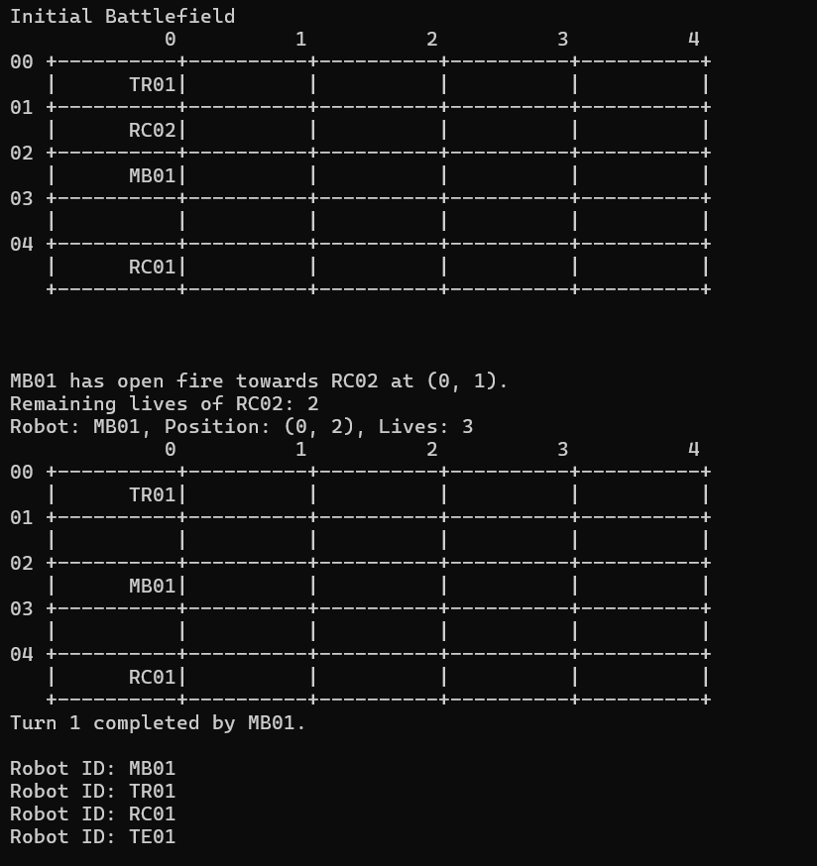
- actionFire(battlefield, N, M):
  - This method is responsible for the robot's firing actions:
    - It selects a random target position within a 3x3 area around the robot's current position.
    - It checks if the target position is within the battlefield's bounds and is not the same as the robot's current position.
    - If there is an enemy robot at the target position, it prints a message indicating the attack and retrieves the target robot.
    - It decreases the target robot's lives and checks if the robot has any remaining lives:
      - If the robot has remaining lives, it is removed from the battlefield and queued for reentry.
      - If the robot has no remaining lives, it is permanently destroyed and removed from the battlefield.
    - It increments the totalKills counter and clears the battlefield position of the destroyed robot.
    - If totalKills reaches 3, the Madbot upgrades to a RoboTank.

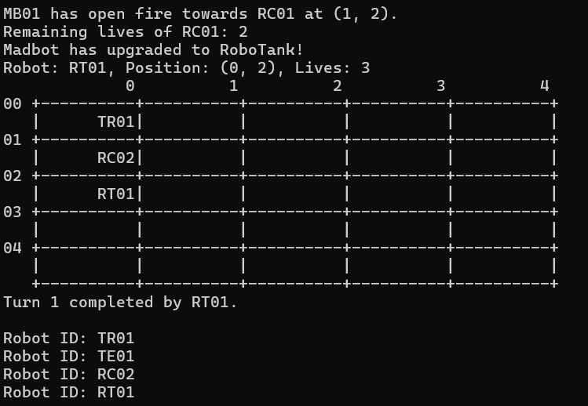
- upgradeToRobotTank(battlefield, posX, posY):
  - This method handles the upgrade of Madbot to a RoboTank:
    - It clears the current position of Madbot on the battlefield.
    - It prints an upgrade message.
    - It sets the upgrade flag to true.
    - It creates a new RoboTank robot.
    - It updates the robot's ID to reflect the new RoboTank identity.
    - It updates the battlefield with the new robot ID and upgrades the robot in the robot list.

f. RoboTank:
This robot does not move. It fires at one random location (x, y) in the battlefield, killing a robot if one exists in that position.
If RoboTank kills a total of 3 other robots, it will be upgraded to UltimateRobot.

Code segments:
void RoboTank::actionFire(char** battlefield, int N, int M) {

// Fire at one random position within the battlefield
int fireX = rand() % M;
int fireY = rand() % N;

// Ensure that the target position is not the robot's own position
if (fireX != posX || fireY != posY) {
// Check if there's a robot at the target position
if (battlefield[fireY][fireX * (CELL_WIDTH + 1)] != ' ') {
// A robot is hit
string destroyedrobotid = battlefield[fireY] + fireX * (CELL_WIDTH + 1);
const string& destroyedRobotName = destroyedrobotid;
cout << robot_id << " has open fire towards " << destroyedRobotName << " at (" << fireX << ", " << fireY << ")." << endl;
totalKills++; // Increase the kill count
Robot* destroyedRobot = robotList->search(destroyedRobotName);
if (destroyedRobot) {
destroyedRobot->decreaseLives();
cout << "Remaining lives of " << destroyedRobotName << ": " << destroyedRobot->getLives() << endl;
if (destroyedRobot->getLives() > 0) {
robotList->remove(destroyedRobotName); // Remove from linked list
queueWaitingRobots.enqueue(destroyedRobot); // Queue for reentry
} else {
queueDestroyedRobots.enqueue(destroyedRobot);
robotList->remove(destroyedRobotName);
cout<< destroyedRobotName << " has no lives left and is permanently destroyed."<< endl;
//robotList->remove(destroyedRobotName);
strncpy(battlefield[fireY] + fireX * (CELL_WIDTH + 1), " ", CELL_WIDTH);
battlefield[fireY][fireX * (CELL_WIDTH + 1) + CELL_WIDTH] = '\0'; // Ensure null-termination
//return;
}
}
//robotList->remove(destroyedRobotName);
//robotList.remove(destroyedRobotName)
// Clear the battlefield position of the destroyed robot
strncpy(battlefield[fireY] + fireX * (CELL_WIDTH + 1), " ", CELL_WIDTH);
battlefield[fireY][fireX * (CELL_WIDTH + 1) + CELL_WIDTH] = '\0'; // Ensure null-termination

if (totalKills == 3) {
string ur = battlefield[posY] + posX * (CELL_WIDTH + 1);
const string& ulti = ur;
robotList->remove(ulti);
upgradeToUltimateRobot(battlefield, posX, posY);
}
}
else {
cout << robot_id << " fired at an empty position at (" << fireX << ", " << fireY << ")." << endl;
}
}
}

void RoboTank::upgradeToUltimateRobot(char** battlefield, int posX, int posY){

strncpy(battlefield[posY] + posX * (CELL_WIDTH + 1), " ", CELL_WIDTH);
battlefield[posY][posX * (CELL_WIDTH + 1) + CELL_WIDTH] = '\0'; // Ensure null-termination
// Inform about the upgrade and update battlefield with TerminatorRoboCop
upgrade = true; // Set upgrade flag
cout << "RoboTank has upgraded to UltimateRobot!" << endl;
Robot* newRobot = new RoboTank();
const string& current_robot_id = "RT01"; // Example current robot ID to upgrade
const string& new_robotid_letters = "UR"; // New robot letters ID
int new_robotid_numbers = 1; // New robot numbers ID
robot_id=robotList->nehtid(current_robot_id,new_robotid_letters,new_robotid_numbers,posX,posY,newRobot);;
strncpy(battlefield[posY] + posX * (CELL_WIDTH + 1), robot_id.c_str(), CELL_WIDTH);
battlefield[posY][posX * (CELL_WIDTH + 1) + CELL_WIDTH] = '\0'; // Ensure null-termination
robotList->upgrade(current_robot_id,new_robotid_letters,new_robotid_numbers,posX,posY,newRobot);
}

Pseudocode parts:
CLASS RoboTank EXTENDS ShootingRobot:

PRIVATE ammo = 3
PRIVATE totalKills = 0
PRIVATE upgrade = false

METHOD actionFire(battlefield, N, M):
// Fire at one random position within the battlefield
fireX = random(0, M-1)
fireY = random(0, N-1)

IF (fireX != posX OR fireY != posY):
IF (battlefield[fireY][fireX] != ' '):
// A robot is hit
destroyedRobotName = battlefield[fireY][fireX]
PRINT(robot_id + " has fired towards " + destroyedRobotName + " at (" + fireX + ", " + fireY + ").")

totalKills += 1

destroyedRobot = robotList.search(destroyedRobotName)

IF destroyedRobot:
destroyedRobot.decreaseLives()
PRINT("Remaining lives of " + destroyedRobotName + ": " + destroyedRobot.getLives())

IF destroyedRobot.getLives() > 0:
robotList.remove(destroyedRobotName)
queueWaitingRobots.enqueue(destroyedRobot)
ELSE:
queueDestroyedRobots.enqueue(destroyedRobot)
robotList.remove(destroyedRobotName)
PRINT(destroyedRobotName + " has no lives left and is permanently destroyed.")
battlefield[fireY][fireX] = ' '

battlefield[fireY][fireX] = ' '

IF (totalKills == 3):
robotList.remove(robot_id)
upgradeToUltimateRobot(battlefield, posX, posY)
ELSE:
PRINT(robot_id + " fired at an empty position at (" + fireX + ", " + fireY + ").")

METHOD upgradeToUltimateRobotbattlefield, posX, posY):
battlefield[posY][posX] = ' '
PRINT("RoboTank has upgraded to UltimateRobot!")

upgrade = true
newRobot = NEW UltimateRobot()
robot_id = robotList.nehtid(current_robot_id, "UR", 1, posX, posY, newRobot)

battlefield[posY][posX] = robot_id
robotList.upgrade(current_robot_id, "UR", 1, posX, posY, newRobot)

Explanations:

Attributes:
- totalKills:
  - Purpose: To keep track of the number of robots the RoboTank has destroyed.
  - Usage: This attribute is updated in the actionFire method whenever an enemy robot is successfully destroyed. It is also checked to determine if the RoboTank should upgrade to the next level.

Methods:
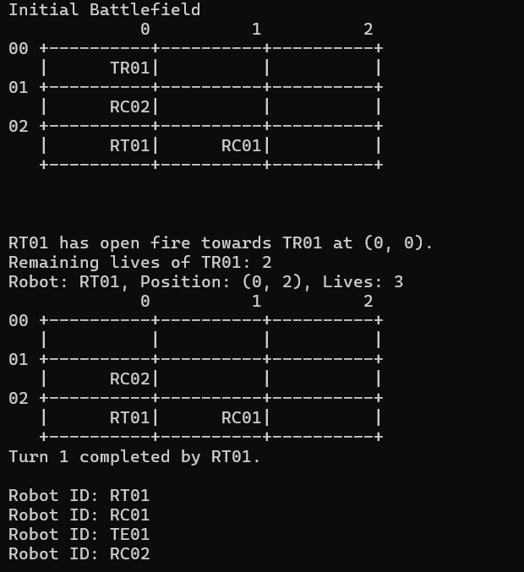
- actionFire(battlefield, N, M):
  - Purpose: To fire at enemies on the battlefield.
  - Functionality:
    - The robot fires at a randomly selected position within the battlefield.
    - Ensures that the target position is not the robot's own position.
    - If an enemy robot is present at the target position:
      - Prints a message indicating the attack.
      - Increments the totalKills counter.
      - Retrieves the target robot and decreases its lives.
      - If the target robot still has lives remaining, it is removed from the battlefield and queued for reentry.
      - If the target robot has no lives left, it is permanently destroyed and removed from the battlefield.
      - Clears the battlefield position of the destroyed robot.
      - If totalKills reaches 3, the RoboTank upgrades to UltimateRobot.
    - If the target position is empty, prints a message indicating a missed shot.
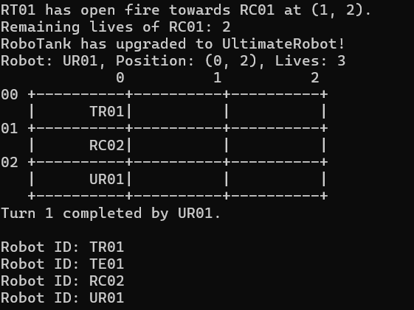
- upgradeToUltimateRobot(battlefield, posX, posY):
  - Purpose: To upgrade the RoboTank to an UltimateRobot.
  - Functionality:
    - Clears the current position of the RoboTank on the battlefield.
    - Prints a message indicating the upgrade.
    - Sets the upgrade flag to true.
    - Creates a new UltimateRobot.
    - Updates the robot's ID to reflect the new UltimateRobot identity.
    - Updates the battlefield with the new robot ID and upgrades the robot in the robot list.

g. UltimateRobot:
This robot moves like the TerminatorRoboCop, stepping and killing any robots on its path.
On top of that, in each turn, this robot fires randomly at 3 locations (x, y) in the battlefield.

Code segments:
void UltimateRobot::actionLook(char** battlefield, int N, int M) {

// Clear the previous look results
enemyPositions.clear();

// Look at the immediate neighborhood (3x3 window)
for (int dx = -1; dx <= 1; ++dx) {
for (int dy = -1; dy <= 1; ++dy) {
int x = posX + dx;
int y = posY + dy;

// Check if the position is within bounds
if (x >= 0 && x < M && y >= 0 && y < N &&(x != posX || y != posY)) {
char* cell = battlefield[y] + x * (CELL_WIDTH + 1);

// Check if the cell contains an enemy robot
if (cell[0] != ' ' && cell[0] != robot_id[0]) {
enemyPositions.push_back({x, y});
cout<<"UltimateRobot found an Enemy at (" << x << ", " << y<< ")."<<endl;
}
}
}
}
}

void UltimateRobot::actionFire(char** battlefield, int N, int M) {

// Fire at three random positions within the battlefield
for (int fireCount = 0; fireCount < 3; ++fireCount) {
int fireX = rand() % M;
int fireY = rand() % N;
bool validTarget = false;

while (!validTarget) {
if (fireX >= 0 && fireX < M && fireY >= 0 && fireY < N) {
bool isEnemyPosition = std::find(enemyPositions.begin(), enemyPositions.end(), std::make_pair(fireX, fireY)) != enemyPositions.end();

if (!isEnemyPosition) {
validTarget = true;
}
}

}
// Check if the firing position is within the maximum city block distance
if (battlefield[fireY][fireX * (CELL_WIDTH + 1)] != ' ') {
// A robot is hit

string destroyedrobotid = battlefield[fireY] + fireX * (CELL_WIDTH + 1);
const string& destroyedRobotName = destroyedrobotid;
cout << robot_id << " has open fire towards " << destroyedRobotName << " at (" << fireX << ", " << fireY << ")." << endl;
Robot* destroyedRobot = robotList->search(destroyedRobotName);
if (destroyedRobot) {
destroyedRobot->decreaseLives();
cout << "Remaining lives of " << destroyedRobotName << ": " << destroyedRobot->getLives() << endl;
if (destroyedRobot->getLives() > 0) {
robotList->remove(destroyedRobotName); // Remove from linked list
queueWaitingRobots.enqueue(destroyedRobot); // Queue for reentry
} else {
queueDestroyedRobots.enqueue(destroyedRobot);
robotList->remove(destroyedRobotName);
cout<< destroyedRobotName << " has no lives left and is permanently destroyed."<< endl;
//robotList->remove(destroyedRobotName);
strncpy(battlefield[fireY] + fireX * (CELL_WIDTH + 1), " ", CELL_WIDTH);
battlefield[fireY][fireX * (CELL_WIDTH + 1) + CELL_WIDTH] = '\0'; // Ensure null-termination

//return;
}
}
//robotList->remove(destroyedRobotName);
//robotList.remove(destroyedRobotName);
totalKills++; // Increase the kill count
strncpy(battlefield[fireY] + fireX * (CELL_WIDTH + 1), " ", CELL_WIDTH);
battlefield[fireY][fireX * (CELL_WIDTH + 1) + CELL_WIDTH] = '\0'; // Ensure null-termination

}
else {
cout << robot_id << " fired at an empty position at (" << fireX << ", " << fireY << ")." << endl;
}
}
}

void UltimateRobot::actionStep(char** battlefield, int N, int M) {

// If enemies are found, move to the first enemy position
if (!enemyPositions.empty()) {
int bestX = enemyPositions[0].first;
int bestY = enemyPositions[0].second;

// "Kill" the enemy
totalKills++;

// Print message about destroyed robot
string destroyedrobotid = battlefield[bestY] + bestX * (CELL_WIDTH + 1);
const string& destroyedRobotName = destroyedrobotid;
cout << robot_id << " has stomp on " << destroyedRobotName << " at (" << bestX << ", " << bestY << ")." << endl;
Robot* destroyedRobot = robotList->search(destroyedRobotName);
if (destroyedRobot) {
destroyedRobot->decreaseLives();
cout << "Remaining lives of " << destroyedRobotName << ": " << destroyedRobot->getLives() << endl;
if (destroyedRobot->getLives() > 0) {
robotList->remove(destroyedRobotName); // Remove from linked list
queueWaitingRobots.enqueue(destroyedRobot); // Queue for reentry
} else {
queueDestroyedRobots.enqueue(destroyedRobot);
robotList->remove(destroyedRobotName);
cout<< destroyedRobotName << " has no lives left and is permanently destroyed."<< endl;
strncpy(battlefield[bestY] + bestX * (CELL_WIDTH + 1), " ", CELL_WIDTH);
battlefield[bestY][bestX * (CELL_WIDTH + 1) + CELL_WIDTH] = '\0'; // Ensure null-termination

//return;
}
}
//robotList->remove(destroyedRobotName);
//robotList.remove(destroyedRobotName);
// Clear the battlefield position of the destroyed robot
strncpy(battlefield[bestY] + bestX * (CELL_WIDTH + 1), " ", CELL_WIDTH);
battlefield[bestY][bestX * (CELL_WIDTH + 1) + CELL_WIDTH] = '\0'; // Ensure null-termination

// Erase ID from previous position
strncpy(battlefield[posY] + posX * (CELL_WIDTH + 1), " ", CELL_WIDTH);
battlefield[posY][posX * (CELL_WIDTH + 1) + CELL_WIDTH] = '\0'; // Ensure null-termination

// Move to the new position
posX = bestX;
posY = bestY;

// Mark the new position with the robot ID
strncpy(battlefield[posY] + posX * (CELL_WIDTH + 1), robot_id.c_str(), CELL_WIDTH);
battlefield[posY][posX * (CELL_WIDTH + 1) + CELL_WIDTH] = '\0'; // Ensure null-termination
return;
} else {
// No enemies found, attempt to move to a new position
int newX, newY;

// Attempt to move to a new position up to 3 times to find a free spot
for (int attempt = 0; attempt < 3; ++attempt) {
newX = posX + rand() % 3 - 1; // Move randomly within -1, 0, or 1 in x direction
newY = posY + rand() % 3 - 1; // Move randomly within -1, 0, or 1 in y direction

if (newX >= 0 && newX < M && newY >= 0 && newY < N && battlefield[newY][newX * (CELL_WIDTH + 1)] == ' '&&(newX != posX || newY != posY)) {
// Erase ID from previous position
strncpy(battlefield[posY] + posX * (CELL_WIDTH + 1), " ", CELL_WIDTH);
battlefield[posY][posX * (CELL_WIDTH + 1) + CELL_WIDTH] = '\0'; // Ensure null-termination

// Update the position of the Terminator
posX = newX;
posY = newY;

// Place ID at the new position
strncpy(battlefield[posY] + posX * (CELL_WIDTH + 1), robot_id.c_str(), CELL_WIDTH);
battlefield[posY][posX * (CELL_WIDTH + 1) + CELL_WIDTH] = '\0'; // Ensure null-termination
cout<<"UltimateRobot moved to location ("<<posX<<","<<posY<<")"<<endl;
return; // Successfully moved to the new position
}
}
}
}

Pseudocode parts:
CLASS UltimateRobot EXTENDS SeeingRobot, MovingRobot, ShootingRobot,StepRobot:

PRIVATE ammo = 3
PRIVATE totalKills = 0
PRIVATE upgrade = false

METHOD actionLook(battlefield, N, M):
// Clear previous enemy positions
enemyPositions.clear()

// Inspect immediate 3x3 neighborhood
FOR dx FROM -1 TO 1:
FOR dy FROM -1 TO 1:
x = posX + dx
y = posY + dy
IF x and y are within bounds AND NOT (x == posX AND y == posY):
cell = battlefield[y][x]
IF cell contains an enemy:
ADD (x, y) TO enemyPositions
PRINT "Enemy found at (x, y)"

METHOD actionStep(battlefield, N, M):
IF enemyPositions is NOT empty:
bestX, bestY = first position in enemyPositions
// "Kill" the enemy
INCREMENT totalKills
destroyedRobotName = battlefield[bestY][bestX]
PRINT "Stomped on destroyedRobotName at (bestX, bestY)"
destroyedRobot = robotList.search(destroyedRobotName)
IF destroyedRobot EXISTS:
destroyedRobot.decreaseLives()
IF destroyedRobot.getLives() > 0:
robotList.remove(destroyedRobotName)
queueWaitingRobots.enqueue(destroyedRobot)
ELSE:
queueDestroyedRobots.enqueue(destroyedRobot)
robotList.remove(destroyedRobotName)
PRINT "destroyedRobotName has no lives left"
battlefield[bestY][bestX] = ' '

battlefield[posY][posX] = ' '
posX = bestX
posY = bestY
battlefield[posY][posX] = robot_id
ELSE:
FOR attempt FROM 1 TO 3:
newX = posX + random(-1, 1)
newY = posY + random(-1, 1)
IF newX and newY are within bounds AND battlefield[newY][newX] is empty:
battlefield[posY][posX] = ' '
posX = newX
posY = newY
battlefield[posY][posX] = robot_id
PRINT "Moved to (posX, posY)"
BREAK
METHOD actionMove(battlefield, N, M):
//Implement actionStep instruction
METHOD actionFire(battlefield, N, M):
FOR fireCount FROM 1 TO 3:
fireX = random(0, M)
fireY = random(0, N)
IF fireX != posX OR fireY != posY:
IF battlefield[fireY][fireX] is not empty:
destroyedRobotName = battlefield[fireY][fireX]
PRINT "Fired at destroyedRobotName at (fireX, fireY)"
totalKills += 1
destroyedRobot = robotList.search(destroyedRobotName)
IF destroyedRobot EXISTS:
destroyedRobot.decreaseLives()
IF destroyedRobot.getLives() > 0:
robotList.remove(destroyedRobotName)
queueWaitingRobots.enqueue(destroyedRobot)
ELSE:
queueDestroyedRobots.enqueue(destroyedRobot)
robotList.remove(destroyedRobotName)
PRINT "destroyedRobotName has no lives left"
battlefield[fireY][fireX] = ' '
ELSE:
PRINT "Fired at empty position (fireX, fireY)"

Explanations:

Attributes:
- enemyPositions: This attribute stores the positions of detected enemy robots within the immediate 3x3 neighborhood around the robot.
- totalKills: This is a counter that keeps track of the number of enemy robots destroyed by the UltimateRobot.

Methods:
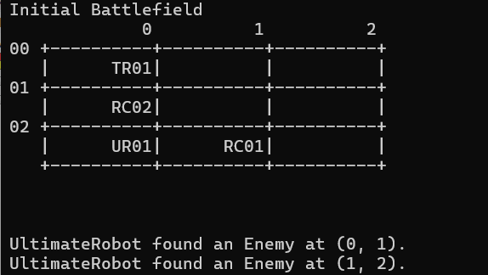
- actionLook:
  - This method inspects the immediate 3x3 neighborhood around the robot to detect enemy robots.
  - The method clears any previously stored enemy positions and then iterates through the 3x3 grid centered on the robot's current position.
  - For each cell in the grid, if the cell is within the battlefield boundaries and is not the robot's own position, it checks if the cell contains an enemy robot.
  - If an enemy robot is found, its position is added to the enemyPositions list.
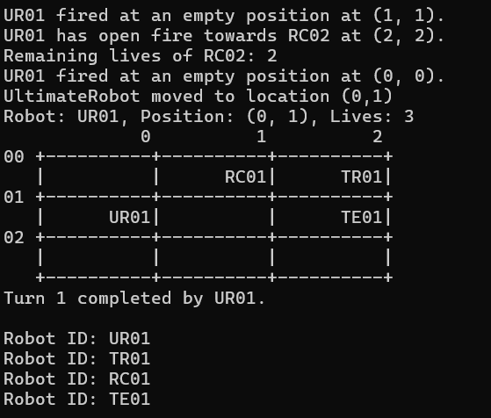
- actionFire:
  - This method allows the robot to fire at enemies on the battlefield.
  - The robot fires at three random positions within the battlefield.
  - For each firing position, if it is within the battlefield and not the robot's own position, it checks if there is an enemy robot at that position.
  - If an enemy robot is hit, the method decreases the enemy robot's lives and updates the battlefield accordingly.
  - If the robot's total kills reach a certain threshold, it upgrades to a more powerful robot.
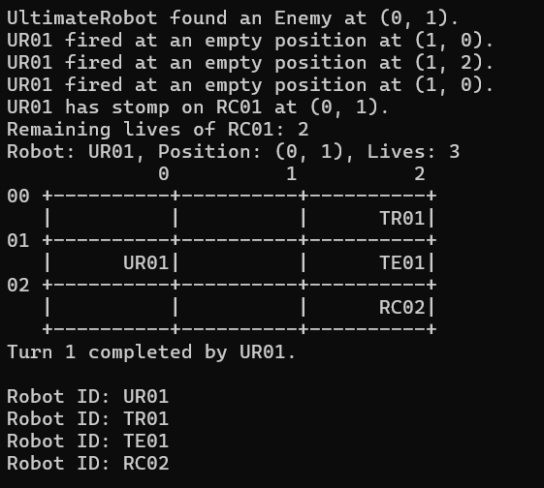
- actionStep:
  - This method allows the robot to step on and destroy enemy robots.
  - If there are detected enemies in the enemyPositions list, the robot moves to the position of the first enemy in the list and "kills" the enemy by decreasing its lives and updating the battlefield.
  - If no enemies are found, the robot attempts to move to a random new position up to three times, ensuring the new position is within the battlefield and is empty.

- actionMove: (Same implementation as actionstep for UltimateRobot)

Q5. [8] Implementation of the required 7 robot classes with OOP concepts +1 or I&P&OO -3

Inheritance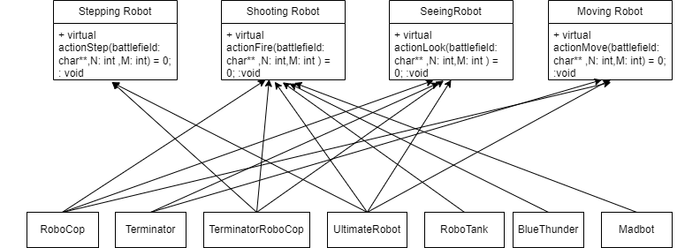

Explanation:
- RoboCop
- Inherits from SeeingRobot, MovingRobot, and ShootingRobot
- actionLook: Scans the 3x3 grid around its current position to detect enemies.
- actionMove: Moves to a new position based on the result of actionLook.
- actionFire: Fires at detected enemies within range.

- Terminator
- Inherit from SeeingRobot and MovingRobot.
- actionLook: Scans the 3x3 grid around its current position to detect enemies.
- actionMove: Moves towards detected enemies or strategizes based on the battlefield state.

- TerminatorRoboCop
- Inherits from SeeingRobot, ShootingRobot, and SteppingRobot.
- actionLook: Scans the 3x3 grid around its current position to detect enemies.
- actionStep: Steps on enemies to destroy them if in an advantageous position.
- actionFire: Fires at detected enemies within range.

- UltimateRobot
- Inherits from SeeingRobot, MovingRobot, ShootingRobot, and SteppingRobot.
- actionLook: Scans the 3x3 grid around its current position to detect enemies.
- actionMove: Moves to the best position based on all detected threats and opportunities.
- actionFire: Fires at detected enemies with advanced targeting.
- actionStep: Steps on enemies to destroy them.

- RoboTank
- Inherits from ShootingRobot
- actionFire: Fires at enemies with heavy weaponry, potentially causing more destruction.

- BlueThunder
- Inherits from ShootingRobot.
- actionFire: Fires at enemies following a predefined firing sequence.

- Matbot
- Inherits from ShootingRobot.
- actionFire: Fires at enemies with a more chaotic or aggressive strategy.

Polymorphism
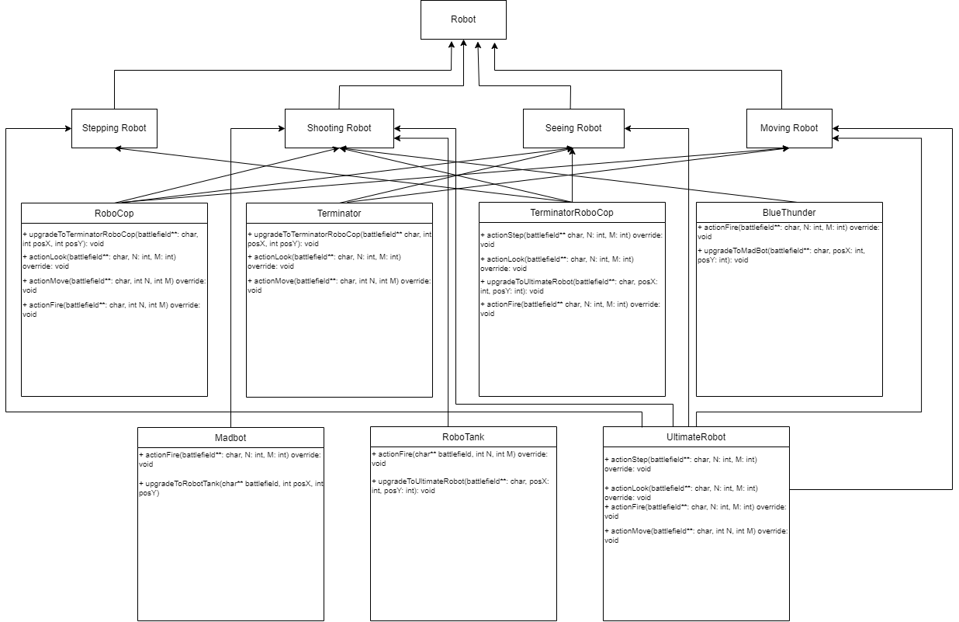
Explanation:
- RoboCop
- Inherits from SeeingRobot, MovingRobot, and ShootingRobot
- When a RoboCop object is passed to a function expecting a SeeingRobot, MovingRobot, or ShootingRobot pointer, the appropriate method (actionLook, actionMove, actionFire) is invoked based on the actual type of the object.

- Terminator
- Inherits from SeeingRobot and MovingRobot.
- When a Terminator object is passed to a function expecting a SeeingRobot or MovingRobot pointer, the appropriate method (actionLook, actionMove) is invoked.

- TerminatorRoboCop
- Inherits from SeeingRobot, ShootingRobot, and SteppingRobot.
- When a TerminatorRoboCop object is passed to a function expecting a SeeingRobot, ShootingRobot, or SteppingRobot pointer, the appropriate method (actionLook, actionStep, actionFire) is invoked.
- UltimateRobot
- Inherits from SeeingRobot, MovingRobot, ShootingRobot, and SteppingRobot.
- When an UltimateRobot object is passed to a function expecting a SeeingRobot, MovingRobot, ShootingRobot, or SteppingRobot pointer, the appropriate method (actionLook, actionMove, actionFire, actionStep) is invoked.

- RoboTank
- Inherits from ShootingRobot
- When a RoboTank object is passed to a function expecting a ShootingRobot pointer, the actionFire method is invoked.

- BlueThunder
- Inherits from ShootingRobot.
- When a BlueThunder object is passed to a function expecting a ShootingRobot pointer, the actionFire method is invoked.

- Matbot
- Inherits from ShootingRobot.
- When a Madbot object is passed to a function expecting a ShootingRobot pointer, the actionFire method is invoked.

Operator overloading
void DisplayFunctions::displayBattlefieldHelper(char** battlefield, int rows, int cols, int cellWidth, int cellHeight, ostream& os) {
os << " "; // Leading spaces for column headers
for (int j = 0; j < cols; ++j) {
os << setw(cellWidth) << setfill(' ') << j << ' ';
}
os << endl;

for (int i = 0; i < rows; ++i) {
os << setw(2) << setfill('0') << i << " +";
for (int j = 0; j < cols; ++j) {
for (int w = 0; w < cellWidth; ++w) {
os << '-';
}
os << '+';
}
os << endl;

for (int h = 0; h < cellHeight; ++h) {
os << " |"; // Left boundary
for (int j = 0; j < cols; ++j) {
os << setw(cellWidth) << setfill(' ') << (battlefield[i] + j * (cellWidth + 1)) << '|';
}
os << endl;
}
}

os << " +";
for (int j = 0; j < cols; ++j) {
for (int w = 0; w < cellWidth; ++w) {
os << '-';
}
os << '+';
}
os << endl;
}

void DisplayFunctions::displayBattlefield(char** battlefield, int rows, int cols, int cellWidth, int cellHeight) {
displayBattlefieldHelper(battlefield, rows, cols, cellWidth, cellHeight, cout);
}

void DisplayFunctions::displayBattlefield(char** battlefield, int rows, int cols, int cellWidth, int cellHeight, ofstream& outfile) {
displayBattlefieldHelper(battlefield, rows, cols, cellWidth, cellHeight, outfile);
}
Explanation:
Using << with ostream and ofstream:
- os << " ";: This uses the << operator to insert a string into the output stream.
- os << setw(cellWidth) << setfill(' ') << j << ' ';: This chain of calls uses manipulators setw and setfill, along with the << operator, to format the output width and fill character before inserting a variable.
- os << endl;: This inserts a newline character into the stream.

Code segments, pseudocode parts, explanations
a. RoboCop
class RoboCop : public SeeingRobot, public MovingRobot, public ShootingRobot {
private:
int ammo = 3; // Number of fires remaining in current turn
int totalKills = 0; // Total number of robots killed
bool upgrade = false; // Flag to check if upgraded to step on robots
public:

void actionLook(char** battlefield, int N, int M) override; // Inspect immediate 3x3 neighborhood
void actionMove(char** battlefield, int N, int M) override; //
void actionFire(char** battlefield, int N, int M) override;
void upgradeToTerminatorRoboCop(char** battlefield, int posx, int posY);

};

Pseudocode:
CLASS RoboCop extends SeeingRobot, MovingRobot, ShootingRobot:
PRIVATE ammo = 3
PRIVATE totalKills = 0
PRIVATE upgrade = false

METHOD actionLook(battlefield, N, M):
// Implement look functionality

METHOD actionMove(battlefield, N, M):
// Implement move functionality

METHOD actionFire(battlefield, N, M):
// Implement fire functionality

METHOD upgradeToTerminatorRoboCop(battlefield, posx, posY):
// Implement upgrade functionality

Explanation:
- Attributes:
  - ammo: Number of fires remaining in current turn.
  - totalKills: Total number of robots killed.
  - upgrade: Flag to check if upgraded to step on robots.
- Methods:
  - actionLook: Inspect immediate 3x3 neighborhood.
  - actionMove: Moves the robot on the battlefield.
  - actionFire: Fires at enemies on the battlefield.
  - upgradeToTerminatorRoboCop: Upgrades the robot to a TerminatorRoboCop.

b. Terminator
class Terminator : public SeeingRobot, public MovingRobot {
private:
vector<pair<int, int>> enemyPositions; // To store positions of detected enemies (vector enemyPositions will be a pair of integers.)
int totalKills = 0; // Counter for the number of kills
bool upgrade = false;
public:
void actionLook(char** battlefield, int N, int M) override; // Inspect immediate 3x3 neighborhood
void actionMove(char** battlefield, int N, int M) override; // Move based on inspection
void upgradeToTerminatorRoboCop(char** battlefield, int posX, int posY);

};

Pseudocode:
CLASS Terminator extends SeeingRobot, MovingRobot:
PRIVATE enemyPositions = []
PRIVATE totalKills = 0
PRIVATE upgrade = false

METHOD actionLook(battlefield, N, M):
// Implement look functionality

METHOD actionMove(battlefield, N, M):
// Implement move functionality

METHOD upgradeToTerminatorRoboCop(battlefield, posX, posY):
// Implement upgrade functionality

Explanation:
- Attributes:
  - enemyPositions: To store positions of detected enemies.
  - totalKills: Counter for the number of kills.
  - upgrade: Flag to check if upgraded to step on robots.
- Methods:
  - actionLook: Inspect immediate 3x3 neighborhood.
  - actionMove: Moves the robot based on inspection.
  - upgradeToTerminatorRoboCop: Upgrades the robot to a TerminatorRoboCop.

c. TerminatorRoboCop
class TerminatorRoboCop : public SeeingRobot, public ShootingRobot, public SteppingRobot {
private:
vector<pair<int, int>> enemyPositions; // To store positions of detected enemies
int totalKills = 0;
bool upgrade = false;
public:
void actionLook(char** battlefield, int N, int M) override;
void actionStep(char** battlefield, int N, int M) override;
void actionFire(char** battlefield, int N, int M) override;
void upgradeToUltimateRobot(char** battlefield, int posX, int posY);
};

Pseudocode:
CLASS TerminatorRoboCop extends SeeingRobot, ShootingRobot, SteppingRobot:
PRIVATE enemyPositions = []
PRIVATE totalKills = 0
PRIVATE upgrade = false

METHOD actionLook(battlefield, N, M):
// Implement look functionality

METHOD actionStep(battlefield, N, M):
// Implement step functionality

METHOD actionFire(battlefield, N, M):
// Implement fire functionality

METHOD upgradeToUltimateRobot(battlefield, posX, posY):
// Implement upgrade functionality

Explanation:
- Attributes:
  - enemyPositions: To store positions of detected enemies.
  - totalKills: Counter for the number of kills.
  - upgrade: Flag to check if upgraded to step on robots.
- Methods:
  - actionLook: Inspect immediate 3x3 neighborhood.
  - actionStep: Steps on robots.
  - actionFire: Fires at enemies on the battlefield.
  - upgradeToUltimateRobot: Upgrades the robot to an UltimateRobot.

d. BlueThunder
class BlueThunder : public ShootingRobot {
private:
int totalKills = 0;
bool upgrade = false;
vector<pair<int, int>> firingSequence;
size_t fireSequenceIndex = 0;
public:
void actionFire(char** battlefield, int N, int M) override;
void upgradeToMadBot(char** battlefield, int posX, int posY);

};

Pseudocode:
CLASS BlueThunder extends ShootingRobot:
PRIVATE totalKills = 0
PRIVATE upgrade = false
PRIVATE firingSequence = []
PRIVATE fireSequenceIndex = 0

METHOD actionFire(battlefield, N, M):
// Implement fire functionality

METHOD upgradeToMadBot(battlefield, posX, posY):
// Implement upgrade functionality

Explanation:
- Attributes:
  - totalKills: Counter for the number of kills.
  - upgrade: Flag to check if upgraded to step on robots.
  - firingSequence: Stores the sequence of firing positions.
  - fireSequenceIndex: Index for the current position in the firing sequence.
- Methods:
  - actionFire: Fires at enemies on the battlefield.
  - upgradeToMadBot: Upgrades the robot to a Madbot.

e. Madbot
class Madbot : public ShootingRobot {
private:
int totalKills = 0;
bool upgrade = false;
public:
void actionFire(char** battlefield, int N, int M) override;
void upgradeToRobotTank(char** battlefield, int posX, int posY);

};

Pseudocode:
CLASS Madbot extends ShootingRobot:
PRIVATE totalKills = 0
PRIVATE upgrade = false

METHOD actionFire(battlefield, N, M):
// Implement fire functionality

METHOD upgradeToRobotTank(battlefield, posX, posY):
// Implement upgrade functionality

Explanation:
- Attributes:
  - totalKills: Counter for the number of kills.
  - upgrade: Flag to check if upgraded to step on robots.
- Methods:
  - actionFire: Fires at enemies on the battlefield.
  - upgradeToRobotTank: Upgrades the robot to a RoboTank.

f. RoboTank
class RoboTank : public ShootingRobot {
private:
int totalKills = 0;
bool upgrade = false;
public:
void actionFire(char** battlefield, int posX, int posY) override;
void upgradeToUltimateRobot(char** battlefield, int posX, int posY);

};

Pseudocode:
CLASS RoboTank extends ShootingRobot:
PRIVATE totalKills = 0
PRIVATE upgrade = false

METHOD actionFire(battlefield, posX, posY):
// Implement fire functionality

METHOD upgradeToUltimateRobot(battlefield, posX, posY):
// Implement upgrade functionality

Explanation:
- Attributes:
  - totalKills: Counter for the number of kills.
  - upgrade: Flag to check if upgraded to step on robots.
- Methods:
  - actionFire: Fires at enemies on the battlefield.
  - upgradeToUltimateRobot: Upgrades the robot to an UltimateRobot.

g. UltimateRobot
class UltimateRobot : public SeeingRobot, public MovingRobot, public ShootingRobot, public SteppingRobot {
private:
vector<pair<int, int>> enemyPositions; // To store positions of detected enemies
int totalKills = 0;
public:
void actionLook(char** battlefield, int N, int M) override;
void actionMove(char** battlefield, int N, int M) override;
void actionFire(char** battlefield, int N, int M) override;
void actionStep(char** battlefield, int N, int M) override;

};

Pseudocode:
CLASS UltimateRobot extends SeeingRobot, MovingRobot, ShootingRobot, SteppingRobot:
PRIVATE enemyPositions = []
PRIVATE totalKills = 0

METHOD actionLook(battlefield, N, M):
// Implement look functionality

METHOD actionMove(battlefield, N, M):
// Implement move functionality

METHOD actionFire(battlefield, N, M):
// Implement fire functionality

METHOD actionStep(battlefield, N, M):
// Implement step functionality

Explanation:
- Attributes:
  - enemyPositions: To store positions of detected enemies.
  - totalKills: Counter for the number of kills.
- Methods:
  - actionLook: Inspect immediate 3x3 neighborhood.
  - actionMove: Moves the robot on the battlefield.
  - actionFire: Fires at enemies on the battlefield.
  - actionStep: Steps on robots.

Q6. [5] The algorithms used to optimize the actions of robots, optimize the two actions or -2

Algorithm 1 optimize the action MOVE, figures, explanations

Code Segment:
void RoboCop::actionMove(char** battlefield, int N, int M) {
// Attempt to move RoboCop to a random new position
int newX, newY;

// Attempt to move to a new position up to 10 times to find a free spot
for (int attempt = 0; attempt < 10; ++attempt) {
newX = posX + rand() % 3 - 1; // Move randomly within -1, 0, or 1 in x direction
newY = posY + rand() % 3 - 1; // Move randomly within -1, 0, or 1 in y direction

// Check if the new position is within bounds and not occupied by another robot
if (newX >= 0 && newX < M && newY >= 0 && newY < N && battlefield[newY][newX * (CELL_WIDTH + 1)] == ' '&& (newX != posX || newX != posY)) {
// Erase ID from previous position
strncpy(battlefield[posY] + posX * (CELL_WIDTH + 1), " ", CELL_WIDTH);
battlefield[posY][posX * (CELL_WIDTH + 1) + CELL_WIDTH] = '\0'; // Ensure null-termination

// Update the position of RoboCop
posX = newX;
posY = newY;

// Place ID at the new position
strncpy(battlefield[posY] + posX * (CELL_WIDTH + 1), robot_id.c_str(), CELL_WIDTH);
battlefield[posY][posX * (CELL_WIDTH + 1) + CELL_WIDTH] = '\0'; // Ensure null-termination
cout<<"Robocop moved to location ("<<posX<<","<<posY<<")"<<endl;
return; // Successfully moved to the new position
}
}
}
Pseudocode:
FUNCTION actionMove(battlefield, N, M):
# Initialize new position variables
newX, newY

# Try to find a new position up to 10 times
for attempt from 0 to 9:
# Calculate random new position within -1, 0, or 1 step in both x and y directions
newX = posX + random value between -1 and 1
newY = posY + random value between -1 and 1

# Check if the new position is within the bounds of the battlefield
# Also check if the new position is not occupied and different from the current position
IF newX is within 0 and M-1 and newY is within 0 and N-1 and
battlefield[newY][newX * (CELL_WIDTH + 1)] is empty and
(newX is not equal to posX or newY is not equal to posY):

# Erase the ID from the current position
WRITE a space character to battlefield at (posY, posX * (CELL_WIDTH + 1))
null-terminate the string at the current position

# Update RoboCop's position
posX = newX
posY = newY

# Place the ID at the new position
WRITE robot_id to battlefield at (posY, posX * (CELL_WIDTH + 1))
null-terminate the string at the new position

# Output the new position
PRINT "Robocop moved to location (posX, posY)"

# Exit the function as the move was successful
RETURN

# If no valid position was found after 10 attempts, the function will end here

Explanation:
The `RoboCop::actionMove` function attempts to move the robot to a new random position within the battlefield, making up to 10 attempts to find an unoccupied spot. It generates new potential coordinates within a range of -1 to +1 around the current position and checks if the new position is within the battlefield bounds and not already occupied. If a valid position is found, it updates the battlefield by erasing RoboCop's ID from the old position and placing it at the new position, then prints the new coordinates and exits. If no valid position is found after 10 attempts, the robot remains in its original position.

Code Segment:
void Terminator::actionMove(char** battlefield, int N, int M) {

// If enemies are found, move to the first enemy position
if (!enemyPositions.empty()) {
int bestX = enemyPositions[0].first;
int bestY = enemyPositions[0].second;
// "Kill" the enemy
totalKills++;

// Print message about destroyed robot
string destroyedrobotid=battlefield[bestY] + bestX * (CELL_WIDTH + 1);
const string& destroyedRobotName = destroyedrobotid;
cout << robot_id << " has stomp on " << destroyedrobotid << " at (" << bestX << ", " << bestY << ")." << endl;
// Remove the destroyed robot from the linked list
Robot* destroyedRobot = robotList->search(destroyedRobotName);
if (destroyedRobot) {
destroyedRobot->decreaseLives();
cout << "Remaining lives of " << destroyedRobotName << ": " << destroyedRobot->getLives() << endl;
if (destroyedRobot->getLives() > 0) {
robotList->remove(destroyedRobotName); // Remove from linked list
queueWaitingRobots.enqueue(destroyedRobot); // Queue for reentry
} else {
queueDestroyedRobots.enqueue(destroyedRobot);
robotList->remove(destroyedRobotName);
cout<< destroyedRobotName << " has no lives left and is permanently destroyed."<< endl;
//robotList->remove(destroyedRobotName);
//strncpy(battlefield[bestY] + bestX * (CELL_WIDTH + 1), " ", CELL_WIDTH);
//battlefield[bestY][bestX * (CELL_WIDTH + 1) + CELL_WIDTH] = '\0'; // Ensure null-termination
//return;

}
}

// Clear the battlefield position of the destroyed robot
strncpy(battlefield[bestY] + bestX * (CELL_WIDTH + 1), " ", CELL_WIDTH);
battlefield[bestY][bestX * (CELL_WIDTH + 1) + CELL_WIDTH] = '\0'; // Ensure null-termination

// Erase ID from previous position
strncpy(battlefield[posY] + posX * (CELL_WIDTH + 1), " ", CELL_WIDTH);
battlefield[posY][posX * (CELL_WIDTH + 1) + CELL_WIDTH] = '\0'; // Ensure null-termination

// Move to the new position
posX = bestX;
posY = bestY;

// Mark the new position with the robot ID
strncpy(battlefield[posY] + posX * (CELL_WIDTH + 1), robot_id.c_str(), CELL_WIDTH);
battlefield[posY][posX * (CELL_WIDTH + 1) + CELL_WIDTH] = '\0'; // Ensure null-termination
if (totalKills == 3) {
// Upgrade to TerminatorRoboCop
string te=battlefield[posY] + posX * (CELL_WIDTH + 1);
const string& terminator = te;
robotList->remove(terminator);
upgradeToTerminatorRoboCop(battlefield, posX, posY);

}
return;
} else {
// No enemies found, attempt to move to a new position
int newX, newY;

// Attempt to move to a new position up to 3 times to find a free spot
for (int attempt = 0; attempt < 3; ++attempt) {
newX = posX + rand() % 3 - 1; // Move randomly within -1, 0, or 1 in x direction
newY = posY + rand() % 3 - 1; // Move randomly within -1, 0, or 1 in y direction

if (newX >= 0 && newX < M && newY >= 0 && newY < N && battlefield[newY][newX * (CELL_WIDTH + 1)] == ' '&&(newX != posX || newY != posY)) {
// Erase ID from previous position
strncpy(battlefield[posY] + posX * (CELL_WIDTH + 1), " ", CELL_WIDTH);
battlefield[posY][posX * (CELL_WIDTH + 1) + CELL_WIDTH] = '\0'; // Ensure null-termination

// Update the position of the Terminator
posX = newX;
posY = newY;

// Place ID at the new position
strncpy(battlefield[posY] + posX * (CELL_WIDTH + 1), robot_id.c_str(), CELL_WIDTH);
battlefield[posY][posX * (CELL_WIDTH + 1) + CELL_WIDTH] = '\0'; // Ensure null-termination
cout<<"Terminator moved to location ("<<posX<<","<<posY<<")"<<endl;
return; // Successfully moved to the new position
}
}
}
}

Pseudocode:
function actionMove(battlefield, N, M):
if enemyPositions is not empty:
bestX = enemyPositions[0].first
bestY = enemyPositions[0].second

// "Kill" the enemy
totalKills++

// Print message about destroyed robot
destroyedrobotid = battlefield[bestY] + bestX * (CELL_WIDTH + 1)
destroyedRobotName = destroyedrobotid
print robot_id + " has stomped on " + destroyedrobotid + " at (" + bestX + ", " + bestY + ")."

// Remove the destroyed robot from the linked list
destroyedRobot = robotList.search(destroyedRobotName)
if destroyedRobot is not null:
destroyedRobot.decreaseLives()
print "Remaining lives of " + destroyedRobotName + ": " + destroyedRobot.getLives()

if destroyedRobot.getLives() > 0:
robotList.remove(destroyedRobotName) // Remove from linked list
queueWaitingRobots.enqueue(destroyedRobot) // Queue for reentry
else:
queueDestroyedRobots.enqueue(destroyedRobot)
robotList.remove(destroyedRobotName)
print destroyedRobotName + " has no lives left and is permanently destroyed."

// Clear the battlefield position of the destroyed robot
strncpy(battlefield[bestY] + bestX * (CELL_WIDTH + 1), " ", CELL_WIDTH)
battlefield[bestY][bestX * (CELL_WIDTH + 1) + CELL_WIDTH] = '\0'

// Erase ID from previous position
strncpy(battlefield[posY] + posX * (CELL_WIDTH + 1), " ", CELL_WIDTH)
battlefield[posY][posX * (CELL_WIDTH + 1) + CELL_WIDTH] = '\0'

// Move to the new position
posX = bestX
posY = bestY

// Mark the new position with the robot ID
strncpy(battlefield[posY] + posX * (CELL_WIDTH + 1), robot_id, CELL_WIDTH)
battlefield[posY][posX * (CELL_WIDTH + 1) + CELL_WIDTH] = '\0'

if totalKills == 3:
// Upgrade to TerminatorRoboCop
terminator = battlefield[posY] + posX * (CELL_WIDTH + 1)
robotList.remove(terminator)
upgradeToTerminatorRoboCop(battlefield, posX, posY)

else:
// No enemies found, attempt to move to a new position
for attempt from 0 to 2:
newX = posX + random value in {-1, 0, 1}
newY = posY + random value in {-1, 0, 1}

if newX >= 0 and newX < M and newY >= 0 and newY < N and battlefield[newY][newX * (CELL_WIDTH + 1)] == ' ' and (newX != posX or newY != posY):
// Erase ID from previous position
strncpy(battlefield[posY] + posX * (CELL_WIDTH + 1), " ", CELL_WIDTH)
battlefield[posY][posX * (CELL_WIDTH + 1) + CELL_WIDTH] = '\0'

// Update the position of the Terminator
posX = newX
posY = newY

// Place ID at the new position
strncpy(battlefield[posY] + posX * (CELL_WIDTH + 1), robot_id, CELL_WIDTH)
battlefield[posY][posX * (CELL_WIDTH + 1) + CELL_WIDTH] = '\0'
print "Terminator moved to location (" + posX + "," + posY + ")"
return // Successfully moved to the new position
Explaination:
The `Terminator::actionMove` method first checks if there are any enemies nearby (`enemyPositions`). If enemies are found, it selects the first enemy position, "kills" the enemy, updates the battlefield and robot lists accordingly, and moves to the enemy's position while marking its new location. If the Terminator has killed three enemies (`totalKills == 3`), it upgrades to a stronger robot type. If no enemies are nearby, it attempts to move randomly up to three times to find a free spot on the battlefield, updating its position and marking the new location if successful. This method integrates battlefield management, enemy interaction, and robot upgrade logic based on game conditions.

Code Segment:
void UltimateRobot::actionMove(char** battlefield, int N, int M) {

}
Pseudocode:
FUNCTION actionMove(battlefield, N, M)
Explaination:
This function is implemented in function actionStep

Algorithm 2 optimize the action FIRE, figures, explanations
Code Segment:
void RoboCop::actionFire(char** battlefield, int N, int M) {
// Fire at three random positions within the battlefield

for (int fireCount = 0; fireCount < 3; ++fireCount) {
int fireX = rand() % M;
int fireY = rand() % N;

// Check if the firing position is within the maximum city block distance
if (abs(fireX - posX) + abs(fireY - posY) <= 10 && abs(fireX - posX) + abs(fireY - posY) >=1 ) {
// Check if there's a robot at the firing position
if (battlefield[fireY][fireX * (CELL_WIDTH + 1)] != ' ')
{
// A robot is hit
string destroyedrobotid = battlefield[fireY] + fireX * (CELL_WIDTH + 1);
const string& destroyedRobotName = destroyedrobotid;
cout << robot_id << " has open fire towards " << destroyedRobotName << " at (" << fireX << ", " << fireY << ")." << endl;
Robot* destroyedRobot =robotList->search(destroyedRobotName);
if (destroyedRobot) {
destroyedRobot->decreaseLives();
cout << "Remaining lives of " << destroyedRobotName << ": " << destroyedRobot->getLives() << endl;
if (destroyedRobot->getLives() > 0) {
robotList->remove(destroyedRobotName); // Remove from linked list
queueWaitingRobots.enqueue(destroyedRobot); // Queue for reentry
} else {
queueDestroyedRobots.enqueue(destroyedRobot);
robotList->remove(destroyedRobotName);
cout<< destroyedRobotName << " has no lives left and is permanently destroyed."<< endl;
//robotList->remove(destroyedRobotName);
//strncpy(battlefield[fireY] + fireX * (CELL_WIDTH + 1), " ", CELL_WIDTH);
//battlefield[fireY][fireX * (CELL_WIDTH + 1) + CELL_WIDTH] = '\0'; // Ensure null-termination
//return;
}
}
totalKills++; // Increase the kill count
strncpy(battlefield[fireY] + fireX * (CELL_WIDTH + 1), " ", CELL_WIDTH);
battlefield[fireY][fireX * (CELL_WIDTH + 1) + CELL_WIDTH] = '\0'; // Ensure null-termination

// Check if RoboCop has killed 3 robots to upgrade
if (totalKills == 3) {
string rc=battlefield[posY] + posX * (CELL_WIDTH + 1);
const string& robocop = rc;
robotList->remove(robocop);
upgradeToTerminatorRoboCop(battlefield, posX, posY);
// Exit the method after upgrade
}

}
}
}
}

Pseudocode:
FUNCTION actionFire(battlefield, N, M):
# Fire at three random positions within the battlefield
FOR fireCount from 0 to 2:
# Generate random firing position within the battlefield bounds
fireX = random value between 0 and M-1
fireY = random value between 0 and N-1

# Check if the firing position is within the maximum city block distance and at least 1 block away
IF abs(fireX - posX) + abs(fireY - posY) <= 10 and abs(fireX - posX) + abs(fireY - posY) >= 1:
# Check if there's a robot at the firing position
IF battlefield[fireY][fireX * (CELL_WIDTH + 1)] is not empty:
# A robot is hit
destroyedRobotID = battlefield[fireY] + fireX * (CELL_WIDTH + 1)
PRINT robot_id + " has open fire towards " + destroyedRobotID + " at (" + fireX + ", " + fireY + ")."

# Search for the destroyed robot in the robot list
destroyedRobot = robotList.search(destroyedRobotID)

IF destroyedRobot exists:
# Decrease the lives of the destroyed robot
destroyedRobot.decreaseLives()
PRINT "Remaining lives of " + destroyedRobotID + ": " + destroyedRobot.getLives()

IF destroyedRobot.getLives() > 0:
# Remove from linked list and queue for reentry
robotList.remove(destroyedRobotID)
queueWaitingRobots.enqueue(destroyedRobot)
ELSE:
# Permanently destroy the robot
queueDestroyedRobots.enqueue(destroyedRobot)
robotList.remove(destroyedRobotID)
PRINT destroyedRobotID + " has no lives left and is permanently destroyed."

# Increase the kill count
totalKills++

# Erase the destroyed robot ID from the battlefield
WRITE a space character to battlefield at (fireY, fireX * (CELL_WIDTH + 1))
null-terminate the string at the firing position

# Check if RoboCop has killed 3 robots to upgrade
IF totalKills == 3:
robocopID = battlefield[posY] + posX * (CELL_WIDTH + 1)
robotList.remove(robocopID)
upgradeToTerminatorRoboCop(battlefield, posX, posY)
# Exit the method after upgrade
RETURN

Explanation:
The `RoboCop::actionFire` function fires at three random positions on the battlefield within a specified range of the robot's current position. For each shot, it checks if the target position contains another robot and is within a distance of 1 to 10 units. If a robot is hit, it decreases the robot's lives, handles its status (re-entry or permanent destruction), and increments RoboCop's kill count. If RoboCop achieves three kills, it is upgraded to Terminator RoboCop, and the function exits.

Code Segment:
void TerminatorRoboCop::actionFire(char** battlefield, int N, int M) {
for (int fireCount = 0; fireCount < 3; ++fireCount) {
int fireX, fireY;
bool validTarget = false;

while (!validTarget) {
int range = rand() % 10 + 1; // Random range between 1 and 10
int dx = rand() % (2 * range + 1) - range; // Random x offset between -range and +range
int dy = rand() % (2 * range + 1) - range; // Random y offset between -range and +range

if (abs(dx) + abs(dy) >= 1 && abs(dx) + abs(dy) <= 10) {
fireX = posX + dx;
fireY = posY + dy;

if (fireX >= 0 && fireX < M && fireY >= 0 && fireY < N) {
bool isEnemyPosition = std::find(enemyPositions.begin(), enemyPositions.end(), std::make_pair(fireX, fireY)) != enemyPositions.end();

if (!isEnemyPosition) {
validTarget = true;
}
}
}
}

if (battlefield[fireY][fireX * (CELL_WIDTH + 1)] != ' ') {
totalKills++;
string destroyedrobotid = battlefield[fireY] + fireX * (CELL_WIDTH + 1);
const string& destroyedRobotName = destroyedrobotid;
Robot* destroyedRobot = robotList->search(destroyedRobotName);
cout << robot_id << " has open fire towards " << destroyedRobotName << " at (" << fireX << ", " << fireY << ")." << endl;
if (destroyedRobot) {
destroyedRobot->decreaseLives();
cout << "Remaining lives of " << destroyedRobotName << ": " << destroyedRobot->getLives() << endl;
if (destroyedRobot->getLives() > 0) {
robotList->remove(destroyedRobotName); // Remove from linked list
queueWaitingRobots.enqueue(destroyedRobot); // Queue for reentry
} else {
queueDestroyedRobots.enqueue(destroyedRobot);
robotList->remove(destroyedRobotName);
cout << destroyedRobotName << " has no lives left and is permanently destroyed." << endl;
}
}

if (totalKills == 3) {
string tre = battlefield[posY] + posX * (CELL_WIDTH + 1);
const string& terminatorRoboCop = tre;
robotList->remove(terminatorRoboCop);
upgradeToUltimateRobot(battlefield, posX, posY);
}
strncpy(battlefield[fireY] + fireX * (CELL_WIDTH + 1), " ", CELL_WIDTH);
battlefield[fireY][fireX * (CELL_WIDTH + 1) + CELL_WIDTH] = '\0'; // Ensure null-termination
} else {
cout << robot_id << " fired at an empty position at (" << fireX << ", " << fireY << ")." << endl;
}
}
}

Pseudocode:
FUNCTION actionFire(battlefield, N, M):
fireCount = 0
WHILE fireCount < 3:
validTarget = false

WHILE NOT validTarget:
range = random value between 1 and 10
dx = random value between -range and +range
dy = random value between -range and +range

// Calculate target coordinates
fireX = posX + dx
fireY = posY + dy

// Check if target coordinates are within battlefield bounds
IF fireX >= 0 and fireX < M and fireY >= 0 and fireY < N:
// Check if target position is not occupied by an enemy
isEnemyPosition = enemyPositions contains (fireX, fireY)
IF NOT isEnemyPosition:
validTarget = true

// Check if the target position is occupied by a robot
IF battlefield[fireY][fireX * (CELL_WIDTH + 1)] != ' ':
totalKills++
destroyedRobotID = battlefield[fireY] + fireX * (CELL_WIDTH + 1)
destroyedRobotName = destroyedRobotID

// Search for the destroyed robot in the robot list
destroyedRobot = robotList.search(destroyedRobotName)
PRINT robot_id + " has open fire towards " + destroyedRobotName + " at (" + fireX + ", " + fireY + ")."

// Decrease lives of the destroyed robot and handle its removal or re-entry
IF destroyedRobot is not null:
destroyedRobot.decreaseLives()
PRINT "Remaining lives of " + destroyedRobotName + ": " + destroyedRobot.getLives()

IF destroyedRobot.getLives() > 0:
robotList.remove(destroyedRobotName) // Remove from linked list
queueWaitingRobots.enqueue(destroyedRobot) // Queue for reentry
ELSE:
queueDestroyedRobots.enqueue(destroyedRobot)
robotList.remove(destroyedRobotName)
print destroyedRobotName + " has no lives left and is permanently destroyed."

// Upgrade to UltimateRobot if total kills reach 3
IF totalKills == 3:
terminatorRoboCop = battlefield[posY] + posX * (CELL_WIDTH + 1)
robotList.remove(terminatorRoboCop)
upgradeToUltimateRobot(battlefield, posX, posY)

// Clear the battlefield position of the destroyed robot
strncpy(battlefield[fireY] + fireX * (CELL_WIDTH + 1), " ", CELL_WIDTH)
battlefield[fireY][fireX * (CELL_WIDTH + 1) + CELL_WIDTH] = '\0'

ELSE:
PRINT robot_id + " fired at an empty position at (" + fireX + ", " + fireY + ")."

fireCount++

Explaination:
The `TerminatorRoboCop::actionFire` method iterates three times to simulate firing actions. For each iteration, it randomly selects a target within a variable range around its current position on the battlefield, ensuring the target is not occupied by an enemy. If a valid target is found and it's occupied by a robot, the TerminatorRoboCop "fires" at it, potentially decreasing its lives, removing it from the battlefield if its lives reach zero, and upgrading itself to an UltimateRobot after three successful kills. If the target position is empty, it logs that no action was taken. This method integrates strategic targeting, robot interaction, and potential self-upgrade based on game conditions.
Code Segment:
void BlueThunder::actionFire(char** battlefield, int N, int M) {

firingSequence = { {0, -1}, {1, -1}, {1, 0}, {1, 1}, {0, 1}, {-1, 1}, {-1, 0}, {-1, -1} };
int targetX = posX + firingSequence[fireSequenceIndex].first;
int targetY = posY + firingSequence[fireSequenceIndex].second;

// Ensure the target position is within bounds
if (targetX >= 0 && targetX < M && targetY >= 0 && targetY < N)
{
//Check if there's a robot at the target position
if (battlefield[targetY][targetX * (CELL_WIDTH + 1)] != ' ') {
// A robot is hit
string destroyedrobotid = battlefield[targetY] + targetX * (CELL_WIDTH + 1);
const string& destroyedRobotName = destroyedrobotid;
cout << robot_id << " has open fire towards " << destroyedRobotName << " at (" << targetX << ", " << targetY << ")." << endl;
Robot* destroyedRobot = robotList->search(destroyedRobotName);
if (destroyedRobot) {
destroyedRobot->decreaseLives();
cout << "Remaining lives of " << destroyedRobotName << ": " << destroyedRobot->getLives() << endl;
if (destroyedRobot->getLives() > 0) {
robotList->remove(destroyedRobotName); // Remove from linked list
queueWaitingRobots.enqueue(destroyedRobot); // Queue for reentry
} else {
queueDestroyedRobots.enqueue(destroyedRobot);
robotList->remove(destroyedRobotName);
cout<< destroyedRobotName << " has no lives left and is permanently destroyed."<< endl;
//robotList->remove(destroyedRobotName);
//strncpy(battlefield[targetY] + targetX * (CELL_WIDTH + 1), " ", CELL_WIDTH);
//battlefield[targetY][targetX * (CELL_WIDTH + 1) + CELL_WIDTH] = '\0'; // Ensure null-termination
//return;
}
}
//robotList->remove(destroyedRobotName);
//robotList.remove(destroyedRobotName);
totalKills++; // Increase the shot count

// Clear the battlefield position of the destroyed robot
strncpy(battlefield[targetY] + targetX * (CELL_WIDTH + 1), " ", CELL_WIDTH);
battlefield[targetY][targetX * (CELL_WIDTH + 1) + CELL_WIDTH] = '\0'; // Ensure null-termination

// Check if BlueThunder has shot 3 robots to upgrade
if (totalKills == 3) {
string mb=battlefield[posY] + posX * (CELL_WIDTH + 1);
const string& madbot = mb;
robotList->remove(madbot);
upgradeToMadBot(battlefield, posX, posY);
}
}
else {
cout << robot_id << " fired at an empty position at (" << targetX << ", " << targetY << ")." << endl;
}
fireSequenceIndex = (fireSequenceIndex + 1) % firingSequence.size(); // Move to the next position in the firing sequence (circular)
}
}

Pseudocode:
FUNCTION actionFire(battlefield, N, M):
firingSequence = { {0, -1}, {1, -1}, {1, 0}, {1, 1}, {0, 1}, {-1, 1}, {-1, 0}, {-1, -1} }
fireSequenceIndex = 0

// Iterate through the firing sequence
WHILE fireSequenceIndex < firingSequence.size():
targetX = posX + firingSequence[fireSequenceIndex].first
targetY = posY + firingSequence[fireSequenceIndex].second

// Ensure the target position is within bounds
IF targetX >= 0 and targetX < M and targetY >= 0 and targetY < N:
// Check if there's a robot at the target position
IF battlefield[targetY][targetX * (CELL_WIDTH + 1)] != ' ':
// A robot is hit
destroyedRobotID = battlefield[targetY] + targetX * (CELL_WIDTH + 1)
destroyedRobotName = destroyedRobotID
PRINT robot_id + " has open fire towards " + destroyedRobotName + " at (" + targetX + ", " + targetY + ")."

// Search for the destroyed robot in the robot list
destroyedRobot = robotList.search(destroyedRobotName)
IF destroyedRobot is not null:
// Decrease lives of the destroyed robot and handle its removal or re-entry
destroyedRobot.decreaseLives()
PRINT "Remaining lives of " + destroyedRobotName + ": " + destroyedRobot.getLives()

IF destroyedRobot.getLives() > 0:
robotList.remove(destroyedRobotName) // Remove from linked list
queueWaitingRobots.enqueue(destroyedRobot) // Queue for reentry
ELSE:
queueDestroyedRobots.enqueue(destroyedRobot)
robotList.remove(destroyedRobotName)
PRINT destroyedRobotName + " has no lives left and is permanently destroyed."

// Increase the shot count and clear the battlefield position of the destroyed robot
totalKills++
strncpy(battlefield[targetY] + targetX * (CELL_WIDTH + 1), " ", CELL_WIDTH)
battlefield[targetY][targetX * (CELL_WIDTH + 1) + CELL_WIDTH] = '\0'

// Check if BlueThunder has shot 3 robots to upgrade
IF totalKills == 3:
madbot = battlefield[posY] + posX * (CELL_WIDTH + 1)
robotList.remove(madbot)
upgradeToMadBot(battlefield, posX, posY)
ELSE:
PRINT "Robot not found in the robot list."
ELSE:
PRINT robot_id + " fired at an empty position at (" + targetX + ", " + targetY + ")."

fireSequenceIndex = (fireSequenceIndex + 1) % firingSequence.size() // Move

Explaination:
The `BlueThunder::actionFire` method executes a sequential firing sequence in eight directions around its current position on the battlefield. For each direction, it calculates a target position and checks if it contains a robot. If a robot is found, it fires, potentially decreasing its lives, removing it from the battlefield if necessary, and counting the kills. After firing in all directions, if the robot has accumulated three kills, it upgrades itself to a more advanced form. If no robot is found at a target position, it logs that the shot was fired at an empty space. This method integrates strategic targeting, robot interaction, and potential self-upgrade based on game conditions within the simulated battlefield environment.

Code Segment:
void Madbot::actionFire(char** battlefield, int N, int M) {
int fireX, fireY;
bool validTarget = false;

// Loop until a valid target is found within bounds
while (!validTarget) {
fireX = posX + rand() % 3 - 1; // Fire randomly within -1, 0, or 1 in x direction
fireY = posY + rand() % 3 - 1; // Fire randomly within -1, 0, or 1 in y direction

if (fireX >= 0 && fireX < M && fireY >= 0 && fireY < N && (fireX != posX || fireY != posY)) {
validTarget = true;

// Check if there's a robot at the target position
if (battlefield[fireY][fireX * (CELL_WIDTH + 1)] != ' ') {
// A robot is hit
string destroyedrobotid = battlefield[fireY] + fireX * (CELL_WIDTH + 1);
const string& destroyedRobotName = destroyedrobotid;
cout << robot_id << " has open fire towards " << destroyedRobotName << " at (" << fireX << ", " << fireY << ")." << endl;

Robot* destroyedRobot = robotList->search(destroyedRobotName);
if (destroyedRobot) {
destroyedRobot->decreaseLives();
cout << "Remaining lives of " << destroyedRobotName << ": " << destroyedRobot->getLives() << endl;
if (destroyedRobot->getLives() > 0) {
robotList->remove(destroyedRobotName); // Remove from linked list
queueWaitingRobots.enqueue(destroyedRobot); // Queue for reentry
} else {
queueDestroyedRobots.enqueue(destroyedRobot);
robotList->remove(destroyedRobotName);
cout<< destroyedRobotName << " has no lives left and is permanently destroyed."<< endl;
//robotList->remove(destroyedRobotName);
strncpy(battlefield[fireY] + fireX * (CELL_WIDTH + 1), " ", CELL_WIDTH);
battlefield[fireY][fireX * (CELL_WIDTH + 1) + CELL_WIDTH] = '\0'; // Ensure null-termination
//return;
}
}
totalKills++; // Increase the shot count

// Clear the battlefield position of the destroyed robot
strncpy(battlefield[fireY] + fireX * (CELL_WIDTH + 1), " ", CELL_WIDTH);
battlefield[fireY][fireX * (CELL_WIDTH + 1) + CELL_WIDTH] = '\0'; // Ensure null-termination

// Upgrade to RobotTank if totalKills reaches 1
if (totalKills == 3) {
string rt = battlefield[posY] + posX * (CELL_WIDTH + 1);
const string& robottank = rt;
robotList->remove(robottank);
upgradeToRobotTank(battlefield, posX, posY);
}

}
else {
cout << robot_id << " fired at an empty position at (" << fireX << ", " << fireY << ")." << endl;
}
}
}
}

Pseudocode:
FUNCTION actionFire(battlefield, N, M):
validTarget = false

// Loop until a valid target is found within bounds
WHILE NOT validTarget:
fireX = posX + rand() % 3 - 1 // Fire randomly within -1, 0, or 1 in x direction
fireY = posY + rand() % 3 - 1 // Fire randomly within -1, 0, or 1 in y direction

// Check if the target position is within bounds and not the Madbot's own position
IF fireX >= 0 and fireX < M and fireY >= 0 and fireY < N and (fireX != posX or fireY != posY):
validTarget = true

// Check if there's a robot at the target position
IF battlefield[fireY][fireX * (CELL_WIDTH + 1)] != ' ':
// A robot is hit
destroyedRobotID = battlefield[fireY] + fireX * (CELL_WIDTH + 1)
destroyedRobotName = destroyedRobotID
PRINT robot_id + " has open fire towards " + destroyedRobotName + " at (" + fireX + ", " + fireY + ")."

// Search for the destroyed robot in the robot list
destroyedRobot = robotList.search(destroyedRobotName)
IF destroyedRobot is not null:
// Decrease lives of the destroyed robot and handle its removal or re-entry
destroyedRobot.decreaseLives()
PRINT "Remaining lives of " + destroyedRobotName + ": " + destroyedRobot.getLives()

IF destroyedRobot.getLives() > 0:
robotList.remove(destroyedRobotName) // Remove from linked list
queueWaitingRobots.enqueue(destroyedRobot) // Queue for reentry
ELSE:
queueDestroyedRobots.enqueue(destroyedRobot)
robotList.remove(destroyedRobotName)
PRINT destroyedRobotName + " has no lives left and is permanently destroyed."

// Increase the shot count and clear the battlefield position of the destroyed robot
totalKills++
strncpy(battlefield[fireY] + fireX * (CELL_WIDTH + 1), " ", CELL_WIDTH)
battlefield[fireY][fireX * (CELL_WIDTH + 1) + CELL_WIDTH] = '\0'

// Check if Madbot has shot 3 robots to upgrade
IF totalKills == 3:
robottank = battlefield[posY] + posX * (CELL_WIDTH + 1)
robotList.remove(robottank)
upgradeToRobotTank(battlefield, posX, posY)
ELSE:
PRINT "Robot not found in the robot list."
ELSE:
PRINT robot_id + " fired at an empty position at (" + fireX + ", " + fireY + ")."
Explaination:
The `Madbot::actionFire` method simulates a firing behavior where the Madbot randomly selects positions around itself to fire within a small range. It continues selecting positions until it finds a valid target within the battlefield boundaries that isn't its own position. Upon hitting a robot at the target position, it logs the action, decreases the robot's lives, potentially removes it from the battlefield if it loses all lives, increments its own kill count, and clears the battlefield position. If the Madbot accumulates three kills, it upgrades itself to a more advanced form called RobotTank. If no robot is found at a target position, it logs that it fired at an empty space. This method integrates randomized targeting, robot interaction, and potential self-upgrade mechanics within the context of a battlefield simulation.

Code Segment:
void RoboTank::actionFire(char** battlefield, int N, int M) {

// Fire at one random position within the battlefield
int fireX = rand() % M;
int fireY = rand() % N;

// Ensure that the target position is not the robot's own position
if (fireX != posX || fireY != posY) {
// Check if there's a robot at the target position
if (battlefield[fireY][fireX * (CELL_WIDTH + 1)] != ' ') {
// A robot is hit
string destroyedrobotid = battlefield[fireY] + fireX * (CELL_WIDTH + 1);
const string& destroyedRobotName = destroyedrobotid;
cout << robot_id << " has open fire towards " << destroyedRobotName << " at (" << fireX << ", " << fireY << ")." << endl;
totalKills++; // Increase the kill count
Robot* destroyedRobot = robotList->search(destroyedRobotName);
if (destroyedRobot) {
destroyedRobot->decreaseLives();
cout << "Remaining lives of " << destroyedRobotName << ": " << destroyedRobot->getLives() << endl;
if (destroyedRobot->getLives() > 0) {
robotList->remove(destroyedRobotName); // Remove from linked list
queueWaitingRobots.enqueue(destroyedRobot); // Queue for reentry
} else {
queueDestroyedRobots.enqueue(destroyedRobot);
robotList->remove(destroyedRobotName);
cout<< destroyedRobotName << " has no lives left and is permanently destroyed."<< endl;
//robotList->remove(destroyedRobotName);
strncpy(battlefield[fireY] + fireX * (CELL_WIDTH + 1), " ", CELL_WIDTH);
battlefield[fireY][fireX * (CELL_WIDTH + 1) + CELL_WIDTH] = '\0'; // Ensure null-termination
//return;
}
}
//robotList->remove(destroyedRobotName);
//robotList.remove(destroyedRobotName)
// Clear the battlefield position of the destroyed robot
strncpy(battlefield[fireY] + fireX * (CELL_WIDTH + 1), " ", CELL_WIDTH);
battlefield[fireY][fireX * (CELL_WIDTH + 1) + CELL_WIDTH] = '\0'; // Ensure null-termination

if (totalKills == 3) {
string ur = battlefield[posY] + posX * (CELL_WIDTH + 1);
const string& ulti = ur;
robotList->remove(ulti);
upgradeToUltimateRobot(battlefield, posX, posY);
}
}
else {
cout << robot_id << " fired at an empty position at (" << fireX << ", " << fireY << ")." << endl;
}
}
}

Pseudocode:
FUNCTION actionFire(battlefield, N, M):

// Fire at one random position within the battlefield
fireX = rand() % M
fireY = rand() % N

// Ensure that the target position is not the robot's own position
IF fireX != posX or fireY != posY:
// Check if there's a robot at the target position
IF battlefield[fireY][fireX * (CELL_WIDTH + 1)] != ' ':
// A robot is hit
destroyedRobotID = battlefield[fireY] + fireX * (CELL_WIDTH + 1)
destroyedRobotName = destroyedRobotID
PRINT robot_id + " has open fire towards " + destroyedRobotName + " at (" + fireX + ", " + fireY + ")."
totalKills++ // Increase the kill count

// Search for the destroyed robot in the robot list
destroyedRobot = robotList.search(destroyedRobotName)
IF destroyedRobot is not null:
// Decrease lives of the destroyed robot and handle its removal or re-entry
destroyedRobot.decreaseLives()
PRINT "Remaining lives of " + destroyedRobotName + ": " + destroyedRobot.getLives()

IF destroyedRobot.getLives() > 0:
robotList.remove(destroyedRobotName) // Remove from linked list
queueWaitingRobots.enqueue(destroyedRobot) // Queue for reentry
ELSE:
queueDestroyedRobots.enqueue(destroyedRobot)
robotList.remove(destroyedRobotName)
PRINT destroyedRobotName + " has no lives left and is permanently destroyed."

// Clear the battlefield position of the destroyed robot
strncpy(battlefield[fireY] + fireX * (CELL_WIDTH + 1), " ", CELL_WIDTH)
battlefield[fireY][fireX * (CELL_WIDTH + 1) + CELL_WIDTH] = '\0'

// Check if RoboTank has shot 3 robots to upgrade
IF totalKills == 3:
ulti = battlefield[posY] + posX * (CELL_WIDTH + 1)
robotList.remove(ulti)
upgradeToUltimateRobot(battlefield, posX, posY)
ELSE:
PRINT "Robot not found in the robot list."
ELSE:
PRINT robot_id + " fired at an empty position at (" + fireX + ", " + fireY + ")."

Explaination:
The `RoboTank::actionFire` method randomly selects a target position within the battlefield and fires. It checks if there's a robot at the target position, logs the action if a hit occurs, decreases the robot's lives, potentially removes it from the battlefield, and increments its own kill count. If it accumulates three kills, it upgrades to an UltimateRobot. If no robot is present at the target position, it logs that it fired at an empty space. This method encapsulates random targeting and battlefield interaction, integrating combat and upgrade mechanics in a simulated robot warfare scenario.

Code Segment:
void UltimateRobot::actionFire(char** battlefield, int N, int M) {

// Fire at three random positions within the battlefield
for (int fireCount = 0; fireCount < 3; ++fireCount) {
int fireX = rand() % M;
int fireY = rand() % N;
bool validTarget = false;

while (!validTarget) {
if (fireX >= 0 && fireX < M && fireY >= 0 && fireY < N) {
bool isEnemyPosition = std::find(enemyPositions.begin(), enemyPositions.end(), std::make_pair(fireX, fireY)) != enemyPositions.end();

if (!isEnemyPosition) {
validTarget = true;
}
}

}
// Check if the firing position is within the maximum city block distance
if (battlefield[fireY][fireX * (CELL_WIDTH + 1)] != ' ') {
// A robot is hit

string destroyedrobotid = battlefield[fireY] + fireX * (CELL_WIDTH + 1);
const string& destroyedRobotName = destroyedrobotid;
cout << robot_id << " has open fire towards " << destroyedRobotName << " at (" << fireX << ", " << fireY << ")." << endl;
Robot* destroyedRobot = robotList->search(destroyedRobotName);
if (destroyedRobot) {
destroyedRobot->decreaseLives();
cout << "Remaining lives of " << destroyedRobotName << ": " << destroyedRobot->getLives() << endl;
if (destroyedRobot->getLives() > 0) {
robotList->remove(destroyedRobotName); // Remove from linked list
queueWaitingRobots.enqueue(destroyedRobot); // Queue for reentry
} else {
queueDestroyedRobots.enqueue(destroyedRobot);
robotList->remove(destroyedRobotName);
cout<< destroyedRobotName << " has no lives left and is permanently destroyed."<< endl;
//robotList->remove(destroyedRobotName);
strncpy(battlefield[fireY] + fireX * (CELL_WIDTH + 1), " ", CELL_WIDTH);
battlefield[fireY][fireX * (CELL_WIDTH + 1) + CELL_WIDTH] = '\0'; // Ensure null-termination
//return;
}
}
//robotList->remove(destroyedRobotName);
//robotList.remove(destroyedRobotName);
totalKills++; // Increase the kill count
strncpy(battlefield[fireY] + fireX * (CELL_WIDTH + 1), " ", CELL_WIDTH);
battlefield[fireY][fireX * (CELL_WIDTH + 1) + CELL_WIDTH] = '\0'; // Ensure null-termination

}
else {
cout << robot_id << " fired at an empty position at (" << fireX << ", " << fireY << ")." << endl;
}
}
}
Pseudocode:
FUNCTION actionFire(battlefield, N, M):
FOR fireCount from 0 to 2 DO:
fireX = random number between 0 and M-1
fireY = random number between 0 and N-1
validTarget = false

WHILE NOT validTarget DO:
IF fireX >= 0 and fireX < M and fireY >= 0 and fireY < N then:
// Check if the target is not an enemy position
isEnemyPosition = check if (fireX, fireY) is in enemyPositions
IF not isEnemyPosition then:
validTarget = true

// Check if the target position has a robot
IF battlefield[fireY][fireX * (CELL_WIDTH + 1)] is not empty then:
// A robot is hit
destroyedRobotId = ID of the robot at battlefield[fireY][fireX * (CELL_WIDTH + 1)]
PRINT robot_id + " has open fire towards " + destroyedRobotId + " at (" + fireX + ", " + fireY + ")."
destroyedRobot = search robotList for destroyedRobotId
IF destroyedRobot is not null then:
destroyedRobot.decreaseLives()
PRINT "Remaining lives of " + destroyedRobotId + ": " + destroyedRobot.getLives()
IF destroyedRobot.getLives() > 0 then:
robotList.remove(destroyedRobotId) // Remove from linked list
queueWaitingRobots.enqueue(destroyedRobot) // Queue for reentry
ELSE:
queueDestroyedRobots.enqueue(destroyedRobot)
robotList.remove(destroyedRobotId)
PRINT destroyedRobotId + " has no lives left and is permanently destroyed."
// Clear the battlefield position of the destroyed robot
strncpy(battlefield[fireY] + fireX * (CELL_WIDTH + 1), " ", CELL_WIDTH)
battlefield[fireY][fireX * (CELL_WIDTH + 1) + CELL_WIDTH] = '\0' // Ensure null-termination
//return
totalKills++ // Increase the kill count
// Clear the battlefield position of the destroyed robot
strncpy(battlefield[fireY] + fireX * (CELL_WIDTH + 1), " ", CELL_WIDTH)
battlefield[fireY][fireX * (CELL_WIDTH + 1) + CELL_WIDTH] = '\0' // Ensure null-termination
ELSE:
PRINT robot_id + " fired at an empty position at (" + fireX + ", " + fireY + ")."

Explanation:
The `UltimateRobot::actionFire` method randomly selects three positions on the battlefield to fire at. It verifies each target to ensure it's not an enemy position, then checks if there's a robot at the target position. If a robot is hit, it logs the action, decreases the robot's lives, potentially removes it from the battlefield, and increments its own kill count. If no robot is present, it logs that it fired at an empty position. This method encapsulates random targeting and combat mechanics, integrated with functionality to manage robot lives and battlefield interactions in a simulated warfare scenario.

Q7. [5] Design and implementation of data structures, linked list and queues or –2

Linked List:
Code Segment:
struct Node {
string robot_id, robotid_letters;
int x, y, robotid_numbers, lives;
Robot* robot;
Node* next;

Node(const string& id, string letter, int number, int posX, int posY, int lives, Robot* r = nullptr, Node* n = nullptr)
: robot_id(id), robotid_letters(letter), robotid_numbers(number), x(posX), y(posY), lives(lives), robot(r), next(n) {}
};

Pseudocode:
Node:
- string robot_id
- string robotid_letters
- int robotid_numbers
- int x
- int y
- int lives
- Robot* robot
- Node* next

INITIALIAZE Node with (robot_id, robotid_letters, robotid_numbers, x, y, lives, robot, next)
Explanation:
- Represents each element in the linked list.
- robot_id: The identifier for the robot.
- robotid_letters: The letter part of the robot's ID.
- robotid_numbers: The numerical part of the robot's ID.
- x, y: Coordinates representing the robot's position.
- lives: The number of lives the robot has.
- robot: A pointer to the actual Robot object.
- next: A pointer to the next node in the list.

Code Segment:
class RobotLinkedList {
private:
Node *head;

public:
RobotLinkedList();
~RobotLinkedList();
void insert(const string &robot_id, string robotid_letters, int robotid_numbers, int x, int y, Robot *robot, int lives = 3);
void rotate();
Node *getHead() const;
void remove(const string& robot_id);
void deduct(const string& robot_id) const;
void display() const;
Robot* search(const string& idOrName) const;
void upgrade(const string& robot_id, const string& robotid_letters, int robotid_numbers, int x, int y, Robot* robot);
string nehtid(const string& robot_id, const string& robotid_letters, int robotid_numbers, int x, int y, Robot* robot);
};

Pseudocode:
RobotLinkedList:
- Node* head

INITIALIZE RobotLinkedList:
head = null

Destructor RobotLinkedList:
IF head is null, return

current = head
DO:
next = current.next
delete current.robot
delete current
current = next
WHILE current != head

Explanation:
- Manages the linked list of robots.
Initialize RobotLinkedList:
- head: The pointer to the first node in the list. Initially set to null.
Destructor RobotLinkedList:
- Frees the memory allocated for the nodes and robot objects to prevent memory leaks.
- If the list is empty (head is null), it returns immediately.
- Otherwise, it iterates through the list, deleting each node and its associated robot.

Code Segment:
void RobotLinkedList::insert(const string &robot_id, string robotid_letters, int robotid_numbers, int x, int y, Robot *robot, int lives) {
Node *newNode = new Node(robot_id, robotid_letters, robotid_numbers, x, y, lives, robot);
if (head == nullptr) {
head = newNode;
head->next = head;
} else {
Node *current = head;
while (current->next != head) {
current = current->next;
}
current->next = newNode;
newNode->next = head;
}
}

Pseudocode:
INSERT(robot_id, robotid_letters, robotid_numbers, x, y, robot, lives = 3):
newNode = new Node(robot_id, robotid_letters, robotid_numbers, x, y, lives, robot)

IF head is null:
head = newNode
head.next = head
ELSE:
current = head
while current.next != head:
current = current.next
current.next = newNode
newNode.next = head
Explanation:
- Creates a new node with the given robot details.
- If the list is empty (head is null), the new node becomes the head and points to itself.
- If the list is not empty, it finds the last node and inserts the new node at the end, maintaining the circular nature of the list.

Code Segment:
void RobotLinkedList::rotate() {
if (head == nullptr || head->next == head) return;
head = head->next;
}

Pseudocode:
Rotate():
IF head is null or head.next == head, return

head = head.next

Explanation:
- Moves the head pointer to the next node, effectively rotating the list.
- If the list is empty or has only one node, no rotation is needed.

Code Segment:
void RobotLinkedList::remove(const string& robot_id) {
if (head == nullptr) {
cout << "List is empty. Cannot remove robot with ID: " << robot_id << endl;
return;
}

Node* current = head;
Node* prev = nullptr;

if (head->robot_id == robot_id) {
if (head->next == head) {
delete head;
head = nullptr;
} else {
Node* last = head;
while (last->next != head) {
last = last->next;
}
last->next = head->next;
Node* toDelete = head;
head = head->next;
delete toDelete;
}
return;
}

prev = head;
current = head->next;
while (current != head && current->robot_id != robot_id) {
prev = current;
current = current->next;
}

if (current->robot_id == robot_id) {
prev->next = current->next;
delete current;
} else {
cout << "Robot with ID " << robot_id << " not found." << endl;
}
}

Pseudocode:
Remove(robot_id):
IF head is null:
PRINT "List is empty. Cannot remove robot with ID: " + robot_id
RETURN

IF head.robot_id == robot_id:
IF head.next == head:
DELETE head
head = null
ELSE:
last = head
WHILE last.next != head:
last = last.next
last.next = head.next
toDelete = head
head = head.next
DELETE toDelete
RETURN

prev = head
current = head.next
WHILE current != head and current.robot_id != robot_id:
prev = current
current = current.next

IF current.robot_id == robot_id:
prev.next = current.next
DELETE current
ELSE:
PRINT "Robot with ID " + robot_id + " not found."

Explanation:
- Removes a node with the specified robot_id from the list.
- If the list is empty, it prints a message and returns it.
- If the node to be removed is the head, it handles two cases:
- If there's only one node, it deletes it and sets head to null.
- If there are multiple nodes, it finds the last node, updates its next pointer to the new head, and deletes the old head.
- If the node to be removed is not the head, it traverses the list to find the node, updates pointers, and deletes the node.

Code Segment:
void RobotLinkedList::display() const {
if (head == nullptr) {
cout << "List is empty." << endl;
return;
}

Node* current = head;
do {
cout << "Robot ID: " << current->robot_id << endl;
current = current->next;
} while (current != head);
}
Pseudocode:
Display():
IF head is null:
PRINT "List is empty."
RETURN

current = head
DO:
PRINT "Robot ID: " + current.robot_id
current = current.next
WHILE current != head
Explanation:

- Prints the details of all nodes in the list.
- If the list is empty, it prints a message and returns.
- Otherwise, it traverses the list and prints the robot_id of each node.

Code Segment:
Robot* RobotLinkedList::search(const string& idOrName) const {
if (head == nullptr) {
cout << "List is empty. Cannot search." << endl;
return nullptr;
}

Node* current = head;
do {
if (current->robot_id == idOrName) {
return current->robot;
}
current = current->next;
} while (current != head);

cout << "Robot with ID or name " << idOrName << " not found." << endl;
return nullptr;
}

Pseudocode:
Search(idOrName):
IF head is null:
PRINT "List is empty. Cannot search."
RETURN null

current = head
DO:
IF current.robot_id == idOrName:
RETURN current.robot
current = current.next
WHILE current != head

PRINT "Robot with ID or name " + idOrName + " not found."
RETURN null
Explanation:
- Searches for a robot by its ID or name.
- If the list is empty, it prints a message and returns null.
- Otherwise, it traverses the list to find the robot and returns a pointer to the Robot object.
- If no robot is found, it prints a message and returns null.

Code Segment:
void RobotLinkedList::upgrade(const string& robot_id, const string& robotid_letters, int robotid_numbers, int x, int y, Robot* robot) {
if (robotid_letters == "TR") {
int count = 1;
Node* current = head;
do {
if (current->robotid_letters == "TR") {
count++;
}
current = current->next;
} while (current != head);

string new_id = "TR0" + to_string(count);
insert(new_id, robotid_letters, count, x, y, robot);
}
else if (robotid_letters == "UR") {
int count = 1;
Node* current = head;
do {
if (current->robotid_letters == "UR") {
count++;
}
current = current->next;
} while (current != head);

string new_id = "UR0" + to_string(count);
insert(new_id, robotid_letters, count, x, y, robot);
}
else if (robotid_letters == "MB") {
int count = 1;
Node* current = head;
do {
if (current->robotid_letters == "MB") {
count++;
}
current = current->next;
} while (current != head);

string new_id = "MB0" + to_string(count);
insert(new_id, robotid_letters, count, x, y, robot);
}
else if (robotid_letters == "RT") {
int count = 1;
Node* current = head;
do {
if (current->robotid_letters == "RT") {
count++;
}
current = current->next;
} while (current != head);

string new_id = "RT0" + to_string(count);
insert(new_id, robotid_letters, count, x, y, robot);
}
}

Pseudocode:
Upgrade(robot_id, robotid_letters, robotid_numbers, x, y, robot):
IF robotid_letters in ["TR", "UR", "MB", "RT"]:
count = 1
current = head
DO:
IF current.robotid_letters == robotid_letters:
count++
current = current.next
WHILE current != head

new_id = robotid_letters + "0" + to_string(count)
Insert(new_id, robotid_letters, count, x, y, robot)
Explanation:
- Upgrades a robot by assigning a new ID and inserting it into the list.
- It handles four types of robots (TR, UR, MB, RT).
- For each type, it counts existing robots of that type in the list.
- It generates a new ID for the robot based on the count and inserts the robot into the list.

Code Segment:
string RobotLinkedList::nehtid(const string& robot_id, const string& robotid_letters, int robotid_numbers, int x, int y, Robot* robot) {
if (robotid_letters == "TR") {
int count = 1;
Node* current = head;
do {
if (current->robotid_letters == "TR") {
count++;
}
current = current->next;
} while (current != head);

string new_id = "TR0" + to_string(count);
return new_id;
}
else if (robotid_letters == "UR") {
int count = 1;
Node* current = head;
do {
if (current->robotid_letters == "UR") {
count++;
}
current = current->next;
} while (current != head);

string new_id = "UR0" + to_string(count);
return new_id;
}
else if (robotid_letters == "MB") {
int count = 1;
Node* current = head;
do {
if (current->robotid_letters == "MB") {
count++;
}
current = current->next;
} while (current != head);

string new_id = "MB0" + to_string(count);
return new_id;
}
else if (robotid_letters == "RT") {
int count = 1;
Node* current = head;
do {
if (current->robotid_letters == "RT") {
count++;
}
current = current->next;
} while (current != head);

string new_id = "RT0" + to_string(count);
return new_id;
}
}

Pseudocode:
Nehtid(robot_id, robotid_letters, robotid_numbers, x, y, robot):
IF robotid_letters in ["TR", "UR", "MB", "RT"]:
count = 1
current = head
DO:
IF current.robotid_letters == robotid_letters:
count++
current = current.next
WHILE current != head

new_id = robotid_letters + "0" + to_string(count)
RETURN new_id
Explanation:
- Similar to the Upgrade function but only generates a new ID without inserting the robot.
- It counts existing robots of the specified type in the list and generates a new ID based on the count.
- Returns the new ID.

Two queues:
keep track of the respective destroyed and waiting robots, figures, explanations

Code Segment:
void enqueue(T x) {

IF (empty()) {
front_ = new QueueNode<T>(x);
back_ = front_;
} ELSE {
back_->next = new QueueNode<T>(x);
back_ = back_->next;
}
sz++;
robotcount++;
}
Pseudocode:
FUNCTION enqueue(x):
IF queue is empty then:
front = new QueueNode(x)
back = front
ELSE:
back.next = new QueueNode(x)
back = back.next
sz = sz + 1
robotcount = robotcount + 1

Explanation:
The `enqueue` function adds a new element `x` of type `T` to the end of the queue. It checks if the queue is empty; if so, it initializes both `front_` and `back_` with a new node containing `x`. If the queue is not empty, it creates a new node with `x`, links it to the current back node, and updates `back_` to this new node. Finally, it increments the queue size (`sz`) and the robot count (`robotcount`). This ensures elements are added sequentially to the queue, maintaining order.

Code Segment:
void dequeue() {
IF (!empty()) {
QueueNode<T>* p = front_;
front_ = front_->next;
DELETE p;
sz--;
robotcount--;
robotcount--;
} ELSE {
PRINT "Queue is empty"
exit(EXIT_FAILURE);
}
}
Pseudocode:
Function dequeue():
IF not empty() then:
p = front_
front_ = front_.next
DELETE p
sz = sz - 1
robotcount = robotcount - 1
ELSE:
PRINT "Queue is empty"
exit(EXIT_FAILURE)
Explanation:
The `dequeue` function removes the front element from the queue of type `T`. It first checks if the queue is not empty. If so, it retrieves the front node (`front_`), updates `front_` to point to the next node (`front_->next`), deletes the retrieved node to free memory, and decrements both the queue size (`sz`) and the robot count (`robotcount`). If the queue is empty, it outputs an error message indicating that the queue is empty and exits the program with failure status.
CodeSegment：
Queue<Robot*> queueDestroyedRobots;
if (destroyedRobot) {
destroyedRobot->decreaseLives();
cout << "Remaining lives of " << destroyedRobotName << ": " << destroyedRobot->getLives() << endl;
if (destroyedRobot->getLives() > 0) {
robotList->remove(destroyedRobotName); // Remove from linked list
queueWaitingRobots.enqueue(destroyedRobot); // Queue for reentry
} else {
queueDestroyedRobots.enqueue(destroyedRobot);
robotList->remove(destroyedRobotName);
cout<< destroyedRobotName << " has no lives left and is permanently destroyed."<< endl;

Pseudocode:
Queue<Robot*> queueDestroyedRobots;

IF destroyedRobot exists then:
destroyedRobot.decreaseLives()
PRINT "Remaining lives of " + destroyedRobotName + ": " + destroyedRobot.getLives()

IF destroyedRobot.getLives() > 0 then:
robotList.remove(destroyedRobotName) // Remove from linked list
queueWaitingRobots.enqueue(destroyedRobot) // Queue for reentry
ELSE:
queueDestroyedRobots.enqueue(destroyedRobot)
robotList.remove(destroyedRobotName)
PRINT destroyedRobotName + " has no lives left and is permanently destroyed."

Explanation:
This code snippet manages a scenario where a destroyedRobot object's lives are decremented. Depending on whether it has remaining lives or not, it updates data structures (robotList and various queues) and provides feedback via console output on the robot's status and actions taken.

Code Segment:
Queue<Robot*> queueWaitingRobots;
void reEnterBattlefield(char** battlefield, int N, int M, RobotLinkedList* robotList) {
//queueWaitingRobots.displayQueue();
IF (queueWaitingRobots.robotcounter()>= 4) { //one robot occupies two space
Robot* r = queueWaitingRobots.front();
queueWaitingRobots.dequeue();
// Find a random empty position
int x, y;
do {
x = rand() % M;
y = rand() % N;
} while (battlefield[y][x * (CELL_WIDTH + 1)] != ' ');

// Re-enter the battlefield
strncpy(battlefield[y] + x * (CELL_WIDTH + 1), r->getRobotId().c_str(), CELL_WIDTH);
battlefield[y][x * (CELL_WIDTH + 1) + CELL_WIDTH] = '\0'; // Ensure null-termination
r->setPosition(x, y);
cout << "Robot " << r->getRobotId() << " re-entered at (" << x << ", " << y << ")\n";

// Reinsert into the linked list with existing properties
robotList->insert(r->getRobotId(), r->getRobotIdLetters(), r->getRobotIdNumbers(), x, y, r);
}

}

Pseudocode:
FUNCTION reEnterBattlefield(battlefield, N, M, robotList):
// Check if there are enough robots waiting to re-enter
IF queueWaitingRobots.robotcounter() >= 4 then:
// Get the first robot from the waiting queue
r = queueWaitingRobots.front()
queueWaitingRobots.dequeue()

// Find a random empty position on the battlefield
DO:
x = rand() % M
y = rand() % N
WHILE battlefield[y][x * (CELL_WIDTH + 1)] is not ' '

// Re-enter the battlefield at the chosen position
strncpy(battlefield[y] + x * (CELL_WIDTH + 1), r.getRobotId().c_str(), CELL_WIDTH)
battlefield[y][x * (CELL_WIDTH + 1) + CELL_WIDTH] = '\0' // Ensure null-termination
r.setPosition(x, y)
PRINT "Robot " + r.getRobotId() + " re-entered at (" + x + ", " + y + ")"

// Reinsert the robot into the linked list with existing properties
robotList.insert(r.getRobotId(), r.getRobotIdLetters(), r.getRobotIdNumbers(), x, y, r)

Explanation:
The reEnterBattlefield function checks if there are at least four robots waiting (queueWaitingRobots.robotcounter() >= 4). If so, it dequeues the first robot from queueWaitingRobots, finds a random empty position on a game battlefield of size N x M, and places the robot there. It updates the robot's position and reinserts it into a linked list robotList. This process ensures that robots waiting to re-enter the battlefield do so randomly and efficiently, maintaining game dynamics and robot management.

Question: How to compile, how to run the program

Step 1: Extract the zip folder
Ensure your system meets the following requirements:
Operating System: Windows 7 and above or macOS
CodeBlocks IDE installed
Step 2: Launch the CodeBlocks IDE on your computer.
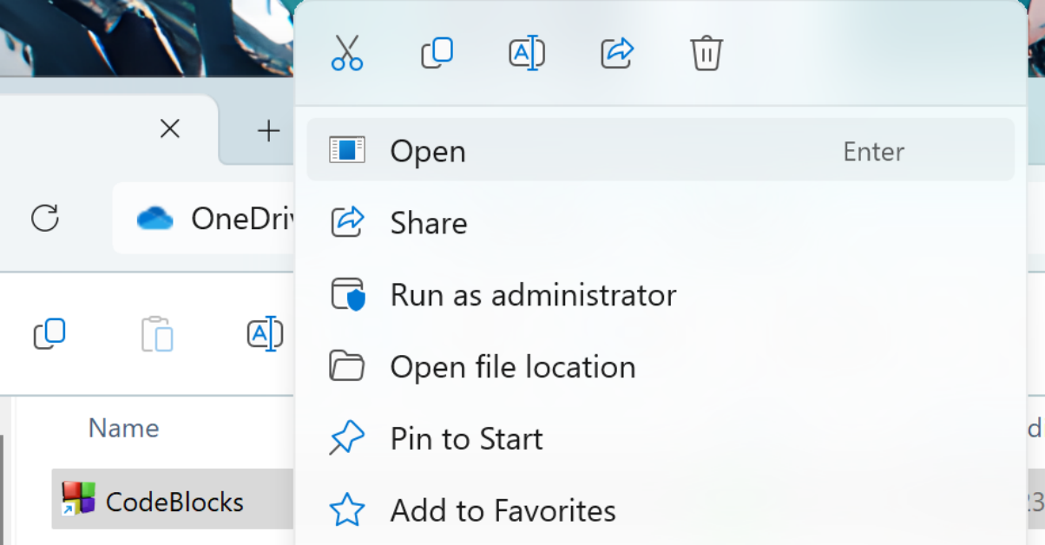

Step 3: Navigate to the 'File' menu and select 'Open'.
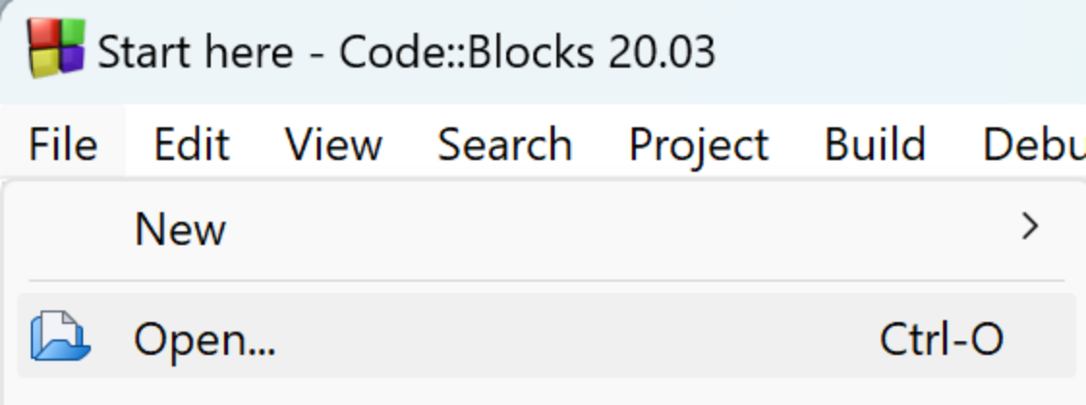

Step 4: Locate the ' Robocopassignment.cbp ' file in the extracted folder and open it.
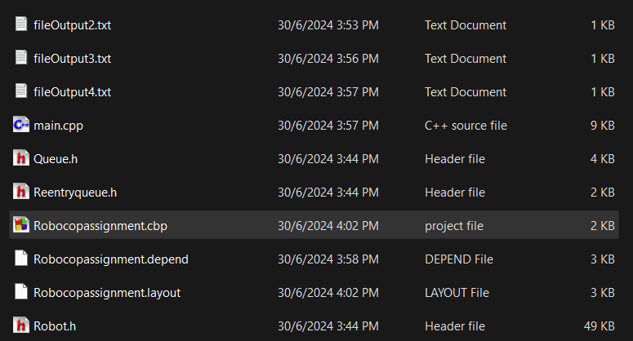

Step 5: Navigate to 'main.cpp' in the project explorer, then click 'Build and Run' to compile and execute the program.

