**1. INTRODUCTION**

**Overview of the project**

It is developed in C using OpenGL and implemented in the WINDOWS platform. The graphics package designed here provides an interface for the users for handling display and manipulation of basic picture objects. The interface is user-friendly with icons, menus.

**General Constraints**

1. As software is being built to run on a WINDOWS platform, efficient use of the memory is very important.

2. The code should be efficient and optimal with the minimal redundancies.

3. Needless to say, the package should also be robust and fast.

**Assumptions and Dependencies**

1. It is assumed that the standard output device, namely the monitor, supports colors and users system is required to have the C compiler for the appropriate version.

2. The system is also expected to have a mouse connected since most of the drawing and other graphical operations implemented assume the presence of a mouse.

**2. REQUIREMENTS SPECIFICATION**

The requirement specifications of this project is not perfectly optimized. However the following hardware and software specifications were done to be of my best efforts. Here are the specifications:

1. **Hardware Requirements:**

The hardware requirements given here is minimal requirements for the project to run even though the project can smoothly run on almost all i3h86 machines.

* Processor Speed -300 Mhz and above
* Ram Size -64 Mb or above
* Storage Space -2MB or above

1. **Software Requirements:**

* Operating System -Windows Family
* Compiler -Dev C++/CODBLOCKS
* Graphics Library -glut.h
* Programming Language -C using OpenGL

**3. ABOUT OPENGL**

The OpenGL specification describes an abstract for drawing 2D and 3D graphics.Although it is possible for the API to be implemented entirely in software,it is designed to be implemented mostly or entirely in hardware.

The API is defined as a number of functions which may be called by the client program,alongside a number of named integer constants.Although the function definition are superficially similar to those of the C programming language,they are independent.As such, OpenGl has many language bindings,some of the most noteworthy being the JavaScript binding WebGL(API based on OpenGL ES2.0);the C bindings WGL ,GLX,CGL;the C binding provided by iOS and the Java and C binding provided by the Android.

In addition to being language-independent,OpenGL is also platform independent.The specification says nothing on the subject of obtaining ,managing an OpnGL context,leaving this as a detail of the underying windwing system.For the same reason,OpenGL is purely concerned with the rendering,providing no APIs related to input,audio,or windowing.

**OPENGL GRAPHICS PIPELINE ARCHITECTURE**

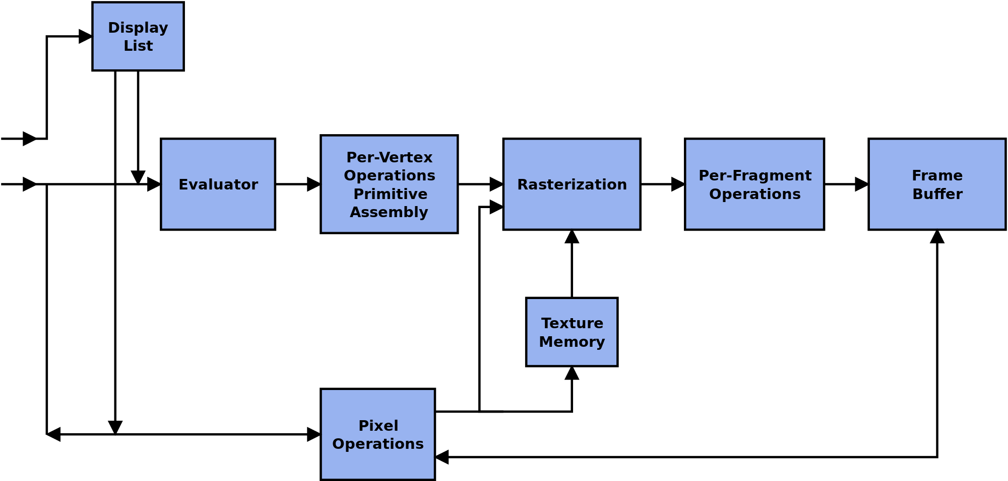

**4. TO ACCESS GLUT IN DEV - C++**

**1.** Click File/New/Project. Pick a name for the project .Click "C Project", Click on "Empty Project", Click "OK".

**2.** In "Create New Project", click "save".

**3.** Click "File/New/Source File" and in "Add source file to current project" click "Yes". You now get a screen where you can get edit the source file.

**4.** Type in a simple C program. Now click "File/Save As" and save the file as "hello.c". (Be sure the file extension is .c).

**5.** Tell Dev-Cpp what libraries need to be linked. Click "Project/Project Options".

**6.** Now click "Parameters". Click the "Add Library or Object" button and navigate to the libraries that should be added, found under C:\Devv-Cpp\lib.

../lib/libopengl32.a

../lib/libglu32.a

../lib/libglut32.a

**5. SNAPSHOTS FOR CREATING A PROJECT AND ADDING PARAMETERS**

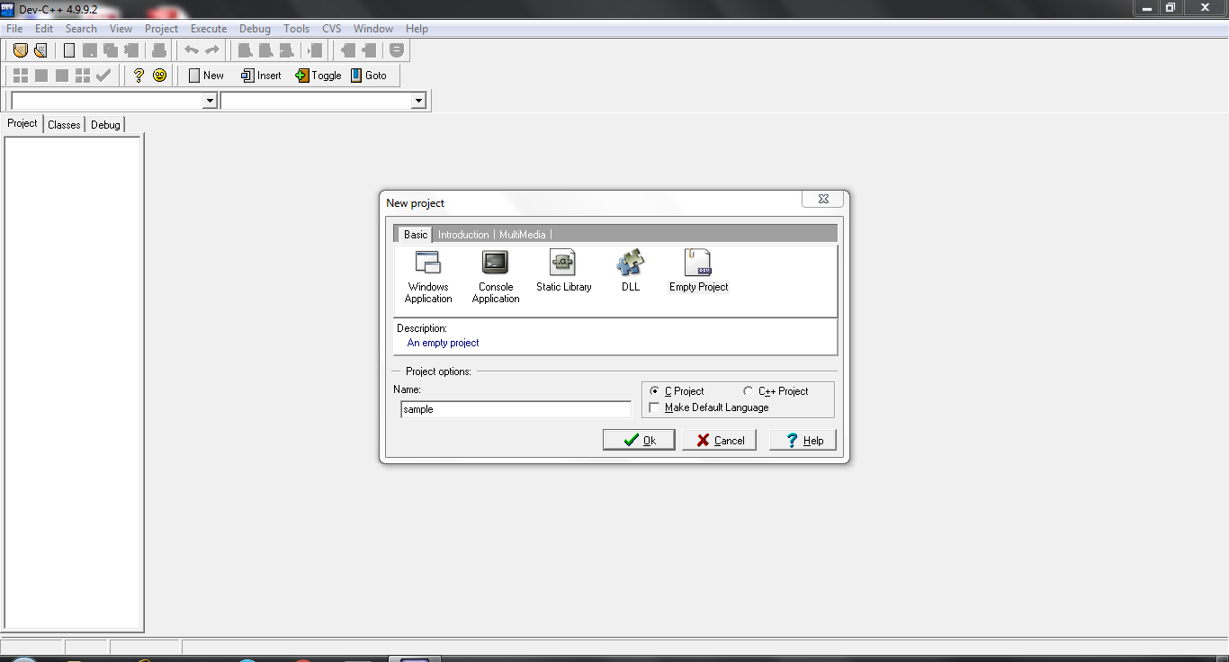

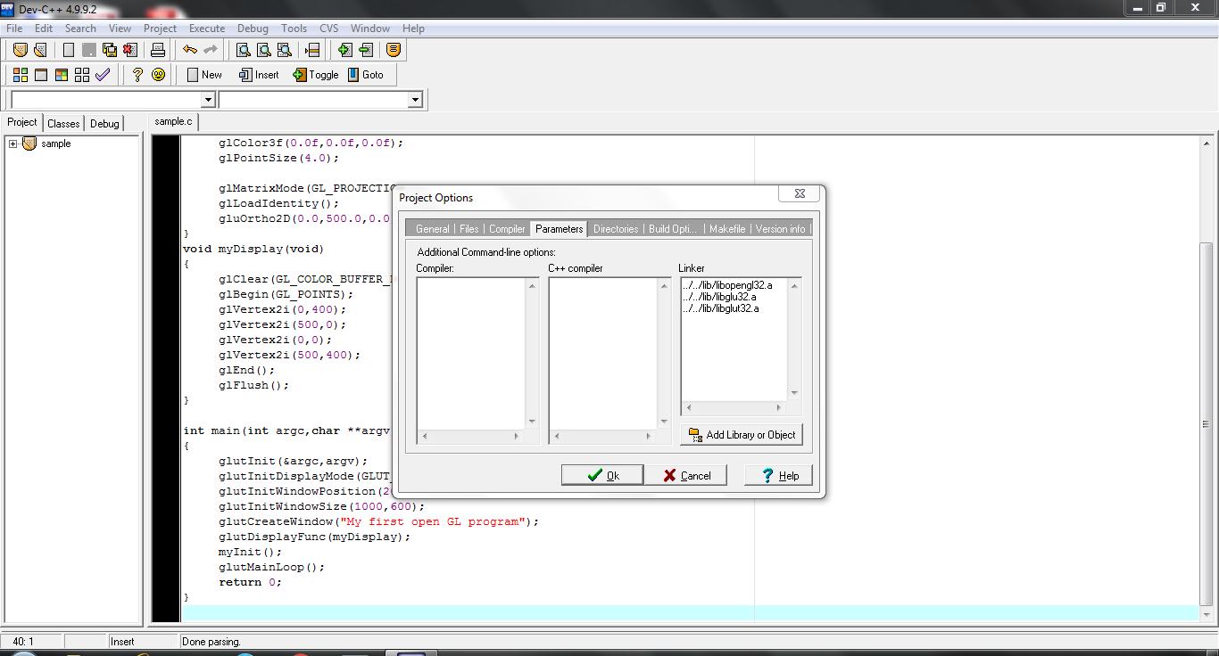

**6. FLOWCHART**

**INITIALZE THE WINDOW**

**CREATE THE WINDOW**

**CREATE WORKING AREA AND ICONS ON THE WINOW**

**CREATE BUTTON**

**START**

**LEFT CLICK OF MOUSE ICON**

**TETRAHEDRON**

**LIANG BARSKY**

**HOUSE**

**CUBE SPIN**

**COHEN**

**CYLLINDER**

**TEAPOT**

**CUBE VIEW**

**SCANLINE**

**MESH**

**STROKE**

**EXIT**

**STOP**