NIP Project — Submission Template
Pega Platform project · This document is your complete submission
Read this before you start:
1. Fill in Section 1 completely. The Pega application name must follow the format NIP-[Project]-[YourName].
2. Create a new Operator in Pega with your full name and log in as that operator before taking any screenshot.
3. When you create your test case, enter YOUR FULL NAME in the Issue Description (Vehicle) or Movie Name (Movie) field.
4. Complete only the section for your chosen project. Delete the other project section.
5. Paste one screenshot per user story (10 total). Follow the screenshot rules in your selected project section.
6. Answer every question in Sections 3 and 4 in your own words.
7. Save the file using this format: ProjectName_FirstName_LastName.docx. Use VehicleService or MovieTicket as the ProjectName. Examples: VehicleService_Ravi_Kumar.docx or MovieTicket_Ravi_Kumar.docx.

Section 1 — Your Details
Full Name | Aarthi S
Email ID (registered on NIP) | aarthiselvaraj05@gmail.com
Phone Number | +91 8637456475
College Name | VSB Engineering College ,Karur
Course (e.g. IT, CS) | CS
State | Tamil Nadu
Project Chosen (Vehicle Service OR Movie Ticket Booking) | Movie Ticket Booking
Pega Application Name (e.g. NIP-VehicleService-YourName) | NIP-MovieTicket-AarthiS
Case Type Name (exact) | Movie Ticket Request
Pega Instance URL | https://khl7r79v.pegaacademy.net/prweb/app/movie-ticket-booking-management/1O3kfChUoyqPj2zmFwqFq7C8uA6oWcaK*/!STANDARD?pzPostData=-768612106
Operator Name (created in Pega with your full name) | Aarthi S  Login -aarthiselvaraj05@gmail.com

Section 2B — Movie Ticket Booking Management Application
Complete this section only if you selected this project. Delete the other project section before submitting.

Screenshot rules — IMPORTANT before you start:
1. Name your Pega application as: NIP-VehicleService-YourName OR NIP-MovieTicket-YourName
2. Create a new Operator in Pega with your full name (Security → Operators) and log in as that operator.
3. When you create your test case, enter YOUR FULL NAME in the Issue Description (Vehicle) or Movie Name (Movie) field.
4. The logged-in operator name must be visible in every screenshot wherever the Pega interface displays it.
5. The student's full name must be visible in all running-case screenshots.
6. Configuration screenshots must clearly show the relevant application or rule name.
Screenshots that do not show these will not be accepted.

US-001 — Submit Movie Ticket Request
What is expected:
Case created, customer submits Movie Name, Show Date, Show Time, Number of Tickets. Validation applied.
Screenshot — paste your screenshot below this line:
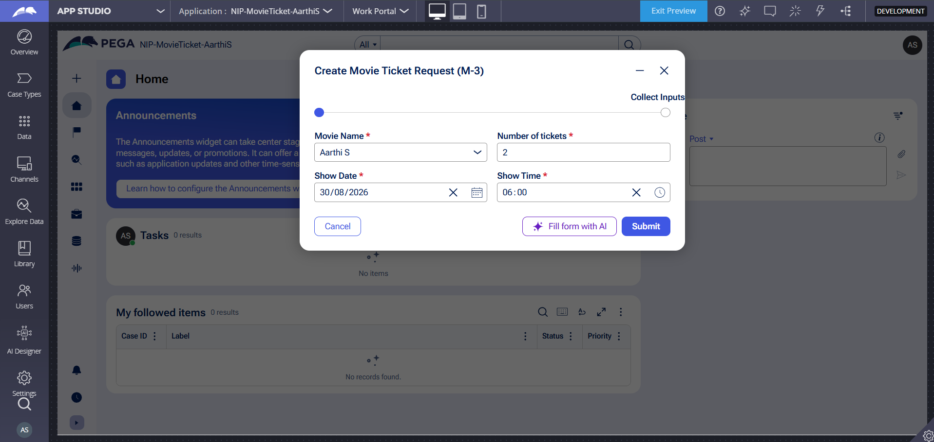

What I built for this (1–2 lines in your own words):
Configured the initial submission step within the Movie Ticket Request case lifecycle to capture Movie Name, Show Date, Show Time, and Number of Tickets as required inputs, linking them to reusable Movie and Show data objects for validated customer intake

US-002 — Check Show Availability
What is expected:
Availability stage. Seat Availability Status and Available Seats Count captured. Booking proceeds only if available.
Screenshot — paste your screenshot below this line:
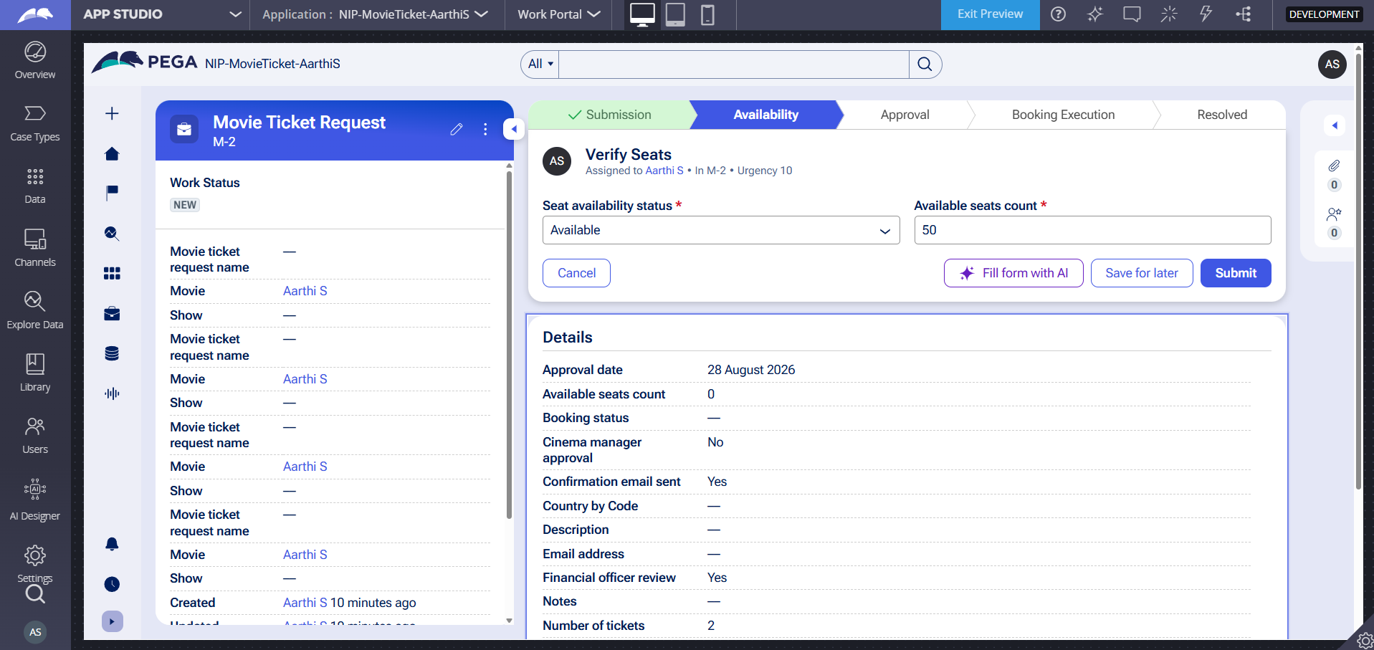

What I built for this (1–2 lines in your own words):
Integrated the Availability stage in the case lifecycle to capture Seat Availability Status and Available Seats Count as required inputs, applying validation rules to ensure ticket booking proceeds only when sufficient show seats are available.

US-003 — Calculate Booking Cost
What is expected:
Total Cost calculated automatically from Ticket Price and Number of Tickets using a business rule.
Screenshot — paste your screenshot below this line:
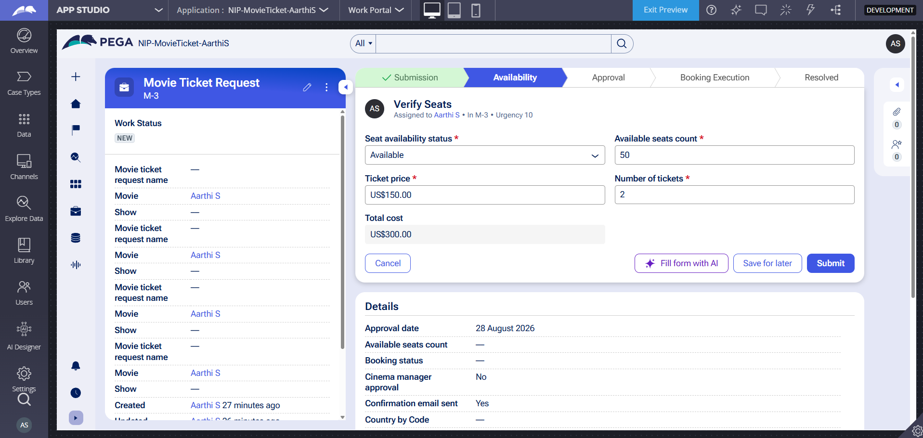

What I built for this (1–2 lines in your own words):
Configured an automated expression calculation rule in the Availability stage to dynamically compute Total Cost from Ticket Price and Number of Tickets at runtime.

US-004 — Confirm Booking Request
What is expected:
Approval stage assigned to Customer. Booking Status captured. Flow branches on confirm/cancel.
Screenshot — paste your screenshot below this line:
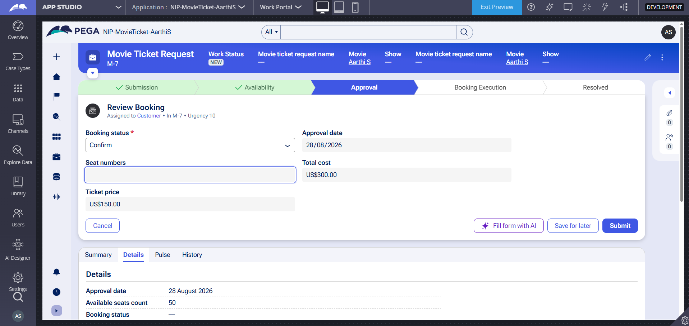
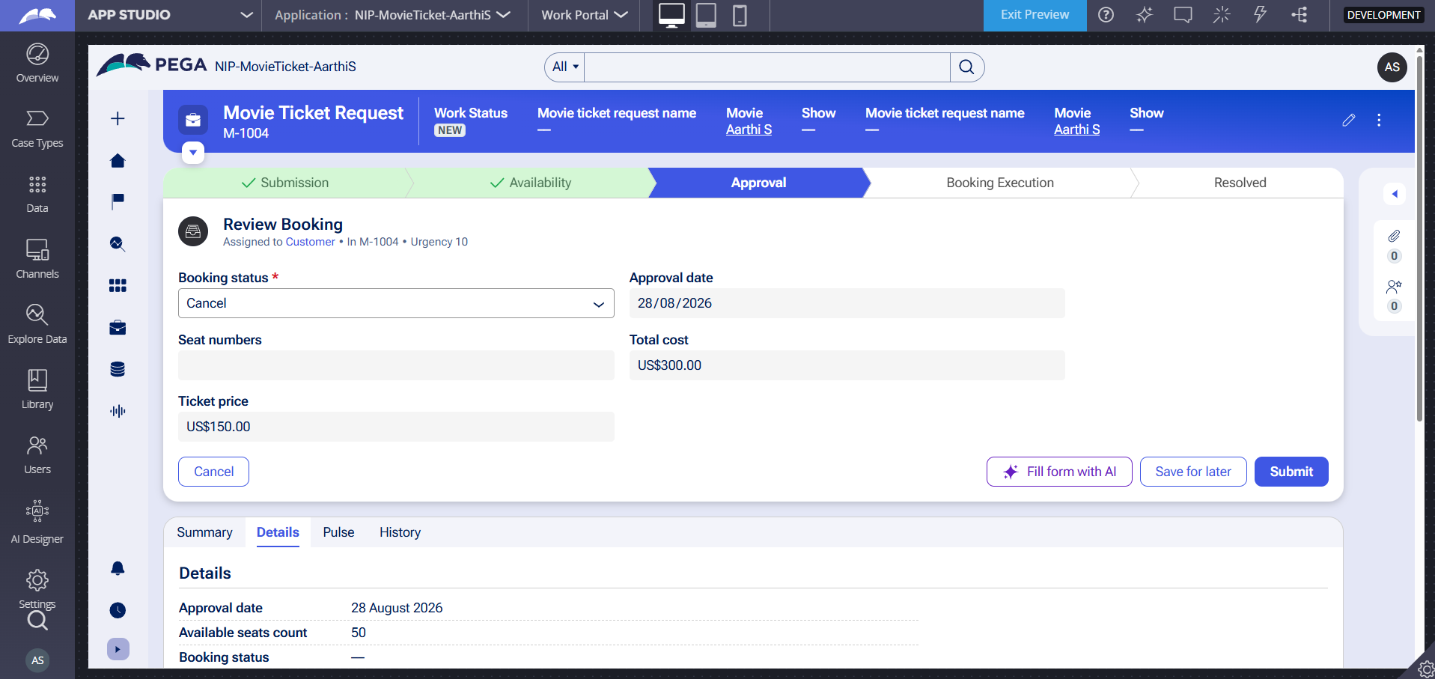

What I built for this (1–2 lines in your own words):
Configured an Approval step assigned to the Customer persona in the Approval stage, capturing the customer's decision via the Booking status property.

US-005 — Maintain Movie and Show Data
What is expected:
Reusable Movie and Show data objects created with Movie Name, Genre, Show Date, Show Time, Seat Capacity — linked to case.
Screenshot — paste your screenshot below this line:
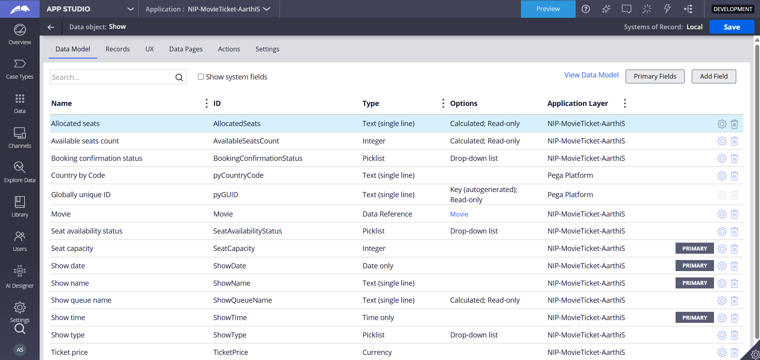

What I built for this (1–2 lines in your own words):
Configured reusable data objects for Movie and Show with independent properties (including Movie Name, Genre, Show Date, Show Time, and Seat Capacity) to ensure consistency across booking requests.

US-006 — Review Booking Details
What is expected:
Confirmation screen shows Movie Name, Show Timing, Number of Tickets and Total Cost clearly.
Screenshot — paste your screenshot below this line:
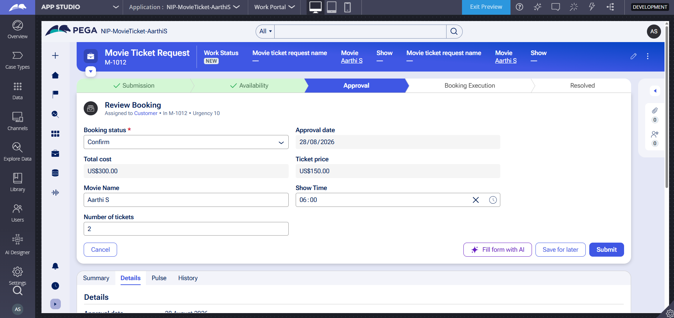

What I built for this (1–2 lines in your own words):
Configured the review and confirmation interface to clearly present all booking parameters—such as Movie Name, Show Timing, Number of Tickets, and Total Cost—ensuring complete customer visibility prior to final confirmation.

US-007 — Process Ticket Booking
What is expected:
Booking Execution stage. Seat Numbers, Ticket ID and Booking Confirmation Status maintained.
Screenshot — paste your screenshot below this line:
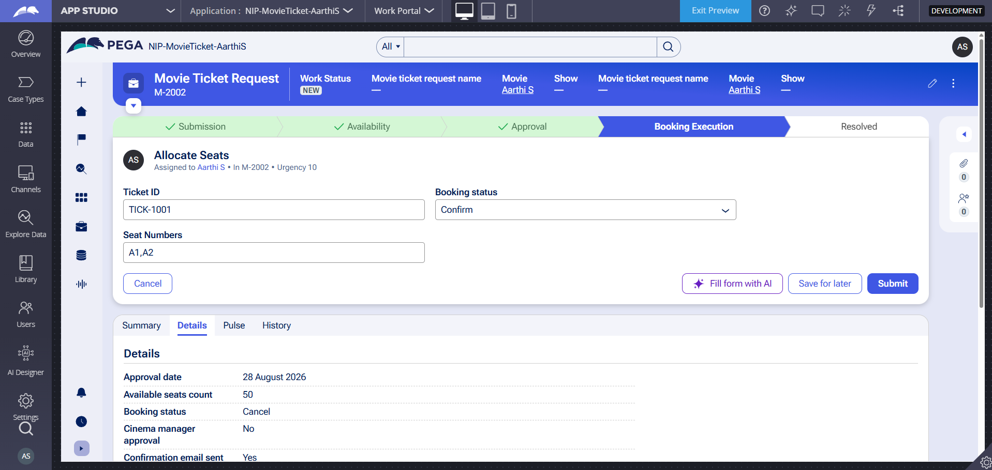

What I built for this (1–2 lines in your own words):
I implemented the Booking Execution stage to process final seat allocation and update booking status. I configured properties for Booking Confirmation Status, Seat Numbers, and Ticket ID to ensure completed bookings are permanently recorded for tracking.

US-008 — Notify Booking Confirmation
What is expected:
Correspondence rule triggered on case resolution. Email includes movie, show, seat and cost details.
Screenshot — paste your screenshot below this line:
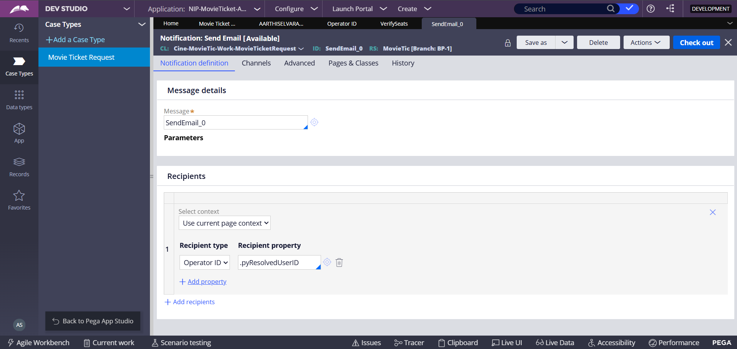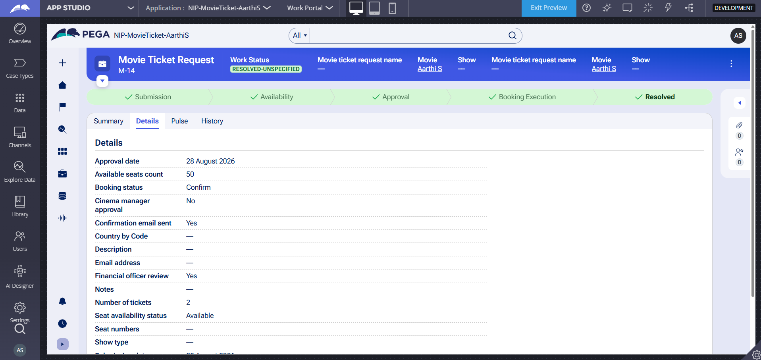

What I built for this (1–2 lines in your own words):
Configured an automated correspondence notification triggered upon case resolution to send a booking confirmation to the customer persona, mapping the recipient via operator ID and verifying successful dispatch in the audit details.

US-009 — Define Booking SLA
What is expected:
SLA configured on the case type. Goal: 1 day. Deadline: 2 days. Priority increases on breach.
Screenshot — paste your screenshot below this line:
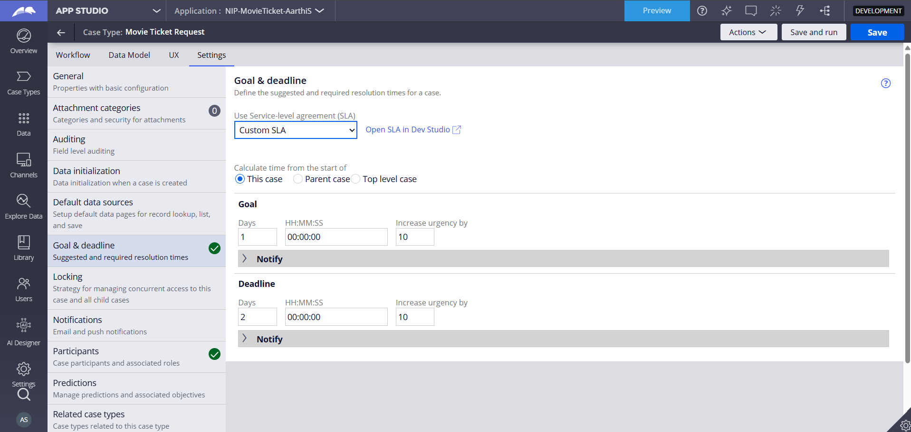

What I built for this (1–2 lines in your own words):
Configured a custom Service-Level Agreement (SLA) at the case type level with a 1-day Goal and a 2-day Deadline from case creation, applying automatic urgency adjustments to track and manage resolution timing effectively.

US-010 — Route by Show Type
What is expected:
Routing rule or Decision Table routes to PremiumShowQueue or StandardShowQueue based on Show Type property.
Screenshot — paste your screenshot below this line:
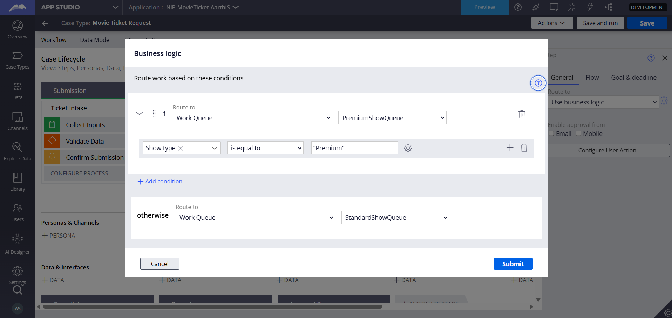

What I built for this (1–2 lines in your own words):
Configured automated business logic routing within the Booking Execution stage to dynamically direct cases to either PremiumShowQueue or StandardShowQueue based on the Show Type property value.

Section 3 — About Your Application
These answers are checked against your screenshots. Write exactly what is in your application.

Q1. List your stages in the order they appear in your case lifecycle.
Stage names in order, separated by commas.
Submission, Availability, Approval, Booking Execution, Resolved

Q2. Name the data object(s) you created and the properties inside them.
Data object name and its properties.
Movie Details (Properties: MovieName, ShowTime, ShowType, SeatNumber, TicketPrice, TotalCost)

Q3. What is the exact name and type of the rule you used to calculate Total Cost?
Provide:
• Rule Name
• Rule Type
• Properties used in the calculation
• Formula used
• Rule Name: CalculateCost (or CalculateTotalCost)
• Rule Type: Declare Expression
• Properties used in the calculation: TicketPrice, Quantity
• Formula used: TicketPrice * Quantity

Section 4 — Your Understanding
Short, honest and specific answers score well.

Q4. What did Blueprint generate for you, and what did you add or change yourself afterwards?
Be specific about what was already there and what you built or modified on top.
Blueprint generated the initial project structure, baseline case lifecycle stages (Submission, Availability, Approval, Booking Execution, Resolved), and basic process flows. Afterwards, I configured and modified data models, set up UI views, built the Declare Expression for cost calculation, and implemented automated routing logic using business rules for work queues.

Q5. Was there anything Blueprint created that you had to correct or configure further? Describe one example.
A real example from your own work.
Yes, the routing step initially defaulted to a manual user assignment rather than automatic routing. I had to reconfigure the "Route Show Type" step in the Booking Execution stage from manual operator assignment to "Use business logic" to route cases automatically based on the Show Type property.

Q6. Explain your case flow from creation to resolution, in order.
What happens first, who does what, when the case closes.
The case starts in the Submission stage where user inputs are collected and validated. It moves to Availability, where seats are verified and costs are calculated. Next, it enters the Approval stage for customer review and status confirmation. In the Booking Execution stage, the case automatically routes to either PremiumShowQueue or StandardShowQueue, followed by seat allocation, ticket ID assignment, and status updates. Finally, the case reaches the Resolved stage after a confirmation email is sent and the booking is finalized.

Q7. Pick two design choices you made in your application and explain why you made them.
For each design choice, provide:
• What you implemented
• Why you chose that approach
• What benefit it provides to the application
1.What I implemented: Automated business logic routing for show types. Why I chose that approach: To split premium and standard bookings seamlessly without manual intervention. What benefit it provides: Speeds up processing time and ensures tickets are handled by the correct specialized work queue.

2.What I implemented: Using a Declare Expression for cost calculation. Why I chose that approach: To calculate totals automatically in real-time whenever ticket price or quantity updates. What benefit it provides: Eliminates manual entry errors and ensures pricing data integrity.

Q8. What was the hardest part, and how exactly did you fix it?
Specific and honest. A real challenge scores much better than a generic answer.
The hardest part was configuring the conditional business logic routing for the work queues to ensure cases split correctly between premium and standard queues. I fixed it by accessing the routing step configuration, switching the route type to business logic, mapping the "Show type equals Premium" condition to the premium queue, and utilizing the otherwise clause for the standard queue.

Q9. If the approval step was only needed when Total Cost is above a certain amount, what would you change in your application?
Explain what you would change and where. You do not need to build this.
I would add a conditional path or a When condition on the Approval stage or step in the case lifecycle, specifying that the approval process only triggers when Total Cost is greater than the specified threshold amount, allowing lower-cost bookings to bypass approval automatically.

Q10. List three exact rule names from your application that you personally created or modified.
Include the rule name and rule type for each one (for example: CalculateTotalCost - Declare Expression).
• CalculateCost - Declare Expression
• Route Show Type - Routing (Decision/Assignment)
• Review Booking - Flow Action / UI View
Q11. List all personas used in your application.
List the persona names exactly as they appear in your application.
1.Cinema Manager
2.Customer
3.Email Notification System
4.Ticket Agent
5.Users
Q12. List all work queues used in your application and explain when each one is used.
For each work queue, provide its exact name and the condition or type of work routed to it.
• PremiumShowQueue: Used when the Show Type property value indicates a premium or special screening.
• StandardShowQueue: Used as the default routing queue (otherwise condition) for all regular or standard show screenings
Before You Submit — Check These
Read through once before uploading.
1. Section 1 filled in. Application named as NIP-[Project]-[YourName]. Names match the actual application.
2. New Operator created in Pega with my full name. I logged in as that operator for all screenshots.
3. Only my chosen project section remains — the other project section is deleted.
4. All 10 user story screenshots are pasted and follow the operator, running-case, application, and rule-name evidence requirements.
5. Every question in Sections 3 and 4, including Q10, Q11, and Q12, is answered in my own words.
6. This file is named using the required format: ProjectName_FirstName_LastName.docx (for example, VehicleService_Ravi_Kumar.docx or MovieTicket_Ravi_Kumar.docx) and uploaded as required.

