DEVOPS-ENABLED CAMPUS PLACEMENT TRACKING PORTAL — TASK REPORT
TASK 01: PROBLEM DEFINITION AND SCOPE
Student Name: Aarti Sakpal | Roll Number: 23102A0007
Course / Project: DevOps-Enabled Placement Portal | Target Release: release/final-v1.0.0 (v1.0.0)
GitHub Repository: https://github.com/AARTI756/CampusPlacementPortal | Evaluation Branch: release/final-v1.0.0
Task Objective: Define the operational problem statement, identify key academic stakeholders, establish concrete project objectives, define boundary constraints, and delineate the approved 15-task MVP scope.
1. Tools and Environment
This foundational task was conducted using project specification documents, Markdown standards, Git version control, and Visual Studio Code. The project specification is maintained under the repository's docs/ directory (PROJECT_DOCUMENTATION.md and SRS.md).
2. Problem Statement and Real-World Need
In higher education institutions, managing the campus recruitment cycle involves tracking hundreds of undergraduate and postgraduate students across diverse academic departments, coordinating with dozens of recruiting companies, scheduling multi-stage interview drives, and logging candidate outcomes. Traditionally, this process is conducted using disconnected spreadsheet workbooks, physical noticeboards, and scattered email threads. This operational model suffers from critical vulnerabilities:
- Data Fragmentation: Placement coordinators across different engineering departments maintain unsynchronized spreadsheets, causing inconsistent student records, conflicting CGPA entries, and duplicated communications.
- Eligibility Filtering Overhead: Placement officers manually cross-reference academic thresholds (such as minimum CGPA cut-offs and backlog rules), leading to human error, missed applicant eligibility, or inadvertent disqualification.
- Opaque Status Progression: Tracking candidate progression across stages (Applied, Shortlisted, Interview Scheduled, Selected, Rejected) is cumbersome, leaving students in the dark and placement officers unable to provide instant status updates.
- Reporting Latency: Compiling annual accreditation figures (e.g., NAAC, NBA, NIRF placement percentages, average CTC) requires days of manual calculation from incomplete records.
3. Target Users and Stakeholder Matrix
The portal explicitly identifies and supports four principal stakeholder groups:
Stakeholder Group | Primary Role in Placement Cycle | Core Needs Addressed by Portal
Placement Coordinators | Primary system operators in the T&P Cell. | Centralized CRUD operations for students, companies, and drives; instant application status updates; unplaced student alerts.
College Administration | Department Heads, Deans, and Management. | High-level visibility into institutional placement rates, drive volume, and partner recruiter engagement.
Enrolled Students | Registered job seekers (Tracked Entities). | Accurate profile records (CGPA, department) and transparent tracking through recruitment stages.
Recruiting Companies | External partner organizations. | Defined drive dates, role designations, minimum eligibility standards, and structured candidate evaluation lists.

4. Problem Resolution & Conceptual Model
The DevOps-Enabled Campus Placement Tracking Portal transforms this error-prone manual process into an automated, highly available web application backed by PostgreSQL and managed through a complete DevOps delivery pipeline.
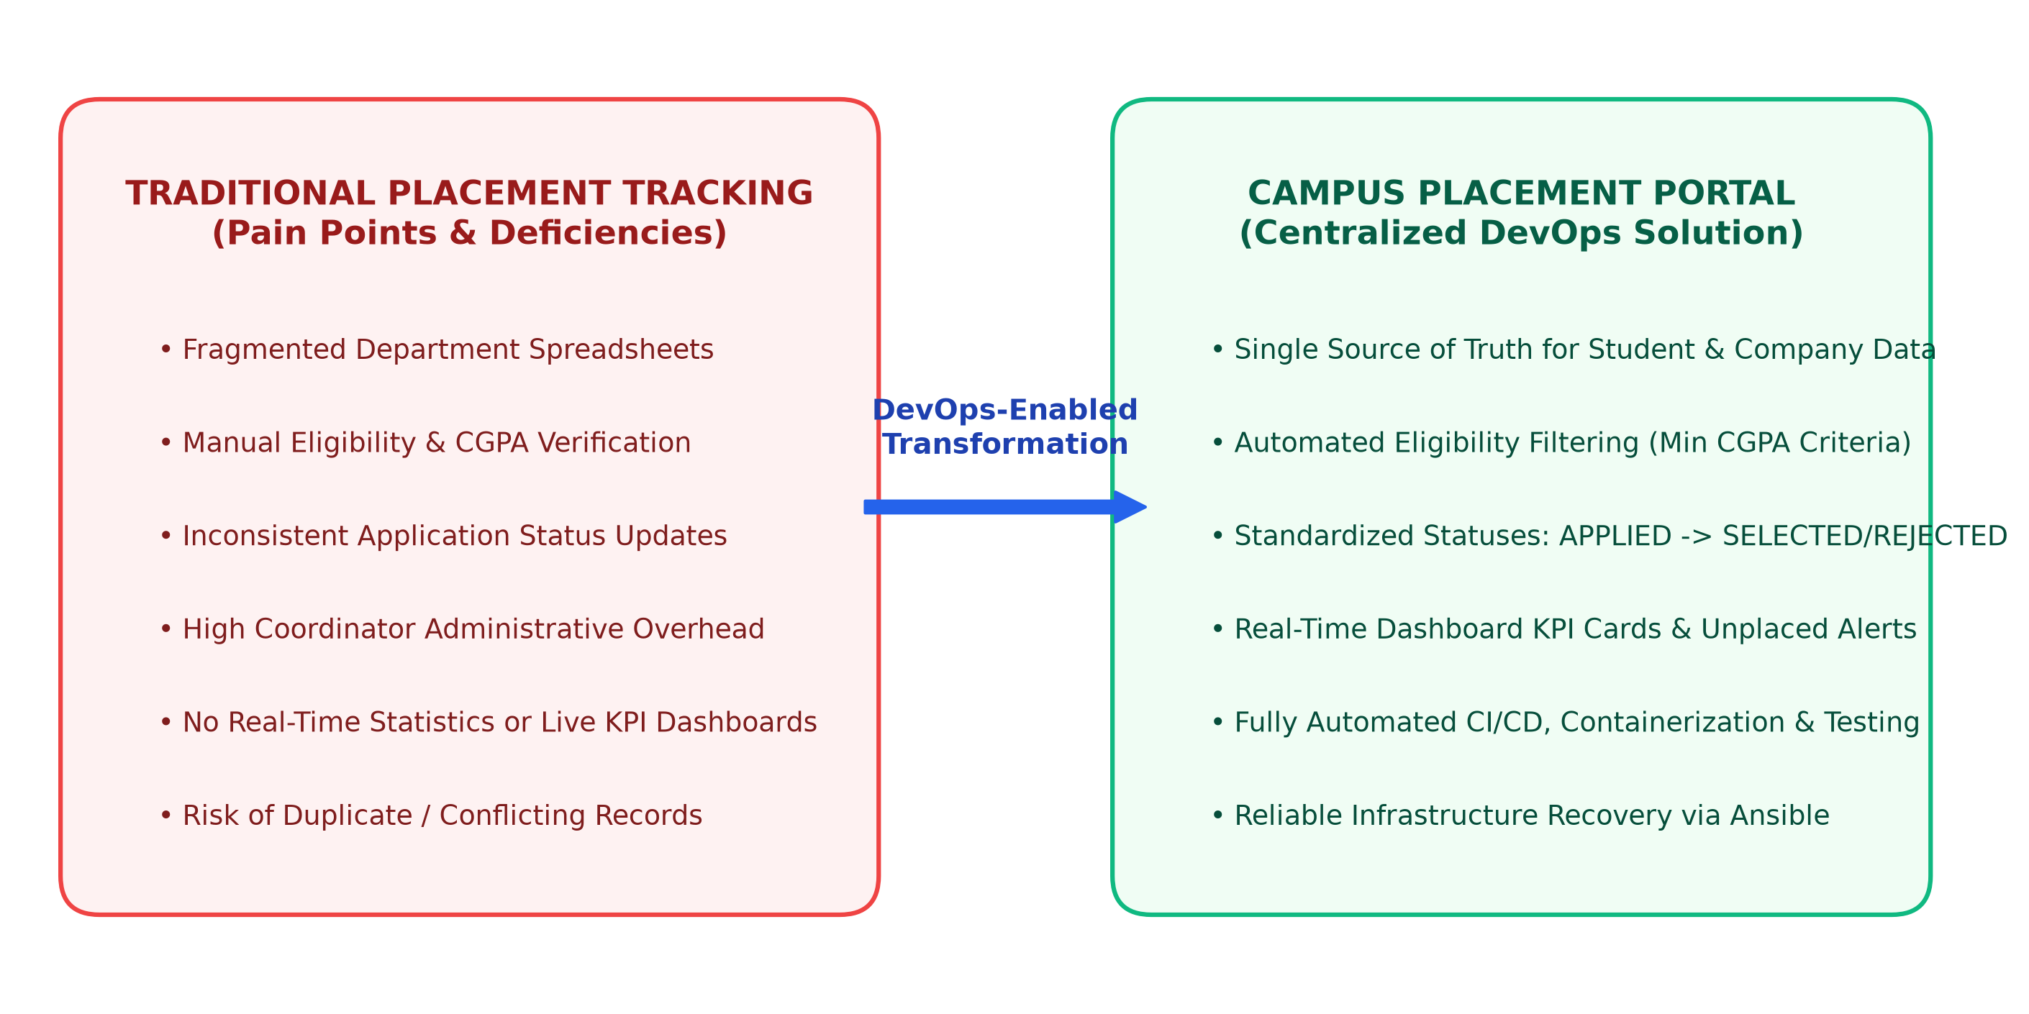
Figure 1.1: Problem Definition & Scope — Traditional Spreadsheet Deficiencies vs. Centralized DevOps Solution
5. Project Objectives and Success Criteria
The primary objective is to deliver a functional, resilient web application while establishing a complete automated CI/CD and configuration management lifecycle. To prevent subjective evaluation, measurable success criteria were defined:
- Single Source of Truth: Centralize all student profiles, company records, drives, and student applications in a structured relational database (PostgreSQL 15), eliminating spreadsheet silos.
- Automated Status Synchronization: When a student's application status is transitioned to 'SELECTED', the global student entity flag (isPlaced) must automatically update to true.
- System Performance & Integrity: The application must load pages in under 3 seconds locally, boot up within 30 seconds inside Docker, and preserve data integrity during container restarts.
- Automated Quality Gate: Achieve 100% automated test pass rate (7/7 tests: 2 unit tests + 5 Selenium UI tests) in the Jenkins CI/CD pipeline prior to deployment.
Engineering Verification Boundary
Distinction Between Intended Benefits and Measured Results:
• Intended Benefits: Elimination of coordinator administrative fatigue, complete institutional transparency, and zero communication delays.
• Actually Measured Results (in Release v1.0.0): 5 relational entities implemented; automated status sync verified in database; sub-2s response across all 5 endpoints on port 8083; 7/7 automated tests passing in Jenkins; and containerized deployment validated.

6. Project Constraints and Assumptions
To ensure feasibility within the semester timeframe, explicit boundaries were instituted:
- Single-User Coordinator Scope: The initial MVP is designed as an internal placement coordinator portal without multi-user role-based authentication (RBAC) or student self-service login.
- Local Deployment Boundary: The application is deployed locally via Docker Desktop on Windows with WSL2 Ubuntu running Ansible, avoiding commercial cloud infrastructure costs.
- Notification Model: Alerts are rendered dynamically on the dashboard; automated outbound email dispatch is excluded from the MVP scope.
7. Approved 15-Task MVP Scope
The project scope was formalized into 15 sequential tasks spanning the entire software engineering and DevOps lifecycle:
- Phase 1: Inception & Architecture — Tasks 1–4 establish the problem definition, Agile user stories, layered 3-tier architecture, and initial Git/GitHub repository structure.
- Phase 2: Core MVP Development — Tasks 5–6 implement student search, application status workflows, delete-all data resets, and GitHub pull request merging.
- Phase 3: CI/CD & Automated Testing — Tasks 7–10 establish Jenkins CI, declarative Pipeline as Code (Jenkinsfile), local JAR deployment (port 8082), and Selenium UI continuous testing.
- Phase 4: Containerization, Infrastructure & Release — Tasks 11–15 implement Docker containerization, Jenkins-Docker CD (port 8083), Ansible configuration management (site.yml), automated provisioning & reliability (provision.yml, reliability.yml), and final release v1.0.0.
8. Conclusion
Task 01 successfully formulated the operational problem, bounded the functional scope, and established quantifiable acceptance criteria. By setting precise scope boundaries, the project avoided scope creep and laid the groundwork for structured Agile delivery.

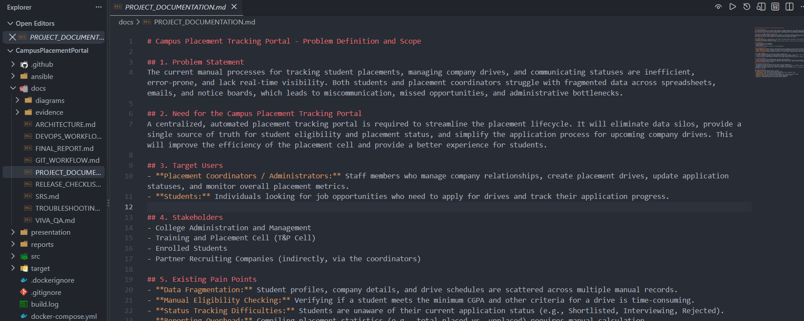
Project Documentation Files : VS Code editor view displaying Problem Definition, Need, and Approved MVP Scope in the repository.

