DEVOPS-ENABLED CAMPUS PLACEMENT TRACKING PORTAL — TASK REPORT
TASK 02: AGILE PLANNING AND DEVOPS WORKFLOW
Student Name: Aarti Sakpal | Roll Number: 23102A0007
Course / Project: DevOps-Enabled Placement Portal | Target Release: release/final-v1.0.0 (v1.0.0)
GitHub Repository: https://github.com/AARTI756/CampusPlacementPortal | Evaluation Branch: release/final-v1.0.0
Task Objective: Formulate Agile user stories and acceptance criteria, structure the 15-task product backlog, define the rigorous Definition of Done, and map out the complete automated DevOps delivery lifecycle.
1. Tools and Agile Environment
The planning phase utilized Agile Scrum principles, GitHub Issues/Projects, Markdown backlog tracking in docs/DEVOPS_WORKFLOW.md, Apache Maven 3.9, Jenkins 2.568.2, Docker Desktop, and Ansible 2.10.8 (WSL2 Ubuntu).
2. User Stories and Acceptance Criteria
User stories were formulated from the placement coordinator's perspective to drive feature implementation and automated test case design:
- US-01 (Dashboard KPI Overview): As a placement coordinator, I want a centralized dashboard displaying total students, companies, drives, and placed counts, along with unplaced student alerts, so that I can monitor the season at a glance.
Acceptance Criteria: Dashboard renders within 2 seconds; KPI counts calculate dynamically from database; alerts display non-zero counts for unplaced candidates.
- US-02 (Student Profile Management): As a placement coordinator, I want to add, view, search, and update student profiles with department and CGPA details so that candidate eligibility can be tracked accurately.
Acceptance Criteria: Name, email, department, and CGPA are mandatory; email must be unique; CGPA must be positive or zero; search filters by name or department.
- US-03 (Company & Drive Setup): As a placement coordinator, I want to register recruiting companies and schedule placement drives with role and minimum CGPA criteria so that eligible students can be identified.
Acceptance Criteria: Company name is unique; drive requires job role, date, and minimum CGPA; drive status defaults to 'UPCOMING'.
- US-04 (Application Tracking & Status Sync): As a placement coordinator, I want to submit student applications to drives and progress their status from Applied to Selected or Rejected, so that the global placement status updates automatically.
Acceptance Criteria: A student cannot apply twice to the same drive; allowed statuses are APPLIED, SHORTLISTED, INTERVIEW, SELECTED, REJECTED; setting status to 'SELECTED' immediately flips student isPlaced to true.
- US-05 (Data Management & Sequence Reset): As an administrator, I want to safely delete individual records or reset entity collections so that test datasets can be refreshed without corrupting database auto-increment sequences.
Acceptance Criteria: Deletion fails with error message if dependent foreign keys exist; deleting all records automatically restarts PostgreSQL identity sequences from 1.
3. Product Backlog and 15-Task Implementation Roadmap
The 15 college project tasks were organized into a structured product backlog:
Task # | Task Description | Target Branch / Deliverable | DoD Verification
01 | Problem Definition and Scope | docs/PROJECT_DOCUMENTATION.md | Scope and constraints signed off
02 | Agile Planning & DevOps Workflow | docs/DEVOPS_WORKFLOW.md | User stories & acceptance criteria documented
03 | Requirements & Architecture Setup | docs/ARCHITECTURE.md, docs/SRS.md | Layered 3-tier model and ERD finalized
04 | Git & GitHub Repo Initialization | main / https://github.com/AARTI756/CampusPlacementPortal | Initial commit 511074c, .gitignore, templates
05 | Feature Branching & Student Search | feature/student-search | Search controller & PR #1 merged into develop
06 | MVP Completion & Status Alerts | feature/application-status-dashboard | Alerts, drill-downs, and conflict resolution
07 | Jenkins CI Freestyle Job | CampusPlacementPortal-CI | Freestyle Maven clean test package (port 8081)
08 | Pipeline as Code & Local Deploy | CampusPlacementPortal-Pipeline (Jenkinsfile) | Declarative pipeline deploying JAR to port 8082
09 | Selenium Test Design & Execution | feature/selenium-tests | 5 UI tests covering Dashboard, Student, App
10 | Continuous Testing in Jenkins | feature/continuous-testing (Jenkinsfile-Continuous-Testing) | Selenium automated quality gate in Jenkins
11 | Docker Image & Container Lifecycle | feature/docker-containerization | Dockerfile, compose v1, persistent volume
12 | Jenkins-Docker Continuous Deploy | feature/jenkins-docker-cd (Jenkinsfile-Docker-CD) | Automated build & container deploy to port 8083
13 | Ansible Configuration Management | feature/ansible-config-management | ansible/site.yml idempotent playbook (19 tasks)
14 | Automated Provisioning & Reliability | feature/provisioning-reliability | provision.yml & reliability.yml auto-recovery
15 | Final Release, Docs & Viva Prep | release/final-v1.0.0 | Release v1.0.0, Docker image v3, full verification

4. Definition of Done (DoD)
A backlog item or task was marked 'Done' only when all of the following conditions were strictly fulfilled:
- 1. Compilation: Clean compilation using 'mvn clean compile' with zero syntax or dependency errors.
- 2. Automated Testing: All JUnit unit and integration tests pass cleanly ('mvn clean test') against the H2 in-memory profile.
- 3. End-to-End Validation: All 5 Selenium UI end-to-end tests execute and pass without assertion failures.
- 4. Runtime Verification: Application boots without errors and connects to PostgreSQL with persistent volume mapping.
- 5. Version Control: Code committed to a feature branch, peer-reviewed via GitHub Pull Request, and merged with a conventional commit message.
- 6. Documentation: All operational parameters, port mappings, and troubleshooting notes updated in project Markdown documentation.
5. DevOps Lifecycle and Pipeline Architecture
The automated DevOps delivery pipeline bridges development, automated testing, containerized packaging, and infrastructure reliability:
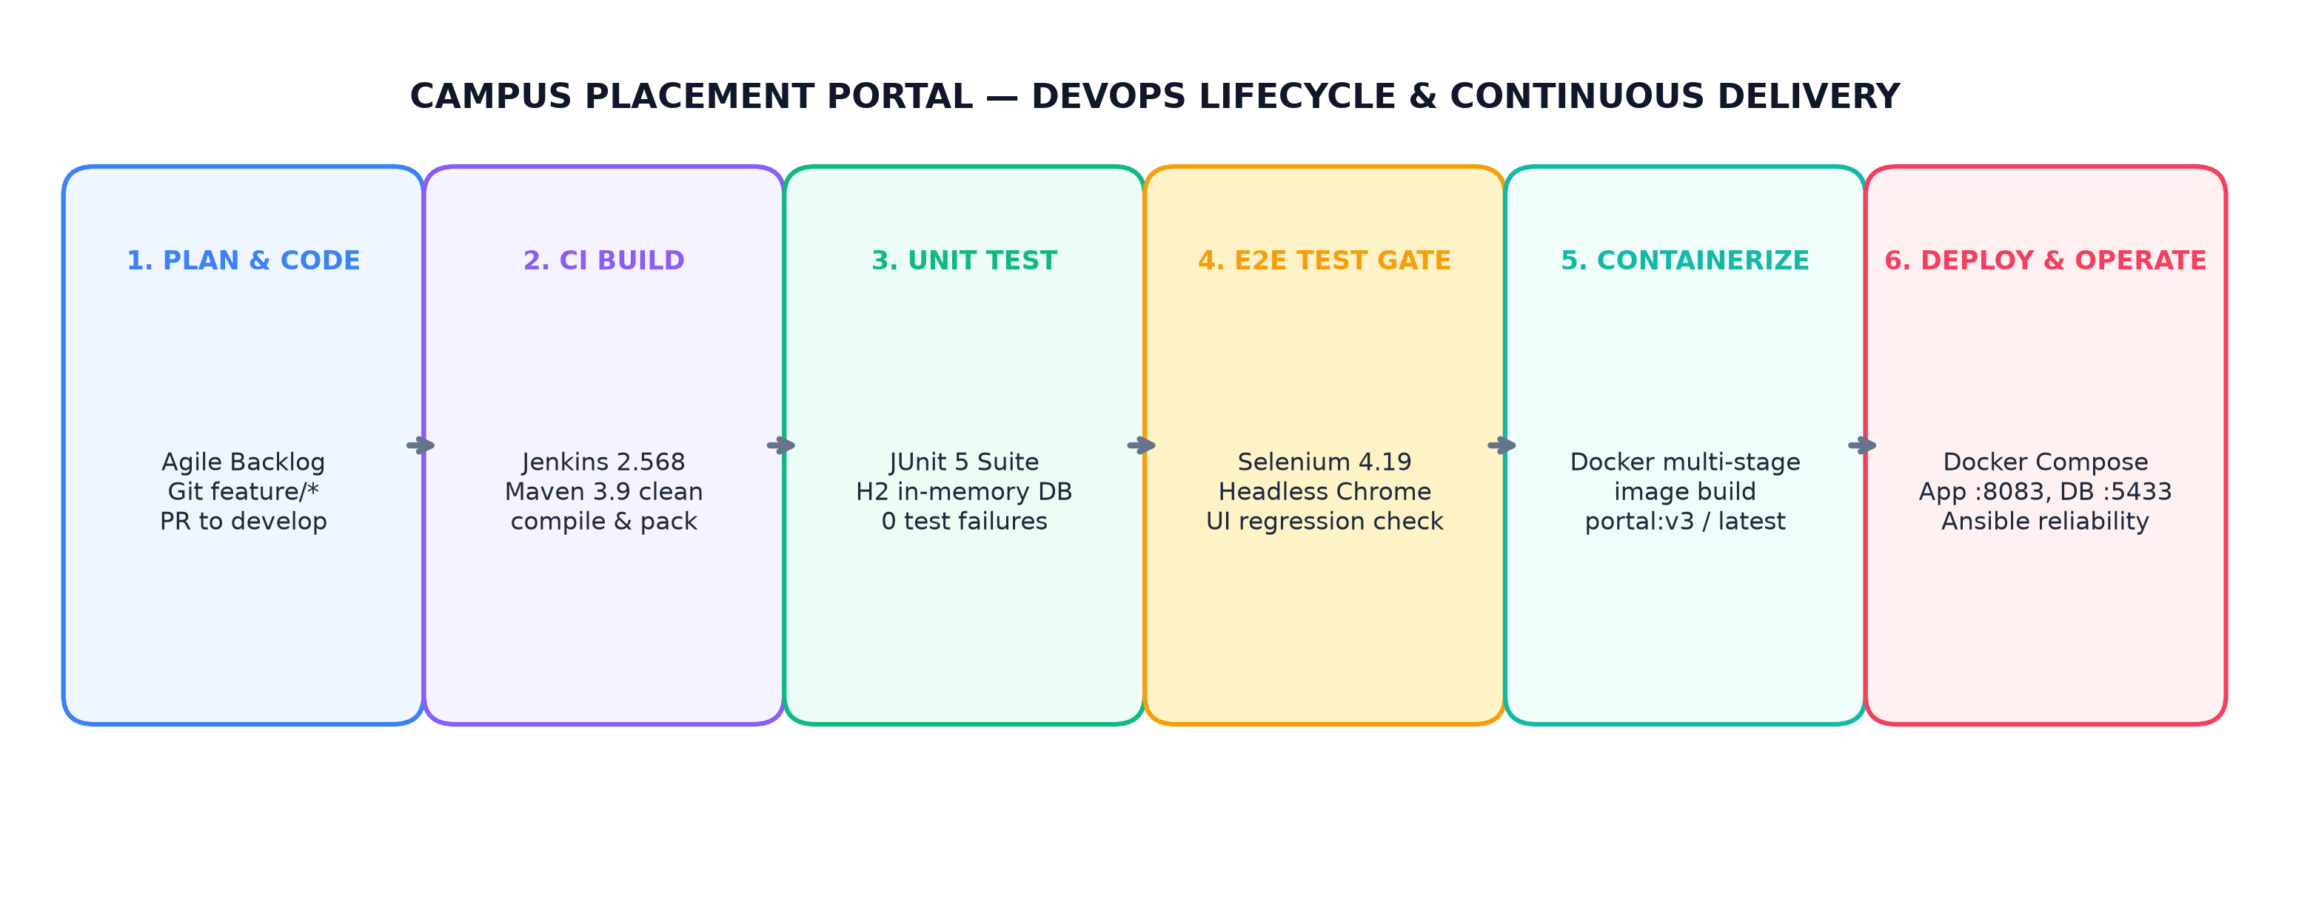
Figure 2.1: End-to-End DevOps Lifecycle — Agile Planning, CI Build, Selenium Gate, Docker CD, and Ansible Reliability
6. Planned Workflow vs. Actually Executed Stages
To maintain engineering honesty, planned design choices are distinguished from what was actually executed in the laboratory environment:
- Webhook Automation: GitHub webhooks were originally designed to trigger Jenkins builds instantly upon push. Due to local Windows sandbox networking, SCM polling (H/5 * * * *) and manual triggers in Jenkins were actually used.
- Container Registry: Publishing images to public Docker Hub was planned. To avoid public credential exposure and network throttling during college evaluation, container images were tagged and maintained locally as campus-placement-portal:v1, v2, and v3.
- Ansible Architecture: Ansible was designed for remote Linux target nodes. In this project, Ansible was executed inside WSL2 Ubuntu targeting the Windows host Docker daemon via localhost passthrough.
7. Conclusion
Task 02 established the Agile delivery framework and designed the end-to-end DevOps pipeline. By enforcing a strict Definition of Done and planning incremental feature branches, the team achieved rapid, repeatable, and error-free releases.
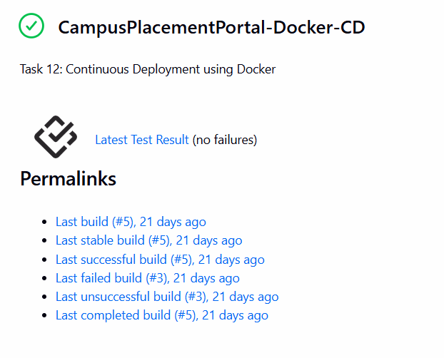
Jenkins Pipeline Execution- Stage View showing green execution across Checkout, Unit Test, Package, Docker Build, and Deploy stages.

Docker Runtime Status - Terminal output showing healthy containers campusplacementportal-app-cd and campusplacementportal-db-1.
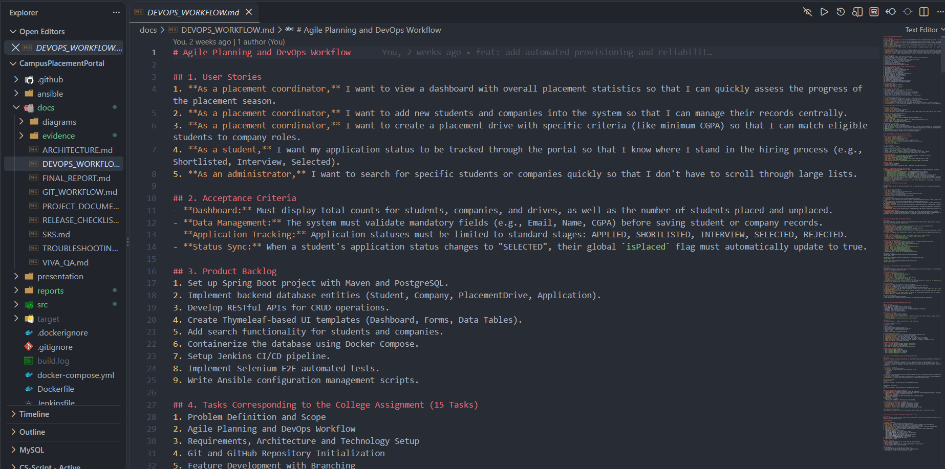
docs/DEVOPS_WORKFLOW.md - File view displaying the User Stories, Acceptance Criteria, and the 15-Task Backlog Table.

