DEVOPS-ENABLED CAMPUS PLACEMENT TRACKING PORTAL — TASK REPORT
TASK 03: REQUIREMENTS, ARCHITECTURE AND TECHNOLOGY SETUP
Student Name: Aarti Sakpal | Roll Number: 23102A0007
Course / Project: DevOps-Enabled Placement Portal | Target Release: release/final-v1.0.0 (v1.0.0)
GitHub Repository: https://github.com/AARTI756/CampusPlacementPortal | Evaluation Branch: release/final-v1.0.0
Task Objective: Document the functional and non-functional requirements, layered 3-tier software architecture, JPA database entity relationships, API routing, and multi-environment configuration.
1. Technology Stack Selection
The application stack was selected to demonstrate enterprise Java development, lightweight server rendering, robust relational data modeling, and containerized deployment:
Architecture Tier | Technology Selected | Version / Profile | Architectural Rationale
Programming Language | Java | OpenJDK 17 LTS | Strong typing, modern record features, standard in enterprise backend engineering.
Web Framework | Spring Boot | 3.2.4 | Auto-configuration, embedded Tomcat, seamless Spring Data JPA integration, rapid testing context.
Frontend / UI | Thymeleaf + Bootstrap | Thymeleaf 3 / Bootstrap 5.3 | Server-side rendering eliminates separate node build pipelines; static DOM IDs simplify Selenium automation.
ORM / Data Access | Spring Data JPA / Hibernate | Spring Data 3.2 | Eliminates boilerplate SQL; auto-generates CRUD repositories and query methods.
Primary Database | PostgreSQL | 15.0 (Docker) | Production-grade ACID relational database; persistent Docker volume postgres_data.
Testing Database | H2 Database | In-Memory Profile | Lightweight in-memory DB configured in application-test.properties for fast, isolated CI unit tests.
Build Automation | Apache Maven | 3.9+ | Standard project object model; deterministic dependency resolution and lifecycle plugins.
CI / CD Engine | Jenkins | 2.568.2 (Port 8081) | Declarative Pipeline as Code; runs Maven builds, test gates, and container deployments.
Containerization | Docker & Docker Compose | Docker Desktop (Windows) | Reproducible runtime environment isolating application (port 8083) and database (port 5433).
Config Management | Ansible | 2.10.8 (WSL Ubuntu) | Agentless YAML playbooks enforcing idempotent server configuration and health recovery.

2. System Requirements Specification
Requirements were categorized into functional capabilities and non-functional engineering standards:
- Functional Requirements: FR1 (Dashboard): Real-time KPI counts (students, companies, drives, placed, in-process, rejected) and dynamic unplaced student alerts; FR2 (Students): Create, list, search, and delete student records with department and CGPA; FR3 (Companies): Register and search recruiting companies; FR4 (Placement Drives): Schedule drives with company association, job role, date, and minimum CGPA; FR5 (Applications): Link eligible students to drives; FR6 (Status Workflow): Progress applications through APPLIED -> SHORTLISTED -> INTERVIEW -> SELECTED / REJECTED, with auto-flip of student isPlaced upon selection; FR7 (Data Management): Safe deletion of individual records and cascading reset of auto-increment sequences.
- Non-Functional Requirements: NFR1 (Performance): Sub-2-second HTML page response time and under 30-second cold container boot; NFR2 (Reliability): Input validation via Jakarta Validation (@NotBlank, @Email, @PositiveOrZero); NFR3 (Maintainability): Clear separation of concerns across Controller, Service, and Repository layers; NFR4 (Portability): Self-contained executable JAR and multi-stage Docker container; NFR5 (Data Integrity): Database constraints enforcing unique student emails, unique company names, and composite unique (student_id, drive_id) application pairs.
3. Application Architecture and Component Interaction
The system follows a classic 3-Tier Layered Architecture implemented via Spring Boot MVC:
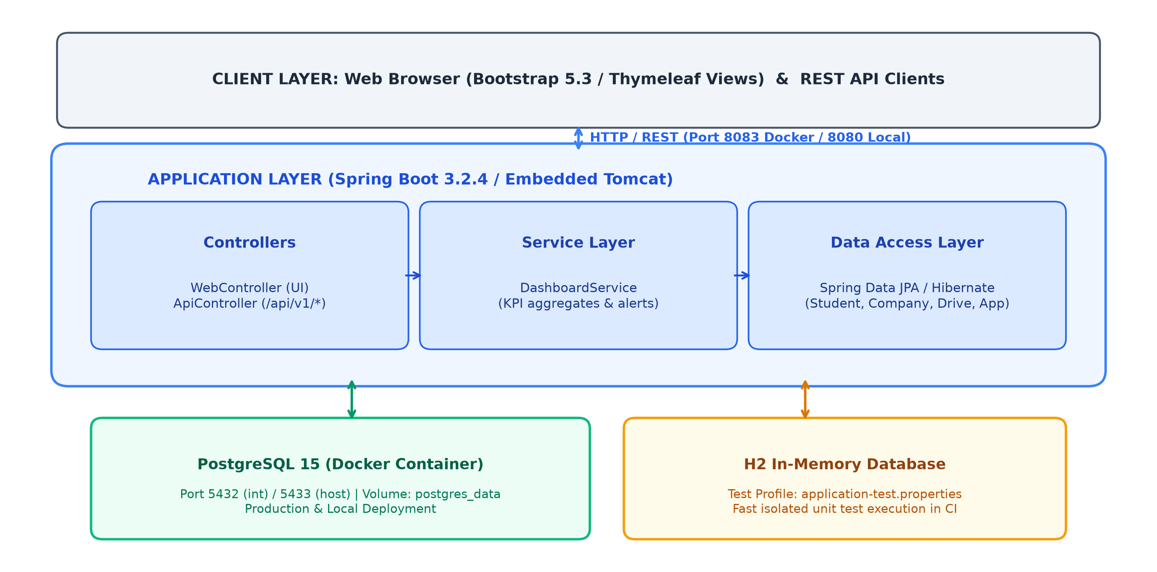
Figure 3.1: Layered 3-Tier Architecture — Client, Spring Boot Application, Service Layer, and Dual-Database Strategy
4. Database Entities and Data Model
The persistence layer consists of four core JPA entities mapped to relational PostgreSQL tables:
- 1. Student Entity: Table 'students': id (BIGSERIAL PK), name (VARCHAR), email (VARCHAR UNIQUE), department (VARCHAR), cgpa (DOUBLE), is_placed (BOOLEAN). One-to-many relationship with applications.
- 2. Company Entity: Table 'companies': id (BIGSERIAL PK), name (VARCHAR UNIQUE), industry (VARCHAR), description (TEXT). One-to-many relationship with placement_drives.
- 3. PlacementDrive Entity: Table 'placement_drives': id (BIGSERIAL PK), company_id (BIGINT FK), date (DATE), job_role (VARCHAR), minimum_cgpa (DOUBLE), status (VARCHAR: UPCOMING, ONGOING, COMPLETED). One-to-many with applications.
- 4. Application Entity: Table 'placement_applications': id (BIGSERIAL PK), student_id (BIGINT FK), drive_id (BIGINT FK), status (VARCHAR ENUM: APPLIED, SHORTLISTED, INTERVIEW, SELECTED, REJECTED), application_date (DATE). Composite unique constraint on (student_id, drive_id).
5. Web Routes and REST API Endpoints
The application exposes both Thymeleaf web views and raw JSON REST endpoints:
Endpoint Route | HTTP Method | Handler Controller | Functional Purpose
/ | GET | WebController.index | Renders dashboard view with live statistics and alerts.
/students | GET / POST | WebController.students | Lists/searches students; processes new student creation.
/students/delete/{id} | POST | WebController.deleteStudent | Deletes individual student; resets sequence if table empty.
/companies | GET / POST | WebController.companies | Lists/searches companies; creates new company.
/drives | GET / POST | WebController.drives | Lists drives; schedules new drive linked to company.
/applications | GET / POST | WebController.applications | Lists applications; registers student application to drive.
/applications/{id}/status | POST | WebController.updateStatus | Updates application status; auto-sets isPlaced if SELECTED.
/api/v1/students | GET / POST | ApiController.students | REST endpoint returning JSON student array or saving student.
/api/v1/companies | GET / POST | ApiController.companies | REST endpoint returning JSON company array or saving company.
/api/v1/drives | GET / POST | ApiController.drives | REST endpoint returning JSON placement drives.
/api/v1/applications | GET | ApiController.applications | REST endpoint returning all placement applications.

6. Multi-Environment Port Configuration
To prevent port collisions between local tools, a clear port mapping matrix was configured:
Service / Environment | Host Port | Internal Port | Operational Purpose
App (Local Dev) | 8080 | 8080 | Running locally via 'mvn spring-boot:run'.
Jenkins Server | 8081 | 8081 | Continuous Integration server running as a Windows service.
App (Task 8 JAR Deploy) | 8082 | 8082 | Standalone JAR deployed by Jenkinsfile pipeline stage.
App (Docker CD Deploy) | 8083 | 8080 | Containerized deployment managed by Docker Compose (release).
PostgreSQL Database | 5433 | 5432 | Docker container host port mapping for external tools (pgAdmin).

7. System Limitations and Incomplete Features
In accordance with engineering integrity principles, the following omissions are documented:
- No Authentication / RBAC: The portal operates in a single-user coordinator mode without authentication (Spring Security / JWT) or student login portals.
- No Pagination: Entities are rendered in full tables without pagination or lazy infinite scrolling.
- Test Port Dependency: Selenium automated UI tests require the application to be running on port 8083 (-DbaseUrl=http://localhost:8083); executing without the flag falls back to port 8080.
- No External Email Server: Notifications exist as in-app badges on the dashboard; outbound SMTP email dispatch was not implemented.
8. Conclusion
Task 03 established a resilient layered architecture, an enterprise-grade relational data model, and an isolated dual-database configuration. This modular design enabled rapid containerization and frictionless automated testing.

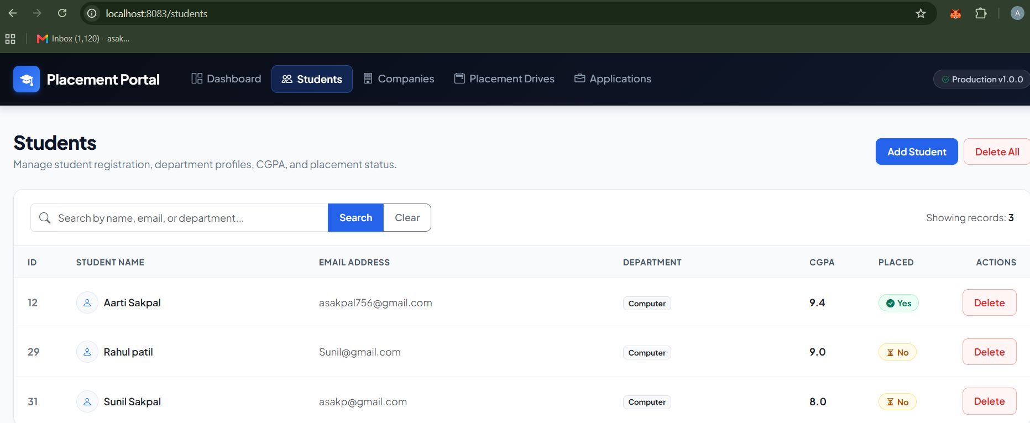
Student Management View - Browser view displaying the student table, search bar, and Add Student modal button.
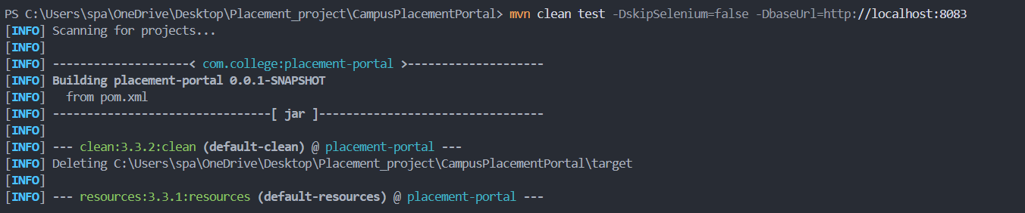
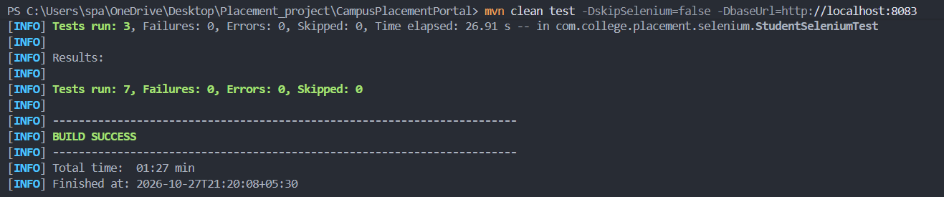
Unit Test Execution Output - Terminal output showing tests passing against H2 in-memory DB: 'Tests run: 7, Failures: 0, Errors: 0'.

