DEVOPS-ENABLED CAMPUS PLACEMENT TRACKING PORTAL — TASK REPORT
TASK 04: GIT AND GITHUB REPOSITORY INITIALIZATION
Student Name: Aarti Sakpal | Roll Number: 23102A0007
Course / Project: DevOps-Enabled Placement Portal | Target Release: release/final-v1.0.0 (v1.0.0)
GitHub Repository: https://github.com/AARTI756/CampusPlacementPortal | Evaluation Branch: release/final-v1.0.0
Task Objective: Initialize version control, establish the remote GitHub repository, structure project directories according to Maven standards, configure .gitignore and issue templates, and define the branching and commit conventions.
1. GitHub Repository Purpose and Remote Configuration
Version control is the bedrock of modern DevOps engineering. The repository was initialized locally using Git and linked to a centralized remote repository on GitHub:
- Repository URL: https://github.com/AARTI756/CampusPlacementPortal
- Primary Purpose: A centralized, distributed source of truth for application code, Maven build scripts, Docker deployment definitions, Ansible playbooks, and Markdown documentation.
- Collaboration Model: Facilitate isolated feature development via short-lived branches, enforce peer review via Pull Requests, and trigger automated builds in Jenkins.
2. Initial Repository Directory Structure
The repository follows standard Maven project layout with structured subdirectories for DevOps assets:
Verified Project Directory Tree
CampusPlacementPortal/
├── .github/
│ └── ISSUE_TEMPLATE/ # Verified issue templates (bug_report.md, feature_request.md)
├── ansible/ # Ansible configuration management & reliability playbooks
├── docs/ # Technical specifications (SRS.md, ARCHITECTURE.md, etc.)
│ ├── diagrams/ # Mermaid architecture and database model diagrams
│ └── evidence/ # Test logs and screen capture evidence
├── src/
│ ├── main/java/ # Spring Boot MVC controllers, models, repositories, services
│ ├── main/resources/ # Thymeleaf HTML templates, application.properties
│ └── test/java/ # JUnit 5 unit tests and Selenium WebDriver E2E UI tests
├── .gitignore # Exclusion rules for build artifacts and secrets
├── docker-compose.yml # Container definitions for app (8083) and db (5433)
├── Dockerfile # Multi-stage container build definition
├── Jenkinsfile # Declarative pipeline script for automated CI/CD
├── pom.xml # Apache Maven dependency and build configuration
└── README.md # Project overview, port mappings, and run instructions

3. Purpose and Configuration of .gitignore and README.md
Two critical governance files were established during initial repository setup:
- The .gitignore File: Prevents unwanted build artifacts (target/, build/), IDE configuration files (.idea/, .vscode/, *.iml, .project), operating system files (.DS_Store, Thumbs.db), sensitive environment secrets (*.env, *.pem, *.key), and utility binaries (jenkins-cli.jar) from entering version control. This maintains repository cleanliness and prevents credential leakage.
- The README.md File: Serves as the developer handbook, detailing the problem statement, technology stack table, architecture overview, local and Docker run commands, port allocation table (8080 to 8083, 5433), automated test execution instructions, and known system limitations.
4. Branching Strategy and Verified Branch Naming
A structured Git branching model was adopted to maintain stability in release branches while supporting parallel feature development:
Branch Name | Category / Role | Verified Status in Repository
main | Production baseline | Contains stable, production-ready code tagged with v1.0.0.
develop | Integration branch | Active development branch where all completed features merge.
feature/student-search | Feature branch (Task 5) | Implemented student search controller; merged via PR #1.
feature/application-status-dashboard | Feature branch (Task 6) | Implemented status drill-downs and dashboard exception alerts.
feature/data-management-delete | Feature branch | Implemented safe single-record and delete-all sequence reset.
feature/selenium-tests | Feature branch (Task 9) | Implemented 5 Selenium WebDriver UI test cases.
feature/continuous-testing | Feature branch (Task 10) | Added Jenkinsfile-Continuous-Testing quality gate.
feature/docker-containerization | Feature branch (Task 11) | Added Dockerfile and docker-compose.yml.
feature/jenkins-docker-cd | Feature branch (Task 12) | Added Jenkinsfile-Docker-CD automated container pipeline.
feature/ansible-config-management | Feature branch (Task 13) | Added ansible/site.yml configuration playbook.
feature/provisioning-reliability | Feature branch (Task 14) | Added provision.yml and reliability.yml recovery.
release/final-v1.0.0 | Release branch (Task 15) | Active HEAD: Final v1.0.0 release with documentation & polish.

5. Git Branching Model Visual
The evolution from initial commit through feature branches to final release is illustrated below:
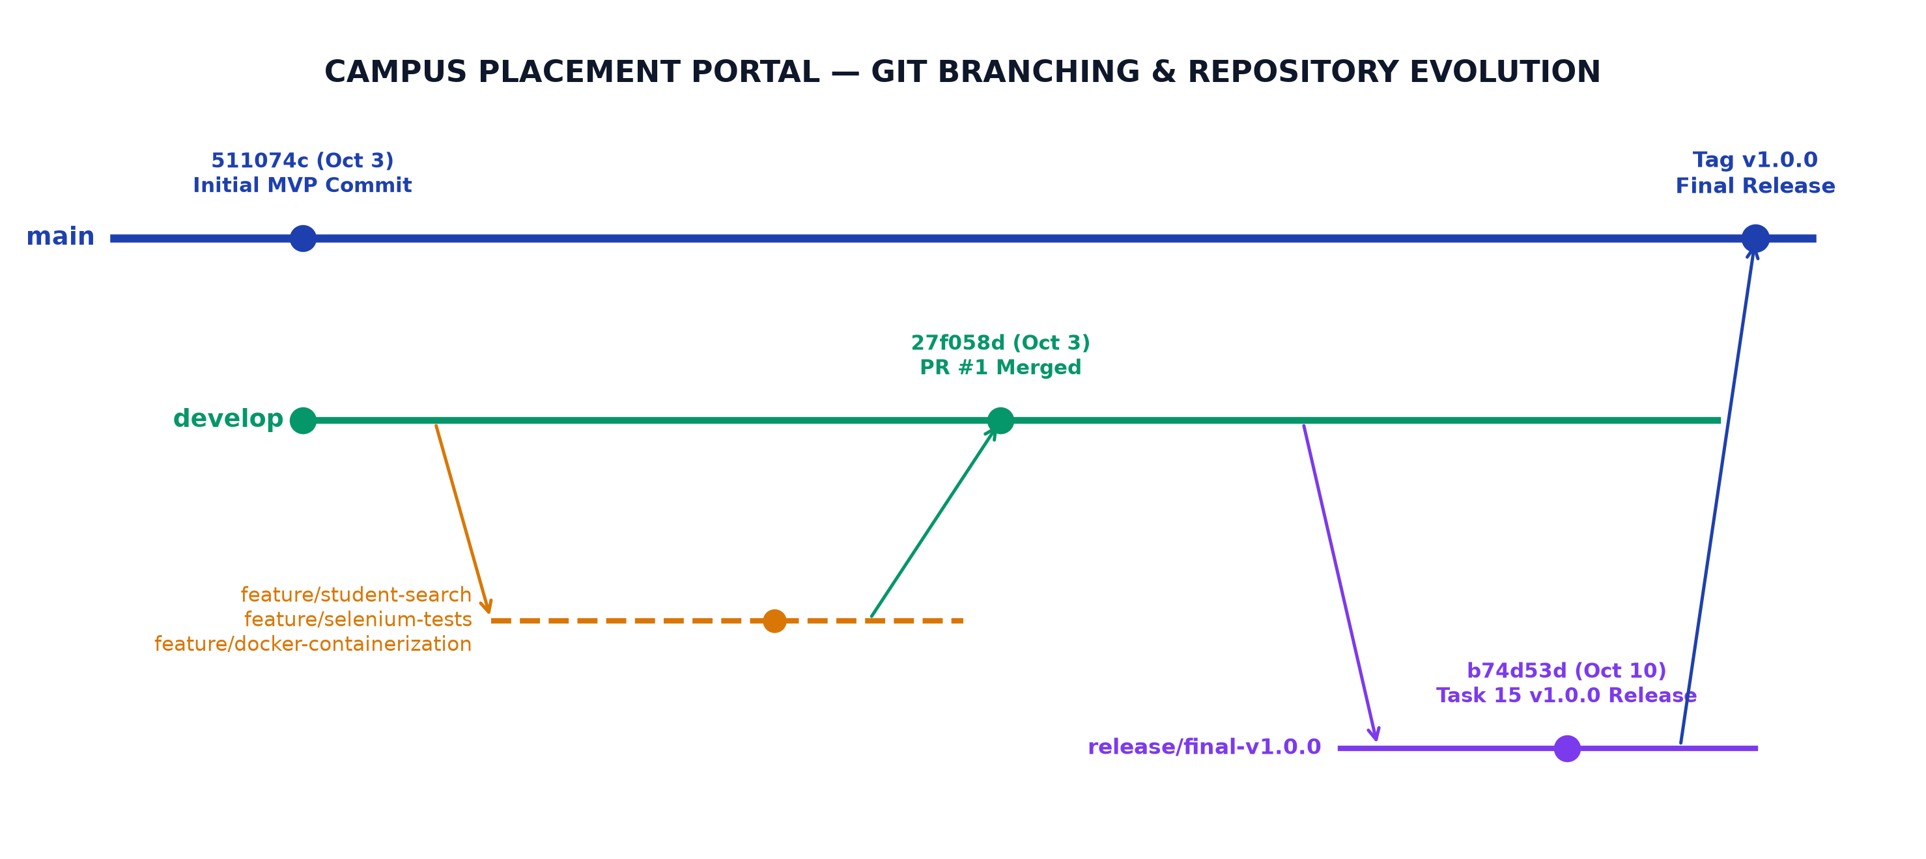
Figure 4.1: Git Branching Model — main, develop, feature/* branches, PR #1 merge, and release/final-v1.0.0
6. Initial Commits and Repository Evolution (Genuine Git History)
The repository's evolution is verified directly from git log records:
- Initial Commit: Commit 511074c (Date: Sat Oct 3 19:12:33 2026 +0530, Author: AARTI756 <asakpal756@gmail.com>, Message: 'chore: initial commit of MVP with docs and templates'). Introduced 42 files and 1,435 insertions spanning source code, templates, and specifications.
- First PR & Collaboration: Branch 'feature/student-search' added commits 7c7595a ('feat: add student search workflow') and fd4ab2c ('fix: resolve PostgreSQL connection and JVM timezone issues'). Merged into develop via commit 27f058d ('Merge pull request #1 from AARTI756/feature/student-search').
- Milestone Commits: Feature commits 051a682 (Task 8 Jenkins deploy), 2c31a79 (Task 9 Selenium tests), c823756 (Task 10 testing gate), b9bc2ed (Task 11 Docker), c0d065b (Task 12 Docker CD), 4f505de (Task 13 Ansible), 3025c32 (Task 14 Reliability), and final commit b74d53d ('feat: complete task 15 - final release v1.0.0').
7. Issue Templates and Governance Policies
To standardize bug reporting and feature proposals, GitHub issue templates were configured in .github/ISSUE_TEMPLATE/:
- Bug Report Template: Located at .github/ISSUE_TEMPLATE/bug_report.md. Enforces title prefix '[BUG] ', labels 'bug', and requires structured fields: bug description, steps to reproduce, expected behavior, screenshots, and runtime environment (OS, Browser, Java version).
- Feature Request Template: Located at .github/ISSUE_TEMPLATE/feature_request.md. Enforces title prefix '[FEAT] ', labels 'enhancement', and requires problem statement, proposed solution, and considered alternatives.
- Commit Convention: Commits strictly follow the format [type]: [Subject] (e.g., feat, fix, docs, test, chore), ensuring clean git log readability.
8. Conclusion
Task 04 established a robust, professional Git and GitHub foundation. Structured directory layout, rigorous .gitignore rules, feature branch isolation, pull request review workflows, and standardized issue templates ensured total version control integrity throughout the project lifecycle.

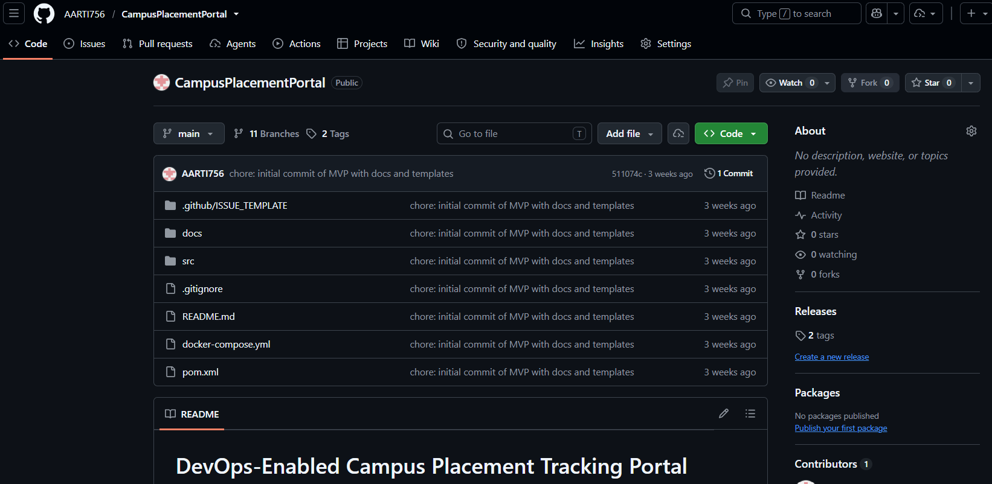
GitHub Repository Homepage - Web view of GitHub showing repository root, branch dropdown, and README.md.

