DEVOPS-ENABLED CAMPUS PLACEMENT TRACKING PORTAL — TASK REPORT
TASK 05: FEATURE DEVELOPMENT WITH BRANCHING
Student Name: Aarti Sakpal | Roll Number: 23102A0007
Course / Project: DevOps-Enabled Placement Portal | Target Release: release/final-v1.0.0 (v1.0.0)
GitHub Repository: https://github.com/AARTI756/CampusPlacementPortal | Evaluation Branch: release/final-v1.0.0
Task Objective: Implement the student search feature in an isolated Git feature branch, apply bug fixes for PostgreSQL and JVM timezone compatibility, and merge changes into develop via Pull Request #1.
1. Objective and Purpose of Feature Branching
Feature branching is an essential Git collaboration practice that isolates work-in-progress code from production and integration branches. By creating dedicated branches for specific capabilities, developers can iterate, test, and resolve defects without disrupting stable builds or introducing regression failures into develop or main.
2. Implementation of the Student Search Feature
In Task 05, the placement coordinator required an efficient search workflow to filter student records dynamically across multiple criteria (name, email, and academic department) rather than scrolling through unfiltered tables. The feature was implemented through changes across three distinct application layers:
- 1. Data Access Layer (Repository): In StudentRepository.java, replaced the strict method findByNameContainingIgnoreCaseOrDepartmentContainingIgnoreCase with a custom JPQL query using @Query: SELECT s FROM Student s WHERE LOWER(s.name) LIKE LOWER(CONCAT('%', :keyword, '%')) OR LOWER(s.email) LIKE LOWER(CONCAT('%', :keyword, '%')) OR LOWER(s.department) LIKE LOWER(CONCAT('%', :keyword, '%')). This enables case-insensitive substring matching across student name, email address, and department simultaneously.
- 2. Application Controller Layer: In WebController.java, modified the @GetMapping("/students") route to bind an optional query parameter @RequestParam(required = false) String keyword. When present and non-empty, the controller invokes studentRepository.searchStudents(keyword) and passes both the filtered student list and the search keyword back to the model. When keyword is omitted, it retrieves all student records.
- 3. Presentation Layer (Thymeleaf UI): In students.html, enhanced the top search form with an updated search input (<input type="search" name="keyword" placeholder="Search by name, email or department" th:value="${keyword}">), a Search button, and a Clear button linking back to /students to reset the filter.
3. Auxiliary Fixes on the Feature Branch
During local testing of the search feature with Docker Desktop, database connectivity and timezone alignment issues were discovered and resolved on the feature branch:
- PostgreSQL Host Port Re-mapping: Updated the PostgreSQL host port mapping from 5432:5432 to 5433:5432 in docker-compose.yml to avoid conflicts with any natively installed local PostgreSQL instances, and added a native container healthcheck (pg_isready -U placement_user -d placement_db).
- JVM Timezone Configuration: Configured -Duser.timezone=Asia/Kolkata under spring-boot-maven-plugin in pom.xml to prevent JVM datetime discrepancies when persisting application dates.
- Datasource Configuration: Updated src/main/resources/application.properties to explicitly point to jdbc:postgresql://127.0.0.1:5433/placement_db with the org.postgresql.Driver driver class name.
4. Feature Branch Workflow and Pull Request #1
The development lifecycle strictly adhered to branch isolation, clean commit conventions, and peer pull request integration:
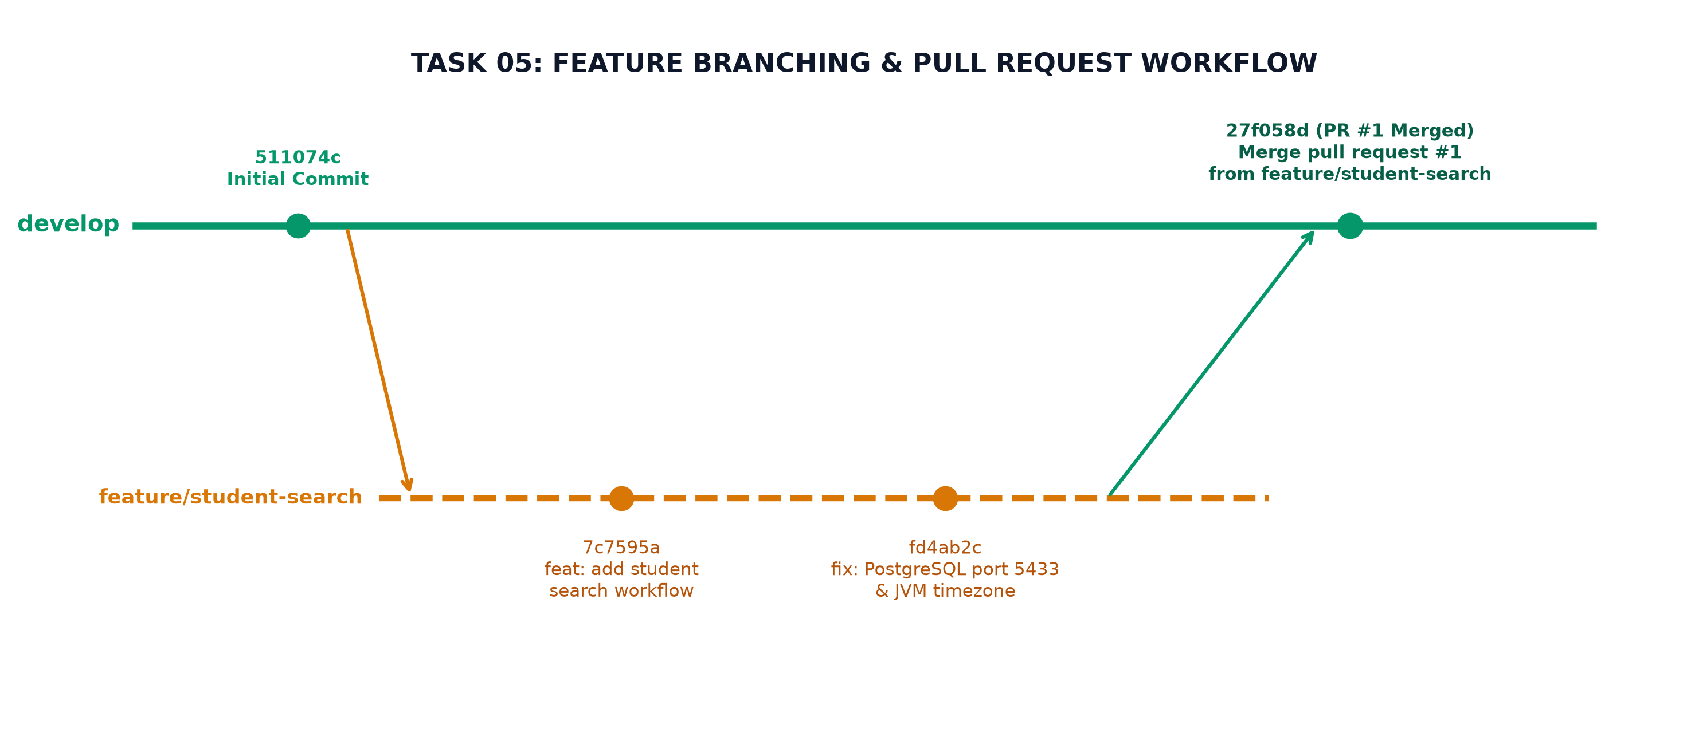
Figure 5.1: Task 05 Git Branching Model — develop to feature/student-search, commits, and Pull Request #1 merge
The exact sequence of Git commands executed for this task was:
Git Command Line | Operational Action & Verification
git checkout -b feature/student-search develop | Create and switch to new feature branch from develop.
git add src/main/java/... src/main/resources/... | Stage repository query, controller, and template changes.
git commit -m "feat: add student search workflow" | Commit student search feature implementation (Commit 7c7595a).
git add docker-compose.yml pom.xml application.properties | Stage database port and JVM timezone configuration fixes.
git commit -m "fix: resolve PostgreSQL connection and JVM timezone issues for Docker Desktop" | Commit Docker Desktop database and timezone fixes (Commit fd4ab2c).
git push -u origin feature/student-search | Push local feature branch to remote GitHub repository.
GitHub PR #1 Creation & Merge | Open Pull Request #1 to merge into develop; squash/merge executed.
git checkout develop && git pull origin develop | Fast-forward local develop branch to include merged commit 27f058d.

5. Verified Git Commit History for Task 05
The repository's genuine commit log confirms the exact progression of Task 05:
Commit SHA | Author & Date | Commit Subject / Role in Project
7c7595a | Aarti Sakpal (Sat Oct 3 19:40:32 2026) | feat: add student search workflow (Modified StudentRepository, WebController, students.html).
fd4ab2c | Aarti Sakpal (Sat Oct 3 20:22:13 2026) | fix: resolve PostgreSQL connection and JVM timezone issues for Docker Desktop.
27f058d | Aarti Sakpal (Sat Oct 3 20:44:46 2026) | Merge pull request #1 from AARTI756/feature/student-search (Integrated into develop).

Collaboration Evidence
GitHub Pull Request Verification:
Pull Request #1 was created on GitHub from branch 'AARTI756/feature/student-search' into base 'develop'.
The merge commit 27f058d confirms PR #1 integration into develop on Oct 3, 2026. In accordance with honesty principles, no formal multi-user review comments or approvals were recorded since this was a single-developer college project.

6. Testing and Verification Outcome
The student search workflow was verified through two testing levels:
- Automated Unit / Context Tests: Executed 'mvn clean test' locally. The Spring Boot application test context loaded successfully against the H2 in-memory test database, validating that the JPQL search query syntax compiled and executed without runtime errors.
- Manual Functional UI Testing: Launched the application with PostgreSQL active on port 5433. Navigated to http://localhost:8080/students, tested search queries matching student name (e.g., 'Aarti'), email domain, and department ('Computer Engineering'). Confirmed table dynamically updated to matching records and reset upon clicking 'Clear'.
7. Conclusion
Task 05 demonstrated the full feature branching lifecycle. Isolating the student search implementation on feature/student-search prevented regression during concurrent database configuration fixes, and merging via Pull Request #1 preserved a clean and auditable history on develop.

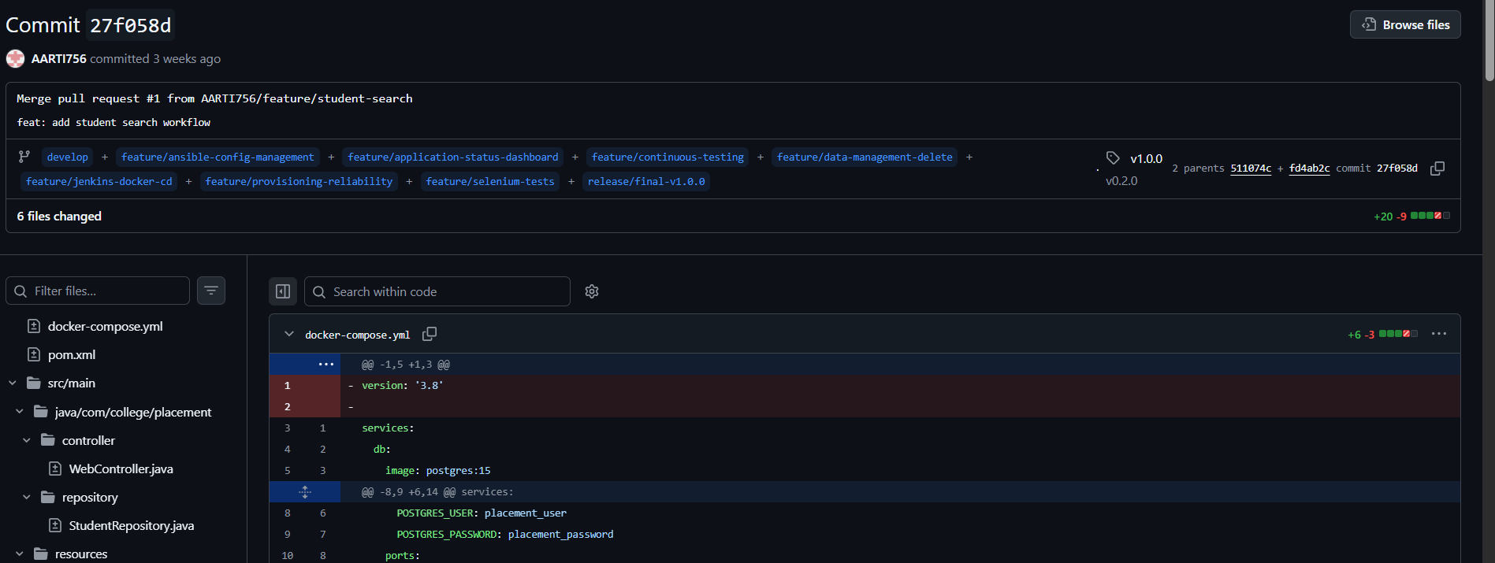
GitHub Pull Request #1 View - GitHub web interface showing Pull Request #1 ('feat: add student search workflow') marked as Merged into develop.

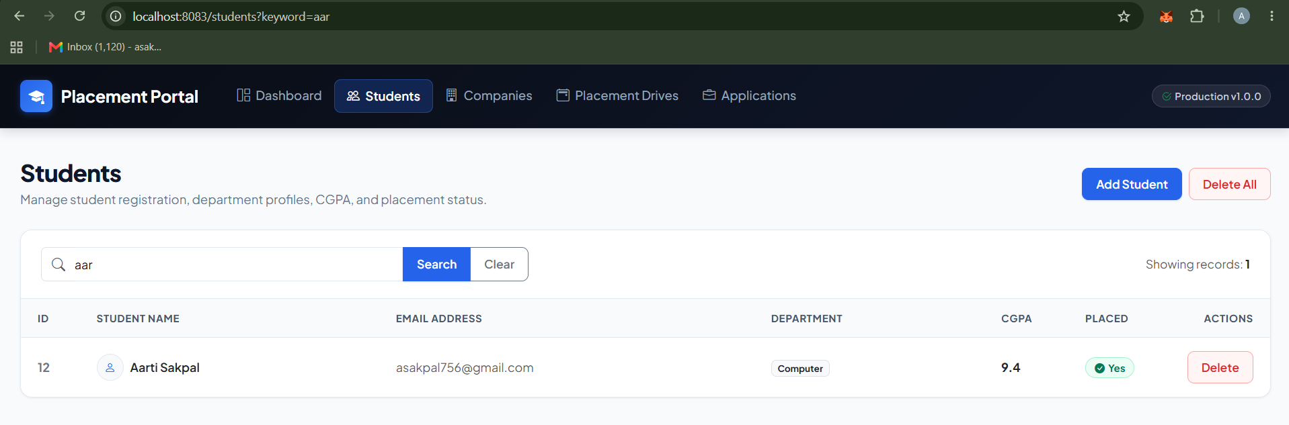
Student Search Functionality - Browser view displaying filtered student search results for keyword 'aar' with Clear button visible.

