DEVOPS-ENABLED CAMPUS PLACEMENT TRACKING PORTAL — TASK REPORT
TASK 06: MVP COMPLETION AND GIT COLLABORATION
Student Name: Aarti Sakpal | Roll Number: 23102A0007
Course / Project: DevOps-Enabled Placement Portal | Target Release: release/final-v1.0.0 (v1.0.0)
GitHub Repository: https://github.com/AARTI756/CampusPlacementPortal | Evaluation Branch: release/final-v1.0.0
Task Objective: Consolidate core MVP management modules, implement application status drill-downs and pending interview alerts, resolve a documented Git merge conflict, and tag the v0.2.0 baseline release.
1. Objective and Essential MVP Scope
The objective of Task 06 was to bring the Minimum Viable Product (MVP) to functional completion. This required delivering full CRUD capabilities across core entities, establishing a centralized KPI dashboard with exception indicators, resolving parallel documentation conflicts in Git, and formally establishing the milestone release tag v0.2.0.
2. Core Management Capabilities Implemented
The completed MVP provides placement coordinators with centralized management across four interconnected functional modules:
- Student Management (/students): Full profile tracking including student name, unique institutional email, academic department, CGPA, and placement boolean status (isPlaced). Includes keyword search and safe deletion.
- Company Management (/companies): Recruiting partner records including company name (unique constraint), industry sector, and job description.
- Placement Drive Management (/drives): Recruitment drive scheduling associated with companies, specifying drive date, job role designation, minimum eligible CGPA, and drive status ('UPCOMING', 'ONGOING', 'COMPLETED').
- Application Management (/applications): Linking enrolled students to scheduled placement drives. Implements a database-level composite unique constraint on (student_id, drive_id) to prevent duplicate applications.
3. Application Status Drill-Down and Dashboard Exception Alerts
A key deliverable of Task 06 (implemented in commit b6faaaa on branch feature/application-status-dashboard) was enhancing application tracking and dashboard visibility:
- Application Status Drill-Down: Added an onchange status filter dropdown (<select name="status">) on applications.html, enabling placement officers to drill down into candidates by stage: APPLIED, SHORTLISTED, INTERVIEW, SELECTED, or REJECTED. In WebController.java, @GetMapping("/applications") filters by ApplicationStatus when provided.
- Service & Repository Enhancements: Added findByStatus(ApplicationStatus status) and countByStatus(ApplicationStatus status) in ApplicationRepository.java, and exposed a new metric pendingInterviewsCount in DashboardService.java.
- Dashboard Alert Card: In dashboard.html, added an alert card: 'Pending Interviews: X students are currently scheduled for interviews' alongside existing alerts for unplaced students and upcoming drives.
4. Git Collaboration and Merge Conflict Resolution
During Task 06, parallel development occurred: commit 70133e8 updated the task 6 backlog on the feature branch while commit b93eb24 updated the release backlog on develop. Both commits modified the Kanban section in docs/DEVOPS_WORKFLOW.md, creating a genuine merge conflict upon merging into develop.
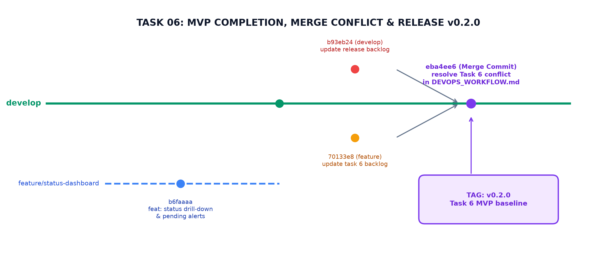
Figure 6.1: Task 06 Git Collaboration — Feature Branch, Parallel Doc Commits, Merge Conflict Resolution, and v0.2.0 Tag
The conflict was inspected, manually resolved, and committed via merge commit eba4ee6:
Verified Merge Conflict Markers & Manual Resolution
Conflict in docs/DEVOPS_WORKFLOW.md:
<<<<<<< HEAD (develop / b93eb24)
- **In Progress:** Task 6 (MVP Completion)
- **Done:** Tasks 1, 2, 3, 4, 5 (MVP Development, Scope, Architecture, Git init, Branching)
=======
- **In Progress:** Task 4, 5 (Git init, Branching)
- **Done:** Tasks 1, 2, 3, 6 (MVP Development, Scope, Architecture, MVP Completion)
>>>>>>> 70133e8 (feature/application-status-dashboard)
Resolved Output in commit eba4ee6:
- **In Progress:** None
- **Done:** Tasks 1, 2, 3, 4, 5, 6 (MVP Development, Scope, Architecture, Git init, Branching, MVP Completion)

5. Release Tagging: Milestone Tag v0.2.0
Following conflict resolution and successful local build verification, the MVP milestone was formally tagged:
Tag Name | Target Commit SHA | Tagger & Date | Tag Annotation Message
v0.2.0 | eba4ee6 | Aarti Sakpal (Sat Oct 3 21:17:30 2026) | Task 6 MVP release baseline

6. Verified Git Commit Progression for Task 06
The genuine Git log verifies the commits constituting Task 06:
Commit SHA | Author & Date | Commit Subject / Functional Contribution
b6faaaa | Aarti Sakpal (Oct 3 21:04:56) | feat: add application status drill-down and alerts (WebController, templates, repo).
70133e8 | Aarti Sakpal (Oct 3 21:10:48) | docs: update task 6 backlog (Feature branch backlog update).
b93eb24 | Aarti Sakpal (Oct 3 21:14:52) | docs: update release backlog (Develop branch backlog update).
eba4ee6 | Aarti Sakpal (Oct 3 21:17:03) | merge: resolve Task 6 documentation conflict (Merged into develop; tagged v0.2.0).

7. MVP Status, Known Limitations, and Omissions
In accordance with academic integrity, the operational state and limitations of the v0.2.0 MVP are noted:
- Verified Capabilities: All 4 CRUD entities, status tracking, keyword search, and dashboard alerts functioned as designed.
- No Authentication / RBAC: The MVP was implemented as a single-user system without authentication or role separation (placement officer vs student view).
- No Pagination: Data tables display all records without pagination.
- No Outbound Notifications: Alerts are confined to dashboard badges; external notification services (email/SMS) were out of scope.
8. Conclusion
Task 06 achieved full MVP operational readiness, successfully resolved a real Git merge conflict, and established the v0.2.0 release milestone. This provided a stable baseline for subsequent CI/CD and containerization stages.
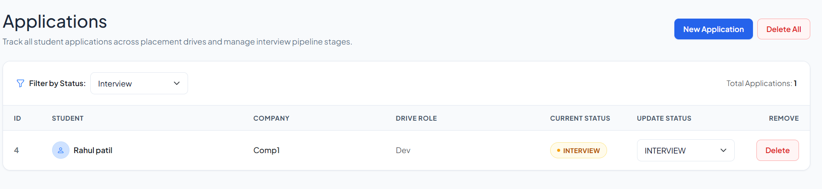
Application Status Drill-Down - Browser view of Applications table filtered by status 'INTERVIEW' via dropdown.
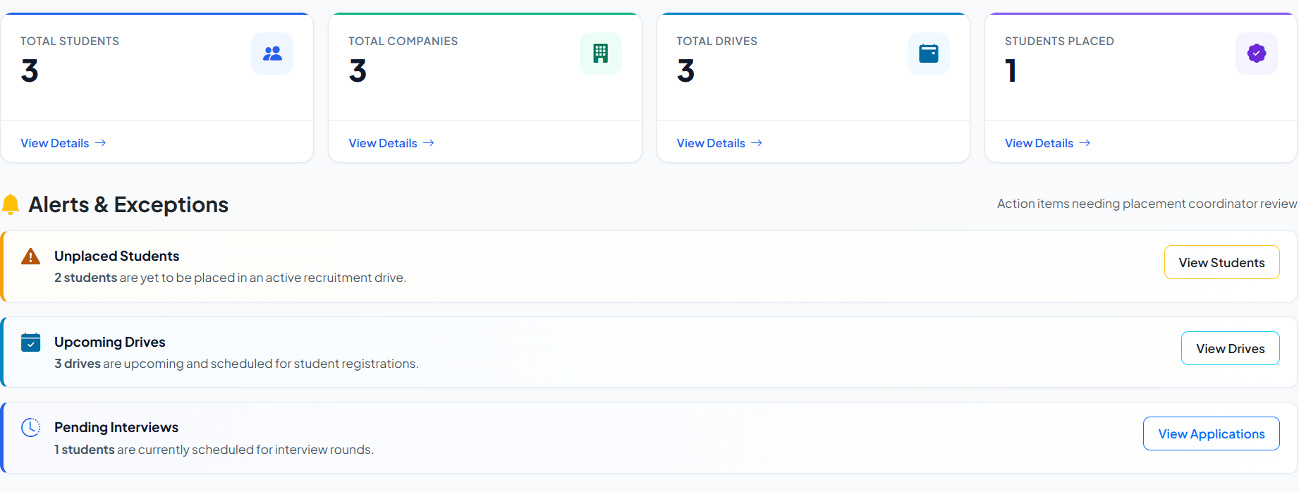
Dashboard Pending Alert Card - Browser view showing the 'Pending Interviews' alert banner alongside Unplaced Students.

