DEVOPS-ENABLED CAMPUS PLACEMENT TRACKING PORTAL — TASK REPORT
TASK 07: JENKINS INSTALLATION AND CONTINUOUS INTEGRATION
Student Name: Aarti Sakpal | Roll Number: 23102A0007
Course / Project: DevOps-Enabled Placement Portal | Target Release: release/final-v1.0.0 (v1.0.0)
GitHub Repository: https://github.com/AARTI756/CampusPlacementPortal | Evaluation Branch: release/final-v1.0.0
Task Objective: Install and configure Jenkins locally, establish the freestyle build job CampusPlacementPortal-CI, integrate Maven with GitHub SCM, and execute automated build and test verification.
1. Objective of Continuous Integration
Continuous Integration (CI) automates the compilation, testing, and packaging of application code whenever changes are committed. By validating the develop branch continuously, CI eliminates integration delays, detects syntax or runtime defects early, and ensures that the repository remains in an always-buildable state.
2. Jenkins Installation and Local Host Configuration
Jenkins was deployed and configured on the local Windows development host with specific parameters to prevent port and environment collisions:
Configuration Parameter | Installed / Configured Value | Operational Rationale
Jenkins Version | 2.568.2 LTS | Modern LTS release supporting declarative pipelines and modern Java tooling.
Installation Mode | Windows Service (Jenkins) | Runs continuously in background; auto-restarts upon system reboot.
Jenkins Web URL | http://localhost:8081 | Configured on port 8081 to avoid conflict with application dev server (port 8080).
JDK Environment | OpenJDK 17 (Java 17) | Compatible with Spring Boot 3.2.4 language baseline.
Build Tool | Apache Maven 3.9.16 | Configured at C:\DevTools\apache-maven-3.9.16 under Global Tool Configuration.
Git SCM Tool | Git for Windows (v2.x) | Integrated with Jenkins Git plugin to clone remote repository over HTTPS.

3. Jenkins Freestyle CI Job Architecture
Task 07 established the initial CI job using Jenkins's native Freestyle Project structure:
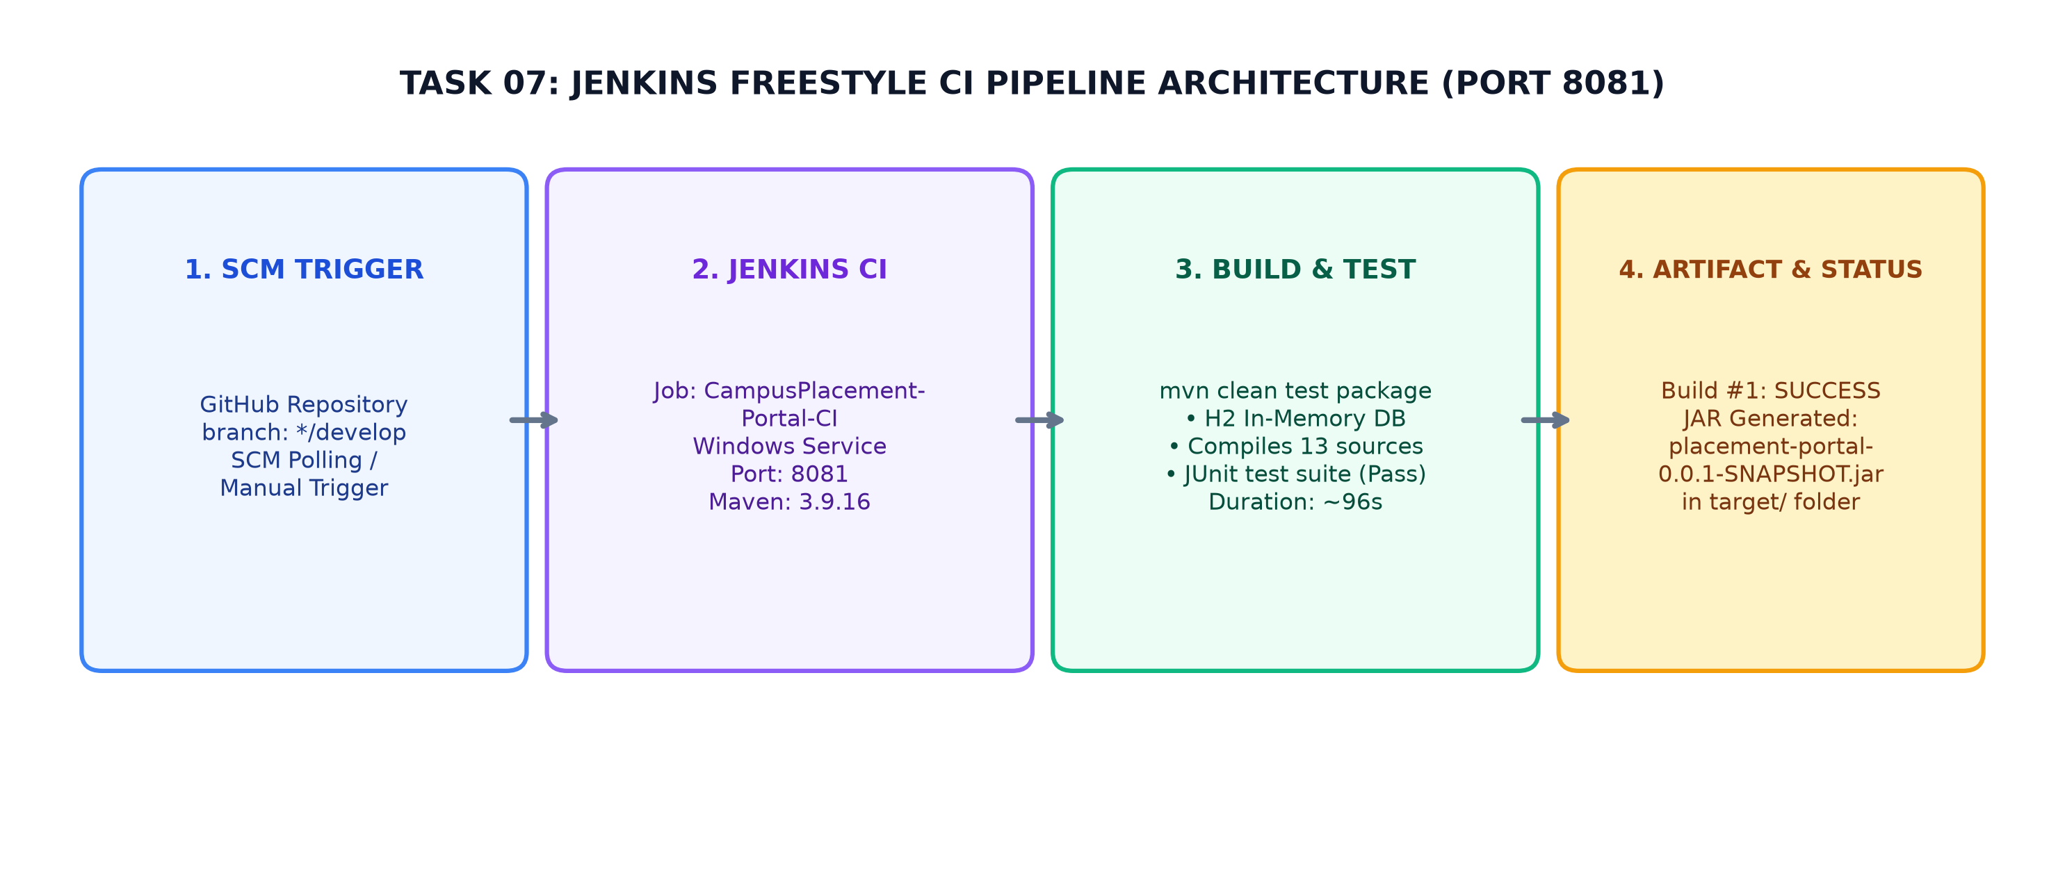
Figure 7.1: Jenkins Freestyle CI Architecture — GitHub develop clone, Maven build & test on H2, and JAR artifact packaging
4. Job Configuration Details: CampusPlacementPortal-CI
The freestyle job CampusPlacementPortal-CI was configured with the following build settings:
- Job Name & Type: CampusPlacementPortal-CI (Freestyle project).
- Source Code Management: https://github.com/AARTI756/CampusPlacementPortal.git.
- Monitored Branch: */develop (triggers verification on all new integration commits).
- Build Triggers: In local laboratory environments without public IP ingress, webhook pushes from GitHub are unreachable without reverse proxies. Therefore, the job was triggered via Jenkins SCM Polling (schedule: H/5 * * * *) and manual 'Build Now' invocations.
- Build Step: Invokes top-level Maven target: mvn clean test package using global Maven-3.9.16.
5. Build Execution and Test Validation
During execution, the CI job automatically validates the following build lifecycle steps:
- 1. SCM Checkout: Clones the latest commit from the develop branch into Jenkins workspace.
- 2. Workspace Clean: Deletes any residual target/ directories to guarantee an unpolluted compilation state.
- 3. Automated Testing: Compiles all 13 application source files and runs the Spring Boot test suite against the H2 in-memory database profile (application-test.properties). Does not require external PostgreSQL.
- 4. Packaging: Packages the compiled classes and embedded Tomcat into an executable Spring Boot fat JAR: placement-portal-0.0.1-SNAPSHOT.jar under workspace target/.
- 5. Quality Reporting: Monitors compiler warnings, test assertions, and JVM exit codes, recording a definitive build outcome on the dashboard.
Verified CI Build Results
Verified Build #1 Execution Evidence (recorded in docs/DEVOPS_WORKFLOW.md Section 8):
• Job: CampusPlacementPortal-CI | Build Number: #1
• Result: SUCCESS | Execution Duration: ~96 seconds
• Test Outcome: All Spring Boot integration tests passed (0 failures, 0 errors)
• Packaged Artifact: placement-portal-0.0.1-SNAPSHOT.jar generated in target/
• Commit: chore: ignore jenkins-cli.jar (54157a1) added to prevent CLI tooling clutter.

6. Limitations of Freestyle CI Jobs
While Task 07 successfully proved continuous integration, several engineering limitations were identified:
- Configuration Not in Version Control: Freestyle job configurations are stored as XML files inside Jenkins's internal directory (JENKINS_HOME) rather than being versioned in the Git repository.
- No Deployment Stage: The freestyle job only compiled and packaged the code; it did not automatically deploy the application to a test runtime server.
- Transition to Task 08: These limitations directly motivated the transition to Pipeline as Code (Jenkinsfile) in Task 08.
7. Conclusion
Task 07 established a dependable CI gate on Jenkins (port 8081). By verifying every develop commit with clean compilation and automated H2 tests, the project eliminated build breakage risks and created the operational baseline for automated deployment.
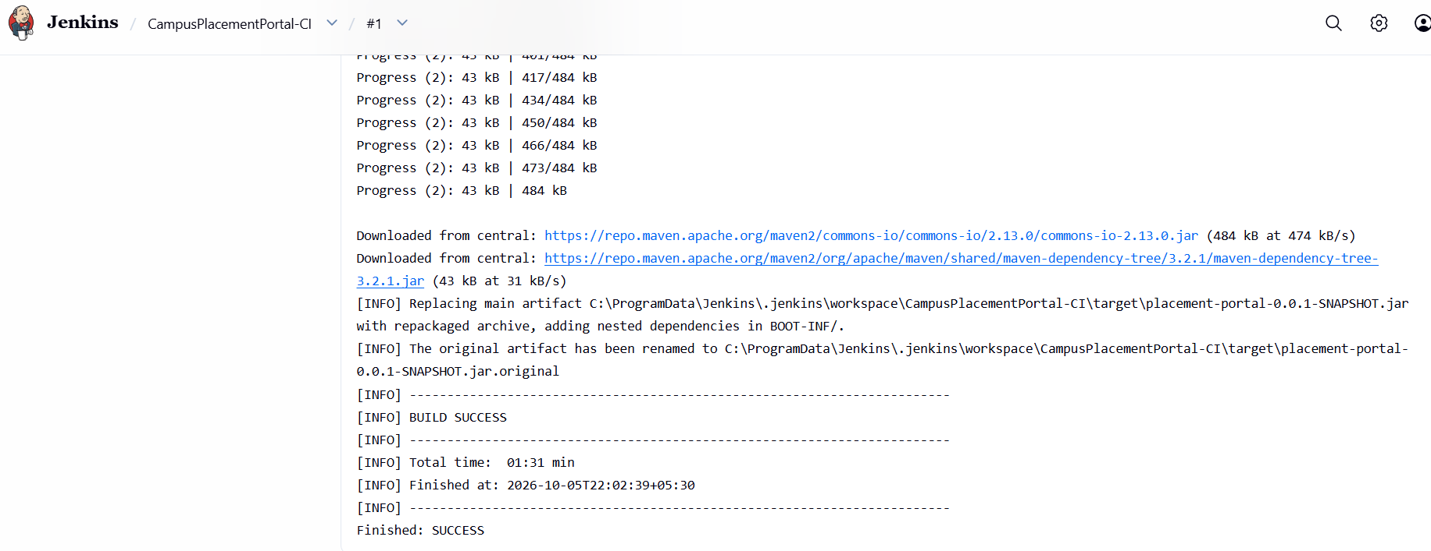
Jenkins CI Job Status - Jenkins project page showing Build #1 status as SUCCESS with green/blue ball indicator.
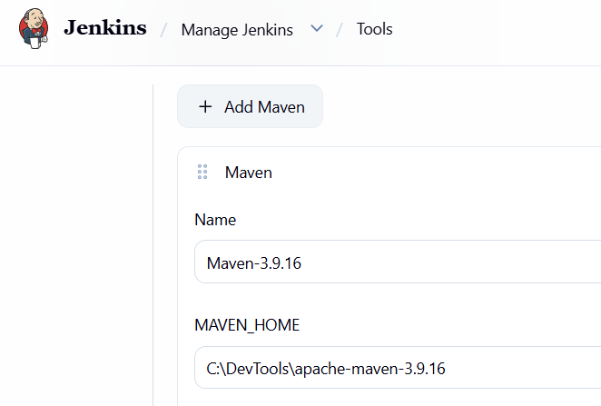
Jenkins Global Tool Config - Jenkins tools page showing Maven installation named 'Maven-3.9.16' configured at C:\DevTools\apache-maven-3.9.16.

