DEVOPS-ENABLED CAMPUS PLACEMENT TRACKING PORTAL — TASK REPORT
TASK 08: PIPELINE AS CODE AND SERVER DEPLOYMENT
Student Name: Aarti Sakpal | Roll Number: 23102A0007
Course / Project: DevOps-Enabled Placement Portal | Target Release: release/final-v1.0.0 (v1.0.0)
GitHub Repository: https://github.com/AARTI756/CampusPlacementPortal | Evaluation Branch: release/final-v1.0.0
Task Objective: Implement a declarative Jenkinsfile pipeline versioned in Git, execute automated build and test stages, and deploy the application as a standalone Spring Boot JAR on port 8082 with automated health verification.
1. Objective of Pipeline as Code
Pipeline as Code shifts CI/CD pipeline definitions from fragile web UI configurations into version-controlled source code. Storing a Jenkinsfile at the root of the repository ensures that pipeline stages, build steps, deployment parameters, and verification tests are auditable, reproducible, reviewable via pull requests, and versioned synchronously with application features.
2. The Actual Task 8 Jenkinsfile Pipeline Structure
The repository root contains the declarative Jenkinsfile used for the Task 08 deployment pipeline:
- Execution Agent: agent any — Executes on any available Jenkins executor agent.
- Tools Directive: tools { maven 'Maven-3.9.16' } — Leverages the centrally configured Maven installation.
- Environment Block: DEPLOY_DIR = 'C:\\CampusPlacementPortal\\deploy', JAR_NAME = 'placement-portal-0.0.1-SNAPSHOT.jar', DEPLOY_PORT = '8082'.
The pipeline executes five sequential stages as visualized below:
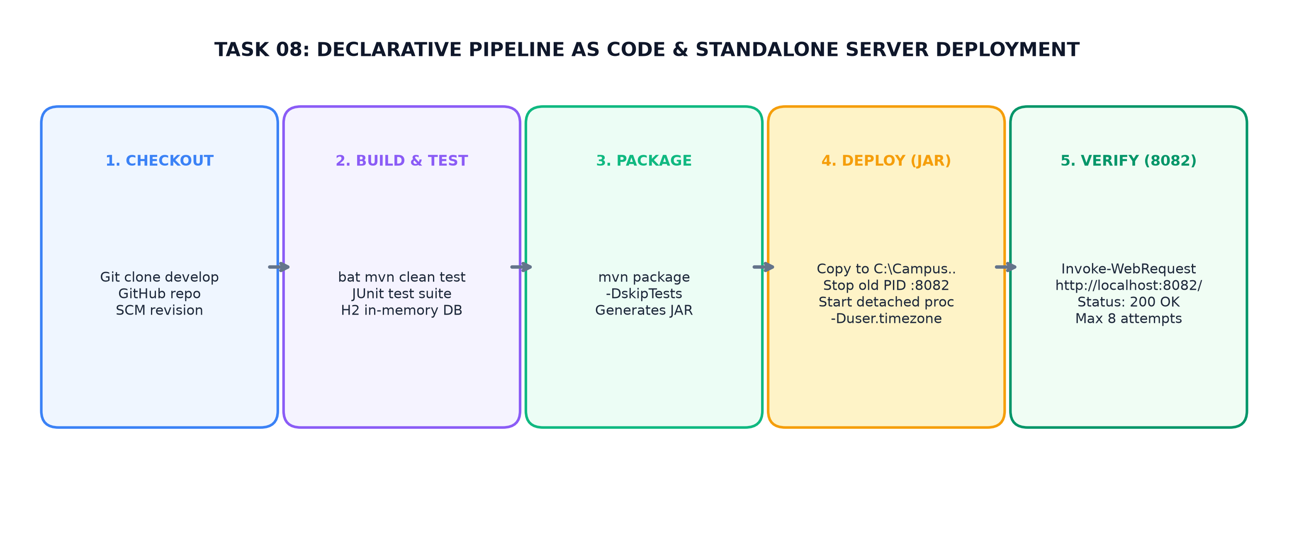
Figure 8.1: Task 08 Pipeline as Code Architecture — Checkout, Build & Test, Package, Local JAR Deploy, and HTTP Health Verification
3. Stage-by-Stage Pipeline Execution
The five pipeline stages defined in Jenkinsfile execute sequentially:
Stage Name | Jenkins Command / Script | Operational Objective & Actions
1. Checkout | checkout scmGit(... branches: '*/develop') | Clones develop branch from GitHub repository over HTTPS.
2. Build & Test | bat 'mvn clean test' | Executes clean compile and runs JUnit integration test suite against H2 in-memory DB.
3. Package | bat 'mvn package -DskipTests' | Compiles production artifacts and builds executable JAR: placement-portal-0.0.1-SNAPSHOT.jar.
4. Deploy | bat powershell Stop-Process :8082  copy target/JAR to DEPLOY_DIR  Start-Process java -jar detached | Creates deploy directory; terminates any stale process on port 8082; copies JAR; launches detached background process with Asia/Kolkata timezone and PostgreSQL 5433 config; sleeps 30s.
5. Verify | bat powershell Invoke-WebRequest  http://localhost:8082/ (max 8 tries) | Performs automated HTTP health check expecting HTTP 200 OK. Fails pipeline if verification unsuccessful.

4. Standalone JAR Deployment vs. Later Docker Deployment
A critical technical distinction must be noted regarding the deployment mechanism used in Task 08:
- Host Standalone Process: Task 08 deployed the application as a standalone executable Spring Boot JAR running directly on the Windows host operating system via PowerShell process control (Start-Process java -jar ...).
- No External Web Server / Docker: The application did NOT utilize an external web server container (such as Apache Tomcat standalone or Nginx) nor did it use Docker.
- Embedded Tomcat & Roadmap: Spring Boot provides an embedded Tomcat server embedded directly inside the JAR. Containerized deployment using Docker was formally reserved for Task 11, and Docker-based continuous deployment on port 8083 was established in Task 12.
5. Environment Parameterization and Port Allocation
To ensure isolation, port 8082 was chosen specifically for the Task 08 pipeline deployment:
Port | Target Service | Role in DevOps Workflow
8080 | Local Development Application | Used when developers run 'mvn spring-boot:run' locally.
8081 | Jenkins Server | Hosting the Jenkins web dashboard and build agents.
8082 | Task 08 Pipeline Deployment | Dedicated port for Jenkinsfile local JAR deployment.
8083 | Tasks 11/12 Docker CD Deployment | Production containerized port mapped from Docker Compose.
5433 | PostgreSQL Database | Exposed host port connecting to containerized PostgreSQL 15.

Verified Pipeline as Code Results
Verified Build #2 Execution Evidence (from docs/DEVOPS_WORKFLOW.md Section 9):
• Job Name: CampusPlacementPortal-Pipeline (Pipeline from SCM)
• Build Result: SUCCESS | Execution Duration: ~81 seconds
• Deploy Target: C:\CampusPlacementPortal\deploy\placement-portal-0.0.1-SNAPSHOT.jar
• Verification Output: HTTP Status: 200 OK | 'Deployment verified successfully!'
• Application reachable at: http://localhost:8082/

6. Windows Compatibility Enhancements in Jenkinsfile
In commit 0288cc2, the deploy stage was refined specifically for Windows Jenkins agents:
- Port Clearing: Added PowerShell NetTCPConnection inspection to gracefully kill stale Java processes holding port 8082 before launching new instances.
- Log Redirection: Added -RedirectStandardOutput and -RedirectStandardError to pipe application logs to app.log and app-error.log in the deployment directory.
- Retry Loop: Included a 30-second startup sleep followed by an 8-attempt retry loop using Invoke-WebRequest, accommodating Spring Boot initialization overhead.
7. Conclusion
Task 08 successfully established Pipeline as Code using a declarative Jenkinsfile. Automating checkout, testing, packaging, deployment to port 8082, and HTTP health verification provided a fully automated, auditable continuous delivery pipeline.
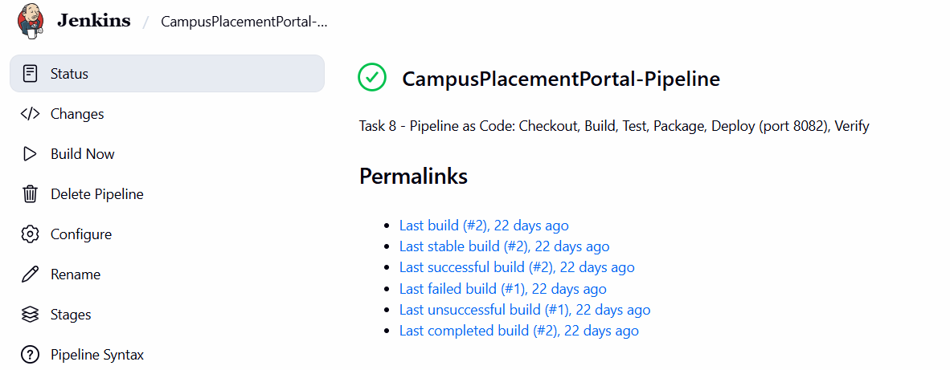
Jenkins Pipeline Stage View - Stage View showing green rectangular boxes across Checkout, Build & Test, Package, Deploy, and Verify.
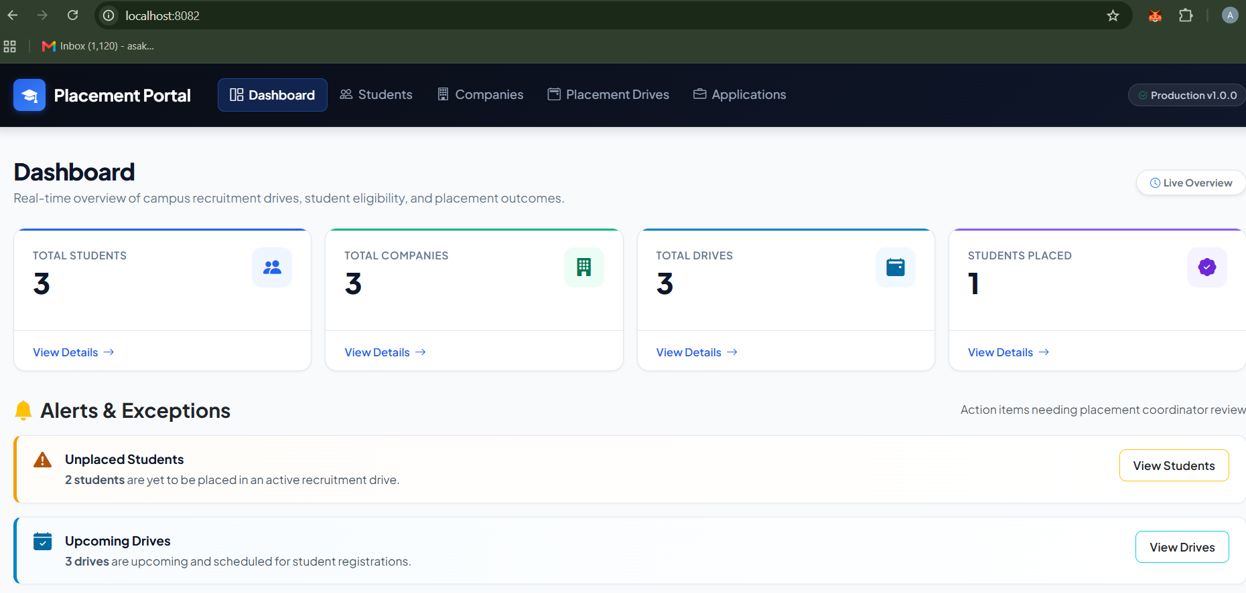

Deployed Application on Port 8082 - Browser view of the Placement Portal dashboard loading successfully from the Task 8 deployment port 8082.

