DEVOPS-ENABLED CAMPUS PLACEMENT TRACKING PORTAL — TASK REPORT
TASK 09: SELENIUM TEST DESIGN AND LOCAL EXECUTION
Student Name: Aarti Sakpal | Roll Number: 23102A0007
Course / Project: DevOps-Enabled Placement Portal | Target Release: release/final-v1.0.0 (v1.0.0)
GitHub Repository: https://github.com/AARTI756/CampusPlacementPortal | Evaluation Branch: release/final-v1.0.0
Task Objective: Design and execute automated end-to-end browser tests using Selenium WebDriver 4.19 and JUnit 5 to validate critical user journeys against the running placement portal.
1. Objective of Automated Browser Testing
Automated browser testing validates that server-rendered HTML templates, client-side styling, forms, and backend database transactions function synchronously as perceived by real end-users. While unit tests verify isolated service logic, Selenium WebDriver tests simulate genuine user interactions—navigating views, submitting forms, filtering records, and handling browser alerts—ensuring high software quality and zero UI regression across releases.
2. Selenium WebDriver, JUnit 5, and Maven Test Harness
The automated UI testing framework was integrated into the Maven lifecycle using standard Java testing libraries:
- WebDriver Library: Selenium WebDriver 4.19.1 (configured in pom.xml to maintain compatibility with modern Chrome drivers).
- Browser Configuration: Google Chrome executing via ChromeDriver with Headless mode enabled (options: --headless=new, --remote-allow-origins=*). Window is maximized with an implicit timeout of 5 seconds.
- Base Test Harness: BaseSeleniumTest.java provides common setup (@BeforeEach) and teardown (@AfterEach driver.quit()) lifecycle methods. It dynamically resolves the target application URL using System.getProperty("baseUrl", "http://localhost:8080"), allowing seamless switching between local and containerized instances.
- Test Ordering & Runner: JUnit 5 (Jupiter) with @TestMethodOrder(MethodOrderer.OrderAnnotation.class) to ensure strict deterministic execution sequence for dependent CRUD steps.
3. Critical User Journeys Tested
The test suite covers three critical placement portal user journeys across five automated test methods:
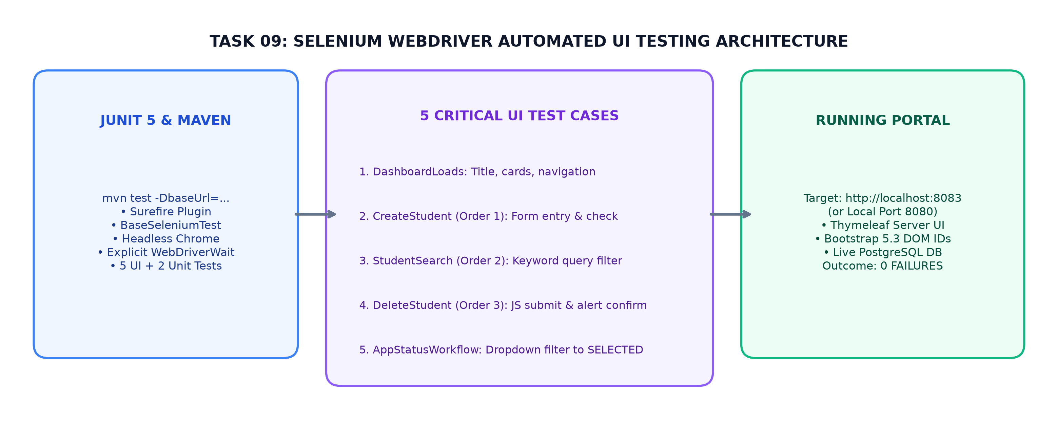
Figure 9.1: Selenium Automated E2E Testing Architecture — Test Harness, 5 UI Scenarios, and Target Portal on Port 8083
4. The Five Selenium Test Cases (Verified from Code)
The five automated test cases implemented in the project are structured as follows:
Class & Method Name | Order | Journey Tested | Actions, Assertions & Test Data
DashboardSeleniumTest  .testDashboardLoads | Unordered | Dashboard UI Verification | Navigates to baseUrl + '/'. Asserts page title/header contains 'Placement Portal', asserts .card summary elements exist, and confirms nav links to Students, Companies, Drives, and Applications.
StudentSeleniumTest  .testCreateStudent | @Order(1) | Student Creation Workflow | Navigates to /students, clicks 'Add Student', enters name 'Selenium Test Student', UUID-based email, department 'Computer Engineering', CGPA '8.8'. Submits form; asserts redirected URL and verifies record exists.
StudentSeleniumTest  .testStudentSearch | @Order(2) | Student Search Filtering | Enters newly created student email into search box (name='keyword'), submits search form. Waits for 'keyword=' in URL; asserts table contains matching record.
StudentSeleniumTest  .testDeleteStudent | @Order(3) | Student Safe Deletion | Navigates to /students?keyword=<email>, finds delete form via XPath, submits via JavaScript executor, accepts browser alert dialog, asserts student is absent from DOM.
ApplicationSeleniumTest  .testApplicationStatusWorkflow | Unordered | Application Status Filter | Navigates to /applications, locates <select name='status'>, selects 'SELECTED'. Asserts URL updates to status=SELECTED and dropdown has 'Selected' active.

5. Local Test Execution Commands and Results
Selenium tests target an actively running instance of the application. They were executed locally via Maven command line:
- Container Testing Command: mvn clean test -DbaseUrl=http://localhost:8083 (targets the Docker Compose container deployment).
- Selective Execution Command: mvn test -Dtest="*SeleniumTest" (runs only UI tests defaulting to http://localhost:8080).
Verified Test Suite Execution Evidence
Actual Test Results (Verified from surefire-reports and docs/evidence/README.md):
• Total Tests Run: 7 (2 Spring Boot context/unit tests + 5 Selenium UI tests)
• Failures: 0 | Errors: 0 | Skipped: 0
• Execution Duration: ~42 seconds
• Status: BUILD SUCCESS
• XML Reports: target/surefire-reports/TEST-com.college.placement.selenium.*.xml

6. Test Failure and Screenshot Handling
In accordance with academic integrity guidelines, the failure handling mechanism is documented honestly:
- Failure Screenshots: Automatic failure screenshot capture (e.g., via JUnit 5 TestWatcher or AWT Robot) was NOT implemented in the test codebase.
- Stack Trace Logging: When a test assertion fails, the driver throws standard Selenium exceptions (e.g., NoSuchElementException, TimeoutException), which are recorded with complete JVM stack traces in target/surefire-reports/ XML logs and printed to the terminal console.
7. Conclusion
Task 09 established a robust, deterministic automated browser testing suite. By executing 5 critical UI tests against live application endpoints, the project verified that navigation, student CRUD, keyword search, and application status workflows operate reliably without UI regressions.
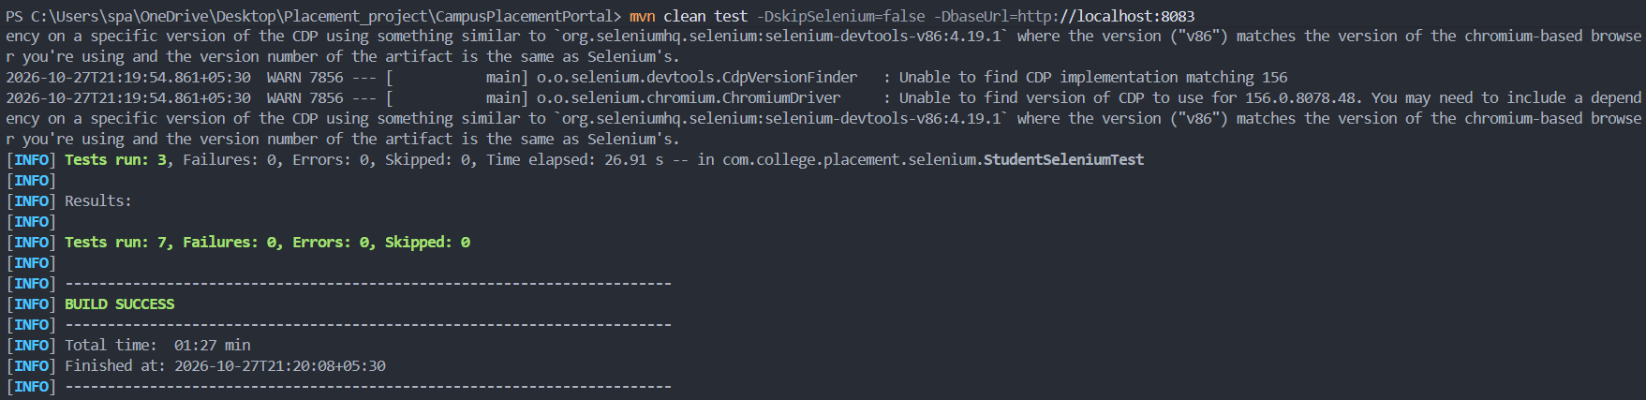
Terminal Test Results - Terminal showing 'Tests run: 7, Failures: 0, Errors: 0, Skipped: 0' and 'BUILD SUCCESS'.

