DEVOPS-ENABLED CAMPUS PLACEMENT TRACKING PORTAL — TASK REPORT
TASK 10: CONTINUOUS TESTING IN JENKINS
Student Name: Aarti Sakpal | Roll Number: 23102A0007
Course / Project: DevOps-Enabled Placement Portal | Target Release: release/final-v1.0.0 (v1.0.0)
GitHub Repository: https://github.com/AARTI756/CampusPlacementPortal | Evaluation Branch: release/final-v1.0.0
Task Objective: Implement automated continuous testing in Jenkins using Jenkinsfile-Continuous-Testing, establishing a quality gate that executes unit and Selenium UI tests and publishes JUnit reports.
1. Objective of Continuous Testing and Quality Gates
Continuous Testing integrates automated test suites directly into the CI/CD pipeline, transforming tests from an isolated manual verification step into an automated quality gate. In a mature DevOps workflow, no build artifact can progress to staging or production unless all backend unit tests and end-to-end UI tests pass with zero failures. A test failure immediately halts pipeline execution, preventing defective code from impacting downstream environments.
2. Pipeline Configuration: Jenkinsfile-Continuous-Testing
Task 10 established a dedicated testing pipeline using Jenkinsfile-Continuous-Testing, stored in the repository root and executed on branch feature/continuous-testing:
- Jenkins Job Name: CampusPlacementPortal-Continuous-Testing (Pipeline from SCM).
- Jenkins Server URL: http://localhost:8081.
- SCM Repository: https://github.com/AARTI756/CampusPlacementPortal.git on branch */feature/continuous-testing.
- Environment & Tools: TEST_PORT = '8080', JAR_NAME = 'placement-portal-0.0.1-SNAPSHOT.jar', Maven tool 'Maven-3.9.16'.
The pipeline executes five sequential stages followed by guaranteed cleanup and report publishing:
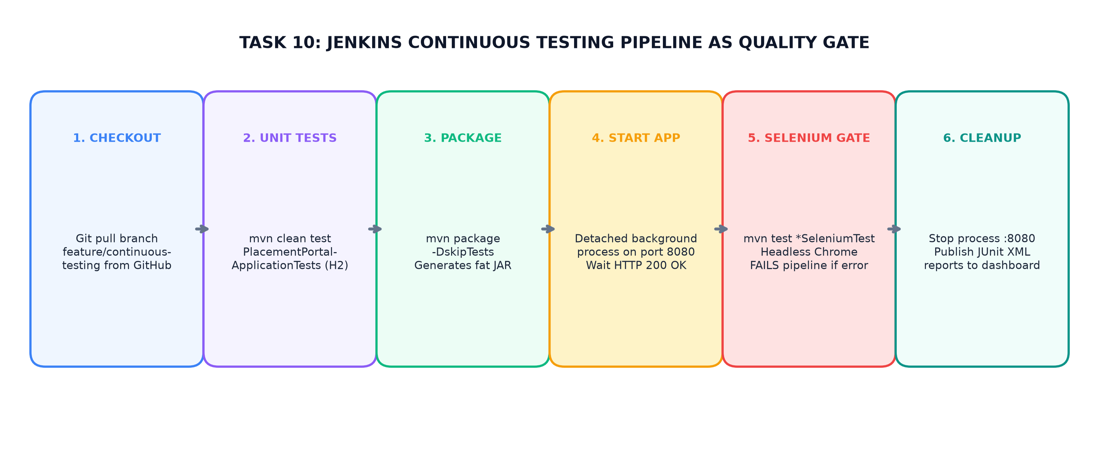
Figure 10.1: Continuous Testing Pipeline as Quality Gate — Unit Tests, App Startup, Selenium UI Gate, and JUnit Publishing
3. Stage-by-Stage Pipeline Workflow
The pipeline stages execute in strict order to enforce the quality gate:
Stage Name | Commands Executed | Operational Validation Action
1. Checkout | checkout scmGit(...) | Pulls latest commits from feature/continuous-testing branch.
2. Maven Unit Tests | bat 'mvn clean test -Dtest="PlacementPortalApplicationTests"' | Runs backend JPA reset and Spring context tests against H2 in-memory DB. Fails pipeline immediately if unit test fails.
3. Build & Package | bat 'mvn package -DskipTests' | Compiles sources and packages executable JAR placement-portal-0.0.1-SNAPSHOT.jar in target/.
4. Start Application | PowerShell Stop-Process :8080  Start-Process java -jar :8080  Invoke-WebRequest loop (max 24x) | Clears port 8080, launches application as detached background process with -Duser.timezone=UTC, and polls HTTP 200 health until live.
5. Selenium UI Tests | bat 'mvn test -Dtest="*SeleniumTest" "-DbaseUrl=http://localhost:8080"' | Executes all 5 Selenium test cases in Headless Chrome. Acts as the final quality gate prior to deployment.
Post / Cleanup | PowerShell Stop-Process :8080  junit 'target/surefire-reports/*.xml' | Always terminates background process on port 8080; parses and publishes JUnit XML test metrics to Jenkins dashboard.

4. Quality Gate Enforcement and Test Report Publishing
The pipeline enforces quality through two critical mechanisms:
- Pipeline Halt on Failure: Because Jenkins declarative pipelines abort execution upon any non-zero exit code, a failure in either the 'Maven Unit Tests' or 'Selenium UI Tests' stage immediately terminates the build with FAILURE status, preventing subsequent deployment stages from executing.
- JUnit Test Publishing: The post { always { junit 'target/surefire-reports/*.xml' } } block guarantees that Surefire test XML files are parsed and published to the Jenkins UI, generating visual trend graphs showing test count, pass/fail ratios, and execution durations.
5. Genuine Git Evidence on Defects vs. Fabricated Failures
In accordance with strict anti-fabrication guidelines, the project's real defect and resolution history is documented:
- No Fabricated Defect: No artificial failure was deliberately introduced or fabricated into the repository code.
- Real-World Defects Resolved: Genuine environment and driver compatibility issues occurred during Task 10 implementation and were committed to Git:
- • Commit 46fa520: Upgraded Selenium dependency to 4.19.1 in pom.xml to resolve Chrome 154 CDP (Chrome DevTools Protocol) communication incompatibilities under Jenkins service execution.
- • Commits 34ad83a & 3c42ed3: Resolved PowerShell argument parsing issues for the JVM timezone flag (-Duser.timezone=UTC) during detached process launch.
- • Final Task 10 Commit c823756: Following these fixes, the pipeline achieved clean, repeatable SUCCESS with all 7 tests passing.
6. Conclusion
Task 10 established an automated Continuous Testing quality gate in Jenkins. Automating unit tests, application startup, headless Selenium UI execution, and JUnit report publishing ensured that regressions are caught automatically before deployment.
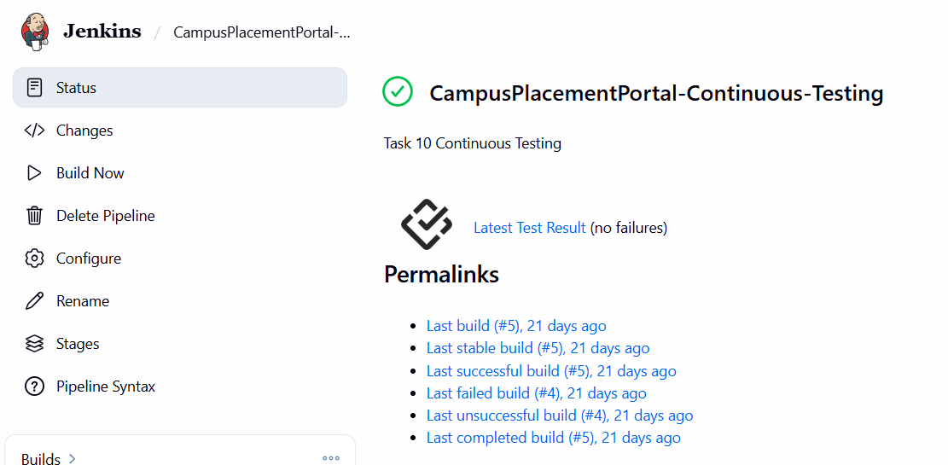
Jenkins Continuous Testing Stage View - Stage View showing all stages green: Checkout, Unit Tests, Package, Start App, and Selenium Tests.

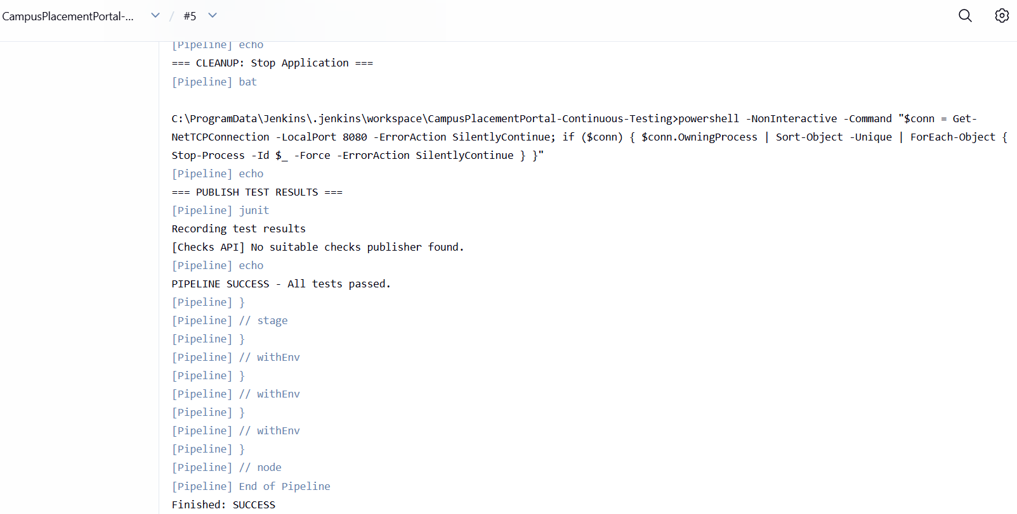
Jenkins Test Result Trend

