DEVOPS-ENABLED CAMPUS PLACEMENT TRACKING PORTAL — TASK REPORT
TASK 11: DOCKER IMAGE AND CONTAINER LIFECYCLE
Student Name: Aarti Sakpal | Roll Number: 23102A0007
Course / Project: DevOps-Enabled Placement Portal | Target Release: release/final-v1.0.0 (v1.0.0)
GitHub Repository: https://github.com/AARTI756/CampusPlacementPortal | Evaluation Branch: release/final-v1.0.0
Task Objective: Containerize the placement portal using a production-grade multi-stage Dockerfile, orchestrate services with Docker Compose, and validate container lifecycle commands and volume persistence.
1. Objective of Containerization
Containerization packages application code, runtime dependencies, system libraries, and runtime configuration into lightweight, immutable container images. By isolating the application and database into containers, Docker eliminates the classic 'works on my machine' defect, ensuring complete parity between local development, CI testing, and production environments.
2. Multi-Stage Dockerfile Architecture
The application utilizes a two-stage multi-stage Dockerfile to separate the compilation environment from the lean runtime container:
- Stage 1 (Maven Build): FROM maven:3.9.6-eclipse-temurin-17 AS build. Sets /app as working directory, copies pom.xml, caches dependencies via mvn dependency:go-offline -B, copies src/, and compiles the executable JAR via mvn clean package -DskipTests.
- Stage 2 (Alpine JRE Runtime): FROM eclipse-temurin:17-jre-alpine. Uses a lightweight Alpine JRE base (~280 MB vs ~800 MB for full JDK). Copies only the finished JAR from the build stage (COPY --from=build /app/target/placement-portal-0.0.1-SNAPSHOT.jar app.jar), exposes port 8080, and specifies ENTRYPOINT ["java", "-Duser.timezone=UTC", "-jar", "app.jar"].
3. Docker Compose Multi-Container Orchestration
The container stack is coordinated using docker-compose.yml, defining two interconnected services:
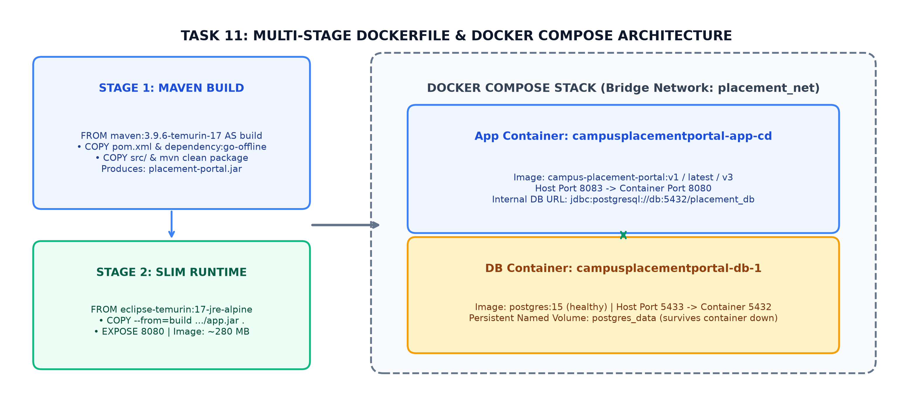
Figure 11.1: Multi-Stage Dockerfile, Docker Compose Services, Bridge Network, and Persistent Volume Architecture
Service attributes defined in docker-compose.yml:
Compose Service | Image & Container Name | Port Mapping | Network & Volume Configuration
db | postgres:15  campusplacementportal-db-1 | Host 5433 -> Container 5432 | Attached to placement_net bridge network. Persistent volume postgres_data mapped to /var/lib/postgresql/data. Healthcheck: pg_isready.
app | campus-placement-portal:v1 (latest)  campusplacementportal-app-cd | Host 8083 -> Container 8080 | Attached to placement_net. Depends on db (condition: service_healthy). Internal DB URL: jdbc:postgresql://db:5432/placement_db.

4. Container Lifecycle Commands Demonstrated
The complete container lifecycle was exercised and verified using standard Docker CLI commands:
Lifecycle Action | Exact Docker Command | Operational Verification
Build Image | docker build -t campus-placement-portal:v1 -t campus-placement-portal:latest . | Compiles multi-stage Dockerfile and tags local image v1 and latest.
List Images | docker images campus-placement-portal | Displays image ID, tags (v1, latest), creation date, and size (~280 MB).
Start Stack | docker compose -p campusplacementportal up -d | Spins up db and app containers in background on network placement_net.
Inspect Status | docker ps --filter "name=campusplacementportal" | Shows app container on 0.0.0.0:8083->8080 and db container healthy on 5433.
View Logs | docker logs campusplacementportal-app-cd | Inspects Spring Boot startup log: confirms database connection established.
Stop / Start | docker compose -p campusplacementportal stop / start | Gracefully pauses and resumes containers without recreating them.
Teardown (Safe) | docker compose -p campusplacementportal down | Stops and removes containers and network while preserving postgres_data volume.
Teardown (Purge) | docker compose -p campusplacementportal down -v | Destructive cleanup removing containers, network, and database volume.

5. Database Persistence Verification
Data durability was verified by creating candidate records, executing docker compose down (destroying both containers and network), and restarting via docker compose up -d. Upon reloading http://localhost:8083/students, all student records remained completely intact, proving that postgres_data volume successfully decouples data from container lifecycles.
6. Image Version Evolution & Registry Status
The evolution of image tags across the project and registry status are noted honestly:
- Image Tag Evolution: Task 11 established campus-placement-portal:v1; Task 12 introduced v2 during automated CD; Task 15 established v3 as the final release image.
- Registry Status (Local Only): Images exist strictly within the local host Docker daemon. Publishing to remote registries (such as Docker Hub or AWS ECR) was not configured to prevent public credential exposure and network latency during college laboratory evaluation.
7. Conclusion
Task 11 delivered a production-ready containerized deployment using a slim multi-stage Dockerfile, isolated bridge networking, healthchecked dependencies, and persistent PostgreSQL storage.

