DEVOPS-ENABLED CAMPUS PLACEMENT TRACKING PORTAL — TASK REPORT
TASK 12: JENKINS-DOCKER CONTINUOUS DEPLOYMENT
Student Name: Aarti Sakpal | Roll Number: 23102A0007
Course / Project: DevOps-Enabled Placement Portal | Target Release: release/final-v1.0.0 (v1.0.0)
GitHub Repository: https://github.com/AARTI756/CampusPlacementPortal | Evaluation Branch: release/final-v1.0.0
Task Objective: Implement an automated continuous deployment pipeline in Jenkins using Jenkinsfile-Docker-CD to build versioned Docker images, deploy containers to port 8083, and verify HTTP health.
1. Objective of Automated Docker Continuous Deployment
Continuous Deployment (CD) automates the delivery of thoroughly tested code into runtime environments without manual intervention. By combining Jenkins automation with Docker containerization, every successful commit to the deployment branch triggers automated testing, packages a newly tagged container image, redeploys the application container, and validates HTTP health, achieving seamless and reproducible software delivery.
2. Pipeline Configuration: Jenkinsfile-Docker-CD
Task 12 established the continuous deployment pipeline using Jenkinsfile-Docker-CD:
- Jenkins Job Name: CampusPlacementPortal-Docker-CD (Pipeline from SCM).
- Jenkins Server URL: http://localhost:8081.
- Monitored Branch: https://github.com/AARTI756/CampusPlacementPortal.git on branch feature/jenkins-docker-cd.
- Docker Image Tags: campus-placement-portal:v2 and campus-placement-portal:latest.
- Target Container: campusplacementportal-app-cd on host port 8083 -> container port 8080.
The automated deployment lifecycle is visualized below:
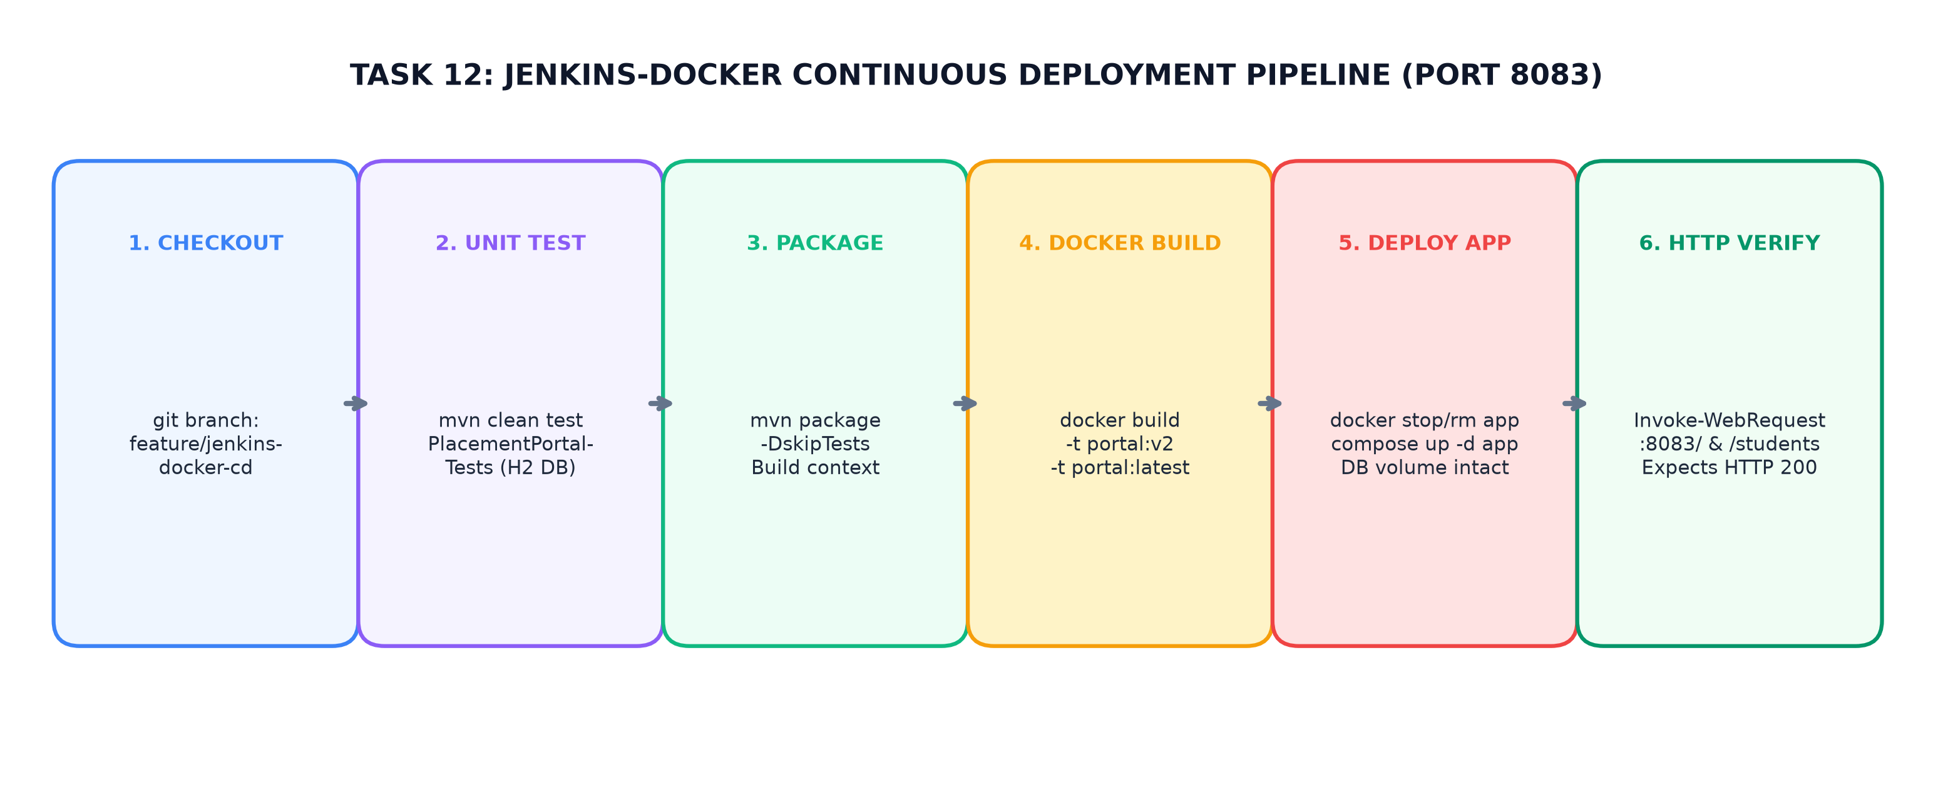
Figure 12.1: Jenkins-Docker CD Pipeline — Unit Test, Package, Docker Build v2, Compose Deployment, and Health Verification
3. Stage-by-Stage CD Pipeline Execution
The seven pipeline stages defined in Jenkinsfile-Docker-CD execute sequentially:
Pipeline Stage | Script / Command Executed | Operational Action & Validation
1. Checkout | git branch: 'feature/jenkins-docker-cd' | Pulls latest commits from feature/jenkins-docker-cd branch.
2. Unit Test | bat 'mvn clean test -Dtest="..."' | Runs backend unit tests; immediately fails pipeline if any test fails.
3. Package | bat 'mvn package -DskipTests' | Produces fresh application fat JAR for the Docker build context.
4. Docker Build | bat 'docker build -t ...:v2 -t ...:latest .' | Compiles multi-stage Dockerfile into versioned image :v2 and updates :latest.
5. Docker Deployment | bat 'docker stop/rm app-cd'  bat 'docker compose ... up -d app' | Stops and removes old app container; deploys new container via Compose while preserving PostgreSQL container and volume.
6. Health Verify | PowerShell Invoke-WebRequest  :8083/ and :8083/students (Status 200) | Waits 15s; probes dashboard and students endpoints; fails build if status != 200.
7. Docker Verify | bat 'docker images' & 'docker ps -a' | Executes inspection commands to record running container state in console log.

4. Container Replacement and Volume Preservation
A critical engineering capability of the CD pipeline is zero-data-loss container updates:
- Selective App Replacement: The pipeline selectively stops and removes only the application container (campusplacementportal-app-cd) using docker stop and docker rm, leaving the database container (campusplacementportal-db-1) running uninterrupted.
- Zero Data Loss: By executing docker compose -p campusplacementportal up -d app, Docker Compose attaches the newly built application container to the existing placement_net bridge network and reconnects to PostgreSQL without resetting the postgres_data volume.
5. Docker Registry Status (Explicitly Documented Limitation)
In accordance with honesty and technical accuracy guidelines, registry status is documented:
- Local Image Storage: The pipeline operates exclusively with locally tagged Docker images (campus-placement-portal:v2 and latest) on the host daemon.
- No Remote Registry Push: No remote Docker registry (such as Docker Hub, Harbor, or AWS ECR) was integrated or configured with push credentials.
- Laboratory Rationale: This design choice was deliberate for the college project to avoid exposing Docker Hub credentials in pipeline scripts and eliminate dependency on internet bandwidth during evaluation demonstrations.
6. Conclusion
Task 12 successfully established end-to-end continuous deployment. Automating unit testing, image building, container recreation, and HTTP health verification provided a fully automated, auditable CD workflow delivering tested code to port 8083.

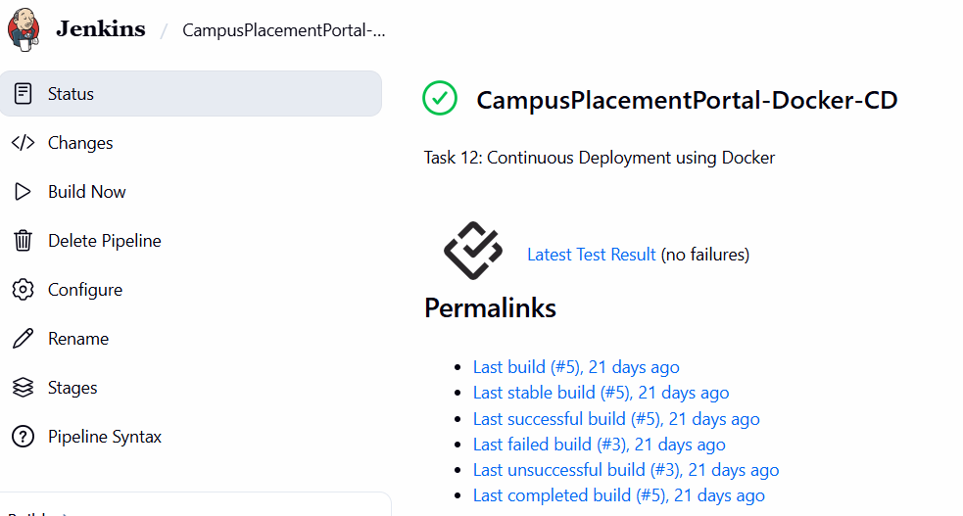
Jenkins Docker CD Stage View - Stage View showing all stages green: Checkout, Unit Test, Package, Docker Build, Deployment, and Verification.
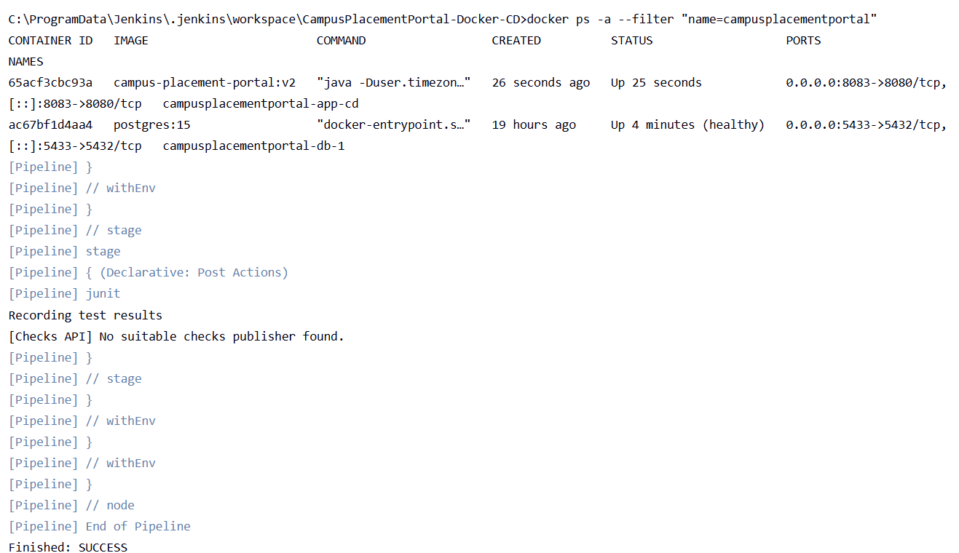
Console Output Log of CD Pipeline - Console log showing 'Dashboard OK (200)', 'Students Page OK (200)', and 'Finished: SUCCESS'.
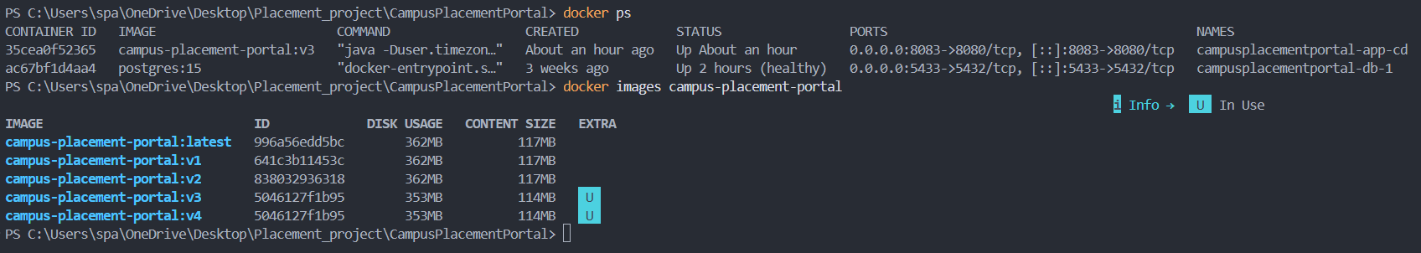
Docker Images and Container Status - Terminal output showing campusplacementportal-app-cd running on port 8083 and image tag v2.

