DEVOPS-ENABLED CAMPUS PLACEMENT TRACKING PORTAL — TASK REPORT
TASK 13: CONFIGURATION MANAGEMENT WITH ANSIBLE
Student Name: Aarti Sakpal | Roll Number: 23102A0007
Course / Project: Computer Engineering / DevOps Portal | Target Release: release/final-v1.0.0 (v1.0.0)
GitHub Repository: https://github.com/AARTI756/CampusPlacementPortal | Release Tag: v1.0.0 (Commit b74d53d)
Task Objective: Implement Infrastructure as Code using Ansible playbooks in WSL2 Ubuntu to verify, validate, and manage running Docker containers idempotently on the Windows host.
1. Objective and Importance of Configuration Management
Configuration Management (CM) enforces consistency, repeatability, and state predictability across software infrastructure. Without automated CM, multi-container deployments are prone to configuration drift, unrecorded manual interventions, and unpredictable runtime discrepancies. By codifying infrastructure verification into declarative Ansible playbooks, operational teams can audit, reproduce, and enforce desired system states reliably.
2. Rationale for Selecting Ansible
Ansible was selected for the Campus Placement Portal project based on key operational advantages:
- Agentless Architecture: Unlike Puppet or Chef, Ansible requires no custom background daemon or agent installed on target containers or hosts, minimizing operational overhead.
- Declarative YAML Syntax: Playbooks are written in declarative YAML, making system verification steps readable, reviewable in Git, and self-documenting.
- First-Class Idempotency: Native idempotency ensures that executing a playbook multiple times against an already healthy stack produces no redundant state changes (changed=0).
- WSL2 and Docker Interoperability: Ansible seamlessly executes in local connection mode (ansible_connection=local) within WSL2, interacting directly with the Windows host Docker daemon.
3. Execution Environment and Directory Structure
The configuration management environment operates across a Windows host and a WSL2 Linux guest:
- Host Platform: Windows 11 / Windows 10 Host running Docker Desktop with WSL2 backend enabled.
- Linux Guest: Ubuntu 22.04 LTS running inside WSL2.
- Ansible Version: Ansible version 2.10.8 running on Python 3.10.12 (verified via 'wsl ansible --version').
- Daemon Passthrough: Commands interact with Docker Desktop via Windows command prompt passthrough: /mnt/c/Windows/System32/cmd.exe /c "docker ...".
The verified directory layout and file responsibilities within the ansible/ folder are structured as follows:
File Path in Repository | Type / Format | Actual Responsibility and Content
ansible/inventory.ini | INI Inventory | Defines the target host group [local] containing localhost with ansible_connection=local.
ansible/group_vars/all.yml | YAML Variables | Centralizes variables: app_port: 8083, app_url, container names, db_port: 5433, image tags, and verification endpoints.
ansible/site.yml | Playbook (Task 13) | Main configuration management playbook (19 tasks) verifying Docker CLI, image presence, container states, and HTTP health.
ansible/provision.yml | Playbook (Task 14) | Automated provisioning playbook ensuring Docker Compose stack is up and running.
ansible/reliability.yml | Playbook (Task 14) | Reliability validation playbook guarding PostgreSQL state and auto-recovering stopped application containers.
ansible/README.md | Documentation | Complete execution guide detailing prerequisites, ping checks, playbook commands, and verification endpoints.

Infrastructure Scope Boundary
Verified Configuration Scope:
• No separate ansible.cfg file was required; the default Ansible installation in WSL2 was used.
• Target Host: The playbooks target localhost via local connection mode. In accordance with honesty principles, Ansible did NOT manage remote cloud Linux servers over SSH.

4. Ansible Configuration Architecture
The interaction between WSL2 Ubuntu, Windows Docker daemon, and application endpoints is illustrated below:
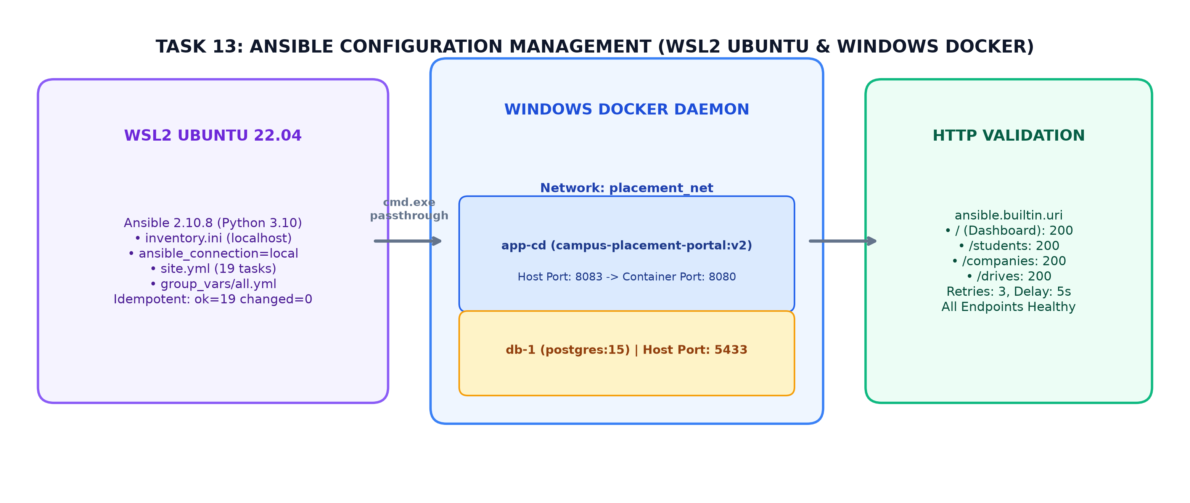
Figure 13.1: Ansible Configuration Management Architecture — WSL2 Ubuntu, Windows Docker Passthrough, and HTTP Validation
5. Playbook Structure and Tasks in site.yml
The main playbook ansible/site.yml executes 19 structured tasks organized into 6 functional sections:
- Section 1 (Environment Verification): Verifies Docker CLI availability via cmd.exe, registers version output, and lists active running containers.
- Section 2 (Image Inspection): Executes 'docker image inspect campus-placement-portal:v2', asserting image presence prior to verification.
- Section 3 (Database Verification): Filters for running PostgreSQL container (campusplacementportal-db-1); triggers 'docker start' only if stopped.
- Section 4 (Application Container): Inspects application container (campusplacementportal-app-cd); starts container if stopped, otherwise reports 'no change required'.
- Section 5 (HTTP Validation): Uses ansible.builtin.uri to execute HTTP GET requests against http://localhost:8083/ (Dashboard), /students, /companies, and /drives, asserting HTTP 200 with 3 retries and 5-second delays.
- Section 6 (Summary Report): Outputs a formatted ASCII status table confirming health across all containers and endpoints.
6. Idempotency and Verified Execution Results
Idempotency was verified through repeated sequential executions against the running Docker stack:
- Execution Command: wsl ansible-playbook -i ansible/inventory.ini ansible/site.yml
- Run 1 Result: Run 1 (Initial validation on running stack): localhost : ok=19 changed=0 unreachable=0 failed=0 skipped=2.
- Run 2 Result (Idempotency): Run 2 (Repeat execution without modifications): localhost : ok=19 changed=0 unreachable=0 failed=0 skipped=2.
Because the running containers and endpoints already satisfied the desired configuration state, Ansible correctly introduced zero modifications (changed=0), proving absolute idempotency.
7. Conclusion
Task 13 established automated configuration management using Ansible in WSL2. Codifying environment checks, container lifecycle verification, and HTTP health probes into version-controlled YAML playbooks eliminated manual verification and guaranteed repeatable deployments.

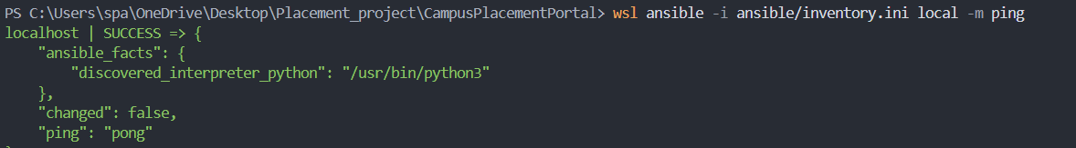
Ansible Ping Verification - Terminal output showing 'localhost | SUCCESS => {"ping": "pong"}'.
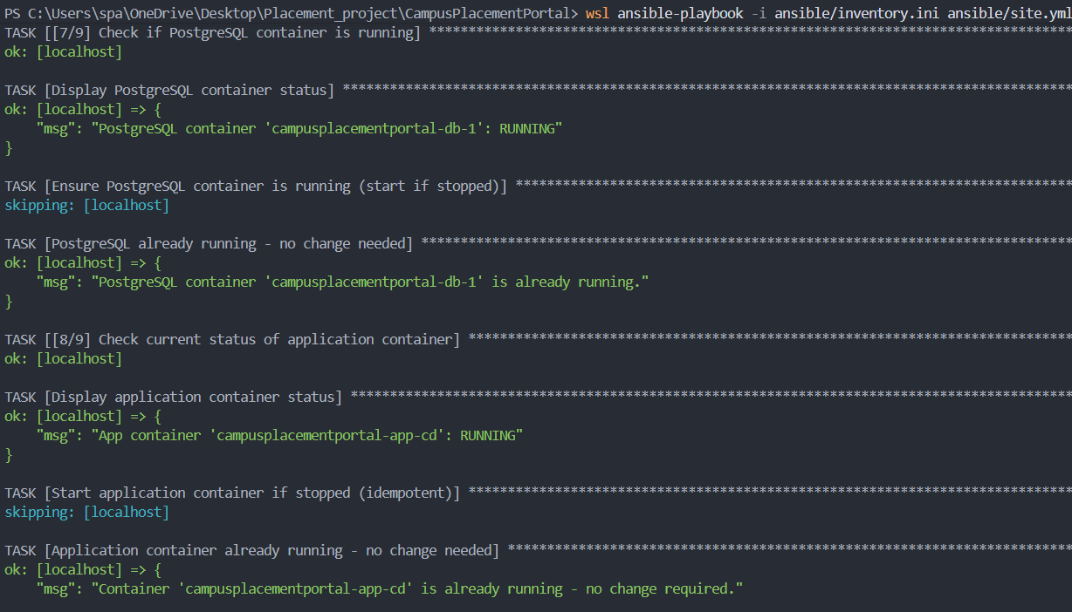
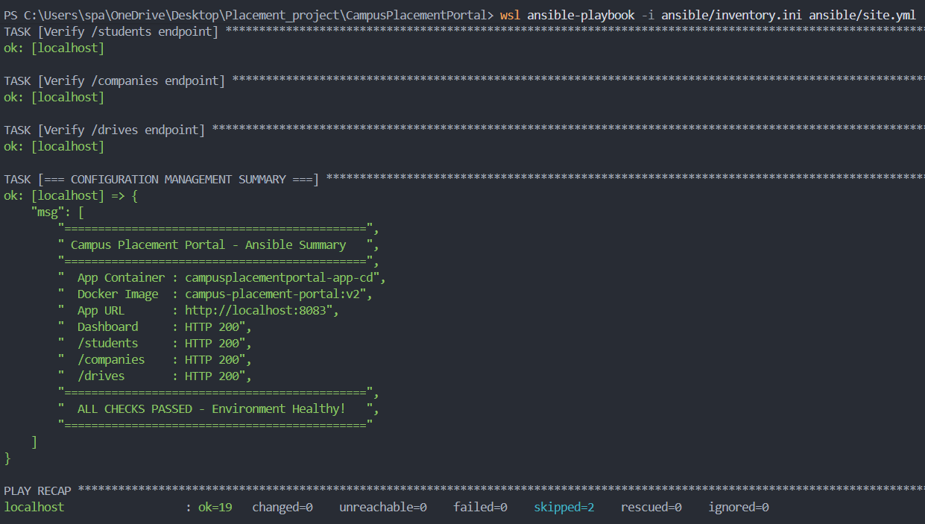
site.yml Playbook Execution - Terminal showing 19 tasks passing and Play Recap: 'ok=19 changed=0 failed=0'.

