DEVOPS-ENABLED CAMPUS PLACEMENT TRACKING PORTAL — TASK REPORT
TASK 14: AUTOMATED PROVISIONING AND RECOVERY
Student Name: Aarti Sakpal | Roll Number: 23102A0007
Course / Project: Computer Engineering / DevOps Portal | Target Release: release/final-v1.0.0 (v1.0.0)
GitHub Repository: https://github.com/AARTI756/CampusPlacementPortal | Release Tag: v1.0.0 (Commit b74d53d)
Task Objective: Implement automated infrastructure provisioning and self-recovery validation using Ansible playbooks, verifying idempotency, container recovery, database guards, and HTTP health checks.
1. Objective of Automated Provisioning and Reliability Validation
Automated provisioning ensures that complete application stacks can be instantiated repeatably from cold states using codified scripts. In production environments, systems must additionally exhibit high reliability by continuously monitoring operational health, guarding persistent data stores, and automatically recovering from transient service outages without manual administrator intervention.
2. Implementation of Provisioning and Reliability Playbooks
Task 14 implemented two dedicated Ansible playbooks in the repository's ansible/ directory:
- 1. ansible/provision.yml (Automated Provisioning): Executes 'docker compose -p campusplacementportal up -d' via cmd.exe. Inspects stdout/stderr using changed_when conditions for keywords ('Started', 'Created', 'Recreated') to accurately report whether infrastructure changes occurred.
- 2. ansible/reliability.yml (Reliability & Recovery): Validates multi-tier container health, enforces database guard conditions, auto-recovers stopped application containers, and executes HTTP health check polling with retries.
The automated self-recovery lifecycle implemented in reliability.yml is illustrated below:
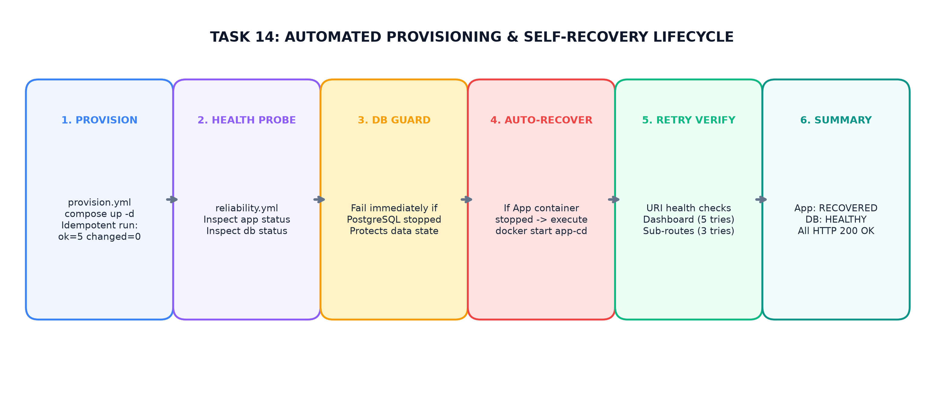
Figure 14.1: Automated Provisioning & Self-Recovery Workflow — Health Probing, Database Guard, Auto-Restart, and Retried HTTP Verification
3. Health Check Logic and Retried Polling
Health monitoring in reliability.yml combines container-level process inspections with retried HTTP endpoint verification:
- Container Process Health: Inspects running container IDs using 'docker ps -q --filter name=... --filter status=running'.
- Dashboard Health Check: Probes http://localhost:8083/ using ansible.builtin.uri expecting HTTP status 200, configured with retries: 5, delay: 5 (allowing up to 25 seconds for Spring Boot JVM initialization).
- Sub-Route Probing: Probes /students, /companies, and /drives with retries: 3, delay: 5, ensuring that Spring MVC controllers and Hibernate ORM mappings respond correctly.
4. Failure Scenarios and Implemented Recovery Mechanisms
The project evaluated two critical failure scenarios, establishing distinct recovery and guard behaviors:
Reliability Feature | Implementation in Playbook | Verified Evidence / Status
Docker CLI Verification | Checks /mnt/c/.../cmd.exe /c 'docker --version'. Fails if Docker Desktop is stopped. | Verified: rc=0, Docker version output displayed in console.
PostgreSQL Database Guard | Inspects db_running_id. If empty, executes ansible.builtin.fail immediately. | Implemented: Halts playbook to prevent starting app against an unavailable database.
Application Self-Recovery | If app_running_id is empty, triggers 'docker start {{ app_container_name }}' (changed=1). | Verified: Successfully restarted stopped container; changed=1 recorded.
Retried HTTP Health Checks | ansible.builtin.uri on / with retries: 5 and delay: 5s until status == 200. | Verified: Waited through container startup; confirmed HTTP 200.
Zero-Data-Loss Persistence | Recovery uses 'docker start' which attaches to existing postgres_data volume. | Verified: All candidate records intact after container recovery.
Idempotent Provisioning | provision.yml executes compose up -d; reports changed=0 when already up. | Verified: ok=5 changed=0 recorded when services idle.

Engineering Verification Boundary
Distinction Between Implemented Recovery and Planned Outage Scenarios:
• Implemented and Tested: Automated container self-recovery when the application container was intentionally stopped ('docker stop campusplacementportal-app-cd'). The reliability playbook detected the stopped process, executed 'docker start', polled HTTP health, and reported 'App Container: RECOVERED'.
• Not Implemented / Planned: Automated database replication failover, multi-node cluster failover, and automated rollback to earlier Docker image versions upon application runtime errors were not implemented.

5. Actual Test Evidence (Recorded in docs/evidence/README.md)
The repository's evidence log confirms four verified Ansible test runs on 2026-10-10:
- 1. provision.yml Idle Run: localhost : ok=5 changed=0 unreachable=0 failed=0 skipped=0 (Services already running; no modifications made).
- 2. provision.yml Recovery Run: localhost : ok=5 changed=1 unreachable=0 failed=0 skipped=0 (App container was stopped; Compose started service).
- 3. reliability.yml Healthy Run: localhost : ok=9 changed=0 unreachable=0 failed=0 skipped=2 (All services healthy; no recovery needed).
- 4. reliability.yml Auto-Recovery Run: localhost : ok=10 changed=1 unreachable=0 failed=0 skipped=1 (App container stopped; playbook recovered container, waited for JVM boot, and verified all 4 endpoints HTTP 200 OK).
6. Limitations and Future Improvements
Identified limitations of the current reliability architecture include:
- Trigger Dependency: Recovery depends on manually invoking the Ansible playbook or scheduling cron jobs; autonomous orchestrators like Kubernetes offer native self-healing liveness probes.
- Database Self-Healing: If PostgreSQL crashes, the playbook halts safely but does not attempt automatic recovery from backup snapshots.
7. Conclusion
Task 14 proved that infrastructure provisioning and recovery can be fully automated using declarative playbooks. The reliability playbook successfully detected container outages, safely guarded PostgreSQL, executed self-recovery, and confirmed complete endpoint availability with zero data loss.

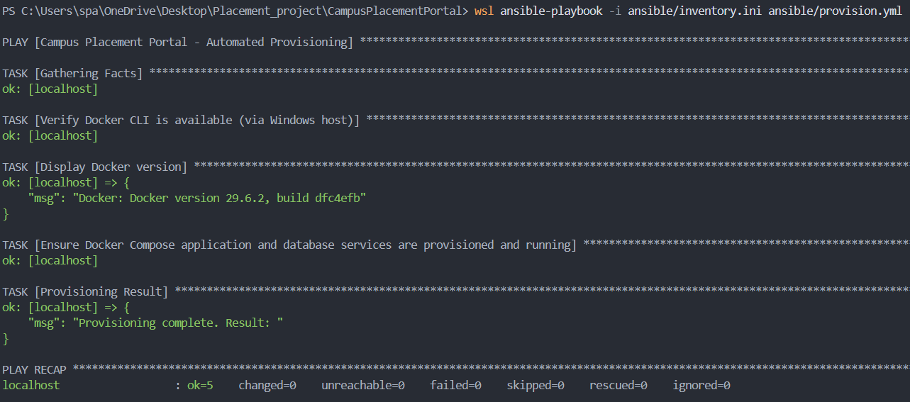
Ansible Provisioning Idempotency - Terminal showing Play Recap: 'ok=5 changed=0 failed=0' on idle stack.

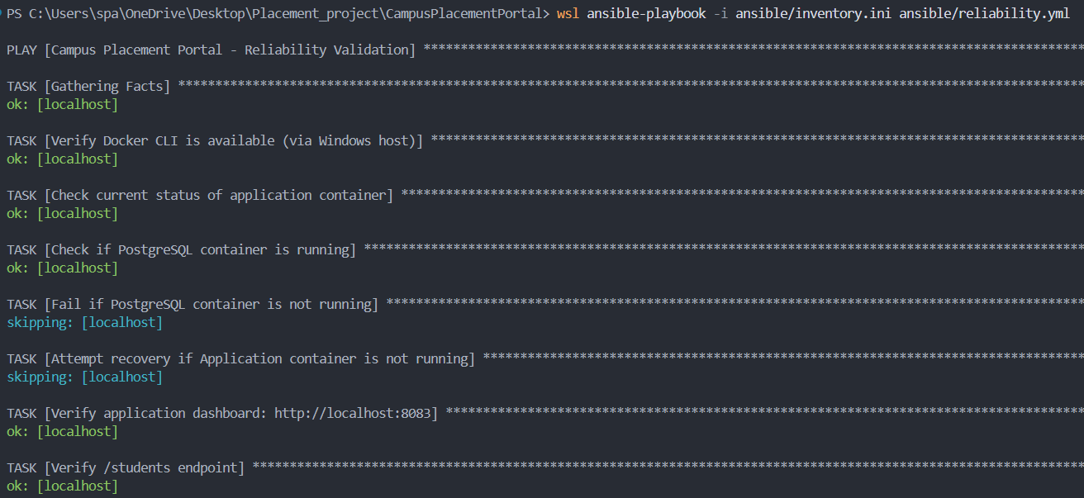
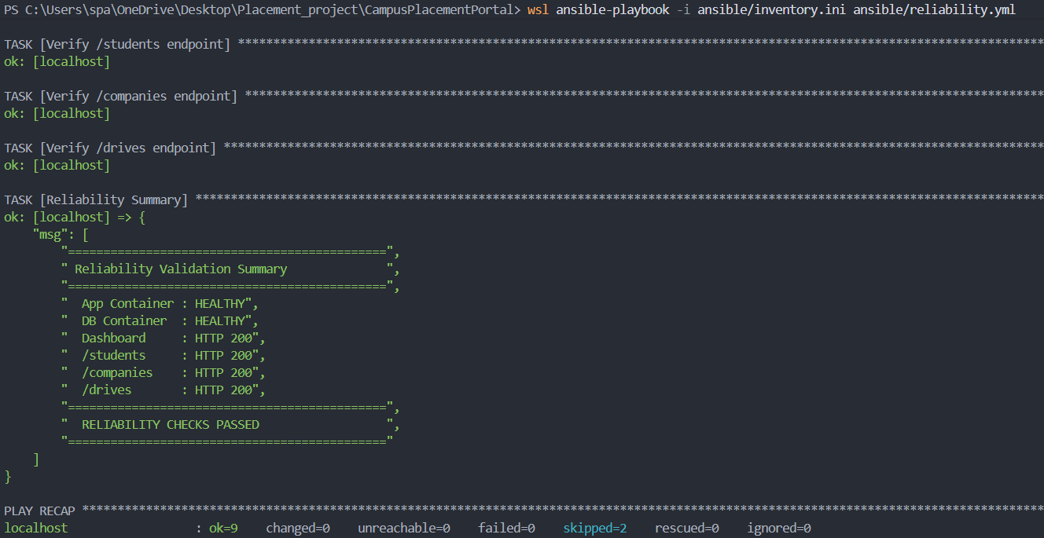
Reliability Auto-Recovery Run - Terminal showing task 'Attempt recovery...' with changed=1 and Play Recap 'ok=10 changed=1'.

