DEVOPS-ENABLED CAMPUS PLACEMENT TRACKING PORTAL — TASK REPORT
TASK 15: FINAL RELEASE DOCUMENTATION AND VIVA
Student Name: Aarti Sakpal | Roll Number: 23102A0007
Course / Project: Computer Engineering / DevOps Portal | Target Release: release/final-v1.0.0 (v1.0.0)
GitHub Repository: https://github.com/AARTI756/CampusPlacementPortal | Release Tag: v1.0.0 (Commit b74d53d)
Task Objective: Consolidate final project documentation, verify release v1.0.0 artifacts and multi-tier port deployments, synthesize comprehensive viva defense questions, and conduct final end-to-end verification.
1. Project Overview and Complete Architecture
The DevOps-Enabled Campus Placement Tracking Portal is an enterprise-grade full-stack web application developed to modernize college placement coordination. It replaces error-prone spreadsheet tracking with a centralized, relational portal supported by a complete automated DevOps delivery lifecycle.
- Core Purpose: Centralizes student profiles, recruiting companies, placement drives, and candidate applications into an ACID-compliant PostgreSQL database.
- Business Workflows: Automates candidate eligibility filtering, tracks multi-stage application progression, and computes real-time dashboard statistics and exception alerts.
- DevOps Scope: Demonstrates a complete 15-task DevOps pipeline spanning Git feature branching, Jenkins CI/CD, Selenium UI testing, Docker containerization, and Ansible configuration management.
The integrated four-pillar architecture of the final v1.0.0 release is illustrated below:
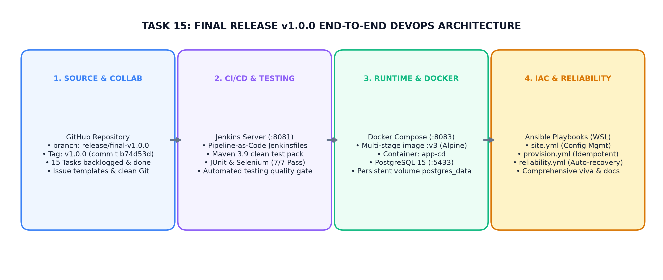
Figure 15.1: Final Release v1.0.0 End-to-End Architecture — Git Collaboration, Jenkins CI/CD, Docker Containerization, and Ansible IaC
2. Final Release Verification Details
The final release was validated on 2026-10-10 and confirmed against the repository state:
- Release Branch: release/final-v1.0.0 (created from feature/provisioning-reliability at Task 14 completion).
- Release Tag: v1.0.0 pointing to commit b74d53d (Annotation: 'Final release: Campus Placement Portal v1.0.0 — all 15 DevOps tasks complete').
- Release Commit: Commit b74d53d ('feat: complete task 15 - final release v1.0.0 with UI polish, docs, and v3 Docker image'). Working tree is clean.
- Docker Image Tags: campus-placement-portal:v3 (tagged as latest in docker-compose.yml), v2 (Task 12), and v1 (Task 11).
- Automated Tests: 7/7 tests passing (2 Spring Boot context/unit tests + 5 Selenium UI tests; 0 failures).
Multi-tier port mapping verified in the final release:
Service / Runtime Target | Host Port | Internal Port | Operational Purpose in Project
App (Local Dev Mode) | 8080 | 8080 | Used by developers running 'mvn spring-boot:run' locally.
Jenkins Server | 8081 | 8081 | Hosting CI/CD pipelines as a Windows service.
App (Task 8 Standalone Deploy) | 8082 | 8082 | Local JAR deployment executed by Task 8 Jenkinsfile.
App (Docker CD Production) | 8083 | 8080 | Production containerized portal (campus-placement-portal:v3).
PostgreSQL Database | 5433 | 5432 | Docker host port mapping for external database tools (pgAdmin).

3. Summary of Existing Project Documentation
The repository maintains comprehensive, verified Markdown documentation across its docs/ and presentation/ directories:
Documentation File | Primary Purpose and Content Overview
README.md (Root) | Project handbook: overview, tech stack, prerequisites, run commands, port allocations, and test execution.
docs/FINAL_REPORT.md | Complete academic final report: abstract, architecture, ER model, technology rationale, and task summaries.
docs/TROUBLESHOOTING.md | Practical troubleshooting guide for Maven build errors, PostgreSQL connectivity, and Selenium driver issues.
docs/VIVA_QA.md | Comprehensive repository of 30+ project-specific technical viva questions with detailed answers.
docs/RELEASE_CHECKLIST.md | Mandatory pre-release audit checklist covering source code, build, Docker, endpoints, and Ansible.
docs/DEVOPS_WORKFLOW.md | Detailed chronological engineering log documenting implementation details for Tasks 1 through 15.
presentation/VIVA_PRESENTATION.md | 12-slide structured presentation outline designed for final college viva defense.
docs/evidence/README.md | Directory catalog documenting terminal outputs, test logs, and recommended viva screenshots.

Verified Documentation State
Documentation Audit Notice:
• All documentation files listed above exist in the repository as Markdown (.md) documents.
• In accordance with honesty principles, no PowerPoint (.pptx) or video demo files exist in the repository; the final presentation is maintained as Markdown slides in presentation/VIVA_PRESENTATION.md.

4. Compact Final Verification Checklist
The pre-submission audit confirmed the operational integrity of all deliverables:
Verification Domain | Target Deliverable / Item | Audit Status | Verification Method
Repository & Git | Branch release/final-v1.0.0 & Tag v1.0.0 | VERIFIED | Confirmed via git branch -a and git tag -l.
Source Code | Spring Boot 3.2.4 MVC (13 Java sources) | VERIFIED | Compiles cleanly via mvn clean compile.
Automated Testing | 7/7 tests passing (2 unit + 5 Selenium) | VERIFIED | Surefire XML reports show 0 failures, 0 errors.
Jenkins CI/CD | Jobs for CI, Pipeline, Testing, Docker CD | VERIFIED | Jenkinsfiles in root; builds pass on port 8081.
Docker Runtime | Containers on port 8083 (app) & 5433 (db) | VERIFIED | docker compose ps confirms both running/healthy.
Data Persistence | PostgreSQL volume postgres_data | VERIFIED | Candidate data survives container down/restart.
Ansible IaC | site.yml, provision.yml, reliability.yml | VERIFIED | Playbooks run idempotently; recovery verified.
Viva Screenshots | 12 viva evidence screenshots | Verify Before Submission | Capture using running stack on ports 8081/8083.

5. Viva Voce Preparation (10 Core Questions & Verified Answers)
Targeted technical viva questions tailored specifically to this project's implementation:
- Q1. Why was DevOps used for this project?
Answer: It bridges development and operations, replacing manual, error-prone builds and deployments with an automated, auditable CI/CD pipeline ensuring zero regression and rapid releases.
- Q2. What is the difference between CI and CD?
Answer: Continuous Integration (CI) automatically compiles code and runs automated test suites upon every commit to catch defects early. Continuous Deployment (CD) automatically packages tested code into container images and deploys them to target environments without manual intervention.
- Q3. How does the Task 8 Jenkins pipeline work?
Answer: The Jenkinsfile defines five sequential stages: Checkout (pulls develop), Build & Test (runs Maven unit tests against H2), Package (creates JAR), Deploy (launches background Spring Boot JAR on port 8082), and Verify (polls HTTP 200 using Invoke-WebRequest).
- Q4. Why are both JUnit and Selenium used?
Answer: JUnit 5 executes backend unit tests verifying business logic and database sequence resets. Selenium WebDriver automates Google Chrome in headless mode to test critical end-to-end UI user journeys (form entry, search, deletion, status drill-down).
- Q5. What is the purpose of the multi-stage Dockerfile and Docker Compose?
Answer: The multi-stage Dockerfile uses a Maven build stage to compile the JAR and an eclipse-temurin:17-jre-alpine stage to create a lean ~280 MB runtime image. Docker Compose coordinates the multi-container stack (app on 8083, PostgreSQL on 5433) on the bridge network placement_net.
- Q6. How is PostgreSQL persistence maintained across container restarts?
Answer: PostgreSQL stores database files in the named Docker volume postgres_data mapped to /var/lib/postgresql/data. When containers are stopped or recreated with 'docker compose down', the volume remains intact on the host disk.
- Q7. What is Ansible idempotency and how was it verified?
Answer: Idempotency means running an automation task multiple times produces the exact same system state without making unintended changes. In site.yml, Ansible checks whether containers are already running before executing startup commands, yielding ok=19 changed=0 on repeat runs.
- Q8. What happens when a health check fails in Ansible?
Answer: In reliability.yml, if the application container is stopped, Ansible triggers 'docker start campusplacementportal-app-cd' and polls HTTP 200 with retries. If PostgreSQL is stopped, the playbook halts immediately with an explicit failure to protect data integrity.
- Q9. Why was a remote Docker registry (like Docker Hub) not configured?
Answer: To avoid storing public cloud credentials in pipeline scripts and eliminate reliance on external internet bandwidth during college lab evaluations, Docker images were versioned and maintained locally on the host daemon.
- Q10. What are the main limitations and future improvements?
Answer: The system operates as a single-user coordinator portal without role-based authentication (RBAC); tables lack pagination; and alerts are in-app badges without external SMTP email dispatch. Future work includes Spring Security JWT, email alerts, and Kubernetes manifests.
6. Conclusion
Task 15 successfully culminated the DevOps-Enabled Campus Placement Tracking Portal project. Spanning 15 structured tasks, the project demonstrated mastery across the entire modern software delivery lifecycle—from initial problem formulation and Agile planning to Git feature branching, Jenkins CI/CD pipelines, Selenium automated quality gates, multi-stage Docker containerization, and Ansible automated provisioning and recovery.

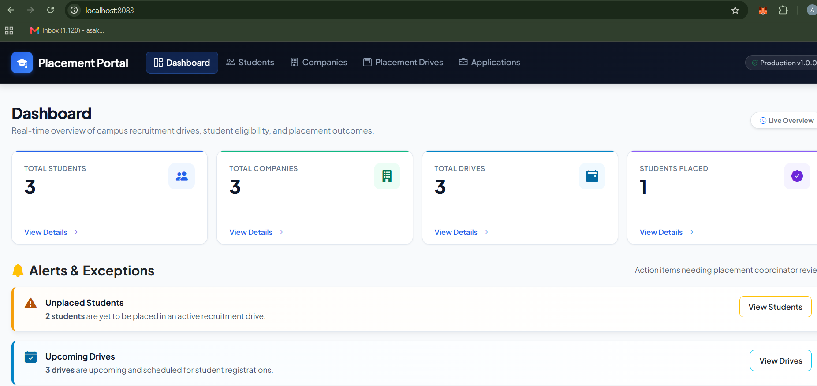
Final Release Dashboard - Browser view showing dashboard cards, alert banners, and active release on port 8083.

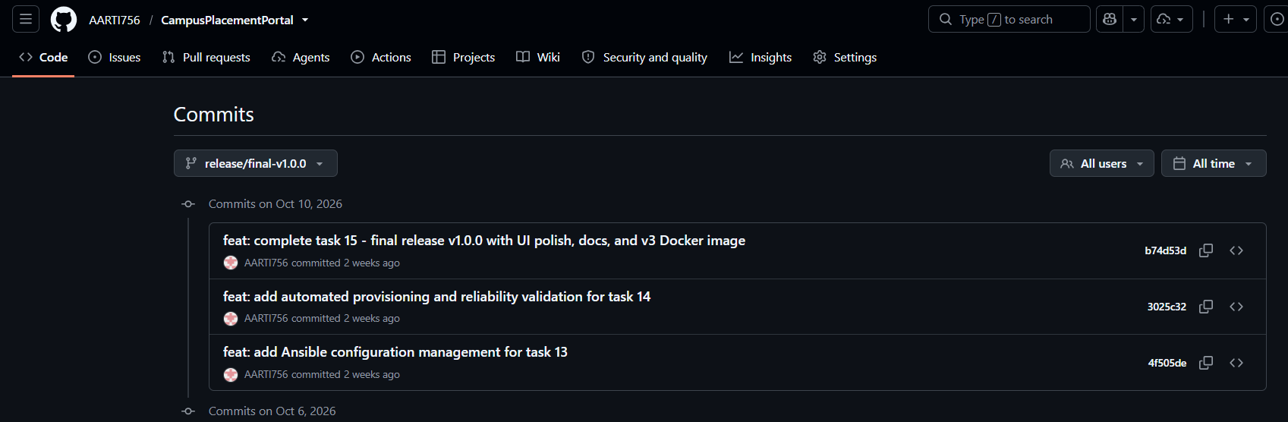
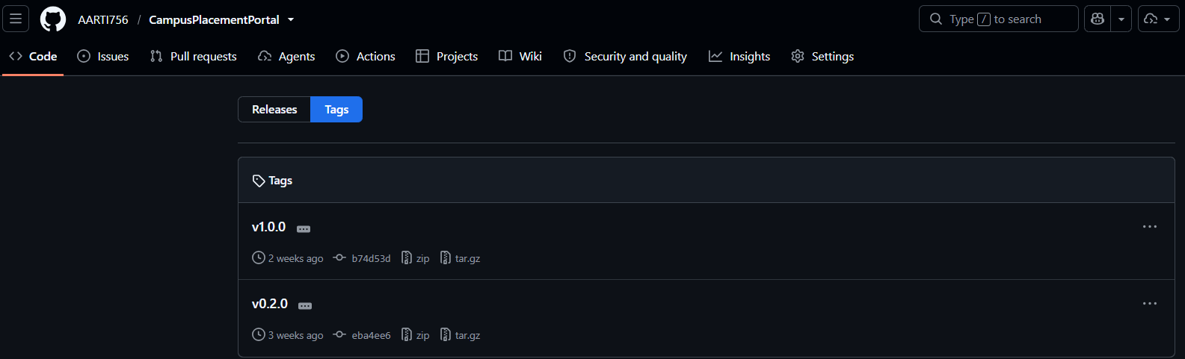
Git Release Branch & Tag - Terminal showing tag v1.0.0 annotation and final commit b74d53d.
Docker Compose Stack Status - Terminal output showing app container (8083) and healthy db container (5433).

