Kirana_Store

Database Management System

A **Kirana Store** (or grocery store) database typically refers to a structured collection of data related to the operations, sales, inventory, and customer management of a small neighborhood grocery store. Such databases are essential for managing day-to-day operations efficiently and can help in analyzing sales trends, managing stock, and understanding customer preferences.

**Overview of a Kirana Store Database**

1. **Purpose**:
   * To keep track of inventory (items available for sale).
   * To manage customer data (loyalty programs, preferences).
   * To record sales transactions.
   * To analyze sales trends and stock levels.
   * To facilitate reordering of stock based on sales patterns.
2. **Key Components**:
   * **Tables**: The database typically consists of multiple tables that store different types of data. Common tables include:
     + **Customers**: Information about customers, including names, contact details, and purchase history.
     + **Products**: Details of items sold, such as product ID, name, category, price, and stock level.
     + **Categories**: Categories of products (e.g., dairy, grains, snacks) to help organize inventory.
     + **Sales**: Records of each sale transaction, including date, customer ID, total amount, and payment method.
     + **SalesDetails**: A table that breaks down each sale into its individual products, linking to the Sales table.
3. **Relationships**:
   * **One-to-Many Relationships**: For example, one customer can have multiple sales transactions, and one sale can include multiple products.
   * **Many-to-One Relationships**: Multiple products can belong to one category.
4. **Functionality**:
   * **Inventory Management**: Track quantities of products, update stock levels after sales, and reorder low-stock items.
   * **Customer Management**: Store customer information, manage loyalty programs, and analyze purchasing behavior.
   * **Sales Analysis**: Generate reports on sales performance, identify best-selling products, and analyze seasonal trends.
   * **Reporting**: Create reports for business analysis, such as sales by category, top customers, or inventory turnover rates.
5. **Technology**:
   * The database can be built using various database management systems (DBMS) like MySQL, PostgreSQL, Microsoft SQL Server, or SQLite, depending on the scale and requirements of the store.

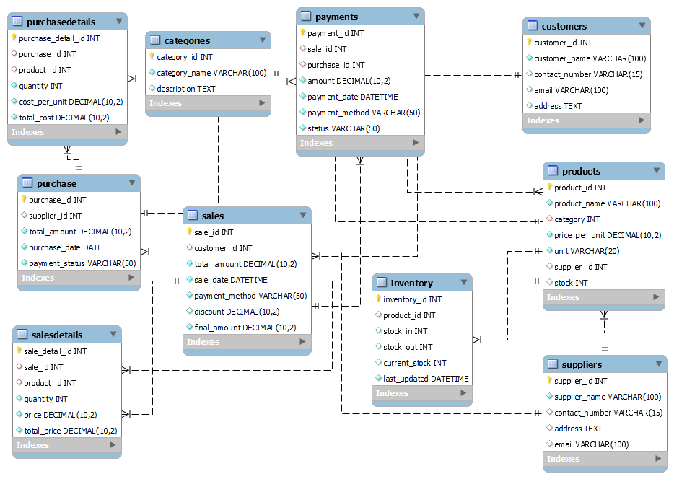**ER Diagram**

Create database **Kirana_Store**;

use **Kirana_Store**;

-- 1 Create **Categories** Table

CREATE TABLE **Categories** (

category_id INT AUTO_INCREMENT PRIMARY KEY,

category_name VARCHAR(100) NOT NULL,

description TEXT

);

-- 2 Create **Suppliers** Table

CREATE TABLE **Suppliers** (

supplier_id INT AUTO_INCREMENT PRIMARY KEY,

supplier_name VARCHAR(100) NOT NULL,

contact_number VARCHAR(15),

address TEXT,

email VARCHAR(100)

);

-- 3 Create **Products** Table

CREATE TABLE **Products** (

product_id INT AUTO_INCREMENT PRIMARY KEY,

product_name VARCHAR(100) NOT NULL,

category int,

price_per_unit DECIMAL(10, 2) NOT NULL,

unit VARCHAR(20) NOT NULL,

supplier_id INT,

stock INT DEFAULT 0,

FOREIGN KEY (category) REFERENCES Categories(category_id),

FOREIGN KEY (supplier_id) REFERENCES Suppliers(supplier_id)

);

-- 4 Create **Customers** Table

CREATE TABLE **Customers** (

customer_id INT AUTO_INCREMENT PRIMARY KEY,

customer_name VARCHAR(100) NOT NULL,

contact_number VARCHAR(15),

email VARCHAR(100),

address TEXT

);

-- 5 Create **Sales** Table

CREATE TABLE **Sales** (

sale_id INT AUTO_INCREMENT PRIMARY KEY,

customer_id INT,

total_amount DECIMAL(10, 2) NOT NULL,

sale_date DATETIME NOT NULL,

payment_method VARCHAR(50) NOT NULL,

discount DECIMAL(10, 2) DEFAULT 0,

final_amount DECIMAL(10, 2) NOT NULL,

FOREIGN KEY (customer_id) REFERENCES Customers(customer_id)

);

-- 6 Create **SalesDetails** Table

CREATE TABLE **SalesDetails** (

sale_detail_id INT AUTO_INCREMENT PRIMARY KEY,

sale_id INT,

product_id INT,

quantity INT NOT NULL,

price DECIMAL(10, 2) NOT NULL,

total_price DECIMAL(10, 2) NOT NULL,

FOREIGN KEY (sale_id) REFERENCES Sales(sale_id),

FOREIGN KEY (product_id) REFERENCES Products(product_id)

);

-- 7 Create **Inventory** Table

CREATE TABLE **Inventory** (

inventory_id INT AUTO_INCREMENT PRIMARY KEY,

product_id INT,

stock_in INT DEFAULT 0,

stock_out INT DEFAULT 0,

current_stock INT DEFAULT 0,

last_updated DATETIME NOT NULL DEFAULT CURRENT_TIMESTAMP ON UPDATE CURRENT_TIMESTAMP,

FOREIGN KEY (product_id) REFERENCES Products(product_id)

);

-- 8 Create **Purchase** Table

CREATE TABLE **Purchase** (

purchase_id INT AUTO_INCREMENT PRIMARY KEY,

supplier_id INT,

total_amount DECIMAL(10, 2) NOT NULL,

purchase_date DATE NOT NULL,

payment_status VARCHAR(50) NOT NULL,

FOREIGN KEY (supplier_id) REFERENCES Suppliers(supplier_id)

);

-- 9 Create **PurchaseDetails** Table

CREATE TABLE **PurchaseDetails** (

purchase_detail_id INT AUTO_INCREMENT PRIMARY KEY,

purchase_id INT,

product_id INT,

quantity INT NOT NULL,

cost_per_unit DECIMAL(10, 2) NOT NULL,

total_cost DECIMAL(10, 2) NOT NULL,

FOREIGN KEY (purchase_id) REFERENCES Purchase(purchase_id),

FOREIGN KEY (product_id) REFERENCES Products(product_id)

);

-- 10 Create **Payments** Table

CREATE TABLE **Payments** (

payment_id INT AUTO_INCREMENT PRIMARY KEY,

sale_id INT,

purchase_id INT,

amount DECIMAL(10, 2) NOT NULL,

payment_date DATETIME NOT NULL,

payment_method VARCHAR(50) NOT NULL,

status VARCHAR(50) NOT NULL,

FOREIGN KEY (sale_id) REFERENCES Sales(sale_id),

FOREIGN KEY (purchase_id) REFERENCES Purchase(purchase_id)

);

-- Insert Values

INSERT INTO Products (product_id, product_name, category, price_per_unit, unit, supplier_id, stock) VALUES

(1, 'Rice', 1, 50, 'kg', 1, 100),

(2, 'Sugar', 1, 45, 'kg', 2, 150),

(3, 'Milk', 2, 25, 'liter', 3, 200),

(4, 'Biscuits', 3, 10, 'piece', 4, 500),

(5, 'Tea', 4, 200, 'kg', 5, 50),

(6, 'Wheat Flour', 1, 40, 'kg', 1, 200),

(7, 'Butter', 2, 50, 'piece', 3, 120),

(8, 'Chips', 3, 20, 'packet', 4, 300),

(9, 'Green Tea', 4, 250, 'kg', 5, 40),

(10, 'Dish Soap', 5, 30, 'bottle', 6, 150);

INSERT INTO Suppliers (supplier_id, supplier_name, contact_number, address, email) VALUES

(1, 'ABC Grains', '1234567890', 'Street 1, City A', 'abcgrains@example.com'),

(2, 'XYZ Sugars', '0987654321', 'Street 2, City B', 'xyzsugars@example.com'),

(3, 'Dairy Farm', '1122334455', 'Street 3, City C', 'dairyfarm@example.com'),

(4, 'Snack Foods Ltd.', '2233445566', 'Street 4, City D', 'snackfoods@example.com'),

(5, 'Tea House', '3344556677', 'Street 5, City E', 'teahouse@example.com'),

(6, 'Home Essentials', '4455667788', 'Street 6, City F', 'homeessentials@example.com'),

(7, 'Green Grocers', '5566778899', 'Street 7, City G', 'greengrocers@example.com'),

(8, 'SnackHub', '6677889900', 'Street 8, City H', 'snackhub@example.com'),

(9, 'Daily Needs', '7788990011', 'Street 9, City I', 'dailyneeds@example.com'),

(10, 'Fresh Foods', '8899001122', 'Street 10, City J', 'freshfoods@example.com');

INSERT INTO Customers (customer_id, customer_name, contact_number, email, address) VALUES

(1, 'John Doe', '9990011223', 'john@example.com', 'Area 51, City F'),

(2, 'Jane Smith', '8881122334', 'jane@example.com', 'Area 52, City G'),

(3, 'Bob Johnson', '7772233445', 'bob@example.com', 'Area 53, City H'),

(4, 'Alice Williams', '6663344556', 'alice@example.com', 'Area 54, City I'),

(5, 'Mike Brown', '5554455667', 'mike@example.com', 'Area 55, City J'),

(6, 'Sam Taylor', '1112233445', 'sam@example.com', 'Area 56, City K'),

(7, 'Linda Brown', '2223344556', 'linda@example.com', 'Area 57, City L'),

(8, 'Tom Harris', '3334455667', 'tom@example.com', 'Area 58, City M'),

(9, 'Emily Clark', '4445566778', 'emily@example.com', 'Area 59, City N'),

(10, 'Michael Lee', '5556677889', 'michael@example.com', 'Area 60, City O');

INSERT INTO Sales (sale_id, customer_id, total_amount, sale_date, payment_method, discount, final_amount) VALUES

(1, 1, 500, '2024-10-01', 'Cash', 0, 500),

(2, 2, 750, '2024-10-02', 'UPI', 50, 700),

(3, 3, 300, '2024-10-03', 'Credit Card', 20, 280),

(4, 4, 450, '2024-10-04', 'Cash', 0, 450),

(5, 5, 1200, '2024-10-05', 'Debit Card', 100, 1100),

(6, 6, 650, '2024-10-06', 'Cash', 0, 650),

(7, 7, 500, '2024-10-07', 'Credit Card', 25, 475),

(8, 8, 800, '2024-10-08', 'UPI', 50, 750),

(9, 9, 1000, '2024-10-09', 'Debit Card', 0, 1000),

(10, 10, 350, '2024-10-10', 'Cash', 0, 350);

INSERT INTO SalesDetails (sale_detail_id, sale_id, product_id, quantity, price, total_price) VALUES

(1, 1, 1, 5, 50, 250),

(2, 1, 3, 2, 25, 50),

(3, 2, 2, 10, 45, 450),

(4, 2, 4, 5, 10, 50),

(5, 3, 5, 1, 200, 200),

(6, 4, 3, 5, 25, 125),

(7, 5, 1, 10, 50, 500),

(8, 6, 6, 5, 40, 200),

(9, 6, 7, 3, 50, 150),

(10, 7, 8, 10, 20, 200),

(11, 7, 2, 5, 45, 225),

(12, 8, 9, 2, 250, 500),

(13, 8, 4, 5, 10, 50),

(14, 9, 3, 15, 25, 375),

(15, 9, 10, 10, 30, 300);

INSERT INTO Inventory (inventory_id, product_id, stock_in, stock_out, current_stock, last_updated) VALUES

(1, 1, 50, 10, 90, '2024-10-01'),

(2, 2, 100, 20, 130, '2024-10-02'),

(3, 3, 200, 50, 150, '2024-10-03'),

(4, 4, 500, 100, 400, '2024-10-04'),

(5, 5, 60, 10, 50, '2024-10-05'),

(6, 6, 200, 20, 180, '2024-10-06'),

(7, 7, 150, 30, 120, '2024-10-07'),

(8, 8, 300, 50, 250, '2024-10-08'),

(9, 9, 40, 10, 30, '2024-10-09'),

(10, 10, 150, 50, 100, '2024-10-10');

INSERT INTO Purchase (purchase_id, supplier_id, total_amount, purchase_date, payment_status) VALUES

(1, 1, 2500, '2024-09-01', 'Paid'),

(2, 2, 4000, '2024-09-02', 'Unpaid'),

(3, 3, 5000, '2024-09-03', 'Paid'),

(4, 4, 600, '2024-09-04', 'Pending'),

(5, 5, 1200, '2024-09-05', 'Paid'),

(6, 6, 1800, '2024-09-06', 'Paid'),

(7, 7, 2500, '2024-09-07', 'Unpaid'),

(8, 8, 6000, '2024-09-08', 'Paid'),

(9, 9, 900, '2024-09-09', 'Pending'),

(10, 10, 3500, '2024-09-10', 'Paid');

INSERT INTO PurchaseDetails (purchase_detail_id, purchase_id, product_id, quantity, cost_per_unit, total_cost) VALUES

(1, 1, 1, 50, 50, 2500),

(2, 2, 2, 100, 40, 4000),

(3, 3, 3, 200, 25, 5000),

(4, 4, 4, 60, 10, 600),

(5, 5, 5, 30, 40, 1200),

(6, 6, 6, 45, 40, 1800),

(7, 7, 8, 125, 20, 2500),

(8, 8, 9, 24, 250, 6000),

(9, 9, 10, 30, 30, 900),

(10, 10, 4, 350, 10, 3500);

INSERT INTO Payments (payment_id, sale_id, purchase_id, amount, payment_date, payment_method, status) VALUES

(1, 1, NULL, 500, '2024-10-01', 'Cash', 'Completed'),

(2, NULL, 2, 4000, '2024-09-02', 'Bank Transfer', 'Pending'),

(3, 2, NULL, 700, '2024-10-02', 'UPI', 'Completed'),

(4, NULL, 4, 600, '2024-09-04', 'Credit Card', 'Pending'),

(5, 5, NULL, 1100, '2024-10-05', 'Debit Card', 'Completed'),

(6, 6, NULL, 650, '2024-10-06', 'Cash', 'Completed'),

(7, NULL, 7, 2500, '2024-09-07', 'Bank Transfer', 'Unpaid'),

(8, 8, NULL, 750, '2024-10-08', 'UPI', 'Completed'),

(9, NULL, 9, 900, '2024-09-09', 'Credit Card', 'Pending'),

(10, 10, NULL, 350, '2024-10-10', 'Cash', 'Completed');

INSERT INTO Categories (category_id, category_name, description) VALUES

(1, 'Grains', 'Includes rice, wheat, and other grains'),

(2, 'Dairy', 'Includes milk, cheese, and other dairy products'),

(3, 'Snacks', 'Includes biscuits, chips, and other snacks'),

(4, 'Beverages', 'Includes tea, coffee, and other beverages'),

(5, 'Household', 'Household essentials like soap, detergent'),

(6, 'Condiments', 'Spices, sauces, and other flavoring agents'),

(7, 'Bakery', 'Includes bread, biscuits, and pastries'),

(8, 'Fruits', 'Fresh fruits of various types'),

(9, 'Vegetables', 'Fresh vegetables of various types'),

(10, 'Personal Care', 'Toiletries and other personal care items');

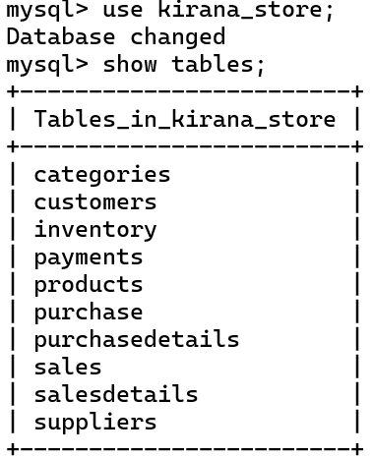**SELECT & Desc**

Select * from Categories ;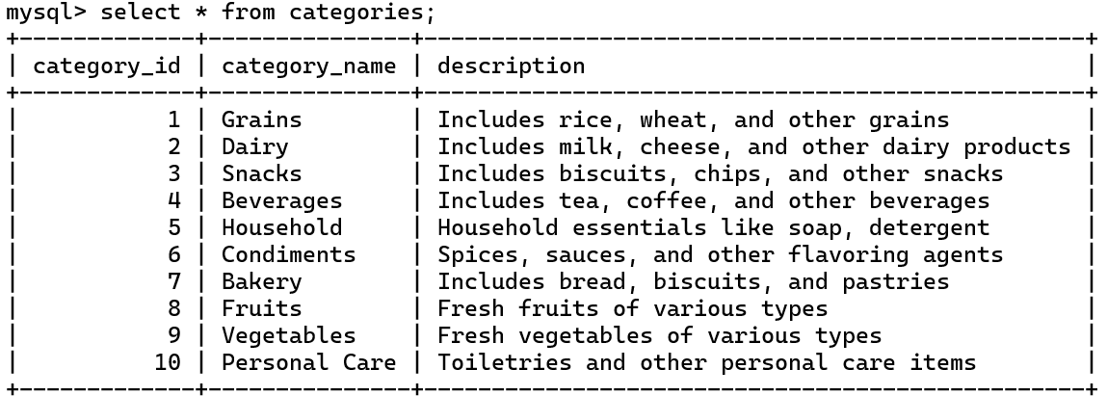

Select * from Suppliers ;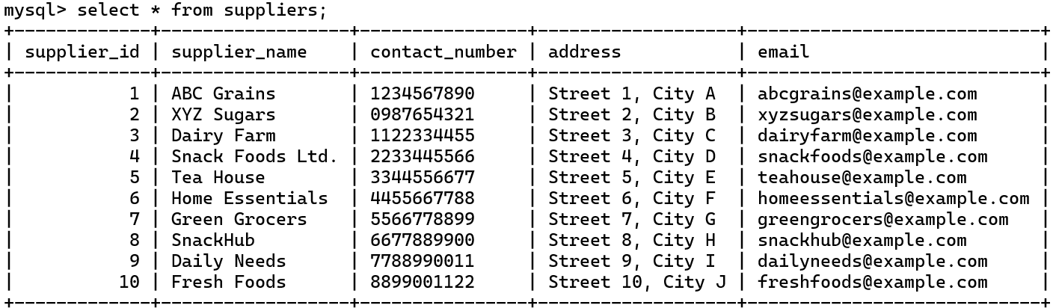

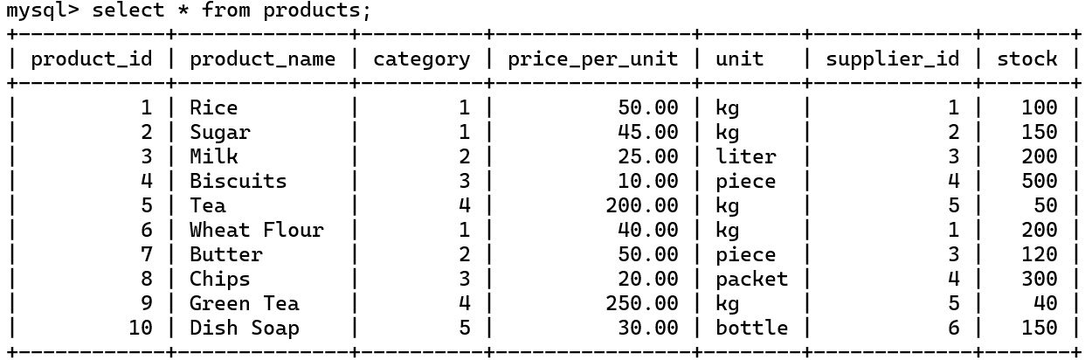select * from Products ;

select * from Payments ;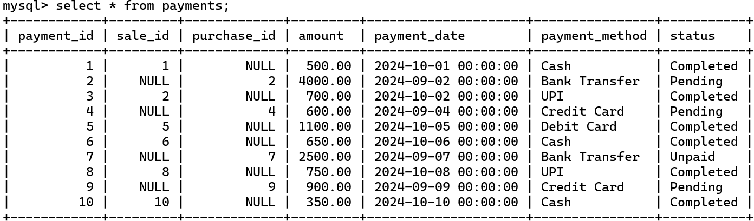

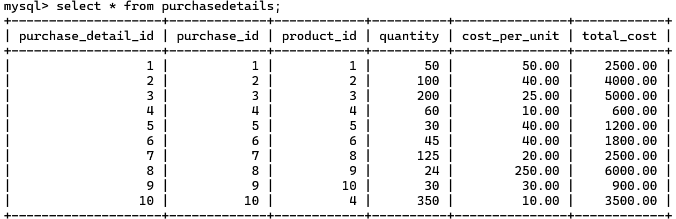select * from PurchaseDetails ;

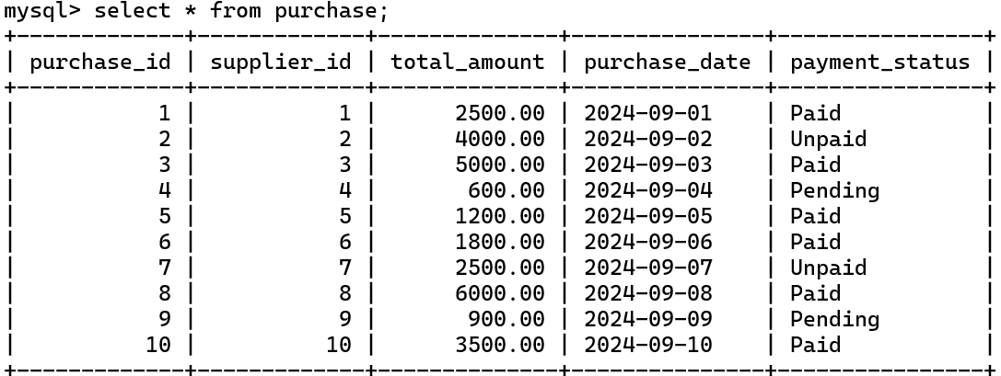select * from Purchase ;

select * from Inventory ;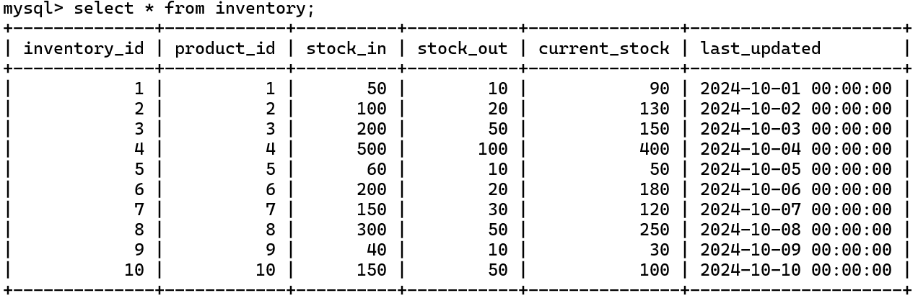

select * from SalesDetails ;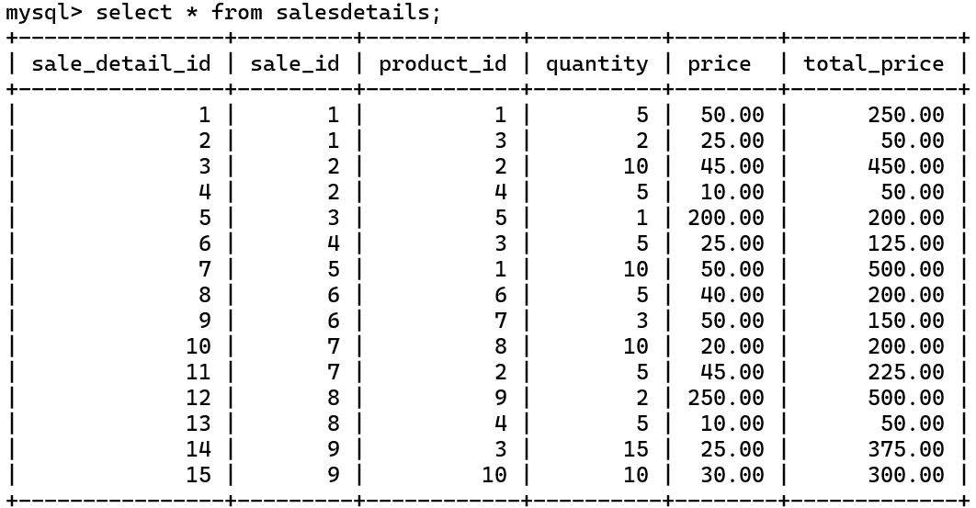

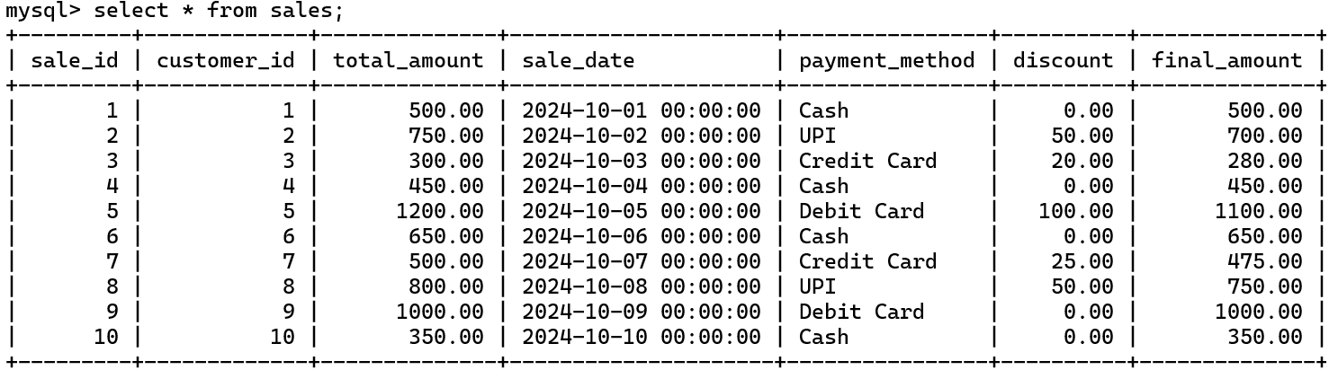select * from sales ;

select * from Customers ;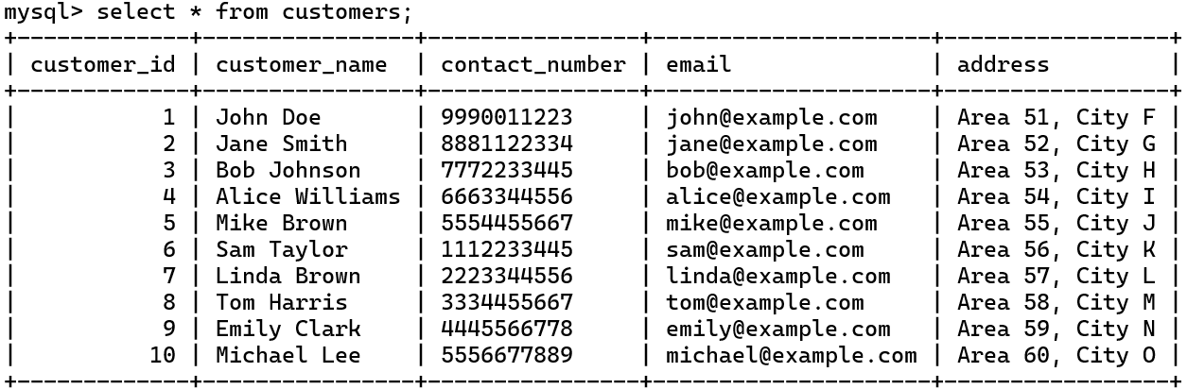

**DESC**

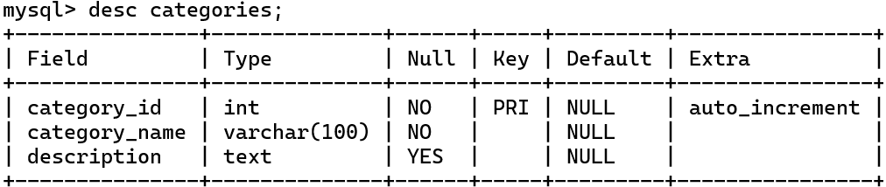desc Categories ;

desc Suppliers ;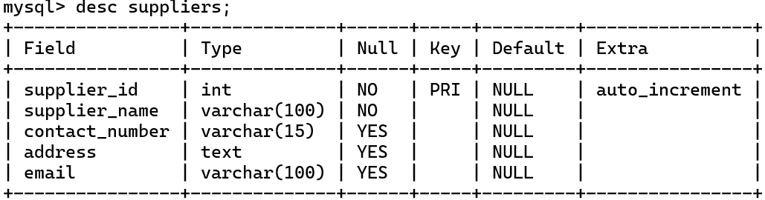

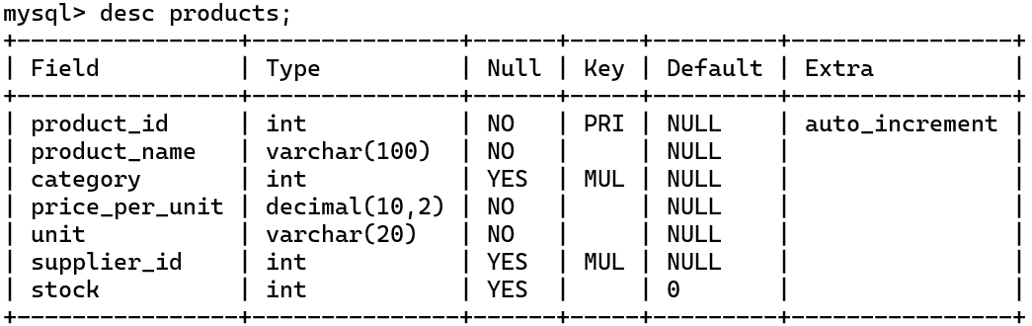desc Products ;

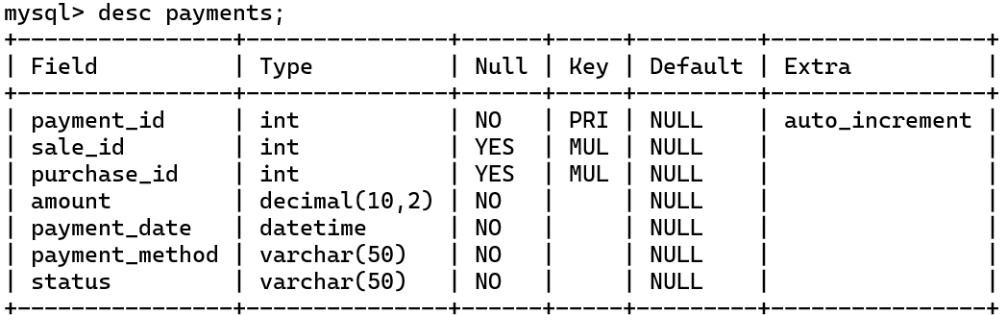desc Payments ;

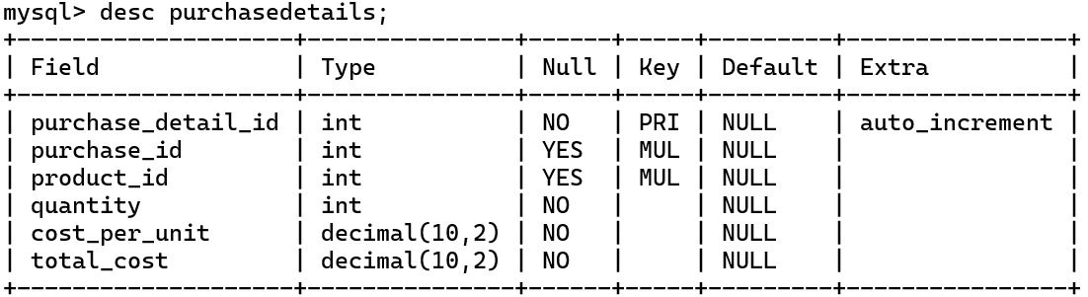desc PurchaseDetails ;

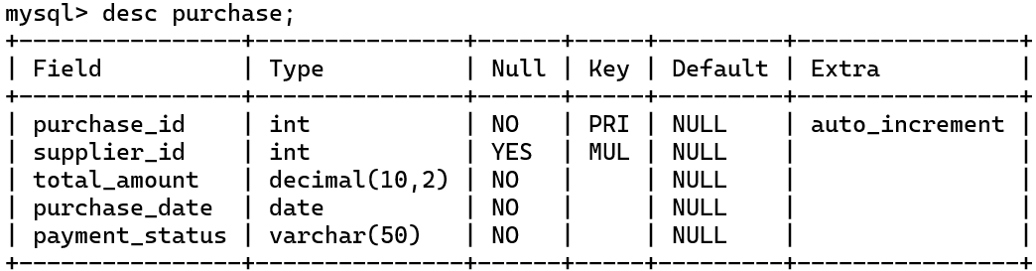desc Purchase ;

desc Inventory ;

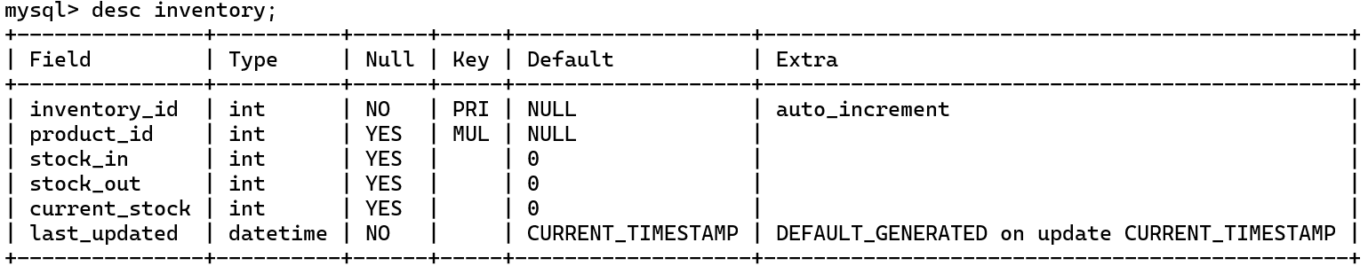

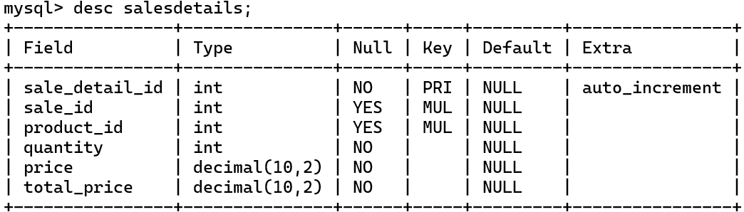desc SalesDetails ;

desc Sales ;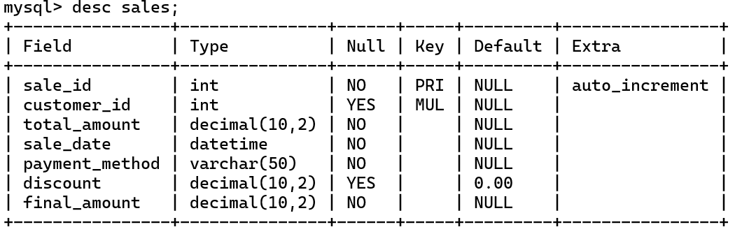

desc Customers ;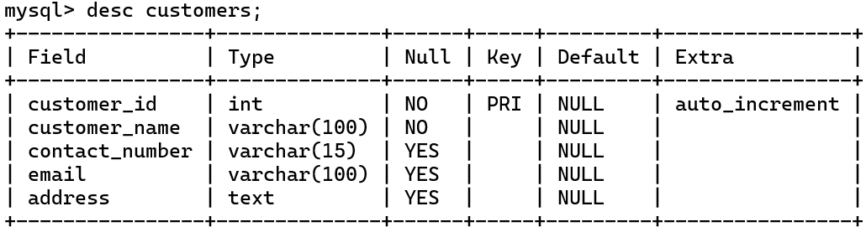

*** Questions ***

-- Fetch all products in the "Snacks" category.

SELECT product_name, price_per_unit, unit

FROM Products

WHERE category = 3;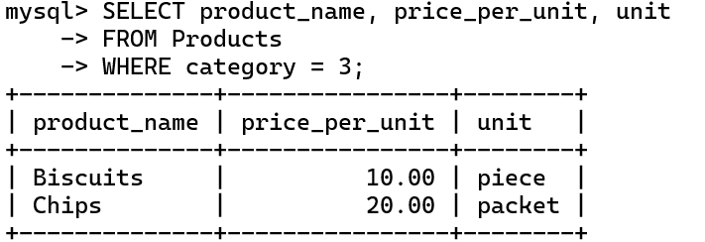

-- Retrieve all products and their categories

SELECT p.product_name, c.category_name

FROM Products p

JOIN Categories c ON p.category = c.category_id;

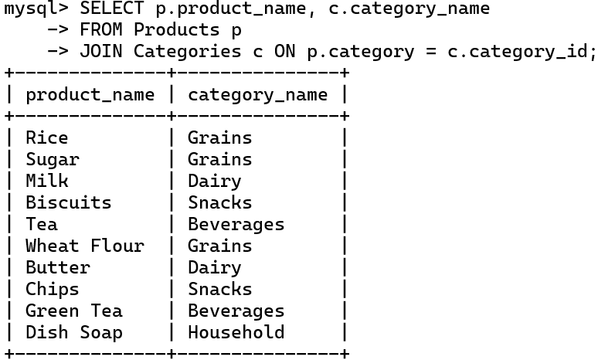

-- List all suppliers with their contact information

SELECT supplier_name, contact_number, email

FROM Suppliers;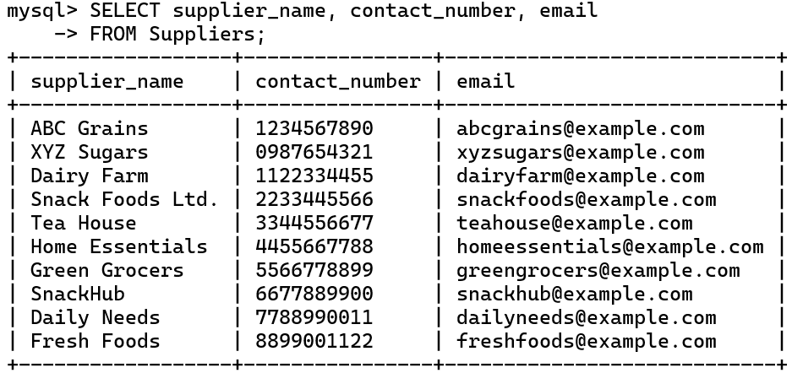

-- Get all customers who have made purchases

SELECT DISTINCT c.customer_name, c.contact_number

FROM Customers c

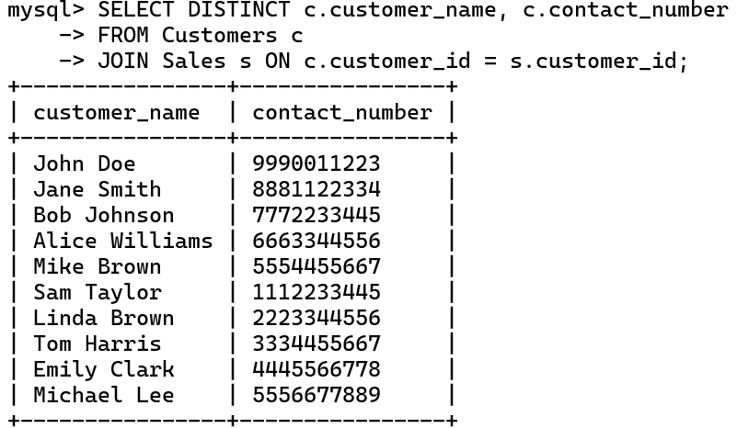JOIN Sales s ON c.customer_id = s.customer_id;

-- Find total sales made in a specific month (October 2024)

SELECT SUM(total_amount) AS total_sales

FROM Sales

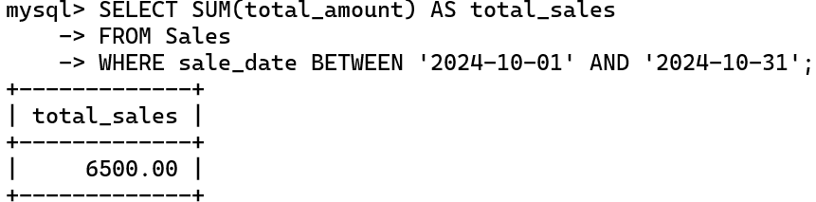WHERE sale_date BETWEEN '2024-10-01' AND '2024-10-31';

-- Show all sales details along with the product names

SELECT sd.sale_detail_id, s.sale_id, p.product_name, sd.quantity, sd.price, sd.total_price

FROM SalesDetails sd

JOIN Sales s ON sd.sale_id = s.sale_id

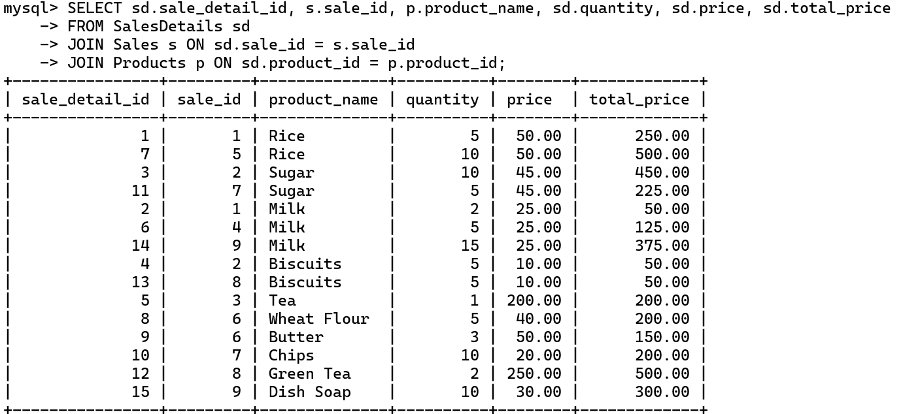JOIN Products p ON sd.product_id = p.product_id;

-- Count the number of products in stock

SELECT SUM(stock) AS total_products_in_stock

FROM Products;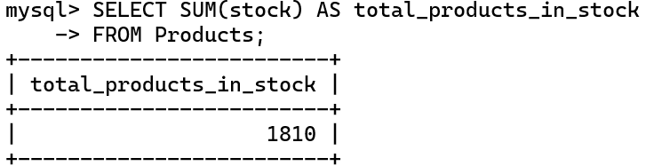

-- List all purchases along with supplier names

SELECT p.purchase_id, s.supplier_name, p.total_amount, p.purchase_date

FROM Purchase p

JOIN Suppliers s ON p.supplier_id = s.supplier_id;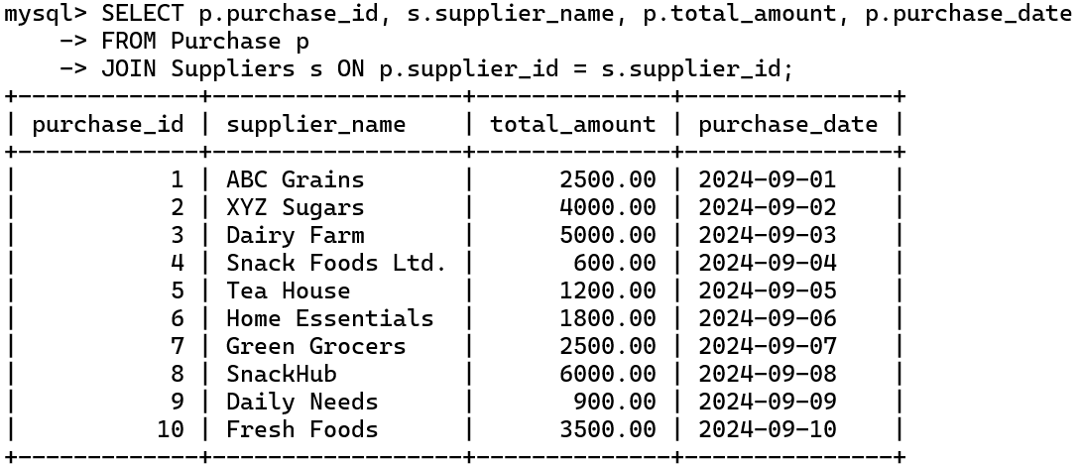

-- Retrieve inventory details for all products

SELECT p.product_name, i.current_stock, i.stock_in, i.stock_out

FROM Inventory i

JOIN Products p ON i.product_id = p.product_id;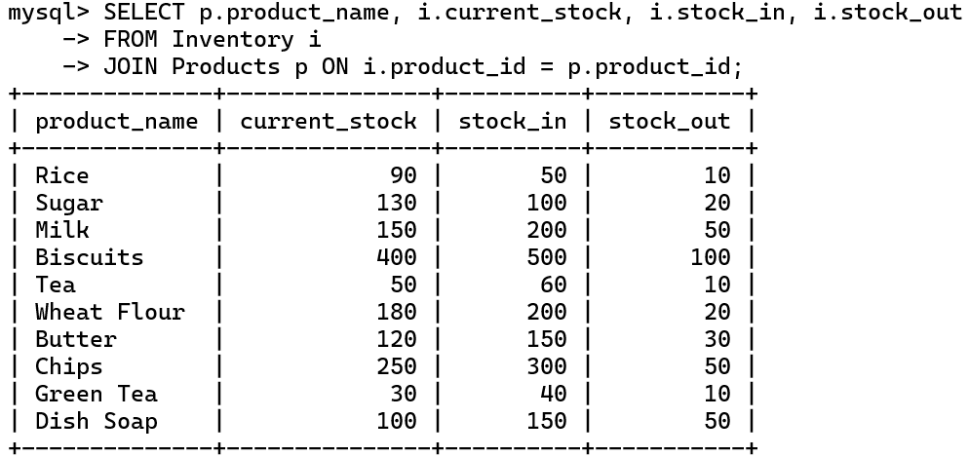

-- Get the total number of sales for each customer

SELECT c.customer_name, COUNT(s.sale_id) AS total_sales

FROM Customers c

LEFT JOIN Sales s ON c.customer_id = s.customer_id

GROUP BY c.customer_name;

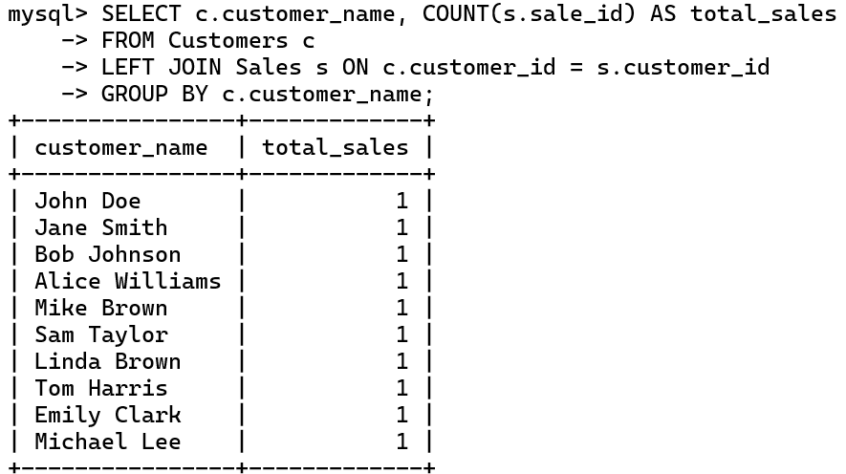

-- Find products that have low stock (less than 100 units)

SELECT product_name, stock

FROM Products

WHERE stock < 100;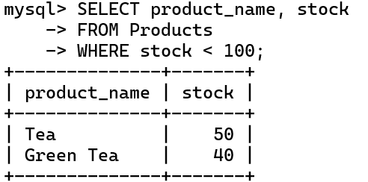

-- Calculate the average price of products per category

SELECT c.category_name, AVG(p.price_per_unit) AS average_price

FROM Products p

JOIN Categories c ON p.category = c.category_id

GROUP BY c.category_name;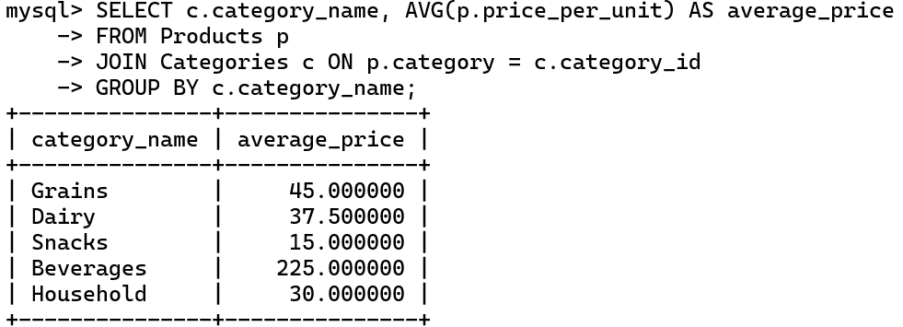

-- Find the highest sales amount:

SELECT MAX(total_amount) AS highest_sales

FROM Sales;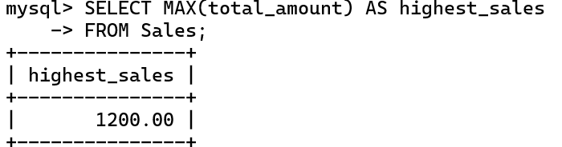

-- Show all payments made for sales

SELECT p.payment_id, s.sale_id, p.amount, p.payment_date

FROM Payments p

LEFT JOIN Sales s ON p.sale_id = s.sale_id;

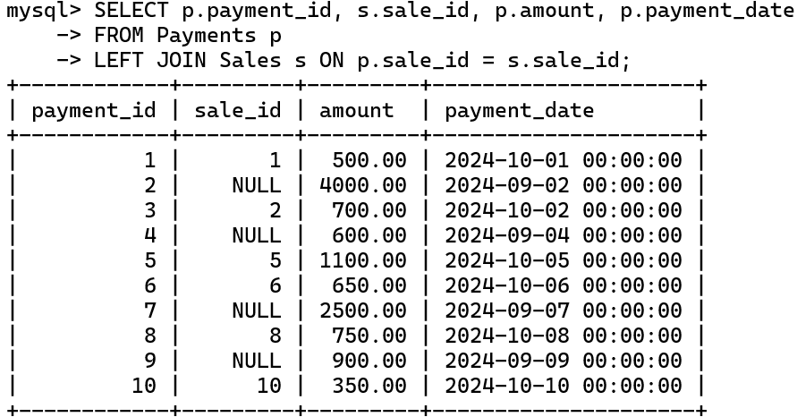

-- Retrieve all sales with applied discounts

SELECT s.sale_id, s.total_amount, s.discount, s.final_amount

FROM Sales s

WHERE s.discount > 0;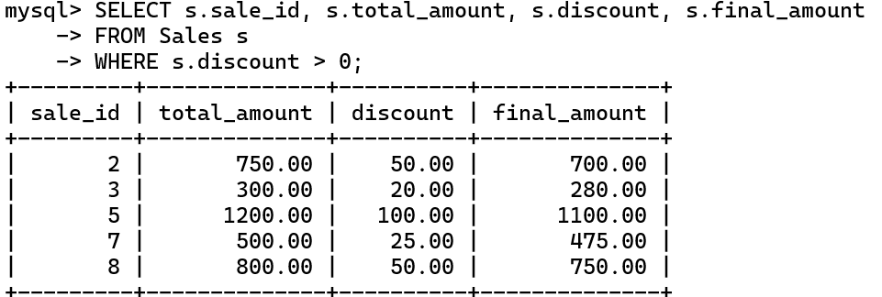

-- Find the total number of customers

SELECT COUNT(customer_id) AS total_customers

FROM Customers;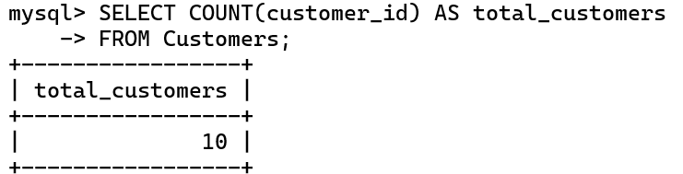

-- Get the latest inventory updates for each product

SELECT p.product_name, i.last_updated

FROM Inventory i

JOIN Products p ON i.product_id = p.product_id

ORDER BY i.last_updated DESC;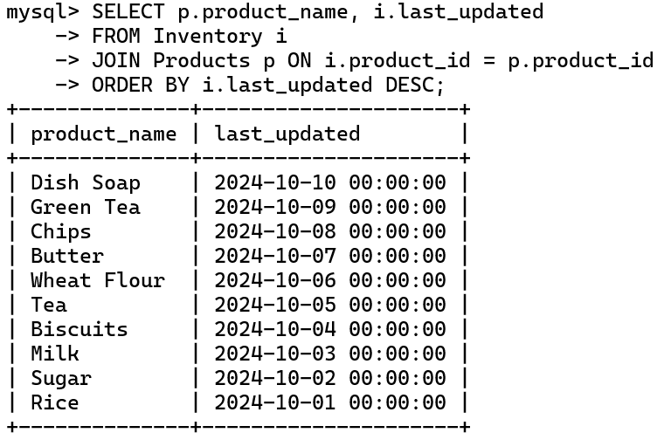

-- List all purchases that are pending payment:

SELECT * FROM Purchase

WHERE payment_status = 'Pending';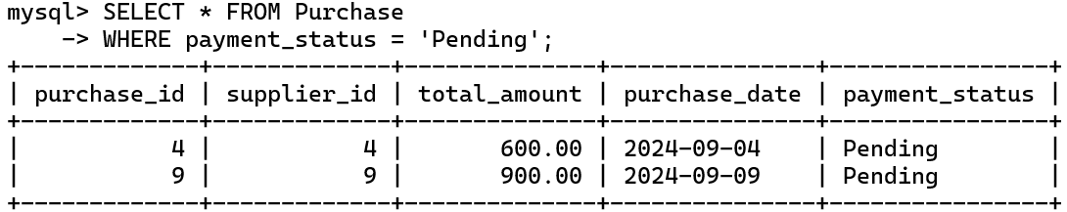

-- Get the details of sales, including product name and quantity sold:

SELECT s.sale_id, p.product_name, sd.quantity

FROM Sales s

JOIN SalesDetails sd ON s.sale_id = sd.sale_id

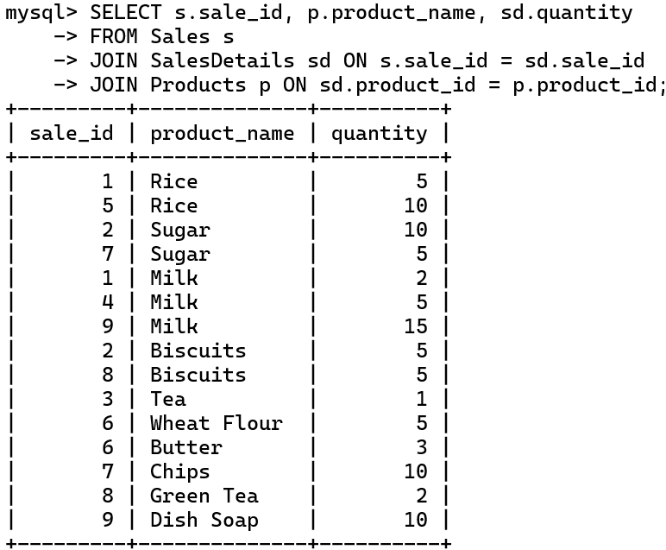JOIN Products p ON sd.product_id = p.product_id;

-- Calculate the total cost of purchases made on a specific date

SELECT SUM(total_amount) AS total_purchase_amount

FROM Purchase

WHERE purchase_date = '2024-09-05';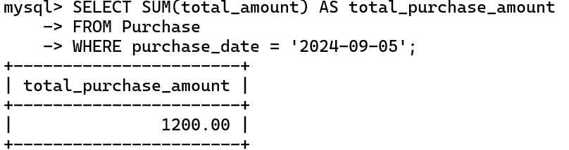

-- Find the second highest sales amount:

SELECT MAX(total_amount) AS second_highest_sales

FROM Sales

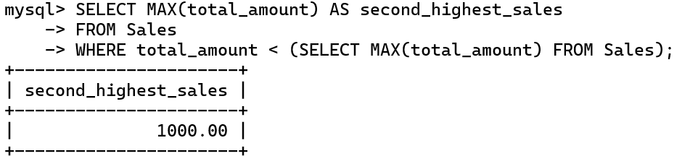WHERE total_amount < (SELECT MAX(total_amount) FROM Sales);

-- Find the 3 highest sales amount:

SELECT MAX(total_amount) AS second_highest_sales

FROM Sales

WHERE total_amount < (SELECT MAX(total_amount) FROM Sales)

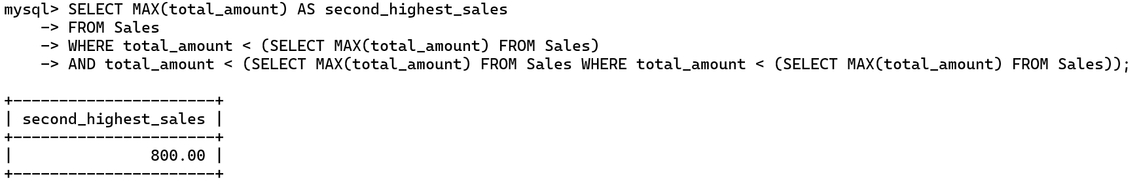AND total_amount < (SELECT MAX(total_amount) FROM Sales WHERE total_amount < (SELECT MAX(total_amount) FROM Sales));

-- Find 1,2,3 highest sales

SELECT

(SELECT MAX(total_amount) FROM Sales) AS First_Highest_sales,

(SELECT MAX(total_amount) FROM Sales WHERE total_amount < (SELECT MAX(total_amount) FROM Sales)) AS Second_highest_sales,

(SELECT MAX(total_amount) FROM Sales WHERE total_amount < (SELECT MAX(total_amount) FROM Sales WHERE

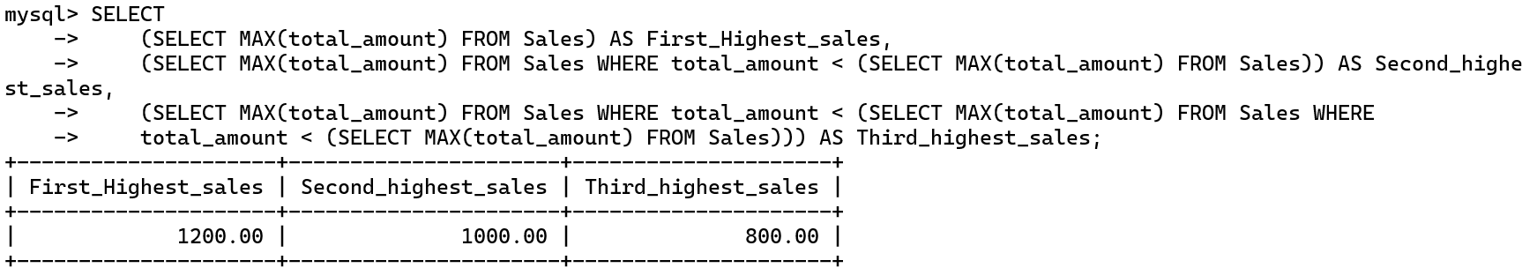 total_amount < (SELECT MAX(total_amount) FROM Sales))) AS Third_highest_sales;

-- find all products whose name start with 'b'

SELECT *

FROM Products

WHERE product_name LIKE 'B%';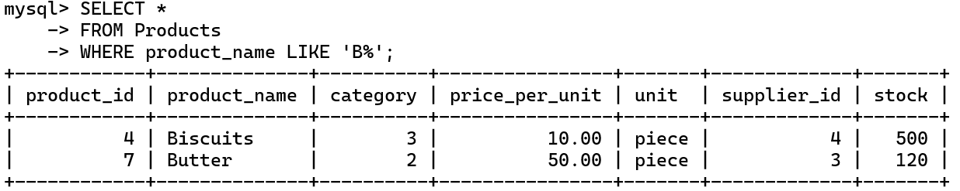

-- find all products with a price per unit greater than 50?

SELECT product_name, price_per_unit

FROM Products

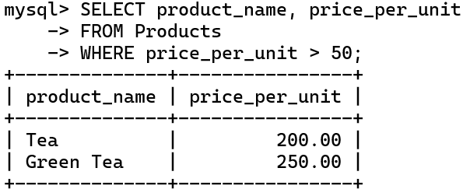WHERE price_per_unit > 50;

-- retrieve all customers who have either a contact number starting with '9' or an email address ending with 'example.com'?

SELECT customer_name, contact_number, email

FROM Customers

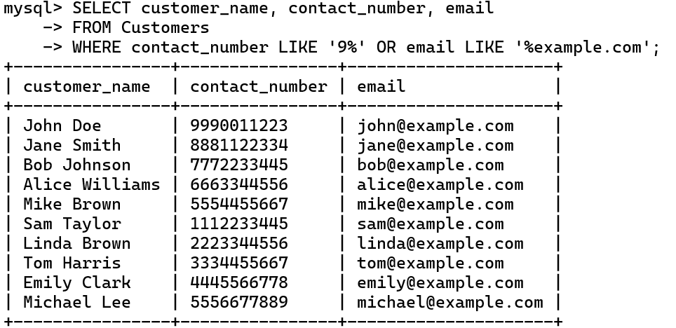WHERE contact_number LIKE '9%' OR email LIKE '%example.com';

-- find products where the current stock is less than 50 or the stock out exceeds 100

SELECT p.product_name, i.current_stock, i.stock_out

FROM Products p

JOIN Inventory i ON p.product_id = i.product_id

WHERE i.current_stock < 50 OR i.stock_out > 100;

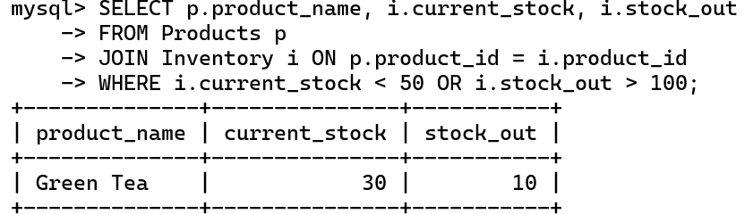

-- retrieve all purchases that are either 'Paid' or 'Pending'?

SELECT purchase_id, supplier_id, total_amount, purchase_date, payment_status

FROM Purchase

WHERE payment_status IN ('Paid', 'Pending');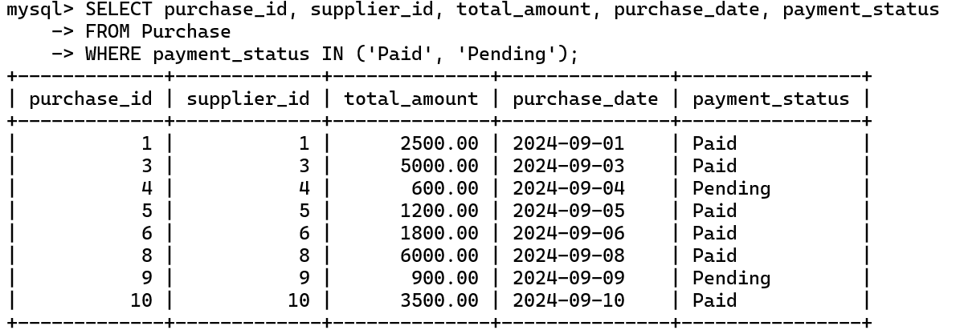

-- to find all sales made using 'Cash' or 'Debit Card'.

SELECT sale_id, customer_id, total_amount, sale_date

FROM Sales

WHERE payment_method IN ('Cash', 'Debit Card');

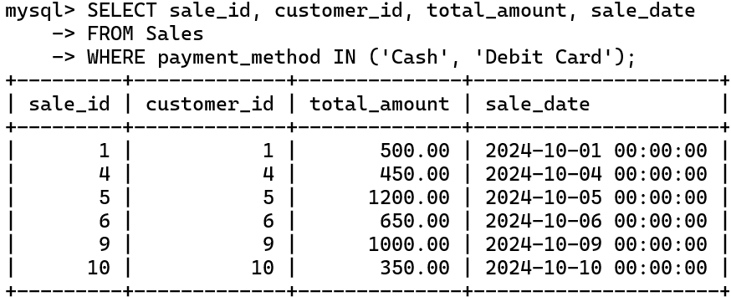

-- find out whose sales is greater than 600 ?

SELECT customer_id, SUM(total_amount) AS total_sales

FROM Sales

GROUP BY customer_id

HAVING total_sales > 600;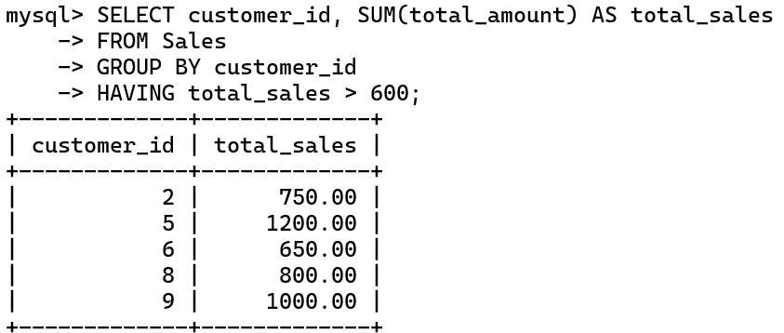

-- find the count of each payment method used by customers

SELECT payment_method,

COUNT(*) AS payment_count

FROM Sales

GROUP BY payment_method;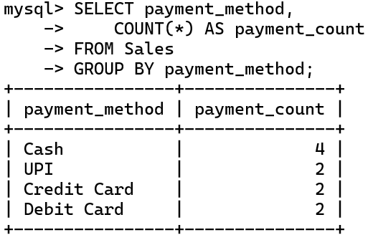

-- Which Customer has purchase Diary Product ?

SELECT DISTINCT Customers.customer_name, Products.product_name

FROM SalesDetails

JOIN Products ON SalesDetails.product_id = Products.product_id

JOIN Categories ON Products.category = Categories.category_id

JOIN Sales ON SalesDetails.sale_id = Sales.sale_id

JOIN Customers ON Sales.customer_id = Customers.customer_id

WHERE Categories.category_name = 'Dairy';

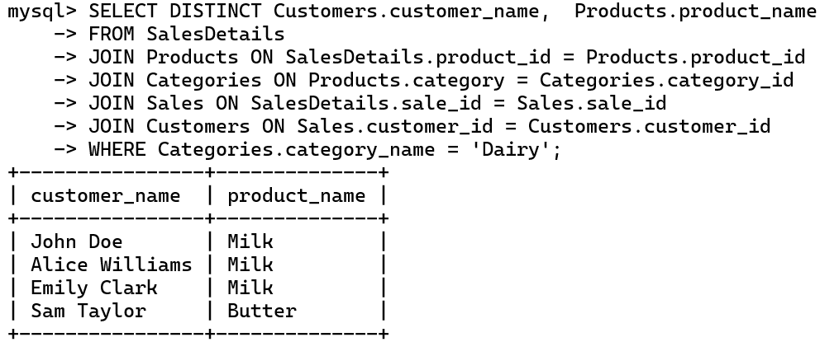

Conclusion : -

A Kirana Store database is a vital tool for efficiently managing grocery store operations. It allows for better decision-making, helps in maintaining customer satisfaction, and ultimately contributes to the store's profitability.

***********************

**\*\*\* THE END \*\*\***

***********************