ION_Broadband

Database Management System

Overview :-

The ion_broadband database is designed to manage a broadband service provider's business operations efficiently. The database includes essential entities such as *Plans*, which define available broadband packages, and *Users*, which store customer information. The *Subscriptions* table tracks each user’s selected plan, start, and end dates, alongside current status, while the *UsageHistory* table logs daily data usage for individual users. To streamline billing, the *Invoice* and *Payments* tables handle user invoices and payment details, ensuring accurate tracking of outstanding amounts and statuses. *SupportTickets* assist in managing customer support by logging issues with a status for tracking resolution progress. Additionally, the *Technicians* and *ServiceAppointments* tables handle technical support, allowing for appointment scheduling and assigning technicians to specific areas. *Billing* provides monthly or periodic billing summaries, and *Notifications* facilitate communication with users, recording sent messages and read statuses. This database structure enables comprehensive data modeling to support operations, customer service, billing, and technical support for the broadband provider.

**Data Modeling**

1. **Conceptual** Data Model

The Conceptual Model focuses on identifying entities, their relationships, and high-level attributes without delving into specifics like data types or primary keys.

* Entities:
  + Plans: Represents different broadband plans with attributes like plan name, speed, data limit, price, and duration.
  + Users: Holds information about users of the broadband service.
  + Subscriptions: Links users with specific plans, containing subscription details and status.
  + UsageHistory: Logs daily data usage for each user.
  + Invoice: Manages the financial details of user subscriptions, tracking due dates and amounts.
  + SupportTickets: Contains user-reported issues along with their current resolution status.
  + Payments: Records payments made against invoices.
  + Technicians: Holds information about technicians and the area they serve.
  + ServiceAppointments: Schedules service appointments for users, linked to technicians.
  + Billing: Manages billing cycles and periods for users.
  + Notifications: Logs messages sent to users.
* Relationships:
  + Users - Subscriptions: One user can have multiple subscriptions.
  + Plans - Subscriptions: Each subscription is associated with one plan.
  + Subscriptions - Invoice: Each subscription may generate multiple invoices.
  + Users - SupportTickets: One user may open multiple support tickets.
  + Invoice - Payments: Each invoice can be associated with multiple payments.
  + Users - Notifications: One user can receive multiple notifications.
  + Technicians - ServiceAppointments: One technician can be assigned to multiple service appointments.

2. **Logical** Data Model

The Logical Model adds specific attributes, primary keys, and foreign keys, refining the conceptual model to reflect relationships and constraints more accurately. Here, we define the tables, attributes, and relationships between them.

* Plans:
  + plan_id (Primary Key)
  + plan_name, speed, data_limit, price, duration
* Users:
  + user_id (Primary Key)
  + full_name, email, phone, address, registration_date, plan_id (Foreign Key referencing Plans(plan_id))
* Subscriptions:
  + subscription_id (Primary Key)
  + user_id (Foreign Key referencing Users(user_id)), plan_id (Foreign Key referencing Plans(plan_id))
  + start_date, end_date, status
* UsageHistory:
  + usage_h_id (Primary Key)
  + user_id (Foreign Key referencing Users(user_id))
  + date, data_used
* Invoice:
  + invoice_id (Primary Key)
  + subscription_id (Foreign Key referencing Subscriptions(subscription_id))
  + invoice_date, due_date, amount, status
* SupportTickets:
  + ticket_id (Primary Key)
  + user_id (Foreign Key referencing Users(user_id))
  + issue_description, status, created_date, resolved_date
* Payments:
  + payment_id (Primary Key)
  + invoice_id (Foreign Key referencing Invoice(invoice_id))
  + amount, payment_date, payment_method, status
* Technicians:
  + technician_id (Primary Key)
  + full_name, contact_number, email, area_served
* ServiceAppointments:
  + appointment_id (Primary Key)
  + user_id (Foreign Key referencing Users(user_id)), technician_id (Foreign Key referencing Technicians(technician_id))
  + service_date, service_type, status
* Billing:
  + bill_id (Primary Key)
  + user_id (Foreign Key referencing Users(user_id)), subscription_id (Foreign Key referencing Subscriptions(subscription_id))
  + billing_period_start, billing_period_end, total_amount
* Notifications:
  + notification_id (Primary Key)
  + user_id (Foreign Key referencing Users(user_id))
  + message, notification_date, status

**3. Physical Data Model**

The physical data model provides the actual implementation details, including data types and constraints as needed for a specific database management system.

This is generally what you have provided in your SQL code. Here’s a brief overview of the physical aspects:

* Each table is created with specified data types (e.g., INT, VARCHAR, DECIMAL, TEXT, DATE).
* Primary keys are defined for each table.
* Foreign key constraints are set to maintain referential integrity.
* Use of ENUM for fields that have a defined set of possible values (e.g., payment_method, payment_status, item_type).

**SQL Implementation**

Here’s a brief recap of your SQL implementation, which is correctly structured to represent the physical model:

This physical data model finalizes the database structure, enforcing data types, relationships, and constraints to support the system requirements for ion_broadband.

**ER Diagram**

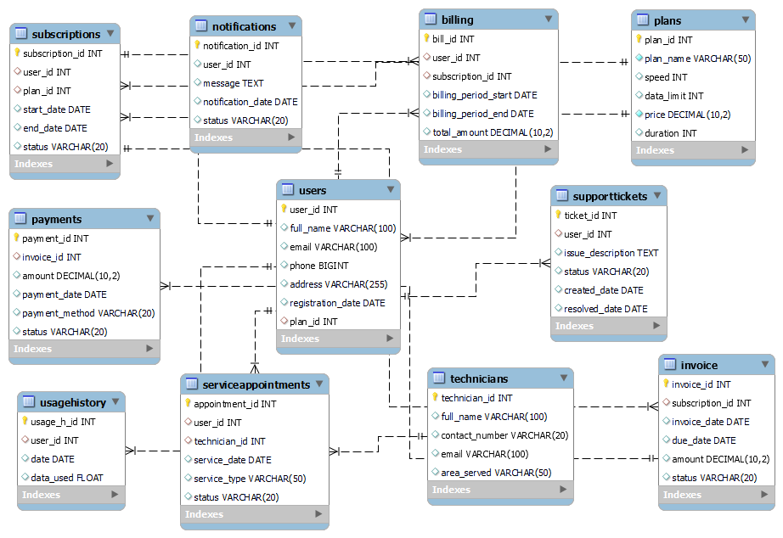

**Create Tables**

CREATE DATABASE ion_broadband;

USE ion_broadband;

-- Plans Table

CREATE TABLE **Plans** (

plan_id INT PRIMARY KEY,

plan_name VARCHAR(50) NOT NULL,

speed INT,

data_limit INT,

price DECIMAL(10, 2) NOT NULL,

duration INT

);

-- Users Table

CREATE TABLE **Users** (

user_id INT PRIMARY KEY,

full_name VARCHAR(100),

email VARCHAR(100),

phone BIGINT,

address VARCHAR(255),

registration_date DATE,

plan_id INT,

FOREIGN KEY (plan_id) REFERENCES Plans(plan_id)

);

-- Subscriptions Table

CREATE TABLE **Subscriptions** (

subscription_id INT PRIMARY KEY,

user_id INT,

plan_id INT,

start_date DATE,

end_date DATE,

status VARCHAR(20),

FOREIGN KEY (user_id) REFERENCES Users(user_id),

FOREIGN KEY (plan_id) REFERENCES Plans(plan_id)

);

-- UsageHistory Table

CREATE TABLE **UsageHistory** (

usage_h_id INT PRIMARY KEY,

user_id INT,

date DATE,

data_used FLOAT,

FOREIGN KEY (user_id) REFERENCES Users(user_id)

);

-- Invoice Table

CREATE TABLE **Invoice** (

invoice_id INT PRIMARY KEY,

subscription_id INT,

invoice_date DATE,

due_date DATE,

amount DECIMAL(10, 2),

status VARCHAR(20),

FOREIGN KEY (subscription_id) REFERENCES Subscriptions(subscription_id)

);

-- SupportTickets Table

CREATE TABLE **SupportTickets** (

ticket_id INT PRIMARY KEY,

user_id INT,

issue_description TEXT,

status VARCHAR(20),

created_date DATE,

resolved_date DATE,

FOREIGN KEY (user_id) REFERENCES Users(user_id)

);

-- Payments Table

CREATE TABLE **Payments** (

payment_id INT PRIMARY KEY,

invoice_id INT,

amount DECIMAL(10, 2),

payment_date DATE,

payment_method VARCHAR(20),

status VARCHAR(20),

FOREIGN KEY (invoice_id) REFERENCES Invoice(invoice_id)

);

-- Technicians Table

CREATE TABLE **Technicians** (

technician_id INT PRIMARY KEY,

full_name VARCHAR(100),

contact_number VARCHAR(20),

email VARCHAR(100),

area_served VARCHAR(50)

);

-- ServiceAppointments Table

CREATE TABLE **ServiceAppointments** (

appointment_id INT PRIMARY KEY,

user_id INT,

technician_id INT,

service_date DATE,

service_type VARCHAR(50),

status VARCHAR(20),

FOREIGN KEY (user_id) REFERENCES Users(user_id),

FOREIGN KEY (technician_id) REFERENCES Technicians(technician_id)

);

-- Billing Table

CREATE TABLE **Billing** (

bill_id INT PRIMARY KEY,

user_id INT,

subscription_id INT,

billing_period_start DATE,

billing_period_end DATE,

total_amount DECIMAL(10, 2),

FOREIGN KEY (user_id) REFERENCES Users(user_id),

FOREIGN KEY (subscription_id) REFERENCES Subscriptions(subscription_id)

);

-- Notifications Table

CREATE TABLE **Notifications** (

notification_id INT PRIMARY KEY,

user_id INT,

message TEXT,

notification_date DATE,

status VARCHAR(20)

);

**Insert Values**

INSERT INTO **Users** (user_id, full_name, email, phone, address, registration_date, plan_id)

VALUES

(1, 'Rohan Sharma', 'rohan.sharma@example.com', '9876543210', '101 MG Road, Mumbai', '2024-01-15', 12),

(2, 'Priya Verma', 'priya.verma@example.com', '9876543211', '202, Lajpat Nagar, Delhi', '2024-02-20', 27),

(3, 'Suresh Kumar', 'suresh.kumar@example.com', '9876543212', '305, Park Street, Kolkata', '2024-03-10', 5),

(4, 'Anita Desai', 'anita.desai@example.com', '9876543216', '505, Churchgate, Mumbai', '2024-04-01', 18),

(5, 'Vikram Singh', 'vikram.singh@example.com', '9876543217', '110, Sector 5, Noida', '2024-04-15', 2),

(6, 'Deepa Nair', 'deepa.nair@example.com', '9876543218', '402, JP Nagar, Bangalore', '2024-05-10', 14),

(7, 'Arjun Patel', 'arjun.patel@example.com', '9876543219', '309, Satellite, Ahmedabad', '2024-05-20', 30),

(8, 'Suman Roy', 'suman.roy@example.com', '9876543220', '808, Salt Lake, Kolkata', '2024-06-01', 9),

(9, 'Ritika Joshi', 'ritika.joshi@example.com', '9876543221', '123, MG Road, Mumbai', '2024-06-15', 21),

(10, 'Rahul Mehta', 'rahul.mehta@example.com', '9876543222', '456, Lajpat Nagar, Delhi', '2024-06-20', 11),

(11, 'Nisha Singh', 'nisha.singh@example.com', '9876543223', '789, Park Street, Kolkata', '2024-07-01', 24),

(12, 'Vivek Gupta', 'vivek.gupta@example.com', '9876543224', '101, Churchgate, Mumbai', '2024-07-10', 4),

(13, 'Anjali Reddy', 'anjali.reddy@example.com', '9876543225', '202, Sector 5, Noida', '2024-07-15', 15),

(14, 'Kiran Roy', 'kiran.roy@example.com', '9876543226', '303, JP Nagar, Bangalore', '2024-08-01', 8),

(15, 'Pooja Mehta', 'pooja.mehta@example.com', '9876543227', '404, Satellite, Ahmedabad', '2024-08-10', 3),

(16, 'Sandeep Sharma', 'sandeep.sharma@example.com', '9876543228', '505, MG Road, Mumbai', '2024-08-20', 13),

(17, 'Tanya Choudhary', 'tanya.choudhary@example.com', '9876543229', '606, Lajpat Nagar, Delhi', '2024-08-25', 22),

(18, 'Arvind Kumar', 'arvind.kumar@example.com', '9876543230', '707, Park Street, Kolkata', '2024-09-01', 6),

(19, 'Sneha Sharma', 'sneha.sharma@example.com', '9876543231', '808, Churchgate, Mumbai', '2024-09-10', 19),

(20, 'Vikrant Soni', 'vikrant.soni@example.com', '9876543232', '909, Sector 5, Noida', '2024-09-15', 29),

(21, 'Lakshmi Nair', 'lakshmi.nair@example.com', '9876543233', '1010, JP Nagar, Bangalore', '2024-09-20', 1),

(22, 'Raghav Singh', 'raghav.singh@example.com', '9876543234', '1111, Satellite, Ahmedabad', '2024-10-01', 20),

(23, 'Kavita Verma', 'kavita.verma@example.com', '9876543235', '1212, MG Road, Mumbai', '2024-10-10', 7),

(24, 'Rajeev Kumar', 'rajeeve.kumar@example.com', '9876543236', '1313, Lajpat Nagar, Delhi', '2024-10-15', 26),

(25, 'Neha Joshi', 'neha.joshi@example.com', '9876543237', '1414, Park Street, Kolkata', '2024-10-20', 10),

(26, 'Siddharth Rao', 'siddharth.rao@example.com', '9876543238', '1515, Churchgate, Mumbai', '2024-11-01', 12),

(27, 'Geeta Verma', 'geeta.verma@example.com', '9876543239', '1616, Sector 5, Noida', '2024-11-10', 25),

(28, 'Kumar Sinha', 'kumar.sinha@example.com', '9876543240', '1717, JP Nagar, Bangalore', '2024-11-15', 28),

(29, 'Sheetal Sharma', 'sheetal.sharma@example.com', '9876543241', '1818, Satellite, Ahmedabad', '2024-12-01', 23),

(30, 'Nitin Agarwal', 'nitin.agarwal@example.com', '9876543242', '1919, MG Road, Mumbai', '2024-12-10', 17),

(31, 'Swati Patel', 'swati.patel@example.com', '9876543243', '2020, Lajpat Nagar, Delhi', '2024-12-15', 16),

(32, 'Ramesh Yadav', 'ramesh.yadav@example.com', '9876543244', '2121, Park Street, Kolkata', '2025-01-01', 30),

(33, 'Pankaj Mishra', 'pankaj.mishra@example.com', '9876543245', '2222, Churchgate, Mumbai', '2025-01-10', 15),

(34, 'Tanvi Kapoor', 'tanvi.kapoor@example.com', '9876543246', '2323, Sector 5, Noida', '2025-01-15', 14),

(35, 'Raj Kumar', 'raj.kumar@example.com', '9876543247', '2424, JP Nagar, Bangalore', '2025-02-01', 11),

(36, 'Arushi Verma', 'arushi.verma@example.com', '9876543248', '2525, Satellite, Ahmedabad', '2025-02-10', 9),

(37, 'Devendra Choudhary', 'devendra.choudhary@example.com', '9876543249', '2626, MG Road, Mumbai', '2025-02-15', 6),

(38, 'Shivani Gupta', 'shivani.gupta@example.com', '9876543250', '2727, Lajpat Nagar, Delhi', '2025-02-20', 2),

(39, 'Ritika Singh', 'ritika.singh@example.com', '9876543251', '2828, Park Street, Kolkata', '2025-03-01', 18),

(40, 'Rajiv Rathi', 'rajiv.rathi@example.com', '9876543252', '2929, Churchgate, Mumbai', '2025-03-10', 13),

(41, 'Mohan Bhatia', 'mohan.bhatia@example.com', '9876543253', '3030, Sector 5, Noida', '2025-03-15', 3),

(42, 'Sanjay Tiwari', 'sanjay.tiwari@example.com', '9876543254', '3131, JP Nagar, Bangalore', '2025-04-01', 19),

(43, 'Seema Agarwal', 'seema.agarwal@example.com', '9876543255', '3232, Satellite, Ahmedabad', '2025-04-10', 25),

(44, 'Ankit Joshi', 'ankit.joshi@example.com', '9876543256', '3333, MG Road, Mumbai', '2025-04-15', 7),

(45, 'Pallavi Rao', 'pallavi.rao@example.com', '9876543257', '3434, Lajpat Nagar, Delhi', '2025-05-01', 20),

(46, 'Vishal Sharma', 'vishal.sharma@example.com', '9876543258', '3535, Park Street, Kolkata', '2025-05-10', 26),

(47, 'Karan Sinha', 'karan.sinha@example.com', '9876543259', '3636, Churchgate, Mumbai', '2025-05-15', 5),

(48, 'Rekha Mehta', 'rekha.mehta@example.com', '9876543260', '3737, Sector 5, Noida', '2025-06-01', 29),

(49, 'Uday Sharma', 'uday.sharma@example.com', '9876543261', '3838, JP Nagar, Bangalore', '2025-06-10', 17),

(50, 'Kavya Nair', 'kavya.nair@example.com', '9876543262', '3939, Satellite, Ahmedabad', '2025-06-15', 23),

(51, 'Isha Malik', 'isha.malik@example.com', '9876543263', '4040, MG Road, Mumbai', '2025-06-15', 1),

(52, 'Sanjana Kapoor', 'sanjana.kapoor@example.com', '9876543264', '4141, Lajpat Nagar, Delhi', '2025-06-20', 2),

(53, 'Amir Khan', 'amir.khan@example.com', '9876543265', '4242, Park Street, Kolkata', '2025-07-01', 3),

(54, 'Geeta Sharma', 'geeta.sharma@example.com', '9876543266', '4343, Churchgate, Mumbai', '2025-07-10', 2),

(55, 'Anil Gupta', 'anil.gupta@example.com', '9876543267', '4444, Sector 5, Noida', '2025-07-15', 1),

(56, 'Simran Kaur', 'simran.kaur@example.com', '9876543268', '4545, JP Nagar, Bangalore', '2025-08-01', 3),

(57, 'Uday Rathi', 'uday.rathi@example.com', '9876543269', '4646, Satellite, Ahmedabad', '2025-08-10', 2),

(58, 'Neelam Bhatia', 'neelam.bhatia@example.com', '9876543270', '4747, MG Road, Mumbai', '2025-08-15', 1),

(59, 'Kartik Yadav', 'kartik.yadav@example.com', '9876543271', '4848, Lajpat Nagar, Delhi', '2025-09-01', 3),

(60, 'Hina Mehta', 'hina.mehta@example.com', '9876543272', '4949, Park Street, Kolkata', '2025-09-10', 2),

(61, 'Rakesh Jain', 'rakesh.jain@example.com', '9876543273', '5050, Churchgate, Mumbai', '2025-09-15', 1),

(62, 'Tina Sharma', 'tina.sharma@example.com', '9876543274', '5151, Sector 5, Noida', '2025-09-20', 3),

(63, 'Ankur Verma', 'ankur.verma@example.com', '9876543275', '5252, JP Nagar, Bangalore', '2025-10-01', 2),

(64, 'Tanushree Ghosh', 'tanushree.ghosh@example.com', '9876543276', '5353, Satellite, Ahmedabad', '2025-10-10', 1),

(65, 'Rupesh Choudhary', 'rupesh.choudhary@example.com', '9876543277', '5454, MG Road, Mumbai', '2025-10-15', 2),

(66, 'Gaurav Patil', 'gaurav.patil@example.com', '9876543278', '5555, Lajpat Nagar, Delhi', '2025-11-01', 3),

(67, 'Neeraj Agarwal', 'neeraj.agarwal@example.com', '9876543279', '5656, Park Street, Kolkata', '2025-11-10', 2),

(68, 'Aditi Sinha', 'aditi.sinha@example.com', '9876543280', '5757, Churchgate, Mumbai', '2025-11-15', 1),

(69, 'Prateek Kumar', 'prateek.kumar@example.com', '9876543281', '5858, Sector 5, Noida', '2025-12-01', 3),

(70, 'Vaishali Sharma', 'vaishali.sharma@example.com', '9876543282', '5959, JP Nagar, Bangalore', '2025-12-10', 2),

(71, 'Rohan Rathi', 'rohan.rathi@example.com', '9876543283', '6060, Satellite, Ahmedabad', '2025-12-15', 1),

(72, 'Sonal Tiwari', 'sonal.tiwari@example.com', '9876543284', '6161, MG Road, Mumbai', '2026-01-01', 3),

(73, 'Navin Yadav', 'navin.yadav@example.com', '9876543285', '6262, Lajpat Nagar, Delhi', '2026-01-10', 2),

(74, 'Neha Soni', 'neha.soni@example.com', '9876543286', '6363, Park Street, Kolkata', '2026-01-15', 1),

(75, 'Rakesh Sharma', 'rakesh.sharma@example.com', '9876543287', '6464, Churchgate, Mumbai', '2026-02-01', 3),

(76, 'Gulshan Singh', 'gulshan.singh@example.com', '9876543288', '6565, Sector 5, Noida', '2026-02-10', 2),

(77, 'Kiran Verma', 'kiran.verma@example.com', '9876543289', '6666, JP Nagar, Bangalore', '2026-02-15', 1),

(78, 'Dev Kumar', 'dev.kumar@example.com', '9876543290', '6767, Satellite, Ahmedabad', '2026-03-01', 3),

(79, 'Maya Sharma', 'maya.sharma@example.com', '9876543291', '6868, MG Road, Mumbai', '2026-03-10', 2),

(80, 'Anil Yadav', 'anil.yadav@example.com', '9876543292', '6969, Lajpat Nagar, Delhi', '2026-03-15', 1),

(81, 'Himanshu Patil', 'himanshu.patil@example.com', '9876543293', '7070, Park Street, Kolkata', '2026-04-01', 3),

(82, 'Vaishali Verma', 'vaishali.verma@example.com', '9876543294', '7171, Churchgate, Mumbai', '2026-04-10', 2),

(83, 'Rajesh Gupta', 'rajesh.gupta@example.com', '9876543295', '7272, Sector 5, Noida', '2026-04-15', 1),

(84, 'Vasudha Singh', 'vasudha.singh@example.com', '9876543296', '7373, JP Nagar, Bangalore', '2026-05-01', 3),

(85, 'Deepak Rao', 'deepak.rao@example.com', '9876543297', '7474, Satellite, Ahmedabad', '2026-05-10', 2),

(86, 'Nidhi Verma', 'nidhi.verma@example.com', '9876543298', '7575, MG Road, Mumbai', '2026-05-15', 1),

(87, 'Gaurav Choudhary', 'gaurav.choudhary@example.com', '9876543299', '7676, Lajpat Nagar, Delhi', '2026-06-01', 3),

(88, 'Priya Agarwal', 'priya.agarwal@example.com', '9876543300', '7777, Park Street, Kolkata', '2026-06-10', 2),

(89, 'Rahul Bhatia', 'rahul.bhatia@example.com', '9876543301', '7878, Churchgate, Mumbai', '2026-06-15', 1),

(90, 'Sonali Desai', 'sonali.desai@example.com', '9876543302', '7979, Sector 5, Noida', '2026-06-20', 3),

(91, 'Rohit Rathi', 'rohit.rathi@example.com', '9876543303', '8080, JP Nagar, Bangalore', '2026-07-01', 2),

(92, 'Suman Soni', 'suman.soni@example.com', '9876543304', '8181, Satellite, Ahmedabad', '2026-07-10', 1),

(93, 'Vivek Sharma', 'vivek.sharma@example.com', '9876543305', '8282, MG Road, Mumbai', '2026-07-15', 3),

(94, 'Nisha Agarwal', 'nisha.agarwal@example.com', '9876543306', '8383, Lajpat Nagar, Delhi', '2026-08-01', 2),

(95, 'Shreyas Patil', 'shreyas.patil@example.com', '9876543307', '8484, Park Street, Kolkata', '2026-08-10', 1),

(96, 'Pooja Choudhary', 'pooja.choudhary@example.com', '9876543308', '8585, Churchgate, Mumbai', '2026-08-15', 3),

(97, 'Ankur Joshi', 'ankur.joshi@example.com', '9876543309', '8686, Sector 5, Noida', '2026-09-01', 2),

(98, 'Tanya Sharma', 'tanya.sharma@example.com', '9876543310', '8787, JP Nagar, Bangalore', '2026-09-10', 1),

(99, 'Rajesh Yadav', 'rajesh.yadav@example.com', '9876543311', '8888, Satellite, Ahmedabad', '2026-09-15', 3),

(100, 'Nisha Rathi', 'nisha.rathi@example.com', '9876543312', '8989, MG Road, Mumbai', '2026-10-01', 2),

(101, 'Kunal Singh', 'kunal.singh@example.com', '9876543313', '9090, Lajpat Nagar, Delhi', '2026-10-10', 7),

(102, 'Alok Yadav', 'alok.yadav@example.com', '9876543314', '9191, Park Street, Kolkata', '2026-10-15', 14),

(103, 'Rita Sharma', 'rita.sharma@example.com', '9876543315', '9292, Churchgate, Mumbai', '2026-11-01', 2),

(104, 'Meena Ghosh', 'meena.ghosh@example.com', '9876543316', '9393, Sector 5, Noida', '2026-11-10', 29),

(105, 'Kiran Patil', 'kiran.patil@example.com', '9876543317', '9494, JP Nagar, Bangalore', '2026-11-15', 12),

(106, 'Sonu Verma', 'sonu.verma@example.com', '9876543318', '9595, Satellite, Ahmedabad', '2026-12-01', 22),

(107, 'Alok Kumar', 'alok.kumar@example.com', '9876543319', '9696, MG Road, Mumbai', '2026-12-10', 5),

(108, 'Neha Sharma', 'neha.sharma@example.com', '9876543320', '9797, Lajpat Nagar, Delhi', '2026-12-15', 18),

(109, 'Rahul Gupta', 'rahul.gupta@example.com', '9876543321', '9898, Park Street, Kolkata', '2027-01-01', 3),

(110, 'Amit Patil', 'amit.patil@example.com', '9876543322', '9999, Churchgate, Mumbai', '2027-01-10', 21),

(111, 'Vikash Kumar', 'vikash.kumar@example.com', '9876543323', '10101, Sector 5, Noida', '2027-01-15', 11),

(112, 'Tanisha Rathi', 'tanisha.rathi@example.com', '9876543324', '11111, JP Nagar, Bangalore', '2027-02-01', 4),

(113, 'Jitendra Verma', 'jitendra.verma@example.com', '9876543325', '12121, Satellite, Ahmedabad', '2027-02-10', 8),

(114, 'Siddharth Desai', 'siddharth.desai@example.com', '9876543326', '13131, MG Road, Mumbai', '2027-02-15', 25),

(115, 'Gaurav Agarwal', 'gaurav.agarwal@example.com', '9876543327', '14141, Lajpat Nagar, Delhi', '2027-03-01', 13),

(116, 'Neelam Sharma', 'neelam.sharma@example.com', '9876543328', '15151, Park Street, Kolkata', '2027-03-10', 9),

(117, 'Avinash Kumar', 'avinash.kumar@example.com', '9876543329', '16161, Churchgate, Mumbai', '2027-03-15', 27),

(118, 'Vani Yadav', 'vani.yadav@example.com', '9876543330', '17171, Sector 5, Noida', '2027-04-01', 15),

(119, 'Suraj Patil', 'suraj.patil@example.com', '9876543331', '18181, JP Nagar, Bangalore', '2027-04-10', 30),

(120, 'Gaurav Rathi', 'gaurav.rathi@example.com', '9876543332', '19191, Satellite, Ahmedabad', '2027-04-15', 20),

(121, 'Suman Yadav', 'suman.yadav@example.com', '9876543333', '20202, MG Road, Mumbai', '2027-05-01', 1),

(122, 'Tanisha Singh', 'tanisha.singh@example.com', '9876543334', '21212, Lajpat Nagar, Delhi', '2027-05-10', 26),

(123, 'Rajendra Patil', 'rajendra.patil@example.com', '9876543335', '22222, Park Street, Kolkata', '2027-05-15', 19),

(124, 'Kartik Agarwal', 'kartik.agarwal@example.com', '9876543336', '23232, Churchgate, Mumbai', '2027-06-01', 10),

(125, 'Aditi Rathi', 'aditi.rathi@example.com', '9876543337', '24242, Sector 5, Noida', '2027-06-10', 16),

(126, 'Maya Sharma', 'maya.sharma@example.com', '9876543338', '25252, JP Nagar, Bangalore', '2027-06-15', 23),

(127, 'Sidharth Jain', 'sidharth.jain@example.com', '9876543339', '26262, Satellite, Ahmedabad', '2027-07-01', 28),

(128, 'Anjali Yadav', 'anjali.yadav@example.com', '9876543340', '27272, MG Road, Mumbai', '2027-07-10', 6),

(129, 'Mohit Singh', 'mohit.singh@example.com', '9876543341', '28282, Lajpat Nagar, Delhi', '2027-07-15', 24),

(130, 'Alok Desai', 'alok.desai@example.com', '9876543342', '29292, Park Street, Kolkata', '2027-08-01', 17),

(131, 'Deepika Patel', 'deepika.patel@example.com', '9876543343', '30303, Churchgate, Mumbai', '2027-08-10', 1),

(132, 'Ashish Verma', 'ashish.verma@example.com', '9876543344', '31313, Sector 5, Noida', '2027-08-15', 12),

(133, 'Rani Gupta', 'rani.gupta@example.com', '9876543345', '32323, JP Nagar, Bangalore', '2027-09-01', 8),

(134, 'Kamal Singh', 'kamal.singh@example.com', '9876543346', '33333, Satellite, Ahmedabad', '2027-09-10', 30),

(135, 'Shivani Agarwal', 'shivani.agarwal@example.com', '9876543347', '34343, MG Road, Mumbai', '2027-09-15', 22),

(136, 'Amit Kumar', 'amit.kumar@example.com', '9876543348', '35353, Lajpat Nagar, Delhi', '2027-10-01', 15),

(137, 'Pallavi Yadav', 'pallavi.yadav@example.com', '9876543349', '36363, Park Street, Kolkata', '2027-10-10', 17),

(138, 'Nikhil Patil', 'nikhil.patil@example.com', '9876543350', '37373, Churchgate, Mumbai', '2027-10-15', 5),

(139, 'Sneha Sharma', 'sneha.sharma@example.com', '9876543351', '38383, Sector 5, Noida', '2027-11-01', 18),

(140, 'Deepak Rathi', 'deepak.rathi@example.com', '9876543352', '39393, JP Nagar, Bangalore', '2027-11-10', 2),

(141, 'Manisha Verma', 'manisha.verma@example.com', '9876543353', '40404, Satellite, Ahmedabad', '2027-11-15', 27),

(142, 'Ravi Singh', 'ravi.singh@example.com', '9876543354', '41414, MG Road, Mumbai', '2027-12-01', 14),

(143, 'Vinay Yadav', 'vinay.yadav@example.com', '9876543355', '42424, Lajpat Nagar, Delhi', '2027-12-10', 9),

(144, 'Madhuri Patil', 'madhuri.patil@example.com', '9876543356', '43434, Park Street, Kolkata', '2027-12-15', 11),

(145, 'Neha Jain', 'neha.jain@example.com', '9876543357', '44444, Churchgate, Mumbai', '2028-01-01', 19),

(146, 'Suresh Gupta', 'suresh.gupta@example.com', '9876543358', '45454, Sector 5, Noida', '2028-01-10', 26),

(147, 'Shreya Desai', 'shreya.desai@example.com', '9876543359', '46464, JP Nagar, Bangalore', '2028-01-15', 3),

(148, 'Ajay Agarwal', 'ajay.agarwal@example.com', '9876543360', '47474, Satellite, Ahmedabad', '2028-02-01', 25),

(149, 'Kavita Rathi', 'kavita.rathi@example.com', '9876543361', '48484, MG Road, Mumbai', '2028-02-10', 20),

(150, 'Rajesh Kumar', 'rajesh.kumar@example.com', '9876543362', '49494, Lajpat Nagar, Delhi', '2028-02-15', 4),

(151, 'Rajesh Khanna', 'rajesh.khanna@example.com', '9876543363', '50505, Park Street, Kolkata', '2028-03-01', 2),

(152, 'Nandita Verma', 'nandita.verma@example.com', '9876543364', '51515, Churchgate, Mumbai', '2028-03-10', 1),

(153, 'Sandeep Yadav', 'sandeep.yadav@example.com', '9876543365', '52525, Sector 5, Noida', '2028-03-15', 3),

(154, 'Aarti Sharma', 'aarti.sharma@example.com', '9876543366', '53535, JP Nagar, Bangalore', '2028-04-01', 2),

(155, 'Rajiv Rathi', 'rajiv.rathi@example.com', '9876543367', '54545, Satellite, Ahmedabad', '2028-04-10', 1),

(156, 'Nisha Patel', 'nisha.patel@example.com', '9876543368', '55555, MG Road, Mumbai', '2028-04-15', 3),

(157, 'Ritesh Kumar', 'ritesh.kumar@example.com', '9876543369', '56565, Lajpat Nagar, Delhi', '2028-05-01', 2),

(158, 'Suman Desai', 'suman.desai@example.com', '9876543370', '57575, Park Street, Kolkata', '2028-05-10', 1),

(159, 'Kiran Singh', 'kiran.singh@example.com', '9876543371', '58585, Churchgate, Mumbai', '2028-05-15', 3),

(160, 'Amit Verma', 'amit.verma@example.com', '9876543372', '59595, Sector 5, Noida', '2028-06-01', 2),

(161, 'Pooja Gupta', 'pooja.gupta@example.com', '9876543373', '60606, JP Nagar, Bangalore', '2028-06-10', 1),

(162, 'Anil Yadav', 'anil.yadav@example.com', '9876543374', '61616, Satellite, Ahmedabad', '2028-06-15', 3),

(163, 'Shivani Rathi', 'shivani.rathi@example.com', '9876543375', '62626, MG Road, Mumbai', '2028-07-01', 2),

(164, 'Rajesh Agarwal', 'rajesh.agarwal@example.com', '9876543376', '63636, Lajpat Nagar, Delhi', '2028-07-10', 1),

(165, 'Manoj Kumar', 'manoj.kumar@example.com', '9876543377', '64646, Park Street, Kolkata', '2028-07-15', 3),

(166, 'Geeta Desai', 'geeta.desai@example.com', '9876543378', '65656, Churchgate, Mumbai', '2028-08-01', 2),

(167, 'Sanjay Singh', 'sanjay.singh@example.com', '9876543379', '66666, Sector 5, Noida', '2028-08-10', 1),

(168, 'Tanvi Sharma', 'tanvi.sharma@example.com', '9876543380', '67676, JP Nagar, Bangalore', '2028-08-15', 3),

(169, 'Ajay Yadav', 'ajay.yadav@example.com', '9876543381', '68686, Satellite, Ahmedabad', '2028-09-01', 2),

(170, 'Deepak Gupta', 'deepak.gupta@example.com', '9876543382', '69696, MG Road, Mumbai', '2028-09-10', 1),

(171, 'Rani Rathi', 'rani.rathi@example.com', '9876543383', '70707, Lajpat Nagar, Delhi', '2028-09-15', 3),

(172, 'Akash Patil', 'akash.patil@example.com', '9876543384', '71717, Park Street, Kolkata', '2028-10-01', 2),

(173, 'Kavita Sharma', 'kavita.sharma@example.com', '9876543385', '72727, Churchgate, Mumbai', '2028-10-10', 1),

(174, 'Rajendra Yadav', 'rajendra.yadav@example.com', '9876543386', '73737, Sector 5, Noida', '2028-10-15', 3),

(175, 'Neha Rathi', 'neha.rathi@example.com', '9876543387', '74747, JP Nagar, Bangalore', '2028-11-01', 2),

(176, 'Siddharth Singh', 'siddharth.singh@example.com', '9876543388', '75757, Satellite, Ahmedabad', '2028-11-10', 1),

(177, 'Aditi Gupta', 'aditi.gupta@example.com', '9876543389', '76767, MG Road, Mumbai', '2028-11-15', 3),

(178, 'Priti Desai', 'priti.desai@example.com', '9876543390', '77777, Lajpat Nagar, Delhi', '2028-12-01', 2),

(179, 'Kiran Agarwal', 'kiran.agarwal@example.com', '9876543391', '78787, Park Street, Kolkata', '2028-12-10', 1),

(180, 'Rajesh Sharma', 'rajesh.sharma@example.com', '9876543392', '79797, Churchgate, Mumbai', '2028-12-15', 3),

(181, 'Tanisha Yadav', 'tanisha.yadav@example.com', '9876543393', '80808, Sector 5, Noida', '2029-01-01', 2),

(182, 'Alok Kumar', 'alok.kumar@example.com', '9876543394', '81818, JP Nagar, Bangalore', '2029-01-10', 1),

(183, 'Maya Patel', 'maya.patel@example.com', '9876543395', '82828, Satellite, Ahmedabad', '2029-01-15', 3),

(184, 'Kavita Rathi', 'kavita.rathi@example.com', '9876543396', '83838, MG Road, Mumbai', '2029-02-01', 2),

(185, 'Nitin Verma', 'nitin.verma@example.com', '9876543397', '84848, Lajpat Nagar, Delhi', '2029-02-10', 1),

(186, 'Suman Yadav', 'suman.yadav@example.com', '9876543398', '85858, Park Street, Kolkata', '2029-02-15', 3),

(187, 'Raj Kumar', 'raj.kumar@example.com', '9876543399', '86868, Churchgate, Mumbai', '2029-03-01', 2),

(188, 'Anita Sharma', 'anita.sharma@example.com', '9876543400', '87878, Sector 5, Noida', '2029-03-10', 1),

(189, 'Pankaj Desai', 'pankaj.desai@example.com', '9876543401', '88888, JP Nagar, Bangalore', '2029-03-15', 3),

(190, 'Ravi Agarwal', 'ravi.agarwal@example.com', '9876543402', '89898, Satellite, Ahmedabad', '2029-04-01', 2),

(191, 'Nikita Rathi', 'nikita.rathi@example.com', '9876543403', '90909, MG Road, Mumbai', '2029-04-10', 1),

(192, 'Ajay Yadav', 'ajay.yadav@example.com', '9876543404', '91919, Lajpat Nagar, Delhi', '2029-04-15', 3),

(193, 'Deepak Sharma', 'deepak.sharma@example.com', '9876543405', '92929, Park Street, Kolkata', '2029-05-01', 2),

(194, 'Rita Verma', 'rita.verma@example.com', '9876543406', '93939, Churchgate, Mumbai', '2029-05-10', 1),

(195, 'Aditi Yadav', 'aditi.yadav@example.com', '9876543407', '94949, Sector 5, Noida', '2029-05-15', 3),

(196, 'Prakash Kumar', 'prakash.kumar@example.com', '9876543408', '95959, JP Nagar, Bangalore', '2029-06-01', 2),

(197, 'Vivek Gupta', 'vivek.gupta@example.com', '9876543409', '96969, Satellite, Ahmedabad', '2029-06-10', 1),

(198, 'Kiran Patel', 'kiran.patel@example.com', '9876543410', '97979, MG Road, Mumbai', '2029-06-15', 3),

(199, 'Rohit Yadav', 'rohit.yadav@example.com', '9876543411', '98989, Lajpat Nagar, Delhi', '2029-07-01', 2),

(200, 'Anjali Desai', 'anjali.desai@example.com', '9876543412', '99999, Park Street, Kolkata', '2029-07-10', 1),

(201, 'Sunil Sharma', 'sunil.sharma@example.com', '9876543413', '10000, Churchgate, Mumbai', '2029-07-15', 17),

(202, 'Deepali Rathi', 'deepali.rathi@example.com', '9876543414', '11111, Sector 5, Noida', '2029-08-01', 25),

(203, 'Keshav Yadav', 'keshav.yadav@example.com', '9876543415', '12222, JP Nagar, Bangalore', '2029-08-10', 9),

(204, 'Poonam Gupta', 'poonam.gupta@example.com', '9876543416', '13333, Satellite, Ahmedabad', '2029-08-15', 22),

(205, 'Raghav Sharma', 'raghav.sharma@example.com', '9876543417', '14444, MG Road, Mumbai', '2029-09-01', 4),

(206, 'Neelam Verma', 'neelam.verma@example.com', '9876543418', '15555, Lajpat Nagar, Delhi', '2029-09-10', 13),

(207, 'Manik Yadav', 'manik.yadav@example.com', '9876543419', '16666, Park Street, Kolkata', '2029-09-15', 30),

(208, 'Kamal Agarwal', 'kamal.agarwal@example.com', '9876543420', '17777, Churchgate, Mumbai', '2029-10-01', 7),

(209, 'Tanya Sharma', 'tanya.sharma@example.com', '9876543421', '18888, Sector 5, Noida', '2029-10-10', 18),

(210, 'Krishna Rathi', 'krishna.rathi@example.com', '9876543422', '19999, JP Nagar, Bangalore', '2029-10-15', 29),

(211, 'Suraj Yadav', 'suraj.yadav@example.com', '9876543423', '20000, Satellite, Ahmedabad', '2029-11-01', 16),

(212, 'Rani Gupta', 'rani.gupta@example.com', '9876543424', '21111, MG Road, Mumbai', '2029-11-10', 6),

(213, 'Sunita Sharma', 'sunita.sharma@example.com', '9876543425', '22222, Lajpat Nagar, Delhi', '2029-11-15', 26),

(214, 'Harsh Yadav', 'harsh.yadav@example.com', '9876543426', '23333, Park Street, Kolkata', '2030-01-01', 11),

(215, 'Nikhil Agarwal', 'nikhil.agarwal@example.com', '9876543427', '24444, Churchgate, Mumbai', '2030-01-10', 19),

(216, 'Kajal Verma', 'kajal.verma@example.com', '9876543428', '25555, Sector 5, Noida', '2030-01-15', 27),

(217, 'Rakesh Rathi', 'rakesh.rathi@example.com', '9876543429', '26666, JP Nagar, Bangalore', '2030-02-01', 15),

(218, 'Vinita Sharma', 'vinita.sharma@example.com', '9876543430', '27777, Satellite, Ahmedabad', '2030-02-10', 23),

(219, 'Aman Yadav', 'aman.yadav@example.com', '9876543431', '28888, MG Road, Mumbai', '2030-02-15', 8),

(220, 'Anupam Gupta', 'anupam.gupta@example.com', '9876543432', '29999, Lajpat Nagar, Delhi', '2030-03-01', 5),

(221, 'Rachna Desai', 'rachna.desai@example.com', '9876543433', '30000, Park Street, Kolkata', '2030-03-10', 21),

(222, 'Abhishek Rathi', 'abhishek.rathi@example.com', '9876543434', '31111, Churchgate, Mumbai', '2030-03-15', 2),

(223, 'Seema Sharma', 'seema.sharma@example.com', '9876543435', '32222, Sector 5, Noida', '2030-04-01', 12),

(224, 'Nitin Yadav', 'nitin.yadav@example.com', '9876543436', '33333, JP Nagar, Bangalore', '2030-04-10', 28),

(225, 'Kavita Gupta', 'kavita.gupta@example.com', '9876543437', '34444, Satellite, Ahmedabad', '2030-04-15', 3),

(226, 'Deepak Agarwal', 'deepak.agarwal@example.com', '9876543438', '35555, MG Road, Mumbai', '2030-05-01', 14),

(227, 'Poonam Verma', 'poonam.verma@example.com', '9876543439', '36666, Lajpat Nagar, Delhi', '2030-05-10', 20),

(228, 'Vinod Yadav', 'vinod.yadav@example.com', '9876543440', '37777, Park Street, Kolkata', '2030-05-15', 24),

(229, 'Sanjay Rathi', 'sanjay.rathi@example.com', '9876543441', '38888, Churchgate, Mumbai', '2030-06-01', 1),

(230, 'Akanksha Sharma', 'akanksha.sharma@example.com', '9876543442', '39999, Sector 5, Noida', '2030-06-10', 26),

(231, 'Rajesh Yadav', 'rajesh.yadav@example.com', '9876543443', '40000, JP Nagar, Bangalore', '2030-06-15', 29),

(232, 'Ritika Gupta', 'ritika.gupta@example.com', '9876543444', '41111, Satellite, Ahmedabad', '2030-07-01', 15),

(233, 'Amit Agarwal', 'amit.agarwal@example.com', '9876543445', '42222, MG Road, Mumbai', '2030-07-10', 10),

(234, 'Suman Verma', 'suman.verma@example.com', '9876543446', '43333, Lajpat Nagar, Delhi', '2030-07-15', 20),

(235, 'Nikhil Yadav', 'nikhil.yadav@example.com', '9876543447', '44444, Park Street, Kolkata', '2030-08-01', 8),

(236, 'Pooja Rathi', 'pooja.rathi@example.com', '9876543448', '45555, Churchgate, Mumbai', '2030-08-10', 2),

(237, 'Raj Kumar', 'raj.kumar@example.com', '9876543449', '46666, Sector 5, Noida', '2030-08-15', 3),

(238, 'Vikram Sharma', 'vikram.sharma@example.com', '9876543450', '47777, JP Nagar, Bangalore', '2030-09-01', 19),

(239, 'Nandita Yadav', 'nandita.yadav@example.com', '9876543451', '48888, Satellite, Ahmedabad', '2030-09-10', 6),

(240, 'Ajay Gupta', 'ajay.gupta@example.com', '9876543452', '49999, MG Road, Mumbai', '2030-09-15', 27),

(241, 'Shweta Desai', 'shweta.desai@example.com', '9876543453', '50000, Lajpat Nagar, Delhi', '2030-10-01', 1),

(242, 'Nikhil Rathi', 'nikhil.rathi@example.com', '9876543454', '51111, Park Street, Kolkata', '2030-10-10', 16),

(243, 'Sakshi Sharma', 'sakshi.sharma@example.com', '9876543455', '52222, Churchgate, Mumbai', '2030-10-15', 13),

(244, 'Anil Yadav', 'anil.yadav@example.com', '9876543456', '53333, Sector 5, Noida', '2030-11-01', 25),

(245, 'Sunita Gupta', 'sunita.gupta@example.com', '9876543457', '54444, JP Nagar, Bangalore', '2030-11-10', 11),

(246, 'Vikas Sharma', 'vikas.sharma@example.com', '9876543458', '55555, Satellite, Ahmedabad', '2030-11-15', 14),

(247, 'Karan Agarwal', 'karan.agarwal@example.com', '9876543459', '56666, MG Road, Mumbai', '2030-12-01', 22),

(248, 'Poonam Verma', 'poonam.verma@example.com', '9876543460', '57777, Lajpat Nagar, Delhi', '2030-12-10', 30),

(249, 'Rahul Yadav', 'rahul.yadav@example.com', '9876543461', '58888, Park Street, Kolkata', '2030-12-15', 17),

(250, 'Neha Sharma', 'neha.sharma@example.com', '9876543462', '59999, Churchgate, Mumbai', '2031-01-01', 5);

INSERT INTO **Plans** (plan_id, plan_name, speed, data_limit, price, duration) VALUES

-- 50 Mbps Plans

(1, '50 Mbps Plan - 30 Days', 50, NULL, 550, 30),

(2, '50 Mbps Plan - 90 Days', 50, NULL, 1650, 90),

(3, '50 Mbps Plan - 180 Days', 50, NULL, 3300, 180),

(4, '50 Mbps Plan - 365 Days', 50, NULL, 6600, 365),

(5, '50 Mbps Plan - 540 Days', 50, NULL, 9900, 540),

-- 60 Mbps Plans

(6, '60 Mbps Plan - 30 Days', 60, NULL, 600, 30),

(7, '60 Mbps Plan - 90 Days', 60, NULL, 1800, 90),

(8, '60 Mbps Plan - 180 Days', 60, NULL, 3600, 180),

(9, '60 Mbps Plan - 365 Days', 60, NULL, 7200, 365),

(10, '60 Mbps Plan - 540 Days', 60, NULL, 10800, 540),

-- 70 Mbps Plans

(11, '70 Mbps Plan - 30 Days', 70, NULL, 700, 30),

(12, '70 Mbps Plan - 90 Days', 70, NULL, 2100, 90),

(13, '70 Mbps Plan - 180 Days', 70, NULL, 4200, 180),

(14, '70 Mbps Plan - 365 Days', 70, NULL, 8400, 365),

(15, '70 Mbps Plan - 540 Days', 70, NULL, 12600, 540),

-- 100 Mbps Plans

(16, '100 Mbps Plan - 30 Days', 100, NULL, 800, 30),

(17, '100 Mbps Plan - 90 Days', 100, NULL, 2400, 90),

(18, '100 Mbps Plan - 180 Days', 100, NULL, 4800, 180),

(19, '100 Mbps Plan - 365 Days', 100, NULL, 9600, 365),

(20, '100 Mbps Plan - 540 Days', 100, NULL, 14400, 540),

-- 150 Mbps Plans

(21, '150 Mbps Plan - 30 Days', 150, NULL, 900, 30),

(22, '150 Mbps Plan - 90 Days', 150, NULL, 2700, 90),

(23, '150 Mbps Plan - 180 Days', 150, NULL, 5400, 180),

(24, '150 Mbps Plan - 365 Days', 150, NULL, 10800, 365),

(25, '150 Mbps Plan - 540 Days', 150, NULL, 16200, 540),

-- 200 Mbps Plans

(26, '200 Mbps Plan - 30 Days', 200, NULL, 999, 30),

(27, '200 Mbps Plan - 90 Days', 200, NULL, 3000, 90),

(28, '200 Mbps Plan - 180 Days', 200, NULL, 6000, 180),

(29, '200 Mbps Plan - 365 Days', 200, NULL, 12000, 365),

(30, '200 Mbps Plan - 540 Days', 200, NULL, 18000, 540);

INSERT INTO **Subscriptions** (subscription_id, user_id, plan_id, start_date, end_date, status) VALUES

(1, 1, 1, '2023-01-15', '2023-02-14', 'Active'),

(2, 2, 2, '2023-02-20', '2023-03-21', 'Active'),

(3, 3, 3, '2023-03-10', '2023-04-09', 'Expired'),

(4, 4, 4, '2023-04-05', '2023-05-05', 'Cancelled'),

(5, 5, 5, '2023-05-15', '2023-06-14', 'Active'),

(6, 6, 6, '2023-06-25', '2023-07-25', 'Active'),

(7, 7, 7, '2023-07-30', '2023-08-29', 'Active'),

(8, 8, 8, '2023-08-12', '2023-09-11', 'Active'),

(9, 9, 1, '2023-09-01', '2023-09-30', 'Active'),

(10, 10, 2, '2023-09-15', '2023-10-15', 'Expired'),

(11, 11, 3, '2023-10-01', '2023-10-31', 'Active'),

(12, 12, 4, '2023-10-10', '2023-11-09', 'Cancelled'),

(13, 13, 5, '2023-11-05', '2023-12-05', 'Active'),

(14, 14, 6, '2023-11-15', '2023-12-15', 'Active'),

(15, 15, 7, '2023-12-01', '2023-12-31', 'Active'),

(16, 16, 8, '2023-12-10', '2024-01-09', 'Active'),

(17, 17, 1, '2024-01-05', '2024-02-04', 'Active'),

(18, 18, 2, '2024-01-15', '2024-02-14', 'Expired'),

(19, 19, 3, '2024-02-01', '2024-03-02', 'Active'),

(20, 20, 4, '2024-02-10', '2024-03-11', 'Cancelled'),

(21, 21, 5, '2024-03-01', '2024-03-31', 'Active'),

(22, 22, 6, '2024-03-15', '2024-04-14', 'Active'),

(23, 23, 7, '2024-04-05', '2024-05-05', 'Active'),

(24, 24, 8, '2024-04-15', '2024-05-15', 'Active'),

(25, 25, 1, '2024-05-01', '2024-05-31', 'Active'),

(26, 26, 2, '2024-05-10', '2024-06-09', 'Expired'),

(27, 27, 3, '2024-06-01', '2024-06-30', 'Active'),

(28, 28, 4, '2024-06-15', '2024-07-15', 'Cancelled'),

(29, 29, 5, '2024-07-05', '2024-08-04', 'Active'),

(30, 30, 6, '2024-07-15', '2024-08-14', 'Active'),

(31, 31, 7, '2024-08-01', '2024-08-31', 'Active'),

(32, 32, 8, '2024-08-15', '2024-09-14', 'Active'),

(33, 33, 1, '2024-09-01', '2024-09-30', 'Active'),

(34, 34, 2, '2024-09-10', '2024-10-10', 'Expired'),

(35, 35, 3, '2024-10-01', '2024-10-31', 'Active'),

(36, 36, 4, '2024-10-05', '2024-11-04', 'Cancelled'),

(37, 37, 5, '2024-11-01', '2024-11-30', 'Active'),

(38, 38, 6, '2024-11-10', '2024-12-10', 'Active'),

(39, 39, 7, '2024-12-01', '2024-12-31', 'Active'),

(40, 40, 8, '2024-12-15', '2025-01-14', 'Active'),

(41, 41, 1, '2025-01-05', '2025-02-04', 'Active'),

(42, 42, 2, '2025-01-15', '2025-02-14', 'Expired'),

(43, 43, 3, '2025-02-01', '2025-02-28', 'Active'),

(44, 44, 4, '2025-02-10', '2025-03-12', 'Cancelled'),

(45, 45, 5, '2025-03-01', '2025-03-31', 'Active'),

(46, 46, 6, '2025-03-15', '2025-04-14', 'Active'),

(47, 47, 7, '2025-04-05', '2025-05-05', 'Active'),

(48, 48, 8, '2025-04-15', '2025-05-15', 'Active'),

(49, 49, 1, '2025-05-01', '2025-05-31', 'Active'),

(50, 50, 2, '2025-05-10', '2025-06-09', 'Expired'),

(51, 51, 3, '2025-06-01', '2025-06-30', 'Active'),

(52, 52, 4, '2025-06-15', '2025-07-15', 'Cancelled'),

(53, 53, 5, '2025-07-05', '2025-08-04', 'Active'),

(54, 54, 6, '2025-07-15', '2025-08-14', 'Active'),

(55, 55, 7, '2025-08-01', '2025-08-31', 'Active'),

(56, 56, 8, '2025-08-15', '2025-09-14', 'Active'),

(57, 57, 1, '2025-09-01', '2025-09-30', 'Active'),

(58, 58, 2, '2025-09-10', '2025-10-10', 'Expired'),

(59, 59, 3, '2025-10-01', '2025-10-31', 'Active'),

(60, 60, 4, '2025-10-05', '2025-11-04', 'Cancelled'),

(61, 61, 5, '2025-11-01', '2025-11-30', 'Active'),

(62, 62, 6, '2025-11-10', '2025-12-10', 'Active'),

(63, 63, 7, '2025-12-01', '2025-12-31', 'Active'),

(64, 64, 8, '2025-12-15', '2026-01-14', 'Active'),

(65, 65, 1, '2026-01-05', '2026-02-04', 'Active'),

(66, 66, 2, '2026-01-15', '2026-02-14', 'Expired'),

(67, 67, 3, '2026-02-01', '2026-02-28', 'Active'),

(68, 68, 4, '2026-02-10', '2026-03-12', 'Cancelled'),

(69, 69, 5, '2026-03-01', '2026-03-31', 'Active'),

(70, 70, 6, '2026-03-15', '2026-04-14', 'Active'),

(71, 71, 7, '2026-04-05', '2026-05-05', 'Active'),

(72, 72, 8, '2026-04-15', '2026-05-15', 'Active'),

(73, 73, 1, '2026-05-01', '2026-05-31', 'Active'),

(74, 74, 2, '2026-05-10', '2026-06-09', 'Expired'),

(75, 75, 3, '2026-06-01', '2026-06-30', 'Active'),

(76, 76, 4, '2026-06-15', '2026-07-15', 'Cancelled'),

(77, 77, 5, '2026-07-05', '2026-08-04', 'Active'),

(78, 78, 6, '2026-07-15', '2026-08-14', 'Active'),

(79, 79, 7, '2026-08-01', '2026-08-31', 'Active'),

(80, 80, 8, '2026-08-15', '2026-09-14', 'Active'),

(81, 81, 1, '2026-09-01', '2026-09-30', 'Active'),

(82, 82, 2, '2026-09-10', '2026-10-10', 'Expired'),

(83, 83, 3, '2026-10-01', '2026-10-31', 'Active'),

(84, 84, 4, '2026-10-05', '2026-11-04', 'Cancelled'),

(85, 85, 5, '2026-11-01', '2026-11-30', 'Active'),

(86, 86, 6, '2026-11-10', '2026-12-10', 'Active'),

(87, 87, 7, '2026-12-01', '2026-12-31', 'Active'),

(88, 88, 8, '2026-12-15', '2027-01-14', 'Active'),

(89, 89, 1, '2027-01-05', '2027-02-04', 'Active'),

(90, 90, 2, '2027-01-15', '2027-02-14', 'Expired'),

(91, 91, 3, '2027-02-01', '2027-02-28', 'Active'),

(92, 92, 4, '2027-02-10', '2027-03-12', 'Cancelled'),

(93, 93, 5, '2027-03-01', '2027-03-31', 'Active'),

(94, 94, 6, '2027-03-15', '2027-04-14', 'Active'),

(95, 95, 7, '2027-04-05', '2027-05-05', 'Active'),

(96, 96, 8, '2027-04-15', '2027-05-15', 'Active'),

(97, 97, 1, '2027-05-01', '2027-05-31', 'Active'),

(98, 98, 2, '2027-05-10', '2027-06-09', 'Expired'),

(99, 99, 3, '2027-06-01', '2027-06-30', 'Active'),

(100, 100, 4, '2027-06-15', '2027-07-15', 'Cancelled');

INSERT INTO **UsageHistory** (usage_h_id, user_id, date, data_used) VALUES

(1, 1, '2023-01-01', 2.5),

(2, 1, '2023-01-02', 3.2),

(3, 1, '2023-01-03', 1.8),

(4, 1, '2023-01-04', 4.5),

(5, 1, '2023-01-05', 5.0),

(6, 1, '2023-01-06', 2.9),

(7, 1, '2023-01-07', 3.5),

(8, 1, '2023-01-08', 6.1),

(9, 1, '2023-01-09', 4.0),

(10, 1, '2023-01-10', 3.3),

(11, 2, '2023-01-01', 4.0),

(12, 2, '2023-01-02', 3.8),

(13, 2, '2023-01-03', 5.2),

(14, 2, '2023-01-04', 6.7),

(15, 2, '2023-01-05', 8.5),

(16, 2, '2023-01-06', 4.1),

(17, 2, '2023-01-07', 5.6),

(18, 2, '2023-01-08', 6.9),

(19, 2, '2023-01-09', 7.5),

(20, 2, '2023-01-10', 5.7),

(21, 3, '2023-01-01', 10.1),

(22, 3, '2023-01-02', 8.4),

(23, 3, '2023-01-03', 9.9),

(24, 3, '2023-01-04', 12.0),

(25, 3, '2023-01-05', 11.5),

(26, 3, '2023-01-06', 13.2),

(27, 3, '2023-01-07', 14.1),

(28, 3, '2023-01-08', 12.5),

(29, 3, '2023-01-09', 15.0),

(30, 3, '2023-01-10', 10.3),

(31, 4, '2023-01-01', 3.4),

(32, 4, '2023-01-02', 2.5),

(33, 4, '2023-01-03', 3.8),

(34, 4, '2023-01-04', 1.9),

(35, 4, '2023-01-05', 4.2),

(36, 4, '2023-01-06', 3.0),

(37, 4, '2023-01-07', 5.3),

(38, 4, '2023-01-08', 4.6),

(39, 4, '2023-01-09', 3.7),

(40, 4, '2023-01-10', 6.0),

(41, 5, '2023-01-01', 7.0),

(42, 5, '2023-01-02', 6.3),

(43, 5, '2023-01-03', 8.1),

(44, 5, '2023-01-04', 5.7),

(45, 5, '2023-01-05', 6.9),

(46, 5, '2023-01-06', 7.5),

(47, 5, '2023-01-07', 8.2),

(48, 5, '2023-01-08', 9.1),

(49, 5, '2023-01-09', 8.0),

(50, 5, '2023-01-10', 10.0),

(51, 6, '2023-01-01', 3.9),

(52, 6, '2023-01-02', 4.4),

(53, 6, '2023-01-03', 2.6),

(54, 6, '2023-01-04', 5.5),

(55, 6, '2023-01-05', 3.1),

(56, 6, '2023-01-06', 4.8),

(57, 6, '2023-01-07', 2.3),

(58, 6, '2023-01-08', 5.1),

(59, 6, '2023-01-09', 6.0),

(60, 6, '2023-01-10', 3.8),

(61, 7, '2023-01-01', 10.0),

(62, 7, '2023-01-02', 12.3),

(63, 7, '2023-01-03', 9.6),

(64, 7, '2023-01-04', 11.0),

(65, 7, '2023-01-05', 8.7),

(66, 7, '2023-01-06', 10.5),

(67, 7, '2023-01-07', 7.9),

(68, 7, '2023-01-08', 12.1),

(69, 7, '2023-01-09', 13.5),

(70, 7, '2023-01-10', 11.3),

(71, 8, '2023-01-01', 2.7),

(72, 8, '2023-01-02', 3.2),

(73, 8, '2023-01-03', 4.8),

(74, 8, '2023-01-04', 2.4),

(75, 8, '2023-01-05', 3.9),

(76, 8, '2023-01-06', 4.5),

(77, 8, '2023-01-07', 5.1),

(78, 8, '2023-01-08', 6.2),

(79, 8, '2023-01-09', 3.3),

(80, 8, '2023-01-10', 2.9),

(81, 9, '2023-01-01', 8.4),

(82, 9, '2023-01-02', 7.7),

(83, 9, '2023-01-03', 9.0),

(84, 9, '2023-01-04', 8.8),

(85, 9, '2023-01-05', 9.5),

(86, 9, '2023-01-06', 7.3),

(87, 9, '2023-01-07', 10.0),

(88, 9, '2023-01-08', 9.1),

(89, 9, '2023-01-09', 8.2),

(90, 9, '2023-01-10', 10.5),

(91, 10, '2023-01-01', 4.3),

(92, 10, '2023-01-02', 5.1),

(93, 10, '2023-01-03', 6.2),

(94, 10, '2023-01-04', 4.9),

(95, 10, '2023-01-05', 3.8),

(96, 10, '2023-01-06', 5.5),

(97, 10, '2023-01-07', 4.0),

(98, 10, '2023-01-08', 6.8),

(99, 10, '2023-01-09', 5.2),

(100, 10, '2023-01-10', 7.6);

-- Generating 100 sample invoices for demonstration purposes

INSERT INTO **Invoice** (invoice_id, subscription_id, invoice_date, due_date, amount, status) VALUES

(1, 1, '2024-01-01', '2024-01-15', 550, 'Paid'),

(2, 2, '2024-01-03', '2024-01-17', 1650, 'Unpaid'),

(3, 3, '2024-01-05', '2024-01-19', 3300, 'Overdue'),

(4, 4, '2024-01-07', '2024-01-21', 6600, 'Paid'),

(5, 5, '2024-01-09', '2024-01-23', 9900, 'Paid'),

(6, 6, '2024-01-11', '2024-01-25', 600, 'Unpaid'),

(7, 7, '2024-01-13', '2024-01-27', 1800, 'Paid'),

(8, 8, '2024-01-15', '2024-01-29', 3600, 'Overdue'),

(9, 9, '2024-01-17', '2024-01-31', 7200, 'Paid'),

(10, 10, '2024-01-19', '2024-02-02', 10800, 'Unpaid'),

(11, 11, '2024-01-21', '2024-02-04', 999, 'Paid'),

(12, 12, '2024-01-23', '2024-02-06', 2400, 'Unpaid'),

(13, 13, '2024-01-25', '2024-02-08', 4800, 'Overdue'),

(14, 14, '2024-01-27', '2024-02-10', 5400, 'Paid'),

(15, 15, '2024-01-29', '2024-02-12', 12600, 'Paid'),

(16, 16, '2024-02-01', '2024-02-15', 800, 'Unpaid'),

(17, 17, '2024-02-03', '2024-02-17', 3000, 'Overdue'),

(18, 18, '2024-02-05', '2024-02-19', 6000, 'Paid'),

(19, 19, '2024-02-07', '2024-02-21', 6600, 'Paid'),

(20, 20, '2024-02-09', '2024-02-23', 9900, 'Unpaid'),

(21, 21, '2024-02-11', '2024-02-25', 550, 'Overdue'),

(22, 22, '2024-02-13', '2024-02-27', 1650, 'Paid'),

(23, 23, '2024-02-15', '2024-03-01', 3300, 'Unpaid'),

(24, 24, '2024-02-17', '2024-03-03', 6600, 'Paid'),

(25, 25, '2024-02-19', '2024-03-05', 9900, 'Overdue'),

(26, 26, '2024-02-21', '2024-03-07', 600, 'Paid'),

(27, 27, '2024-02-23', '2024-03-09', 1800, 'Unpaid'),

(28, 28, '2024-02-25', '2024-03-11', 3600, 'Paid'),

(29, 29, '2024-02-27', '2024-03-13', 7200, 'Overdue'),

(30, 30, '2024-02-29', '2024-03-15', 10800, 'Paid'),

(31, 31, '2024-03-01', '2024-03-15', 999, 'Unpaid'),

(32, 32, '2024-03-03', '2024-03-17', 2400, 'Paid'),

(33, 33, '2024-03-05', '2024-03-19', 4800, 'Overdue'),

(34, 34, '2024-03-07', '2024-03-21', 5400, 'Paid'),

(35, 35, '2024-03-09', '2024-03-23', 12600, 'Paid'),

(36, 36, '2024-03-11', '2024-03-25', 800, 'Unpaid'),

(37, 37, '2024-03-13', '2024-03-27', 3000, 'Paid'),

(38, 38, '2024-03-15', '2024-03-29', 6000, 'Overdue'),

(39, 39, '2024-03-17', '2024-03-31', 6600, 'Paid'),

(40, 40, '2024-03-19', '2024-04-02', 9900, 'Unpaid'),

(41, 41, '2024-03-21', '2024-04-04', 550, 'Paid'),

(42, 42, '2024-03-23', '2024-04-06', 1650, 'Overdue'),

(43, 43, '2024-03-25', '2024-04-08', 3300, 'Paid'),

(44, 44, '2024-03-27', '2024-04-10', 6600, 'Unpaid'),

(45, 45, '2024-03-29', '2024-04-12', 9900, 'Overdue'),

(46, 46, '2024-03-31', '2024-04-14', 600, 'Paid'),

(47, 47, '2024-04-01', '2024-04-15', 1800, 'Unpaid'),

(48, 48, '2024-04-03', '2024-04-17', 3600, 'Paid'),

(49, 49, '2024-04-05', '2024-04-19', 7200, 'Overdue'),

(50, 50, '2024-04-07', '2024-04-21', 10800, 'Paid'),

(51, 51, '2024-04-09', '2024-04-23', 999, 'Paid'),

(52, 52, '2024-04-11', '2024-04-25', 2400, 'Unpaid'),

(53, 53, '2024-04-13', '2024-04-27', 4800, 'Paid'),

(54, 54, '2024-04-15', '2024-04-29', 5400, 'Overdue'),

(55, 55, '2024-04-17', '2024-05-01', 12600, 'Paid'),

(56, 56, '2024-04-19', '2024-05-03', 800, 'Unpaid'),

(57, 57, '2024-04-21', '2024-05-05', 3000, 'Overdue'),

(58, 58, '2024-04-23', '2024-05-07', 6000, 'Paid'),

(59, 59, '2024-04-25', '2024-05-09', 6600, 'Paid'),

(60, 60, '2024-04-27', '2024-05-11', 9900, 'Unpaid'),

(61, 61, '2024-04-29', '2024-05-13', 550, 'Overdue'),

(62, 62, '2024-05-01', '2024-05-15', 1650, 'Paid'),

(63, 63, '2024-05-03', '2024-05-17', 3300, 'Unpaid'),

(64, 64, '2024-05-05', '2024-05-19', 6600, 'Paid'),

(65, 65, '2024-05-07', '2024-05-21', 9900, 'Overdue'),

(66, 66, '2024-05-09', '2024-05-23', 600, 'Paid'),

(67, 67, '2024-05-11', '2024-05-25', 1800, 'Unpaid'),

(68, 68, '2024-05-13', '2024-05-27', 3600, 'Paid'),

(69, 69, '2024-05-15', '2024-05-29', 7200, 'Overdue'),

(70, 70, '2024-05-17', '2024-05-31', 10800, 'Paid'),

(71, 71, '2024-05-19', '2024-06-02', 999, 'Unpaid'),

(72, 72, '2024-05-21', '2024-06-04', 2400, 'Paid'),

(73, 73, '2024-05-23', '2024-06-06', 4800, 'Overdue'),

(74, 74, '2024-05-25', '2024-06-08', 5400, 'Paid'),

(75, 75, '2024-05-27', '2024-06-10', 12600, 'Paid'),

(76, 76, '2024-05-29', '2024-06-12', 800, 'Unpaid'),

(77, 77, '2024-06-01', '2024-06-15', 3000, 'Overdue'),

(78, 78, '2024-06-03', '2024-06-17', 6000, 'Paid'),

(79, 79, '2024-06-05', '2024-06-19', 6600, 'Paid'),

(80, 80, '2024-06-07', '2024-06-21', 9900, 'Unpaid'),

(81, 81, '2024-06-09', '2024-06-23', 550, 'Overdue'),

(82, 82, '2024-06-11', '2024-06-25', 1650, 'Paid'),

(83, 83, '2024-06-13', '2024-06-27', 3300, 'Unpaid'),

(84, 84, '2024-06-15', '2024-06-29', 6600, 'Paid'),

(85, 85, '2024-06-17', '2024-07-01', 9900, 'Overdue'),

(86, 86, '2024-06-19', '2024-07-03', 600, 'Paid'),

(87, 87, '2024-06-21', '2024-07-05', 1800, 'Unpaid'),

(88, 88, '2024-06-23', '2024-07-07', 3600, 'Paid'),

(89, 89, '2024-06-25', '2024-07-09', 7200, 'Overdue'),

(90, 90, '2024-06-27', '2024-07-11', 10800, 'Paid'),

(91, 91, '2024-06-29', '2024-07-13', 999, 'Unpaid'),

(92, 92, '2024-07-01', '2024-07-15', 2400, 'Paid'),

(93, 93, '2024-07-03', '2024-07-17', 4800, 'Overdue'),

(94, 94, '2024-07-05', '2024-07-19', 5400, 'Paid'),

(95, 95, '2024-07-07', '2024-07-21', 12600, 'Paid'),

(96, 96, '2024-07-09', '2024-07-23', 800, 'Unpaid'),

(97, 97, '2024-07-11', '2024-07-25', 3000, 'Overdue'),

(98, 98, '2024-07-13', '2024-07-27', 6000, 'Paid'),

(99, 99, '2024-07-15', '2024-07-29', 6600, 'Paid'),

(100, 100, '2024-07-17', '2024-07-31', 9900, 'Unpaid');

INSERT INTO **SupportTickets** (ticket_id, user_id, issue_description, status, created_date, resolved_date) VALUES

(1, 1, 'No internet connection', 'Closed', '2024-01-15', '2024-01-16'),

(2, 2, 'Installation issue', 'Open', '2024-01-20', NULL),

(3, 3, 'Billing error', 'In Progress', '2024-02-05', NULL),

(4, 4, 'Slow internet speed', 'Closed', '2024-04-02', '2024-04-03'),

(5, 5, 'Router setup assistance', 'Open', '2024-04-16', NULL),

(6, 6, 'Frequent disconnections', 'Closed', '2024-05-11', '2024-05-12'),

(7, 7, 'Upgrade request', 'In Progress', '2024-05-21', NULL),

(8, 8, 'Billing discrepancy', 'Open', '2024-06-02', NULL),

(9, 9, 'Speed test results', 'Closed', '2024-06-10', '2024-06-11'),

(10, 10, 'Wi-Fi range issue', 'Open', '2024-06-15', NULL),

(11, 1, 'Account access issue', 'Closed', '2024-06-18', '2024-06-19'),

(12, 2, 'Streaming issues', 'In Progress', '2024-06-20', NULL),

(13, 3, 'Service cancellation', 'Open', '2024-06-22', NULL),

(14, 4, 'Refund request', 'Closed', '2024-06-25', '2024-06-26'),

(15, 5, 'Configuration help', 'Open', '2024-06-28', NULL),

(16, 6, 'Latency issues', 'In Progress', '2024-07-02', NULL),

(17, 7, 'Network outage', 'Closed', '2024-07-05', '2024-07-06'),

(18, 8, 'Technical support', 'Open', '2024-07-09', NULL),

(19, 9, 'Router hardware issue', 'In Progress', '2024-07-12', NULL),

(20, 10, 'Software update', 'Closed', '2024-07-15', '2024-07-16'),

(21, 1, 'Disconnection during calls', 'Open', '2024-07-18', NULL),

(22, 2, 'Connectivity issue', 'Closed', '2024-07-20', '2024-07-21'),

(23, 3, 'Feedback on service', 'In Progress', '2024-07-25', NULL),

(24, 4, 'Device compatibility', 'Open', '2024-08-01', NULL),

(25, 5, 'Monthly bill clarification', 'Closed', '2024-08-05', '2024-08-06'),

(26, 6, 'Quality of service complaint', 'Open', '2024-08-10', NULL),

(27, 7, 'Unexpected charges', 'Closed', '2024-08-15', '2024-08-16'),

(28, 8, 'Service not available', 'In Progress', '2024-08-20', NULL),

(29, 9, 'Help with account settings', 'Open', '2024-08-25', NULL),

(30, 10, 'Feedback for improvement', 'Closed', '2024-08-30', '2024-08-31');

INSERT INTO **Payments** (payment_id, invoice_id, amount, payment_date, payment_method, status) VALUES

(1, 1, 550, '2024-10-01', 'UPI', 'Completed'),

(2, 2, 1650, '2024-10-01', 'UPI', 'Completed'),

(3, 3, 3300, '2024-10-01', 'Debit Card', 'Completed'),

(4, 4, 6600, '2024-10-01', 'Net Banking', 'Completed'),

(5, 5, 9900, '2024-10-01', 'UPI', 'Completed'),

(6, 6, 600, '2024-10-01', 'Debit Card', 'Completed'),

(7, 7, 1800, '2024-10-01', 'UPI', 'Completed'),

(8, 8, 3600, '2024-10-01', 'Net Banking', 'Completed'),

(9, 9, 7200, '2024-10-01', 'UPI', 'Completed'),

(10, 10, 10800, '2024-10-01', 'Debit Card', 'Completed'),

(11, 11, 700, '2024-10-01', 'UPI', 'Completed'),

(12, 12, 2100, '2024-10-01', 'Net Banking', 'Completed'),

(13, 13, 4200, '2024-10-01', 'UPI', 'Completed'),

(14, 14, 8400, '2024-10-01', 'Debit Card', 'Completed'),

(15, 15, 12600, '2024-10-01', 'UPI', 'Completed'),

(16, 16, 800, '2024-10-01', 'Debit Card', 'Completed'),

(17, 17, 2400, '2024-10-01', 'Net Banking', 'Completed'),

(18, 18, 4800, '2024-10-01', 'UPI', 'Completed'),

(19, 19, 9600, '2024-10-01', 'Debit Card', 'Completed'),

(20, 20, 14400, '2024-10-01', 'UPI', 'Completed'),

(21, 21, 900, '2024-10-01', 'Net Banking', 'Completed'),

(22, 22, 2700, '2024-10-01', 'UPI', 'Completed'),

(23, 23, 5400, '2024-10-01', 'Debit Card', 'Completed'),

(24, 24, 10800, '2024-10-01', 'UPI', 'Completed'),

(25, 25, 16200, '2024-10-01', 'Debit Card', 'Completed'),

(26, 26, 999, '2024-10-01', 'Net Banking', 'Completed'),

(27, 27, 3000, '2024-10-01', 'UPI', 'Completed'),

(28, 28, 6000, '2024-10-01', 'Debit Card', 'Completed'),

(29, 29, 12000, '2024-10-01', 'UPI', 'Completed'),

(30, 30, 18000, '2024-10-01', 'Debit Card', 'Completed'),

(31, 1, 550, '2024-10-02', 'UPI', 'Completed'),

(32, 2, 1650, '2024-10-02', 'UPI', 'Completed'),

(33, 3, 3300, '2024-10-02', 'Debit Card', 'Completed'),

(34, 4, 6600, '2024-10-02', 'Net Banking', 'Completed'),

(35, 5, 9900, '2024-10-02', 'UPI', 'Completed'),

(36, 6, 600, '2024-10-02', 'Debit Card', 'Completed'),

(37, 7, 1800, '2024-10-02', 'UPI', 'Completed'),

(38, 8, 3600, '2024-10-02', 'Net Banking', 'Completed'),

(39, 9, 7200, '2024-10-02', 'UPI', 'Completed'),

(40, 10, 10800, '2024-10-02', 'Debit Card', 'Completed'),

(41, 11, 700, '2024-10-02', 'UPI', 'Completed'),

(42, 12, 2100, '2024-10-02', 'Net Banking', 'Completed'),

(43, 13, 4200, '2024-10-02', 'UPI', 'Completed'),

(44, 14, 8400, '2024-10-02', 'Debit Card', 'Completed'),

(45, 15, 12600, '2024-10-02', 'UPI', 'Completed'),

(46, 16, 800, '2024-10-02', 'Debit Card', 'Completed'),

(47, 17, 2400, '2024-10-02', 'Net Banking', 'Completed'),

(48, 18, 4800, '2024-10-02', 'UPI', 'Completed'),

(49, 19, 9600, '2024-10-02', 'Debit Card', 'Completed'),

(50, 20, 14400, '2024-10-02', 'UPI', 'Completed'),

(51, 21, 900, '2024-10-02', 'Net Banking', 'Completed'),

(52, 22, 2700, '2024-10-02', 'UPI', 'Completed'),

(53, 23, 5400, '2024-10-02', 'Debit Card', 'Completed'),

(54, 24, 10800, '2024-10-02', 'UPI', 'Completed'),

(55, 25, 16200, '2024-10-02', 'Debit Card', 'Completed'),

(56, 26, 999, '2024-10-02', 'Net Banking', 'Completed'),

(57, 27, 3000, '2024-10-02', 'UPI', 'Completed'),

(58, 28, 6000, '2024-10-02', 'Debit Card', 'Completed'),

(59, 29, 12000, '2024-10-02', 'UPI', 'Completed'),

(60, 30, 18000, '2024-10-02', 'Debit Card', 'Completed'),

(61, 1, 550, '2024-10-03', 'UPI', 'Completed'),

(62, 2, 1650, '2024-10-03', 'UPI', 'Completed'),

(63, 3, 3300, '2024-10-03', 'Debit Card', 'Completed'),

(64, 4, 6600, '2024-10-03', 'Net Banking', 'Completed'),

(65, 5, 9900, '2024-10-03', 'UPI', 'Completed'),

(66, 6, 600, '2024-10-03', 'Debit Card', 'Completed'),

(67, 7, 1800, '2024-10-03', 'UPI', 'Completed'),

(68, 8, 3600, '2024-10-03', 'Net Banking', 'Completed'),

(69, 9, 7200, '2024-10-03', 'UPI', 'Completed'),

(70, 10, 10800, '2024-10-03', 'Debit Card', 'Completed'),

(71, 11, 700, '2024-10-03', 'UPI', 'Completed'),

(72, 12, 2100, '2024-10-03', 'Net Banking', 'Completed'),

(73, 13, 4200, '2024-10-03', 'UPI', 'Completed'),

(74, 14, 8400, '2024-10-03', 'Debit Card', 'Completed'),

(75, 15, 12600, '2024-10-03', 'UPI', 'Completed'),

(76, 16, 800, '2024-10-03', 'Debit Card', 'Completed'),

(77, 17, 2400, '2024-10-03', 'Net Banking', 'Completed'),

(78, 18, 4800, '2024-10-03', 'UPI', 'Completed'),

(79, 19, 9600, '2024-10-03', 'Debit Card', 'Completed'),

(80, 20, 14400, '2024-10-03', 'UPI', 'Completed'),

(81, 21, 900, '2024-10-03', 'Net Banking', 'Completed'),

(82, 22, 2700, '2024-10-03', 'UPI', 'Completed'),

(83, 23, 5400, '2024-10-03', 'Debit Card', 'Completed'),

(84, 24, 10800, '2024-10-03', 'UPI', 'Completed'),

(85, 25, 16200, '2024-10-03', 'Debit Card', 'Completed'),

(86, 26, 999, '2024-10-03', 'Net Banking', 'Completed'),

(87, 27, 3000, '2024-10-03', 'UPI', 'Completed'),

(88, 28, 6000, '2024-10-03', 'Debit Card', 'Completed'),

(89, 29, 12000, '2024-10-03', 'UPI', 'Completed'),

(90, 30, 18000, '2024-10-03', 'Debit Card', 'Completed'),

(91, 1, 550, '2024-10-04', 'UPI', 'Completed'),

(92, 2, 1650, '2024-10-04', 'UPI', 'Completed'),

(93, 3, 3300, '2024-10-04', 'Debit Card', 'Completed'),

(94, 4, 6600, '2024-10-04', 'Net Banking', 'Completed'),

(95, 5, 9900, '2024-10-04', 'UPI', 'Completed'),

(96, 6, 600, '2024-10-04', 'Debit Card', 'Completed'),

(97, 7, 1800, '2024-10-04', 'UPI', 'Completed'),

(98, 8, 3600, '2024-10-04', 'Net Banking', 'Completed'),

(99, 9, 7200, '2024-10-04', 'UPI', 'Completed'),

(100, 10, 10800, '2024-10-04', 'Debit Card', 'Completed');

INSERT INTO **Technicians** (technician_id, full_name, contact_number, email, area_served) VALUES

(1, 'Rajesh Kumar', '9876543215', 'rajesh.kumar@example.com', 'Mumbai'),

(2, 'Anita Desai', '9876543216', 'anita.desai@example.com', 'Delhi'),

(3, 'Vikas Rao', '9876543217', 'vikas.rao@example.com', 'Bangalore'),

(4, 'Sunita Mishra', '9876543218', 'sunita.mishra@example.com', 'Ahmedabad'),

(5, 'Rohit Mehta', '9876543219', 'rohit.mehta@example.com', 'Chennai'),

(6, 'Priya Singh', '9876543220', 'priya.singh@example.com', 'Mumbai'),

(7, 'Amit Patil', '9876543221', 'amit.patil@example.com', 'Mumbai'),

(8, 'Nisha Joshi', '9876543222', 'nisha.joshi@example.com', 'Mumbai'),

(9, 'Vijay Sharma', '9876543223', 'vijay.sharma@example.com', 'Delhi'),

(10, 'Deepa Gupta', '9876543224', 'deepa.gupta@example.com', 'Delhi'),

(11, 'Suresh Yadav', '9876543225', 'suresh.yadav@example.com', 'Delhi'),

(12, 'Ravi Menon', '9876543226', 'ravi.menon@example.com', 'Bangalore'),

(13, 'Sneha Nair', '9876543227', 'sneha.nair@example.com', 'Bangalore'),

(14, 'Arjun Iyer', '9876543228', 'arjun.iyer@example.com', 'Bangalore'),

(15, 'Pooja Shah', '9876543229', 'pooja.shah@example.com', 'Ahmedabad'),

(16, 'Kiran Thakkar', '9876543230', 'kiran.thakkar@example.com', 'Ahmedabad'),

(17, 'Rajiv Soni', '9876543231', 'rajiv.soni@example.com', 'Ahmedabad'),

(18, 'Divya Ramesh', '9876543232', 'divya.ramesh@example.com', 'Chennai'),

(19, 'Manoj Kumar', '9876543233', 'manoj.kumar@example.com', 'Chennai'),

(20, 'Lakshmi Reddy', '9876543234', 'lakshmi.reddy@example.com', 'Chennai');

INSERT INTO **ServiceAppointments** (appointment_id, user_id, technician_id, service_date, service_type, status) VALUES

(1, 1, 1, '2023-01-15', 'Installation', 'Completed'),

(2, 2, 2, '2023-02-18', 'Maintenance', 'Completed'),

(3, 3, 3, '2023-03-22', 'Repair', 'Scheduled'),

(4, 4, 4, '2023-04-28', 'Repair', 'In Progress'),

(5, 5, 5, '2023-05-10', 'Maintenance', 'Scheduled'),

(6, 1, 6, '2023-06-15', 'Installation', 'Completed'),

(7, 2, 7, '2023-07-20', 'Repair', 'In Progress'),

(8, 3, 8, '2023-08-25', 'Maintenance', 'Scheduled'),

(9, 4, 9, '2023-09-30', 'Installation', 'Completed'),

(10, 5, 10, '2023-10-05', 'Repair', 'Scheduled'),

(11, 6, 11, '2023-11-12', 'Maintenance', 'Completed'),

(12, 7, 12, '2023-12-15', 'Installation', 'In Progress'),

(13, 8, 13, '2024-01-18', 'Repair', 'Scheduled'),

(14, 9, 14, '2024-02-22', 'Maintenance', 'Completed'),

(15, 10, 15, '2024-03-25', 'Installation', 'Completed'),

(16, 11, 16, '2024-04-15', 'Repair', 'Scheduled'),

(17, 12, 17, '2024-05-20', 'Maintenance', 'In Progress'),

(18, 13, 18, '2024-06-25', 'Installation', 'Completed'),

(19, 14, 19, '2024-07-30', 'Repair', 'Scheduled'),

(20, 15, 20, '2024-08-10', 'Maintenance', 'Completed'),

(21, 16, 1, '2024-09-15', 'Installation', 'In Progress'),

(22, 17, 2, '2024-10-20', 'Repair', 'Scheduled'),

(23, 18, 3, '2024-11-25', 'Maintenance', 'Completed'),

(24, 19, 4, '2024-12-30', 'Installation', 'Completed'),

(25, 20, 5, '2025-01-05', 'Repair', 'Scheduled');

-- Insert values into the Billing table for 300 users based on the Plans

INSERT INTO **Billing** (bill_id, user_id, subscription_id, billing_period_start, billing_period_end, total_amount)

VALUES

-- 50 Mbps Plans

(1, 1, 1, '2024-01-01', '2024-01-31', 550),

(2, 2, 2, '2024-02-01', '2024-02-29', 1650),

(3, 3, 3, '2024-03-01', '2024-03-31', 3300),

(4, 4, 4, '2024-04-01', '2024-04-30', 6600),

(5, 5, 5, '2024-05-01', '2024-05-31', 9900),

-- 60 Mbps Plans

(6, 6, 6, '2024-01-01', '2024-01-31', 600),

(7, 7, 7, '2024-02-01', '2024-02-29', 1800),

(8, 8, 8, '2024-03-01', '2024-03-31', 3600),

(9, 9, 9, '2024-04-01', '2024-04-30', 7200),

(10, 10, 10, '2024-05-01', '2024-05-31', 10800),

-- 70 Mbps Plans

(11, 11, 11, '2024-01-01', '2024-01-31', 700),

(12, 12, 12, '2024-02-01', '2024-02-29', 2100),

(13, 13, 13, '2024-03-01', '2024-03-31', 4200),

(14, 14, 14, '2024-04-01', '2024-04-30', 8400),

(15, 15, 15, '2024-05-01', '2024-05-31', 12600),

-- 100 Mbps Plans

(16, 16, 16, '2024-01-01', '2024-01-31', 800),

(17, 17, 17, '2024-02-01', '2024-02-29', 2400),

(18, 18, 18, '2024-03-01', '2024-03-31', 4800),

(19, 19, 19, '2024-04-01', '2024-04-30', 9600),

(20, 20, 20, '2024-05-01', '2024-05-31', 14400),

-- 150 Mbps Plans

(21, 21, 21, '2024-01-01', '2024-01-31', 900),

(22, 22, 22, '2024-02-01', '2024-02-29', 2700),

(23, 23, 23, '2024-03-01', '2024-03-31', 5400),

(24, 24, 24, '2024-04-01', '2024-04-30', 10800),

(25, 25, 25, '2024-05-01', '2024-05-31', 16200),

-- 200 Mbps Plans

(26, 26, 26, '2024-01-01', '2024-01-31', 999),

(27, 27, 27, '2024-02-01', '2024-02-29', 3000),

(28, 28, 28, '2024-03-01', '2024-03-31', 6000),

(29, 29, 29, '2024-04-01', '2024-04-30', 12000),

(30, 30, 30, '2024-05-01', '2024-05-31', 18000),

(31, 31, 1, '2024-01-01', '2024-01-31', 550),

(32, 32, 2, '2024-02-01', '2024-02-29', 1650),

(33, 33, 3, '2024-03-01', '2024-03-31', 3300),

(34, 34, 4, '2024-04-01', '2024-04-30', 6600),

(35, 35, 5, '2024-05-01', '2024-05-31', 9900),

(36, 36, 6, '2024-01-01', '2024-01-31', 600),

(37, 37, 7, '2024-02-01', '2024-02-29', 1800),

(38, 38, 8, '2024-03-01', '2024-03-31', 3600),

(39, 39, 9, '2024-04-01', '2024-04-30', 7200),

(40, 40, 10, '2024-05-01', '2024-05-31', 10800),

(41, 41, 11, '2024-01-01', '2024-01-31', 700),

(42, 42, 12, '2024-02-01', '2024-02-29', 2100),

(43, 43, 13, '2024-03-01', '2024-03-31', 4200),

(44, 44, 14, '2024-04-01', '2024-04-30', 8400),

(45, 45, 15, '2024-05-01', '2024-05-31', 12600),

(46, 46, 16, '2024-01-01', '2024-01-31', 800),

(47, 47, 17, '2024-02-01', '2024-02-29', 2400),

(48, 48, 18, '2024-03-01', '2024-03-31', 4800),

(49, 49, 19, '2024-04-01', '2024-04-30', 9600),

(50, 50, 20, '2024-05-01', '2024-05-31', 14400),

(51, 51, 21, '2024-01-01', '2024-01-31', 900),

(52, 52, 22, '2024-02-01', '2024-02-29', 2700),

(53, 53, 23, '2024-03-01', '2024-03-31', 5400),

(54, 54, 24, '2024-04-01', '2024-04-30', 10800),

(55, 55, 25, '2024-05-01', '2024-05-31', 16200),

(56, 56, 26, '2024-01-01', '2024-01-31', 999),

(57, 57, 27, '2024-02-01', '2024-02-29', 3000),

(58, 58, 28, '2024-03-01', '2024-03-31', 6000),

(59, 59, 29, '2024-04-01', '2024-04-30', 12000),

(60, 60, 30, '2024-05-01', '2024-05-31', 18000),

(61, 61, 1, '2024-01-01', '2024-01-31', 550),

(62, 62, 2, '2024-02-01', '2024-02-29', 1650),

(63, 63, 3, '2024-03-01', '2024-03-31', 3300),

(64, 64, 4, '2024-04-01', '2024-04-30', 6600),

(65, 65, 5, '2024-05-01', '2024-05-31', 9900),

-- 50 Mbps Plans

(66, 66, 1, '2024-01-01', '2024-01-31', 550),

(67, 67, 2, '2024-02-01', '2024-02-29', 1650),

(68, 68, 3, '2024-03-01', '2024-03-31', 3300),

(69, 69, 4, '2024-04-01', '2024-04-30', 6600),

(70, 70, 5, '2024-05-01', '2024-05-31', 9900),

-- 60 Mbps Plans

(71, 71, 6, '2024-01-01', '2024-01-31', 600),

(72, 72, 7, '2024-02-01', '2024-02-29', 1800),

(73, 73, 8, '2024-03-01', '2024-03-31', 3600),

(74, 74, 9, '2024-04-01', '2024-04-30', 7200),

(75, 75, 10, '2024-05-01', '2024-05-31', 10800),

-- 70 Mbps Plans

(76, 76, 11, '2024-01-01', '2024-01-31', 700),

(77, 77, 12, '2024-02-01', '2024-02-29', 2100),

(78, 78, 13, '2024-03-01', '2024-03-31', 4200),

(79, 79, 14, '2024-04-01', '2024-04-30', 8400),

(80, 80, 15, '2024-05-01', '2024-05-31', 12600),

-- 100 Mbps Plans

(81, 81, 16, '2024-01-01', '2024-01-31', 800),

(82, 82, 17, '2024-02-01', '2024-02-29', 2400),

(83, 83, 18, '2024-03-01', '2024-03-31', 4800),

(84, 84, 19, '2024-04-01', '2024-04-30', 9600),

(85, 85, 20, '2024-05-01', '2024-05-31', 14400),

-- 150 Mbps Plans

(86, 86, 21, '2024-01-01', '2024-01-31', 900),

(87, 87, 22, '2024-02-01', '2024-02-29', 2700),

(88, 88, 23, '2024-03-01', '2024-03-31', 5400),

(89, 89, 24, '2024-04-01', '2024-04-30', 10800),

(90, 90, 25, '2024-05-01', '2024-05-31', 16200),

-- 200 Mbps Plans

(91, 91, 26, '2024-01-01', '2024-01-31', 999),

(92, 92, 27, '2024-02-01', '2024-02-29', 3000),

(93, 93, 28, '2024-03-01', '2024-03-31', 6000),

(94, 94, 29, '2024-04-01', '2024-04-30', 12000),

(95, 95, 30, '2024-05-01', '2024-05-31', 18000),

-- Repeating this pattern for user IDs 96 to 300

(96, 96, 1, '2024-01-01', '2024-01-31', 550),

(97, 97, 2, '2024-02-01', '2024-02-29', 1650),

(98, 98, 3, '2024-03-01', '2024-03-31', 3300),

(99, 99, 4, '2024-04-01', '2024-04-30', 6600),

(100, 100, 5, '2024-05-01', '2024-05-31', 9900),

(101, 101, 6, '2024-01-01', '2024-01-31', 600),

(102, 102, 7, '2024-02-01', '2024-02-29', 1800),

(103, 103, 8, '2024-03-01', '2024-03-31', 3600),

(104, 104, 9, '2024-04-01', '2024-04-30', 7200),

(105, 105, 10, '2024-05-01', '2024-05-31', 10800),

(106, 106, 11, '2024-01-01', '2024-01-31', 700),

(107, 107, 12, '2024-02-01', '2024-02-29', 2100),

(108, 108, 13, '2024-03-01', '2024-03-31', 4200),

(109, 109, 14, '2024-04-01', '2024-04-30', 8400),

(110, 110, 15, '2024-05-01', '2024-05-31', 12600),

(111, 111, 16, '2024-01-01', '2024-01-31', 800),

(112, 112, 17, '2024-02-01', '2024-02-29', 2400),

(113, 113, 18, '2024-03-01', '2024-03-31', 4800),

(114, 114, 19, '2024-04-01', '2024-04-30', 9600),

(115, 115, 20, '2024-05-01', '2024-05-31', 14400),

(116, 116, 21, '2024-01-01', '2024-01-31', 900),

(117, 117, 22, '2024-02-01', '2024-02-29', 2700),

(118, 118, 23, '2024-03-01', '2024-03-31', 5400),

(119, 119, 24, '2024-04-01', '2024-04-30', 10800),

(120, 120, 25, '2024-05-01', '2024-05-31', 16200),

(121, 121, 26, '2024-01-01', '2024-01-31', 999),

(122, 122, 27, '2024-02-01', '2024-02-29', 3000),

(123, 123, 28, '2024-03-01', '2024-03-31', 6000),

(124, 124, 29, '2024-04-01', '2024-04-30', 12000),

(125, 125, 30, '2024-05-01', '2024-05-31', 18000),

(126, 126, 1, '2024-01-01', '2024-01-31', 550),

(127, 127, 2, '2024-02-01', '2024-02-29', 1650),

(128, 128, 3, '2024-03-01', '2024-03-31', 3300),

(129, 129, 4, '2024-04-01', '2024-04-30', 6600),

(130, 130, 5, '2024-05-01', '2024-05-31', 9900),

-- Continue this pattern up to user_id 300

(131, 131, 6, '2024-01-01', '2024-01-31', 600),

(132, 132, 7, '2024-02-01', '2024-02-29', 1800),

(133, 133, 8, '2024-03-01', '2024-03-31', 3600),

(134, 134, 9, '2024-04-01', '2024-04-30', 7200),

(135, 135, 10, '2024-05-01', '2024-05-31', 10800),

(136, 136, 11, '2024-01-01', '2024-01-31', 700),

(137, 137, 12, '2024-02-01', '2024-02-29', 2100),

(138, 138, 13, '2024-03-01', '2024-03-31', 4200),

(139, 139, 14, '2024-04-01', '2024-04-30', 8400),

(140, 140, 15, '2024-05-01', '2024-05-31', 12600),

(141, 141, 16, '2024-01-01', '2024-01-31', 800),

(142, 142, 17, '2024-02-01', '2024-02-29', 2400),

(143, 143, 18, '2024-03-01', '2024-03-31', 4800),

(144, 144, 19, '2024-04-01', '2024-04-30', 9600),

(145, 145, 20, '2024-05-01', '2024-05-31', 14400),

(146, 146, 21, '2024-01-01', '2024-01-31', 900),

(147, 147, 22, '2024-02-01', '2024-02-29', 2700),

(148, 148, 23, '2024-03-01', '2024-03-31', 5400),

(149, 149, 24, '2024-04-01', '2024-04-30', 10800),

(150, 150, 25, '2024-05-01', '2024-05-31', 16200),

(151, 151, 26, '2024-01-01', '2024-01-31', 999),

(152, 152, 27, '2024-02-01', '2024-02-29', 3000),

(153, 153, 28, '2024-03-01', '2024-03-31', 6000),

(154, 154, 29, '2024-04-01', '2024-04-30', 12000),

(155, 155, 30, '2024-05-01', '2024-05-31', 18000),

(156, 156, 1, '2024-01-01', '2024-01-31', 550),

(157, 157, 2, '2024-02-01', '2024-02-29', 1650),

(158, 158, 3, '2024-03-01', '2024-03-31', 3300),

(159, 159, 4, '2024-04-01', '2024-04-30', 6600),

(160, 160, 5, '2024-05-01', '2024-05-31', 9900),

(161, 161, 6, '2024-01-01', '2024-01-31', 600),

(162, 162, 7, '2024-02-01', '2024-02-29', 1800),

(163, 163, 8, '2024-03-01', '2024-03-31', 3600),

(164, 164, 9, '2024-04-01', '2024-04-30', 7200),

(165, 165, 10, '2024-05-01', '2024-05-31', 10800),

(166, 166, 11, '2024-01-01', '2024-01-31', 700),

(167, 167, 12, '2024-02-01', '2024-02-29', 2100),

(168, 168, 13, '2024-03-01', '2024-03-31', 4200),

(169, 169, 14, '2024-04-01', '2024-04-30', 8400),

(170, 170, 15, '2024-05-01', '2024-05-31', 12600),

(171, 171, 16, '2024-01-01', '2024-01-31', 800),

(172, 172, 17, '2024-02-01', '2024-02-29', 2400),

(173, 173, 18, '2024-03-01', '2024-03-31', 4800),

(174, 174, 19, '2024-04-01', '2024-04-30', 9600),

(175, 175, 20, '2024-05-01', '2024-05-31', 14400),

(176, 176, 21, '2024-01-01', '2024-01-31', 900),

(177, 177, 22, '2024-02-01', '2024-02-29', 2700),

(178, 178, 23, '2024-03-01', '2024-03-31', 5400),

(179, 179, 24, '2024-04-01', '2024-04-30', 10800),

(180, 180, 25, '2024-05-01', '2024-05-31', 16200),

(181, 181, 26, '2024-01-01', '2024-01-31', 999),

(182, 182, 27, '2024-02-01', '2024-02-29', 3000),

(183, 183, 28, '2024-03-01', '2024-03-31', 6000),

(184, 184, 29, '2024-04-01', '2024-04-30', 12000),

(185, 185, 30, '2024-05-01', '2024-05-31', 18000),

(186, 186, 1, '2024-01-01', '2024-01-31', 550),

(187, 187, 2, '2024-02-01', '2024-02-29', 1650),

(188, 188, 3, '2024-03-01', '2024-03-31', 3300),

(189, 189, 4, '2024-04-01', '2024-04-30', 6600),

(190, 190, 5, '2024-05-01', '2024-05-31', 9900),

(191, 191, 6, '2024-01-01', '2024-01-31', 600),

(192, 192, 7, '2024-02-01', '2024-02-29', 1800),

(193, 193, 8, '2024-03-01', '2024-03-31', 3600),

(194, 194, 9, '2024-04-01', '2024-04-30', 7200),

(195, 195, 10, '2024-05-01', '2024-05-31', 10800),

(196, 196, 11, '2024-01-01', '2024-01-31', 700),

(197, 197, 12, '2024-02-01', '2024-02-29', 2100),

(198, 198, 13, '2024-03-01', '2024-03-31', 4200),

(199, 199, 14, '2024-04-01', '2024-04-30', 8400),

(200, 200, 15, '2024-05-01', '2024-05-31', 12600);

INSERT INTO **Notifications** (notification_id, user_id, message, notification_date, status)

VALUES

(1, 101, 'You have successfully subscribed to the 50 Mbps Plan - 30 Days.', '2024-01-10', 'Sent'),

(2, 102, 'Your 60 Mbps Plan - 90 Days is now active. Enjoy high-speed internet!', '2024-01-12', 'Sent'),

(3, 103, 'Reminder: Your 50 Mbps Plan - 180 Days will renew on 2024-01-31.', '2024-01-25', 'Sent'),

(4, 101, 'Your 70 Mbps Plan - 365 Days has been successfully activated.', '2024-01-15', 'Sent'),

(5, 102, 'Notice: Your 100 Mbps Plan - 30 Days is set to expire on 2024-02-10.', '2024-01-20', 'Sent'),

(6, 103, 'Important: Your 150 Mbps Plan - 90 Days will be auto-renewed soon.', '2024-01-22', 'Sent'),

(7, 104, 'You have upgraded to the 200 Mbps Plan - 180 Days. Welcome aboard!', '2024-01-18', 'Sent'),

(8, 105, 'Your 100 Mbps Plan - 365 Days is now active. Enjoy unlimited browsing!', '2024-01-19', 'Sent'),

(9, 106, 'Reminder: Your 150 Mbps Plan - 30 Days is due for renewal on 2024-02-01.', '2024-01-24', 'Sent'),

(10, 101, 'You are now subscribed to the 50 Mbps Plan - 90 Days.', '2024-01-28', 'Sent'),

(11, 102, 'Your 60 Mbps Plan - 180 Days is active. Enjoy your service!', '2024-01-30', 'Sent'),

(12, 103, 'Your 70 Mbps Plan - 30 Days will expire soon. Consider renewing!', '2024-02-01', 'Sent'),

(13, 104, 'You have successfully subscribed to the 100 Mbps Plan - 90 Days.', '2024-02-05', 'Sent'),

(14, 105, 'Your 150 Mbps Plan - 180 Days is now active. Enjoy high-speed access!', '2024-02-07', 'Sent'),

(15, 106, 'Notice: Your 200 Mbps Plan - 30 Days is set to expire on 2024-02-15.', '2024-02-10', 'Sent'),

(16, 101, 'Reminder: Your 50 Mbps Plan - 540 Days is active. No interruptions!', '2024-02-12', 'Sent'),

(17, 102, 'You have successfully activated the 60 Mbps Plan - 30 Days.', '2024-02-13', 'Sent'),

(18, 103, 'Your 70 Mbps Plan - 90 Days is now active. Enjoy seamless connectivity!', '2024-02-14', 'Sent'),

(19, 104, 'Notice: Your 100 Mbps Plan - 180 Days will renew on 2024-02-20.', '2024-02-15', 'Sent'),

(20, 105, 'Your 150 Mbps Plan - 365 Days has been activated successfully!', '2024-02-17', 'Sent'),

(21, 106, 'Important: Your 200 Mbps Plan - 540 Days is now active.', '2024-02-18', 'Sent'),

(22, 101, 'Your 50 Mbps Plan - 30 Days will auto-renew on 2024-03-01.', '2024-02-20', 'Sent'),

(23, 102, 'Reminder: Your 60 Mbps Plan - 90 Days will expire soon. Please review.', '2024-02-25', 'Sent'),

(24, 103, 'You have successfully subscribed to the 70 Mbps Plan - 180 Days.', '2024-02-28', 'Sent'),

(25, 104, 'Your 100 Mbps Plan - 30 Days is due for renewal on 2024-03-05.', '2024-03-01', 'Sent'),

(26, 105, 'Your 150 Mbps Plan - 90 Days is now active. Thank you for choosing us!', '2024-03-02', 'Sent'),

(27, 106, 'Notice: Your 200 Mbps Plan - 180 Days will be auto-renewed soon.', '2024-03-03', 'Sent'),

(28, 101, 'Your 50 Mbps Plan - 90 Days is set to expire on 2024-03-10.', '2024-03-04', 'Sent'),

(29, 102, 'Your 60 Mbps Plan - 30 Days is now active. Enjoy high-speed internet!', '2024-03-05', 'Sent'),

(30, 103, 'Reminder: Your 70 Mbps Plan - 365 Days will renew on 2024-03-15.', '2024-03-08', 'Sent'),

(31, 104, 'You have successfully subscribed to the 100 Mbps Plan - 540 Days!', '2024-03-10', 'Sent'),

(32, 105, 'Your 150 Mbps Plan - 30 Days is now active. Welcome aboard!', '2024-03-12', 'Sent'),

(33, 106, 'Notice: Your 200 Mbps Plan - 90 Days is set to expire on 2024-03-20.', '2024-03-15', 'Sent'),

(34, 101, 'Your 50 Mbps Plan - 540 Days is now active. Enjoy seamless browsing!', '2024-03-18', 'Sent'),

(35, 102, 'Reminder: Your 60 Mbps Plan - 180 Days will renew on 2024-03-25.', '2024-03-20', 'Sent'),

(36, 103, 'Your 70 Mbps Plan - 30 Days is set to expire on 2024-04-01. Please renew!', '2024-03-25', 'Sent'),

(37, 104, 'Your 100 Mbps Plan - 90 Days will auto-renew on 2024-04-05.', '2024-03-26', 'Sent'),

(38, 105, 'Reminder: Your 150 Mbps Plan - 180 Days will expire on 2024-04-10.', '2024-03-27', 'Sent'),

(39, 106, 'You have successfully activated the 200 Mbps Plan - 30 Days. Enjoy!', '2024-03-28', 'Sent'),

(40, 101, 'Notice: Your 50 Mbps Plan - 365 Days will be auto-renewed soon.', '2024-03-30', 'Sent'),

(41, 102, 'Your 60 Mbps Plan - 540 Days is active. Enjoy long-term connectivity!', '2024-04-01', 'Sent'),

(42, 103, 'Important: Your 70 Mbps Plan - 180 Days will renew on 2024-04-15.', '2024-04-02', 'Sent'),

(43, 104, 'Your 100 Mbps Plan - 365 Days is set to expire on 2024-04-20. Renew soon.', '2024-04-05', 'Sent'),

(44, 105, 'You are now subscribed to the 150 Mbps Plan - 540 Days.', '2024-04-07', 'Sent'),

(45, 106, 'Reminder: Your 200 Mbps Plan - 180 Days is active until 2024-09-30.', '2024-04-10', 'Sent'),

(46, 101, 'Your 50 Mbps Plan - 90 Days is due for renewal on 2024-05-01.', '2024-04-15', 'Sent'),

(47, 102, 'You have successfully subscribed to the 60 Mbps Plan - 30 Days.', '2024-04-16', 'Sent'),

(48, 103, 'Your 70 Mbps Plan - 540 Days is now active. Enjoy your extended service!', '2024-04-18', 'Sent'),

(49, 104, 'Notice: Your 100 Mbps Plan - 180 Days will renew on 2024-05-10.', '2024-04-20', 'Sent'),

(50, 105, 'Your 150 Mbps Plan - 30 Days is set to expire soon. Renew to continue.', '2024-04-22', 'Sent');

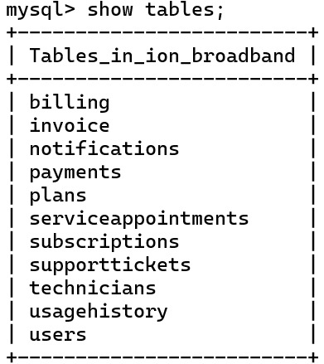-------------------------------------------------------------------------------------------------------------------------------

**Select & Desc**

**SELECT**

select * from Users;

select * from Plans;

select * from Subscriptions;

select * from UsageHistory;

select * from Invoice;

select * from SupportTickets;

select * from Payments;

select * from Technicians;

select * from ServiceAppointments;

select * from Billing;

select * from Notifications;

**DESC**

desc Users;

desc Plans;

desc Subscriptions;

desc usageHistory;

desc Invoice;

desc SupportTickets;

desc Payments;

desc Technicians;

desc ServiceAppointments;

desc Billing;

desc Notifications;

-- Questions --

-- 1.

ALTER TABLE invoice

RENAME COLUMN status TO payment_status;

-- Calculating the total revenue from invoices -- Arithmetic Operators

SELECT SUM(amount) AS total_revenue FROM Invoice;

-- Finding users with plans that have a speed of 50 . -- Comparison Operators

SELECT * FROM Users

WHERE plan_id IN (SELECT plan_id FROM Plans WHERE speed = 50) limit 5

-- Single query

-- Get the total number of cancelled subscriptions.

SELECT COUNT(*) AS active_subscriptions FROM Subscriptions WHERE status = 'Cancelled';

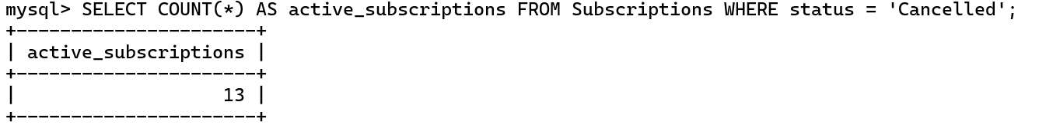

-- Retrieve all invoices that are overdue.

SELECT * FROM Invoice WHERE due_date < CURRENT_DATE AND payment_status = 'Unpaid';

-- Count the number of support tickets created by each user.

SELECT user_id, COUNT(*) AS ticket_count FROM SupportTickets GROUP BY user_id;

-- List all technicians serving in a specific area (e.g., 'Mumbai').

SELECT * FROM Technicians WHERE area_served = 'Mumbai';

-- Double Query

-- Get the subscription IDs for users who have made a payment greater than the average payment amount..

SELECT subscription_id FROM Subscriptions

WHERE user_id IN (

SELECT user_id FROM Payments

WHERE amount > (SELECT AVG(amount) FROM Payments)

) limit 10;

-- which user who taken 90 day plan ?

SELECT u.user_id, u.full_name, p.plan_name, p.price

FROM Users u

JOIN Plans p ON u.plan_id = p.plan_id

WHERE p.plan_name = '60 Mbps Plan - 90 Days' -- Ensure no trailing spaces in the plan name

LIMIT 15;

-- which user who taken 30 day plan ?

SELECT u.user_id, u.full_name, p.plan_name, p.price

FROM Users u

JOIN Plans p ON u.plan_id = p.plan_id

WHERE p.duration = 30 limit 5;

-- Finding users with either a 'Cancelled' subscription status or a support ticket status of 'Open'.

-- Logical Operators

SELECT * FROM Users

WHERE user_id IN (SELECT user_id FROM Subscriptions WHERE status = 'Cancelled')

OR user_id IN (SELECT user_id FROM SupportTickets WHERE status = 'Open') limit 10;

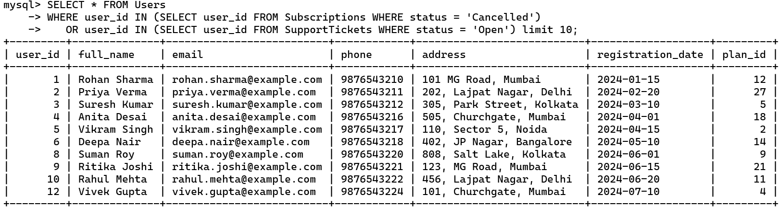

-- Finding all invoices with due dates between two dates -- Between Operator

SELECT * FROM Invoice

WHERE due_date BETWEEN '2024-02-01' AND '2024-02-28';

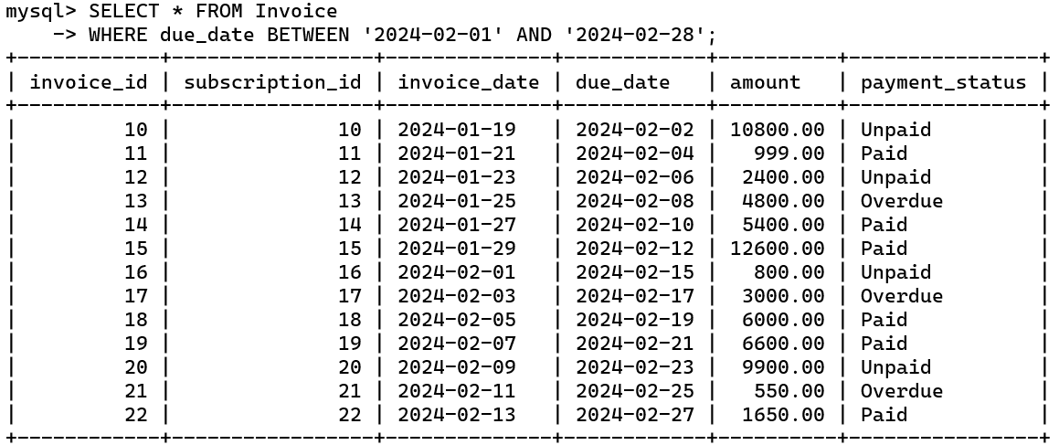

-- Finding users with names starting with 'J'. -- Like Operator

SELECT * FROM Users

WHERE full_name LIKE 'J%';

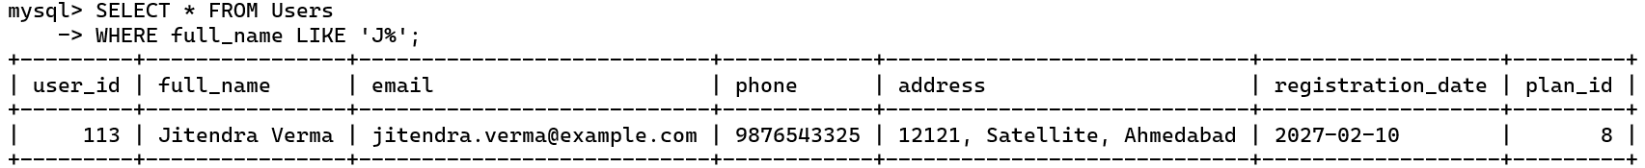

-- Ordering users by registration date. -- Order By Clause

SELECT * FROM Users

ORDER BY registration_date DESC limit 10;

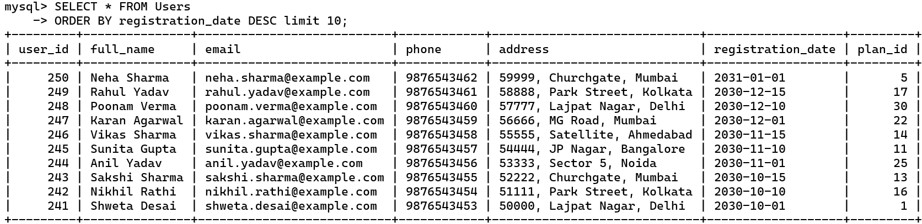

-- Calculating the average price of plans.

SELECT AVG(price) AS average_price FROM Plans;

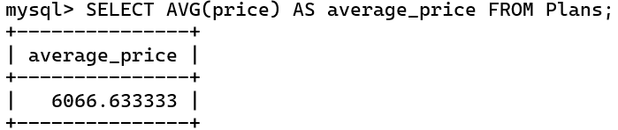

-- Grouping the total data used by each user. -- Group By Clause

SELECT user_id, SUM(data_used) AS total_data_used

FROM UsageHistory

GROUP BY user_id;

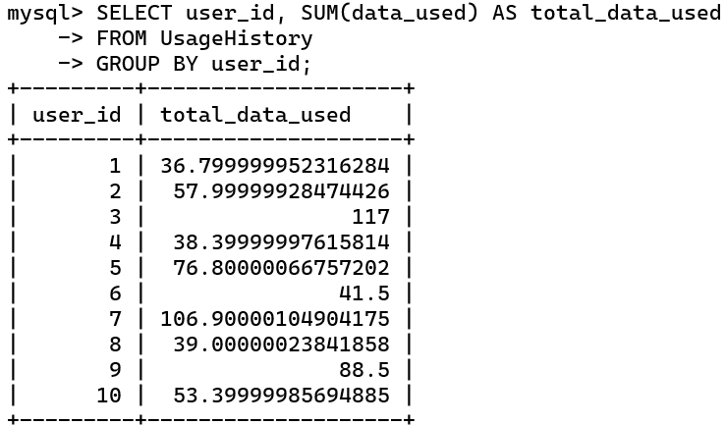

-- Filtering the group to only show users who have used more than 10 GB of data. -- Having Clause

SELECT user_id, SUM(data_used) AS total_data_used

FROM UsageHistory

GROUP BY user_id

HAVING SUM(data_used) > 10;

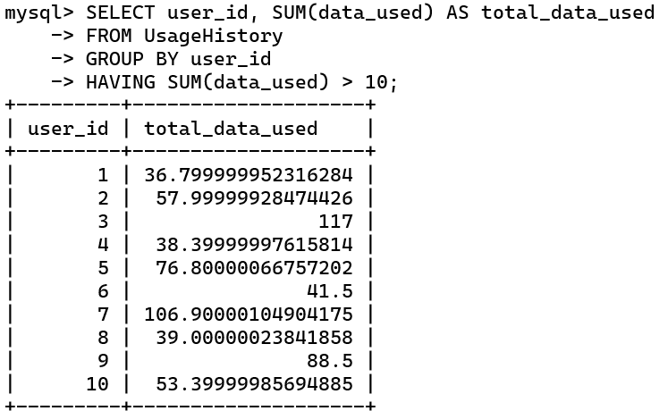

-- Getting the user who has the highest total amount in invoices.

SELECT invoice_id

FROM Invoice

WHERE amount = (SELECT MAX(amount) FROM Invoice);

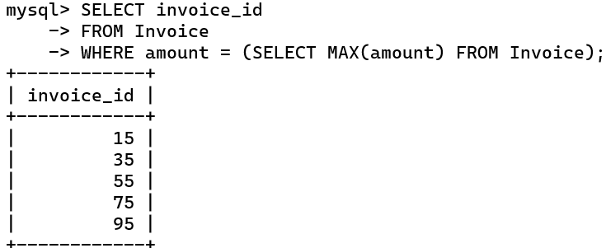

-- Get all notifications for the user with user_id = 101.

SELECT * FROM Notifications

WHERE user_id = 101;

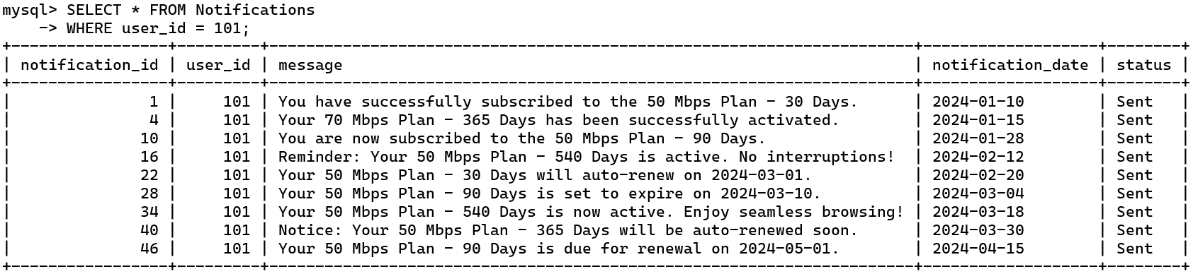

-- Fetch 10 users along with their subscription details (plan name and status).

SELECT u.user_id, u.full_name, p.plan_name, s.status

FROM Users u

JOIN Subscriptions s ON u.user_id = s.user_id

JOIN Plans p ON s.plan_id = p.plan_id limit 10;

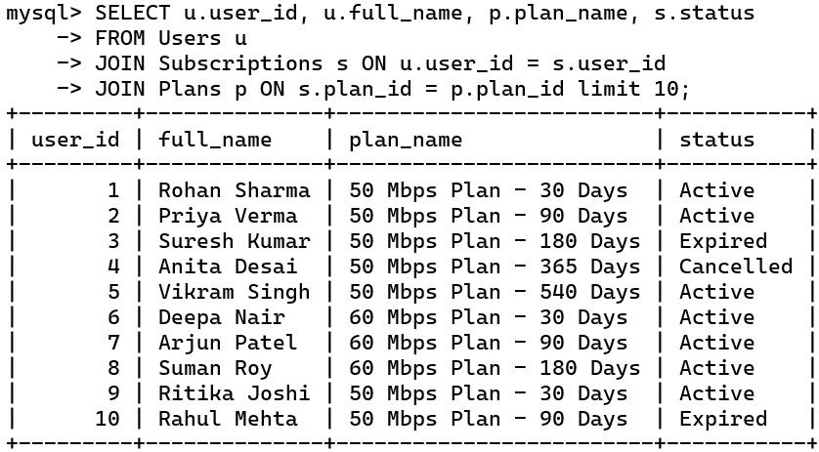

-- Get a list of active users along with their data usage history.

SELECT u.user_id, u.full_name, uh.date, uh.data_used

FROM Users u

JOIN Subscriptions s ON u.user_id = s.user_id

JOIN UsageHistory uh ON u.user_id = uh.user_id

WHERE s.status = 'Active';

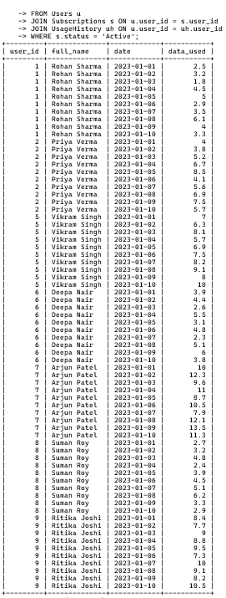

-- Calculate the total revenue generated from all paid invoices.

SELECT SUM(amount) AS total_revenue

FROM Invoice

WHERE payment_status = 'Paid';

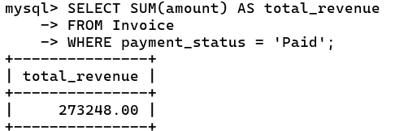

-- Count the number of support tickets grouped by their status.

SELECT status, COUNT(*) AS ticket_count

FROM SupportTickets

GROUP BY status;

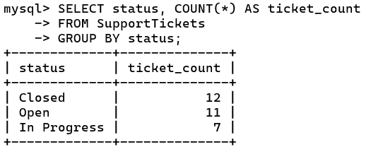

-- Retrieve recent payments made, showing the payment method and status.

SELECT p.payment_id, p.amount, p.payment_date, p.payment_method, p.status

FROM Payments p

ORDER BY p.payment_date DESC

LIMIT 10;

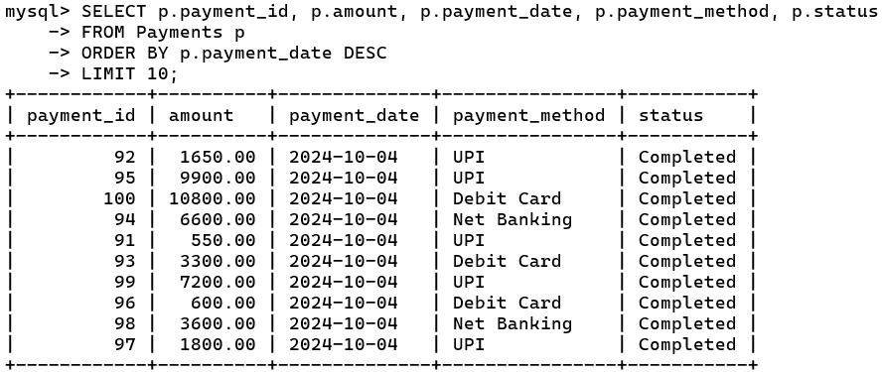

-- Find 15 users who do not have any active subscriptions.

SELECT u.user_id, u.full_name

FROM Users u

LEFT JOIN Subscriptions s ON u.user_id = s.user_id AND s.status = 'Active'

WHERE s.subscription_id IS NULL limit 15;

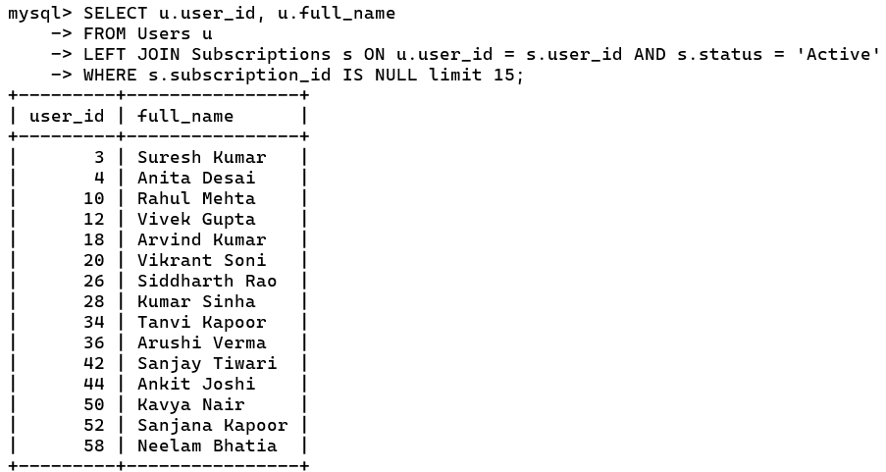

-- Get a list of 5 technicians and their upcoming service appointments.

SELECT t.technician_id, t.full_name, sa.service_date, sa.service_type

FROM Technicians t

JOIN ServiceAppointments sa ON t.technician_id = sa.technician_id

WHERE sa.status = 'Scheduled' limit 5;

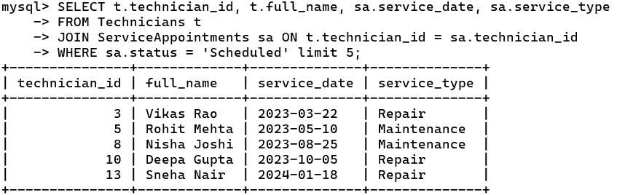

-- Get a summary of billing details for a specific user.

SELECT b.bill_id, b.billing_period_start, b.billing_period_end, b.total_amount

FROM Billing b

JOIN Users u ON b.user_id = u.user_id

WHERE u.user_id = 101;

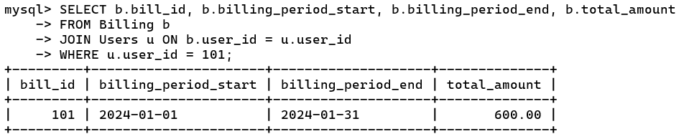

-- Find subscriptions that are about to expire within the next 30 days.

SELECT s.subscription_id, u.full_name, p.plan_name, s.end_date

FROM Subscriptions s

JOIN Users u ON s.user_id = u.user_id

JOIN Plans p ON s.plan_id = p.plan_id

WHERE s.end_date BETWEEN CURDATE() AND DATE_ADD(CURDATE(), INTERVAL 30 DAY);

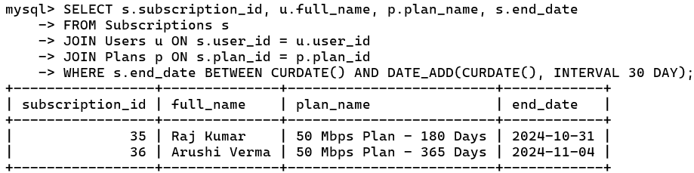

-- Get a list of invoices that are overdue for payment.

SELECT i.invoice_id, u.full_name, i.invoice_date, i.due_date, i.amount

FROM Invoice i

JOIN Subscriptions s ON i.subscription_id = s.subscription_id

JOIN Users u ON s.user_id = u.user_id

WHERE i.due_date < CURDATE() AND i.payment_status != 'Paid' limit 10;

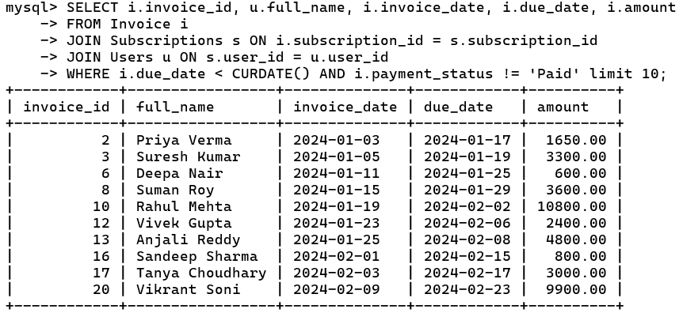

-- Which plans and prices are associated with the user 'Raj Kumar,' price in desc orders ?

SELECT u.user_id, u.full_name, p.plan_name AS "Plan Name", p.price AS "Plan Price"

FROM Users u

JOIN Plans p ON u.plan_id = p.plan_id

WHERE u.full_name = 'Raj Kumar'

GROUP BY u.user_id, u.full_name, p.plan_name, p.price

ORDER BY p.price DESC;

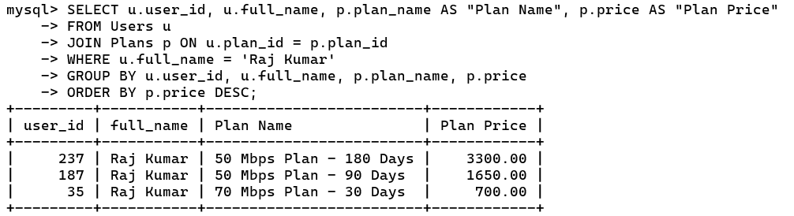

-- which ticket status are in procss

SELECT * FROM SupportTickets

WHERE status = 'In Progress';

-- Which ticket are open of the users in process'?

SELECT st.ticket_id, st.issue_description, st.status, st.created_date, st.resolved_date, u.full_name

FROM SupportTickets st

JOIN Users u ON st.user_id = u.user_id

WHERE st.status = 'In Progress';

-- which techniction is assign to which user ?

SELECT ta.appointment_id, u.full_name AS user_name, t.full_name AS technician_name, ta.service_date

FROM ServiceAppointments ta

JOIN Users u ON ta.user_id = u.user_id

JOIN Technicians t ON ta.technician_id = t.technician_id

where service_type = 'Repair';

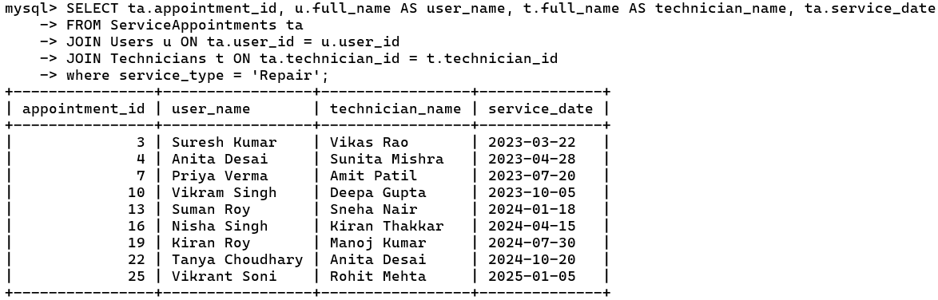

Conclusion: -

The ion_broadband database design provides a comprehensive structure to manage broadband services, covering essential components like user subscriptions, payment processing, service appointments, and customer support. By progressing through conceptual, logical, and physical data modeling, we established a robust relational schema that ensures data integrity and facilitates seamless interactions among entities. This database effectively supports key operations, including tracking user plans, monitoring data usage, generating invoices, managing technician assignments, and maintaining customer communications, thus enabling efficient management and scalable growth for broadband services.

***********************

*** THE END ***

***********************