JAVA PROGRAMMING
Lab Programs Documentation

All programs from Java basics to file handling, in the order they were written, grouped by concept, each with its source code and terminal/GUI output.

Name | Ashutosh Pawar
Roll Number | 150096725130
Cohort | Sam Altman
Programs | 33 (August to September 2026)

Index of Programs
Programs are grouped into six parts by concept. Inside each part they appear in the order they were written.
No. | Program | File | Date
Part 1: Java Fundamentals
1 | Variable Demo | variabledemo.java | 03 Aug 2026
2 | Addition of Two Numbers | addnum.java | 03 Aug 2026
3 | Reading a Name | userInput.java | 10 Aug 2026
4 | Add Two Numbers from Input | inputAddTwo.java | 10 Aug 2026
5 | Exam Eligibility Checker | examEligibility.java | 11 Aug 2026
6 | ATM Menu (Console) | ATM.java | 11 Aug 2026
7 | Search in a Matrix | SearchMatrix.java | 12 Aug 2026
8 | Matrix Input and Display | InputMatrix.java | 12 Aug 2026
9 | Student Profile System | StudentProfileSystem.java | 17 Aug 2026
Part 2: GUI Programming with Swing
10 | Student Form | StudentForm.java | 17 Aug 2026
11 | Login Form | LoginForm.java | 17 Aug 2026
12 | Calculator | Calcu.java | 17 Aug 2026
13 | Student Registration Form | StudentRegisForm.java | 19 Aug 2026
14 | Mouse Events | MouseEvents.java | 19 Aug 2026
15 | Key Events | KeyListener.java | 20 Aug 2026
16 | Student Feedback Form | StudentFeedbackForm.java | 20 Aug 2026
17 | Bus Reservation Booking | BusBooking.java | 21 Aug 2026
Part 3: Object Oriented Programming
18 | ATM (Swing, procedural) | ATM.java | 24 Aug 2026
19 | Bank Account Management (OOP) | ATMOOPS.java | 24 Aug 2026
20 | Student Registration (Encapsulation) | StudentForm.java | 25 Aug 2026
21 | Login Form with User Roles | LoginForm.java | 27 Aug 2026
22 | Array Search Checker | LinearSearch.java | 27 Aug 2026
23 | Array Operations | SearchNDestroy.java | 10 Sep 2026
Part 4: Collections Framework
24 | College Library (TreeMap) | CollegeLibrary.java | 08 Sep 2026
25 | Student Management (HashSet + LinkedList) | StudentManagement.java | 10 Sep 2026
26 | Music Playlist (LinkedList) | LinkedListMusic.java | 10 Sep 2026
27 | HashSet Operations | hash.java | 10 Sep 2026
28 | HashMap Operations | hashmap.java | 10 Sep 2026
29 | Shopping Stock and Cart System | ShoppingAssignment.java | 10 Sep 2026
Part 5: Exception Handling
30 | Bank Withdrawal (throw) | BankExample.java | 11 Sep 2026
31 | Array Index Out of Bounds | OutOfBoundIndex.java | 11 Sep 2026
Part 6: File Handling
32 | Save Student Record to File | StudentFile.java | 16 Sep 2026
33 | Search a Word in a File | SearchWord.java | 16 Sep 2026

Part 1: Java Fundamentals
Every Java program lives inside a class, and execution starts at public static void main(String[] args). A .java file is compiled to bytecode with javac and run on the JVM with java.
This part covers primitive data types, reading input with Scanner, decision making with if-else and switch, and working with one and two dimensional arrays.
Programs in this part:
- Variables and Data Types: 1. Variable Demo, 2. Addition of Two Numbers
- User Input with Scanner: 3. Reading a Name, 4. Add Two Numbers from Input
- Decision Making: 5. Exam Eligibility Checker, 6. ATM Menu (Console)
- Two Dimensional Arrays: 7. Search in a Matrix, 8. Matrix Input and Display
- Arrays and Loops: Student Report Card: 9. Student Profile System

Program 1: Variable Demo
Java Fundamentals › Variables and Data Types
File: variabledemo.java | Class: variabledemo | Date: 03 Aug 2026

Aim: Declare variables of the four most common primitive types and print their values.
Concepts used:
- int stores whole numbers, double stores decimals, char stores a single character in single quotes, boolean stores true/false.
- The + operator joins a String with any value, so "Age = " + age prints the value next to the label.

Source Code
public class variabledemo {
public static void main(String[] args) {
int age = 18;
double marks = 89.5;
char grade = 'A';
boolean passed = true;

System.out.println("Age = " + age);
System.out.println("Marks = " + marks);
System.out.println("Grade = " + grade);
System.out.println("passed = " + passed);

}
}

Output
Run: javac variabledemo.java && java variabledemo
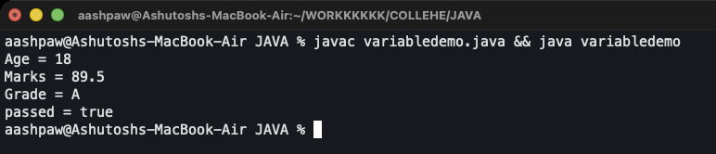
Figure 1: Output

Program 2: Addition of Two Numbers
Java Fundamentals › Variables and Data Types
File: addnum.java | Class: addnum | Date: 03 Aug 2026

Aim: Add two integers stored in variables and print the result.
Concepts used:
- The sum is wrapped in brackets: (numa+numb). Without them Java would join the numbers as text ("2399") instead of adding them.
- Arithmetic operators: + - * / %.

Source Code
public class addnum {
public static void main(String[] args) {
int numa = 23;
int numb = 99;
System.out.println("the addition of the numbers is = " + (numa+numb));

}
}

Output
Run: javac addnum.java && java addnum
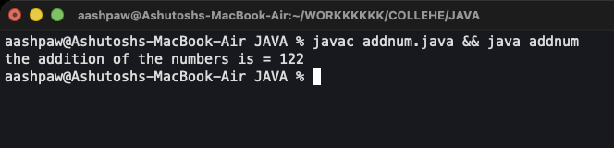
Figure 2: Output

Program 3: Reading a Name
Java Fundamentals › User Input with Scanner
File: userInput.java | Class: userInput | Date: 10 Aug 2026

Aim: Read the user's name from the keyboard and greet them.
Concepts used:
- Scanner sc = new Scanner(System.in) connects a Scanner to keyboard input.
- nextLine() reads the whole line, including spaces.
- sc.close() releases the input stream at the end.

Source Code
import java.util.Scanner;

public class userInput {
public static void main(String[] args) {
Scanner sc = new Scanner(System.in);

System.out.print("Enter your name: ");
String name = sc.nextLine();

System.out.println("Welcome "+ name);

sc.close();
}
}

Output
Run: javac userInput.java && java userInput
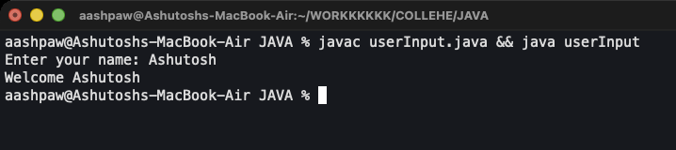
Figure 3: Output

Program 4: Add Two Numbers from Input
Java Fundamentals › User Input with Scanner
File: inputAddTwo.java | Class: inputAddTwo | Date: 10 Aug 2026

Aim: Read two integers from the user and print their sum.
Concepts used:
- nextInt() reads the next whole number typed by the user.
- print() keeps the cursor on the same line so the user types right after the prompt.

Source Code
import java.util.Scanner;

public class inputAddTwo {
public static void main(String[] args) {
Scanner sc = new Scanner(System.in);

System.out.print("Enter the first number: ");
int num1 = sc.nextInt();
System.out.print("Enter the second number: ");
int num2 = sc.nextInt();

System.out.print("The addition of the two numbers is: "+ (num1+num2));

sc.close();
}
}

Output
Run: javac inputAddTwo.java && java inputAddTwo
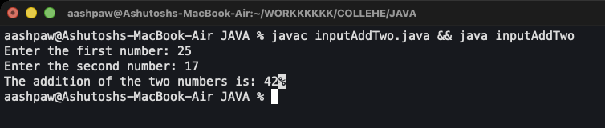
Figure 4: Output

Program 5: Exam Eligibility Checker
Java Fundamentals › Decision Making
File: examEligibility.java | Class: examEligibility | Date: 11 Aug 2026

Aim: Decide whether a student can sit for the exam based on attendance, internal marks and assignment submission.
Concepts used:
- Reads three different types: nextDouble(), nextInt() and nextBoolean().
- The && (logical AND) operator makes the condition true only when all three rules pass.
- if-else picks one of the two messages.

Source Code
import java.util.Scanner;

public class examEligibility {
public static void main(String[] args) {
Scanner sc = new Scanner(System.in);

System.out.print("Enter Attendace percentage: ");
double attendance = sc.nextDouble();

System.out.print("Enter internal marks: ");
int marks = sc.nextInt();

System.out.print("Assignment Submitted? (true/false): ");
boolean assignment = sc.nextBoolean();

if (attendance >= 75.00 && marks >= 40 && assignment) {
System.out.print("ELIGIBLEEEEE!!!!");
} else {
System.out.print("NOT ELIGIBLE");
}

sc.close();
}
}

Output
Run: javac examEligibility.java && java examEligibility
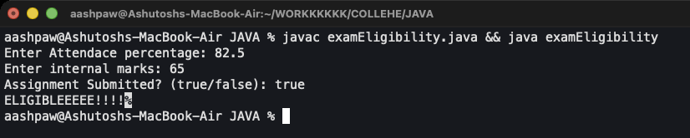
Figure 5: Output

Program 6: ATM Menu (Console)
Java Fundamentals › Decision Making
File: ATM.java | Class: ATM | Date: 11 Aug 2026

Aim: A menu driven ATM that withdraws, deposits or shows the balance.
Concepts used:
- switch-case runs a different block for each menu option; default handles invalid choices.
- hasNextInt() / hasNextDouble() check the input type before reading, so text input does not crash the program.
- Nested if-else validates the amount (non-negative, not more than the balance).

Source Code
import java.util.Scanner;

public class ATM {
public static void main(String[] args) {
Scanner sc = new Scanner(System.in);
double balance = 1000.0;

System.out.println("===== ATM MENU =====");
System.out.println("1. Withdraw");
System.out.println("2. Deposit");
System.out.println("3. Show Balance");
System.out.print("Choose an option: ");

if (!sc.hasNextInt()) {
System.out.println("Invalid input. Please enter a number.");
sc.close();
return;
}

int choice = sc.nextInt();

switch (choice) {
case 1:
System.out.print("Enter amount to withdraw: ");

if (!sc.hasNextDouble()) {
System.out.println("Invalid amount. Please enter a number.");
break;
}

double withdrawAmount = sc.nextDouble();

if (withdrawAmount <= 0) {
System.out.println("Invalid amount.");
} else if (withdrawAmount > balance) {
System.out.println("Insufficient balance. You have: " + balance);
} else {
balance -= withdrawAmount;
System.out.println("Withdrew: " + withdrawAmount);
System.out.println("Remaining balance: " + balance);
}
break;

case 2:
System.out.print("Enter amount to deposit: ");

if (!sc.hasNextDouble()) {
System.out.println("Invalid amount. Please enter a number.");
break;
}

double depositAmount = sc.nextDouble();

if (depositAmount <= 0) {
System.out.println("Invalid amount.");
} else {
balance += depositAmount;
System.out.println("Deposited: " + depositAmount);
System.out.println("New balance: " + balance);
}
break;

case 3:
System.out.println("Your current balance is: " + balance);
break;

default:
System.out.println("Invalid option. Please choose 1-3.");
}

sc.close();
}
}

Output
Run: javac ATM.java && java ATM
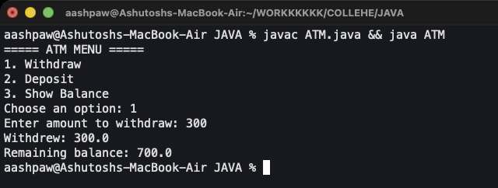
Figure 6: Output: option 1 (withdraw 300)

Program 7: Search in a Matrix
Java Fundamentals › Two Dimensional Arrays
File: SearchMatrix.java | Class: SearchMatrix | Date: 12 Aug 2026

Aim: Search for a number inside a 3x3 matrix and print its row and column.
Concepts used:
- int[][] matrix = {{...},{...},{...}} creates a 2D array with initial values.
- Nested for loops visit every row (i) and column (j).
- A boolean flag plus break stops both loops once the number is found.

Source Code
public class SearchMatrix {
public static void main(String[] args) {
int [][] matrix = {
{10,20,30},
{40,50,60},
{70,80,90}
};

int search = 50;
boolean found = false;

for (int i = 0; i < matrix.length;i++){
for (int j = 0; j < matrix[i].length;j++){
if (matrix[i][j] == search) {
System.out.println("found at row " + i + ", column " + j);
found = true;
break;
}
}
if (found){
break;
}
}
if (!found) {
System.out.println("number not found!!!");
}
}
}

Output
Run: javac SearchMatrix.java && java SearchMatrix
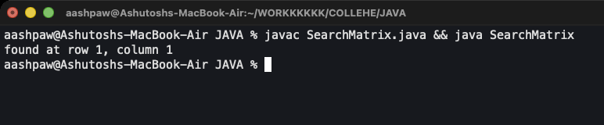
Figure 7: Output

Program 8: Matrix Input and Display
Java Fundamentals › Two Dimensional Arrays
File: InputMatrix.java | Class: InputMatrix | Date: 12 Aug 2026

Aim: Create a matrix of any size entered by the user, fill it element by element, then display it.
Concepts used:
- new int[rows][columns] creates the array at runtime using the user's sizes.
- matrix.length gives the number of rows, matrix[i].length gives the number of columns.
- "\t" (tab) keeps the printed columns aligned.

Source Code
import java.util.Scanner;

public class InputMatrix {
public static void main(String[] args) {
Scanner sc = new Scanner(System.in);

System.out.print("Enter the number of rows: ");
int rows = sc.nextInt();

System.out.print("Enter the number of columns: ");
int columns = sc.nextInt();

int[][] matrix = new int[rows][columns];

for (int i = 0; i < rows; i++) {
for (int j = 0; j < columns; j++) {
System.out.print("Enter element at row " + i + ", column " + j + ": ");
matrix[i][j] = sc.nextInt();
}
}

System.out.println("\nMatrix:");
for (int i = 0; i < matrix.length; i++) {
for (int j = 0; j < matrix[i].length; j++) {
System.out.print(matrix[i][j] + "\t"); // \t adds clean tab spacing
}
System.out.println();
}

sc.close();
}
}

Output
Run: javac InputMatrix.java && java InputMatrix
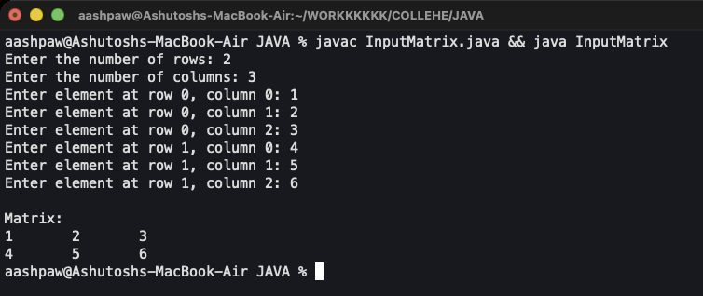
Figure 8: Output: 2 x 3 matrix

Program 9: Student Profile System
Java Fundamentals › Arrays and Loops: Student Report Card
File: StudentProfileSystem.java | Class: StudentProfileSystem | Date: 17 Aug 2026

Aim: Take a student's name and marks for 5 subjects, then print a full report card with total, average, percentage, grade, result, and best/weakest subject.
Concepts used:
- A double[] array stores the 5 marks; a loop reads and validates each one (0 to 100).
- An if-else-if ladder assigns grades A/B/C/D/F; pass mark is 40%.
- A single loop tracks the index of the highest and lowest marks.
- printf("%.2f") prints values rounded to 2 decimal places.

Source Code
import java.util.Scanner;

public class StudentProfileSystem {
public static void main(String[] args) {
Scanner sc = new Scanner(System.in);
int subjects = 5;
double[] marks = new double[subjects];
double total = 0;

System.out.print("Enter your name: ");
String name = sc.nextLine();
System.out.println();

for (int i = 0; i < subjects; i++) {
System.out.print("Enter marks for subject " + (i + 1) + " (0-100): ");

if (!sc.hasNextDouble()) {
System.out.println("Invalid input. Please enter a number.");
sc.close();
return;
}

marks[i] = sc.nextDouble();

if (marks[i] < 0 || marks[i] > 100) {
System.out.println("Marks must be between 0 and 100.");
sc.close();
return;
}

total += marks[i];
}

System.out.println();

double percentage = (total / (subjects * 100)) * 100;
String grade;
String result;

if (percentage >= 90) {
grade = "A";
} else if (percentage >= 75) {
grade = "B";
} else if (percentage >= 60) {
grade = "C";
} else if (percentage >= 40) {
grade = "D";
} else {
grade = "F";
}

if (percentage >= 40) {
result = "Pass";
} else {
result = "Fail";
}

int highest = 0;
int lowest = 0;
int weakCount = 0;

for (int i = 1; i < subjects; i++) {
if (marks[i] > marks[highest]) {
highest = i;
}
if (marks[i] < marks[lowest]) {
lowest = i;
}
}

System.out.println("===== Report Card =====");
System.out.println("Name: " + name);

for (int i = 0; i < subjects; i++) {
if (marks[i] < 40) {
System.out.println("Subject " + (i + 1) + ": " + marks[i] + " (weak)");
weakCount++;
} else {
System.out.println("Subject " + (i + 1) + ": " + marks[i]);
}
}

System.out.println("Total Marks: " + total + " / " + (subjects * 100));
System.out.printf("Average: %.2f\n", total / subjects);
System.out.println("Best Subject: Subject " + (highest + 1) + " (" + marks[highest] + ")");
System.out.println("Weakest Subject: Subject " + (lowest + 1) + " (" + marks[lowest] + ")");
System.out.println("Subjects below 40: " + weakCount);
System.out.printf("Percentage: %.2f%%\n", percentage);
System.out.println("Grade: " + grade);
System.out.println("Result: " + result);
System.out.println();

sc.close();
}
}

Output
Run: javac StudentProfileSystem.java && java StudentProfileSystem
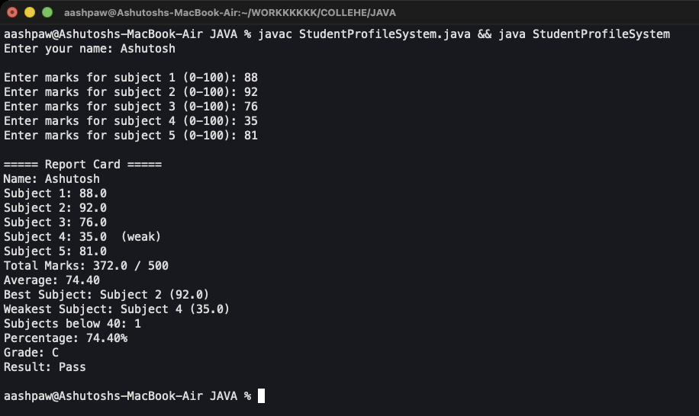
Figure 9: Output

Part 2: GUI Programming with Swing
Swing (javax.swing) is Java's toolkit for desktop windows. A JFrame is the window; components such as JLabel, JTextField, JButton, JComboBox and JCheckBox are added to it.
With setLayout(null) each component is placed by hand using setBounds(x, y, width, height).
Programs react to the user through event listeners: ActionListener for button clicks, MouseListener for mouse actions and KeyListener for keyboard input. JOptionPane shows pop-up message dialogs.
Programs in this part:
- Basic Components and ActionListener: 10. Student Form, 11. Login Form, 12. Calculator
- Choice Components: 13. Student Registration Form
- Mouse and Keyboard Events: 14. Mouse Events, 15. Key Events, 16. Student Feedback Form
- Assignment 1: Bus Reservation: 17. Bus Reservation Booking

Program 10: Student Form
GUI Programming with Swing › Basic Components and ActionListener
File: swing/StudentForm.java | Class: StudentForm | Date: 17 Aug 2026

Aim: A window that asks for a name and greets the user in a pop-up when Submit is clicked.
Concepts used:
- JLabel, JTextField and JButton are created and placed with setBounds().
- button.addActionListener(e -> {...}) uses a lambda to handle the click.
- JOptionPane.showMessageDialog() shows the greeting.

Source Code
import javax.swing.*;

public class StudentForm {
public static void main(String[] args) {
JFrame frame = new JFrame("Student Form");

JLabel nameLabel = new JLabel("Enter your name: ");

JTextField nameTextField = new JTextField();

JButton button = new JButton("Submit");

// (x,y,width,height)
nameLabel.setBounds(50,50,120,30);
nameTextField.setBounds(180,50,200,30);
button.setBounds(180,100,100,30);

frame.add(nameLabel);
frame.add(nameTextField);
frame.add(button);

button.addActionListener(e->{
String name = nameTextField.getText();

JOptionPane.showMessageDialog(
frame,
"Hello " + name + "!"
);
});

frame.setSize(450,200);
frame.setLayout(null);
frame.setDefaultCloseOperation(JFrame.EXIT_ON_CLOSE);
frame.setVisible(true);
}
}

Output
Run: javac StudentForm.java && java StudentForm
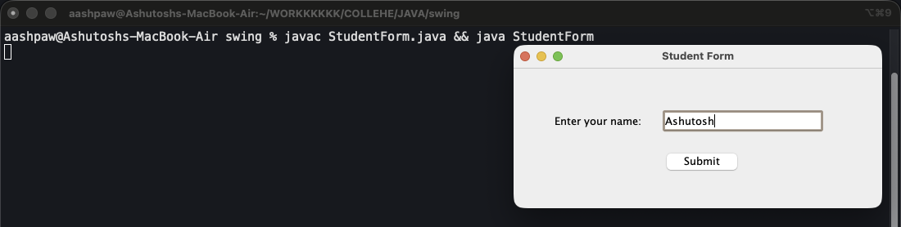
Figure 10.1: Form filled in
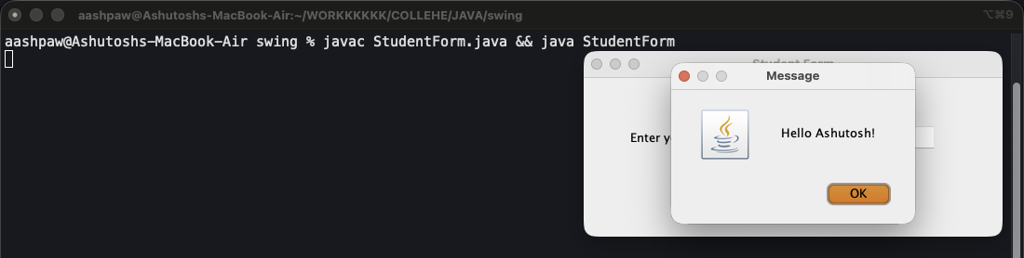
Figure 10.2: After clicking Submit

Program 11: Login Form
GUI Programming with Swing › Basic Components and ActionListener
File: swing/LoginForm.java | Class: LoginForm | Date: 17 Aug 2026

Aim: Check a user id and password and show a success or error dialog.
Concepts used:
- JPasswordField hides the typed characters; getPassword() returns a char[] which is turned into a String.
- String comparison uses equals(), not ==.
- The dialog type (INFORMATION_MESSAGE / ERROR_MESSAGE) changes the icon.

Source Code
import javax.swing.*;

public class LoginForm {
public static void main(String[] args) {
JFrame frame = new JFrame("Login Form");

JLabel userLabel = new JLabel("Enter user id: ");
JLabel passLabel = new JLabel("Enter password: ");

JTextField userTextField = new JTextField();
JPasswordField passField = new JPasswordField();

JButton button = new JButton("Login");

// (x,y,width,height)
userLabel.setBounds(50,50,120,30);
userTextField.setBounds(180,50,200,30);
passLabel.setBounds(50,100,120,30);
passField.setBounds(180,100,200,30);
button.setBounds(180,150,100,30);

frame.add(userLabel);
frame.add(userTextField);
frame.add(passLabel);
frame.add(passField);
frame.add(button);

button.addActionListener(e->{
String userId = userTextField.getText();
String password = new String(passField.getPassword());

if (userId.equals("admin") && password.equals("1234")) {
JOptionPane.showMessageDialog(
frame,
"Login successful! Welcome " + userId + "!",
"Success",
JOptionPane.INFORMATION_MESSAGE
);
} else {
JOptionPane.showMessageDialog(
frame,
"Incorrect user id or password!",
"Login Failed",
JOptionPane.ERROR_MESSAGE
);
}
});

frame.setSize(450,250);
frame.setLayout(null);
frame.setDefaultCloseOperation(JFrame.EXIT_ON_CLOSE);
frame.setVisible(true);
}
}

Output
Run: javac LoginForm.java && java LoginForm
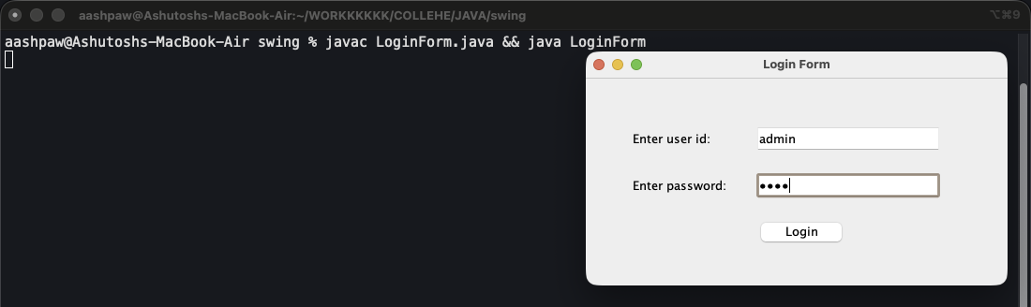
Figure 11.1: Credentials entered (admin / 1234)
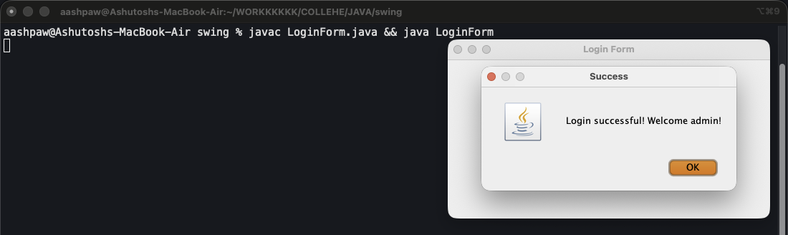
Figure 11.2: Login successful

Program 12: Calculator
GUI Programming with Swing › Basic Components and ActionListener
File: swing/Calcu.java | Class: Calcu | Date: 17 Aug 2026

Aim: A calculator with +, -, * and / buttons for two numbers.
Concepts used:
- Double.parseDouble() converts the text in a field into a number.
- Each button has its own ActionListener; the result is shown in a read-only field (setEditable(false)).
- Division checks for zero and shows an error dialog instead of dividing.

Source Code
import javax.swing.*;

public class Calcu {
public static void main(String[] args) {
JFrame frame = new JFrame("Calculator");

JLabel num1Label = new JLabel("Number 1: ");
JLabel num2Label = new JLabel("Number 2: ");
JLabel resultLabel = new JLabel("Result: ");

JTextField num1TextField = new JTextField();
JTextField num2TextField = new JTextField();
JTextField resultTextField = new JTextField();
resultTextField.setEditable(false);

JButton addButton = new JButton("+");
JButton subButton = new JButton("-");
JButton mulButton = new JButton("*");
JButton divButton = new JButton("/");

// (x,y,width,height)
num1Label.setBounds(50,50,120,30);
num1TextField.setBounds(180,50,200,30);
num2Label.setBounds(50,100,120,30);
num2TextField.setBounds(180,100,200,30);
resultLabel.setBounds(50,150,120,30);
resultTextField.setBounds(180,150,200,30);

addButton.setBounds(50,200,70,30);
subButton.setBounds(130,200,70,30);
mulButton.setBounds(210,200,70,30);
divButton.setBounds(290,200,70,30);

frame.add(num1Label);
frame.add(num1TextField);
frame.add(num2Label);
frame.add(num2TextField);
frame.add(resultLabel);
frame.add(resultTextField);
frame.add(addButton);
frame.add(subButton);
frame.add(mulButton);
frame.add(divButton);

addButton.addActionListener(e->{
double num1 = Double.parseDouble(num1TextField.getText());
double num2 = Double.parseDouble(num2TextField.getText());

resultTextField.setText(String.valueOf(num1 + num2));
});

subButton.addActionListener(e->{
double num1 = Double.parseDouble(num1TextField.getText());
double num2 = Double.parseDouble(num2TextField.getText());

resultTextField.setText(String.valueOf(num1 - num2));
});

mulButton.addActionListener(e->{
double num1 = Double.parseDouble(num1TextField.getText());
double num2 = Double.parseDouble(num2TextField.getText());

resultTextField.setText(String.valueOf(num1 * num2));
});

divButton.addActionListener(e->{
double num1 = Double.parseDouble(num1TextField.getText());
double num2 = Double.parseDouble(num2TextField.getText());

if (num2 == 0) {
JOptionPane.showMessageDialog(
frame,
"Cannot divide by zero!",
"Error",
JOptionPane.ERROR_MESSAGE
);
} else {
resultTextField.setText(String.valueOf(num1 / num2));
}
});

frame.setSize(450,300);
frame.setLayout(null);
frame.setDefaultCloseOperation(JFrame.EXIT_ON_CLOSE);
frame.setVisible(true);
}
}

Output
Run: javac Calcu.java && java Calcu
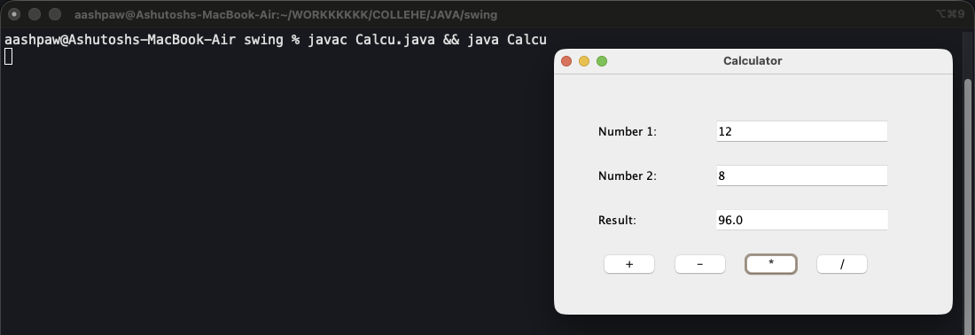
Figure 12: 12 * 8 = 96.0

Program 13: Student Registration Form
GUI Programming with Swing › Choice Components
File: swing/StudentRegisForm.java | Class: StudentRegisForm | Date: 19 Aug 2026

Aim: A full registration form with text fields, gender radio buttons, a course drop-down and hobby check boxes, with validation.
Concepts used:
- JRadioButtons are added to a ButtonGroup so only one can be selected.
- JComboBox<String> is a drop-down list; getSelectedItem() returns the choice.
- JCheckBox allows many selections; isSelected() checks each one.
- try-catch around Long.parseLong() rejects a roll number that is not numeric; the email must contain @ and .com.
- The Clear button resets every component.

Source Code
import javax.swing.*;

public class StudentRegisForm {
public static void main(String[] args) {
JFrame frame = new JFrame("Student Registration Form");

JLabel nameLabel = new JLabel("Name: ");
JLabel rollLabel = new JLabel("Roll Number: ");
JLabel emailLabel = new JLabel("Email: ");
JLabel genderLabel = new JLabel("Gender: ");
JLabel courseLabel = new JLabel("Course: ");
JLabel hobbiesLabel = new JLabel("Hobbies: ");

JTextField nameTextField = new JTextField();
JTextField rollTextField = new JTextField();
JTextField emailTextField = new JTextField();

JRadioButton maleButton = new JRadioButton("Male");
JRadioButton femaleButton = new JRadioButton("Female");

ButtonGroup genderGroup = new ButtonGroup();
genderGroup.add(maleButton);
genderGroup.add(femaleButton);

String[] courses = {"B.Tech", "BBA", "BSc", "BCom", "BA"};
JComboBox<String> courseBox = new JComboBox<>(courses);

JCheckBox readingBox = new JCheckBox("Reading");
JCheckBox sportsBox = new JCheckBox("Sports");
JCheckBox musicBox = new JCheckBox("Music");
JCheckBox codingBox = new JCheckBox("Coding");

JButton submitButton = new JButton("Submit");
JButton clearButton = new JButton("Clear");

// (x,y,width,height)
nameLabel.setBounds(50,30,120,30);
nameTextField.setBounds(200,30,220,30);

rollLabel.setBounds(50,70,120,30);
rollTextField.setBounds(200,70,220,30);

emailLabel.setBounds(50,110,120,30);
emailTextField.setBounds(200,110,220,30);

genderLabel.setBounds(50,150,120,30);
maleButton.setBounds(200,150,80,30);
femaleButton.setBounds(290,150,90,30);

courseLabel.setBounds(50,190,120,30);
courseBox.setBounds(200,190,220,30);

hobbiesLabel.setBounds(50,230,120,30);
readingBox.setBounds(200,230,100,30);
sportsBox.setBounds(310,230,100,30);
musicBox.setBounds(200,265,100,30);
codingBox.setBounds(310,265,100,30);

submitButton.setBounds(150,320,100,30);
clearButton.setBounds(270,320,100,30);

frame.add(nameLabel);
frame.add(nameTextField);
frame.add(rollLabel);
frame.add(rollTextField);
frame.add(emailLabel);
frame.add(emailTextField);
frame.add(genderLabel);
frame.add(maleButton);
frame.add(femaleButton);
frame.add(courseLabel);
frame.add(courseBox);
frame.add(hobbiesLabel);
frame.add(readingBox);
frame.add(sportsBox);
frame.add(musicBox);
frame.add(codingBox);
frame.add(submitButton);
frame.add(clearButton);

submitButton.addActionListener(e->{
String name = nameTextField.getText();
String roll = rollTextField.getText();
String email = emailTextField.getText();

// roll number must be digits only
try {
Long.parseLong(roll);
} catch (NumberFormatException ex) {
JOptionPane.showMessageDialog(
frame,
"Roll number must be a number!",
"Invalid Roll Number",
JOptionPane.ERROR_MESSAGE
);
return;
}

// email must have @ and .com
if (!email.contains("@") || !email.contains(".com")) {
JOptionPane.showMessageDialog(
frame,
"Email must contain @ and .com !",
"Invalid Email",
JOptionPane.ERROR_MESSAGE
);
return;
}

String gender = "Not selected";
if (maleButton.isSelected()) {
gender = "Male";
} else if (femaleButton.isSelected()) {
gender = "Female";
}

String course = (String) courseBox.getSelectedItem();

String hobbies = "";
if (readingBox.isSelected()) hobbies = hobbies + "Reading ";
if (sportsBox.isSelected()) hobbies = hobbies + "Sports ";
if (musicBox.isSelected()) hobbies = hobbies + "Music ";
if (codingBox.isSelected()) hobbies = hobbies + "Coding ";
if (hobbies.equals("")) hobbies = "None";

JOptionPane.showMessageDialog(
frame,
"Name: " + name + "\n" +
"Roll Number: " + roll + "\n" +
"Email: " + email + "\n" +
"Gender: " + gender + "\n" +
"Course: " + course + "\n" +
"Hobbies: " + hobbies,
"Registration Details",
JOptionPane.INFORMATION_MESSAGE
);
});

clearButton.addActionListener(e->{
nameTextField.setText("");
rollTextField.setText("");
emailTextField.setText("");
genderGroup.clearSelection();
courseBox.setSelectedIndex(0);
readingBox.setSelected(false);
sportsBox.setSelected(false);
musicBox.setSelected(false);
codingBox.setSelected(false);
});

frame.setSize(500,420);
frame.setLayout(null);
frame.setDefaultCloseOperation(JFrame.EXIT_ON_CLOSE);
frame.setVisible(true);
}
}

Output
Run: javac StudentRegisForm.java && java StudentRegisForm
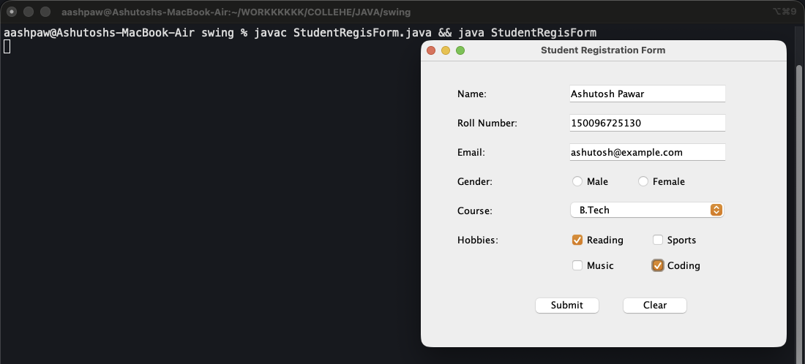
Figure 13.1: Form filled in
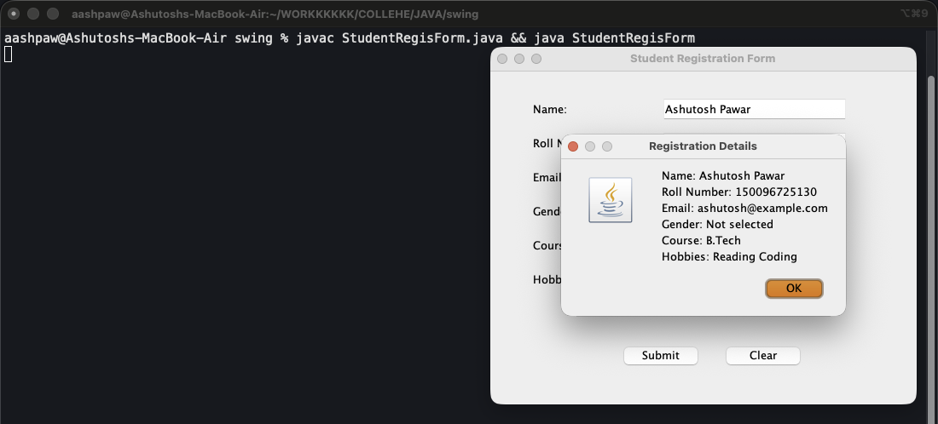
Figure 13.2: Registration details dialog

Program 14: Mouse Events
GUI Programming with Swing › Mouse and Keyboard Events
File: swing/MouseEvents.java | Class: MouseEvents | Date: 19 Aug 2026

Aim: Print a message in the terminal for every mouse event on a label.
Concepts used:
- MouseListener is an interface with 5 methods: mouseClicked, mousePressed, mouseReleased, mouseEntered, mouseExited.
- An anonymous inner class (new MouseListener() {...}) implements all of them in place.
- The terminal shows the order events fire in: Entered, Pressed, Released, Clicked, Exited.

Source Code
import java.awt.event.*;
import javax.swing.*;

public class MouseEvents {
public static void main(String[] args) {
JFrame frame = new JFrame("Mouse Example");

JLabel label = new JLabel("Click Me");

label.setBounds(100,100,100,30);

frame.add(label);

label.addMouseListener(new MouseListener() {
public void mouseClicked(MouseEvent e){
System.out.println("Mouse Clicked");
}
public void mousePressed(MouseEvent e){
System.out.println("Mouse Pressed");
}
public void mouseReleased(MouseEvent e){
System.out.println("Mouse Released");
}
public void mouseEntered(MouseEvent e){
System.out.println("Mouse Entered");
}
public void mouseExited(MouseEvent e){
System.out.println("Mouse Exited");
}
});

frame.setSize(400,300);
frame.setLayout(null);
frame.setDefaultCloseOperation(JFrame.EXIT_ON_CLOSE);
frame.setVisible(true);
}
}

Output
Run: javac MouseEvents.java && java MouseEvents
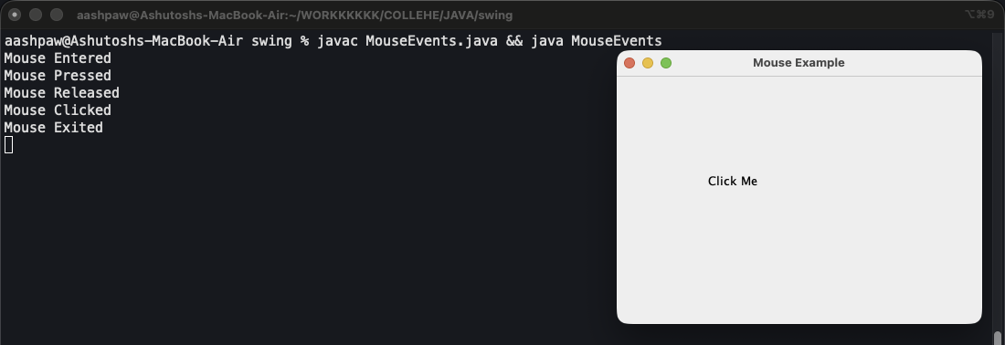
Figure 14: Terminal log after hovering over and clicking the label

Program 15: Key Events
GUI Programming with Swing › Mouse and Keyboard Events
File: swing/KeyListener.java | Class: KeyListener | Date: 20 Aug 2026

Aim: Print keyTyped, keyPressed and keyReleased events for a text field.
Concepts used:
- keyPressed / keyReleased report the physical key (KeyEvent.getKeyText), including Shift.
- keyTyped reports the character produced (getKeyChar), so it shows 'H' and 'i'.
- The class is named KeyListener, so the interface is written with its full name java.awt.event.KeyListener.

Source Code
import java.awt.event.*;
import javax.swing.*;

public class KeyListener {
public static void main(String[] args) {
JFrame frame = new JFrame("Key Example");

JTextField field = new JTextField();

field.setBounds(100,100,150,30);

frame.add(field);

field.addKeyListener(new java.awt.event.KeyListener() {
public void keyTyped(KeyEvent e){
System.out.println("Key Typed: " + e.getKeyChar());
}
public void keyPressed(KeyEvent e){
System.out.println("Key Pressed: " + KeyEvent.getKeyText(e.getKeyCode()));
}
public void keyReleased(KeyEvent e){
System.out.println("Key Released: " + KeyEvent.getKeyText(e.getKeyCode()));
}
});

frame.setSize(400,300);
frame.setLayout(null);
frame.setDefaultCloseOperation(JFrame.EXIT_ON_CLOSE);
frame.setVisible(true);
}
}

Output
Run: javac KeyListener.java && java KeyListener
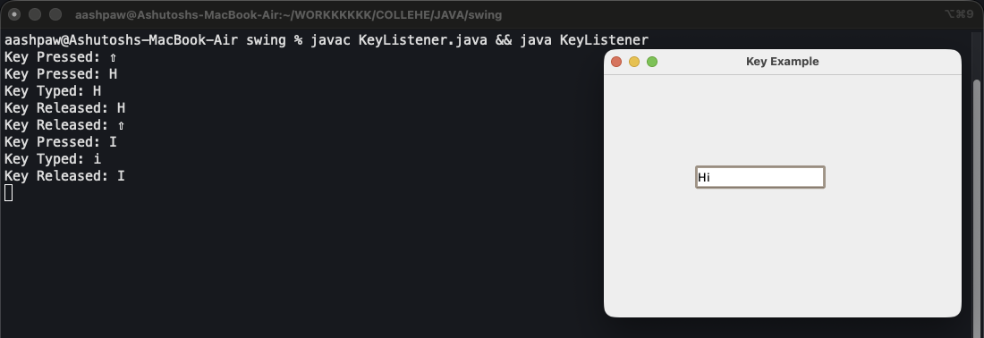
Figure 15: Typing "Hi" in the field

Program 16: Student Feedback Form
GUI Programming with Swing › Mouse and Keyboard Events
File: swing/StudentFeedbackForm.java | Class: StudentFeedbackForm | Date: 20 Aug 2026

Aim: A feedback form whose status line reacts to both keyboard and mouse activity.
Concepts used:
- JTextArea inside a JScrollPane gives a multi-line, scrollable input; setLineWrap(true) wraps long lines.
- A KeyListener on the name field sets the status to 'Student is typing'.
- A MouseListener on the feedback area reports when the mouse enters, leaves, presses or releases.

Source Code
import java.awt.event.*;
import javax.swing.*;

public class StudentFeedbackForm {
public static void main(String[] args) {
JFrame frame = new JFrame("Student Feedback Form");

JLabel nameLabel = new JLabel("Student Name: ");
JLabel feedbackLabel = new JLabel("Feedback: ");
JLabel statusLabel = new JLabel("Status: ");

JTextField nameTextField = new JTextField();

JTextArea feedbackArea = new JTextArea();
feedbackArea.setLineWrap(true);
feedbackArea.setWrapStyleWord(true);
JScrollPane feedbackScroll = new JScrollPane(feedbackArea);

JButton submitButton = new JButton("Submit");
JButton clearButton = new JButton("Clear");

// (x,y,width,height)
nameLabel.setBounds(30,30,120,30);
nameTextField.setBounds(150,30,250,30);

feedbackLabel.setBounds(30,80,120,30);
feedbackScroll.setBounds(150,80,250,120);

submitButton.setBounds(150,220,100,30);
clearButton.setBounds(270,220,100,30);

statusLabel.setBounds(30,270,400,30);

frame.add(nameLabel);
frame.add(nameTextField);
frame.add(feedbackLabel);
frame.add(feedbackScroll);
frame.add(submitButton);
frame.add(clearButton);
frame.add(statusLabel);

// keyboard listener on the name field
nameTextField.addKeyListener(new java.awt.event.KeyListener() {
public void keyTyped(KeyEvent e){
statusLabel.setText("Status: Student is typing");
}
public void keyPressed(KeyEvent e){
statusLabel.setText("Status: Student is typing");
}
public void keyReleased(KeyEvent e){
statusLabel.setText("Status: Student is typing");
}
});

// mouse listener on the feedback area
feedbackArea.addMouseListener(new MouseListener() {
public void mouseEntered(MouseEvent e){
statusLabel.setText("Status: Mouse inside feedback area");
}
public void mouseExited(MouseEvent e){
statusLabel.setText("Status: Mouse outside feedback area");
}
public void mousePressed(MouseEvent e){
statusLabel.setText("Status: Mouse Pressed in feedback area");
}
public void mouseReleased(MouseEvent e){
statusLabel.setText("Status: Mouse Released in feedback area");
}
public void mouseClicked(MouseEvent e){
}
});

submitButton.addActionListener(e->{
String name = nameTextField.getText();

JOptionPane.showMessageDialog(
frame,
name + ", your feedback has been submitted"
);
});

clearButton.addActionListener(e->{
nameTextField.setText("");
feedbackArea.setText("");
statusLabel.setText("Status: Cleared");
});

frame.setSize(470,360);
frame.setLayout(null);
frame.setDefaultCloseOperation(JFrame.EXIT_ON_CLOSE);
frame.setVisible(true);
}
}

Output
Run: javac StudentFeedbackForm.java && java StudentFeedbackForm
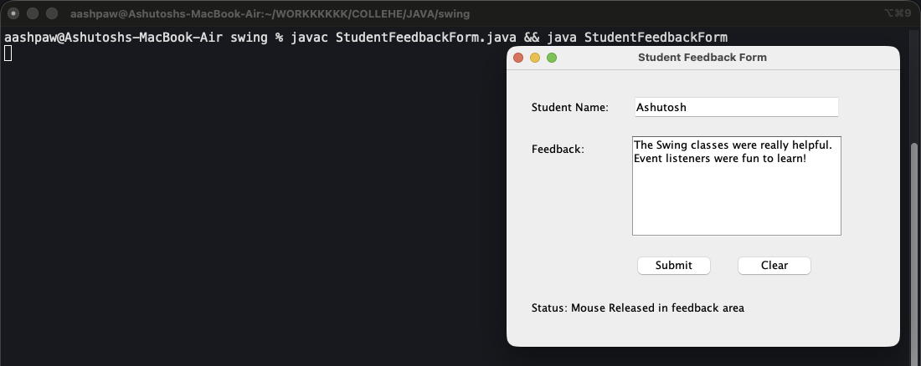
Figure 16.1: Form filled in: status updated by the mouse listener
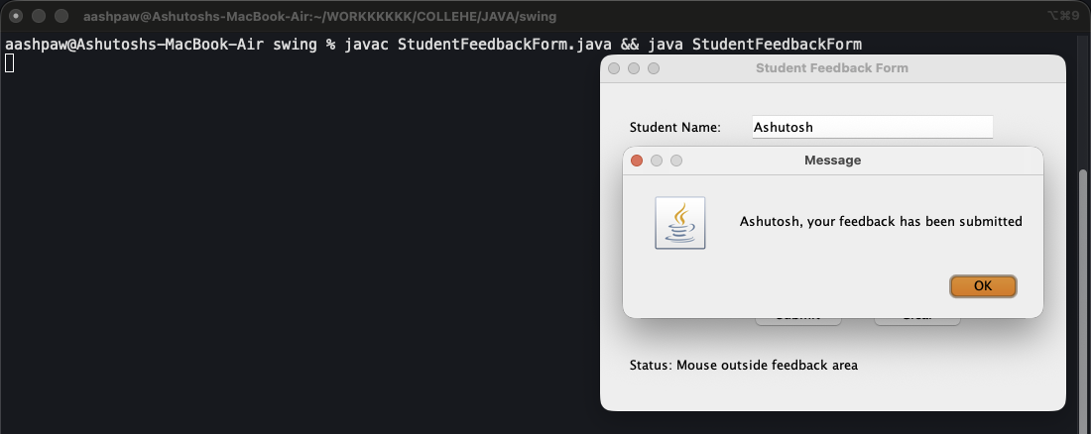
Figure 16.2: After clicking Submit

Program 17: Bus Reservation Booking
GUI Programming with Swing › Assignment 1: Bus Reservation
File: swing/assignment1-booking/BusBooking.java | Class: BusBooking | Date: 21 Aug 2026

Aim: Book bus tickets for up to 5 passengers. Name fields appear as the passenger count is typed, and the fare updates automatically.
Concepts used:
- Arrays of JLabel and JTextField are created in a loop and hidden with setVisible(false) until needed.
- KeyAdapter (keyReleased) shows the right number of name fields on every keystroke.
- Fare = |source index - destination index| x 100 x passengers. It updates from the combo boxes' ActionListeners.
- MouseAdapter on the fare box highlights it on hover and shows a breakdown on click.
- static helper methods readCount(), calcFare() and clearForm() keep main() short.

Source Code
import javax.swing.*;
import java.awt.Color;
import java.awt.Cursor;
import java.awt.event.KeyAdapter;
import java.awt.event.KeyEvent;
import java.awt.event.MouseAdapter;
import java.awt.event.MouseEvent;

public class BusBooking {

static final int MAX_PASSENGERS = 5;
static final int FARE_PER_JUMP = 100;
static final String[] PLACES = {"Airoli", "Kharghar", "Mahalaxmi", "Prabhadevi", "Mulund"};

public static void main(String[] args) {
JFrame frame = new JFrame("Bus Reservation Booking");

JLabel countLabel = new JLabel("Num of Passengers (max 5): ");
JTextField countTextField = new JTextField();

// one label + one text field per passenger, all made up front in a loop
JLabel[] nameLabels = new JLabel[MAX_PASSENGERS];
JTextField[] nameTextFields = new JTextField[MAX_PASSENGERS];

for (int i = 0; i < MAX_PASSENGERS; i++) {
nameLabels[i] = new JLabel("Name of Pass " + (i + 1) + ": ");
nameTextFields[i] = new JTextField();

nameLabels[i].setBounds(50, 90 + (i * 35), 160, 30);
nameTextFields[i].setBounds(220, 90 + (i * 35), 220, 30);

// hidden until the user types a passenger count
nameLabels[i].setVisible(false);
nameTextFields[i].setVisible(false);

frame.add(nameLabels[i]);
frame.add(nameTextFields[i]);
}

JLabel sourceLabel = new JLabel("Source: ");
JComboBox<String> sourceComboBox = new JComboBox<>(PLACES);

JLabel destLabel = new JLabel("Destination: ");
JComboBox<String> destComboBox = new JComboBox<>(PLACES);

JLabel fareLabel = new JLabel("Fare: ");
JTextField fareTextField = new JTextField();
fareTextField.setEditable(false);
fareTextField.setToolTipText("Click to see the fare breakdown");
fareTextField.setCursor(new Cursor(Cursor.HAND_CURSOR));

JButton submitButton = new JButton("Submit");
JButton resetButton = new JButton("Reset");

// (x,y,width,height)
countLabel.setBounds(50, 30, 200, 30);
countTextField.setBounds(250, 30, 60, 30);

sourceLabel.setBounds(50, 290, 160, 30);
sourceComboBox.setBounds(220, 290, 220, 30);
destLabel.setBounds(50, 330, 160, 30);
destComboBox.setBounds(220, 330, 220, 30);
fareLabel.setBounds(50, 370, 160, 30);
fareTextField.setBounds(220, 370, 220, 30);

submitButton.setBounds(220, 420, 100, 30);
resetButton.setBounds(340, 420, 100, 30);

frame.add(countLabel);
frame.add(countTextField);
frame.add(sourceLabel);
frame.add(sourceComboBox);
frame.add(destLabel);
frame.add(destComboBox);
frame.add(fareLabel);
frame.add(fareTextField);
frame.add(submitButton);
frame.add(resetButton);

// KeyListener: every keystroke in the count field redraws the name fields
countTextField.addKeyListener(new KeyAdapter() {
public void keyReleased(KeyEvent e) {
int count = readCount(countTextField.getText());

for (int i = 0; i < MAX_PASSENGERS; i++) {
boolean show = i < count;
nameLabels[i].setVisible(show);
nameTextFields[i].setVisible(show);
if (!show) {
nameTextFields[i].setText("");
}
}

fareTextField.setText(String.valueOf(calcFare(sourceComboBox, destComboBox, count)));
frame.repaint();
}
});

// ActionListener on both dropdowns: fare updates when route changes
sourceComboBox.addActionListener(e -> {
int count = readCount(countTextField.getText());
fareTextField.setText(String.valueOf(calcFare(sourceComboBox, destComboBox, count)));
});

destComboBox.addActionListener(e -> {
int count = readCount(countTextField.getText());
fareTextField.setText(String.valueOf(calcFare(sourceComboBox, destComboBox, count)));
});

// MouseListener: click the fare box to see how the fare was worked out
fareTextField.addMouseListener(new MouseAdapter() {
public void mousePressed(MouseEvent e) {
int count = readCount(countTextField.getText());
int jumps = Math.abs(sourceComboBox.getSelectedIndex() - destComboBox.getSelectedIndex());

JOptionPane.showMessageDialog(
frame,
"Jumps: " + jumps + "\n" +
"Per passenger: " + jumps + " x " + FARE_PER_JUMP + " = " + (jumps * FARE_PER_JUMP) + "\n" +
"Passengers: " + count + "\n" +
"Total: " + calcFare(sourceComboBox, destComboBox, count),
"Fare Breakdown",
JOptionPane.INFORMATION_MESSAGE
);
}

// hover highlight, proves the mouse listener is alive
public void mouseEntered(MouseEvent e) {
fareTextField.setBackground(new Color(220, 235, 255));
}

public void mouseExited(MouseEvent e) {
fareTextField.setBackground(Color.WHITE);
}
});

submitButton.addActionListener(e -> {
int count = readCount(countTextField.getText());

if (count == 0) {
JOptionPane.showMessageDialog(
frame,
"Enter number of passengers (1 to " + MAX_PASSENGERS + ")!",
"Error",
JOptionPane.ERROR_MESSAGE
);
return;
}

if (sourceComboBox.getSelectedIndex() == destComboBox.getSelectedIndex()) {
JOptionPane.showMessageDialog(
frame,
"Source and Destination cannot be the same!",
"Error",
JOptionPane.ERROR_MESSAGE
);
return;
}

// build the summary and check for blank names in the same loop
String summary = "";
for (int i = 0; i < count; i++) {
String name = nameTextFields[i].getText().trim();

if (name.equals("")) {
JOptionPane.showMessageDialog(
frame,
"Name of Passenger " + (i + 1) + " is empty!",
"Error",
JOptionPane.ERROR_MESSAGE
);
return;
}

summary = summary + "Passenger " + (i + 1) + ": " + name + "\n";
}

summary = summary + "\n"
+ "Source: " + sourceComboBox.getSelectedItem() + "\n"
+ "Destination: " + destComboBox.getSelectedItem() + "\n"
+ "Total Fare: " + calcFare(sourceComboBox, destComboBox, count);

JOptionPane.showMessageDialog(frame, summary, "Booking Confirmed", JOptionPane.INFORMATION_MESSAGE);

// reset everything after a successful booking
clearForm(countTextField, nameLabels, nameTextFields, sourceComboBox, destComboBox, fareTextField);
frame.repaint();
});

resetButton.addActionListener(e -> {
clearForm(countTextField, nameLabels, nameTextFields, sourceComboBox, destComboBox, fareTextField);
frame.repaint();
});

frame.setSize(520, 520);
frame.setLayout(null);
frame.setDefaultCloseOperation(JFrame.EXIT_ON_CLOSE);
frame.setVisible(true);
}

// turns whatever is typed into a usable count, 0 if junk, capped at MAX_PASSENGERS
static int readCount(String text) {
int count;

try {
count = Integer.parseInt(text.trim());
} catch (NumberFormatException ex) {
return 0;
}

if (count < 0) {
return 0;
}
if (count > MAX_PASSENGERS) {
return MAX_PASSENGERS;
}
return count;
}

// index distance between the two places x 100 x number of passengers
static int calcFare(JComboBox<String> source, JComboBox<String> dest, int count) {
int jumps = Math.abs(source.getSelectedIndex() - dest.getSelectedIndex());
return jumps * FARE_PER_JUMP * count;
}

static void clearForm(JTextField countTextField, JLabel[] nameLabels, JTextField[] nameTextFields,
JComboBox<String> source, JComboBox<String> dest, JTextField fareTextField) {
countTextField.setText("");

for (int i = 0; i < MAX_PASSENGERS; i++) {
nameTextFields[i].setText("");
nameLabels[i].setVisible(false);
nameTextFields[i].setVisible(false);
}

source.setSelectedIndex(0);
dest.setSelectedIndex(0);
fareTextField.setText("");
}
}

Output
Run: javac BusBooking.java && java BusBooking
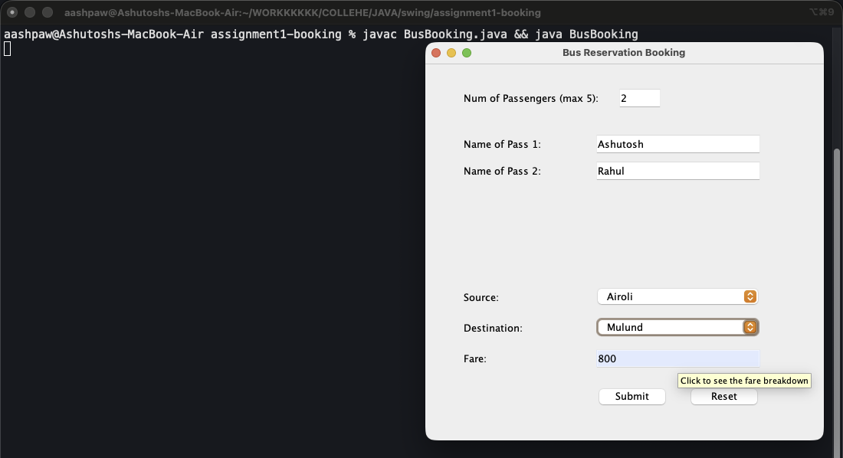
Figure 17.1: 2 passengers, Airoli to Mulund, fare 800
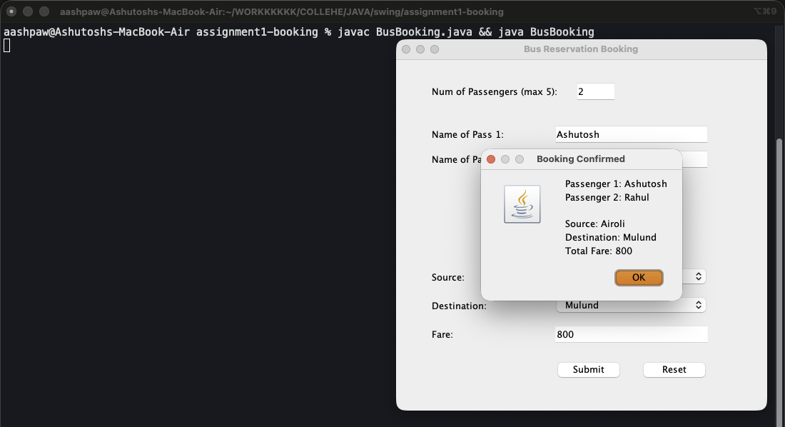
Figure 17.2: Booking confirmed

Part 3: Object Oriented Programming
OOP organises a program around classes (blueprints) and objects (instances).
Encapsulation: fields are private and reached only through public getter/setter methods.
Inheritance: a subclass extends a parent class and reuses its members (super calls the parent constructor or method).
Polymorphism: a subclass overrides a method (@Override), and a parent-type reference holding a child object calls the child's version at runtime.
Interfaces: a class implements an interface such as ActionListener and provides its methods.
Programs in this part:
- Bank Account: from Procedural to OOP: 18. ATM (Swing, procedural), 19. Bank Account Management (OOP)
- Encapsulation: 20. Student Registration (Encapsulation)
- Inheritance and Polymorphism: 21. Login Form with User Roles
- Arrays with Classes and GUI: 22. Array Search Checker, 23. Array Operations

Program 18: ATM (Swing, procedural)
Object Oriented Programming › Bank Account: from Procedural to OOP
File: OOPS/ATM.java | Class: ATM | Date: 24 Aug 2026

Aim: The ATM as a GUI window, written without custom classes, with deposit, withdraw and 5% interest.
Concepts used:
- All logic lives inside lambdas in main(); the balance is read from and written back to the balance field.
- This is the starting point that the next program rebuilds using OOP.

Source Code
import javax.swing.*;

public class ATM {
public static void main(String[] args) {
JFrame frame = new JFrame("ATM");

JLabel accLabel = new JLabel("Account Holder: ");
JLabel balLabel = new JLabel("Initial Balance: ");
JLabel amountLabel = new JLabel("Amount: ");

JTextField accField = new JTextField();
JTextField balField = new JTextField();
JTextField amountField = new JTextField();

JButton depositButton = new JButton("Deposit");
JButton withdrawButton = new JButton("Withdraw");
JButton interestButton = new JButton("Calculate Interest");

JTextArea outputArea = new JTextArea();
outputArea.setEditable(false);
outputArea.setLineWrap(true);
outputArea.setWrapStyleWord(true);
JScrollPane outputScroll = new JScrollPane(outputArea);

// (x,y,width,height)
accLabel.setBounds(30,30,120,30);
accField.setBounds(150,30,200,30);

balLabel.setBounds(30,80,120,30);
balField.setBounds(150,80,200,30);

amountLabel.setBounds(30,130,120,30);
amountField.setBounds(150,130,200,30);

depositButton.setBounds(30,190,150,30);
withdrawButton.setBounds(200,190,150,30);
interestButton.setBounds(115,240,150,30);

outputScroll.setBounds(380,30,260,240);

frame.add(accLabel);
frame.add(accField);
frame.add(balLabel);
frame.add(balField);
frame.add(amountLabel);
frame.add(amountField);
frame.add(depositButton);
frame.add(withdrawButton);
frame.add(interestButton);
frame.add(outputScroll);

depositButton.addActionListener(e->{
String name = accField.getText();
double balance = Double.parseDouble(balField.getText());
double amount = Double.parseDouble(amountField.getText());

balance = balance + amount;
balField.setText(String.valueOf(balance));
outputArea.append(name + " deposited " + amount + "\n");
outputArea.append("Balance: " + balance + "\n\n");
});

withdrawButton.addActionListener(e->{
String name = accField.getText();
double balance = Double.parseDouble(balField.getText());
double amount = Double.parseDouble(amountField.getText());

if (amount > balance) {
outputArea.append("Insufficient balance. Available: " + balance + "\n\n");
} else {
balance = balance - amount;
balField.setText(String.valueOf(balance));
outputArea.append(name + " withdrew " + amount + "\n");
outputArea.append("Balance: " + balance + "\n\n");
}
});

interestButton.addActionListener(e->{
double balance = Double.parseDouble(balField.getText());

// 5% interest on the current balance
double interest = balance * 0.05;
outputArea.append("Interest (5%): " + interest + "\n\n");
});

frame.setSize(670,330);
frame.setLayout(null);
frame.setDefaultCloseOperation(JFrame.EXIT_ON_CLOSE);
frame.setVisible(true);
}
}

Output
Run: javac ATM.java && java ATM
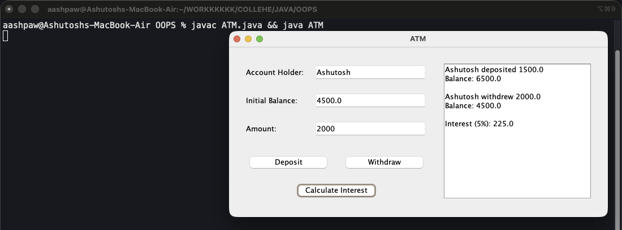
Figure 18: Deposit 1500, withdraw 2000, then interest

Program 19: Bank Account Management (OOP)
Object Oriented Programming › Bank Account: from Procedural to OOP
File: OOPS/ATMOOPS.java | Class: ATMOOPS | Date: 24 Aug 2026

Aim: The same ATM rebuilt with the four OOP pillars.
Concepts used:
- Encapsulation: BankAccount keeps accountHolder and balance private, and exposes deposit(), withdraw() and getters.
- Inheritance: SavingsAccount and CurrentAccount extend BankAccount and call super(...).
- Polymorphism: calculateInterest() and getType() are overridden (5% savings, 2% current). BankAccount account = new SavingsAccount(...) calls the child version.
- atmFrame extends JFrame and implements ActionListener, so 'this' is the listener for all buttons.

Source Code
import java.awt.event.ActionEvent;
import java.awt.event.ActionListener;
import javax.swing.*;

// ENCAPSULATION: fields are private, outside code touches them only through methods
class BankAccount {
private String accountHolder;
private double balance;

BankAccount(String accountHolder, double balance) {
this.accountHolder = accountHolder;
this.balance = balance;
}

public String getAccountHolder() {
return accountHolder;
}

public double getBalance() {
return balance;
}

public void deposit(double amount) {
balance += amount;
}

public boolean withdraw(double amount) {
if (amount <= balance) {
balance -= amount;
return true;
}
return false;
}

// base version, subclasses override this
public double calculateInterest() {
return 0;
}

public String getType() {
return "Bank Account";
}
}

// INHERITANCE: SavingsAccount gets all BankAccount members
class SavingsAccount extends BankAccount {

SavingsAccount(String accountHolder, double balance) {
super(accountHolder, balance);
}

// POLYMORPHISM: same method name, different behaviour
@Override
public double calculateInterest() {
return getBalance() * 0.05;
}

@Override
public String getType() {
return "Savings Account";
}
}

class CurrentAccount extends BankAccount {

CurrentAccount(String accountHolder, double balance) {
super(accountHolder, balance);
}

@Override
public double calculateInterest() {
return getBalance() * 0.02;
}

@Override
public String getType() {
return "Current Account";
}
}

// INHERITANCE from JFrame + IMPLEMENTS the ActionListener interface
class atmFrame extends JFrame implements ActionListener {
JLabel nameLabel;
JLabel balanceLabel;
JLabel amountLabel;

JTextField nameField;
JTextField balanceField;
JTextField amountField;

JButton depositButton;
JButton withdrawButton;
JButton interestButton;

JTextArea outputArea;
JScrollPane outputScroll;

// parent type holding a child object = runtime polymorphism
BankAccount account;

atmFrame() {
setTitle("Bank Account Management");

nameLabel = new JLabel("Account Holder: ");
balanceLabel = new JLabel("Initial Balance: ");
amountLabel = new JLabel("Amount: ");

nameField = new JTextField();
balanceField = new JTextField();
amountField = new JTextField();

depositButton = new JButton("Deposit");
withdrawButton = new JButton("Withdraw");
interestButton = new JButton("Calculate Interest");

outputArea = new JTextArea();
outputArea.setEditable(false);
outputArea.setLineWrap(true);
outputArea.setWrapStyleWord(true);
outputScroll = new JScrollPane(outputArea);

// (x,y,width,height)
nameLabel.setBounds(30, 30, 120, 30);
nameField.setBounds(150, 30, 200, 30);

balanceLabel.setBounds(30, 80, 120, 30);
balanceField.setBounds(150, 80, 200, 30);

amountLabel.setBounds(30, 130, 120, 30);
amountField.setBounds(150, 130, 200, 30);

depositButton.setBounds(30, 190, 150, 30);
withdrawButton.setBounds(200, 190, 150, 30);
interestButton.setBounds(30, 240, 150, 30);

outputScroll.setBounds(380, 30, 260, 240);

add(nameLabel);
add(nameField);
add(balanceLabel);
add(balanceField);
add(amountLabel);
add(amountField);
add(depositButton);
add(withdrawButton);
add(interestButton);
add(outputScroll);

// "this" is the listener because the class implements ActionListener
depositButton.addActionListener(this);
withdrawButton.addActionListener(this);
interestButton.addActionListener(this);

setSize(670, 330);
setLayout(null);
setDefaultCloseOperation(JFrame.EXIT_ON_CLOSE);
setVisible(true);
}

// builds the account object from the text fields
boolean createAccount() {
try {
String name = nameField.getText();
double balance = Double.parseDouble(balanceField.getText());

// parent reference, child object
account = new SavingsAccount(name, balance);
return true;
} catch (NumberFormatException e) {
outputArea.append("Enter a valid initial balance\n");
return false;
}
}

@Override
public void actionPerformed(ActionEvent e) {
if (account == null) {
if (!createAccount()) {
return;
}
}

if (e.getSource() == interestButton) {
// calls the SavingsAccount version, not the BankAccount one
double interest = account.calculateInterest();
outputArea.append(account.getType() + " interest: " + interest + "\n\n");
return;
}

double amount;
try {
amount = Double.parseDouble(amountField.getText());
} catch (NumberFormatException ex) {
outputArea.append("Enter a valid amount\n");
return;
}

if (e.getSource() == depositButton) {
account.deposit(amount);
outputArea.append(account.getAccountHolder() + " deposited " + amount + "\n");
outputArea.append("Balance: " + account.getBalance() + "\n\n");
} else if (e.getSource() == withdrawButton) {
if (account.withdraw(amount)) {
outputArea.append(account.getAccountHolder() + " withdrew " + amount + "\n");
outputArea.append("Balance: " + account.getBalance() + "\n\n");
} else {
outputArea.append("Insufficient balance. Available: " + account.getBalance() + "\n\n");
}
}

balanceField.setText(String.valueOf(account.getBalance()));
}
}

public class ATMOOPS {
public static void main(String[] args) {
new atmFrame();
}
}

Output
Run: javac ATMOOPS.java && java ATMOOPS
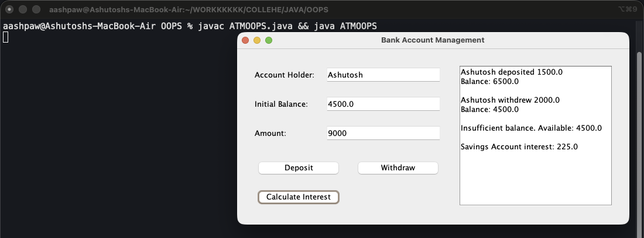
Figure 19: Deposit, withdraw, a rejected withdrawal, then interest

Program 20: Student Registration (Encapsulation)
Object Oriented Programming › Encapsulation
File: OOPS/StudentForm.java | Class: StudentForm | Date: 25 Aug 2026

Aim: Store form data in a Student object with private fields and setters/getters.
Concepts used:
- Student has private name, age and course; setAge() rejects negative ages, which shows why fields are hidden behind setters.
- studentFrame extends JFrame and implements ActionListener; e.getSource() tells which button was clicked.
- Integer.parseInt() inside try-catch handles a non-numeric age.

Source Code
import java.awt.event.ActionEvent;
import java.awt.event.ActionListener;
import javax.swing.*;

class Student {
private String name;
private int age;
private String course;

public void setName(String name) {
this.name = name;
}

public String getName() {
return name;
}

public void setAge(int age) {
if (age > 0) {
this.age = age;
} else {
this.age = 0;
}
}

public int getAge() {
return age;
}

public void setCourse(String course) {
this.course = course;
}

public String getCourse() {
return course;
}
}

class studentFrame extends JFrame implements ActionListener {
JLabel nameLabel;
JLabel ageLabel;
JLabel courseLabel;

JTextField nameField;
JTextField ageField;
JComboBox<String> courseBox;

JButton submitButton;
JButton clearButton;

JTextArea outputArea;
JScrollPane outputScroll;

Student student;

studentFrame() {
setTitle("Student Registration Form");

nameLabel = new JLabel("Student Name: ");
ageLabel = new JLabel("Age: ");
courseLabel = new JLabel("Course: ");

nameField = new JTextField();
ageField = new JTextField();

String[] courses = {"Engineering", "Medical", "Arts"};
courseBox = new JComboBox<>(courses);

submitButton = new JButton("Submit");
clearButton = new JButton("Clear");

outputArea = new JTextArea();
outputArea.setEditable(false);
outputArea.setLineWrap(true);
outputArea.setWrapStyleWord(true);
outputScroll = new JScrollPane(outputArea);

nameLabel.setBounds(30, 30, 120, 30);
nameField.setBounds(150, 30, 200, 30);

ageLabel.setBounds(30, 80, 120, 30);
ageField.setBounds(150, 80, 200, 30);

courseLabel.setBounds(30, 130, 120, 30);
courseBox.setBounds(150, 130, 200, 30);

submitButton.setBounds(30, 190, 150, 30);
clearButton.setBounds(200, 190, 150, 30);

outputScroll.setBounds(380, 30, 262, 240);

add(nameLabel);
add(nameField);
add(ageLabel);
add(ageField);
add(courseLabel);
add(courseBox);
add(submitButton);
add(clearButton);
add(outputScroll);

submitButton.addActionListener(this);
clearButton.addActionListener(this);

setSize(670, 330);
setLayout(null);
setDefaultCloseOperation(JFrame.EXIT_ON_CLOSE);
setVisible(true);
}

@Override
public void actionPerformed(ActionEvent e) {
if (e.getSource() == clearButton) {
nameField.setText("");
ageField.setText("");
courseBox.setSelectedIndex(0);
outputArea.setText("");
return;
}

String name = nameField.getText();
if (name.isEmpty()) {
outputArea.append("Enter a student name\n\n");
return;
}

int age;
try {
age = Integer.parseInt(ageField.getText());
} catch (NumberFormatException ex) {
outputArea.append("Enter a valid age\n\n");
return;
}

String course = (String) courseBox.getSelectedItem();

student = new Student();
student.setName(name);
student.setAge(age);
student.setCourse(course);

outputArea.append("----------Student Details----------"+"\n"+"\n");
outputArea.append("Name: " + student.getName() + "\n");
outputArea.append("Age: " + student.getAge() + "\n");
outputArea.append("Course: " + student.getCourse() + "\n\n");
}
}

public class StudentForm {
public static void main(String[] args) {
new studentFrame();
}
}

Output
Run: javac StudentForm.java && java StudentForm
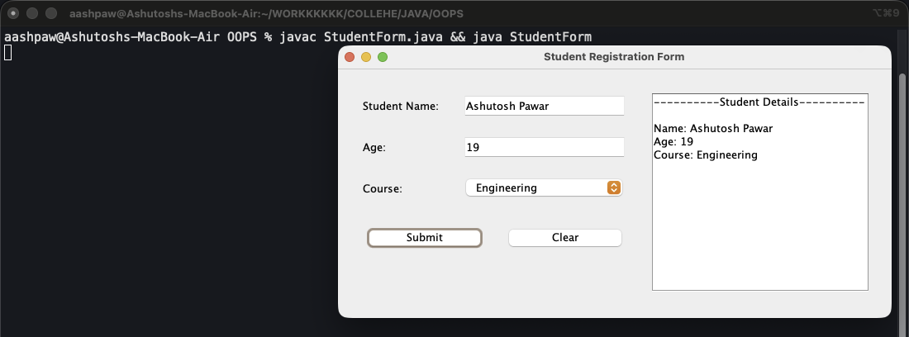
Figure 20: Submitted student details

Program 21: Login Form with User Roles
Object Oriented Programming › Inheritance and Polymorphism
File: OOPS/LoginForm.java | Class: LoginForm | Date: 27 Aug 2026

Aim: Validate passwords with different rules for User, Admin and Guest accounts.
Concepts used:
- User has private username/password; getPassword() is protected so only subclasses can read it.
- AdminUser overrides getMinLength() (10) and validatePassword(), and reuses the parent checks with super.validatePassword().
- GuestUser overrides getMinLength() to 4.
- createUser() returns the right child object for the selected role (a parent reference holding a child object).

Source Code
import java.awt.event.ActionEvent;
import java.awt.event.ActionListener;
import javax.swing.*;

// ENCAPSULATION: username and password are private, reachable only through methods
class User {
private String username;
private String password;

User(String username, String password) {
this.username = username;
this.password = password;
}

public String getUsername() {
return username;
}

// protected, so only subclasses can read it, not outside code
protected String getPassword() {
return password;
}

public String getRole() {
return "User";
}

// minimum length every account has to satisfy, subclasses raise it
public int getMinLength() {
return 6;
}

// returns an error message, or null when the password is fine
public String validatePassword() {
if (password.length() < getMinLength()) {
return "Password must be at least " + getMinLength() + " characters";
}

boolean hasUpper = false;
boolean hasLower = false;
boolean hasDigit = false;
boolean hasSpecial = false;

for (int i = 0; i < password.length(); i++) {
char c = password.charAt(i);

if (Character.isUpperCase(c)) {
hasUpper = true;
} else if (Character.isLowerCase(c)) {
hasLower = true;
} else if (Character.isDigit(c)) {
hasDigit = true;
} else {
hasSpecial = true;
}
}

if (!hasUpper) {
return "Password needs at least one uppercase letter";
}
if (!hasLower) {
return "Password needs at least one lowercase letter";
}
if (!hasDigit) {
return "Password needs at least one digit";
}
if (!hasSpecial) {
return "Password needs at least one special character";
}
if (password.contains(username)) {
return "Password must not contain the username";
}

return null;
}
}

// INHERITANCE: AdminUser gets every User member, then tightens the rules
class AdminUser extends User {

AdminUser(String username, String password) {
super(username, password);
}

// POLYMORPHISM: same method name, stricter answer
@Override
public int getMinLength() {
return 10;
}

@Override
public String getRole() {
return "Admin";
}

@Override
public String validatePassword() {
// reuse the parent checks first
String error = super.validatePassword();
if (error != null) {
return error;
}

if (getPassword().toLowerCase().contains("admin")) {
return "Admin password must not contain the word admin";
}
return null;
}
}

class GuestUser extends User {

GuestUser(String username, String password) {
super(username, password);
}

@Override
public int getMinLength() {
return 4;
}

@Override
public String getRole() {
return "Guest";
}
}

// INHERITANCE from JFrame + IMPLEMENTS the ActionListener interface
class loginFrame extends JFrame implements ActionListener {
JLabel userLabel;
JLabel passLabel;
JLabel roleLabel;

JTextField userField;
JPasswordField passField;
JComboBox<String> roleBox;

JButton loginButton;
JButton clearButton;

JTextArea outputArea;
JScrollPane outputScroll;

// parent type holding a child object = runtime polymorphism
User user;

loginFrame() {
setTitle("Login Form");

userLabel = new JLabel("Username: ");
passLabel = new JLabel("Password: ");
roleLabel = new JLabel("Role: ");

userField = new JTextField();
passField = new JPasswordField();

String[] roles = {"User", "Admin", "Guest"};
roleBox = new JComboBox<>(roles);

loginButton = new JButton("Login");
clearButton = new JButton("Clear");

outputArea = new JTextArea();
outputArea.setEditable(false);
outputArea.setLineWrap(true);
outputArea.setWrapStyleWord(true);
outputScroll = new JScrollPane(outputArea);

// (x,y,width,height)
userLabel.setBounds(30, 30, 120, 30);
userField.setBounds(150, 30, 200, 30);

passLabel.setBounds(30, 80, 120, 30);
passField.setBounds(150, 80, 200, 30);

roleLabel.setBounds(30, 130, 120, 30);
roleBox.setBounds(150, 130, 200, 30);

loginButton.setBounds(30, 190, 150, 30);
clearButton.setBounds(200, 190, 150, 30);

outputScroll.setBounds(380, 30, 262, 240);

add(userLabel);
add(userField);
add(passLabel);
add(passField);
add(roleLabel);
add(roleBox);
add(loginButton);
add(clearButton);
add(outputScroll);

// "this" is the listener because the class implements ActionListener
loginButton.addActionListener(this);
clearButton.addActionListener(this);

setSize(670, 330);
setLayout(null);
setDefaultCloseOperation(JFrame.EXIT_ON_CLOSE);
setVisible(true);
}

// builds the right child object for the selected role
User createUser(String username, String password) {
String role = (String) roleBox.getSelectedItem();

if (role.equals("Admin")) {
return new AdminUser(username, password);
} else if (role.equals("Guest")) {
return new GuestUser(username, password);
}
return new User(username, password);
}

@Override
public void actionPerformed(ActionEvent e) {
if (e.getSource() == clearButton) {
userField.setText("");
passField.setText("");
roleBox.setSelectedIndex(0);
outputArea.setText("");
return;
}

String username = userField.getText();
// JPasswordField hands back a char array, not a String
String password = new String(passField.getPassword());

if (username.isEmpty()) {
outputArea.append("Enter a username\n\n");
return;
}
if (password.isEmpty()) {
outputArea.append("Enter a password\n\n");
return;
}

// parent reference, child object
user = createUser(username, password);

// calls the AdminUser/GuestUser version when that is the real object
String error = user.validatePassword();

outputArea.append("----------Login Attempt----------" + "\n" + "\n");
outputArea.append("Username: " + user.getUsername() + "\n");
outputArea.append("Role: " + user.getRole() + "\n");
outputArea.append("Rule: min " + user.getMinLength() + " characters\n");

if (error != null) {
outputArea.append("Invalid: " + error + "\n\n");
return;
}

outputArea.append("Login successful, welcome " + user.getUsername() + "\n\n");
passField.setText("");
}
}

public class LoginForm {
public static void main(String[] args) {
new loginFrame();
}
}

Output
Run: javac LoginForm.java && java LoginForm
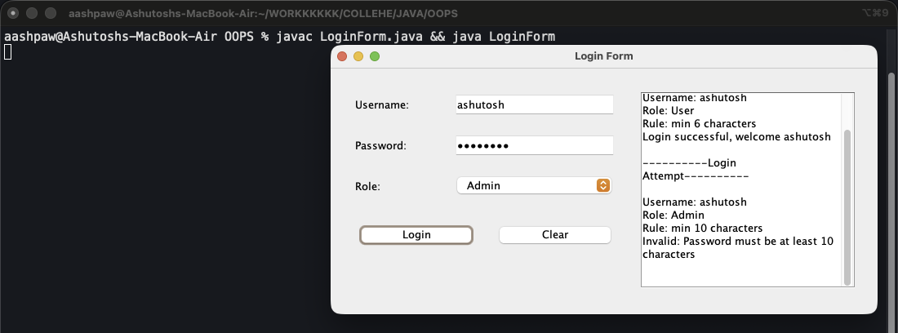
Figure 21: User login succeeds; Admin with a short password is rejected

Program 22: Array Search Checker
Object Oriented Programming › Arrays with Classes and GUI
File: OOPS/LinearSearch.java | Class: LinearSearch | Date: 27 Aug 2026

Aim: Linear search: find a target in a space-separated list of values.
Concepts used:
- split("\\s+") breaks the input into an array on any amount of whitespace.
- A for loop checks each element from the start and stops at the first match.
- Output shows both the index (from 0) and the position (from 1).

Source Code
import javax.swing.*;

public class LinearSearch {
public static void main(String[] args) {
JFrame frame = new JFrame("Array Search Checker");

JLabel arrayLabel = new JLabel("Array: ");
JLabel targetLabel = new JLabel("Target: ");

JTextField arrayTextField = new JTextField();
JTextField targetTextField = new JTextField();

JButton searchButton = new JButton("Search");
JButton clearButton = new JButton("Clear");

JTextArea outputArea = new JTextArea();
outputArea.setEditable(false);

arrayLabel.setBounds(40, 30, 80, 30);
arrayTextField.setBounds(120, 30, 240, 30);

targetLabel.setBounds(40, 80, 80, 30);
targetTextField.setBounds(120, 80, 240, 30);

searchButton.setBounds(80, 130, 110, 30);
clearButton.setBounds(210, 130, 110, 30);

outputArea.setBounds(40, 180, 320, 70);

frame.add(arrayLabel);
frame.add(arrayTextField);
frame.add(targetLabel);
frame.add(targetTextField);
frame.add(searchButton);
frame.add(clearButton);
frame.add(outputArea);

searchButton.addActionListener(e -> {
String arrayInput = arrayTextField.getText().trim();
String targetInput = targetTextField.getText().trim();

if (arrayInput.isEmpty() || targetInput.isEmpty()) {
outputArea.setText("Please enter both array elements and target.");
return;
}

String[] elements = arrayInput.split("\\s+");
int foundIndex = -1;

for (int i = 0; i < elements.length; i++) {
if (elements[i].equals(targetInput)) {
foundIndex = i;
break;
}
}

if (foundIndex != -1) {
outputArea.setText("Target found at Index: " + foundIndex + ", Position: " + (foundIndex + 1));
} else {
outputArea.setText("Target not found in the array.");
}
});

clearButton.addActionListener(e -> {
arrayTextField.setText("");
targetTextField.setText("");
outputArea.setText("");
});

frame.setSize(420, 310);
frame.setLayout(null);
frame.setDefaultCloseOperation(JFrame.EXIT_ON_CLOSE);
frame.setVisible(true);
}
}

Output
Run: javac LinearSearch.java && java LinearSearch
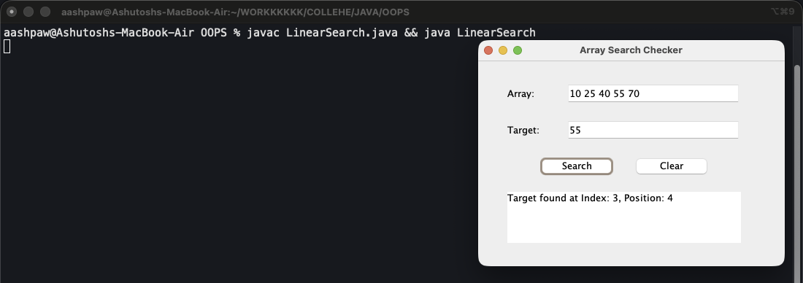
Figure 22: Searching for 55

Program 23: Array Operations
Object Oriented Programming › Arrays with Classes and GUI
File: OOPS/SearchNDestroy.java | Class: SearchNDestroy | Date: 10 Sep 2026

Aim: Insert, delete, update, search and display on an array through a GUI.
Concepts used:
- ArrayStore wraps a fixed int[100] with a separate size counter.
- insert() shifts elements right (looping backwards); delete() shifts them left (looping forwards).
- Invalid indexes throw IllegalArgumentException, which the UI catches and shows in an error dialog.
- ArrayUI uses BorderLayout and GridLayout instead of setBounds; the UI class holds no array logic of its own.

Source Code
import javax.swing.*;
import java.awt.*;

/**
* Basic array operations through a Swing GUI:
* insert at a position, delete a position, update a position,
* linear search, display, and clear.
*/
public class SearchNDestroy {

public static void main(String[] args) {
SwingUtilities.invokeLater(() -> new ArrayUI().setVisible(true));
}
}

/**
* Holds the array and every operation performed on it.
*
* A plain int[] of fixed capacity is used with a separate 'size' counter, so
* inserting and deleting have to shift elements by hand - which is the whole
* point of the exercise. Positions beyond 'size' are unused slots, not data.
*/
class ArrayStore {

private static final int CAPACITY = 100;

private int[] data = new int[CAPACITY];
private int size = 0;

/** Replaces the whole array with the supplied values. */
public void setAll(int[] values) {
if (values.length > CAPACITY) {
throw new IllegalArgumentException("Array cannot hold more than " + CAPACITY + " elements.");
}
for (int i = 0; i < values.length; i++) {
data[i] = values[i];
}
size = values.length;
}

public int getSize() {
return size;
}

public boolean isEmpty() {
return size == 0;
}

/**
* Inserts value at the given index, pushing everything from that index
* onwards one slot to the right. An index equal to size appends at the end.
*/
public void insert(int index, int value) {
if (size == CAPACITY) {
throw new IllegalArgumentException("Array is full.");
}
if (index < 0 || index > size) {
throw new IllegalArgumentException("Index for insert must be between 0 and " + size + ".");
}

// Walk backwards from the end, otherwise each copy would overwrite the
// element that has not been moved yet.
for (int i = size; i > index; i--) {
data[i] = data[i - 1];
}

data[index] = value;
size++;
}

/**
* Removes the element at the given index and pulls everything after it
* one slot to the left. Returns the value that was removed.
*/
public int delete(int index) {
checkIndex(index);
int removed = data[index];

// Forwards this time, so each slot is filled from the one after it.
for (int i = index; i < size - 1; i++) {
data[i] = data[i + 1];
}

size--;
return removed;
}

/** Overwrites the element at the given index. Returns the old value. */
public int update(int index, int value) {
checkIndex(index);
int old = data[index];
data[index] = value;
return old;
}

/**
* Linear search: checks each element from the start until it matches.
* Returns the index of the first match, or -1 when the value is absent.
*/
public int search(int value) {
for (int i = 0; i < size; i++) {
if (data[i] == value) {
return i;
}
}
return -1;
}

public void clear() {
size = 0;
}

/** Builds the array as text, e.g. [10, 20, 30] */
public String display() {
if (size == 0) {
return "[ ] (empty)";
}

StringBuilder text = new StringBuilder("[");
for (int i = 0; i < size; i++) {
text.append(data[i]);
if (i < size - 1) {
text.append(", ");
}
}
text.append("] (size = ").append(size).append(")");
return text.toString();
}

private void checkIndex(int index) {
if (isEmpty()) {
throw new IllegalArgumentException("The array is empty.");
}
if (index < 0 || index >= size) {
throw new IllegalArgumentException("Index must be between 0 and " + (size - 1) + ".");
}
}
}

/**
* The window. It reads the text fields, calls one ArrayStore method,
* and reports the result - no array logic of its own.
*/
class ArrayUI extends JFrame {

private ArrayStore store = new ArrayStore();

private JTextField arrayField = new JTextField();
private JTextField valueField = new JTextField();
private JTextField indexField = new JTextField();
private JTextArea outputArea = new JTextArea();

public ArrayUI() {
setTitle("Array Operations");
setDefaultCloseOperation(JFrame.EXIT_ON_CLOSE);
setSize(700, 430);
setLocationRelativeTo(null);
setLayout(new BorderLayout(8, 8));

add(buildTopPanel(), BorderLayout.NORTH);

outputArea.setEditable(false);
outputArea.setFont(new Font(Font.MONOSPACED, Font.PLAIN, 13));
JScrollPane scroll = new JScrollPane(outputArea);
scroll.setBorder(BorderFactory.createTitledBorder("Output"));
add(scroll, BorderLayout.CENTER);

log("Enter an array like 10, 20, 30 then press Set Array.");
}

private JPanel buildTopPanel() {
JPanel fields = new JPanel(new GridLayout(3, 2, 6, 6));
fields.add(new JLabel("Array (comma separated):"));
fields.add(arrayField);
fields.add(new JLabel("Value:"));
fields.add(valueField);
fields.add(new JLabel("Index (0-based):"));
fields.add(indexField);

JPanel buttons = new JPanel(new GridLayout(1, 7, 4, 4));
buttons.add(makeButton("Set Array", e -> onSetArray()));
buttons.add(makeButton("Insert", e -> onInsert()));
buttons.add(makeButton("Delete", e -> onDelete()));
buttons.add(makeButton("Update", e -> onUpdate()));
buttons.add(makeButton("Search", e -> onSearch()));
buttons.add(makeButton("Display", e -> onDisplay()));
buttons.add(makeButton("Clear", e -> onClear()));

JPanel top = new JPanel(new BorderLayout(6, 6));
top.setBorder(BorderFactory.createEmptyBorder(8, 8, 0, 8));
top.add(fields, BorderLayout.CENTER);
top.add(buttons, BorderLayout.SOUTH);
return top;
}

private JButton makeButton(String text, java.awt.event.ActionListener action) {
JButton button = new JButton(text);
button.addActionListener(action);
return button;
}

private void onSetArray() {
String text = arrayField.getText().trim();
if (text.isEmpty()) {
showError("Enter some numbers first.");
return;
}

// Split on commas and/or spaces, so "1,2 3" is accepted too.
String[] parts = text.split("[,\\s]+");
int[] values = new int[parts.length];

try {
for (int i = 0; i < parts.length; i++) {
values[i] = Integer.parseInt(parts[i]);
}
store.setAll(values);
} catch (NumberFormatException ex) {
showError("The array must contain whole numbers only.");
return;
} catch (IllegalArgumentException ex) {
showError(ex.getMessage());
return;
}

log("Array set.");
logArray();
}

private void onInsert() {
Integer value = readValue();
Integer index = readIndex();
if (value == null || index == null) {
return;
}

try {
store.insert(index, value);
} catch (IllegalArgumentException ex) {
showError(ex.getMessage());
return;
}

log("Inserted " + value + " at index " + index + ".");
logArray();
}

private void onDelete() {
Integer index = readIndex();
if (index == null) {
return;
}

int removed;
try {
removed = store.delete(index);
} catch (IllegalArgumentException ex) {
showError(ex.getMessage());
return;
}

log("Deleted " + removed + " from index " + index + ". Remaining elements shifted left.");
logArray();
}

private void onUpdate() {
Integer index = readIndex();
Integer value = readValue();
if (index == null || value == null) {
return;
}

int old;
try {
old = store.update(index, value);
} catch (IllegalArgumentException ex) {
showError(ex.getMessage());
return;
}

log("Index " + index + " changed from " + old + " to " + value + ".");
logArray();
}

private void onSearch() {
Integer value = readValue();
if (value == null) {
return;
}
if (store.isEmpty()) {
showError("The array is empty.");
return;
}

int index = store.search(value);
if (index == -1) {
log("Search: " + value + " was NOT found.");
} else {
// Index counts from 0, position counts from 1.
log("Search: " + value + " was FOUND -> index " + index + ", position " + (index + 1) + ".");
}
}

private void onDisplay() {
logArray();
}

private void onClear() {
store.clear();
arrayField.setText("");
valueField.setText("");
indexField.setText("");
outputArea.setText("");
log("Array and all input fields cleared.");
}

/** Reads the value field, or shows an error and returns null. */
private Integer readValue() {
String text = valueField.getText().trim();
if (text.isEmpty()) {
showError("Enter a value.");
return null;
}
try {
return Integer.parseInt(text);
} catch (NumberFormatException ex) {
showError("The value must be a whole number.");
return null;
}
}

/** Reads the index field, or shows an error and returns null. */
private Integer readIndex() {
String text = indexField.getText().trim();
if (text.isEmpty()) {
showError("Enter an index.");
return null;
}
try {
return Integer.parseInt(text);
} catch (NumberFormatException ex) {
showError("The index must be a whole number.");
return null;
}
}

private void logArray() {
log("Array: " + store.display());
}

private void log(String message) {
outputArea.append(message + "\n");
outputArea.setCaretPosition(outputArea.getDocument().getLength());
}

private void showError(String message) {
JOptionPane.showMessageDialog(this, message, "Error", JOptionPane.ERROR_MESSAGE);
}
}

Output
Run: javac SearchNDestroy.java && java SearchNDestroy
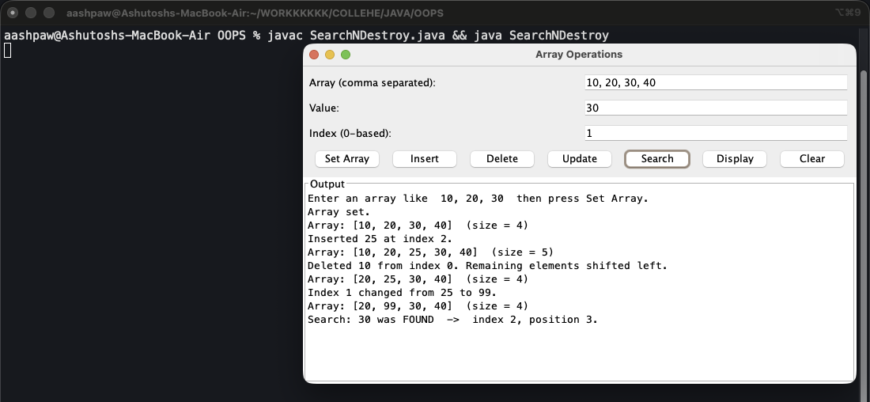
Figure 23: Set, insert, delete, update and search

Part 4: Collections Framework
The Collections Framework (java.util) provides ready-made data structures that grow automatically.
List (LinkedList) keeps insertion order and allows duplicates. Set (HashSet) stores unique values only. Map (HashMap, TreeMap, LinkedHashMap) stores key -> value pairs; TreeMap keeps keys sorted.
Generics such as TreeMap<Integer, String> fix the types a collection can hold.
Programs in this part:
- TreeMap, HashSet, LinkedList and HashMap: 24. College Library (TreeMap), 25. Student Management (HashSet + LinkedList), 26. Music Playlist (LinkedList), 27. HashSet Operations, 28. HashMap Operations
- Assignment: Shopping Stock and Cart: 29. Shopping Stock and Cart System

Program 24: College Library (TreeMap)
Collections Framework › TreeMap, HashSet, LinkedList and HashMap
File: OOPS/MAPS/treemap/CollegeLibrary.java | Class: CollegeLibrary | Date: 08 Sep 2026

Aim: Manage books by ID using a TreeMap, which keeps the IDs sorted automatically.
Concepts used:
- put() adds books in random order; keySet() returns them sorted.
- firstKey() / lastKey() give the smallest and largest IDs.
- headMap(105) gives IDs below 105; tailMap(103) gives IDs from 103 onwards.
- containsKey() and remove() search and delete by key.

Source Code
import java.util.TreeMap;

public class CollegeLibrary {
public static void main(String[] args) {
//create TreeMap
//key = book id
//value = book name
TreeMap<Integer, String> books = new TreeMap<>();

// add the books
books.put(106,"Java Programming");
books.put(102,"Data Structures");
books.put(105,"Operating Systems");
books.put(101,"Computer Networks");
books.put(104,"Database Management");
books.put(103,"Software Engineering");

//display all books in a sorted order

System.out.println("=====COLLEGE LIBRARY=====");
System.out.println("All books:");

for (Integer bookID : books.keySet()){
System.out.println(bookID +" -> "+ books.get(bookID));
}

// find first book id
System.out.println("\nFirst book ID: " + books.firstKey());

// find last book id
System.out.println("\nLast book ID: " + books.lastKey());

//display books before 105
System.out.println("\nBooks before ID 105");

for (Integer bookID : books.headMap(105).keySet()) {
System.out.println(bookID + " -> " + books.get(bookID));
}

// display books from id 103
System.out.println("\nBooks from ID 103 onwards: ");

for (Integer bookID : books.tailMap(103).keySet()){
System.out.println(bookID + " -> " + books.get(bookID));
}

// search for a specific book
int searchID = 104;

System.out.println("\nSearching for Book ID: " + searchID);

if (books.containsKey(searchID)) {
System.out.println("Book Found!!");
System.out.println("Book name: " + books.get(searchID));
} else {
System.out.println("Book not found with the id: " + searchID + " !!!!");
}

//remove a book
int removeID = 102;

System.out.println("\nRemoving Book ID: " + removeID);

if (books.containsKey(removeID)) {
books.remove(removeID);
System.out.println("Book removed successfully!!");
} else {
System.out.println("Book not found with the id: " + removeID + " !!!!");
}

System.out.println("\nBooks after removal: ");

for (Integer bookID : books.keySet()){
System.out.println(bookID + " -> " + books.get(bookID));
}
}
}

Output
Run: javac CollegeLibrary.java && java CollegeLibrary
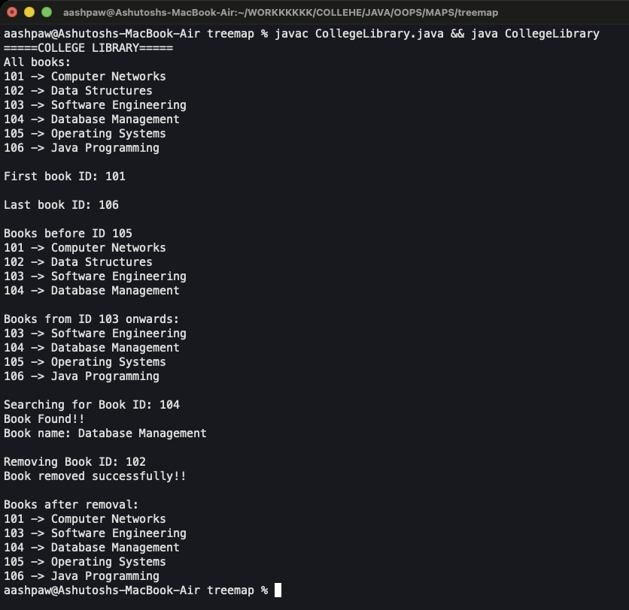
Figure 24: Output

Program 25: Student Management (HashSet + LinkedList)
Collections Framework › TreeMap, HashSet, LinkedList and HashMap
File: OOPS/MAPS/treemap/StudentManagement.java | Class: StudentManagement | Date: 10 Sep 2026

Aim: Unique student names in a HashSet and ordered subjects in a LinkedList.
Concepts used:
- HashSet ignores the duplicate "Rahul"; contains() and remove() work by value.
- LinkedList supports addFirst(), addLast(), getFirst(), getLast(), removeFirst(), removeLast() and indexOf().

Source Code
import java.util.*;

public class StudentManagement {
public static void main(String[] args) {
//1. HashSet
//stores unique student names, no duplicates, no order
HashSet<String> students = new HashSet<>();

students.add("Rahul");
students.add("Priya");
students.add("Amit");
students.add("Rahul"); // duplicate, HashSet ignores it

System.out.println("=====STUDENT MANAGEMENT=====");
System.out.println("All students: " + students);
System.out.println("Total students: " + students.size());

// search for a student
String searchName = "Priya";

System.out.println("\nSearching for student: " + searchName);

if (students.contains(searchName)) {
System.out.println("Student found!!");
} else {
System.out.println("Student not found: " + searchName + " !!!!");
}

// remove a student
String removeName = "Amit";

System.out.println("\nRemoving student: " + removeName);

if (students.remove(removeName)) {
System.out.println("Student removed successfully!!");
} else {
System.out.println("Student not found: " + removeName + " !!!!");
}

System.out.println("\nStudents after removal:");

for (String name : students) {
System.out.println("- " + name);
}

//2. LinkedList
//stores subjects in insertion order, duplicates allowed
LinkedList<String> subject = new LinkedList<>();
subject.add("Java");
subject.add("Science");
subject.add("English");

System.out.println("\nAll subjects: " + subject);
System.out.println("Total subjects: " + subject.size());

// add at both ends
subject.addFirst("Maths");
subject.addLast("History");

System.out.println("\nSubjects after adding at both ends: " + subject);

System.out.println("First subject: " + subject.getFirst());
System.out.println("Last subject: " + subject.getLast());

// search by index
String searchSubject = "English";

System.out.println("\nSearching for subject: " + searchSubject);

if (subject.contains(searchSubject)) {
System.out.println("Subject found at index: " + subject.indexOf(searchSubject));
} else {
System.out.println("Subject not found: " + searchSubject + " !!!!");
}

// remove from front and back
System.out.println("\nRemoved first subject: " + subject.removeFirst());
System.out.println("Removed last subject: " + subject.removeLast());

System.out.println("\nSubjects after removal:");

for (int i = 0; i < subject.size(); i++) {
System.out.println(i + " -> " + subject.get(i));
}
}
}

Output
Run: javac StudentManagement.java && java StudentManagement
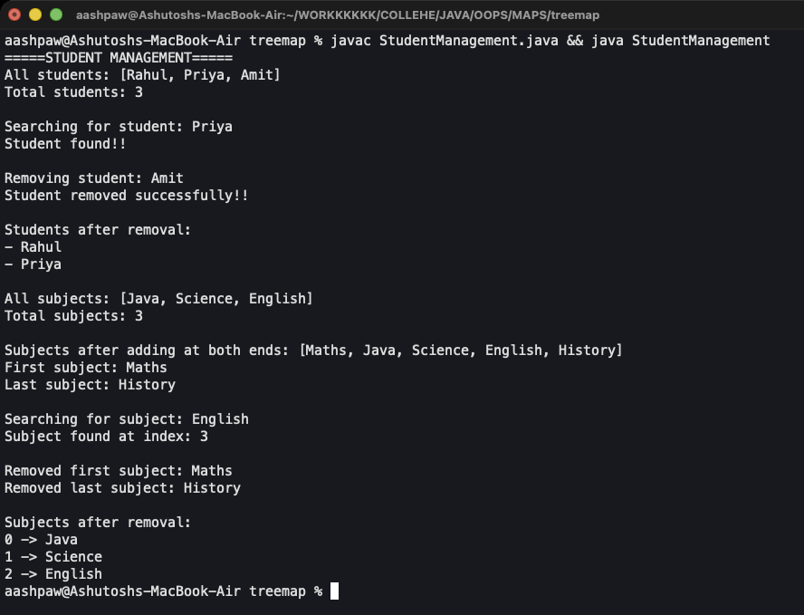
Figure 25: Output

Program 26: Music Playlist (LinkedList)
Collections Framework › TreeMap, HashSet, LinkedList and HashMap
File: OOPS/LinkedList/LinkedListMusic.java | Class: LinkedListMusic | Date: 10 Sep 2026

Aim: A song playlist using LinkedList operations.
Concepts used:
- add() appends songs; addFirst() puts a song at the front.
- getLast(), contains(), remove(Object) and size() inspect and update the list.

Source Code
import java.util.LinkedList;

public class LinkedListMusic {
public static void main(String[] args) {
LinkedList<String> playlist = new LinkedList<>();

playlist.add("Instant Crush");
playlist.add("Mind Games");
playlist.add("Les");

System.out.println("Playlist: " + playlist);

playlist.addFirst("In the Night");

//Display last song
System.out.println("Last song: " + playlist.getLast());

//Search song
if(playlist.contains("Les")) {
System.out.println("Song found in the playlist.");
}

//Remove song
playlist.remove("Mind Games");
System.out.println("Updated Playlist: " + playlist);

//Total Songs
System.out.println("Total Songs: " + playlist.size());
}
}

Output
Run: javac LinkedListMusic.java && java LinkedListMusic
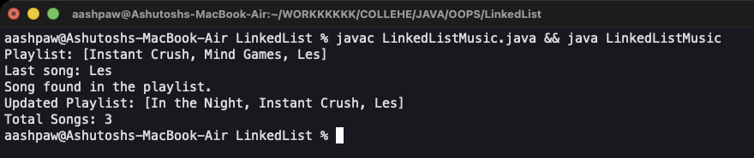
Figure 26: Output

Program 27: HashSet Operations
Collections Framework › TreeMap, HashSet, LinkedList and HashMap
File: OOPS/MAPS/Hashset/hash.java | Class: hash | Date: 10 Sep 2026

Aim: Show how a HashSet handles duplicates, removal, retainAll and conversion to an array.
Concepts used:
- Adding "Apple" twice keeps only one copy.
- retainAll() keeps only the elements that are also in the given list (set intersection).
- toArray(new String[0]) converts the set to a String array.

Source Code
import java.util.Arrays;
import java.util.HashSet;

public class hash {
public static void main(String[] args) {
HashSet<String> set = new HashSet<>();
set.add("Apple");
set.add("Apple"); // ignored (duplicate)
set.add("Banana");

System.out.println("Set: " + set);
System.out.println("Contains Apple? " + set.contains("Apple")); // true

set.remove("Banana");
System.out.println("After removing Banana: " + set);

set.retainAll(Arrays.asList("Apple", "Orange")); // keeps only "Apple"
System.out.println("After retainAll: " + set);

String[] arr = set.toArray(new String[0]);
System.out.println("As array: " + Arrays.toString(arr));
}
}

Output
Run: javac hash.java && java hash
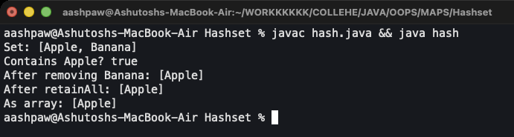
Figure 27: Output

Program 28: HashMap Operations
Collections Framework › TreeMap, HashSet, LinkedList and HashMap
File: OOPS/MAPS/hashmap/hashmap.java | Class: hashmap | Date: 10 Sep 2026

Aim: Use HashMap's update methods on a fruit-to-quantity map.
Concepts used:
- putIfAbsent() only inserts when the key is missing.
- getOrDefault() returns a fallback (0) for a missing key.
- compute() and merge() update a value with a lambda; forEach() prints every entry.

Source Code
import java.util.HashMap;

public class hashmap {
public static void main(String[] args) {
HashMap<String, Integer> map = new HashMap<>();
map.put("Apple", 10);
map.putIfAbsent("Apple", 20); // won't change (10 remains)
map.putIfAbsent("Banana", 15); // inserts new

System.out.println(map.getOrDefault("Orange", 0)); // 0

map.compute("Apple", (k, v) -> v + 5); // becomes 15
map.merge("Banana", 10, (old, incoming) -> old + incoming); // becomes 25

map.forEach((k, v) -> System.out.println(k + ":" + v));
}
}

Output
Run: javac hashmap.java && java hashmap
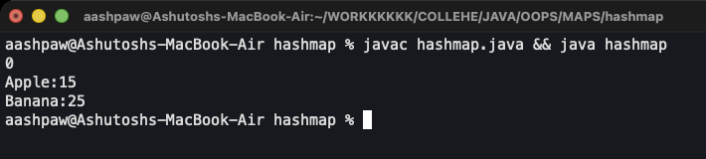
Figure 28: Output

Program 29: Shopping Stock and Cart System
Collections Framework › Assignment: Shopping Stock and Cart
File: OOPS/MAPS/ShoppingAssignment.java | Class: ShoppingAssignment | Date: 10 Sep 2026

Aim: A Swing shop where products move between stock and cart, with a live total and a printed bill.
Concepts used:
- Stock is a LinkedList of HashMaps: each HashMap is one product (id, name, price, qty).
- Cart is a LinkedHashMap<Integer, Integer> of product id -> quantity; it keeps insertion order so rows don't jump.
- Adding moves one unit from stock to cart; removing moves it back. Name and price are always read from Stock, so a price is stored in one place.
- JTable with DefaultTableModel shows both lists; String.format() builds the aligned bill.

Source Code
import javax.swing.*;
import javax.swing.table.DefaultTableModel;
import java.awt.*;
import java.util.LinkedHashMap;
import java.util.LinkedList;
import java.util.HashMap;
import java.util.Map;

/**
* Shopping stock + cart system.
*
* Stock : LinkedList of HashMaps. One HashMap = one product.
* Cart : HashMap of productId -> quantity chosen.
*/
public class ShoppingAssignment {

public static void main(String[] args) {
Stock stock = new Stock();
stock.addProduct(101, "Laptop", 55000.0, 5);
stock.addProduct(102, "Phone", 20000.0, 10);
stock.addProduct(103, "Bottle", 250.0, 10);
stock.addProduct(104, "Book", 400.0, 10);
stock.addProduct(105, "Pen", 20.0, 10);

Cart cart = new Cart(stock);

// Swing wants its windows built on the event dispatch thread.
SwingUtilities.invokeLater(() -> new ShopUI(stock, cart).setVisible(true));
}
}

/**
* Holds every product. Each product is a HashMap with the keys
* "id", "name", "price", "qty", and all of them live in one LinkedList.
*/
class Stock {

private LinkedList<HashMap<String, Object>> products = new LinkedList<>();

public void addProduct(int id, String name, double price, int qty) {
HashMap<String, Object> product = new HashMap<>();
product.put("id", id);
product.put("name", name);
product.put("price", price);
product.put("qty", qty);
products.add(product);
}

public LinkedList<HashMap<String, Object>> getAll() {
return products;
}

/** Returns the product map with this id, or null if there is none. */
public HashMap<String, Object> findById(int id) {
for (HashMap<String, Object> product : products) {
if (getId(product) == id) {
return product;
}
}
return null;
}

/** Adds delta to the stored quantity. Pass -1 to sell one, +1 to put one back. */
public void changeQty(int id, int delta) {
HashMap<String, Object> product = findById(id);
if (product != null) {
product.put("qty", getQty(product) + delta);
}
}

// The map values are Objects, so every read needs a cast. These helpers keep
// the casts in one place instead of scattering them through the whole program.
public static int getId(HashMap<String, Object> product) {
return (int) product.get("id");
}

public static String getName(HashMap<String, Object> product) {
return (String) product.get("name");
}

public static double getPrice(HashMap<String, Object> product) {
return (double) product.get("price");
}

public static int getQty(HashMap<String, Object> product) {
return (int) product.get("qty");
}
}

/**
* The chosen items. Stores only id -> quantity; the name and price are always
* read back from Stock, so there is exactly one copy of a product's price.
*
* LinkedHashMap is a HashMap that also remembers insertion order, which keeps
* the cart table rows from jumping around after every click.
*/
class Cart {

private LinkedHashMap<Integer, Integer> items = new LinkedHashMap<>();
private Stock stock;

public Cart(Stock stock) {
this.stock = stock;
}

/**
* Moves one unit from stock into the cart.
* Returns false when the product is sold out, so nothing changes.
*/
public boolean add(int id) {
HashMap<String, Object> product = stock.findById(id);
if (product == null || Stock.getQty(product) <= 0) {
return false;
}
stock.changeQty(id, -1);
items.put(id, getQty(id) + 1);
return true;
}

/**
* Moves one unit back from the cart into stock.
* Returns false when the product is not in the cart.
*/
public boolean remove(int id) {
if (!items.containsKey(id)) {
return false;
}
stock.changeQty(id, +1);

int left = items.get(id) - 1;
if (left == 0) {
items.remove(id); // last one taken out, drop the row completely
} else {
items.put(id, left);
}
return true;
}

public LinkedHashMap<Integer, Integer> getItems() {
return items;
}

public int getQty(int id) {
if (items.containsKey(id)) {
return items.get(id);
}
return 0;
}

public boolean isEmpty() {
return items.isEmpty();
}

public double getTotal() {
double total = 0;
for (Map.Entry<Integer, Integer> entry : items.entrySet()) {
HashMap<String, Object> product = stock.findById(entry.getKey());
total = total + Stock.getPrice(product) * entry.getValue();
}
return total;
}

public String buildBill() {
StringBuilder bill = new StringBuilder();
bill.append("--------------- BILL ---------------\n");
bill.append(String.format("%-12s %5s %10s %12s%n", "ITEM", "QTY", "PRICE", "AMOUNT"));

for (Map.Entry<Integer, Integer> entry : items.entrySet()) {
HashMap<String, Object> product = stock.findById(entry.getKey());
int qty = entry.getValue();
double price = Stock.getPrice(product);

bill.append(String.format("%-12s %5d %10.2f %12.2f%n",
Stock.getName(product), qty, price, price * qty));
}

bill.append("------------------------------------\n");
bill.append(String.format("%-12s %28.2f%n", "TOTAL", getTotal()));
return bill.toString();
}

public void clear() {
items.clear();
}
}

/**
* The window. It only reads from Stock and calls methods on Cart -
* none of the add/remove rules live in here.
*/
class ShopUI extends JFrame {

private Stock stock;
private Cart cart;

private DefaultTableModel stockModel;
private DefaultTableModel cartModel;
private JTable stockTable;
private JTable cartTable;
private JLabel totalLabel;

public ShopUI(Stock stock, Cart cart) {
this.stock = stock;
this.cart = cart;

setTitle("Shopping System");
setDefaultCloseOperation(JFrame.EXIT_ON_CLOSE);
setSize(760, 400);
setLocationRelativeTo(null);
setLayout(new BorderLayout(8, 8));

stockModel = buildModel(new String[]{"ID", "Name", "Price", "Qty"});
cartModel = buildModel(new String[]{"ID", "Name", "Price", "Qty", "Amount"});

stockTable = new JTable(stockModel);
cartTable = new JTable(cartModel);
stockTable.setSelectionMode(ListSelectionModel.SINGLE_SELECTION);
cartTable.setSelectionMode(ListSelectionModel.SINGLE_SELECTION);

JPanel tables = new JPanel(new GridLayout(1, 2, 8, 8));
tables.add(titled(stockTable, "Stock"));
tables.add(titled(cartTable, "Cart"));
add(tables, BorderLayout.CENTER);

JButton addButton = new JButton("Add to Cart");
JButton removeButton = new JButton("Remove from Cart");
JButton billButton = new JButton("Generate Bill");
totalLabel = new JLabel("Total: 0.00");

addButton.addActionListener(e -> onAdd());
removeButton.addActionListener(e -> onRemove());
billButton.addActionListener(e -> onBill());

JPanel bottom = new JPanel(new FlowLayout(FlowLayout.LEFT, 10, 8));
bottom.add(addButton);
bottom.add(removeButton);
bottom.add(billButton);
bottom.add(totalLabel);
add(bottom, BorderLayout.SOUTH);

refresh();
}

/** A table model whose cells cannot be typed into. */
private DefaultTableModel buildModel(String[] columns) {
return new DefaultTableModel(columns, 0) {
@Override
public boolean isCellEditable(int row, int column) {
return false;
}
};
}

private JScrollPane titled(JTable table, String title) {
JScrollPane pane = new JScrollPane(table);
pane.setBorder(BorderFactory.createTitledBorder(title));
return pane;
}

private void onAdd() {
int row = stockTable.getSelectedRow();
if (row == -1) {
JOptionPane.showMessageDialog(this, "Select a product from the stock table first.");
return;
}

int id = (int) stockModel.getValueAt(row, 0);
if (!cart.add(id)) {
JOptionPane.showMessageDialog(this, "That product is out of stock.");
return;
}
refresh();
stockTable.setRowSelectionInterval(row, row); // keep the same row highlighted
}

private void onRemove() {
int row = cartTable.getSelectedRow();
if (row == -1) {
JOptionPane.showMessageDialog(this, "Select a product from the cart first.");
return;
}

int id = (int) cartModel.getValueAt(row, 0);
cart.remove(id);
refresh();
}

private void onBill() {
if (cart.isEmpty()) {
JOptionPane.showMessageDialog(this, "Cart is empty.");
return;
}

JTextArea area = new JTextArea(cart.buildBill());
area.setFont(new Font(Font.MONOSPACED, Font.PLAIN, 13));
area.setEditable(false);

JOptionPane.showMessageDialog(this, new JScrollPane(area), "Bill",
JOptionPane.PLAIN_MESSAGE);

cart.clear(); // items are sold, stock stays reduced
refresh();
}

/** Throws away every row and rebuilds both tables from the current data. */
private void refresh() {
stockModel.setRowCount(0);
for (HashMap<String, Object> product : stock.getAll()) {
stockModel.addRow(new Object[]{
Stock.getId(product),
Stock.getName(product),
String.format("%.2f", Stock.getPrice(product)),
Stock.getQty(product)
});
}

cartModel.setRowCount(0);
for (Map.Entry<Integer, Integer> entry : cart.getItems().entrySet()) {
HashMap<String, Object> product = stock.findById(entry.getKey());
int qty = entry.getValue();
double price = Stock.getPrice(product);

cartModel.addRow(new Object[]{
Stock.getId(product),
Stock.getName(product),
String.format("%.2f", price),
qty,
String.format("%.2f", price * qty)
});
}

totalLabel.setText(String.format("Total: %.2f", cart.getTotal()));
}
}

Output
Run: javac ShoppingAssignment.java && java ShoppingAssignment
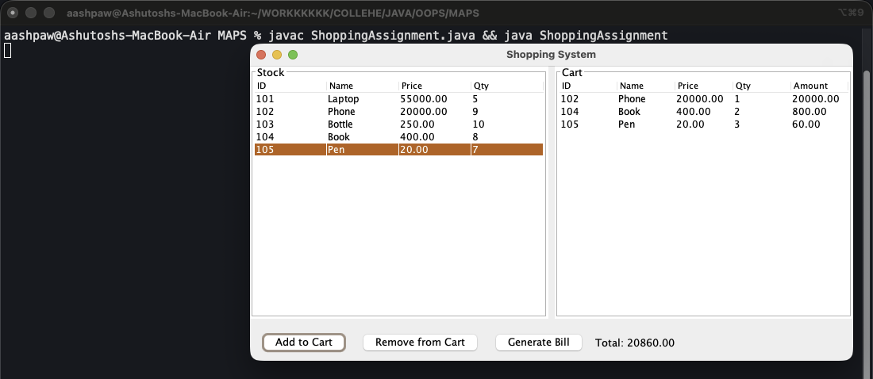
Figure 29.1: Phone x1, Book x2, Pen x3 added to cart
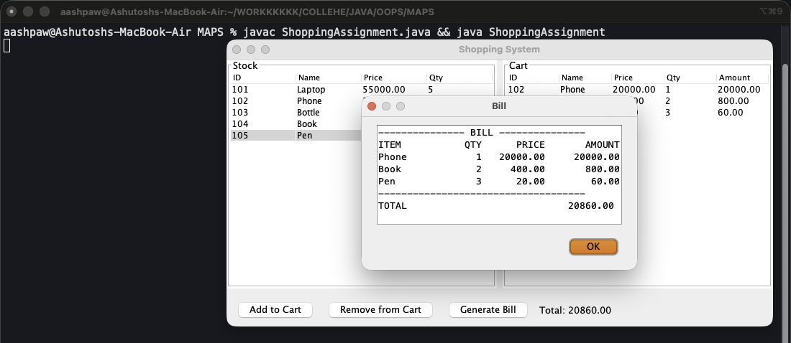
Figure 29.2: Generated bill

Part 5: Exception Handling
An exception is an error that happens while the program runs. try holds code that may fail; catch handles a specific exception so the program doesn't crash.
throw raises an exception on purpose, and getMessage() reads its message. ArrayIndexOutOfBoundsException is an unchecked exception; Exception is the general parent class.
Programs in this part:
- try, catch and throw: 30. Bank Withdrawal (throw), 31. Array Index Out of Bounds

Program 30: Bank Withdrawal (throw)
Exception Handling › try, catch and throw
File: OOPS/exception_handling/BankExample.java | Class: BankExample | Date: 11 Sep 2026

Aim: Withdraw money and throw an exception when the amount is more than the balance.
Concepts used:
- throw new Exception("Insufficient funds...") jumps straight to the catch block.
- catch (Exception e) prints e.getMessage().

Source Code
import java.util.Scanner;

public class BankExample {
public static void main(String[] args) {
Scanner sc = new Scanner(System.in);

double balance = 5000;
try{
System.out.print("Enter amount to withdraw: ");
double amount = sc.nextDouble();

if(amount > balance){
throw new Exception("Insufficient funds for withdrawal.");
}

balance -= amount;
System.out.println("Withdrawal successful.");
System.out.println("Remaining balance: ₹" + balance);

} catch (Exception e){
System.out.println("Transaction failed: "+e.getMessage());
}

sc.close();
}
}

Output
Run: javac BankExample.java && java BankExample
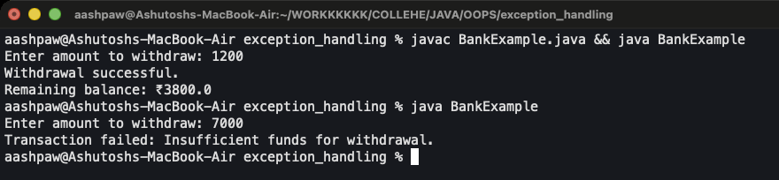
Figure 30: Run 1: 1200 (success) Run 2: 7000 (exception)

Program 31: Array Index Out of Bounds
Exception Handling › try, catch and throw
File: OOPS/exception_handling/OutOfBoundIndex.java | Class: OutOfBoundIndex | Date: 11 Sep 2026

Aim: Catch an invalid array index entered by the user.
Concepts used:
- marks has 6 elements (index 0 to 5); index 8 throws ArrayIndexOutOfBoundsException.
- The catch block prints a friendly message instead of a stack trace.

Source Code
import java.util.Scanner;

public class OutOfBoundIndex {
public static void main(String[] args) {
Scanner sc = new Scanner(System.in);

int[] marks = {10,20,30,40,50,60};

try {
System.out.println("Enter student index: ");
int index = sc.nextInt();

System.out.println("Marks = " + marks[index]);
} catch (ArrayIndexOutOfBoundsException e) {
System.out.println("Invalid student index entered!!!!");
}

sc.close();
}
}

Output
Run: javac OutOfBoundIndex.java && java OutOfBoundIndex
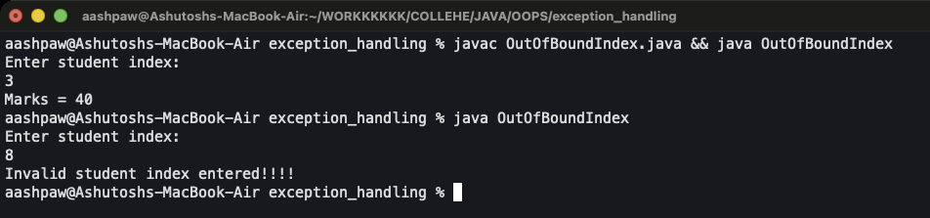
Figure 31: Run 1: index 3 Run 2: index 8

Part 6: File Handling
java.io lets a program save data to files and read it back. FileWriter writes text (append mode with true), File plus Scanner reads it line by line.
File operations can fail (missing file, no permission), so they are wrapped in try-catch for IOException / Exception.
Programs in this part:
- Writing and Reading Files: 32. Save Student Record to File, 33. Search a Word in a File

Program 32: Save Student Record to File
File Handling › Writing and Reading Files
File: FileHandling/StudentFile.java | Class: StudentFile | Date: 16 Sep 2026

Aim: Read a student's details and append them to students.txt.
Concepts used:
- new FileWriter("students.txt", true) opens the file in append mode, so old records are kept.
- write() adds each line; close() saves the file.
- cat students.txt in the terminal shows the saved record.

Source Code
import java.io.FileWriter;
import java.io.IOException;
import java.util.Scanner;

public class StudentFile {

public static void main(String[] args) {

Scanner sc = new Scanner(System.in);

try {
FileWriter writer = new FileWriter("students.txt", true);

System.out.print("Enter student name: ");
String name = sc.nextLine();

System.out.print("Enter course: ");
String course = sc.nextLine();

System.out.print("Enter marks: ");
int marks = sc.nextInt();

writer.write("Name: " + name + "\n");
writer.write("Course: " + course + "\n");
writer.write("Marks: " + marks + "\n");
writer.write("----------------------\n");

writer.close();

System.out.println("Student record saved.");

} catch (IOException e) {
System.out.println("File error occurred.");
}

sc.close();
}
}

Output
Run: javac StudentFile.java && java StudentFile
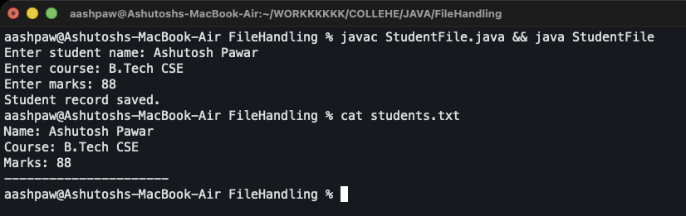
Figure 32: Output, then the contents of students.txt

Program 33: Search a Word in a File
File Handling › Writing and Reading Files
File: FileHandling/SearchWord.java | Class: SearchWord | Date: 16 Sep 2026

Aim: Search data.txt for a word and print every line that contains it.
Concepts used:
- new Scanner(new File("data.txt")) reads the file; hasNextLine() / nextLine() loop over it.
- toLowerCase() on both sides makes the search case-insensitive.
- A found flag prints 'word not found' when nothing matches.

Source Code
import java.io.File;
import java.util.Scanner;

public class SearchWord {
public static void main(String[] args) {
Scanner input = new Scanner(System.in);

System.out.print("enter a word to search: ");
String search = input.nextLine();

boolean found = false;
try {
File file = new File("data.txt");
Scanner sc = new Scanner(file);

while (sc.hasNextLine()) {
String line = sc.nextLine();

if (line.toLowerCase().contains(search.toLowerCase())) {
System.out.println("Found: " + line);
found = true;
}
}
sc.close();
} catch (Exception e) {
System.out.println("File error: data.txt not found!!!");
}

if (!found) {
System.out.println("word not found!!!");
}

input.close();
}
}

Output
Run: javac SearchWord.java && java SearchWord
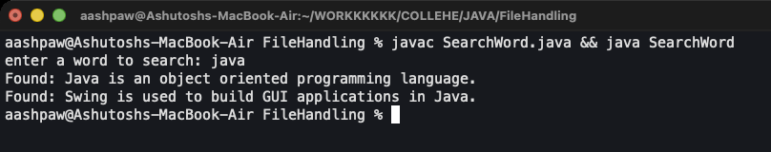
Figure 33: Searching data.txt for "java"

