**WEB TECHNOLOGY-ASSIGNMENT**

(1JT18IS001- Aashritha.H.H)

***Program-1: Write a JavaScript to design a simple calculator to perform the following operations: Sum, Product, Difference and Quotient.***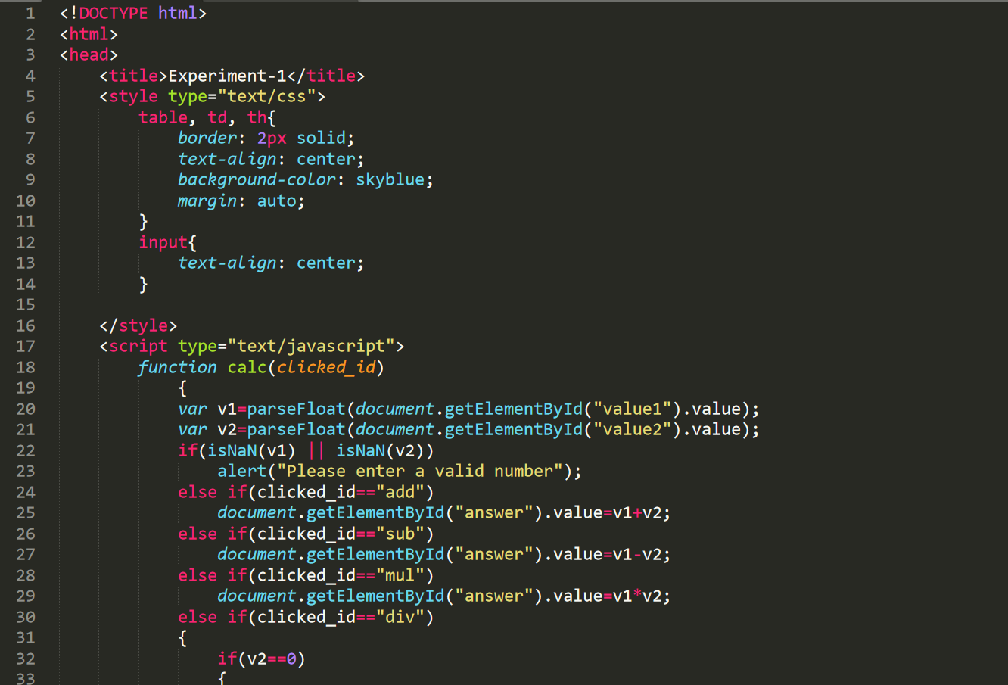

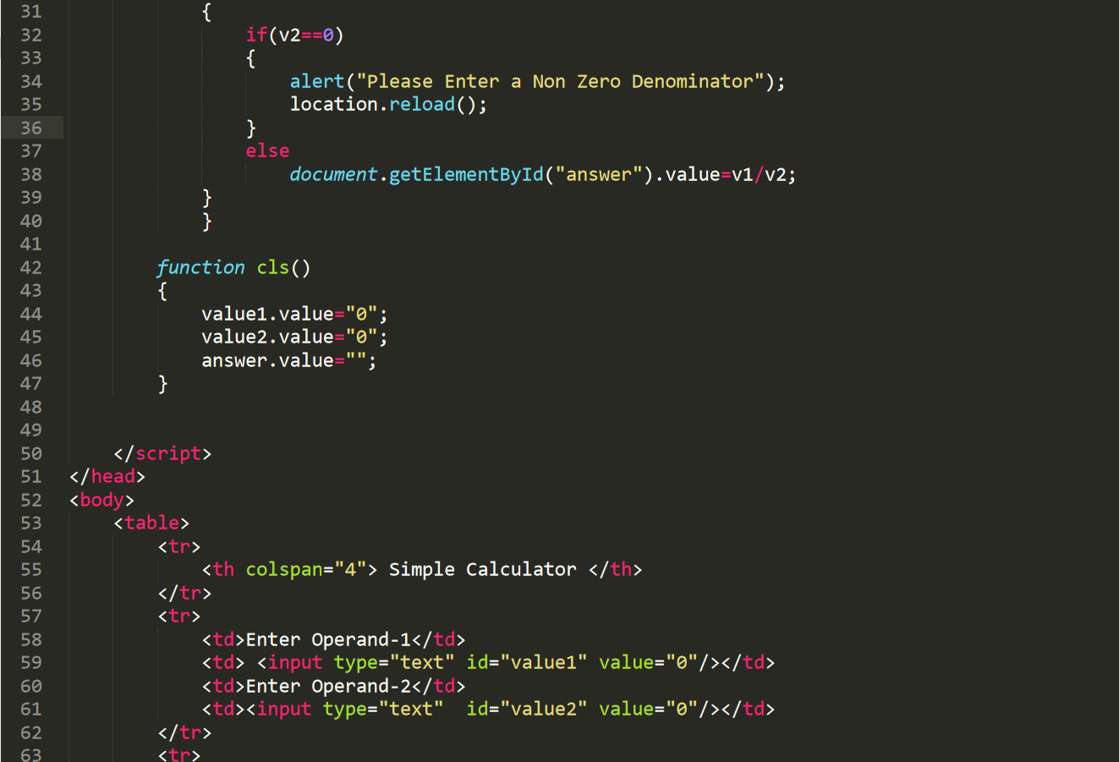

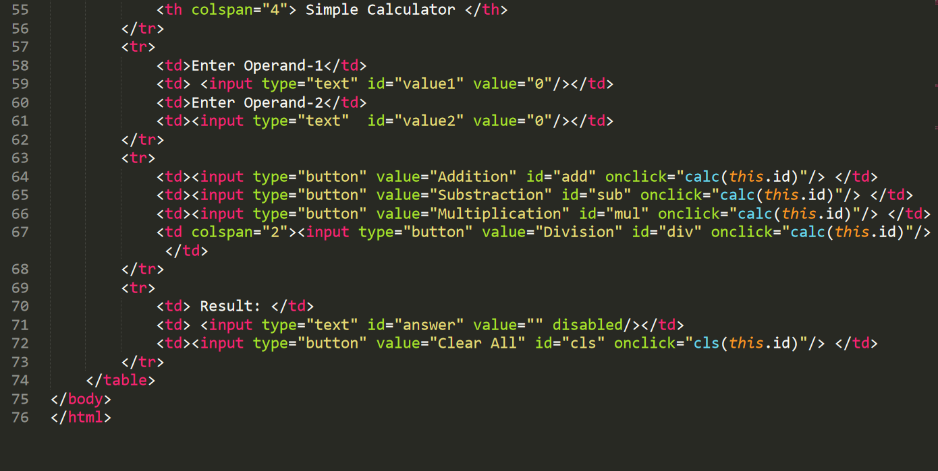

OUTPUT:

Addition:-

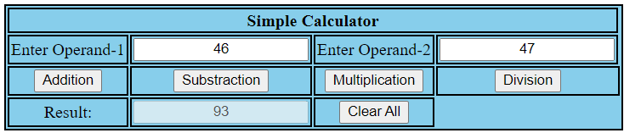

Subtraction:

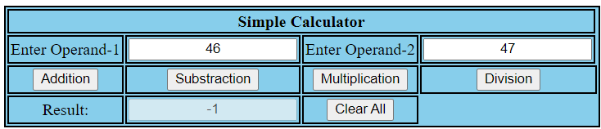

Multiplication:

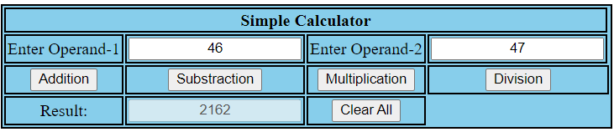

Division:

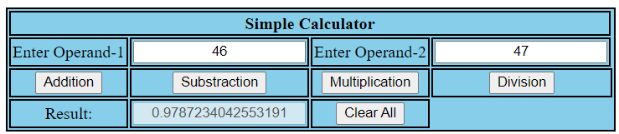

Test Cases:

|  |  |  |  |  |
| --- | --- | --- | --- | --- |
| **Test No.** | **Input Parameters** | **Expected O/P** | **Obtained O/P** | **Remarks** |
| **1.** | V1 = 46  V2 = 47 | Addition = 93 | Addition = 7 | **PASS** |
| Subtraction = -1 | Subtraction = 3 |
| Product = 2162 | Product = 10 |
| Division = 0.978723404 | Division = 2.5 |
| **2.** | V1 = 7.0  V2 = 8.0 | Addition = 15 | Addition = 7 | **PASS** |
| Subtraction = -1 | Subtraction = 3 |
| Product = 56 | Product = 10 |
| Division = 0.875 | Division = 2.5 |
| **3.** | V1 = 2  V2 = 3 | Addition = 5 | Addition = 7 | **PASS** |
| Subtraction = -1 | Subtraction = -3 |
| Product = 6 | Product = 10 |
| Division = 0.6666 | Division = 0.4 |
| **4.** | V1 = 5  V2 =4 | Addition = 9 | Addition = 5 | **PASS** |
| Subtraction = 1 | Subtraction = -5 |
| Product = 20 | Product = 0 |
| Division = 1.25 | Division = 0 |
| **5.** | V1 = 4  V2 = 0 | Addition = 4 | Addition = 4 | **PASS** |
| Subtraction = 4 | Subtraction = 4 |
| Product = 0 | Product = 0 |
| Division = Infinity | Division = Infinity |
| **6.** | V1 = a  V2 = 4 | Enter a number | Enter a number | **PASS** |

Github link: [**https://github.com/Aashrithajitwta/1JT18IS001_WT**](https://github.com/Aashrithajitwta/1JT18IS001_WT)

**ASSIGNMENT-1**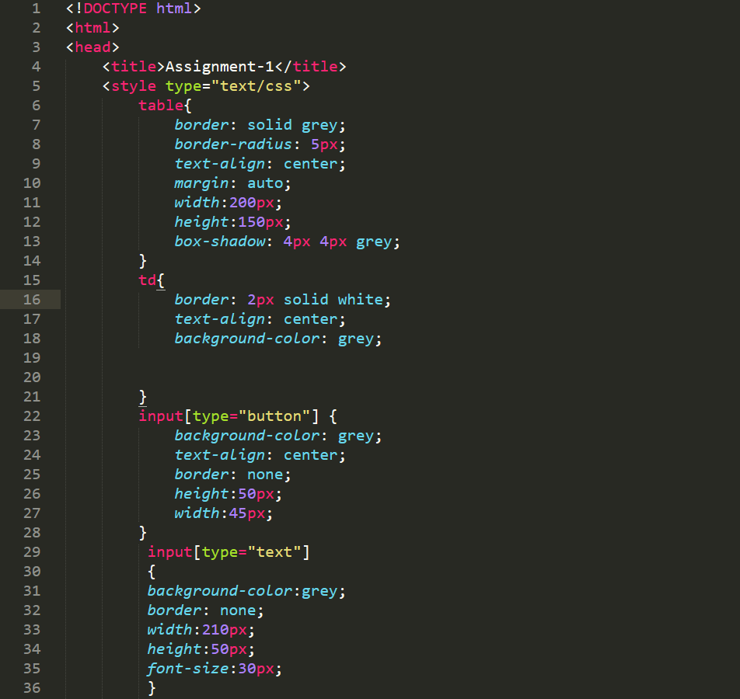

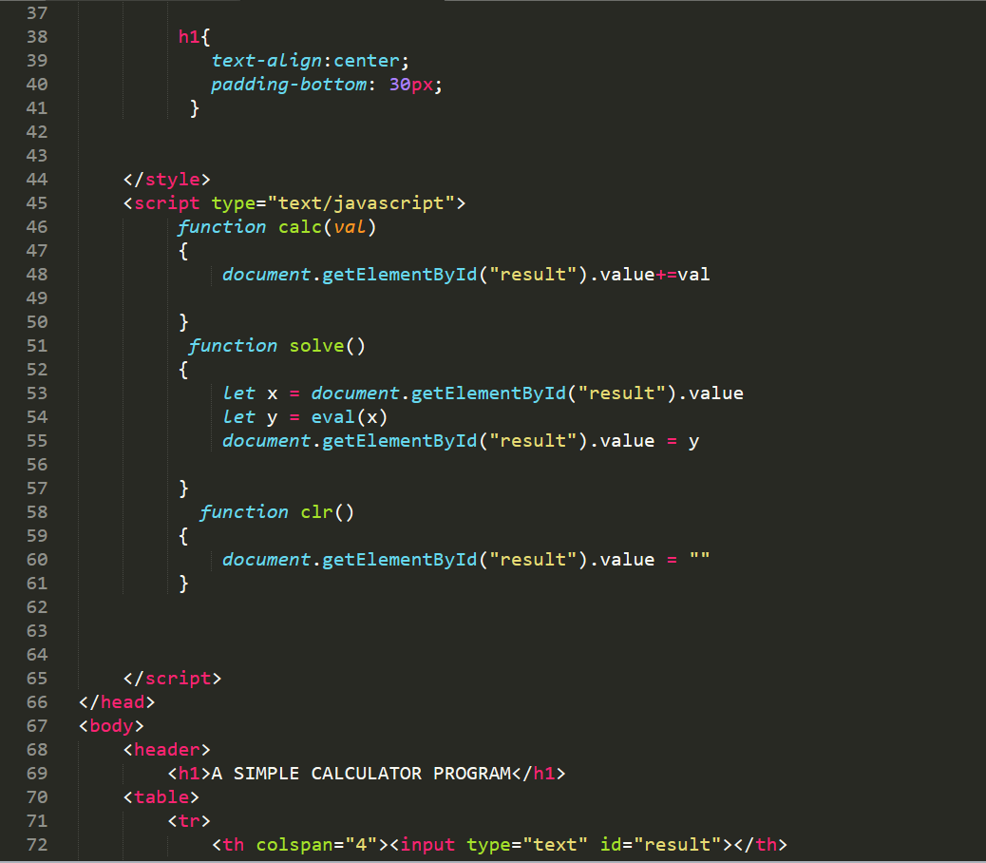

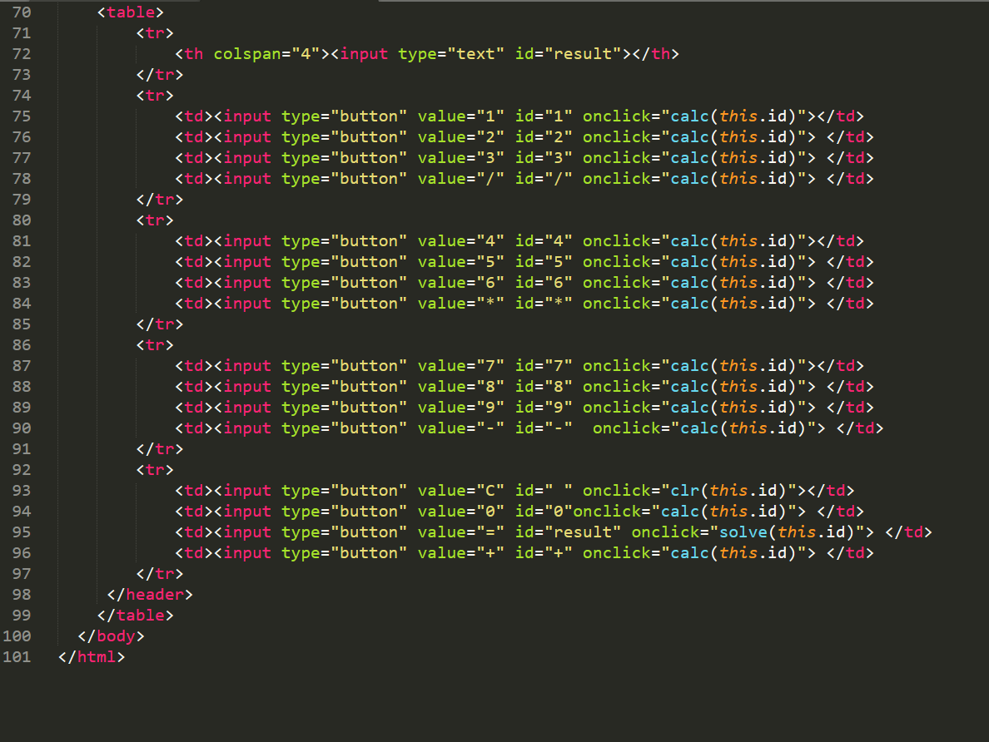

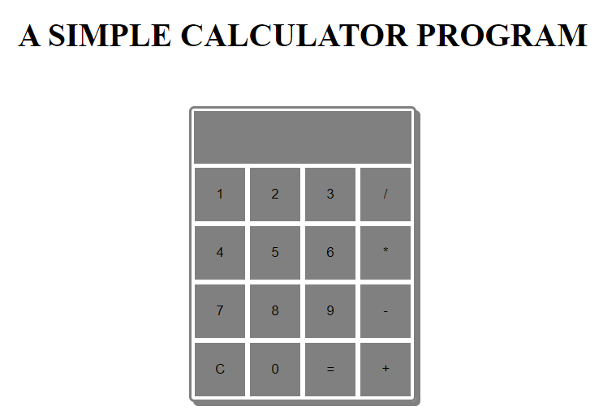OUTPUT:

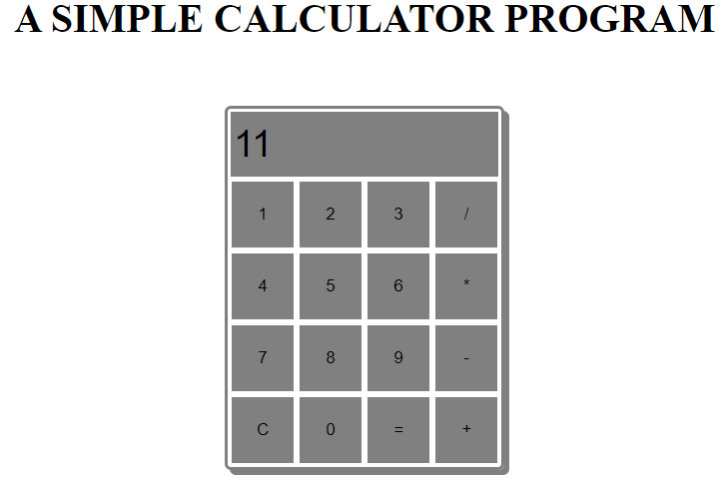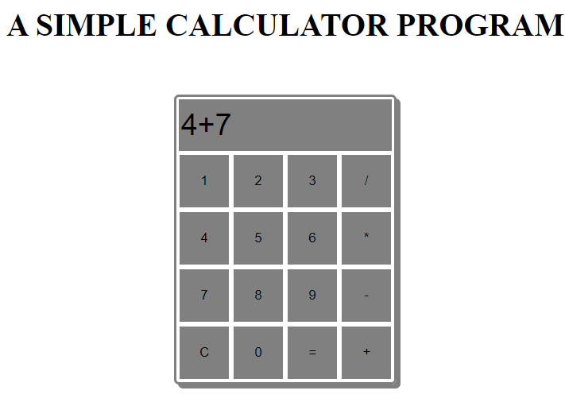Addition:-

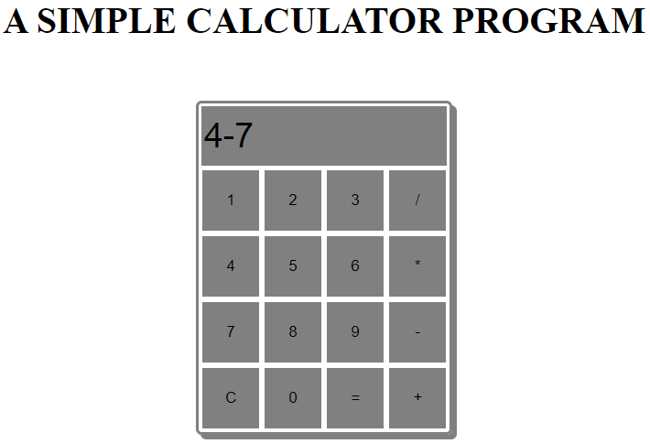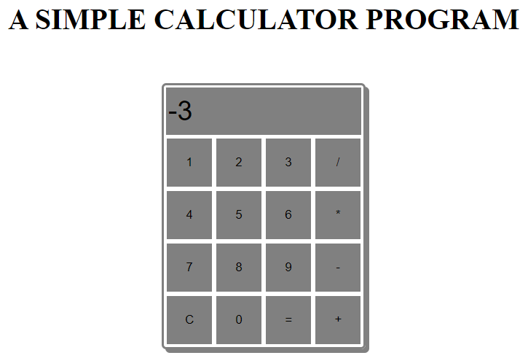Subtraction:-

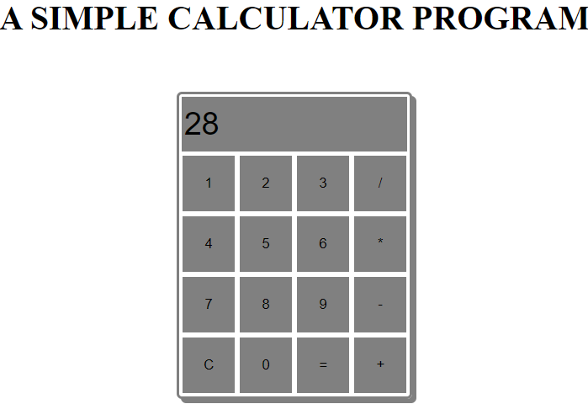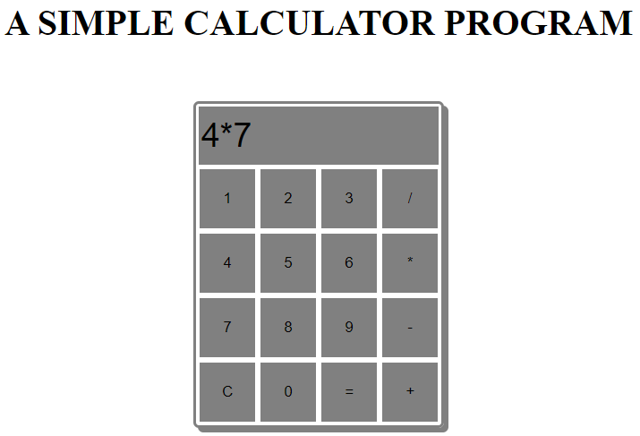Multiplication:

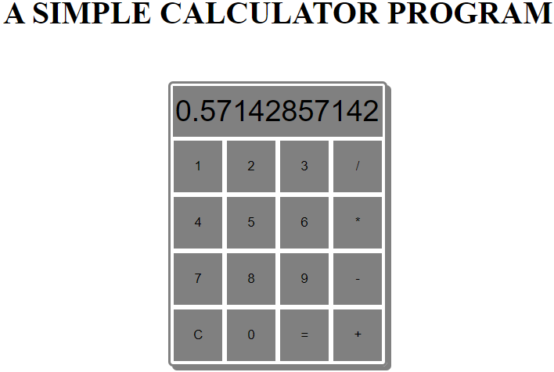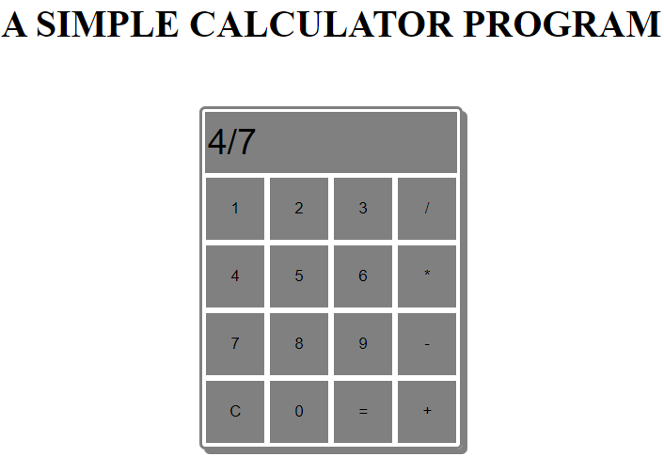Division:

Test Cases:

|  |  |  |  |  |
| --- | --- | --- | --- | --- |
| **Test No.** | **Input Parameters** | **Expected O/P** | **Obtained O/P** | **Remarks** |
| **1.** | V1 = 4  V2 = 7 | Addition = 11 | Addition = 7 | **PASS** |
| Subtraction = -3 | Subtraction = 3 |
| Product = 28 | Product = 10 |
| Division = 0.57142857142 | Division = 2.5 |
| **2.** | V1 = 7.0  V2 = 8.0 | Addition = 7 | Addition = 7 | **PASS** |
| Subtraction = -1 | Subtraction = 3 |
| Product = 56 | Product = 10 |
| Division = 0.875 | Division = 2.5 |
| **3.** | V1 = 2  V2 = 3 | Addition = 5 | Addition = 7 | **PASS** |
| Subtraction = -1 | Subtraction = -3 |
| Product = 6 | Product = 10 |
| Division = 0.6666 | Division = 0.4 |
| **4.** | V1 = 5  V2 =4 | Addition = 9 | Addition = 5 | **PASS** |
| Subtraction = 1 | Subtraction = -5 |
| Product = 20 | Product = 0 |
| Division = 1.25 | Division = 0 |
| **5.** | V1 = 4  V2 = 0 | Addition = 4 | Addition = 4 | **PASS** |
| Subtraction = 4 | Subtraction = 4 |
| Product = 0 | Product = 0 |
| Division = Infinity | Division = Infinity |

Github link: [**https://github.com/Aashrithajitwta/1JT18IS001_WT**](https://github.com/Aashrithajitwta/1JT18IS001_WT)

(1JT18IS001-Aashritha.H.H)