HomeWork3.2A
Weak Prompts
- Explain regression
- Help me understand SQL
- Create a dataset

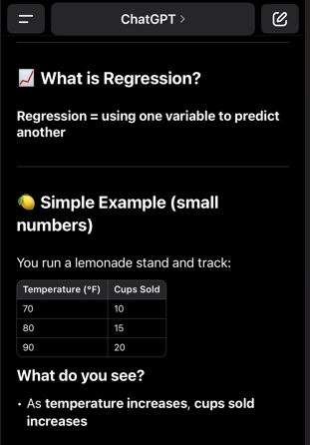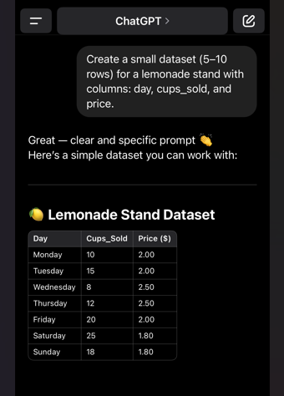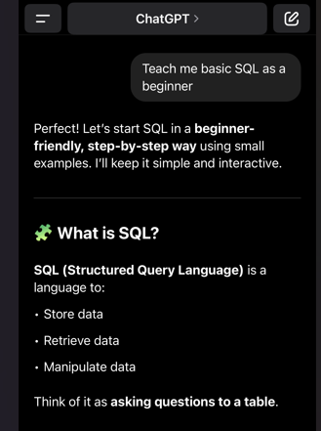

The revised prompts are better because the are not as vague they don’t give enough information for Chat to do its job. You have to add more detail to get a specific answer.

