MES4 / Festo PLC Guide
Link to MES4 interface description:
https://ftp.festo.com/public/DIDACTIC/MES4/Tools/MES4_Interface_en_v1.07.pdf

- Open PLC project (do not update libraries - click “cancel”)
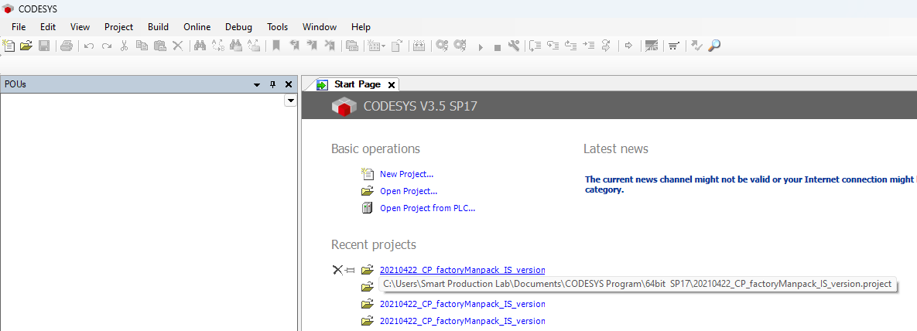
- All PLCs are available within the project and uses more or less the same program structure with “AppModul” being the code controlling all the logics of the operations. “Main” initiliases everything, checks for emergency stops and run the “AppModul” program.
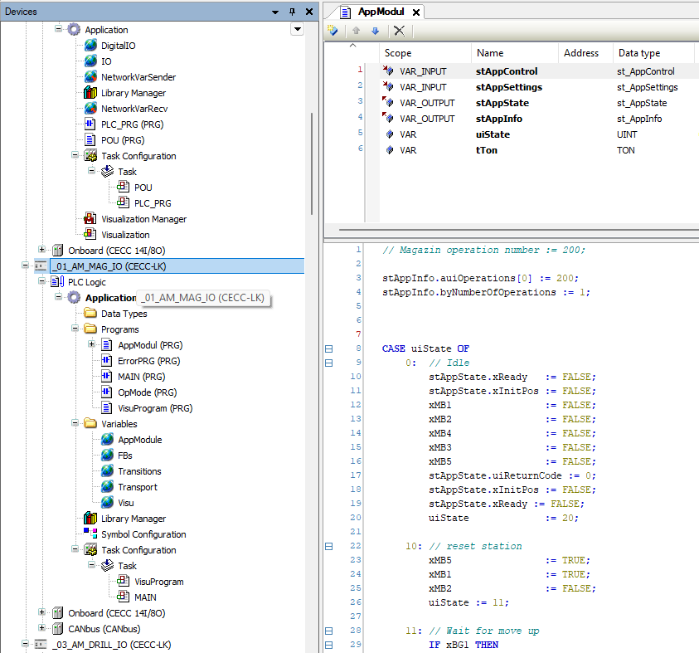

- Under the POU tab the MES4 logic is located under “Programs/StopperWithMes/Private/_MesMode”. This code block is used for all the PLC resources and is the code communicating with the MES4 system.
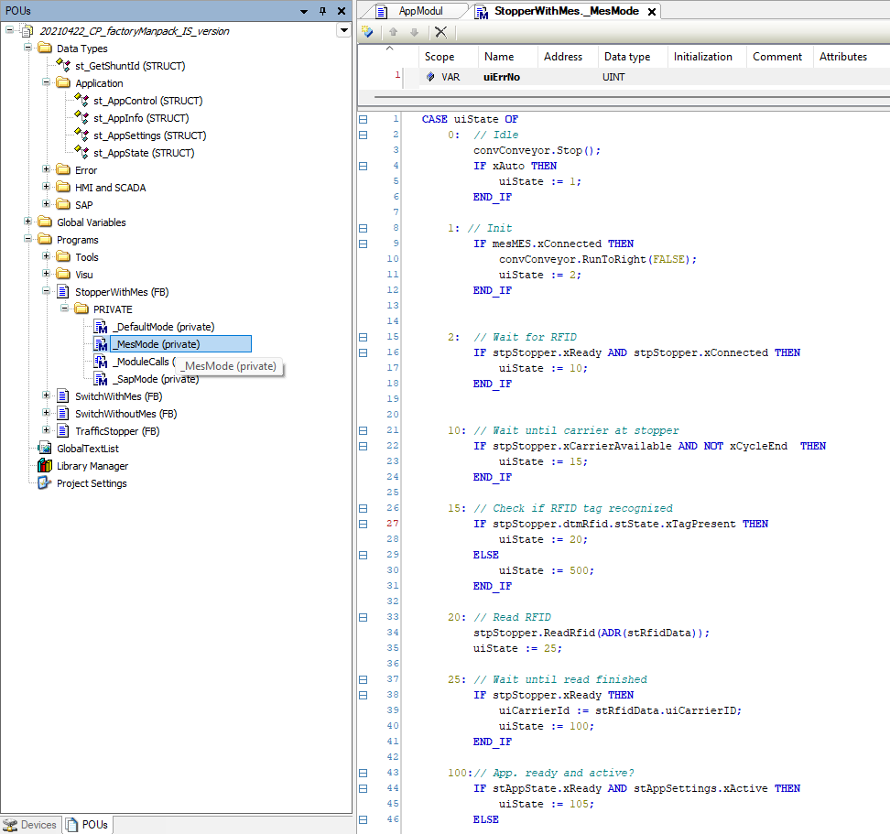
- It sends requests by using variations of “mesMES.<req_type(params)>”. This formats the parameters such as order number (ONo) and order position (OPos) appropriately and sends the request to the MES4 system.
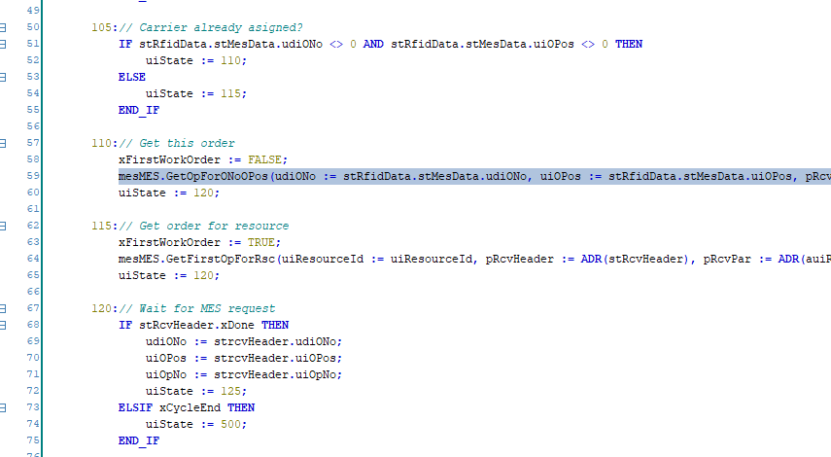
- PRO TIP: To see the values used in the request function go to its definition
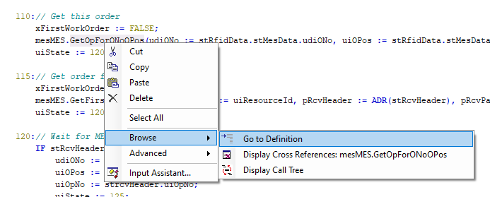
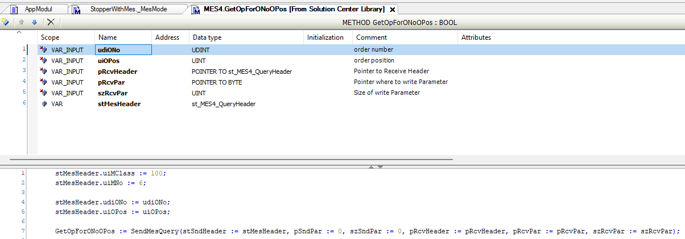

- The general flow of the “_MesMode” is as follows
Wait active RFID signal
If first order (RFID data = 0):
send mesMES.GetFirstOpForRsc
Else:
send mesMES.GetOpForONoOPos
Wait MES4 response
If OpNo and RscID matches current resource:
start operation (run AppModul)
send mesMES.OpStart
Else
Let carrier pass
Wait operation finish
Send mesMES.OpEnd (MES4 knows this operation step has finished and can now continue)
Update RFID tag – write order number and position and more

Note:
(operation numbers are defined in top of “AppModul” and must match the definitions in MES4)
- Use the communication simulator in MES4 to see and test the various request types. First change user to “Special Operator” with password “Festo2”.
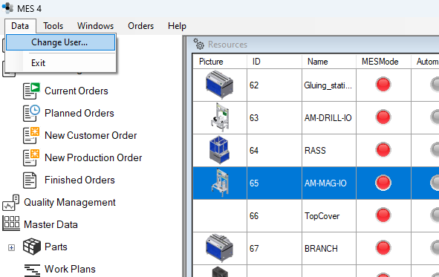

- Under tools go to “Com.-Simulator…”
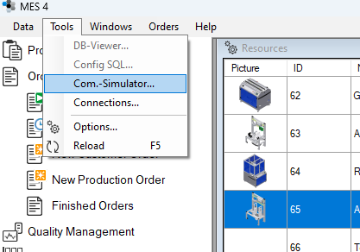

- Here the different requests can be tested by inputting appropriate values for the request variables and clicking “Send”. The respond from MES4 can then be seen in the bottom information box. Notice that an order had been started and the first operation on that order is “200” on resource “65” (bottom cover).
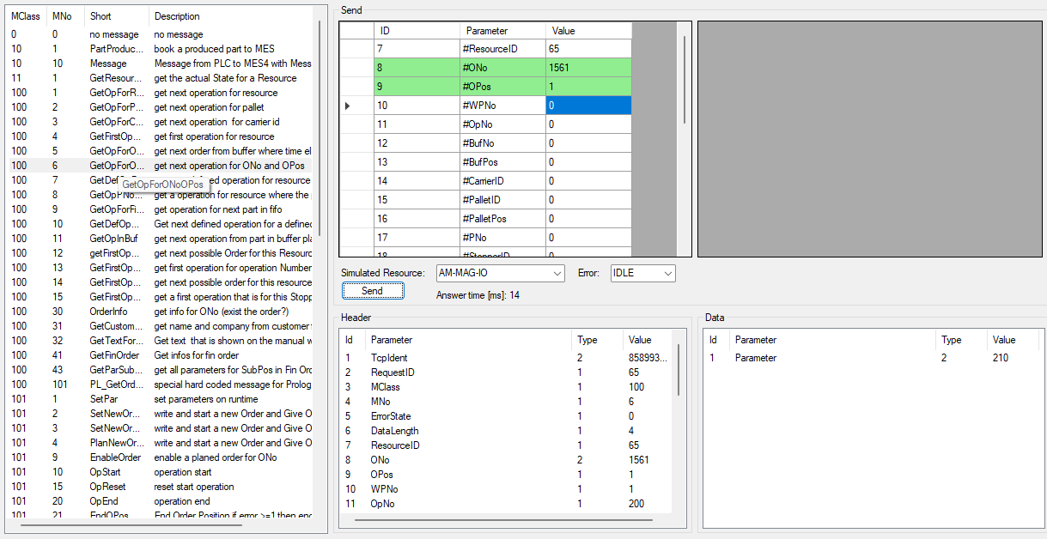
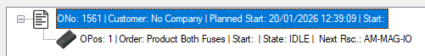

- Overview of the relevant requests
GetFirstOpForRsc OpStart
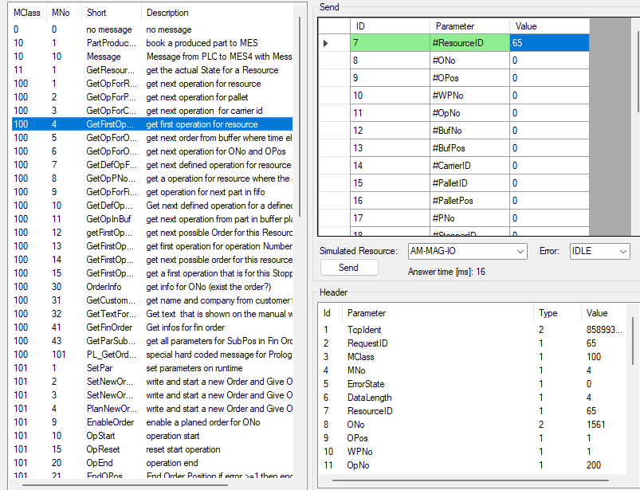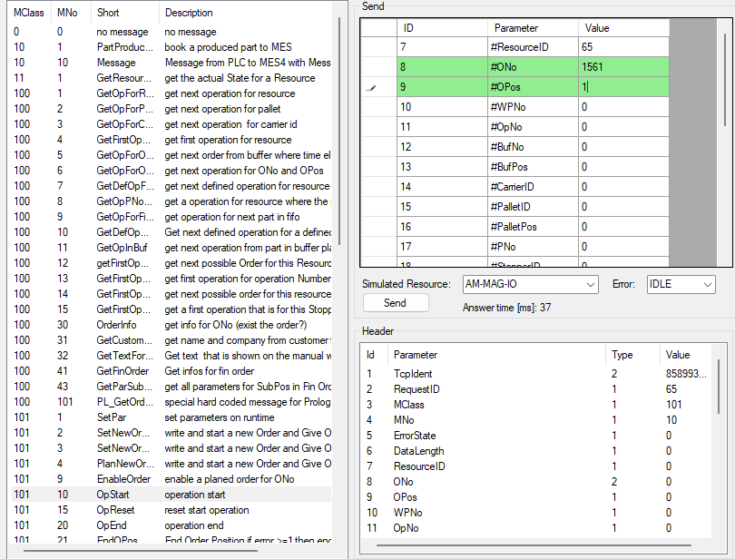
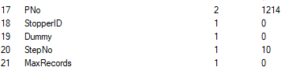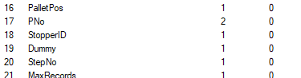

OpEnd GetOpForONoOPos
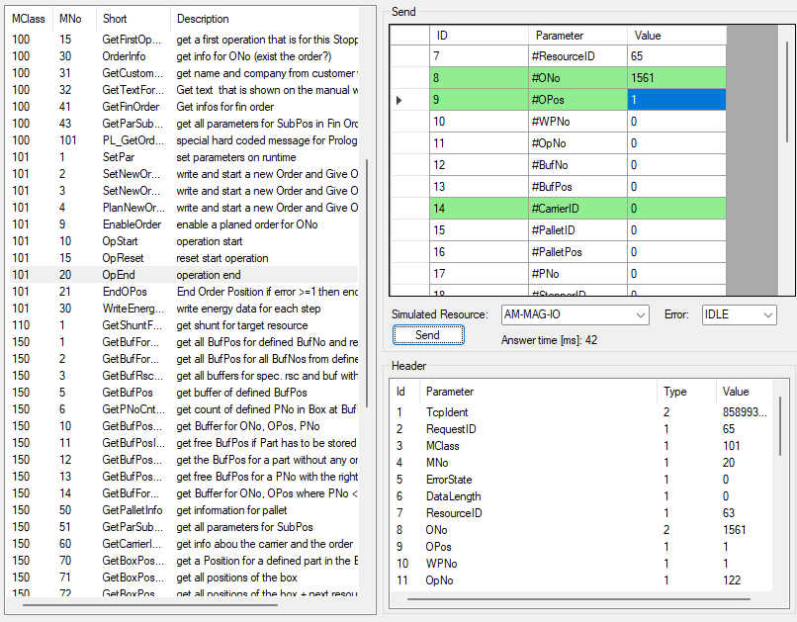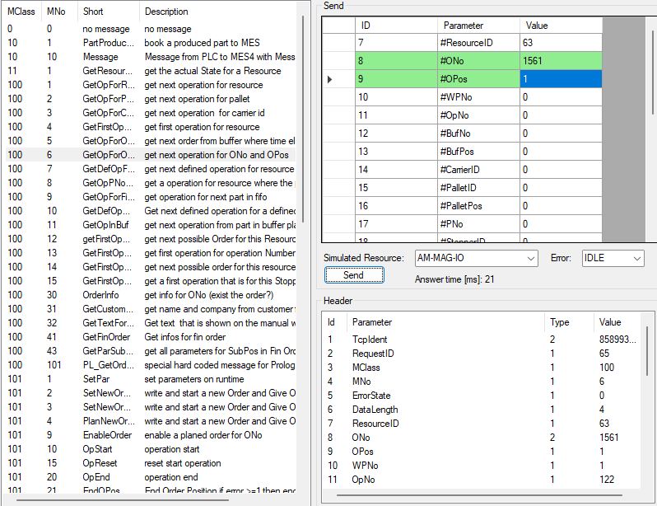
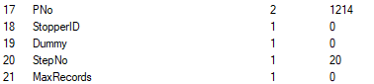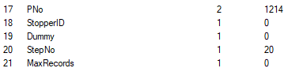

- PRO TIP: When using the communication simulator while having a order, you can follow along be right clicking the expanded order and clicking “Show Details”:
